RISC-V Product Development Hackathon:Top of Form

**Stage 1-Product Idea Submission Form**

1. **Product Title**

S-Band (Safety band)

1. **What does your product do?**

* Detect
* Alert

1. **What all interfaces of the board will used in the product ?**

We will using GPIO pins to control the alert components (i.e led’s ,buzzer etc…).And SPI communication protocol in between nRF24L0 module and riscduino board.

1. **Does the product utilise sensors?**

* Yes

1. **If "Yes" for above question, then list your sensors here**
   * Buzzer (Alert component)
   * LED’s (Alert component)
   * nRF24L0 module**.**(SPI communication module)
2. **Draw a Block diagram of the product.**

Buzzer, LED’s

Mother Band

Child Band

RISCDUINO

nRF24L0

nRF24L0

SPI communication protocol

Alert system to Mother Band

1. **Upload the Algorithm flowchart of the product.**

1. Start.

2. Establishing connection between 2 bands using SPI protocol.

3. If 2 bands are connected with each other.

4. Then LED starts blinking with respect to data packets receiving.

3. If connection is lost between 2 bands.

4. Then alert is passed to mother band.

5. Buzzer present in mother band, get chime and LED glows constantly.

6. Stop.

1. **Explain the algorithm of the product in bullet points.**

* Two bands are connected with each other by NRF modules.
* When child is within the range (Safe / Alert zone) then LED blinks with respect to the data packets it receiving (Mother band).
* At the same time mother able to see in which zone her child is in serial monitor. (Safe zone, Alert zone, Danger zone).
* When child crossed the alert zone it means when child entering into danger zone (Like Accidents in heavy traffic, Hazardous areas).
* Then immediately NRF get disconnected in two bands.
* When the module disconnected, then buzzer present in mother band get chime and LED glows constantly.
* Then mother will able to save her child when child moving away from mother.
* In this way we provided to enhance child safety and peace of mind to mothers.
* In earlier days we have seen so many child deaths(both mentally disabled and abled child and physically handicap child) due to unexpected situations this will change to more pandemic to all employed mothers .

1. **Draw a Rough sketch of the final product.**

­­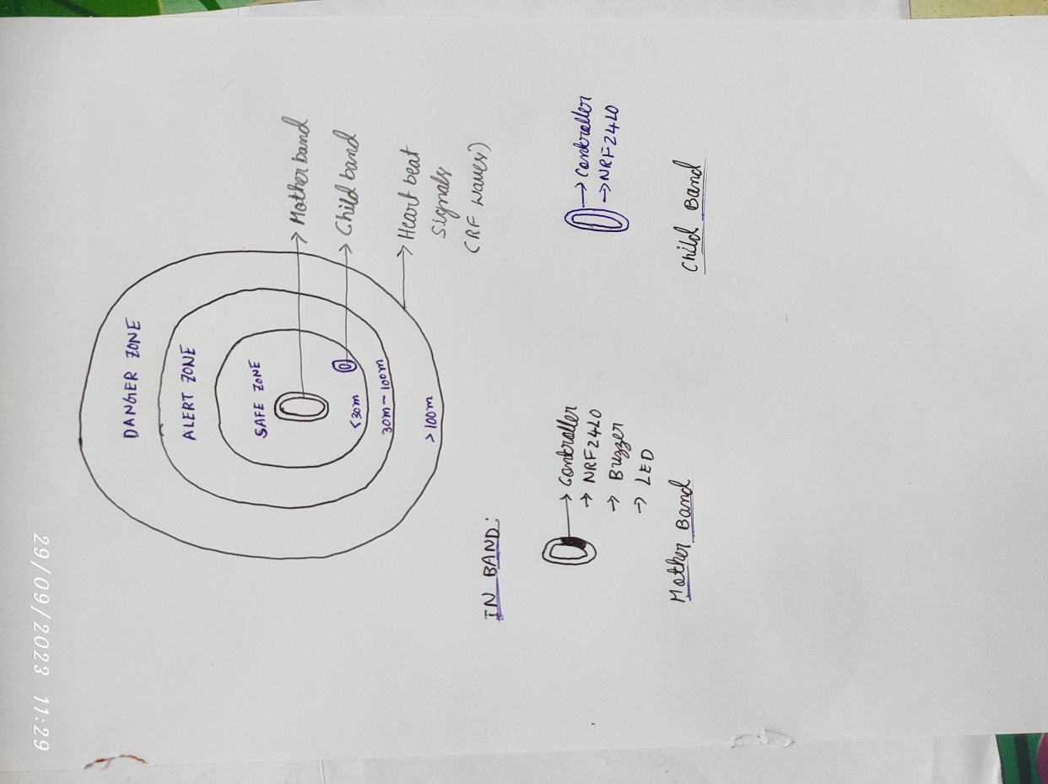

1. **Upload the rough sketch of the Internal product (With all connection of components with the board and the product).**

SPI protocol

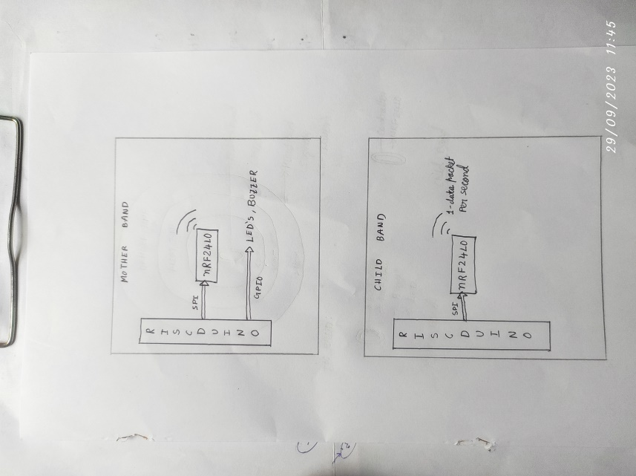 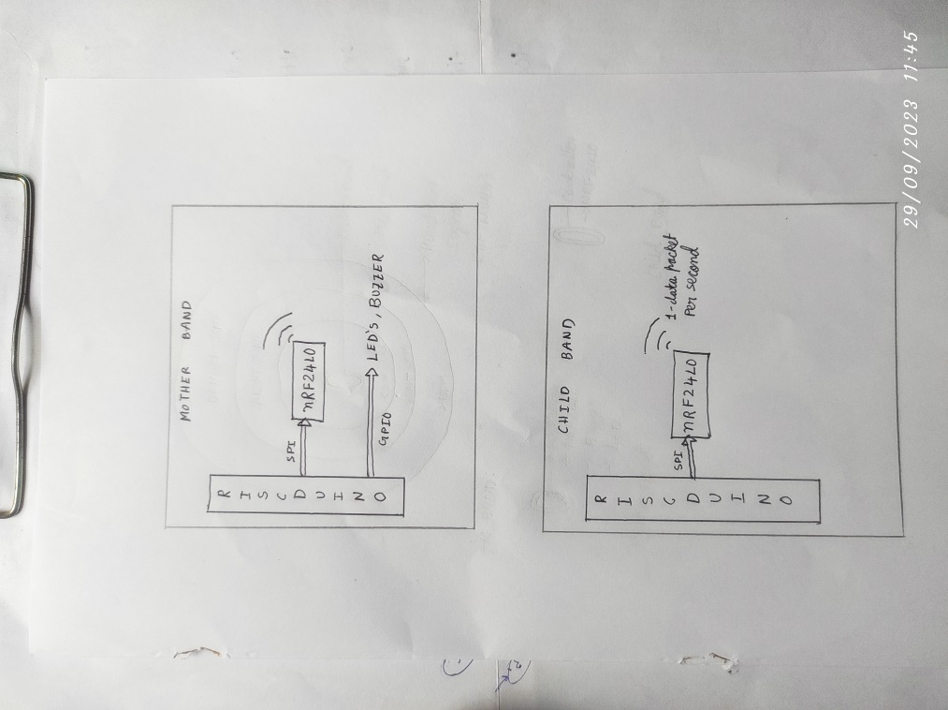

*Communication between mother and children through safety bands.*

1. **BoM list (excluding the board) with cost.**

|  |  |  |  |
| --- | --- | --- | --- |
| **Component name** | **Quantity Required** | **Unit price** | **Total Price**  **(Unit price*Quantity)** |
| **nRF24L0 module** | **2** | **₹160** | **₹320** |
| **LED’S** | **1** | **₹10** | **₹10** |
| **Buzzer** | **1** | **₹10** | **₹10** |
| **Jumper wires** | **3** | **₹40** | **₹120** |
| **Arduino Uno** | **2** | **₹500** | **₹1000** |
| **Total cost** | | | **₹1460** |

1. **Team details**

|  |  |  |  |  |  |  |  |
| --- | --- | --- | --- | --- | --- | --- | --- |
| **Name** | **University/Organisation** | **Age** | **Gender** | **Current Semester** | **Current Address** | **Do you need accommodation if the Demo is to done in Bangalore** | **Role in Product Development** |
| DIGUMARTHI SWARNA | RGUKT  NUZVID | 21 | F | E4 SEM1 | NUZVID | YES | Software |
| APPIKONDA. CHANDRA SEKHAR | RGUKT NUZVID | 21 | M | E3 SEM1 | NUZVID | YES | Hardware |