SAVEETHA ENGINEERING COLLEGE A GRADE · NBA
AUTONOMOUS | Affiliated to Anna University | Approved by AICTE | Thandalam, Chennai
Department of Electronics & Communication Engineering

LAB MANUAL
SUBJECT CODE: 19EC411
SUBJECT: ANTENNA AND MICROWAVE ENGINEERING LAB B.E
(Branch: ECE)

Name : CHANDRAN L
Register Number : 212224060049 Semester : III (Term 1, Foundation Course) Academic Year : 2026 – 2027

TABLE OF CONTENTS

S.No. | Date | Name of the Experiment | Page No. | Marks | Signature
1 | 21.07.2026 | V–I Characteristics of Gunn Diode | 3
2 | 28.07.2026 | Mode Characteristics of Reflex Klystron | 7
3 | 04.08.2026 | Characteristics of Directional Coupler | 11
4 | 11.08.2026 | Characteristics of Magic Tee | 14
5 | 18.08.2026 | Characteristics of H–Plane Tee | 17
6 | 25.08.2026 | Characteristics of E–Plane Tee | 20

EXP–02 : MODE CHARACTERISTICS OF REFLEX KLYSTRON
Date : 28.07.2026

AIM
To study the mode characteristics of a reflex klystron and hence to determine the mode number, electron transit time, electronic tuning range (ETR) and electronic tuning sensitivity (ETS).

EQUIPMENT AND COMPONENTS
- Klystron power supply.
- Klystron tube (type 2K25) with mount.
- Isolator.
- Frequency meter.
- Variable attenuator.
- Detector mount.
- Waveguide stands.
- VSWR meter.
- Cathode Ray Oscilloscope.

EXPERIMENTAL SETUP
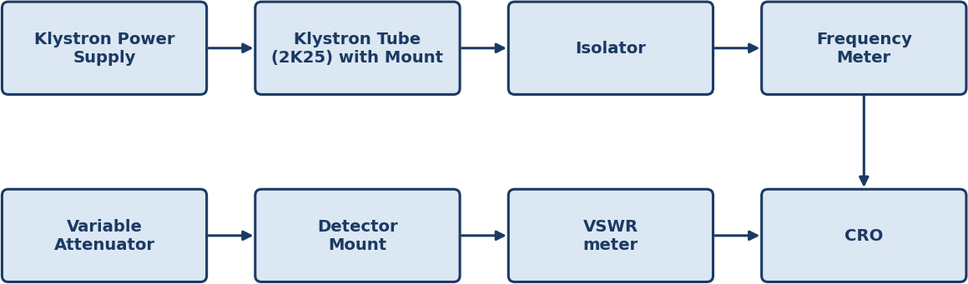

Fig. 1 — Microwave bench setup for reflex klystron mode characteristics
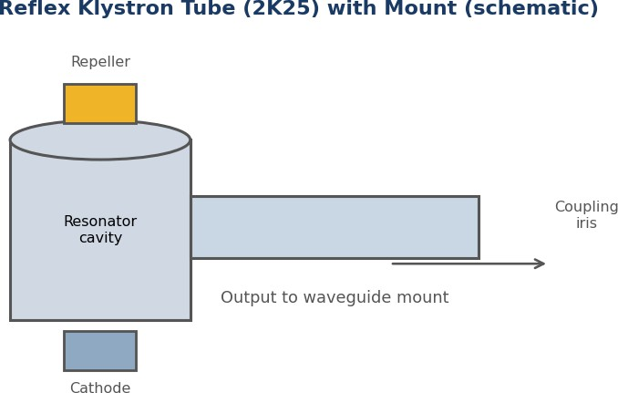

Schematic view of the reflex klystron tube (2K25) with resonator, repeller and mount

THEORY
The reflex klystron is a low–power microwave source widely used in the laboratory. It generates microwave power using velocity modulation of an electron beam. Electrons emitted from the cathode are accelerated toward, and pass through, the positive resonator grids, after which they travel into the region beyond the resonator, called the repeller (reflector) space, where a repeller electrode is held at a negative potential with respect to the cathode. Because of this negative potential, the electrons are decelerated, brought to rest, and turned back (reflected) toward the resonator grids – hence the name “reflex” klystron.

While the beam is oscillating inside the resonator cavity, a radio–frequency field exists across the resonator gap. An electron that crosses the gap while the field is decelerating it loses energy and returns at a lower velocity, while an electron that crosses when the field is accelerating it gains energy and returns faster. Because of this difference, electrons that pass through the gap at different instants of the RF cycle take different times to travel into the repeller space and return – that is, they acquire different transit times. This is velocity modulation. As a result, on the return journey the electrons bunch together in groups (electron bunching).
If a bunch of returning electrons crosses the resonator gap at the instant when the gap field is decelerating (so that the bunch gives up energy to the cavity), the cavity is reinforced and oscillations build up and are sustained. This condition is met when the transit time in the repeller region corresponds to (n + ¾) cycles of the resonator frequency, where n is a positive integer or zero; each value of n identifies a distinct oscillation “mode” of the tube. If the bunch instead arrives when the field would accelerate it, energy is taken from the electrons but delivered to the field only if timed correctly – otherwise energy is removed from the resonator and oscillation is not sustained.
Because several different repeller voltages can satisfy the (n + ¾) transit–time condition, the tube oscillates over several discrete repeller–voltage ranges called modes, each with a characteristic output power and frequency. Tuning within a given mode by varying the repeller voltage is called electronic tuning; the corresponding shift in frequency per volt of repeller change is the electronic tuning sensitivity (ETS), and the total frequency range that can be covered electronically within a mode is the electronic tuning range (ETR). Separately, mechanical tuning changes the physical cavity dimensions, and hence its resonant frequency, without significantly changing the output power.

CIRCUIT / PORT DIAGRAM
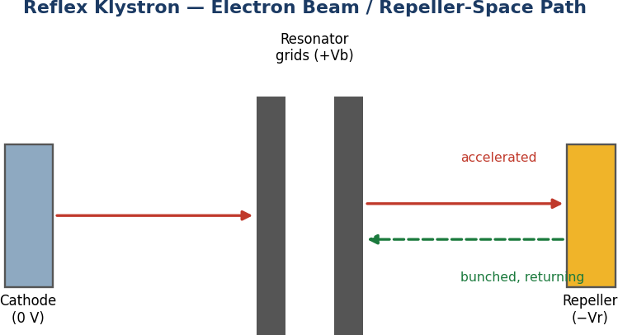

Electron beam path within the reflex klystron: acceleration through the resonator grids and bunched return from the repeller space

PROCEDURE
  - The components are connected as shown in Fig. 1.
  - Initial settings on the klystron power supply are made: mode switch to AM, beam voltage knob fully anticlockwise, repeller voltage knob fully clockwise, and the meter switch set to beam current.
  - The frequency meter is set off–resonance (turned to one side) and must always be rotated very slowly.
  - The klystron power supply, VSWR meter / CRO, and the cooling fan are switched ON, and about 1–2 minutes are allowed for the tube to stabilise.
  - The beam voltage is increased from minimum until the beam current is around 20 mA, ensuring it never exceeds 30 mA.
  - The meter switch is changed to the repeller voltage position, and the repeller voltage is reduced gradually from its maximum negative value; at each mode (region of oscillation) the detected output power and the corresponding repeller voltage are noted.
  - To measure the oscillation frequency at a given mode, the mode switch is set to AM, and the output is observed on the CRO; the frequency meter is rotated slowly until a sharp dip appears in the displayed output, and the frequency reading is taken at that dip.
  - The above steps are repeated for each visible mode, recording the repeller voltage, output power (via the VSWR meter) and frequency (via the dip on the frequency meter) for every mode.
  - A graph of output power versus repeller voltage is plotted to display the mode pattern, and a graph of frequency versus repeller voltage is plotted for each mode to obtain the electronic tuning characteristic.

PROCEDURE FLOWCHART

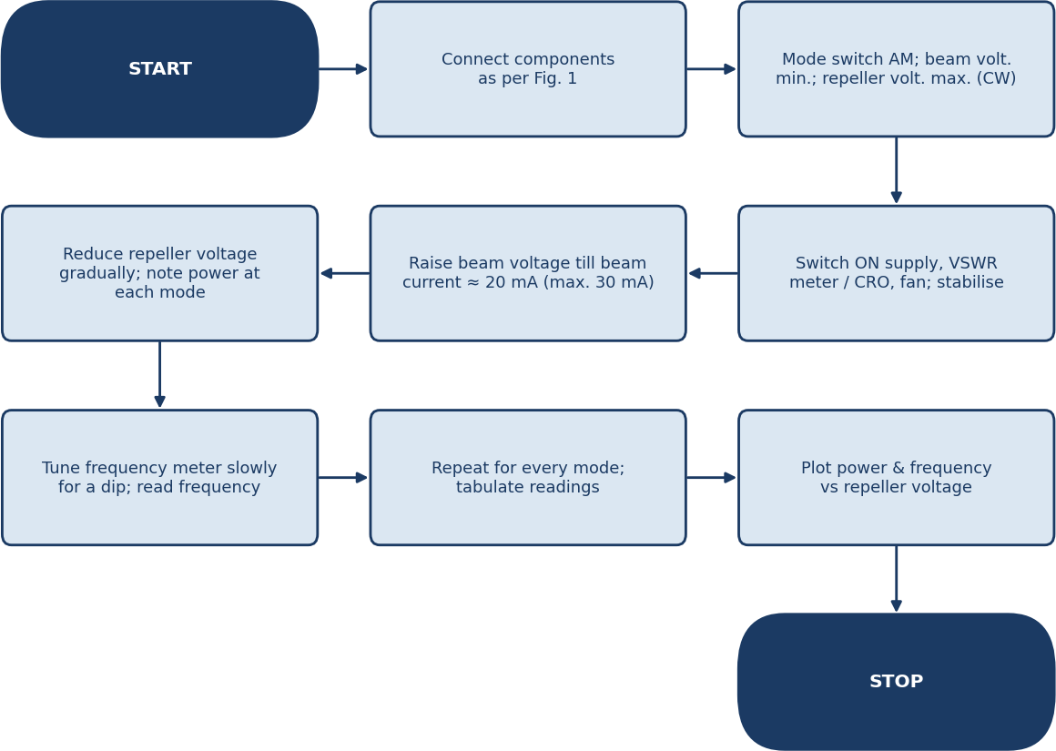

Flowchart — sequence of steps followed in Exp–02

TABULATION

S. No. | Repeller Voltage (V) | Relative Output Power (dB) | Frequency (GHz) | Mode
1 | –100 | –2.0 | 8.938 | Mode 1  (n = 1, N = 1.75)
2 | –120 | 0.0 (peak) | 8.952
3 | –140 | –3.0 | 8.966
4 | –180 | –4.0 | 9.010 | Mode 2  (n = 2, N = 2.75)
5 | –200 | 0.0 (peak) | 9.026
6 | –220 | –5.0 | 9.042

FORMULA
- Mode number: N = n + ¾ (n = 0, 1, 2, …)
- Electronic Tuning Sensitivity: ETS = (f2 – f1) / (V2 – V1) MHz/V
- Electronic Tuning Range (ETR): ETR = fmax – fmin within a mode (MHz)
- Output power: Po = 10(x/20) watts, where x is the dB reading on the VSWR meter

MODEL GRAPH AND ACTUAL GRAPH

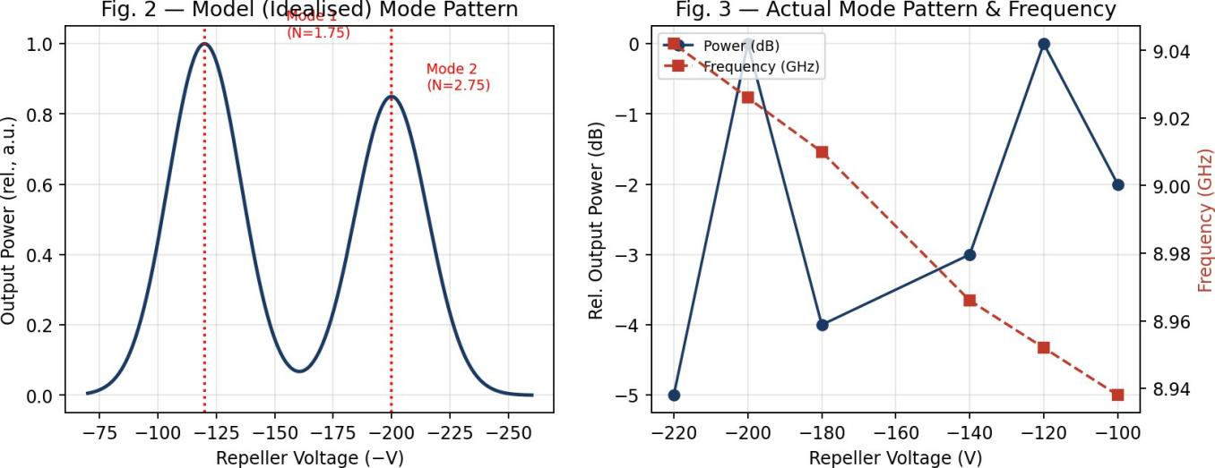

CALCULATION
- Mode 1 (peak at –120 V): N1 = n + ¾ = 1.75 (n = 1).
- ETS1 = (f140 – f100) / (V140 – V100) = (8.966 – 8.938) GHz / (–140 – (–100)) V = 28 MHz / (–40 V) ≈ 0.70 MHz/V.
- ETR1 = 8.966 – 8.938 GHz = 28 MHz.
- Mode 2 (peak at –200 V): N2 = n + ¾ = 2.75 (n = 2).
- ETS2 = (9.042 – 9.010) GHz / (–220 – (–180)) V = 32 MHz / (–40 V) ≈ 0.80 MHz/V.
- ETR2 = 9.042 – 9.010 GHz = 32 MHz.

PRECAUTIONS
- All connections should be checked before switching ON the power supply.
- All knobs should be kept at their minimum position before switching ON the klystron / VSWR power supplies.
- The klystron power supply “HT” switch must be OFF before the main supply is switched ON.
- The beam voltage knob should be fully anticlockwise and the repeller voltage knob fully clockwise before starting.
- Sufficient warm–up time should be given after switching ON the main supply.
- Never look directly into the open waveguide.
- At the end of the experiment, all knobs are returned to minimum before switching OFF the mains.
- If the mains supply fails mid–experiment, all knobs must first be returned to minimum before the main switches are turned OFF.
- The repeller voltage must be kept within –70 V to –270 V and never exceeded.

RESULT / CONCLUSION
The mode characteristics of the given reflex klystron (2K25) were studied over the range –70 V to –270 V. Two oscillation modes were observed, N1 = 1.75 (peak at –120 V, 8.952 GHz) and N2 = 2.75 (peak at –200 V, 9.026 GHz). The electronic tuning sensitivity was found to be 0.70 MHz/V for Mode 1 and 0.80 MHz/V for Mode 2, with electronic tuning ranges of 28 MHz and 32 MHz respectively.

