SAVEETHA ENGINEERING COLLEGE A GRADE · NBA
AUTONOMOUS | Affiliated to Anna University | Approved by AICTE | Thandalam, Chennai
Department of Electronics & Communication Engineering

LAB MANUAL
SUBJECT CODE: 19EC411
SUBJECT: ANTENNA AND MICROWAVE ENGINEERING LAB B.E
(Branch: ECE)

Name : CHANDRAN L
Register Number : 212224060049 Semester : III (Term 1, Foundation Course) Academic Year : 2026 – 2027

TABLE OF CONTENTS

S.No. | Date | Name of the Experiment | Page No. | Marks | Signature
1 | 21.07.2026 | V–I Characteristics of Gunn Diode | 3
2 | 28.07.2026 | Mode Characteristics of Reflex Klystron | 7
3 | 04.08.2026 | Characteristics of Directional Coupler | 11
4 | 11.08.2026 | Characteristics of Magic Tee | 14
5 | 18.08.2026 | Characteristics of H–Plane Tee | 17
6 | 25.08.2026 | Characteristics of E–Plane Tee | 20

EXP–06 : CHARACTERISTICS OF E–PLANE TEE
Date : 25.08.2026

AIM
To study the characteristics of an E–plane tee (series tee) and to determine the power–division ratio between its collinear arms and the isolation between them.

EQUIPMENT AND COMPONENTS
- Klystron power supply.
- Klystron tube (2K25) with mount.
- Isolator.
- Frequency meter.
- Variable attenuator.
- E–plane tee (device under test).
- Matched terminations.
- Detector mount.
- VSWR meter.
- Waveguide stands.

EXPERIMENTAL SETUP
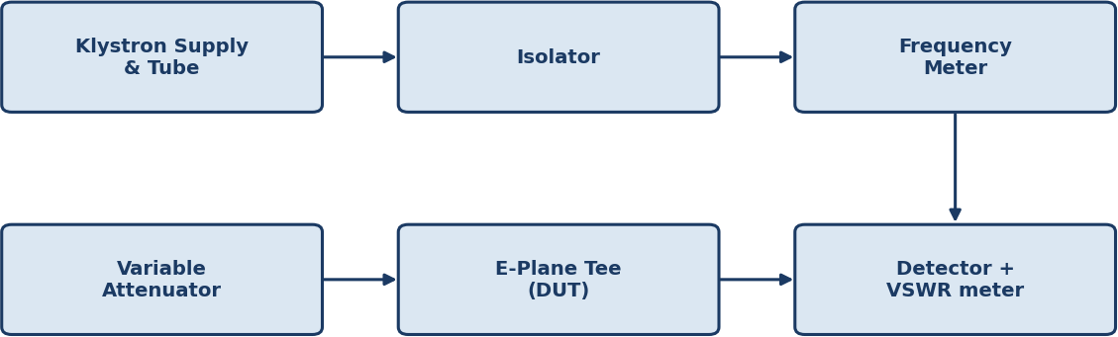

Fig. 1 — Microwave bench setup with E-plane tee as device under test

THEORY
An E–plane tee is a waveguide junction in which the axis of the side arm is parallel to the electric (E) field of the main waveguide, formed by cutting a slot along the narrow wall so the side arm extends in the plane containing the E–field. It behaves as a series junction: when power is fed into the side arm (port 3, the E–arm), it divides equally between the two collinear arms (ports 1 and 2) but the two outputs are 180° out of phase with each other. Conversely, signals fed into the two collinear arms in phase cancel at the E–arm, while signals fed 180° out of phase add at the E–arm. This phase–reversing power split makes the E–plane tee useful in balanced mixers and other circuits requiring a phase difference between the two output signals.

CIRCUIT / PORT DIAGRAM

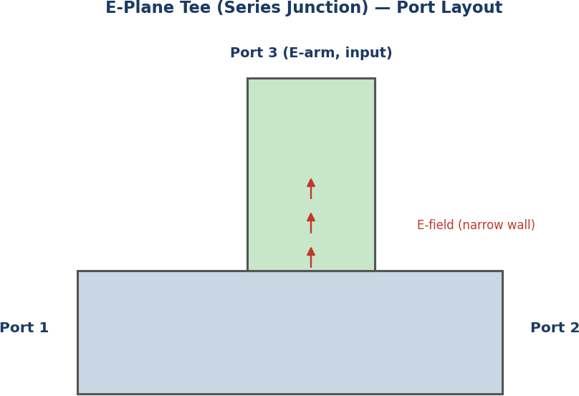

E-plane tee — side arm parallel to the E-field of the main guide (series junction)

PROCEDURE
- The bench is set up with the E–plane tee connected as the device under test and the klystron output stabilised.
- Power is fed into the E–arm (port 3); port 2 is terminated in a matched load and the detector is connected to port 1, and the output reading is noted.
- The detector and matched load are interchanged between ports 1 and 2, and the output at port 2 is noted with port 1 terminated.
- To find the isolation between the two collinear arms, power is fed into port 1, port 3 is terminated in a matched load, and the leakage at port 2 is measured.
- All readings are recorded in dB.

PROCEDURE FLOWCHART

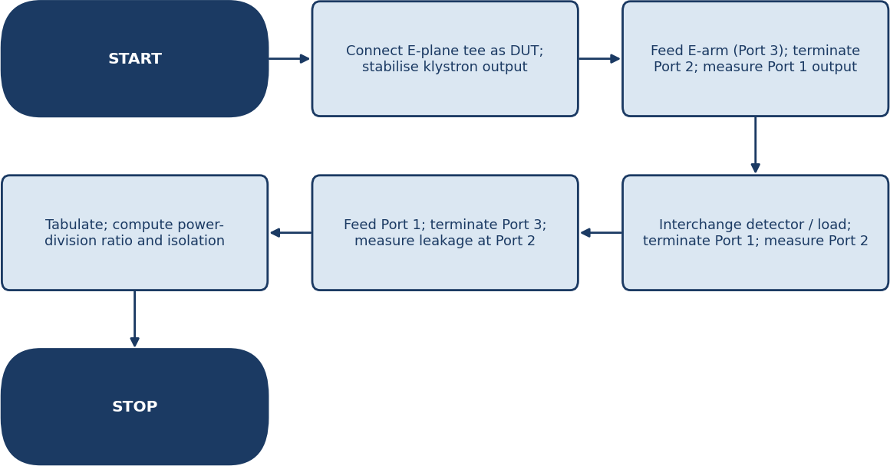

Flowchart — sequence of steps followed in Exp–06

TABULATION

S. No. | Input Port | Output Port | Input Power (dB) | Output Power (dB) | Result (dB)
1 | Port 3 | Port 1 | 0.0 | –3.5 | 3.5
2 | Port 3 | Port 2 | 0.0 | –3.4 | 3.4

S. No. | Input Port | Output Port | Input Power (dB) | Output Power (dB) | Result (dB)
3 | Port 1 | Port 2 (isolation) | 0.0 | –24.0 | 24.0

FORMULA
- Power division ratio (Port 3 → Port 1, Port 2) = Pin – Pout = 10 log10 (Pin / Pout) dB (ideally ≈ 3 dB at each arm, 180° out of phase)
- Isolation between collinear arms = 10 log10 (P1 / P2) dB

MODEL GRAPH AND ACTUAL GRAPH
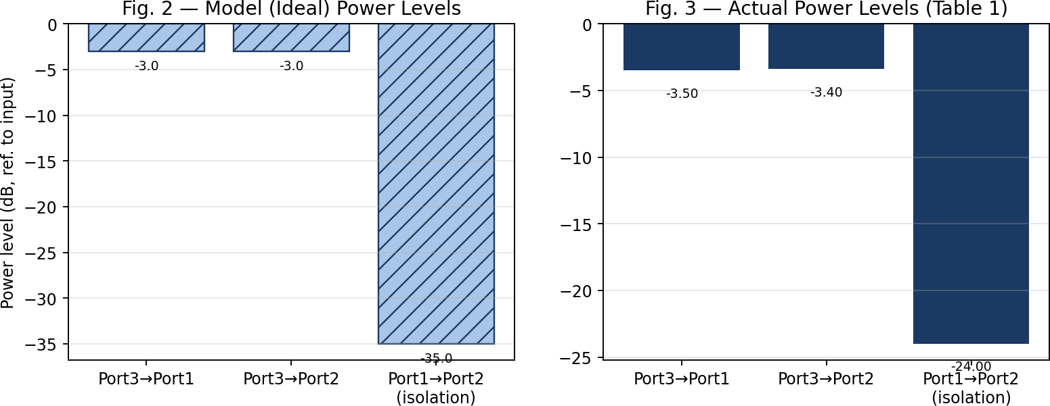

CALCULATION
- Power at Port 1 (from Port 3) = 0.0 – (–3.5) = 3.5 dB down.
- Power at Port 2 (from Port 3) = 0.0 – (–3.4) = 3.4 dB down.
- Both arms are within 0.1 dB of each other and close to the ideal 3 dB point, confirming an equal power split; the 180° phase reversal between the two outputs (a property of the series junction) is confirmed separately using a phase–shifter/slotted–line comparison.
- Isolation (Port 1 → Port 2, with Port 3 matched) = 0.0 – (–24.0) = 24.0 dB.

PRECAUTIONS
- Unused ports must always be terminated in matched loads.
- Flange connections should be tight and properly aligned to avoid reflections.
- The klystron source should be allowed to stabilise before readings are taken.
- Do not look directly into the open waveguide.

RESULT / CONCLUSION
The power–division ratio between the collinear arms of the given E–plane tee was found to be 3.5 dB and 3.4 dB (nearly equal), and the isolation between the collinear arms was found to be 24.0 dB. The equal power split with a 180° phase reversal, characteristic of a series (E–plane) junction, was verified.

