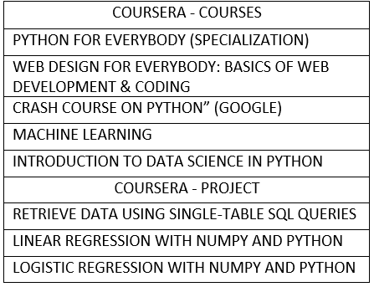

# EXPERIENCE



Chandrima Ghosh

NA AS CSD

## SUMMARY

I am critical thinker, well-organized, and completed B.Tech from Presidency university with a passion of exploring technical field and data management. I’ve done several certifications to improve my technical skills. I have a experienced with technical support. Being a quick and active learner want to improve and develop new skills. I would like to expand my knowledge and technical skills towards an organization goal.

## KEY SKILLS

* Programming: Python,Java,Database(MYSQL)
* Web design: HTML,CSS3,JavaScripts
* MS Excel, Word
* Machine Learning, Data Science

7003906229

[chandrima.ghosh@capgemini.com](mailto:shriyanshu.khare@capgemini.com)

DBLP: https://dblp.org/pid/268/9953

### ANALYST / SOFTWARE ENGINEER

*(Jan 2022 - Present)*

**CAPGEMINI** - Bangalore

### TECHNICAL SUPPORT ENGINEER L1

*(Mar 2021 – Dec 2021)*

**HEWLETT PACKARD (HP)** – Bangalore

* + Technical support engineer for non- voice and partial voice system.
  + Supported all consumer printers.
  + Got training in how to solve the customer query and issue resolved, CRM.
  + Give the support for AU, NZ region.

### ONLINE BUS TICKET RESERVATION SYSTEM

*(Sep 2019 – Jan 2020)*

**HEWLETT PACKARD (HP )** – Bangalore

* + Project Role: Database management and lead the team.
  + Prepared and implemented that website with better algorithm
  + advantage is without login or signup anyone can view and book the tickets
  + Learned Python and Django language, database SQLite and web design
  + Understood of how requirements are received, analyses and designed, project manage and team management

### ACHIEVEMENT: PAPER PUBLICATION

*(Sept 2019 – May 2020)*

**IWCIA – 2020** - NOVI SAD, SERVIA

* Author: Abhisek Midya, Frits W. Vaandrager, D. G. Thomas, Chandrima Ghosh.
* Paper name: “Simulating Parallel Internal Column Contextual Array Grammars Using Two-Dimensional Parallel Restarting Automata with Multiple Windows”.
* Submitted in 20th International Workshop on Combinatorial Image Analysis (IWCIA – 2020), NOVI
* SAD, SERVIA.
* In proc. Lecture Notes in Computer Science (LNCS - 12148), (Springer – Champ, Switzerland), pp. 156 – 169 (2020).
* DOI: http://doi-org- 443.webvpn.fjmu.edu.cn/10.1007/978-3-030-51002-2_8
* Learned designed algorithms, implementation of 2-D restating automaton, Logic implements.

# EDUCATION

### B.Tech.

*(2017-2021)*

#### PRESIDENCY UNIVERSITY, BANGALORE

Specialization- Computer Science and Engineering

### H.S. (12th)

*(2016-2017)*

#### TARASUNDARI BALIKA VIDYA BHABAN, WB

Specialization- Computer Science

CERTIFICATIONS