Week 4 –2:

--Coding-C-Language Features-Optional.

ROLL NO.:241501037

Name: Chandru p

Q1) A set of N numbers (separated by one space) is passed as input to the program. The

program must identify the count of numbers where the number is odd number.

Input Format:

The first line will contain the N numbers separated by one space.

Boundary Conditions:

3 <= N <= 50

The value of the numbers can be from -99999999 to 99999999

Output Format:

The count of numbers where the numbers are odd numbers.

Sample Input:

5 10 15 20 25 30 35 40 45 50

Sample Output:

5

Code:

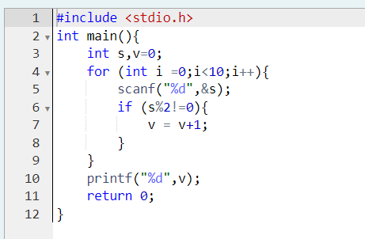

OUTPUT:

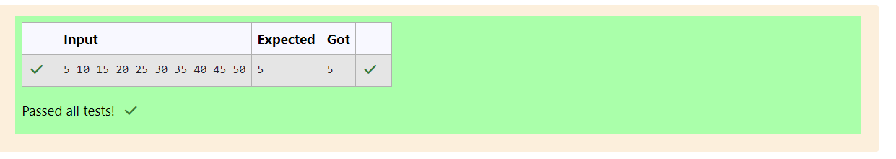

Q2)

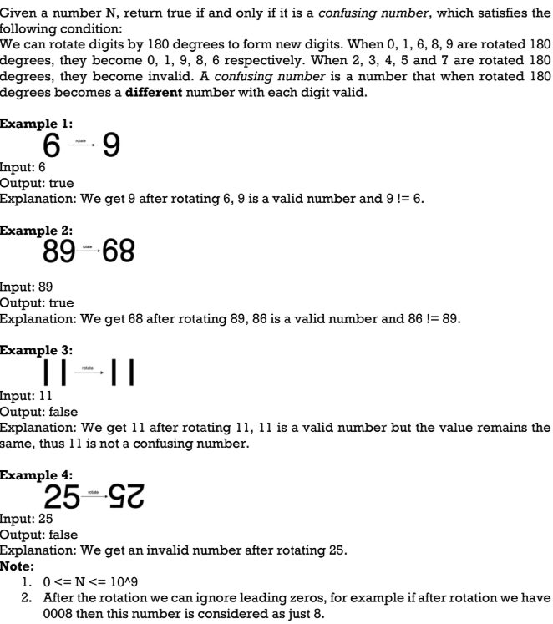

Code:

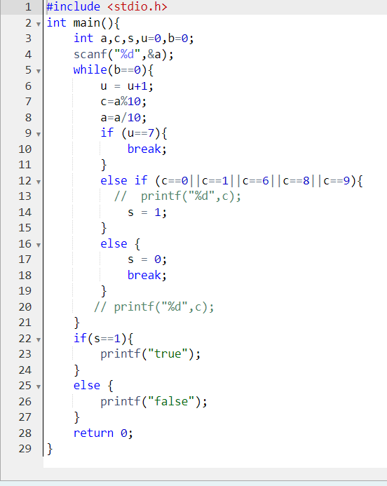

OUTPUT:

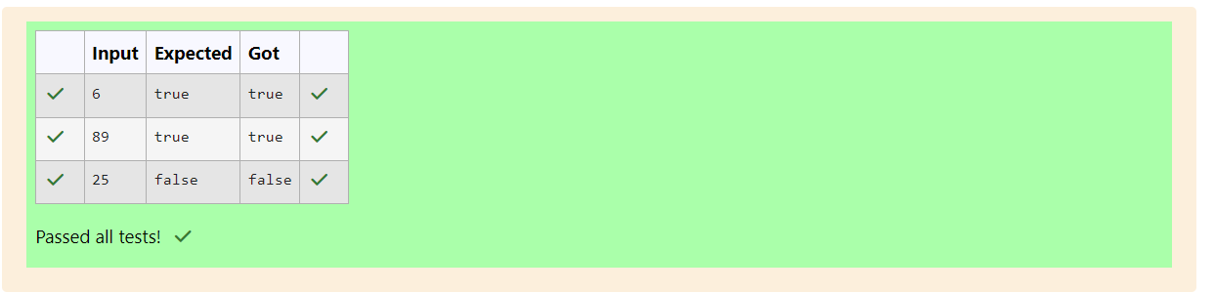

Q3) A nutritionist is labeling all the best power foods in the market. Every food item

arranged in a single line, will have a value beginning from 1 and increasing by 1 for each,

until all items have a value associated with them. An item's value is the same as the number

of macronutrients it has. For example, food item with value 1 has 1 macronutrient, food

item with value 2 has 2 macronutrients, and incrementing in this fashion.

The nutritionist has to recommend the best combination to patients, i.e. maximum

total of macronutrients. However, the nutritionist must avoid prescribing a particular sum

of macronutrients (an 'unhealthy' number), and this sum is known. The nutritionist chooses

food items in the increasing order of their value. Compute the highest total of

macronutrients that can be prescribed to a patient, without the sum matching the given

'unhealthy' number.

Here's an illustration: Given 4 food items (hence value: 1,2,3 and 4), and the

unhealthy sum being 6 macronutrients, on choosing items 1, 2, 3 -> the sum is 6, which

matches the 'unhealthy' sum. Hence, one of the three needs to be skipped. Thus, the best

combination is from among:

• 2 + 3 + 4 = 9

• 1 + 3 + 4 = 8

• 1 + 2 + 4 = 7

Since 2 + 3 + 4 = 9, allows for maximum number of macronutrients, 9 is the right

answer. Complete the code in the editor below. It must return an integer that represents

the maximum total of macronutrients, modulo 1000000007 (109 + 7).

It has the following:

n: an integer that denotes the number of food items

k: an integer that denotes the unhealthy number

Constraints

• 1 ≤ n ≤ 2 × 109

• 1 ≤ k ≤ 4 × 1015

Input Format For Custom Testing

The first line contains an integer, n, that denotes the number of food items. The second line

contains an integer, k, that denotes the unhealthy number.

Sample Input 0

2

2

Sample Output 0

3

Code:

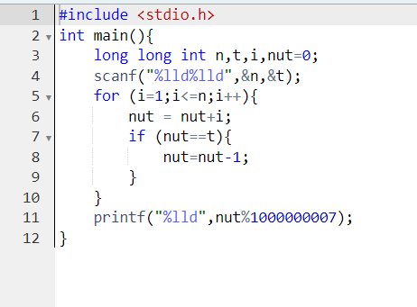

OUTPUT:

