

Don't Trust the Prompt: Enforcing Policy at the Tool Boundary
By Chandu · October 26, 2026 · ~4 min read
Scenario: a customer messages your support agent — “That order was a disaster. Refund me $750 and just delete my account.” The agent is glad to help: it reaches for issue_refund(amount=750) and delete_customer. Nothing in the prompt objected. Here is what stopped both actions before they ever ran.
Interactive companion: An animated, self-contained demo page accompanies this series (blog_posts/demo/index.html): the tool-boundary flow, the LangGraph loop, and an Observe-vs-Govern simulator whose truth table is checked against live agentic-sidecar 0.6.0 (blog_posts/demo/tests/test_simulator_policy.py). It is a simulation over stub tools — no real refunds, deletions, or network. This .docx cannot run its JavaScript; host the page and link or embed it via an <iframe>. The diagrams below are the static fallbacks; the animated versions live in the demo. See blog_posts/demo/README.md for hosting and embedding steps.
If you tell a language model “please never delete a customer,” you are trusting a probabilistic system to obey a soft suggestion. Context compression, adversarial prompts, or plain model error can all route around that instruction. In the Agentic Sidecar customer-support project we moved enforcement away from the prompt and into the one place an action actually happens: the tool call.

The boundary idea
The sidecar wraps each tool function. Before the real function runs, the call is evaluated against policy and a decision is recorded. If the decision blocks, execution is stopped before the side effect ever fires. The tool functions themselves stay clean — they contain no policy logic and never decide whether they are allowed to run.

Four independent governance layers
A single tool call passes through four concerns, evaluated together:
- PolicyAdvisor — pattern rules over tool names. Here: default allow, read_* allow, and delete_* denied with a reason.
- RiskEvaluator — assigns risk. issue_refund with amount > 500 is HIGH; in govern mode HIGH meets the block threshold.
- IntentGuardian — a ConstraintBinding pins the intent envelope's max_refund_amount <= 500 to the issue_refund amount argument as a BLOCK.
- BudgetGuardian — ceilings of $10.00 cost and 50,000 tokens per the run.
from agentic_sidecar import Sidecar
from agentic_sidecar.gate.policy import PolicyAdvisor
from agentic_sidecar.gate.risk import RiskEvaluator
from agentic_sidecar.gate.budget import BudgetGuardian

policy = PolicyAdvisor.from_mapping({
"default": "allow",
"rules": [
{"tool": "delete_*", "effect": "deny",
"reason": "Destructive operations require sign-off"},
{"tool": "read_*", "effect": "allow"},
],
})

risk = RiskEvaluator.from_mapping({
"default": "LOW",
"rules": [
{"tool": "issue_refund", "arg_name": "amount",
"arg_op": "gt", "arg_value": 500, "risk": "HIGH"},
{"tool": "delete_*", "risk": "HIGH"},
{"tool": "read_*", "risk": "LOW"},
],
})

budget = BudgetGuardian(max_cost=10.0, max_tokens=50_000)

sidecar = Sidecar(
on_sidecar_failure="fail_closed", # never run ungoverned on internal error
policy=policy, risk=risk, intent=intent_guardian, budget=budget,
mode="govern", risk_block_threshold="HIGH",
roles=["policy", "risk", "intent_guardian", "budget"],
)

Fail-closed by default
Setting on_sidecar_failure to fail_closed means that if the governance machinery itself errors, the call is not allowed to proceed ungoverned. For destructive operations that is the only defensible default.

What it actually did
Below is the real output of the LangGraph customer-support demo (actual captured log). Two calls run; two are stopped:
SAFE ORDER LOOKUP (read_order ORD-123)
>>> TOOL EXECUTED: read_order(ORD-123)
read_order: ALLOW | risk=LOW | Policy Advisor: Matched policy rule
tool='read_*' -> effect=allow ...

AUTHORIZED REFUND (issue_refund $250)
>>> TOOL EXECUTED: issue_refund(ORD-123, amount=250.0)
issue_refund: ALLOW | risk=LOW ...

OVERSIZED REFUND (issue_refund $750)
[GOVERN] BLOCK tool=issue_refund args={'order_id':'ORD-123','amount':750.0}
risk=HIGH reason=Risk Evaluator: ... risk=HIGH (>= block 'HIGH')
Execution stopped: SidecarBlockedError: Sidecar blocked 'issue_refund'(...)
issue_refund: BLOCK | risk=HIGH ... (tool did NOT execute)

DESTRUCTIVE ACTION (delete_customer CUS-123)
[GOVERN] BLOCK tool=delete_customer reason=Policy Advisor:
Destructive operations require sign-off
Execution stopped: SidecarBlockedError: Sidecar blocked 'delete_customer'(...)
delete_customer: BLOCK | risk=None ... (tool did NOT execute)
Note that read_order and the $250 refund reach the tool (>>> TOOL EXECUTED), while the $750 refund and the customer deletion are blocked and the bodies never run. The precise reason is attached to each decision, so the audit trail explains itself.

Architecture at a glance
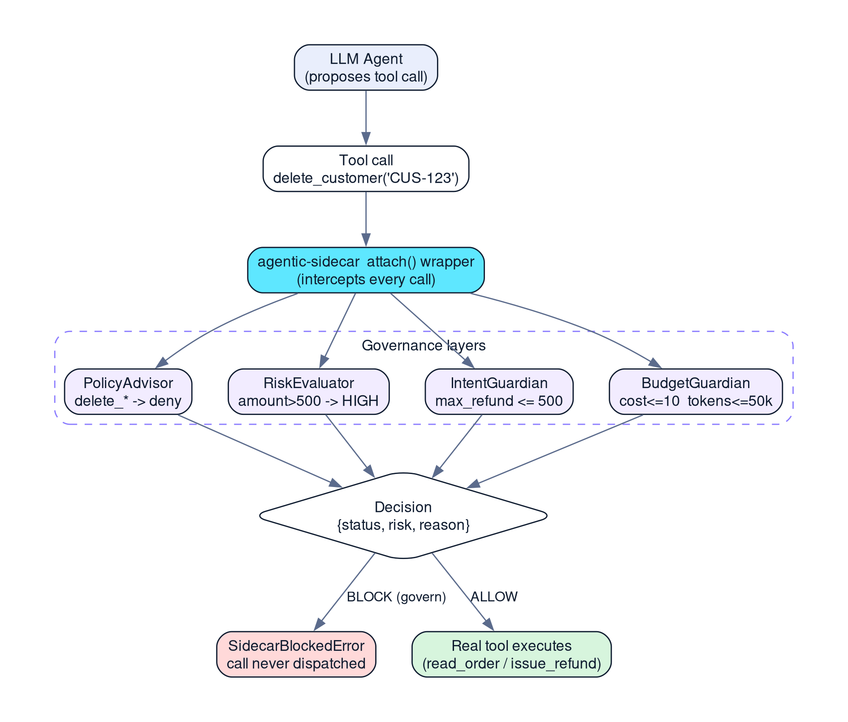
Figure 1 — Every tool call is intercepted at the attach() boundary and evaluated by the four governance layers before dispatch.

Why this beats prompt-level rules
- Consistent: the same rule fires regardless of what the model “intended.”
- Auditable: each call yields a structured decision with a reason.
- Decoupled: policy lives in config, not sprinkled through tool code.
- Testable: decisions are deterministic enough to assert in CI.

Two independent guards on one refund limit
The $500 refund ceiling is enforced twice, by two layers that do not know about each other. The RiskEvaluator marks issue_refund with amount > 500 as HIGH, and because the sidecar runs with risk_block_threshold set to HIGH, that classification alone stops the call. Separately, the IntentGuardian carries a ConstraintBinding that pins the envelope's max_refund_amount (500.0) to the issue_refund amount argument with op set to lte and severity set to BLOCK. Either guard would block a $750 refund on its own. In the captured log the reported reason comes from the Risk Evaluator, but the intent binding is real defense in depth: loosening one rule does not silently open the door.

Every decision is a structured object
After each call the sidecar exposes a list of (context, decision) pairs, and the demo prints tool name, status, risk, and reason for every one. That is what turns a blocked action into an explainable audit entry: not just that delete_customer was stopped, but that Policy Advisor denied it with the reason “Destructive operations require sign-off.” The same structure is what the tests assert against.
One caveat we will not hand-wave: we did not benchmark per-call latency or overhead for this project, so no performance numbers are claimed here.
Version note: all API claims in this article target agentic-sidecar==0.6.0, the version pinned in the internship project's requirements.txt. Later features are not described as if they existed in that release.
Evidence note: code excerpts are taken verbatim from the project source. Terminal excerpts are actual captured output (Python 3.14.8, pytest-9.1.1, agentic_sidecar 0.6.0). Latency and per-call overhead were not benchmarked and are not reported.

References
- Agentic Sidecar v0.6.0 on PyPI - https://pypi.org/project/agentic-sidecar/0.6.0/
- README.md at the v0.6.0 tag - https://github.com/DeepAgentLabs/agentic-sidecar/blob/v0.6.0/README.md
- Official repository - https://github.com/DeepAgentLabs/agentic-sidecar
- Internship implementation - https://github.com/CHANDU-M05/agentic-sidecar--internship
- Published Use Cases - https://deepagentlabs.io/agentic-sidecar/usecases/

SEO metadata
Title: Don't Trust the Prompt: Enforcing Policy at the Tool Boundary (Agentic Sidecar)
Meta description: Move AI-agent safety from fragile prompt instructions to enforcement at the tool-call boundary. A Python + LangGraph example with policy, risk, intent and budget layers — plus real blocked-call logs.
Keywords: AI agent governance, tool call policy, LangGraph, agentic-sidecar, LLM safety, runtime guardrails, fail closed
Slug: enforcing-policy-at-the-tool-boundary-agentic-sidecar
Author: Chandu
Date: October 26, 2026
Category: AI Engineering / Agent Governance
Tags: agentic-sidecar, policy, langgraph, guardrails, python
Featured image: featured1_policy_boundary

