

Observe vs Govern: Recording a BLOCK Isn't Preventing It
By Chandu · October 26, 2026 · ~4 min read
Scenario: your dashboard shows a wall of green BLOCK entries, so the team believes the destructive call was stopped. Scroll three lines and it reads >>> TOOL EXECUTED. The BLOCK was only recorded. This article is about the one flag that turns a recorded BLOCK into a prevented one.
Interactive companion: An animated, self-contained demo page accompanies this series (blog_posts/demo/index.html): the tool-boundary flow, the LangGraph loop, and an Observe-vs-Govern simulator whose truth table is checked against live agentic-sidecar 0.6.0 (blog_posts/demo/tests/test_simulator_policy.py). It is a simulation over stub tools — no real refunds, deletions, or network. This .docx cannot run its JavaScript; host the page and link or embed it via an <iframe>. The diagrams below are the static fallbacks; the animated versions live in the demo. See blog_posts/demo/README.md for hosting and embedding steps.
The most useful thing a governance layer can do early on is nothing. In the Agentic Sidecar, setting mode to observe evaluates every call and records the decision, but it does not stop the tool. Setting mode to govern enforces the decision and prevents the call. Knowing the difference is what lets you roll governance out gradually instead of flipping a risky switch on day one.

Where the enforcement actually lives
A subtlety we confirmed by reading the source: Sidecar.evaluate() never raises. It only produces and records a decision. SidecarBlockedError is raised by the LangGraph adapter's attach() wrapper, which inspects decision.status and sidecar.mode after evaluate() returns. So to see enforce-vs-observe you must call the wrapped tool, not evaluate() directly.

The same blocked call, both modes
Real output — OBSERVE mode. The decision is BLOCK, yet the tool still runs:
MODE: OBSERVE
Calling governed delete_customer(customer_id='CUS-123') ...
[OBSERVE] BLOCK tool=delete_customer args={'customer_id':'CUS-123'}
reason=Policy Advisor: Destructive operations require sign-off
>>> TOOL EXECUTED: delete_customer
Tool returned: 'customer CUS-123 deleted'
Decisions recorded by sidecar (1):
tool=delete_customer status=BLOCK risk=None
Real output — GOVERN mode. The wrapper raises and the tool never executes:
MODE: GOVERN
Calling governed delete_customer(customer_id='CUS-123') ...
[GOVERN] BLOCK tool=delete_customer args={'customer_id':'CUS-123'}
reason=Policy Advisor: Destructive operations require sign-off
SidecarBlockedError raised!
Decision : BLOCK
Reason : Policy Advisor: Destructive operations require sign-off
>>> TOOL NOT EXECUTED
Decisions recorded by sidecar (1):
tool=delete_customer status=BLOCK risk=None

Reading the contrast
- Observe: the tool returned 'customer CUS-123 deleted' — the side effect happened; you have a log entry telling you it SHOULD have been blocked.
- Govern: '>>> TOOL NOT EXECUTED' — the deletion never fired, and the exception carries the same BLOCK decision and reason.
- In both modes the decision count is identical (1 recorded). Only enforcement differs.

What the wrapper actually does in each mode
Both modes run the identical evaluate() step and record the identical decision; the divergence is one branch in the wrapper around your function. In observe mode the wrapper writes the [OBSERVE] line and then falls through to call the real tool. In govern mode the same wrapper sees decision.status of BLOCK plus mode=govern and raises SidecarBlockedError before it ever invokes the tool body — which is exactly why the governed log ends at >>> TOOL NOT EXECUTED instead of a return value. One evaluation, one record, two outcomes decided by a single flag.

Architecture at a glance
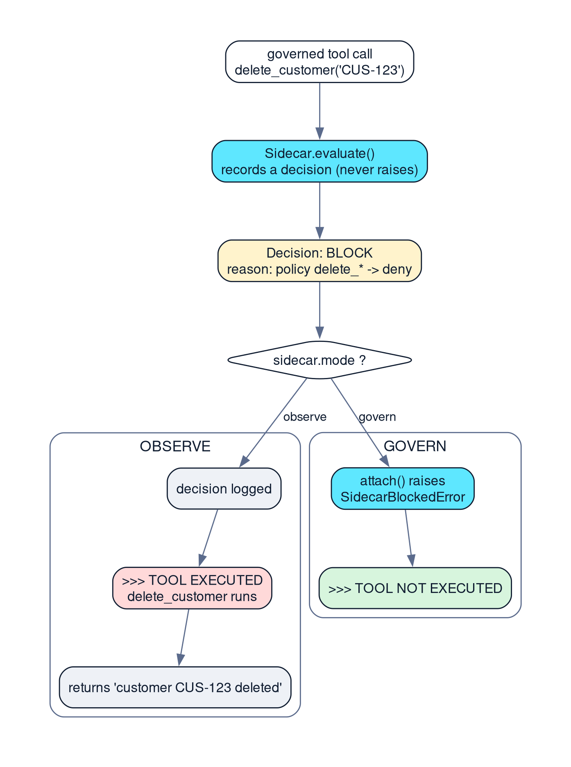
Figure 2 — evaluate() records; the mode flag decides whether attach() merely logs (observe) or raises to block (govern).

A rollout path this enables
Start in observe mode in production: you measure how often your policy would have blocked, and catch misconfigured rules, without breaking legitimate flows. When the recorded BLOCK decisions match what you truly want stopped, switch the sidecar to govern mode and enforcement turns on — the same BLOCK decisions, now prevented.

How we know both modes work
It is covered directly by automated tests, not just claimed. The suite includes test_observe_mode_records_block_but_tool_still_executes and test_govern_mode_raises_and_tool_does_not_execute (among others), and the full run is 22/22 passing — see Article 3 for the complete output.

The same shape shows up with budgets
Govern mode is not a blanket wall; it enforces one status. The budget guardian configured for the demo (max_cost 10.0, max_tokens 50,000) returns PAUSE with escalation_required set when either ceiling is reached, and never BLOCK. attach() raises SidecarBlockedError only for BLOCK, so at 0.6.0 an over-budget call is recorded as PAUSE and the tool runs anyway — in govern mode. Registering @sidecar.on_escalation_required does not rescue it: at this version the hook is stored and never invoked. Stopping on cost means checking decision.escalation_required in your own code. Four tests in test_budget_guardian.py pin this down, including the one asserting the tool still executes.
Later releases close this gap. agentic-sidecar 0.6.1 introduces Sidecar.enforce(): PAUSE and ESCALATE route through a registered escalation handler and, with none registered, raise SidecarSuspendedError before the tool is dispatched (0.8.1 keeps that behaviour). That makes the upgrade more than a version bump — code that only catches SidecarBlockedError now has to handle SidecarSuspendedError too.

The mistake this distinction is meant to prevent
Read the observe-mode log again: the sidecar records status BLOCK for delete_customer, and then the very next line reads >>> TOOL EXECUTED with the tool returning 'customer CUS-123 deleted'. A team that only glances at the decision stream can convince itself they are protected, because the block is right there in the log. They are not — observe mode is a measurement instrument, not a wall. Treat a stream of observe-mode BLOCK entries as evidence that you still need to flip the switch to govern.

Switching modes changes exactly one field
Both runs in the demo share the same policy, risk, intent, budget, roles, and risk_block_threshold. The only thing that differs is mode. That is the point: you build confidence in the decisions first, in observe mode, and when the recorded decisions match what you actually want stopped you change one setting and the same decisions become enforcement — no policy rewrite, no re-testing of the rules themselves.
As with the first article: no latency or overhead figures are reported because we did not benchmark them.
Version note: all API claims in this article target agentic-sidecar==0.6.0, the version pinned in the internship project's requirements.txt. Later features are not described as if they existed in that release.
Evidence note: code excerpts are taken verbatim from the project source. Terminal excerpts are actual captured output (Python 3.14.8, pytest-9.1.1, agentic_sidecar 0.6.0). Latency and per-call overhead were not benchmarked and are not reported.

References
- Agentic Sidecar v0.6.0 on PyPI - https://pypi.org/project/agentic-sidecar/0.6.0/
- README.md at the v0.6.0 tag - https://github.com/DeepAgentLabs/agentic-sidecar/blob/v0.6.0/README.md
- Official repository - https://github.com/DeepAgentLabs/agentic-sidecar
- Internship implementation - https://github.com/CHANDU-M05/agentic-sidecar--internship
- Published Use Cases - https://deepagentlabs.io/agentic-sidecar/usecases/

SEO metadata
Title: Observe vs Govern Modes in Agentic Sidecar: Logging a BLOCK vs Preventing It
Meta description: Why recording a BLOCK is not the same as preventing an action. A Python example showing agentic-sidecar observe mode (shadow logging) vs govern mode (SidecarBlockedError), with real captured logs.
Keywords: agentic-sidecar, observe mode, govern mode, SidecarBlockedError, agent enforcement, shadow rollout, LangGraph adapter
Slug: observe-vs-govern-agentic-sidecar
Author: Chandu
Date: October 26, 2026
Category: AI Engineering / Agent Governance
Tags: agentic-sidecar, modes, enforcement, langgraph, python
Featured image: featured2_observe_vs_govern

