

Wiring Governance Into a LangGraph Agent Without Touching the Tools
By Chandu · October 26, 2026 · ~5 min read
Scenario: your LangGraph support agent already works in production, and security wants runtime governance added this sprint — without rewriting the business tools or breaking the agent → tools → agent loop. This article is the one-seam way to do it.
Interactive companion: An animated, self-contained demo page accompanies this series (blog_posts/demo/index.html): the tool-boundary flow, the LangGraph loop, and an Observe-vs-Govern simulator whose truth table is checked against live agentic-sidecar 0.6.0 (blog_posts/demo/tests/test_simulator_policy.py). It is a simulation over stub tools — no real refunds, deletions, or network. This .docx cannot run its JavaScript; host the page and link or embed it via an <iframe>. The diagrams below are the static fallbacks; the animated versions live in the demo. See blog_posts/demo/README.md for hosting and embedding steps.
The easiest mistake in agent governance is threading policy through every tool: if-statements, decorators, and checks scattered across business code. We kept the opposite boundary in this project — plain tool functions that know nothing about rules, and a governance layer attached from the outside.

The integration pattern
attach(sidecar, [read_order, issue_refund, delete_customer]) returns governed wrapper functions. We convert those into LangChain tools, drop them in a ToolNode, and run the usual agent/tools StateGraph. The policy config and the tool bodies never see each other.
from agentic_sidecar.adapters.langgraph import attach
from langchain_core.tools import tool
from langgraph.prebuilt import ToolNode, tools_condition
from langgraph.graph import StateGraph

# Plain functions know nothing about policy.
def read_order(order_id: str) -> str: ...
def issue_refund(order_id: str, amount: float) -> str: ...
def delete_customer(customer_id: str) -> str: ...

# Governance is applied outside the tool bodies.
governed_functions = attach(sidecar, [read_order, issue_refund, delete_customer])
governed_tools = [tool(fn) for fn in governed_functions]

tool_node = ToolNode(governed_tools)
graph = StateGraph(AgentState)
graph.add_node("agent", scripted_agent) # deterministic, no LLM in tests
graph.add_node("tools", tool_node)
graph.set_entry_point("agent")
graph.add_conditional_edges("agent", tools_condition,
{"tools": "tools", "__end__": "__end__"})
graph.add_edge("tools", "agent")
app = graph.compile()

Deterministic agent, reproducible tests
For tests we swap the language model for a small scripted agent that proposes a fixed tool call based on the user's words (for example a message containing 750 triggers a large refund, and delete triggers deletion). No API key, no network, no flakiness. The tools print a marker when they run, so a test can distinguish an allowed-and-executed call from a blocked-and-never-dispatched one.
The scripted agent also settles the loop cleanly. It inspects the last message: if it is a ToolMessage the tool already ran, so it emits a final text reply instead of re-proposing the same call. The source docstring is explicit that this avoids the infinite agent → tools → agent cycle that happens when an agent keeps reading the original request. Governance and graph-shape are thus both exercised on every run, deterministically.

Real test evidence
This is the actual pytest run for the project (Python 3.14.8, agentic_sidecar 0.6.0, pytest-9.1.1): 22 passed in 0.32s. It covers allowed reads and refunds, blocked oversized refunds and deletions, the intent boundary at the exact limit, both observe and govern modes, and the budget ceilings:
$ pytest -v
platform linux -- Python 3.14.8, pytest-9.1.1, pluggy-1.6.0
collected 22 items

tests/test_budget_guardian.py::test_under_budget_is_allowed PASSED
tests/test_budget_guardian.py::test_cost_limit_exceeded_pauses_for_escalation PASSED
tests/test_budget_guardian.py::test_token_limit_exceeded_pauses_for_escalation PASSED
tests/test_budget_guardian.py::test_govern_mode_does_not_stop_over_budget_tool PASSED
tests/test_customer_support_agent.py::test_safe_order_lookup_is_allowed PASSED
tests/test_customer_support_agent.py::test_authorized_refund_is_allowed PASSED
tests/test_customer_support_agent.py::test_oversized_refund_is_blocked PASSED
tests/test_customer_support_agent.py::test_customer_deletion_is_blocked PASSED
tests/test_intent_guardian.py::test_refund_below_limit_is_allowed PASSED
tests/test_intent_guardian.py::test_refund_at_exact_limit_is_allowed PASSED
tests/test_intent_guardian.py::test_refund_above_limit_is_blocked PASSED
tests/test_intent_guardian.py::test_block_reason_is_from_binding PASSED
tests/test_intent_guardian.py::test_intent_guardian_is_independent_of_policy PASSED
tests/test_intent_guardian.py::test_different_tool_is_not_constrained PASSED
tests/test_observe_vs_govern.py::test_observe_mode_records_block_but_tool_still_executes PASSED
tests/test_observe_vs_govern.py::test_govern_mode_raises_and_tool_does_not_execute PASSED
tests/test_observe_vs_govern.py::test_govern_mode_allows_safe_tool PASSED
tests/test_observe_vs_govern.py::test_observe_mode_decision_is_still_recorded PASSED
tests/test_sidecar_controls.py::test_safe_order_lookup_is_allowed PASSED
tests/test_sidecar_controls.py::test_small_refund_is_allowed PASSED
tests/test_sidecar_controls.py::test_large_refund_is_blocked PASSED
tests/test_sidecar_controls.py::test_customer_deletion_is_blocked PASSED

============================== 22 passed in 0.32s ==============================

Architecture at a glance
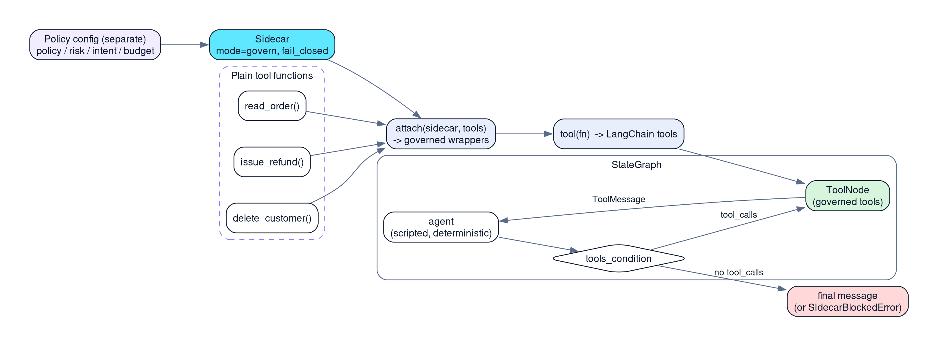
Figure 3 — Plain functions are wrapped by attach(), exposed as governed tools, and used inside the LangGraph agent/tools loop.

One seam, four roles
The sidecar is built with a roles list of policy, risk, intent_guardian, and budget, so a single attach() point runs every call through all four gates. The fourth, BudgetGuardian, is configured with a max_cost of 10.0 and a max_tokens of 50,000 for the run. None of the demo scenarios trips that ceiling — the refund and delete blocks come from policy and risk — so budget is covered by its own tests rather than by the demo. The point of the seam is that adding that fourth concern required no change to the tool functions at all.
Those tests turned up something worth stating plainly. At 0.6.0 the Budget Guardian returns PAUSE with escalation_required set once either ceiling is reached, and never BLOCK. attach() raises SidecarBlockedError only for BLOCK, so the PAUSE verdict is recorded and the over-budget tool still runs — in govern mode. Registering @sidecar.on_escalation_required does not change that: at this version the hook is stored and never invoked, so stopping on cost means checking decision.escalation_required in your own code. Budget is wired in and observable here, not enforcing on its own.

What this buys you
- Separation: changing a refund limit is a config edit, not a tool rewrite.
- Portability: the same sidecar governs the same tools with or without LangGraph.
- Confidence: a deterministic harness means 22 assertions actually exercise both modes and every threshold edge.

How the 22 tests are organized
The suite is split across five files, each checking a different layer so a failure points at the right place: test_sidecar_controls.py exercises the Sidecar directly (safe read allowed, small refund allowed, large refund blocked, deletion blocked); test_customer_support_agent.py drives the full compiled LangGraph graph end to end; test_intent_guardian.py probes the refund boundary including the exact-limit case (test_refund_at_exact_limit_is_allowed) and confirms the intent guardian blocks independently of policy; test_observe_vs_govern.py is the two-mode proof covered in Article 2; and test_budget_guardian.py pins the budget behavior above, including the test that asserts an over-budget tool still executes in govern mode. Because the graph itself is tested, the boundary behavior is asserted with the real ToolNode and tools_condition, not a mock.
We did not measure the runtime overhead of the wrapper graph, so no latency figure is claimed; the honest statement is that governance cost was not benchmarked in this project.
Version note: all API claims in this article target agentic-sidecar==0.6.0, the version pinned in the internship project's requirements.txt. Later features are not described as if they existed in that release.
Evidence note: code excerpts are taken verbatim from the project source. Terminal excerpts are actual captured output (Python 3.14.8, pytest-9.1.1, agentic_sidecar 0.6.0). Latency and per-call overhead were not benchmarked and are not reported.

References
- Agentic Sidecar v0.6.0 on PyPI - https://pypi.org/project/agentic-sidecar/0.6.0/
- README.md at the v0.6.0 tag - https://github.com/DeepAgentLabs/agentic-sidecar/blob/v0.6.0/README.md
- Official repository - https://github.com/DeepAgentLabs/agentic-sidecar
- Internship implementation - https://github.com/CHANDU-M05/agentic-sidecar--internship
- Published Use Cases - https://deepagentlabs.io/agentic-sidecar/usecases/

SEO metadata
Title: Integrating agentic-sidecar Governance with a LangGraph Agent (Python)
Meta description: Attach runtime governance to a LangGraph agent by wrapping plain tool functions with attach() — keeping policy out of tool code — plus a deterministic 22-test suite. Real pytest output included.
Keywords: LangGraph, agentic-sidecar, agent governance, python, ToolNode, attach adapter, deterministic testing, pytest
Slug: langgraph-agent-governance-agentic-sidecar
Author: Chandu
Date: October 26, 2026
Category: AI Engineering / Agent Governance
Tags: agentic-sidecar, langgraph, testing, python, integration
Featured image: featured3_langgraph_integration

