背景資料:

1. 性別: □男 □女
2. 年齡: □16歲以下 □16~25歲 □25~35歲 □35~45歲 □45~55歲 □55歲以上
3. 職業: □公職 □自營 □上班族 □學生
4. 收入: □20000以下 □20000~30000 □30000~40000 □40000~50000 □50000~60000 □60000以上
5. 交通工具: □大眾交通 □自行開車 □遊覽車 □飛機 □機車 □船
6. 一年出去旅遊幾次: □1~3次 □3~5次 □5~7次 □7次以上
7. 旅遊通常會出去幾天: □1天 □2~3天 □4~5天 □5~6天 □6天以上
8. 和甚麼人一起去旅遊: □家人 □同學 □自己 □跟團 □同事
9. 旅遊的目的: □家庭旅遊 □員工旅遊 □
10. 喜歡的旅遊方式: □跟團 □自助旅遊

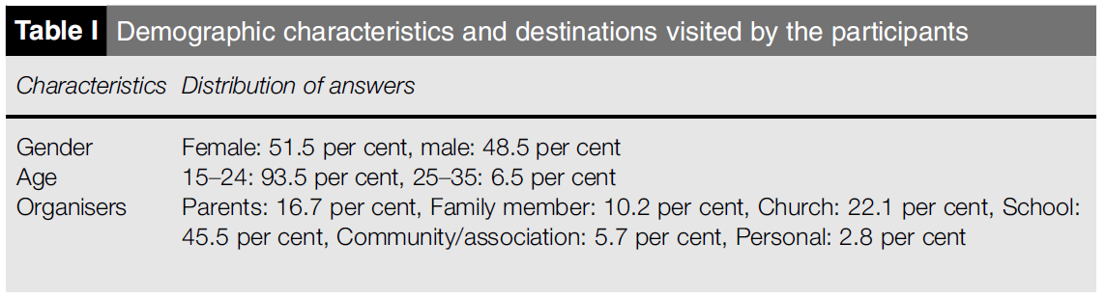

|  |  |  |
| --- | --- | --- |
| 英文 | 中文 | 老師評語 |
| 1. Convenient travelling time to site | 方便的旅行時間 |  |
| 1. Good value for cost | 物超所值 |  |
| 1. Easy accessibility | 容易到達 |  |
| 1. It helped me to see and experience new historical attractions | 它幫助我去看和見識新的歷史景點 |  |
| 1. I am motivated by the good music and dance at destination | 我被目的地的優美音樂和舞蹈所激勵 |  |
| 1. I am motivated by the scenery atmosphere | 我被風景散發的氛圍所激勵 |  |
| 1. I am motivated in different ethnic groups | 我的動機來自不同的民族 |  |
| 1. I am motivated by the history of the place | 我很喜歡這個地方的歷史 |  |
| 1. I am motivated by the Arts and Crafts at destination | 我被當地的藝術及手工藝所吸引 |  |
| 1. I experienced new cultures | 我體驗了新的文化 |  |
| 1. I was motivated by the site environment | 那裡的環境非常吸引我 |  |
| 1. I was inspired in the beautiful of the site | 那裡美麗的環境鼓舞了我 |  |
| 1. Motivated by nature | 那裏的大自然很吸引我 |  |
| 1. I am interested in hygienic facilities at tour site | 我對旅遊景點的衛生設施很感興趣 |  |
| 1. We were received by trained tour guide to take us through | 我們被專業的導遊所帶領 |  |
| 1. There was prompt service delivery at destination | 那裡提供快速服務 |  |
| 1. The environment was clean | 那裏的環境很整潔 |  |
| 1. I wanted to de-stress myself | 我想要自己紓壓一下 |  |
| 1. I wanted a break | 我想要放鬆一下 |  |
| 1. I wanted to some entertainment | 我想要尋找娛樂 |  |
| 1. I wanted to just relax | 我想要放鬆心情 |  |
| 1. I wanted to have fun | 我想要玩得開心 |  |
| 1. I wanted to learn about my heritage | 我想要了解我的遺產 |  |
| 1. I was interested in tracing my route | 我對記錄我的旅程感興趣 |  |
| 1. I wanted to get closer to nature | 我想要更親近大自然 |  |
| 1. I have the desire to learn about site’s history | 我渴望學習這裡的歷史 |  |
| 1. I wanted to discover something new | 我想要發現一些新事物 |  |
| 1. I wanted to experience unfamiliar destination | 我想要體驗這個我不熟悉的地方 |  |
| 1. I have the desire about the site in general | 總的來說，我渴望這地方 |  |
| 1. Visiting places, I can talk about | 我可以講我去過的地方 |  |
| 1. Going to places I have not visited before | 去一些沒去過的地方 |  |
| 1. Going to places my friends have not visited before | 去一些我朋友沒去過的地方 |  |
| 1. The tour helped me to develop my personal values | 這次旅行幫助我拓展我的個人價值觀 |  |
| 1. The tour helped me to rediscovered my heritage | 這次旅行幫助我重新發現遺產 |  |
| 1. It helped me think about my personal values | 他幫助我思考我的個人價值觀 |  |
| 1. I have enjoyed myself with the tour | 我很享受這次旅行 |  |
| 1. I am satisfied with the tour | 我對這次旅行非常滿意 |  |
| 1. I am positive in participating in the tour in the future | 未來我會積極的參與這場旅行 |  |
| 1. I felt emotionally involved in the tour | 在這旅行我感到情緒激動 |  |
| 1. I felt a sense of belonging at the site | 我對這個地點感到有歸屬感 |  |
| 1. I felt my heritage was displayed | 我覺得我的遺產被洩漏 |  |
| 1. I will say positive things about this tour to other people | 我將對同行的人說些正向的事 |  |
| 1. I will encourage friends/relatives to tour | 我會鼓勵朋友/親戚參與旅行 |  |
| 1. I will continue to go on tour, even if my friends are not willing to join me | 即使我的朋友沒有要加入我，我依舊會繼續旅行 |  |
| 1. I would go on tour that is even far from home | 我會去離家較遠的地方旅行 |  |