Albacore Diet Synthesis A - Phylo Graphs

Natasha Hardy & Zachary Roote

15/04/2021

## Set-up your working environment

**Note:** Code issue has arisen discussed here: <https://stackoverflow.com/questions/26619434/install-an-old-version-of-dplyr-0-12-in-r> Here we will be updating some of the phylogenetic packages.

#Install packages if needed  
  
#remotes::install_github("eliocamp/ggnewscale@dev")  
  
#remotes::install_github("YuLab-SMU/ggtree")  
  
#if (!requireNamespace("BiocManager", quietly = TRUE))  
# install.packages("BiocManager")  
  
#BiocManager::install("Biostrings")  
#BiocManager::install("ggtree")

# general  
library(tidyverse)  
library(readxl)  
library(plyr)  
library(dplyr)  
library(devtools)  
library(here)  
"%notin%" = Negate('%in%')  
here::here()  
  
# graphics  
  
library(ggplot2)  
library(lattice)  
library(graphics)  
library(ggnewscale)  
library(ggimage)  
library(reshape2)  
library(pander)  
library(gridExtra)  
library(captioner)  
library(unmarked)  
library(cowplot)  
library(gtable)  
library(viridis)  
library(PNWColors)  
library(RColorBrewer)  
  
# phylogenetic & other tools  
library(ape)  
library(Biostrings)  
library(raster)  
library(dismo)  
library(patchwork)  
library(ggtree)  
library(ggstance)  
library(geiger)  
library(rotl) #for phylogenetic analyses, get all the species? from Hinchliff et al. 2015 PNAS  
library(phylobase)  
library(phytools)  
library(phangorn)  
library(stringr)  
library(taxize)  
library(treeio)

## Load Data

Using combination of my trial code and Matt Savoca and company’s code to build a phylo tree with associated trait and %FO data

#data contains sp list, class, order & family + traits.  
  
#Probable life stage data  
my_prey_prob = read.csv(here("./data/output_data/prey_probable_traits.csv"), header=TRUE) %>%  
 dplyr::select(prey_sp, prey_class:prey_family, life_stage, vert_habitat:maxM, -X) %>%  
 filter(prey_sp %notin% c("Lampanyctus mexicanus", "Janthina exigua"))  
#298 species and 32 variables  
str(my_prey_prob)

## 'data.frame': 298 obs. of 32 variables:  
## $ prey_sp : chr "Abralia redfieldi" "Abraliopsis affinis" "Abraliopsis felis" "Abraliopsis gilchristi" ...  
## $ prey_class : chr "Cephalopoda" "Cephalopoda" "Cephalopoda" "Cephalopoda" ...  
## $ prey_order : chr "Oegopsida" "Oegopsida" "Oegopsida" "Oegopsida" ...  
## $ prey_family : chr "Enoploteuthidae" "Enoploteuthidae" "Enoploteuthidae" "Enoploteuthidae" ...  
## $ life_stage : chr "adult" "adult" "adult" "adult" ...  
## $ vert_habitat : chr "mesopelagic" "mesopelagic" "mesopelagic" "mesopelagic" ...  
## $ horz_habitat : chr "oceanic" "oceanic" "oceanic" "continental slope" ...  
## $ diel_migrant : int 1 1 1 1 1 1 1 NA 1 NA ...  
## $ diel_migrant_cat : chr "diel_yes" "diel_yes" "diel_yes" "diel_yes" ...  
## $ refuge : int 0 0 0 0 0 0 0 0 1 0 ...  
## $ refuge_cat : chr "refuge_no" "refuge_no" "refuge_no" "refuge_no" ...  
## $ season_migrant : int NA NA NA NA NA 1 NA 1 0 NA ...  
## $ season_cat : chr "season_NA" "season_NA" "season_NA" "season_NA" ...  
## $ body_shape : chr "fusiform" "fusiform" "fusiform" "fusiform" ...  
## $ l_max : num 3.6 4.3 8 5.1 3.5 27 NA 7.8 0.43 8.2 ...  
## $ phys_defense : int 0 0 0 0 0 1 0 0 1 0 ...  
## $ transparent : int 1 1 1 0 0 0 1 0 0 1 ...  
## $ col_disrupt : int 1 1 1 0 0 0 0 1 0 0 ...  
## $ silver : int 0 0 0 0 0 0 1 0 0 0 ...  
## $ countershade : int 0 0 0 0 0 0 0 0 0 0 ...  
## $ gregarious_primary: chr NA NA NA NA ...  
## $ trophic_level : num NA NA NA NA NA NA NA NA NA NA ...  
## $ fisheries_status : chr "none" "none" "none" "none" ...  
## $ b_shape_r : num 3.91 5.35 5.28 5.63 8.39 ...  
## $ eye_body_r : num 0.0849 0.0698 0.0508 0.0501 0.0421 ...  
## $ standard_total : num 0.527 0.457 0.458 0.422 0.349 ...  
## $ energy_density : num NA NA 4.4 NA NA NA 1.7 3.9 NA NA ...  
## $ percent_protein : num NA NA 17.4 NA NA NA NA 16.4 NA NA ...  
## $ percent_lipid : num NA NA NA NA NA ...  
## $ maxFO : num 5 1.16 36.4 0.7 4.9 ...  
## $ maxN : num 0 0.0765 11.3 0.2 3.4 ...  
## $ maxM : num 0 0.00609 2.13235 0.1 3.4 ...

sapply(my_prey_prob, class)

## prey_sp prey_class prey_order prey_family   
## "character" "character" "character" "character"   
## life_stage vert_habitat horz_habitat diel_migrant   
## "character" "character" "character" "integer"   
## diel_migrant_cat refuge refuge_cat season_migrant   
## "character" "integer" "character" "integer"   
## season_cat body_shape l_max phys_defense   
## "character" "character" "numeric" "integer"   
## transparent col_disrupt silver countershade   
## "integer" "integer" "integer" "integer"   
## gregarious_primary trophic_level fisheries_status b_shape_r   
## "character" "numeric" "character" "numeric"   
## eye_body_r standard_total energy_density percent_protein   
## "numeric" "numeric" "numeric" "numeric"   
## percent_lipid maxFO maxN maxM   
## "numeric" "numeric" "numeric" "numeric"

## these need to be factors to work on the trees properly  
my_prey_prob[,c("diel_migrant","refuge","season_migrant", "phys_defense", "transparent", "col_disrupt", "silver", "countershade")] <- lapply(my_prey_prob[,c("diel_migrant","refuge","season_migrant", "phys_defense", "transparent", "col_disrupt", "silver", "countershade")], factor)  
  
my_prey_prob$maxFO[my_prey_prob$maxFO == 0.00] <- NA  
my_prey_prob$maxN[my_prey_prob$maxN == 0.00] <- NA  
my_prey_prob$maxM[my_prey_prob$maxM == 0.00] <- NA

**NOTES:** A lot of troubleshooting later and I found that the species list needs to go on the far left side of the data, all other data/factors need to be added to the RHS of the species list

## Tree Build

Building the basic tree

# Tree build 1  
breaks <- c(seq(1,nrow(my_prey_prob),50),nrow(my_prey_prob)+1) # why are we doing this?  
#looking up each of the species in dataset to a phylogeny, doing it by sets of 50  
#if there's an NA (species that didn't match a value in known phylogeny), breaks the whole chunk of 50 species  
  
for (i in 1:(length(breaks)-1)){  
 taxa <- as.character(my_prey_prob$prey_sp[breaks[i]:(breaks[i+1]-1)])  
 taxa <- taxa[taxa != "" & !is.na(taxa)]  
  
 resolved_namest <- tnrs_match_names(taxa) # I think this is where all the extra species fall out  
 resolved_namest <- resolved_namest[!is.na(resolved_namest$unique_name),] # ignore an NA  
 if (i==1){  
 resolved_namess <- resolved_namest  
 } else {  
 resolved_namess <- rbind(resolved_namess, resolved_namest)  
 }  
}  
resolved_names <- resolved_namess  
resolved_names <- resolved_names[resolved_names$flags!="INCERTAE_SEDIS_INHERITED",]  
  
#original tree based on simple taxon datset  
my_tree_prob <- tol_induced_subtree(ott_ids = resolved_names$ott_id, label_format = "name")  
  
my_tree_prob$tip.label<-gsub("_"," ",my_tree_prob$tip.label) # removes underscore between genus and species names  
my_tree_prob$tip.label<-str_extract(my_tree_prob$tip.label, "[A-Z][a-z]+ [a-z]+")  
  
my_tree_prob <- compute.brlen(my_tree_prob, method = "Grafen", power = 1/2) #add branch lengths to my tree using the Grafen (1989) method  
my_tree_prob <- ladderize(my_tree_prob, right = TRUE)  
  
View(my_tree_prob)  
  
# SAVE TREE ----  
write.tree(my_tree_prob, here("./data/output_data/albacore_diet_tree_prob"))

my_tree_prob <- read.tree(here("./data/output_data/albacore_diet_tree_prob"))

## Sort out the tree for graphing

#Edit tip labels  
my_tree_prob$tip.label <- as.factor(sub("_", " ", my_tree_prob$tip.label))  
  
nrow(my_prey_prob) == length(my_tree_prob$tip.label) #TRUE

## [1] TRUE

nrow(my_prey_prob) #298

## [1] 298

length(my_tree_prob$tip.label) #298

## [1] 298

**NOTE:** We have in the past encountered a data frame dimension issue when plotting our data values onto the tree. There are also several species names that do not line up. This issue is addressed in the chunk below.

#my_prey_prob$prey_sp <- gsub(" ", "_", my_prey_prob$prey_sp) #for ease of plotting take away " "  
  
tree_names_prob = data.frame(sort(my_tree_prob$tip.label)) #sort the species names from the phylo tree  
#Still 301 spp  
## sort brings tree_names_prob from 301 to 300 because of an NA in the tip labels  
prey_names_prob = data.frame(sort(my_prey_prob$prey_sp)) #sort the species names from the original list  
  
nrow(tree_names_prob); nrow(prey_names_prob) #one species didn't make it to the tree

## [1] 298

## [1] 298

## here we check the names that are in the prey data but not on the tip labels of the tree  
names_not_in_tree_prob = prey_names_prob %>%  
 filter(sort.my_prey_prob.prey_sp. %notin% tree_names_prob$sort.my_tree_prob.tip.label.)  
  
## check names that are in the tree tip labels but not in the prey data  
names_not_in_prey_prob = tree_names_prob %>%  
 filter(sort.my_tree_prob.tip.label. %notin% prey_names_prob$sort.my_prey_prob.prey_sp.)  
  
## here we decide to match the names in the prey data to the tip labels, so we create a dataset with the names in the prey data that are in the tree (I see this looks kind of confusing with the double negative, the names not not in the tree). These are the names that do not need to be fixed, which we will bind the fixed names to afterwards so we do not get doubles of the same names (with different spelling).  
my_prey_keep_prob = my_prey_prob %>%  
 filter(prey_sp %notin% names_not_in_tree_prob$sort.my_prey_prob.prey_sp.)  
  
## these are the names we are going to fix to match the tip labels of the tree, given they are synonyms/misspellings. These are the same names in 'names_not_in_tree_adult', except they now have the columns of data which will allow use to merge it to 'my_prey_keep_adult' after we fix the names.  
my_prey_fix_prob = my_prey_prob %>%  
 filter(prey_sp %in% names_not_in_tree_prob$sort.my_prey_prob.prey_sp.)  
## this step isn't necessary, but it does make it easier in the names are in alphabetical order  
my_prey_fix_prob = my_prey_fix_prob[order(my_prey_fix_prob$prey_sp),]  
# the names have to be characters for the name reassignment to work, it will give an error if we don't do this (they are factors before this)  
my_prey_fix_prob$prey_sp <- as.character(my_prey_fix_prob$prey_sp)  
## we make these into x2 and y2 because it makes it much easier to write the next section  
x2 = my_prey_fix_prob  
y2 = as.vector(names_not_in_prey_prob$sort.my_tree_prob.tip.label.)  
  
#here we look at the names in both of the lists and see if there are misspellings/synonyms in the names that caused the discrepancy between the name lists. As you can see this is true for all of the species in these lists expect one. 'Diplodus sargus' does not have a match in the tree, since the only other tip labels left in the tree is an NA after the rest of the reassignments.  
# if you want to see how this works you can run individual pieces of this before running the whole thing. For example x2[4,1] is "Leuroglossus stilbius", and y2[1] is "Bathylagus stilbius". Then after running this code we match the name in the prey data (x2) to the names in the tree (y2), so "Leuroglossus stilbius" becomes "Bathylagus stilbius".  
x2[1,1] = y2[4]; x2[2,1] = y2[1]; x2[3,1] = y2[2]; x2[4,1] = y2[3];   
x2[5,1] = y2[5]; x2[6,1] = y2[7]; x2[7,1] = y2[6];  
  
# we need to do the opposite for one of the names here "Diplodus sargus", which is in the prey data but not in the tip labels. So, we are replacing the NA in the tip labels  
tip_labels_prob <- as.vector(my_tree_prob$tip.label)  
tip_labels_prob[28] ##this is the NA we want to replace

## [1] "NA"

tip_labels_prob[28] = "Diplodus sargus"  
## replacing the tip labels with the additional name  
my_tree_prob$tip.label <- tip_labels_prob  
  
# here we bind the fixed names to the names that didnt need to be fixed  
my_prey_prob = rbind(my_prey_keep_prob, x2)  
#here we get rid of any of the names in the data that didn't have a match in the tree tip labels, which was only 'Diplodus sargus'  
my_prey_prob = my_prey_prob %>%  
 filter(prey_sp %in% my_tree_prob$tip.label)  
nrow(my_prey_prob);length(my_tree_prob$tip.label) ## one of those tip labels is an NA

## [1] 297

## [1] 298

#the prey names need to be the rownames for the heatmap to work on the tree  
rownames(my_prey_prob) <- my_prey_prob$prey_sp  
  
#tip labels need to be characters to pipe onto the tree  
my_tree_prob$tip.label <- as.character(my_tree_prob$tip.label)  
str(my_tree_prob)

## List of 5  
## $ edge : int [1:562, 1:2] 299 300 301 302 303 304 305 306 307 308 ...  
## $ edge.length: num [1:562] 0.00168 0.24846 0.00225 0.01824 0.03549 ...  
## $ Nnode : int 265  
## $ node.label : chr [1:265] "mrcaott42ott150" "mrcaott42ott49" "mrcaott42ott658" "Clupeocephala" ...  
## $ tip.label : chr [1:298] "Sebastes wilsoni" "Sebastes zacentrus" "Sebastes proriger" "Sebastes brevispinis" ...  
## - attr(*, "class")= chr "phylo"  
## - attr(*, "order")= chr "cladewise"

## Paper figures - the list

### Basic phylogenies

**Basic prey species phylogeny graph**

#Phylotree without labels  
prob_basic = ggtree(my_tree_prob, layout = 'circular')  
  
#Phylotree with species labels  
prob_basic_lab = ggtree(my_tree_prob, layout = 'circular') + geom_tiplab(size = 2)

**Class-based phylogeny graph**

#Use basic + prey_sp labels + prey_class  
  
# creating a dataset that splits the species data by class  
prey_class_prob_info <- split(x = my_prey_prob$prey_sp, f = my_prey_prob$prey_class)  
unique(my_prey_prob$prey_class)

## [1] "Cephalopoda" "Malacostraca" "Actinopterygii" "Gastropoda"   
## [5] "Hexanauplia" "Hydrozoa" NA "Thaliacea"

# splitting the tree species by class  
my_tree_prob_class <- groupOTU(my_tree_prob, prey_class_prob_info)  
as.character(sort(unique(my_prey_prob$prey_class)))

## [1] "Actinopterygii" "Cephalopoda" "Gastropoda" "Hexanauplia"   
## [5] "Hydrozoa" "Malacostraca" "Thaliacea"

#creating a palette for the class split  
#pal_prob_class = c("grey40", '#0047ab', '#751308', '#4B0082', '#F05E23', '#013220', '#B80F0A', "#66C2A5", "#3288BD") ## the grey40 is needed for a branch between branches, but doesn't assign to a class  
  
  
pal_prob_class = c("grey40", ## the grey40 is needed for a branch between branches, but doesn't assign to a class  
 '#0047ab', #Actinopterygii  
 #'#751308', #Branchiopoda #older teal colour "#66C2A5" #Not in prob data just was used for adult data  
 '#4B0082', #Cephalopoda  
 "#AD15E2", #Gastropoda #old orange '#F05E23'  
 '#B80F0A', #Hexanauplia  
 "#773405", #Hydrozoa #'#013220'  
 "#E86103", #Malacostraca '  
 "#3288BD" #Thaliacea  
 )  
  
## plotting the tree without tip labels  
  
prob_class <- ggtree(my_tree_prob_class, aes(color = group), layout = 'circular') +  
 theme(legend.position = c(0.5,0.50),  
 legend.title = element_text(size = 18),   
 legend.text = element_text(size = 18))+  
 scale_colour_manual('Class', aesthetics = c('colour'), values = pal_prob_class,  
 breaks = c("Actinopterygii", "Cephalopoda","Gastropoda", "Hexanauplia", "Hydrozoa", "Malacostraca","Thaliacea"),  
 labels = c("Actinopterygii", "Cephalopoda","Gastropoda", "Hexanauplia", "Hydrozoa", "Malacostraca","Thaliacea"))  
  
prob_class

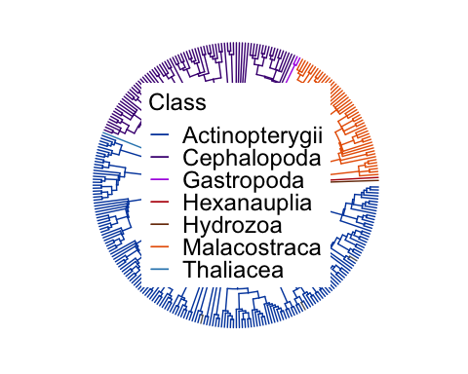

# plotting the tree with tip labels  
prob_class_lab <- ggtree(my_tree_prob_class, aes(color = group), layout = 'circular') +  
 theme(legend.position = c(0.5,0.50),  
 legend.title = element_text(size = 18),   
 legend.text = element_text(size = 18))+  
 scale_colour_manual('Class', aesthetics = c('colour', 'fill'), values = pal_prob_class,  
 breaks = c("Actinopterygii", "Cephalopoda","Gastropoda", "Hexanauplia", "Hydrozoa", "Malacostraca","Thaliacea"),  
 labels = c("Actinopterygii", "Cephalopoda","Gastropoda", "Hexanauplia", "Hydrozoa", "Malacostraca","Thaliacea")) +  
 geom_tiplab(size = 2)  
  
prob_class_lab

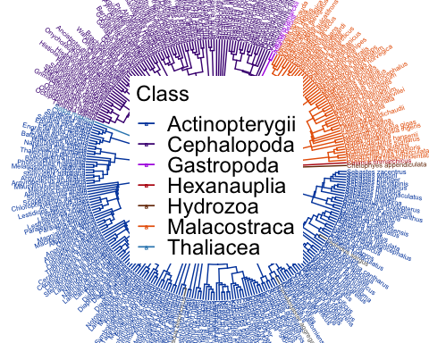

### Diet use data

#Overlay maxFO (frequency of occurrence data) on a basic prey tree coloured by Class  
#Use prey_class, maxFO  
  
prob_maxfo <- gheatmap(prob_class, my_prey_prob[,"maxFO", drop = FALSE],   
 offset = 0, width = 0.05, colnames = FALSE) +  
 theme(#legend.position = c(0.5,0.50),  
 legend.title = element_text(size = 18),   
 legend.text = element_text(size = 18))+  
 scale_fill_viridis_c(name = "Percent frequency (%FO)", na.value = 'grey')  
  
prob_maxfo

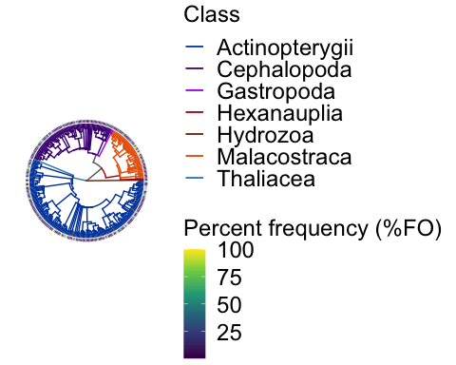

#Overlay maxN (abundance data) on a basic prey tree coloured by Class  
#Use prey_class, maxN  
  
prob_maxn <- gheatmap(prob_class, my_prey_prob[,"maxN", drop = FALSE],   
 offset = 0, width = 0.05, colnames = FALSE) +  
 theme(#legend.position = c(0.5,0.50),  
 legend.title = element_text(size = 18),   
 legend.text = element_text(size = 18))+  
 scale_fill_viridis_c(name = "Percent abundance (%N)", na.value = 'grey')  
prob_maxn

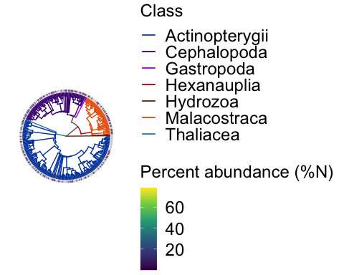

#Overlay maxM (biomass data) on a basic prey tree coloured by Class  
#Use prey_class, maxM  
  
prob_maxm <- gheatmap(prob_class, my_prey_prob[,"maxM", drop = FALSE],   
 offset = 0, width = 0.05, colnames = FALSE) +  
 theme(#legend.position = c(0.5,0.50),  
 legend.title = element_text(size = 18),   
 legend.text = element_text(size = 18))+  
 scale_fill_viridis_c(name = "Percent biomass (%KG)", na.value = 'grey')  
prob_maxm

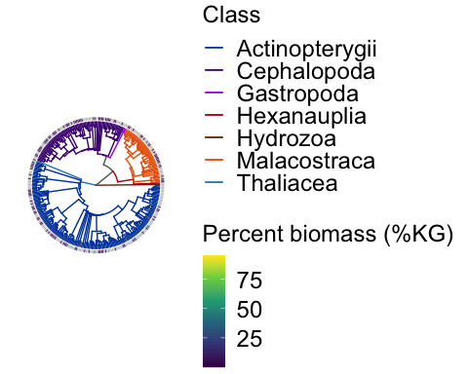

### Trait data

For habitat use traits: we are going to plot multiple rings of data around the phylogenetic trees using vert_habitat, horz_habitat, diel_migrant (change to yes/no), and season_migrant (yes/no)

#creating this plot one iteration at a time. Adding one layer of the heatmap, then allowing for another legend on the plot, and then another layer of the heatmap  
  
habitat_traits_prob1 <- gheatmap(prob_basic, my_prey_prob[, 'vert_habitat',drop=FALSE],   
 offset= 0, width=0.05, colnames = FALSE) +  
 scale_fill_viridis_d(name = "Vertical Habitat (VH)",   
 direction = -1,   
 breaks = c("benthic", "demersal", "epipelagic", "mesopelagic", "bathypelagic"),  
 limits = c("benthic", "demersal", "epipelagic", "mesopelagic", "bathypelagic"),   
 na.translate = TRUE,   
 option = 'D',   
 na.value = 'grey')+  
 theme(legend.position = c(1,0.80),  
 legend.title = element_text(size = 18),   
 legend.text = element_text(size = 18))+  
 scale_y_continuous(expand = c(0,4))+ #this opens up the gap for the Vertical habitat label around the tree  
 annotate('text', x = 1.03, y = -7, label = 'VH', angle = -85, size = 4)  
  
habitat_traits_prob1.5 <- habitat_traits_prob1 + new_scale_fill()  
  
habitat_traits_prob2 <- gheatmap(habitat_traits_prob1.5, my_prey_prob[ ,'horz_habitat',drop=FALSE],   
 offset=0.05, width=0.05, colnames = F) +  
 scale_fill_viridis_d(name = "Horizontal Habitat (HH)",   
 option = "D",   
 direction = -1,  
 breaks = c("reef-associated", "coastal", "continental shelf","continental slope", "oceanic"),  
 limits = c("reef-associated", "coastal", "continental shelf","continental slope", "oceanic"),  
 na.translate = TRUE,   
 na.value = 'grey')+  
 theme(legend.position = c(1,0.683),  
 legend.title = element_text(size = 18),   
 legend.text = element_text(size = 18))+  
 scale_y_continuous(expand = c(0,4))+  
annotate('text', x = 1.08, y = -7.1, label = 'HH', angle = -85, size = 4)  
  
habitat_traits_prob2.5 <- habitat_traits_prob2 + new_scale_fill()  
  
habitat_traits_prob3 <- gheatmap(habitat_traits_prob2.5, my_prey_prob[ , 'diel_migrant',drop=FALSE], offset=0.10, width=0.05, colnames = F) +  
 scale_fill_manual(name = "Diel Migrant (DM)",  
 breaks = c("0", "1"),  
 limits = c("0", "1"),  
 labels = c("no","yes"),  
 values = c("0"="#FDE725FF", "1"="#39568CFF"),   
 na.value = 'grey')+  
 theme(legend.position = c(1,0.5985),  
 legend.title = element_text(size = 18),   
 legend.text = element_text(size = 18))+  
 scale_y_continuous(expand = c(0,4))+  
 annotate('text', x = 1.13, y = -7.5, label = 'DM', angle = -85, size = 4)  
  
habitat_traits_prob3.5 <- habitat_traits_prob3 + new_scale_fill()  
  
habitat_traits_prob_final <- gheatmap(habitat_traits_prob3.5,   
 my_prey_prob[ ,'season_migrant',drop=FALSE],  
 offset=0.15, width=0.05, colnames = F) +  
 theme(legend.position = c(1.05,0.50),  
 legend.title = element_text(size = 18),   
 legend.text = element_text(size = 18))+  
 scale_fill_manual(name = "Seasonal Migrant (SM)",  
 breaks = c("0", "1"),  
 limits = c("0", "1"),  
 labels = c("no", "yes"),  
 values = c("0"="#FDE725FF", "1"="#39568CFF"),   
 na.value = 'grey') +  
 scale_y_continuous(expand = c(0,4))+  
 annotate('text', x = 1.18, y = -7.5, label = 'SM', angle = -85, size = 4)  
  
   
#Check graph  
habitat_traits_prob_final

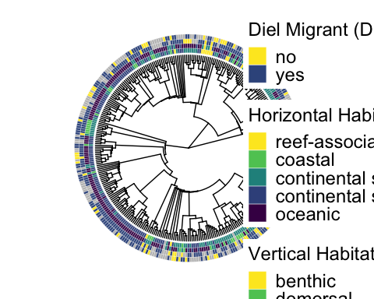

For seasonal, trophic & aggregation behaviour use: trophic_level, gregarious_primary and refuge_use (yes/no)

behav_trophic_prob1 <- gheatmap(prob_basic, my_prey_prob[,'trophic_level', drop=FALSE],   
 offset=0, width=0.05, colnames = F) +  
 theme(legend.position = c(1.05,0.80),  
 legend.title = element_text(size = 18),   
 legend.text = element_text(size = 18))+  
 scale_fill_viridis_c(name = "Trophic Level (TL)", na.value = 'grey') +  
 scale_y_continuous(expand = c(0,3.5))+  
 annotate('text', x = 1.04, y = -6.5, label = 'TL', angle = -85, size = 4)  
  
behav_trophic_prob1.5 <- behav_trophic_prob1 + new_scale_fill()  
  
behav_trophic_prob2 <- gheatmap(behav_trophic_prob1.5, my_prey_prob[,"gregarious_primary",drop=FALSE],   
 offset=0.05, width=0.05, colnames = F) +  
 theme(legend.position = c(1.05,0.65),  
 legend.title = element_text(size = 18),   
 legend.text = element_text(size = 18))+  
 scale_fill_viridis_d(name = "Gregariousness (GG)",   
 direction = -1,  
 breaks = c("solitary", "shoaling","schooling"),  
 limits = c("solitary", "shoaling","schooling"),  
 na.translate = TRUE,  
 option = "D", #'magma',  
 begin = 0.2,end = 0.8,  
 guide = guide_legend(order = 1),   
 na.value = 'grey')+  
 scale_y_continuous(expand = c(0,3.5))+  
 annotate('text', x = 1.09, y = -6.5, label = 'GG', angle = -85, size = 4)  
  
behav_trophic_prob2.5 <- behav_trophic_prob2 + new_scale_fill()  
  
behav_trophic_prob_final <- gheatmap(behav_trophic_prob2.5,   
 my_prey_prob[ ,'refuge',drop=FALSE],   
 offset=0.10, width=0.05, colnames = F)+   
 scale_fill_manual(name = "Refuge (RF)",  
 breaks = c("0", "1"),  
 limits = c("0", "1"),  
 labels = c("no", "yes"),  
 values = c("1"="#FDE725FF", "0"="#39568CFF"),  
 na.value = 'grey')+  
 theme(legend.position = c(1,0.531),  
 legend.title = element_text(size = 18),   
 legend.text = element_text(size = 18))+  
 scale_y_continuous(expand = c(0,4))+  
 annotate('text', x = 1.14, y = -6.5, label = 'RF', angle = -85, size = 4)  
  
behav_trophic_prob_final

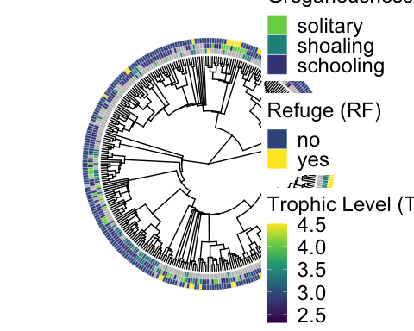

For morphological (shape) traits use: body_shape, b_shape_r and eye_body_r

levels(as.factor(my_prey_prob$body_shape))

## [1] "compressiform" "depressiform" "eel-like" "elongated"   
## [5] "fusiform" "globiform" "unique"

my_prey_prob$body_shape <- as.factor(my_prey_prob$body_shape)  
my_prey_prob$body_shape <- factor(my_prey_prob$body_shape,  
 levels = c("unique", "globiform", "depressiform", "compressiform",  
 "fusiform", "elongated", "eel-like"))  
levels(my_prey_prob$body_shape)

## [1] "unique" "globiform" "depressiform" "compressiform"  
## [5] "fusiform" "elongated" "eel-like"

morphology_comparison_prob1 <- gheatmap(prob_basic,   
 my_prey_prob[ ,'body_shape',drop=FALSE],  
 offset=0, width=0.05,font.size=2, colnames = F) +  
 scale_fill_viridis_d(name = "Body Shape (BD)",   
 option = 'C',  
 breaks = c("unique", "globiform", "depressiform", "compressiform",  
 "fusiform", "elongated", "eel-like"),  
 limits = c("unique", "globiform", "depressiform", "compressiform",  
 "fusiform", "elongated", "eel-like"),  
 guide = guide_legend(order = 1,   
 #reverse = TRUE  
 ), #order = 1  
 na.value = 'grey')+  
 theme(legend.position = c(1.05,0.71),  
 legend.title = element_text(size = 18),   
 legend.text = element_text(size = 18))+  
 scale_y_continuous(expand = c(0,3.5))+  
 annotate('text', x = 1.04, y = -6.5, label = 'BD', angle = -85, size = 4)  
  
morphology_comparison_prob1.5 <- morphology_comparison_prob1 + new_scale_fill()  
  
morphology_comparison_prob2 <- gheatmap(morphology_comparison_prob1.5,   
 my_prey_prob[ ,'b_shape_r',drop=FALSE],   
 offset=0.05, width=0.05, colnames = F) +  
 scale_fill_viridis_c(name = "Body Shape Ratio (BDR)",   
 option = 'C', limits=c(0,15),   
 oob = scales::squish,   
 breaks = c(0,5,10,15),   
 labels = c(0,5,10,"15+"),   
 na.value = 'grey')+  
 theme(legend.position = c(1.05,0.605),  
 legend.title = element_text(size = 18),   
 legend.text = element_text(size = 18))+  
 scale_y_continuous(expand = c(0,3.5))+  
 annotate('text', x = 1.095, y = -6.5, label = 'BDR', angle = -85, size = 4)  
  
morphology_comparison_prob2.5 <- morphology_comparison_prob2 + new_scale_fill()  
  
morphology_comparison_prob_final <- gheatmap(morphology_comparison_prob2.5,   
 my_prey_prob[ ,'eye_body_r',drop=FALSE],   
 offset=0.10, width=0.05, colnames = F) +  
 scale_fill_viridis_c(name = "Eye-Body Ratio (EBR)",   
 option = 'C',  
 limits=c(0,3),   
 oob = scales::squish,   
 breaks = c(0,1,2,3),  
 labels = c(0,1,2,"3+"),   
 na.value = 'grey')+  
 theme(legend.position = c(1.05,0.5),  
 legend.title = element_text(size = 18),   
 legend.text = element_text(size = 18))+  
 scale_y_continuous(expand = c(0,3.5))+  
annotate('text', x = 1.15, y = -6.5, label = 'EBR', angle = -85, size = 4)  
  
morphology_comparison_prob_final

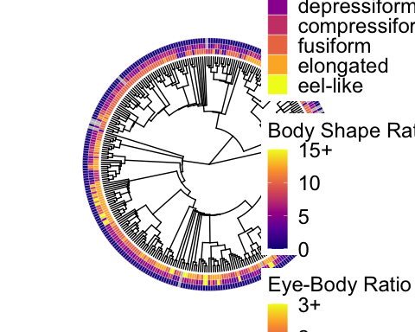

For morphological (defense/avoidance) traits use: phys_defense, countershade, col_disrupt, silver and transparent (in that order)

morphology_binary_prob1 <- gheatmap(prob_basic, my_prey_prob[ ,'phys_defense',drop=FALSE], offset=0, width=0.05, colnames = F) +  
 scale_fill_viridis_d(name = "Physical Defence", #"\nCountershading\nColour disruption\nSilver\nTransparent",  
 option = 'C',  
 breaks = c("1", "0"),  
 limits = c("1", "0"),  
 labels = c("yes", "no"),  
 begin=0.5, end=0.1,   
 na.value = 'grey')+  
 scale_y_continuous(expand = c(0,4.5))+  
 annotate('text', x = 1.04, y = -8.5, label = 'Physical Defence', angle = -85, size = 3)  
  
morphology_binary_prob2 <- gheatmap(morphology_binary_prob1, my_prey_prob[ ,'countershade',drop=FALSE],   
 offset=0.05, width=0.05, colnames = F) +  
 scale_fill_viridis_d(name = "Physical Defence\nCountershading", #"\nColour disruption\nSilver\nTransparent",   
 option = 'C',  
 breaks = c("1", "0"),  
 limits = c("1", "0"),  
 begin=0.5, end=0.1,   
 na.value = 'grey')+  
 scale_y_continuous(expand = c(0,4.5))+  
 annotate('text', x = 1.09, y = -8.5, label = 'Countershading', angle = -85, size = 3)  
  
morphology_binary_prob3 <- gheatmap(morphology_binary_prob2, my_prey_prob[ ,'col_disrupt',drop=FALSE],  
 offset=0.10, width=0.05, colnames = F) +  
 scale_fill_viridis_d(name = "Physical Defence\nCountershading\nColour disruption", #"\nSilver\nTransparent",   
 option = 'C',  
 breaks = c("1", "0"),  
 limits = c("1", "0"),  
 labels = c("yes", "no"),  
 begin=0.5, end=0.1,   
 na.value = 'grey')+  
 scale_y_continuous(expand = c(0,4.5))+  
 annotate('text', x = 1.14, y = -8.5, label = 'Colour Disruption', angle = -85, size = 3)  
  
morphology_binary_prob4 <- gheatmap(morphology_binary_prob3, my_prey_prob[ ,'silver',drop=FALSE],   
 offset=0.15, width=0.05, colnames = F) +  
 scale_fill_viridis_d(name = "Physical Defence\nCountershading\nColour disruption\nSilver", #"\nTransparent",   
 option = 'C',  
 breaks = c("1", "0"),  
 limits = c("1", "0"),  
 labels = c("yes", "no"),  
 begin=0.5, end=0.1,   
 na.value = 'grey')+  
 scale_y_continuous(expand = c(0,4.5))+  
 annotate('text', x = 1.19, y = -8.5, label = 'Silver', angle = -85, size = 3)  
  
morphology_binary_prob_final <- gheatmap(morphology_binary_prob4, my_prey_prob[ ,'transparent',drop=FALSE],   
 offset=0.20, width=0.05, colnames = F) +  
 scale_fill_viridis_d(name = "Physical Defence\nCountershading\nColour disruption\nSilver\nTransparent",   
 option = 'C',  
 breaks = c("1", "0"),  
 limits = c("1", "0"),  
 labels = c("yes", "no"),  
 begin=0.5, end=0.1,   
 na.value = 'grey')+  
 scale_y_continuous(expand = c(0,4.5))+  
 annotate('text', x = 1.24, y = -8.5, label = 'Transparent', angle = -85, size = 3)  
  
morphology_binary_prob_final

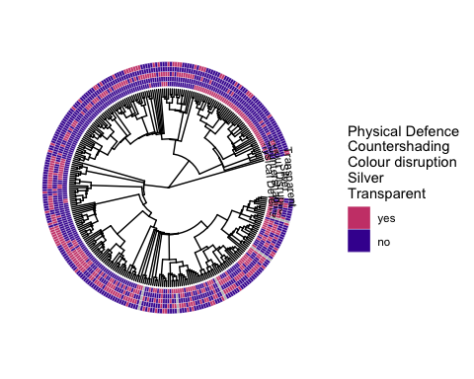

For Prey nutritional quality use: energy_density, percent_protein, percent_lipid

nutritional_quality_prob1 <- gheatmap(prob_basic, my_prey_prob[,'energy_density',drop=FALSE],   
 offset=0, width=0.05, colnames = F) +  
 scale_fill_viridis_c(name = "Energy density (unit)",   
 na.value = 'grey')+  
 scale_y_continuous(expand = c(0,3.5))+  
 annotate('text', x = 1.04, y = -6.5, label = 'Energy density', angle = -85, size = 3)  
  
nutritional_quality_prob1.5 <- nutritional_quality_prob1 + new_scale_fill()  
  
nutritional_quality_prob2 <- gheatmap(nutritional_quality_prob1.5, my_prey_prob[,"percent_protein",drop=FALSE],   
 offset=0.05, width=0.05, colnames = F) +  
 scale_fill_viridis_c(name = "Percent protein (%)",   
 na.value = 'grey')+  
 scale_y_continuous(expand = c(0,3.5))+  
 annotate('text', x = 1.09, y = -6.5, label = 'Percent protein (%)', angle = -85, size = 3)  
  
nutritional_quality_prob2.5 <- nutritional_quality_prob2 + new_scale_fill()  
  
nutritional_quality_prob_final <- gheatmap(nutritional_quality_prob2.5, my_prey_prob[ ,'percent_lipid',drop=FALSE],   
 offset=0.10, width=0.05, colnames = F) +  
 scale_fill_viridis_c(name = "Percent lipid (%)",   
 na.value = 'grey') +  
 theme(legend.position = c(1,0.5985))+  
 scale_y_continuous(expand = c(0,4))+  
 annotate('text', x = 1.14, y = -6.5, label = 'Percent lipid (%)', angle = -85, size = 3)  
  
nutritional_quality_prob_final

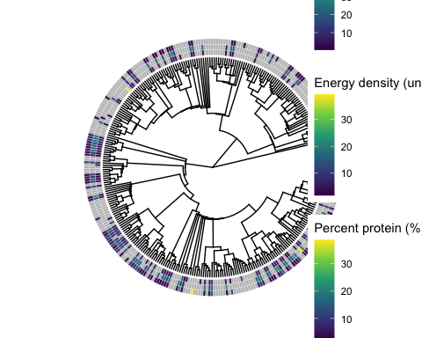

For Fisheries status use: fisheries_status

fishery_prob <- gheatmap(prob_basic, my_prey_prob[ ,'fisheries_status',drop=FALSE],   
 offset=0, width=0.05,font.size=2, colnames = F) +  
 scale_fill_viridis_d(name = "Fisheries status (FS)",   
 option = 'C',  
 breaks = c("none","aquarium", "aquaculture", "potential","minor commercial",  
 "commercial", "highly commercial"),  
 limits = c("none","aquarium", "aquaculture", "potential","minor commercial",  
 "commercial", "highly commercial"))+  
 scale_y_continuous(expand = c(0,3.5))+  
 annotate('text', x = 1.04, y = -6.5, label = 'FS', angle = -85, size = 3)  
  
fishery_prob

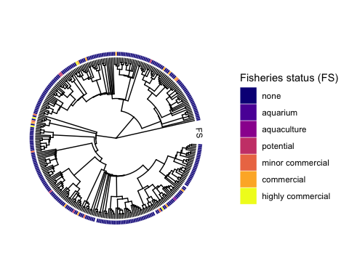

### EXTRAS

**Prey Order & Fam – TO DO:**

Code for these graphs are included in the .Rmd and not in the published document. These graphs are currently a lower priority and we may not get to this, however we include the code for anyone interested. The following would need to be fixed to improve the graphs:

1. Legends are too large as they are. I suggest not changing the colours as they clearly show different groups just not which ones are which using the legend. Is there any way to plot the “order” names near the branch of the tree or in a ring around the tree?
2. Also fix legend labels.

## SAVING OUTPUT

There are numerous issues with saving output either via ggsave() or dev.copy2pdf() functions. I’m batching the output saves below and doing all at once.

**Basic phylogeny**

Including code for saving this graph. Code for saving output for all other figures below are included in the .Rmd and not in the rendered document.

#Basic phylogenies  
  
#ggsave("prob_basic.png",  
 #here('./output_figures/phylos/prey_prob/prob_basic.png'),   
# plot=prob_basic, width=8, height=8, dpi=300)  
  
#ggsave("prob_basic_lab.png",  
 #here('./output_figures/phylos/prey_prob/prob_basic_lab.png'),   
# plot=prob_basic_lab, width=10, height=10, dpi=300)

**Phylogeny by Class**

**Phylogeny by diet use**

**Phylogeny by habitat Use Traits**

**Phylogeny by behaviour & habitat use**

**Phylogeny by morphology - shape**

**Phylogeny by defensive morphology**

**Phylogeny by nutritional quality**

**Phylogeny by fisheries status**