# **Title:** Trait-based analyses reveal global patterns in diverse albacore tuna diets

**Authors:** Natasha A. Hardy*1, [Cindy Matuch](mailto:matuchie@yahoo.com)2, [Zachary Roote](mailto:zroote@ualberta.ca)1, [Iris George](mailto:igeorge@ualberta.ca)1, Barbara A. Muhling3,4, Michael G. Jacox5,6, Elliott L. Hazen4,5, Steven J. Bograd3,5, [Larry B. Crowder](mailto:lbcrowd@stanford.edu)7, Stephanie J. Green1

**Corresponding authors:** [nahardy.wildlife@gmail.com](mailto:nahardy.wildlife@gmail.com) & [stephanie.green@ualberta.ca](mailto:stephanie.green@ualberta.ca); Department of Biological Sciences, CW 422 Biological Sciences Building, University of Alberta, Edmonton, Alberta, Canada, T6G 2E9

**Author affiliations**

1 Department of Biological Sciences, University of Alberta, Edmonton, Alberta, Canada

2 University of California Santa Cruz, Santa Cruz, CA, United States

3 Institute of Marine Sciences, University of California Santa Cruz, Santa Cruz, CA, United States

4 NOAA Southwest Fisheries Science Center, La Jolla, CA, United States

5 NOAA Southwest Fisheries Science Center, Environmental Research Division, Pacific Grove, CA, United States

6 NOAA Physical Sciences Laboratory, Boulder, CO, United States

7 Hopkins Marine Station of Stanford University, Pacific Grove, CA, United States

## Abstract

Simplifying complex species interactions can facilitate prediction of changes in ecosystem function and structure under climate change. This is particularly important for highly migratory pelagic predators, which exploit diverse prey fields as they respond to dynamic environments. We reconstructed the historical resource use of albacore tuna (*Thunnus alalunga*) globally and confirmed highly biodiverse diets with 308 prey species and 240 higher taxa identified. We quantitatively synthesised prey diversity into 7 functional trait guilds using four traits that influence predator-prey encounter rates – prey habitat association, seasonal and diel vertical migration behaviour – using hierarchical divisive clustering algorithms. We further explored variability in historical composition of albacore diets across geographies based on species identity, individual trait information, and functional trait guilds using a multi-matrix modelling framework. Species-based diet composition was highly variable across geographies and years sampled. Trait-based models of albacore diets highlight the historical importance of near-surface epipelagic prey resources from coastal to oceanic habitats, and seasonally-migrating continental shelf prey, compared to less frequent pulses of deeper water and demersal taxa. Our results indicate that trait information and trait guilds serve as useful classification frameworks for identifying functionally redundant food web linkages involving biodiverse prey, and will prove useful in tracking predators’ foraging responses to changing ecological states.

## Table of Contents

1. Introduction

2. Methods

2.1 Historical diet data collation

2.2 Prey life stage estimation

2.3 Prey trait information

2.4 Trait-based analyses

Taxonomic and trait diversity in albacore diets

Albacore prey trait guilds

Trait-based vs taxonomic diet variation

3. Results

3.1 Taxonomic and trait diversity in albacore diets

3.2 Albacore prey trait guilds

3.3 Historical albacore diet composition and prey trait guilds

4. Discussion

4.1 Synthesis of albacore diet diversity and historical trait relationships

4.2 Synthesis limitations, knowledge accessibility and gaps to overcome

5. Conclusions

Acknowledgements

Authorship Statement

References

Data Accessibility

Tables

Figure Legends

Supplementary Information

## Introduction

Pelagic ecosystems are among the last frontiers on Earth, politically and ecologically. Yet stressors such as climate change and intensive fishing efforts [(Casini et al., 2009; Poloczanska et al., 2016)](https://www.zotero.org/google-docs/?Qlfn80) are altering the distributions and composition of pelagic communities [(Cheung et al., 2015; Hazen et al., 2013; Morley et al., 2018)](https://www.zotero.org/google-docs/?54Izra), causing widespread species extirpations and undesirable ecosystem states [(Molinos et al., 2016; Polovina et al., 2011)](https://www.zotero.org/google-docs/?FFPXlY). Altered pelagic ecosystem states can lead to changes in fisheries production and uncertain economic futures [(Blenckner et al., 2015; Cheung et al., 2010; Free et al., 2019)](https://www.zotero.org/google-docs/?2dK9ku).

Within pelagic systems, highly migratory predators such as tunas and billfishes contribute to valuable and extensive international fisheries [(Sala et al., 2018)](https://www.zotero.org/google-docs/?h39oTv). These species evolved to migrate across ocean basin scales in order to exploit seasonal food resources for growth and warmer waters for reproduction [(Block et al., 2005; Mariani et al., 2016; Nikolic et al., 2017)](https://www.zotero.org/google-docs/?etJ7j8). However, anomalies and long-term changes in climate are producing mismatches among predator migration and the productivity of forage resources, with implications for fisheries productivity [(Scheffers et al., 2016; Thackeray et al., 2010)](https://www.zotero.org/google-docs/?Lw8Vw4).

Accounting for trophic interactions is often the missing link to forecasting species redistributions under climate change [(Green et al., 2020; Lan et al., 2021)](https://www.zotero.org/google-docs/?CyFbCe), especially for highly migratory marine species [(Muhling et al., 2019)](https://www.zotero.org/google-docs/?8TCSv2). Marine species redistributions are typically predicted on the basis of habitat use and changing physical oceanographic properties [(Morley et al., 2018)](https://www.zotero.org/google-docs/?akecI3). Despite empirical relationships between the biomass of prey species and their prevalence in predator diets [(Muhling et al., 2019)](https://www.zotero.org/google-docs/?2B9Wap), efforts to model predator distributions in relation to the distribution of key prey are often plagued by numerous issues including the accuracy of prey distribution information (Muhling et al. 2019), the number and functional redundancy of interacting species (Link 2007; Carroll et al. 2019). These hurdles may be overcome by modelling functional ecological relationships using synthetic parameters, or traits [(Zakharova et al., 2019; Green et al. 2022)](https://www.zotero.org/google-docs/?V0RjuB).

Trait-based approaches to modelling predator-prey interactions aim to simplify taxonomically complex interactions among hundreds of species to synthetic and non-taxonomic predictors for those relationships, positioning scientists to predict ecological outcomes in new contexts [(Kiørboe et al., 2018; McGill et al., 2006; Zakharova et al., 2019; Green et al. 2022)](https://www.zotero.org/google-docs/?R010vR). For example, the strength of predator-prey interactions can be modelled as a function of single or multiple individual prey trait variables influencing the predation process [(Arrizabalaga-Escudero et al., 2019; Green et al., 2020)](https://www.zotero.org/google-docs/?y1GmpR). Additionally, grouping prey into ‘guilds’ based on shared traits describing similar trophic roles [(Gitay & Noble, 1997)](https://www.zotero.org/google-docs/?7O1F0v) to model complex species distribution and interactions is a common ecological practice of dimension or variable reduction [(Parravicini et al., 2020; Pomerleau et al., 2015)](https://www.zotero.org/google-docs/?G5Rd6q), .

Trait-based approaches may be particularly useful for tunas because they have taxonomically broad diets [(Duffy et al., 2017; Pethybridge et al., 2018)](https://www.zotero.org/google-docs/?p3ObPl) and do not generally select larger prey with increasing size [(Romanov et al., 2020)](https://www.zotero.org/google-docs/?Yi9lTA). While these foraging properties make tunas salient indicator species to track changing prey communities and predator-prey interactions under climate change, they also make them excellent candidates for trait-based modelling to synthesise complex interactions with numerous prey species and investigate evidence for selection for certain types of forage [(Glaser, 2010; Valls et al., 2022)](https://www.zotero.org/google-docs/?bqmSXv). Previous diet analyses of yellowfin, bluefin, bigeye and albacore tunas indicated dieary shifts and niche partitioning across predator species, latitude, predator life stage, and environmental drivers [(Allain et al., 2012; Duffy et al., 2017; Nickels et al., *In Review*; Pethybridge et al., 2018; Portner et al., 2022; Valls et al., 2022; Young et al., 2015)](https://www.zotero.org/google-docs/?3SCRGN). Additionally,shifts in albacore distribution have been linked to prey availability [(Pearcy, 1973)](https://www.zotero.org/google-docs/?zEuDol). Many of these studies hypothesise about the role of traits in driving observed patterns and shifts. However, the extent to which trait information could explicitly be used to explain tuna foraging ecology across space and time and predict their resource use under changing environmental states remains poorly understood.

Using albacore (*Thunnus alalunga*) as a case study, we seek to move beyond descriptive diet analyses to identify non-taxonomic predictors for trophic relationships in highly-migratory pelagic predators and commercially valuable species. Our synthesis aggregates historical data on albacore diets from published and grey literature dating from 1880–2020 globally. Our aims are threefold, to: (1) reconstruct historical resource use for albacore across geographies, (2) use functional traits to distil diverse predator-prey interactions into key trait-based guilds, and (3) explore species-based and trait-based variability in the historical composition of albacore diets across the geographies sampled.

## Methods

### 2.1 Historical diet data collation

Our synthesis required quantitative data on adult or juvenile albacore diet composition obtained from stomach content analyses that identified consumed prey to species-level. To obtain these data, we compiled published and grey literature, research theses, and historical reports for albacore diets by searching Web of Science [(Clarivate Analytics, 2020)](https://www.zotero.org/google-docs/?UdDKhL), Aquatic Sciences and Fisheries Abstracts [(ASFA, 2020)](https://www.zotero.org/google-docs/?PYAc4J) and Federal Science Library Canada [(FSLN, 2020)](https://www.zotero.org/google-docs/?MkiSiB) bibliographic databases, queried from 1900 until 2020 using diet analysis search terms and synonymous scientific names for albacore (*Thunnus alalunga*; Supporting Information, Table S1). We also investigated diet reports cited within articles, which expanded our range to include several reports from the 1880s. Studies typically reported a mix of data types (i.e., frequency of occurrence and other metrics).

We obtained diet data from 26 studies that were suitable for meta-analysis (Supporting Information, Table S2); this included 69 independent observations of adult and juvenile albacore diet composition, from 1880–2015 that were digitized, transcribed, and aggregated by geographic region, year, or season sampled, (Fig. 1a; [Supplementary Data,](https://docs.google.com/spreadsheets/d/1RD1ipsaG7R-PpR3u2hMmHH6MeNsTfaPOLMH0mPvsF7U/edit" \l "gid=588091555) [Table S3](https://docs.google.com/spreadsheets/d/1RD1ipsaG7R-PpR3u2hMmHH6MeNsTfaPOLMH0mPvsF7U/edit#gid=588091555)). However, several reports presented information that was further aggregated for multi-year sampling programs ([Supplementary Data, Table S3](https://docs.google.com/spreadsheets/d/1RD1ipsaG7R-PpR3u2hMmHH6MeNsTfaPOLMH0mPvsF7U/edit#gid=588091555)) and for analyses in these cases, we use the last year of sampling completed. Albacore were typically collected using surface troll, pole-and-line, longline, or purse seine gear (Supplementary Data, Table S3) via scientific sampling programs (i.e., National Oceanic and Atmospheric Administration [NOAA], Centre National de la Recherche Scientifique [CNRS]) or commercial fishing operations [(Bello, 1999; Joubin & Rouie, 1918; Romanov et al., 2020; Glaser et al., 2015)](https://www.zotero.org/google-docs/?Y63U9X).

### 2.2 Prey life stage estimation

Albacore consume post-larval and juvenile prey as well as adult life stages. Given that traits could vary between life stages for many species, we aimed to match traits to the life stage most commonly consumed by albacore predators for each prey species. Of 308 identified prey species, 72 (or 23%) had associated life stage information reported within their corresponding diet study, with 42 reported as post-larvae, young-of-year, or juveniles, and 37 species consumed as adults (Supplementary Information, Figure S1). Albacore rarely consumed larvae (i.e., 11 species). Of these 72 species, 13 were reported at multiple life stages in albacore diets; however, one life stage was typically dominant across diet studies (i.e., with an order of magnitude greater frequency of occurrence than any other life stage). For example, of 11 species with reported consumption of the larval life stage, 6 species were typically consumed as juveniles (i.e., across multiple studies) and thus were assigned as juveniles for the purpose of this meta-analysis (Supplementary Data, Table S4; Supplementary Information, Figure S1).

When specific information was not provided, it was necessary to estimate prey life stage from available information on the size and age class of either the predator or prey in a given study (Figure S1; Supplementary Data, Table S4). For 15 species (~5%),prey length information was reported but not life stage. Reported total lengths ranged from 1.5–24.5 cm, and these prey species’ life stages were inferred relative to their known length at maturity (Supplementary Data, Table S4; Supplementary Information, Figure S1). The remaining 221 species,or 72%, were identified in albacore diets without metainformation and assumed to be either juveniles or adults. Trait information was often similar between juvenile and adult life stages [(Gleiber et al., 2022)](https://www.zotero.org/google-docs/?rxK8RO). Thus for 127 of these taxa (41% of the species), no further estimation of prey life stage was needed (Figure S1).

There were 94 prey species (31% of the species) remaining where trait information differed by life stage and for which no life stage or size information were recorded; for example, these could include a benthic adult with a pelagic juvenile life stage (Figure S1). Here, the most plausible life stage consumed was then assessed on a case-by-case basis (Table S4). As albacore are epipelagic predators, the pelagic stage of these prey was most likely consumed, and albacore are more likely to consume smaller juvenile prey, for example epipelagic juvenile hake (less than 10 cm and up to 20 cm length) than benthopelagic adult hake (~40–90 cm) [(Bailey et al., 1982)](https://www.zotero.org/google-docs/?ZiE13M). We corroborated these decisions based on calculated maxillary length (or ‘gape limit’) for albacore sampled to determine whether adult prey could feasibly have been consumed from a published relationship between length and gape for closely-related yellowfin tuna [(Ménard et al., 2006)](https://www.zotero.org/google-docs/?1zIKjW). Depending on the data reported, we used either a measured maximum albacore fork length (FL) (51 species [16%]), or an estimated maximum FL for the population of albacore sampled for each study that did not measure or report albacore lengths sampled (43 species [14%]), as inputs to three equation (Figure S1; [(Ménard et al., 2006)](https://www.zotero.org/google-docs/?o4Gd8v). Where albacore lengths were not reported, we matched gear-specific length data (range and mean FL) from relevant regional fisheries management organisations [(ICCAT, 2020; ISC, 2006)](https://www.zotero.org/google-docs/?4A2uj9) to albacore diet studies by year. There was no significant difference between the variances of mean, minimum and maximum FL for studies where these parameters were measured or where these parameters were estimated in this study (Figure S2). This process of estimating albacore length information resulted in estimated gape limits of 6.4–11.5 cm across studies and locations sampled, and affected only 14% of decisions on prey life stage and selection of appropriate trait information (Figure S1). Further detail in estimating the mean and range in albacore lengths for a given study are further described in Supplementary Information (Appendix B). Overall, our synthesis uses the following prey life stages consumed by albacore: 5 larval life stages, 210 juveniles, and 93 adults.

### 2.3 Prey trait information

### 

For each prey species and life stage (i.e., larva, juvenile, adult), we collected information for four habitat use traits known to affect the likelihood of pelagic predators encountering and consuming prey [(Green et al., 2019)](https://www.zotero.org/google-docs/?pjGkKf). These were: (i) vertical and (ii) horizontal habitat association, (iii) presence of diel vertical migration, and (iv) presence of seasonal migration and seasonal aggregation behaviour (Table 1; Supplementary Data, Table S5). These trait data were compiled for a broader database of traits that inform predator-prey interactions for albacore [(Gleiber et al., 2022)](https://www.zotero.org/google-docs/?IvwvyM). We further describe how prey species’ trait values were collected in Supporting Information, Appendix C.

### 2.4 Trait-based analyses

All data manipulation, statistical analysis and graphical illustrations were performed in *R* (version 4.2.1 - updated since version) [(R Core Team, 2022)](https://www.zotero.org/google-docs/?djfN0l) (Code available in public repository).

#### Taxonomic and trait diversity in albacore diets

Species accumulation was calculated and plotted using *BiodiversityR* (version 2-14.1; [Kindt & Coe, 2005)](https://www.zotero.org/google-docs/?eKoXVu) in relation to ocean basins where sampling locations occurred and the final year sampled (n = 69 observations) by each study (n = 26). Prey species’ phylogenetic information was extracted from the Open Tree of Life Data using the package *rotl* (version 3.0.12) [(Michonneau et al., 2016; OpenTree et al, 2020)](https://www.zotero.org/google-docs/?9duwDS) and parsed to a phylogenetic tree using *ape* (version 5.6-2) [(Paradis & Schliep, 2019)](https://www.zotero.org/google-docs/?pnbEHA) and *stringr* (version 1.4.0) [(Wickham, 2021)](https://www.zotero.org/google-docs/?QVXeRQ) with integrated species-specific trait information displayed using *ggtree* (v3.3.1.900) [(Yu et al., 2017)](https://www.zotero.org/google-docs/?zlCQlm) to visualise relationships between taxonomic and trait diversity in the data.

#### Albacore prey trait guilds

For the 292 prey species with complete trait information, key prey trait guilds were identified using a divisive hierarchical clustering algorithm [(Anderberg, 1973; Jain et al., 1999; P. Legendre & Legendre, 1998)](https://www.zotero.org/google-docs/?KPw60i) on a Gower dissimilarity matrix [(Gower, 1971)](https://www.zotero.org/google-docs/?Fep4r4). to identify relational structure among albacore prey in relation to ecological trait data for the four habitat use variables: two binomial variables (seasonal and diel vertical migration) and two multi-level categorical variables (vertical and horizontal habitat use) (Supplementary Information, Table S4) using the *diana* algorithm in *vegan* (v2.5-7) [(Oksanen et al., 2020)](https://www.zotero.org/google-docs/?6aN8S4) and *cluster* (v2.1.2) [(Maechler et al., 2021)](https://www.zotero.org/google-docs/?p1GDzE) and visualised with *ggplot2* (v3.3.5) [(Wickham, 2016)](https://www.zotero.org/google-docs/?49gDgR) and *dendextend* (v1.15.2) [(Galili, 2015)](https://www.zotero.org/google-docs/?KnHqm0)*.*

We used a consensus approach for validating cluster results – optimising cluster selection and partition by assessing several stability and internal validation metrics [(Brock et al., 2008)](https://www.zotero.org/google-docs/?bxAKOv). Specifically, we assessed: (1) inter-cluster variation – maximum separation of species between clusters – indicated by higher average distance between species clusters [(Rousseeuw, 1987)](https://www.zotero.org/google-docs/?agMetT); (2) intra-cluster variance or minimum separation of species within clusters indicated by lower average distance within species clusters [(Handl et al., 2005)](https://www.zotero.org/google-docs/?35D9kx); (3) high silhouette width coefficient value and Dunny Smith residuals [(Dunn, 1974; Rousseeuw, 1987)](https://www.zotero.org/google-docs/?7sFX4i) representing optimal cluster compactness and separation qualities; and lastly, (4) optimal evenness or balance of cluster composition indicated by the number of species in each cluster [(P. Legendre & Legendre, 1998)](https://www.zotero.org/google-docs/?Kb2Q9e). Trait values that influence a species’ occupancy within a cluster were visualised using heat maps illustrating the importance of trait values to the composition of each cluster.

#### Trait-based vs taxonomic diet variation

Historical albacore diet composition across geographies were visualised using frequency of occurrence data from 26 studies that yielded 60 observations of diet composition, because the other 3 studies in this dataset and their 9 observations included presence only data. To visualise overall contributions of prey trait guilds to albacore diets, we calculated a normalised index of contribution for each prey species relative to (i) the trait guild they were classified in and (ii) the sum of frequency of occurrence data within each observation per study.

For further statistical analysis of trait-based variance in albacore diet composition across geographies, all data from the 26 studies and 69 observations were transformed to presence/absence to meet the model data distribution requirements. Poorly sampled locations were excluded from analyses (samples from South Pacific, South Atlantic and Indian Oceans), as well as rarer species that only occurred once or twice in this reduced dataset. We therefore compare the diet composition for albacore from sampling locations in the North Pacific (samples mainly come from the California Current System), North Atlantic (largely representing North Atlantic Drift), and Mediterranean Sea, providing us with 57 observations of albacore diet composition and including 98 species.

We use a fourth-corner, model-based approach [(Dray & Legendre, 2008; Brown et al., 2014; P. Legendre et al., 1997)](https://www.zotero.org/google-docs/?kk4m6x), which builds on the generalised linear modelling (GLM, [(Nelder & Wedderburn, 1972)](https://www.zotero.org/google-docs/?RLqRzV) framework to simultaneously test how the composition of albacore diets (L matrix of species presence/absence) differed as a function of two different types of explanatory variables: an environmental variable (R matrix, here containing geographic locations sampled) and prey trait information (Q matrices), producing the trait-environment interaction (QxR) or the fourth corner solution to a multi-matrix problem. To test the role of two types of trait information (Q1 and Q2), species identity (Q0, no traits), and geographic location (R) in explaining the presence of prey types (L) across the global data set, we built 3 models containing different matrices for trait predictor variables, each using the same diet composition matrix (L) and environmental covariates (R) (Table 2). The two trait matrices are characterised in two ways: Q1 as a matrix of the four individual prey traits and Q2 a single variable composed of the seven trait guilds (Table 2).

We used a binomial distribution for presence/absence data, analysed via logistic regression (with logit link function) using the *traitglm* function in the R package *mvabund* (version 4.1.12) [(Wang et al., 2012, 2021)](https://www.zotero.org/google-docs/?62J96Z). We include a species effect in models (i.e., a different intercept term for each species), akin to fitting a random effect variable to account for differences in absolute number of species occurrences [(Brown et al., 2014; Wang et al., 2012, 2021)](https://www.zotero.org/google-docs/?kOA7uc). Additionally, models were fit with a LASSO penalty, specifying the fitting method as ‘*glm1path’*, using penalised likelihood to impose a constraint on estimates of model parameters [(Brown et al., 2014; Hastie et al., 2009; Warton et al., 2015)](https://www.zotero.org/google-docs/?XzedmY). This constraint shrinks coefficients to zero when not statistically significant, providing a combined approach for variable selection, p-value adjustment for multiple models, and parameter estimation to evaluate the magnitude and significance of an explanatory variable [(Hastie et al., 2009)](https://www.zotero.org/google-docs/?KsbBGg). Trait-environment relationships for individual trait variables and constructed trait guilds were illustrated as heat maps indicating the interaction strength and positive or negative correlation between trait information and geographies sampled. Model fit was assessed by plotting multivariate residuals against fitted values and plotting quantile-quantile (Q-Q) plots. Multivariate data were previously screened for broad trends using conditional boxplots [(Zuur et al., 2010),](https://www.zotero.org/google-docs/?xALnOC) and for overdispersion and outliers by non-metric multidimensional scaling (nMDS) plots [(Field et al., 1982)](https://www.zotero.org/google-docs/?kAdPfB) using *vegan*. All model assumptions were met.

## Results

### 3.1 Taxonomic and trait diversity in albacore diets

Our synthesis reveals the large biodiversity of prey consumed by albacore globally (Figure S2). Prey hailed from 7 classes representing **203** families; mainly of ray-finned fishes (n = **108** families of prey), cephalopods (n = **29**), and crustaceans (Malacostraca n = **45**, Hexanauplia n = **6**), and also including pelagic gastropods (n = **6**), salps (n = **2**), one appendicularian, one branchiopod, one hydrozoan, and one elasmobranch (an unknown Squalidae spp.)(Figure S2). Of these, **308** taxa were reported to species level, with a further ~**240** taxa identified at variable resolutions from genus to order. Whilst the rate of species accumulation appears to level off in well-sampled locations such as the North Pacific and North Atlantic, and in the Mediterranean Sea (Figure 1b/c), an unknown and likely just as large diversity of prey remains to be studied in the South Pacific, South Atlantic, and Indian Oceans (Figure 1b/c).

Additionally, out of **308 prey species, 201** were never observed in > 10% of stomach samples within any study (Supplementary Information, Figure S2). As individual traits varied across phylogeny and recurred across unrelated prey taxa (Figure 2), species traits may be useful in synthesising this large diversity in albacore diet composition.

### 3.2 Albacore prey trait guilds

The **292 prey species** for which we obtained complete trait information were optimally classified into **seven trait guilds** reflecting different combinations of **four** traits affecting predator-prey encounter processes – through vertical and horizontal habitat use, seasonal migration and diel vertical migration (Table 1, Figure 3a; Supplementary Information, Figure S3).

The most taxonomically abundant trait guild consisted of diel migrating mesopelagics (trait guild #2), distinct from the non-diel migrating mesopelagics (#1) and least taxonomically abundant (Figure 3). The second and third most abundant groups included the oceanic (or ‘offshore’) epipelagics (#5) and coastal and shelf epipelagics (#3), followed by seasonal, continental shelf taxa (#6) and resident continental shelf taxa (#7). Finally, among the rarest prey guilds was the coastal and shelf demersal taxa (#4). The hierarchical divisive clustering technique for 7 optimal clusters performed reasonably well in grouping taxa that are also clustered in multivariate space (Figure 3b).

### 3.3 Historical albacore diet composition and prey trait guilds

Almost all trait guilds were observed in albacore diets in nearly all locations sampled (Figure 4). The diet of Mediterranean fish was characterised by consistent high reliance on seasonal shelf taxa (#6), with differential temporal incorporation of resident shelf taxa (#7), diel migrating mesopelagics (#2) and oceanic epipelagics (#5) (Figure 4). North Atlantic samples were also characterised by high prevalences of samples containing species from the seasonal shelf taxa (#6) and resident shelf taxa (#7) groups, the latter group mainly prevalent in earlier 1930’s samples alongside consistent albeit relatively low prevalence of non-diel migrating mesopelagics (#1) at that time. From 1968 however, North Atlantic diet varied between relatively high contributions of the seasonal shelf taxa (#6), coast and shelf epipelagics (#3) and oceanic epipelagics (#5). These prey guilds were also common in North Pacific diets, however samples from this basin were also characterised by oscillations between high prevalences of coast and shelf epipelagics (#3) and and oceanic epipelagics (#5). Oceanic epipelagics (#5) appeared to dominate South Pacific sampling in most years, with intermittent higher prevalences of seasonal shelf taxa (#6) and non-diel migrating mesopelagics (#1). Indian Ocean observations were few in number, and diets varied including two important seasons for resident shelf taxa (#7), one season dominated by samples containing coast and shelf epipelagics (#3), and consistent but low occurrences of non-diel migrating mesopelagics (#1).

Overall, non-diel migrating mesopelagics (#1) were primarily observed in diets prior to 1950 sampled from the North Atlantic and with high prevalence in select years in the mid-2010s in the Indian and South Pacific Oceans. The coast and shelf demersals (#4) were the rarest group across geographies, and observed mainly in North Pacific samples in the 1940s and North Atlantic samples from 1957. Taxonomic variation in regional dietary signatures (Supplementary Information, Figure S5) was significantly mediated by trait information and trait guilds, particularly for samples from the North Pacific and the Mediterranean (Figure 5).

## Discussion

### 4.1 Synthesis of albacore diet diversity and historical trait relationships

We reconstructed historical resource use for albacore tuna (*Thunnus alalunga*) globally, highlighting biodiverse diets in this predator (n = **308** prey identified to species, plus an additional **240** prey taxa identified to genus or higher). We quantitatively synthesised this large prey diversity into **7** functional trait guilds using four sets of traits that influence predator-prey encounter rates: prey habitat association, seasonal and diel vertical migration behaviour. Importantly, this study identifies both taxonomic and trait-based variability in diets of albacore tuna globally, and identifies trait-based dietary signatures in albacore belied by taxonomic variability.

Our results indicate that both trait information and constructed functional trait guilds serve as useful and rapid classification tools for tracking large-scale shifts in albacore diets in time and space, and for analysing diverse prey and functionally redundant food web linkages (Link, 2007) involving highly migratory pelagic predators. A traits approach may be of particular use for retaining data on diets containing less common species in analysis such as species distribution models and network-based food web models, as these typically risk being excluded from analyses seeking to investigate predator-prey interactions due to insufficient data or insufficient weighting of these species in models. Rare prey species likely contribute to diet characterization in sharing forms of traits likely to be consumed with more common prey species. Thus, trait values or trait guilds are likely more tractable forms of analytical currency for ecologists in the context of changing species distributions and trophic interactions [(Green et al., 2022)](https://www.zotero.org/google-docs/?svZ8FM). In applying traits to analysing ecological interactions, it will be important to quantify the extent to which traits recur across unrelated taxa (i.e., phylogenetically conserved) information [(Ives & Helmus, 2011)](https://www.zotero.org/google-docs/?9ZdyKr). Trait and phylogenetic information are likely not redundant and ideally should both be accounted for in modelling frameworks [(Ovaskainen et al., 2017)](https://www.zotero.org/google-docs/?XvMoaZ), as both provide different and useful information in characterising trophic interactions between albacore and their prey.

In the South Pacific, previous studies describe albacore diets as largely consisting of mesopelagic and epipelagic prey, and to a lesser extent include surface migrating bathypelagic and coastal reef-associated taxa [(Allain, 2005; Allain et al., 2012; Young et al., 2010)](https://www.zotero.org/google-docs/?HccAgo). Albacore diets in the Indian Ocean have previously been characterised by a reliance on mixed epipelagic to mesopelagic resident prey stocks [(Romanov et al., 2020)](https://www.zotero.org/google-docs/?7SJiZD). Our reanalysis of these data within the global synthesis corroborated and extend these previous descriptive observations.

Most studies from the North Atlantic and Mediterranean, home to some of the earliest and most detailed investigations of albacore diets (especially from the 1930’s; [Bouxin & Legendre, 1936; R. Legendre, 1934, 1940)](https://www.zotero.org/google-docs/?M6Ed6q), categorised the diets of albacore as ‘specialised’ [(Consoli et al., 2008)](https://www.zotero.org/google-docs/?OBGYe5), of narrow trophic niche width [(Teffer et al., 2015)](https://www.zotero.org/google-docs/?rTfhb4), and of short food chain length and low trophic adaptability [(Pethybridge et al., 2018)](https://www.zotero.org/google-docs/?guXIGw) compared to the longer food chain lengths and higher trophic adaptability of Pacific tunas. Indeed, our reanalysis of the same data found that three habitat trait guilds accounted for a large proportion of diet composition observations from the North Atlantic and Mediterranean. Mediterranean samples were especially dominated by two trait guilds overall: the seasonal and resident shelf taxa. However, in the North Atlantic dominant prey trait guilds shifted over time and samples from the detailed efforts at prey taxonomic identification by Bouxin and Legendre in the 1930’s were particularly trait diverse.

This study also highlights how variable the sampling of albacore tuna diets has been in space and time. Long gaps between studies were punctuated with clear pulses in sampling effort ranging from a few years to over fifty years apart depending on ocean basin. Additionally, sampled locations tended to be aggregated within biogeographic provinces of an ocean basin, such as the California Current System for the North Pacific and North Atlantic Drift for the North Atlantic. Historically, the North Pacific and Atlantic basins were the most studied and taxonomically diverse regions for albacore diet composition, with over 100 species of prey identified in each region, particularly in the productive upwelling system of the Northeast Pacific where most samples were taken in this basin (from 1942 to 2010). In contrast, Pethybridge et al. (2018) found decreased dietary diversity in the productive upwelling regions of the Southeast Pacific (from 2000 to 2015). Trait guilds identified among sampling locations from the North Atlantic and North Pacific were also more diverse than observed elsewhere, and included frequent consumption of continental shelf, offshore to coastal, mesopelagic and epipelagic trait guilds. In most studies examined in this meta-analysis, samples were concentrated in either frontal, upwelling or offshore gyre zones, thus likely more indicative of regional-scale rather than basin-scale processes. We note that published or open-access historical data were sparse for the South Pacific, South Atlantic and Indian Oceans, where we expect the taxonomic and trait biodiversity of prey consumed could be just as large as in the North Pacific.

We posit that investigating trait-based diet shifts in albacore will be a powerful framework for tracking foraging responses to environmental variability. Our study shows clear differences in trait-based diet composition across years and locations sampled; investigating the extent to which the consumption of trait guilds relates to environmental drivers and climate state requires access to disaggregated diet data (i.e. prey from each individual predator) sampled consistently over time and space. It may be that the productivity of prey species alternates and shifts across environmental gradients and inter-annual cycles, whilst that of trait guilds may be more stable and offer predictive insights (e.g., the productivity of offshore mesopelagics and coastal to offshore epipelagics in relation to environmental shifts). Additionally, the extent to which species (something missing here???)

### 4.2 Synthesis limitations, knowledge accessibility and gaps to overcome

Very large disaggregated datasets are needed to understand resource use in highly migratory pelagic predators at both broad and finer spatial scales. Indeed, several project-based, global-scale databases exist for the trophic ecology and resource use of albacore, yellowfin, bluefin and bigeye tunas [(Bizzarro et al., 2022; Duffy et al., 2017; Young et al., 2015)](https://www.zotero.org/google-docs/?7gRyRE). The maintenance, expansion and collaborative accessibility of these datasets will enable the production of powerful and predictive models for tuna resource use under climate change. Critically, Young et al. (2015) note both a lack of long-term monitoring and inadequate sampling in some regions, and to that we add that the availability of such data after collection is also a significant hurdle. [Tewksbury et al. (2014)](https://www.zotero.org/google-docs/?LIEkbH) and Young et al. (2015) also highlight the ongoing need for international cooperation and collaboration on data. While disaggregated historical data cannot be expected back to the late 1800’s, we highlight the sincere need for open science practices moving forward – publicly available raw diet data on commercially valuable pelagic predators (e.g., CC0 licence).

Access to disaggregated diet data at high taxonomic resolution where information on predator and prey sizes (e.g. lengths and widths, predator gape) are recorded will enable more accurate pairing of trait information with individual prey items. This meta-analysis combines prey taxonomic and trait information based either on maximum fork lengths of sampled albacore that were either directly measured and reported, or estimated by each study. Thus some ‘trait average’ has necessarily occurred for these data and some trait variation and resolution has likely been lost. We believe that traits for prey consumed are still representative of the life stage-appropriate habitat use and migratory behaviour traits most likely consumed by albacore but greater accuracy could be achieved more efficiently with disaggregated data.

Further, the need for sound design, maintenance and accessibility of large databases is echoed for species’ trait information. Many such efforts are publicly available for some taxonomic groups and classes [(Froese & Pauly, 2020; Kattge et al., 2020; Palomares & Pauly, 2020)](https://www.zotero.org/google-docs/?gpEhOZ). However, researchers often expend significant effort and personnel towards further processing data from these databases to fill knowledge gaps [(Gleiber et al., 2022; Kim et al., 2018)](https://www.zotero.org/google-docs/?QRBlB1), as well as testing and creating synthetic classifications from species-level data. Knowledge on the underlying distribution of traits across environmental gradients is critical to their use as synthetic predictors in changing ecosystems. This is a key knowledge gap in marine and freshwater ecosystems [(Green et al., 2022)](https://www.zotero.org/google-docs/?CRLP9e).

## Conclusions

Syntheses of historic trophic interactions are crucial for establishing baselines in understudied systems and understanding how they may change. We reveal a comprehensive taxonomic and trait-based portrait of the trophic plasticity of albacore. We generate 7 functional trait-based guilds of prey consumed, applicable beyond this work to classifying prey in albacore and other tunas and useful in models of shifting trophic interactions for albacore and other tunas. We highlight the utility of both functional trait guilds and prey trait information for synthesising variation in predator diets. Trait-based models revealed broad biogeographic signatures in albacore diets and corroborated known ecological differences between sampled geographies, warranting further development of trait-based analyses and investigation to understand how stable or flexible trait-based biogeographic resource use may be for highly migratory pelagic predators, as pelagic ecosystems are altered by climate change and shift to novel states. Ultimately, further modelling applications that use trait database products in predator diet analyses frameworks will shed light on the extent to which future data collection and modelling efforts in pelagic systems will benefit from a focus on traits (rather than taxonomic identity alone) when seeking to characterise the effect of trophic interactions on predator redistribution.

## Acknowledgements

We are grateful to the Lenfest Ocean Program, and Pew Charitable Trust (GRANT 00032174), and MEOPAR (GRANT 0052372) for funding and regular support. Future Seas I and II (NOAA’s Coastal and Ocean Climate Application COCA Program (NA17OAR4310268); NOAA’s Climate and Fisheries Adaptation CAFA Program (NA20OAR4310507)). We sincerely thank Prof. David Warton in the School of Mathematics and Statistics at UNSW for support in multi-matrix modelling and use of *mvabund* R package. We thank Dr. Miram Gleiber, and all anonymous reviewers, for providing valuable feedback on manuscript drafts. We are especially grateful to innumerable and mostly anonymous scientists, fishermen, government-based ecosystem monitoring and data collection initiatives for over 100 years of historical data, collected, published or reported, archived, at least in aggregate form, and made available to us through many online requests to numerous libraries across the world. The authors declare no conflict of interest.

## Authorship Statement

NH led the design, data collection, analysis and writing. LC, SG and BM contributed to the framework and design of the meta-analysis. NH, SG, CM, IG and ZR co-developed data collection protocols. NH, CM, IG and ZR co-developed methods for data re-analysis and graphics. LC, SG, EH, SB and MJ acquired funding for and supervised this project, providing direct intellectual support and contributions from the conceptualization through to publication of the research. All authors contributed text and substantial revision to the final manuscript.

## References

Nickels CF, Portner EJ, Snodgrass O, Muhling BA, Dewar H. (submitted) Juvenile Albacore Tuna (Thunnus alalunga) foraging ecology varies with environmental conditions in the California Current Large Marine Ecosystem. Fisheries Oceanography.

[Allain, V. (2005). DIET OF FOUR TUNA SPECIES OF THE WESTERN AND CENTRAL PACIFIC OCEAN. *SPC Fisheries Newsletter*, *114*.](https://www.zotero.org/google-docs/?InZWGc)

[Allain, V., Fernandez, E., Hoyle, S. D., Caillot, S., Jurado-Molina, J., Andréfouët, S., & Nicol, S. J. (2012). Interaction between Coastal and Oceanic Ecosystems of the Western and Central Pacific Ocean through Predator-Prey Relationship Studies. *PLOS ONE*, *7*(5), e36701. https://doi.org/10.1371/journal.pone.0036701](https://www.zotero.org/google-docs/?InZWGc)

[Anderberg, M. R. (1973). CHAPTER 6—HIERARCHICAL CLUSTERING METHODS. In M. R. Anderberg (Ed.), *Cluster Analysis for Applications* (pp. 131–155). Academic Press. https://doi.org/10.1016/B978-0-12-057650-0.50012-0](https://www.zotero.org/google-docs/?InZWGc)

[Arrizabalaga‐Escudero, A., Merckx, T., García‐Baquero, G., Wahlberg, N., Aizpurua, O., Garin, I., Goiti, U., & Aihartza, J. (2019). Trait‐based functional dietary analysis provides a better insight into the foraging ecology of bats. *Journal of Animal Ecology*.](https://www.zotero.org/google-docs/?InZWGc)

[ASFA. (2020). *Aquatic Sciences and Fisheries Abstracts*. World Wide Web electronic publication, accessed 07/2020: http://www.ala.org.au http://www.fao.org/fishery/asfa/en. Accessed July 2020.](https://www.zotero.org/google-docs/?InZWGc)

[Bailey, K. M., Francis, R. C., & Stevens, P. R. (1982). *The life history and fishery of Pacific whiting, Merluccius productus*. CalCOFl Report, Vol. XXIII.](https://www.zotero.org/google-docs/?InZWGc)

[Bello, G. (1999). Cephalopods in the Diet of Albacore, Thunnus alalunga, from the Adriatic Sea. *Journal of Molluscan Studies*, *65*(2), 233–240. https://doi.org/10.1093/mollus/65.2.233](https://www.zotero.org/google-docs/?InZWGc)

[Bizzarro, J. J., Curtis, K. A., Field, J., Santora, J. A., & Wells, B. (2022, October 18). *California Current Trophic Database*. NOAA ERRDAP. https://oceanview.pfeg.noaa.gov/cctd/](https://www.zotero.org/google-docs/?InZWGc)

[Blenckner, T., Llope, M., Möllmann, C., Voss, R., Quaas, M. F., Casini, M., Lindegren, M., Folke, C., & Chr. Stenseth, N. (2015). Climate and fishing steer ecosystem regeneration to uncertain economic futures. *Proceedings of the Royal Society B: Biological Sciences*, *282*(1803), 20142809. https://doi.org/10.1098/rspb.2014.2809](https://www.zotero.org/google-docs/?InZWGc)

[Block, B. A., Teo, S. L. H., Walli, A., Boustany, A., Stokesbury, M. J. W., Farwell, C. J., Weng, K. C., Dewar, H., & Williams, T. D. (2005). Electronic tagging and population structure of Atlantic bluefin tuna. *Nature*, *434*(7037), Article 7037. https://doi.org/10.1038/nature03463](https://www.zotero.org/google-docs/?InZWGc)

[Bouxin, J., & Legendre, R. (1936). La faune pélagique de l’Atlantique au large du Golfe de Gascogne, recueillie dans des estomacs de Germons—Deuxième Partie: Céphalopodes. *Annales de l’Institute Océanographique*, *16*(1), 1–102.](https://www.zotero.org/google-docs/?InZWGc)

[Brock, G., Pihur, V., Datta, S., & Datta, S. (2008). ClValid, an R package for cluster validation. *Journal of Statistical Software*, *25*(4), 1–22. https://doi.org/10.18637/jss.v025.i04](https://www.zotero.org/google-docs/?InZWGc)

[Brown, A. M., Warton, D. I., Andrew, N. R., Binns, M., Cassis, G., & Gibb, H. (2014). The fourth-corner solution – using predictive models to understand how species traits interact with the environment. *Methods in Ecology and Evolution*, *5*(4), 344–352. https://doi.org/10.1111/2041-210X.12163](https://www.zotero.org/google-docs/?InZWGc)

[Casini, M., Hjelm, J., Molinero, J.-C., Lövgren, J., Cardinale, M., Bartolino, V., Belgrano, A., & Kornilovs, G. (2009). Trophic cascades promote threshold-like shifts in pelagic marine ecosystems. *Proceedings of the National Academy of Sciences*, *106*(1), 197–202. https://doi.org/10.1073/pnas.0806649105](https://www.zotero.org/google-docs/?InZWGc)

[Cheung, W. W. L., Brodeur, R. D., Okey, T. A., & Pauly, D. (2015). Projecting future changes in distributions of pelagic fish species of Northeast Pacific shelf seas. *Progress in Oceanography*, *130*, 19–31. https://doi.org/10.1016/j.pocean.2014.09.003](https://www.zotero.org/google-docs/?InZWGc)

[Cheung, W. W. L., Lam, V. W. Y., Sarmiento, J. L., Kearney, K., Watson, R., Zeller, D., & Pauly, D. (2010). Large-scale redistribution of maximum fisheries catch potential in the global ocean under climate change. *Global Change Biology*, *16*(1), 24–35. https://doi.org/10.1111/j.1365-2486.2009.01995.x](https://www.zotero.org/google-docs/?InZWGc)

[Clarivate Analytics. (2020). *Web of Science*. World Wide Web electronic publication, accessed 07/2020: www.webofknowledge.com.](https://www.zotero.org/google-docs/?InZWGc)

[Consoli, P., Romeo, T., Battaglia, P., Castriota, L., Esposito, V., & Andaloro, F. (2008). Feeding habits of the albacore tuna Thunnus alalunga (Perciformes, Scombridae) from central Mediterranean Sea. *Marine Biology*, *155*(1), 113–120. https://doi.org/10.1007/s00227-008-1012-1](https://www.zotero.org/google-docs/?InZWGc)

[Dray, S., & Legendre, P. (2008). Testing the Species Traits–Environment Relationships: The Fourth-Corner Problem Revisited. *Ecology*, *89*(12), 3400–3412. https://doi.org/10.1890/08-0349.1](https://www.zotero.org/google-docs/?InZWGc)

[Duffy, L. M., Kuhnert, P. M., Pethybridge, H. R., Young, J. W., Olson, R. J., Logan, J. M., Goñi, N., Romanov, E., Allain, V., Staudinger, M. D., Abecassis, M., Choy, C. A., Hobday, A. J., Simier, M., Galván-Magaña, F., Potier, M., & Ménard, F. (2017). Global trophic ecology of yellowfin, bigeye, and albacore tunas: Understanding predation on micronekton communities at ocean-basin scales. *Deep Sea Research Part II: Topical Studies in Oceanography*, *140*, 55–73. https://doi.org/10.1016/j.dsr2.2017.03.003](https://www.zotero.org/google-docs/?InZWGc)

[Dunn†, J. C. (1974). Well-Separated Clusters and Optimal Fuzzy Partitions. *Journal of Cybernetics*, *4*(1), 95–104. https://doi.org/10.1080/01969727408546059](https://www.zotero.org/google-docs/?InZWGc)

[Field, J. G., Clarke, K. R., & Warwick, R. M. (1982). A Practical Strategy for Analysing Multispecies Distribution Patterns. *Marine Ecology Progress Series*, *8*(1), 37–52.](https://www.zotero.org/google-docs/?InZWGc)

[Free, C. M., Thorson, J. T., Pinsky, M. L., Oken, K. L., Wiedenmann, J., & Jensen, O. P. (2019). Impacts of historical warming on marine fisheries production. *Science*, *363*(6430), 979–983. https://doi.org/10.1126/science.aau1758](https://www.zotero.org/google-docs/?InZWGc)

[Froese, R., & Pauly, D. (2020). *FishBase*. World Wide Web electronic publication, accessed 07/2020: www.fishbase.org.](https://www.zotero.org/google-docs/?InZWGc)

[FSLN. (2020). *Federal Science Libraries Network*. World Wide Web electronic publication, accessed 07/2020: https://science-libraries.canada.ca/eng/home/](https://www.zotero.org/google-docs/?InZWGc)

[Galili, T. (2015). dendextend: An R package for visualizing, adjusting and comparing trees of hierarchical clustering. *Bioinformatics*, *31*(22), 3718–3720. https://doi.org/10.1093/bioinformatics/btv428](https://www.zotero.org/google-docs/?InZWGc)

[Gitay, H., & Noble, I. (1997). What are functional types and how should we seek them? In *Plant Functional Types*. In Smith, M. M., Shugart, H. H. and Woodward, F. I. (eds).](https://www.zotero.org/google-docs/?InZWGc)

[Glaser, S. (2010). Interdecadal variability in predator–prey interactions of juvenile North Pacific albacore in the California Current System. *Marine Ecology Progress Series*, *414*, 209–221. https://doi.org/10.3354/meps08723](https://www.zotero.org/google-docs/?InZWGc)

[Glaser, S.M., Waechter, K. E., & Bransome, N. C. (2015). Through the stomach of a predator: Regional patterns of forage in the diet of albacore tuna in the California Current System and metrics needed for ecosystem-based management.](https://www.zotero.org/google-docs/?InZWGc) *[Journal of Marine Systems](https://www.zotero.org/google-docs/?InZWGc)*[,](https://www.zotero.org/google-docs/?InZWGc) *[146](https://www.zotero.org/google-docs/?InZWGc)*[, 38–49. https://doi.org/10.1016/j.jmarsys.2014.07.019](https://www.zotero.org/google-docs/?InZWGc)

[Gleiber, M. R., Hardy, N. A., Roote, Z., Morganson, C. J., Krug-Macleod, A., George, I., Matuch, C., Brookson, C. B., Crowder, L. B., & Green, S. J. (2022). *Pelagic Species Trait Database* [Data set]. Scholars Portal Dataverse. https://doi.org/10.5683/SP3/0YFJED](https://www.zotero.org/google-docs/?InZWGc)

[Gower, J. C. (1971). A General Coefficient of Similarity and Some of Its Properties. *Biometrics*, *27*(4), 857–871. https://doi.org/10.2307/2528823](https://www.zotero.org/google-docs/?InZWGc)

[Green, S. J., Brookson, C. B., Hardy, N. A., & Crowder, L. B. (2022). Trait-based approaches to global change ecology: Moving from description to prediction. *Proceedings of the Royal Society B: Biological Sciences*, *289*(1971), 20220071. https://doi.org/10.1098/rspb.2022.0071](https://www.zotero.org/google-docs/?InZWGc)

[Green, S. J., Brookson, C., Hardy, N., & Crowder, L. (2020). *Trait-based approaches to global change ecology: From description to prediction* [Preprint]. Preprints. https://doi.org/10.22541/au.159595908.80082633](https://www.zotero.org/google-docs/?InZWGc)

[Green, S. J., Dilley, E. R., Benkwitt, C. E., Davis, A. C. D., Ingeman, K. E., Kindinger, T. L., Tuttle, L. J., & Hixon, M. A. (2019). Trait-mediated foraging drives patterns of selective predation by native and invasive coral-reef fishes. *Ecosphere*, *10*(6), e02752. https://doi.org/10.1002/ecs2.2752](https://www.zotero.org/google-docs/?InZWGc)

[Handl, J., Knowles, J., & Kell, D. B. (2005). Computational cluster validation in post-genomic data analysis. *Bioinformatics*, *21*(15), 3201–3212. https://doi.org/10.1093/bioinformatics/bti517](https://www.zotero.org/google-docs/?InZWGc)

[Hastie, T., Tibshirani, R., & Friedman, J. (2009). *The Elements of Statistical Learning: Data Mining, Inference, and Prediction, Second Edition*. Springer Science & Business Media.](https://www.zotero.org/google-docs/?InZWGc)

[Hazen, E. L., Jorgensen, S., Rykaczewski, R. R., Bograd, S. J., Foley, D. G., Jonsen, I. D., Shaffer, S. A., Dunne, J. P., Costa, D. P., Crowder, L. B., & Block, B. A. (2013). Predicted habitat shifts of Pacific top predators in a changing climate. *Nature Climate Change*, *3*(3), Article 3. https://doi.org/10.1038/nclimate1686](https://www.zotero.org/google-docs/?InZWGc)

[ICCAT. (2020). *Albacore (Thunnus alalunga) Task 2 size/weight frequencies from ICCAT (as of Jan/2021) for the period 1956-2019.* Public statistical databases, accessed 07/2020: https://www.iccat.int/en/accesingdb.html](https://www.zotero.org/google-docs/?InZWGc)

[ISC. (2006). *Report of the ISC – Albacore Working Group Stock Assessment Workshop*. National Research Institute of Far Seas Fisheries, Shimizu.](https://www.zotero.org/google-docs/?InZWGc)

[Ives, A. R., & Helmus, M. R. (2011). Generalized linear mixed models for phylogenetic analyses of community structure. *Ecological Monographs*, *81*(3), 511–525. https://doi.org/10.1890/10-1264.1](https://www.zotero.org/google-docs/?InZWGc)

[Jain, A. K., Murty, M. N., & Flynn, P. J. (1999). Data clustering: A review. *ACM Computing Surveys*, *31*(3), 264–323. https://doi.org/10.1145/331499.331504](https://www.zotero.org/google-docs/?InZWGc)

[Joubin, L., & Rouie, L. (1918). Observations sur la nourriture des Thons de l’Atlantique (Germo alalonga Gmelin). *Bulletin de l’Institut Océanographique de Monaco*, *348*, 21–27.](https://www.zotero.org/google-docs/?InZWGc)

[Kattge, J., Bönisch, G., Díaz, S., Lavorel, S., Prentice, I. C., Leadley, P., Tautenhahn, S., Werner, G. D. A., Aakala, T., Abedi, M., Acosta, A. T. R., Adamidis, G. C., Adamson, K., Aiba, M., Albert, C. H., Alcántara, J. M., Alcázar C, C., Aleixo, I., Ali, H., … Wirth, C. (2020). TRY plant trait database – enhanced coverage and open access. *Global Change Biology*, *26*(1), 119–188. https://doi.org/10.1111/gcb.14904](https://www.zotero.org/google-docs/?InZWGc)

[Kim, S. W., Blomberg, S. P., & Pandolfi, J. M. (2018). Transcending data gaps: A framework to reduce inferential errors in ecological analyses. *Ecology Letters*, *21*(8), 1200–1210. https://doi.org/10.1111/ele.13089](https://www.zotero.org/google-docs/?InZWGc)

[Kindt, R., & Coe, R. (2005). *Tree diversity analysis. A manual and software for common statistical methods for ecological and biodiversity studies*. World Agroforestry Centre (ICRAF), Nairobi, Kenya. http://www.worldagroforestry.org/output/tree-diversity-analysis](https://www.zotero.org/google-docs/?InZWGc)

[Kiørboe, T., Visser, A., & Andersen, K. H. (2018). A trait-based approach to ocean ecology. *ICES Journal of Marine Science*, *75*(6), 1849–1863. https://doi.org/10.1093/icesjms/fsy090](https://www.zotero.org/google-docs/?InZWGc)

[Lan, K.-W., Wu, Y.-L., Chen, L.-C., Naimullah, M., & Lin, T.-H. (2021). Effects of Climate Change in Marine Ecosystems Based on the Spatiotemporal Age Structure of Top Predators: A Case Study of Bigeye Tuna in the Pacific Ocean. *Frontiers in Marine Science*, *8*. https://doi.org/10.3389/fmars.2021.614594](https://www.zotero.org/google-docs/?InZWGc)

[Legendre, P., Galzin, R., & Harmelin-Vivien, M. L. (1997). Relating Behavior to Habitat: Solutions to the fourth-Corner Problem. *Ecology*, *78*(2), 547–562. https://doi.org/10.1890/0012-9658(1997)078[0547:RBTHST]2.0.CO;2](https://www.zotero.org/google-docs/?InZWGc)

[Legendre, P., & Legendre, L. (1998). *Numerical ecology: Developments in environmental modelling.*](https://www.zotero.org/google-docs/?InZWGc)

[Legendre, R. (1934). La faune pélagique de l’Atlantique au large du Golfe de Gascogne, recueillie dans des estomacs de Germons—Première Partie: Poissons. *Annales de l’Institute Océanographique*, *14*, 249–418.](https://www.zotero.org/google-docs/?InZWGc)

[Legendre, R. (1940). La faune pélagique de l’Atlantique au large du Golfe de Gascogne, recueillie dans des estomacs de Germons—Troisième partie: Invertébrés (Céphalopodes exclus). *Annales de l’Institute Océanographique*, *16*, 1–99.](https://www.zotero.org/google-docs/?InZWGc)

[Maechler, M., Rousseeuw, P., Struyf, A., Hubert, M., & Hornik, K. (2021). cluster: Cluster Analysis Basics and  Extensions. *R Package Version 2.1.2*. https://CRAN.R-project.org/package=cluster](https://www.zotero.org/google-docs/?InZWGc)

[Mariani, P., Křivan, V., MacKenzie, B. R., & Mullon, C. (2016). The migration game in habitat network: The case of tuna. *Theoretical Ecology*, *9*(2), 219–232. https://doi.org/10.1007/s12080-015-0290-8](https://www.zotero.org/google-docs/?InZWGc)

[McGill, B. J., Enquist, B. J., Weiher, E., & Westoby, M. (2006). Rebuilding community ecology from functional traits. *Trends in Ecology & Evolution*, *21*(4), 178–185. https://doi.org/10.1016/j.tree.2006.02.002](https://www.zotero.org/google-docs/?InZWGc)

[Ménard, F., Labrune, C., Shin, Y.-J., Asine, A. S., & Bard, F.-X. (2006). Opportunistic predation in tuna: A size-based approach. *Marine Ecology Progress Series*, *323*, 223–231. https://doi.org/10.3354/meps323223](https://www.zotero.org/google-docs/?InZWGc)

[Michonneau, F., Brown, J. W., & Winter, D. J. (2016). rotl: An R package to interact with the Open Tree of Life data. *Methods in Ecology and Evolution*, *7*(12), 1476–1481. https://doi.org/10.1111/2041-210X.12593](https://www.zotero.org/google-docs/?InZWGc)

[Molinos, J. G., Halpern, B. S., Schoeman, D. S., Brown, C. J., Kiessling, W., Moore, P. J., Pandolfi, J. M., Poloczanska, E. S., Richardson, A. J., & Burrows, M. T. (2016). Climate velocity and the future global redistribution of marine biodiversity. *Nature Climate Change*, *6*(1), Article 1. https://doi.org/10.1038/nclimate2769](https://www.zotero.org/google-docs/?InZWGc)

[Morley, J. W., Selden, R. L., Latour, R. J., Frölicher, T. L., Seagraves, R. J., & Pinsky, M. L. (2018). Projecting shifts in thermal habitat for 686 species on the North American continental shelf. *PLOS ONE*, *13*(5), e0196127. https://doi.org/10.1371/journal.pone.0196127](https://www.zotero.org/google-docs/?InZWGc)

[Muhling, B., Brodie, S., Snodgrass, O., Tommasi, D., & Jacox, M. (2019). *DYNAMIC HABITAT USE OF ALBACORE AND THEIR PRIMARY PREY SPECIES IN THE CALIFORNIA CURRENT SYSTEM*. *60*, 15.](https://www.zotero.org/google-docs/?InZWGc)

[Nelder, J. A., & Wedderburn, R. W. M. (1972). Generalized Linear Models. *Journal of the Royal Statistical Society: Series A (General)*, *135*(3), 370–384. https://doi.org/10.2307/2344614](https://www.zotero.org/google-docs/?InZWGc)

[Nikolic, N., Morandeau, G., Hoarau, L., West, W., Arrizabalaga, H., Hoyle, S., Nicol, S. J., Bourjea, J., Puech, A., Farley, J. H., Williams, A. J., & Fonteneau, A. (2017). Review of albacore tuna, Thunnus alalunga, biology, fisheries and management. *Reviews in Fish Biology and Fisheries*, *27*(4), 775–810. https://doi.org/10.1007/s11160-016-9453-y](https://www.zotero.org/google-docs/?InZWGc)

[Oksanen, J., Blanchet, F. G., Friendly, M., Kindt, R., Legendre, P., McGlinn, D., Minchin, P. R., OHara, R. B., Simpson, G. L., Solymos, P., Stevens, M. H. H., Szoecs, E., & Wagner, H. (2020). *vegan: Community Ecology Package.* R package version 2.5-7. https://cran.ism.ac.jp/web/packages/vegan/vegan.pdf](https://www.zotero.org/google-docs/?InZWGc)

[OpenTree et al. (2020). *Open Tree of Life Synthetic Tree*. doi: 0.5281/zenodo.39377411](https://www.zotero.org/google-docs/?InZWGc)

[Ovaskainen, O., Tikhonov, G., Norberg, A., Blanchet, F. G., Duan, L., Dunson, D., Roslin, T., & Abrego, N. (2017). How to make more out of community data? A conceptual framework and its implementation as models and software. *Ecology Letters*, *20*(5), 561–576. https://doi.org/10.1111/ele.12757](https://www.zotero.org/google-docs/?InZWGc)

[Palomares, M., & Pauly, D. (2020). *SeaLifeBase*. World Wide Web electronic publication, accessed 07/2020: www.sealifebase.org](https://www.zotero.org/google-docs/?InZWGc)

[Paradis, E., & Schliep, K. (2019). ape 5.0: An environment for modern phylogenetics and evolutionary analyses in R. *Bioinformatics*, *35*(3), 526–528. https://doi.org/10.1093/bioinformatics/bty633](https://www.zotero.org/google-docs/?InZWGc)

[Parravicini, V., Casey, J., Schiettekatte, N., Brandl, S., Pozas-Schacre, C., Carlot, J., Edgar, G., Graham, N., Harmelin-Vivien, M., Kulbicki, M., Strona, G., & Stuart‐Smith, R. (2020). Delineating reef fish trophic guilds with global gut content data synthesis and phylogeny. *PLOS Biology*, *18*, e3000702. https://doi.org/10.1371/journal.pbio.3000702](https://www.zotero.org/google-docs/?InZWGc)

[Pearcy, W. G. (1973). Albacore oceanography off Oregon – 1970. *Fish Bulletin*, *71*, 489–177.](https://www.zotero.org/google-docs/?InZWGc)

[Pethybridge, H., Choy, C. A., Logan, J. M., Allain, V., Lorrain, A., Bodin, N., Somes, C. J., Young, J., Ménard, F., Langlais, C., Duffy, L., Hobday, A. J., Kuhnert, P., Fry, B., Menkes, C., & Olson, R. J. (2018). A global meta-analysis of marine predator nitrogen stable isotopes: Relationships between trophic structure and environmental conditions. *Global Ecology and Biogeography*, *27*(9), 1043–1055. https://doi.org/10.1111/geb.12763](https://www.zotero.org/google-docs/?InZWGc)

[Poloczanska, E. S., Burrows, M. T., Brown, C. J., García Molinos, J., Halpern, B. S., Hoegh-Guldberg, O., Kappel, C. V., Moore, P. J., Richardson, A. J., Schoeman, D. S., & Sydeman, W. J. (2016). Responses of Marine Organisms to Climate Change across Oceans. *Frontiers in Marine Science*, *3*. https://doi.org/10.3389/fmars.2016.00062](https://www.zotero.org/google-docs/?InZWGc)

[Polovina, J. J., Dunne, J. P., Woodworth, P. A., & Howell, E. A. (2011). Projected expansion of the subtropical biome and contraction of the temperate and equatorial upwelling biomes in the North Pacific under global warming. *ICES Journal of Marine Science*, *68*(6), 986–995. https://doi.org/10.1093/icesjms/fsq198](https://www.zotero.org/google-docs/?InZWGc)

[Pomerleau, C., Sastri, A. R., & Beisner, B. E. (2015). Evaluation of functional trait diversity for marine zooplankton communities in the Northeast subarctic Pacific Ocean. *Journal of Plankton Research*, *37*(4), 712–726. https://doi.org/10.1093/plankt/fbv045](https://www.zotero.org/google-docs/?InZWGc)

[Portner, E. J., Snodgrass, O., & Dewar, H. (2022). Pacific bluefin tuna, Thunnus orientalis, exhibits a flexible feeding ecology in the Southern California Bight. *PLOS ONE*, *17*(8), e0272048. https://doi.org/10.1371/journal.pone.0272048](https://www.zotero.org/google-docs/?InZWGc)

[R Core Team. (2022). R: A language and environment for statistical computing, version 4.2.1. *Vienna, Austria, R Foundation for Statistical Computing.*](https://www.zotero.org/google-docs/?InZWGc)

[Romanov, E. V., Nikolic, N., Dhurmeea, Z., Bodin, N., Puech, A., Norman, S., Hollanda, S., Bourjea, J., West, W., & Potier, M. (2020). Trophic ecology of albacore tuna (Thunnus alalunga) in the western tropical Indian Ocean and adjacent waters. *Marine and Freshwater Research*. https://doi.org/10.1071/MF19332](https://www.zotero.org/google-docs/?InZWGc)

[Rousseeuw, P. J. (1987). Silhouettes: A graphical aid to the interpretation and validation of cluster analysis. *Journal of Computational and Applied Mathematics*, *20*, 53–65. https://doi.org/10.1016/0377-0427(87)90125-7](https://www.zotero.org/google-docs/?InZWGc)

[Sala, E., Mayorga, J., Costello, C., Kroodsma, D., Palomares, M. L. D., Pauly, D., Sumaila, U. R., & Zeller, D. (2018). The economics of fishing the high seas. *Science Advances*, *4*(6), eaat2504. https://doi.org/10.1126/sciadv.aat2504](https://www.zotero.org/google-docs/?InZWGc)

[Scheffers, B. R., Meester, L. D., Bridge, T. C. L., Hoffmann, A. A., Pandolfi, J. M., Corlett, R. T., Butchart, S. H. M., Pearce-Kelly, P., Kovacs, K. M., Dudgeon, D., Pacifici, M., Rondinini, C., Foden, W. B., Martin, T. G., Mora, C., Bickford, D., & Watson, J. E. M. (2016). The broad footprint of climate change from genes to biomes to people. *Science*, *354*(6313). https://doi.org/10.1126/science.aaf7671](https://www.zotero.org/google-docs/?InZWGc)

[Teffer, A. K., Staudinger, M. D., & Juanes, F. (2015). Trophic niche overlap among dolphinfish and co-occurring tunas near the northern edge of their range in the western North Atlantic. *Marine Biology*, *162*(9), 1823–1840. https://doi.org/10.1007/s00227-015-2715-8](https://www.zotero.org/google-docs/?InZWGc)

[Tewksbury, J. J., Anderson, J. G. T., Bakker, J. D., Billo, T. J., Dunwiddie, P. W., Groom, M. J., Hampton, S. E., Herman, S. G., Levey, D. J., Machnicki, N. J., del Rio, C. M., Power, M. E., Rowell, K., Salomon, A. K., Stacey, L., Trombulak, S. C., & Wheeler, T. A. (2014). Natural History’s Place in Science and Society. *BioScience*, *64*(4), 300–310. https://doi.org/10.1093/biosci/biu032](https://www.zotero.org/google-docs/?InZWGc)

[Thackeray, S. J., Sparks, T. H., Frederiksen, M., Burthe, S., Bacon, P. J., Bell, J. R., Botham, M. S., Brereton, T. M., Bright, P. W., Carvalho, L., Clutton‐Brock, T., Dawson, A., Edwards, M., Elliott, J. M., Harrington, R., Johns, D., Jones, I. D., Jones, J. T., Leech, D. I., … Wanless, S. (2010). Trophic level asynchrony in rates of phenological change for marine, freshwater and terrestrial environments. *Global Change Biology*, *16*(12), 3304–3313. https://doi.org/10.1111/j.1365-2486.2010.02165.x](https://www.zotero.org/google-docs/?InZWGc)

[Valls, M., Saber, S., Gómez, M. J., Reglero, P., & Mele, S. (2022). Diet and feeding behaviour of albacore Thunnus alalunga in the western Mediterranean Sea during the spawning period. *Journal of Fish Biology*, *100*(1), 203–217. https://doi.org/10.1111/jfb.14935](https://www.zotero.org/google-docs/?InZWGc)

[Wang, Y., Naumann, U., Eddelbuettel, D., Wilshire, J., & Warton, D. I. (2021). mvabund: Statistical Methods for Analysing Multivariate Abundance Data. *R Package Version 4.1.12*. https://CRAN.R-project.org/package=mvabund](https://www.zotero.org/google-docs/?InZWGc)

[Wang, Y., Naumann, U., Wright, S. T., & Warton, D. I. (2012). Mvabund– an R package for model-based analysis of multivariate abundance data. *Methods in Ecology and Evolution*, *3*(3), 471–474. https://doi.org/10.1111/j.2041-210X.2012.00190.x](https://www.zotero.org/google-docs/?InZWGc)

[Warton, D. I., Shipley, B., & Hastie, T. (2015). CATS regression – a model-based approach to studying trait-based community assembly. *Methods in Ecology and Evolution*, *6*(4), 389–398. https://doi.org/10.1111/2041-210X.12280](https://www.zotero.org/google-docs/?InZWGc)

[Wickham, H. (2016). *ggplot2: Elegant Graphics for Data Analysis* (v. 3.3.5).](https://www.zotero.org/google-docs/?InZWGc)

[Wickham, H. (2021). *stringr: Simple, Consistent Wrappers for Common String Operations.* http://stringr.tidyverse.org, https://github.com/tidyverse/stringr](https://www.zotero.org/google-docs/?InZWGc)

[Young, J. W., Lansdell, M. J., Campbell, R. A., Cooper, S. P., Juanes, F., & Guest, M. A. (2010). Feeding ecology and niche segregation in oceanic top predators off eastern Australia. *Marine Biology*, *157*(11), 2347–2368. https://doi.org/10.1007/s00227-010-1500-y](https://www.zotero.org/google-docs/?InZWGc)

[Young, J. W., Olson, R. J., Ménard, F., Kuhnert, P. M., Duffy, L. M., Allain, V., Logan, J. M., Lorrain, A., Somes, C. J., Graham, B., Goñi, N., Pethybridge, H., Simier, M., Potier, M., Romanov, E., Pagendam, D., Hannides, C., & Choy, C. A. (2015). Setting the stage for a global-scale trophic analysis of marine top predators: A multi-workshop review. *Reviews in Fish Biology and Fisheries*, *25*(1), 261–272. https://doi.org/10.1007/s11160-014-9368-4](https://www.zotero.org/google-docs/?InZWGc)

[Yu, G., Smith, D. K., Zhu, H., Guan, Y., & Lam, T. T.-Y. (2017). ggtree: An r package for visualization and annotation of phylogenetic trees with their covariates and other associated data. *Methods in Ecology and Evolution*, *8*(1), 28–36. https://doi.org/10.1111/2041-210X.12628](https://www.zotero.org/google-docs/?InZWGc)

[Zakharova, L., Meyer, K. M., & Seifan, M. (2019). Trait-based modelling in ecology: A review of two decades of research. *Ecological Modelling*, *407*, 108703. https://doi.org/10.1016/j.ecolmodel.2019.05.008](https://www.zotero.org/google-docs/?InZWGc)

[Zuur, A. F., Ieno, E. N., & Elphick, C. S. (2010). A protocol for data exploration to avoid common statistical problems. *Methods in Ecology and Evolution*, *1*(1), 3–14. https://doi.org/10.1111/j.2041-210X.2009.00001.x](https://www.zotero.org/google-docs/?InZWGc)

## Data Accessibility

The database for global and historical albacore diet composition from digitised published and grey literature will be made available on Dataverse’s Borealis repository. All code for analyses will be made publicly available on Github (<https://github.com/CHANGE-Lab/albacore-diet-global>). Both the data and code will be made publicly available through a CC BY 4.0 public use license upon acceptance of this manuscript for publication. Given the nature of the data and commercial value of the study species we cannot make data publicly available prior to acceptance for publication of this product.

## 

## Tables

**Table 1.** Trait variables and values that influence the prey encounter (habitat use, diel vertical and seasonal migration) phase of the predation process [(Green et al., 2019)](https://www.zotero.org/google-docs/?JW64vQ). We used these traits for building prey functional groups and for investigating differences in albacore diets across the world.

|  |  |  |
| --- | --- | --- |
| Trait | Variable type | Definitions & relationships of traits for predator-prey interactions |
| Vertical habitat use | Categorical (demersal, epipelagic, mesopelagic) | Represents the water column position that prey resources primarily occupy (note that species can occur elsewhere, but this trait informs us of their main habitat use). |
| Horizontal habitat use | Categorical (coastal, continental shelf, oceanic) | Represents the typical position from the coastal to offshore waters that prey resources primarily occupy (note that species can occur elsewhere, but this trait informs us of their main habitat use). Coastal = coastal and reef associated; continental shelf = shelf and slope; oceanic = offshore taxa. |
| Diel migration | Binary (yes/no) | The relationship of this trait with predation is complicated due to an evolutionary arms race whereby prey species, particularly at larval, young-of-year and juvenile life stages, evolved to undertake these diel migrations to avoid predation, however, visual predators in turn evolved to mirror these migrations and intercept prey at crepuscular hours. We include this trait for exploratory analyses and generation of hypotheses on how this may affect predator-prey interactions for albacore tuna. |
| Seasonal migration | Binary (yes/no) | Represents whether prey species are seasonally abundant in the system, either in the form of seasonal spawning aggregations or seasonal migrations within the system, or local resident prey present at similar abundances year-round. |

**Table 2.** Model design, variables and matrices used in multi-matrix fourth corner analysis.

|  |  |  |  |
| --- | --- | --- | --- |
| **Diet data (L)** | **Trait variables (Q)** | **Environmental variable (R)** | **Model** |
| Diet composition (SPP) | None | Ocean basin | Diet composition ~ ocean basin |
| Trait variables (Table 1/S1) | Diet composition ~ traits variables + ocean basin |
| Trait guilds (Figure 3) | Diet composition ~ trait guilds + ocean basin |

## Figure Legends

**Figure 1.** a) Geographic distribution of published albacore diet papers, reports and grey literature from 1880–2020, including Longhurst biogeographical province codes. A total of **26 studies** reported diet data for **69 individual sampling** locations and **36 distinct sampling years.** Of the **308** prey species in albacore tuna diets, we illustrate the: b) mean species accumulation curve in relation to the number of seasons sampled in each ocean basin; and c) step-wise species accumulation in relation to year and ocean basin sampled from the 1880’s to 2020.

**Figure 2.** Prey and trait diversity for **306 species** that parsed to a phylogenetic classification tree, including information for **four** habitat use traits. Grey shading indicates no data available for a particular species and trait.

**Figure 3.** Seven optimal albacore prey trait guilds generated by divisive hierarchical clustering for **292 species** with complete trait information for vertical and horizontal habitat use, seasonal and diel vertical migration, and excluding the species that did not parse to phylogenetic tree or with missing trait data. Displayed: a) a radial cluster dendrogram and overlaid description of the main trait values associated with each cluster (including the number of species within clusters), and b) non-metric multidimensional scaling (nMDS) plot illustrating the prey assemblage in multivariate space in relation to the similar or dissimilar trait values.

**Figure 4.** Composition of prey trait guilds within historical albacore diets (y axis; relative % frequency of occurrence [FO]) across locations and dates sampled from 1880–2015 (including first author and publication date information). Studies (x axis) are ordered by year (left = oldest). Diet composition is illustrated using a normalised metric of relative contribution to the total frequency of occurrence of all species within each trait guild, normalised for each replicate diet observation.

**Figure 5.** Correlation coefficients for the fourth corner solution for a) individual trait information, and b) the trait guilds model and their interaction with the explanatory variable for ocean basin sampled. Coefficients for all trait-environment interactions are presented using a (GLM)-LASSO model (Brown *et al.* 2014). Significant trait-based relationships between albacore diet composition and geography sampled are coloured in relation to their correlation coefficient, and the strength and direction of the relationship.

## Figures - delete section and submit as separate files

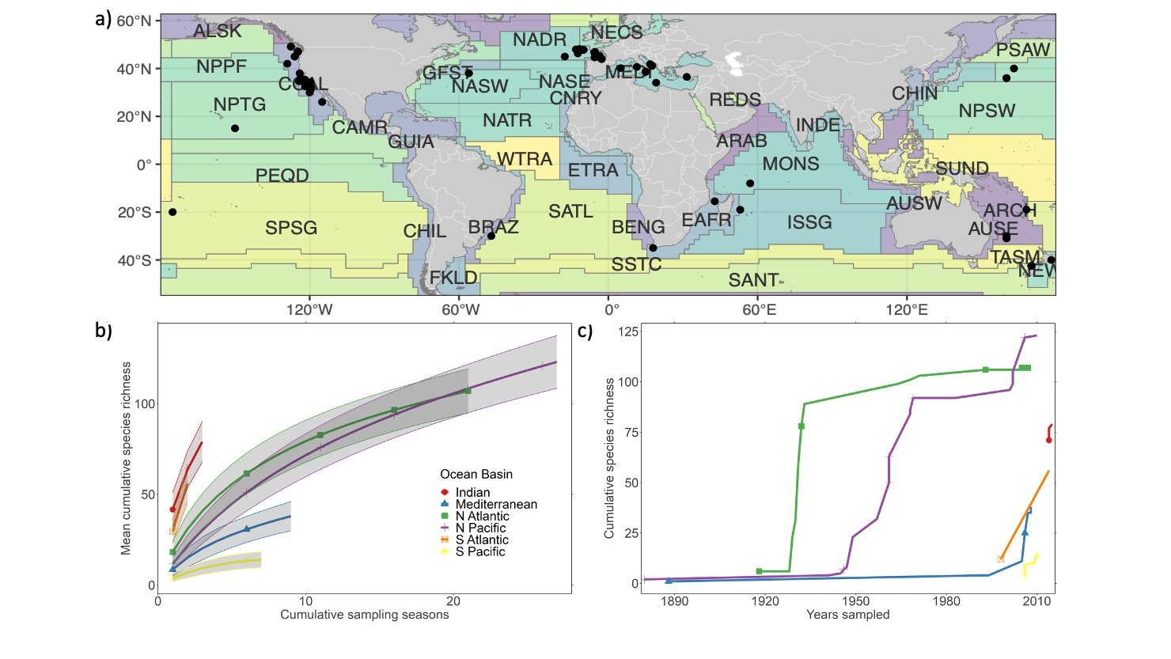

**Figure 1.** a) Geographic distribution of individual observations (n = 69) from 26 published albacore diet papers, reports and grey literature from 36 distinct years sampled from 1880–2015, including Longhurst biogeographical province codes (represented by coloured and lettered polygons). Of the **308** prey identified to species-level in albacore tuna diets, we illustrate the: b) mean species accumulation curve in relation to the number of seasons sampled in each ocean basin; and c) step-wise species accumulation in relation to year and ocean basin sampled from the 1880’s to 2020.

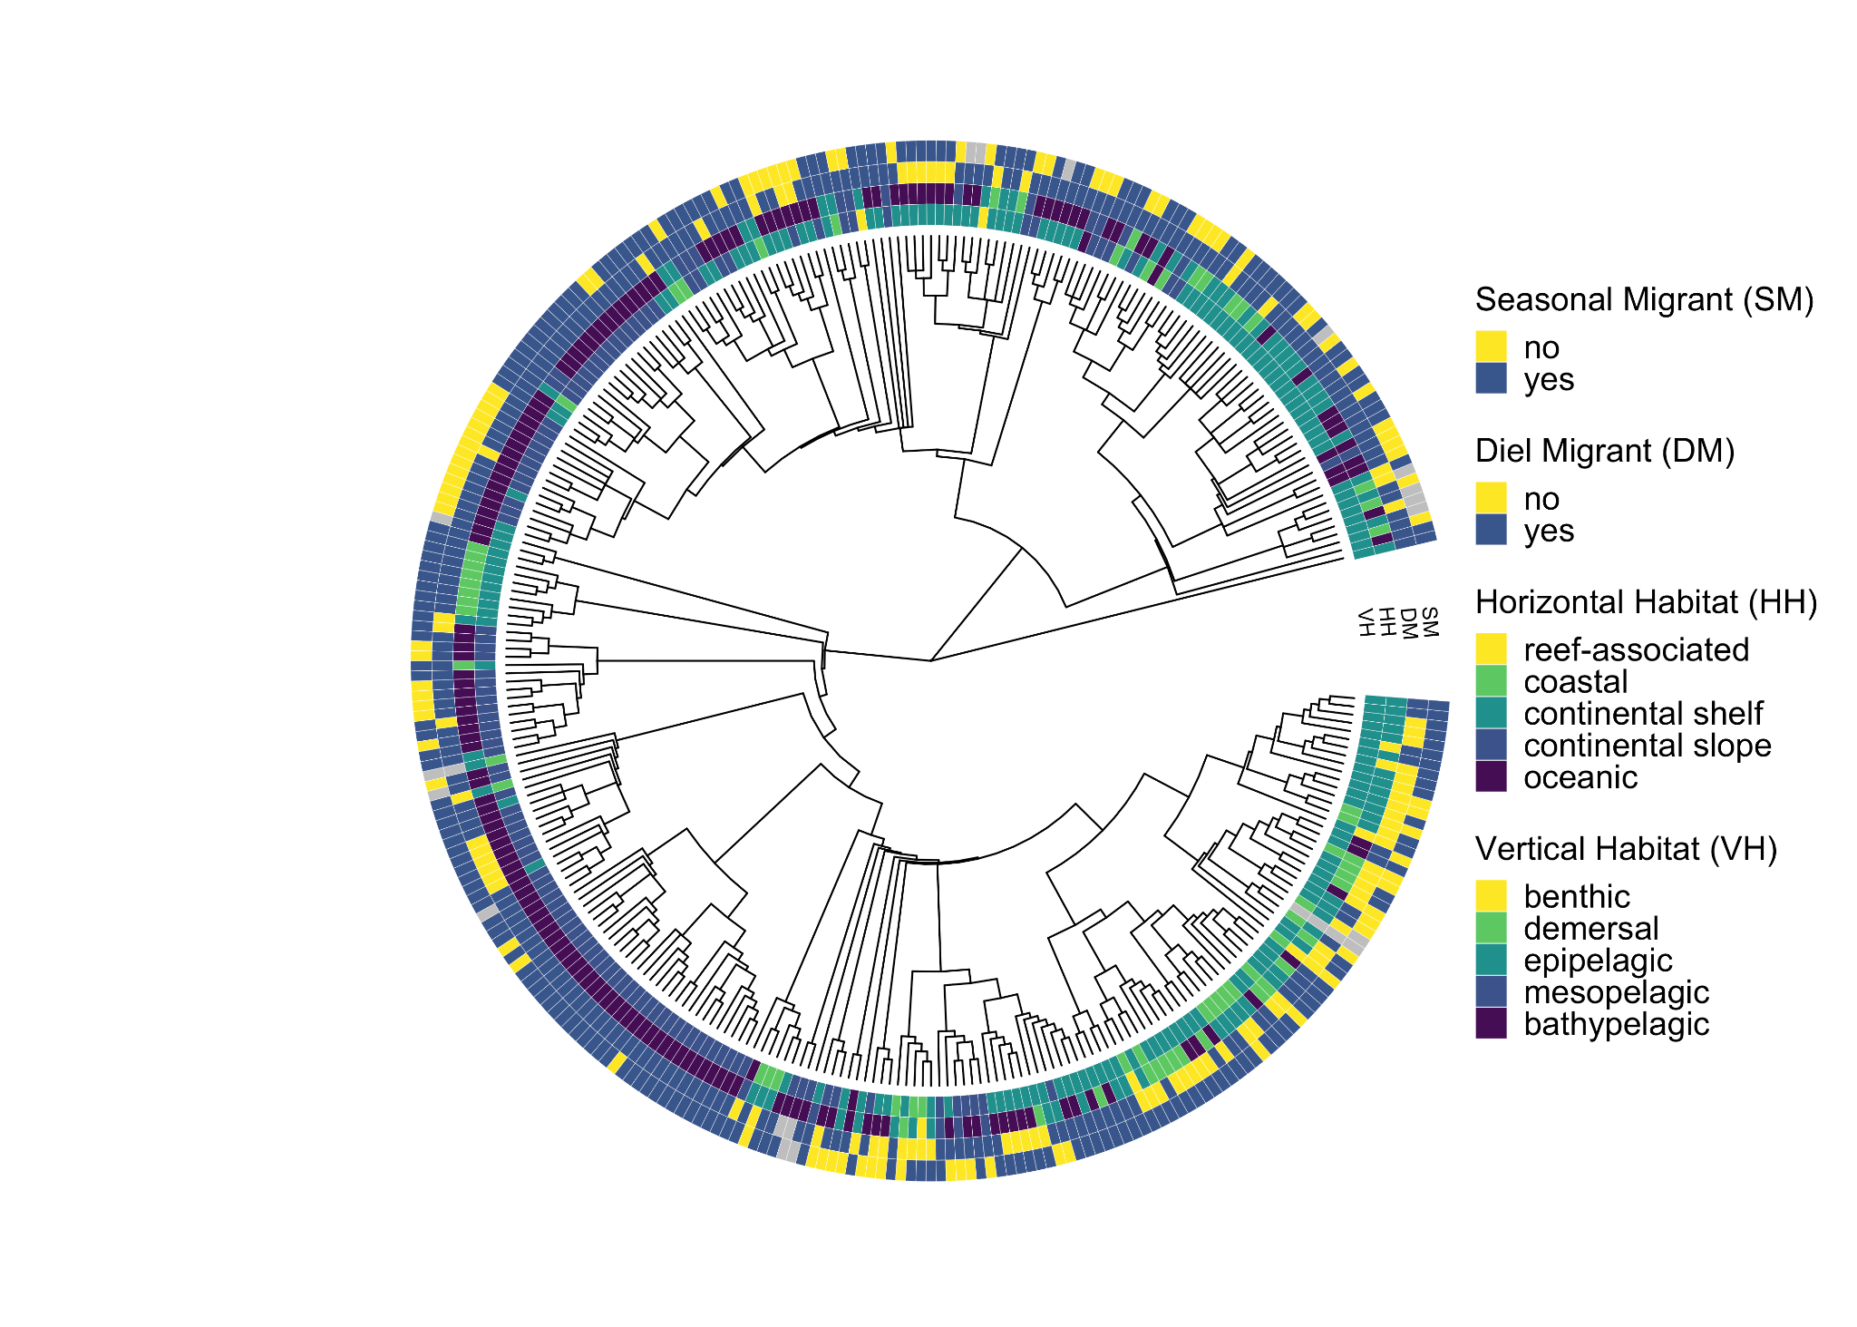

**Figure 2.** Prey and trait diversity for **306 species** that parsed to a phylogenetic classification tree, including information for **four** habitat use traits. Grey shading indicates no data available for a particular species and trait (n = 292 with and 14 without complete trait information).

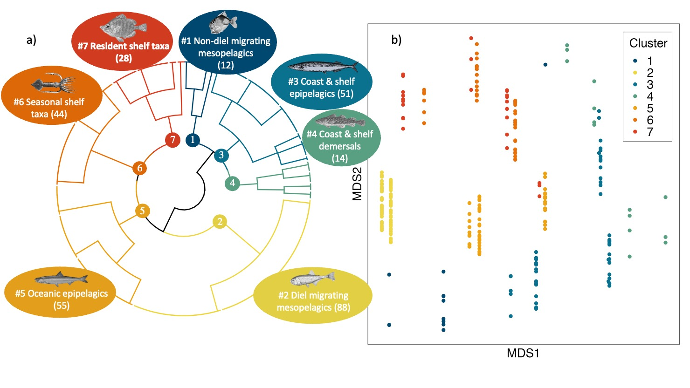

**Figure 3.** Seven optimal albacore prey trait guilds generated by divisive hierarchical clustering for **292 species** with complete trait information for vertical and horizontal habitat use, seasonal and diel vertical migration, and excluding the species that did not parse to phylogenetic tree or with missing trait data. Displayed: a) a radial cluster dendrogram and overlaid description of the main trait values associated with each cluster (including the number of species within clusters), and b) non-metric multidimensional scaling (nMDS) plot illustrating the prey assemblage in multivariate space in relation to the similar or dissimilar trait values.

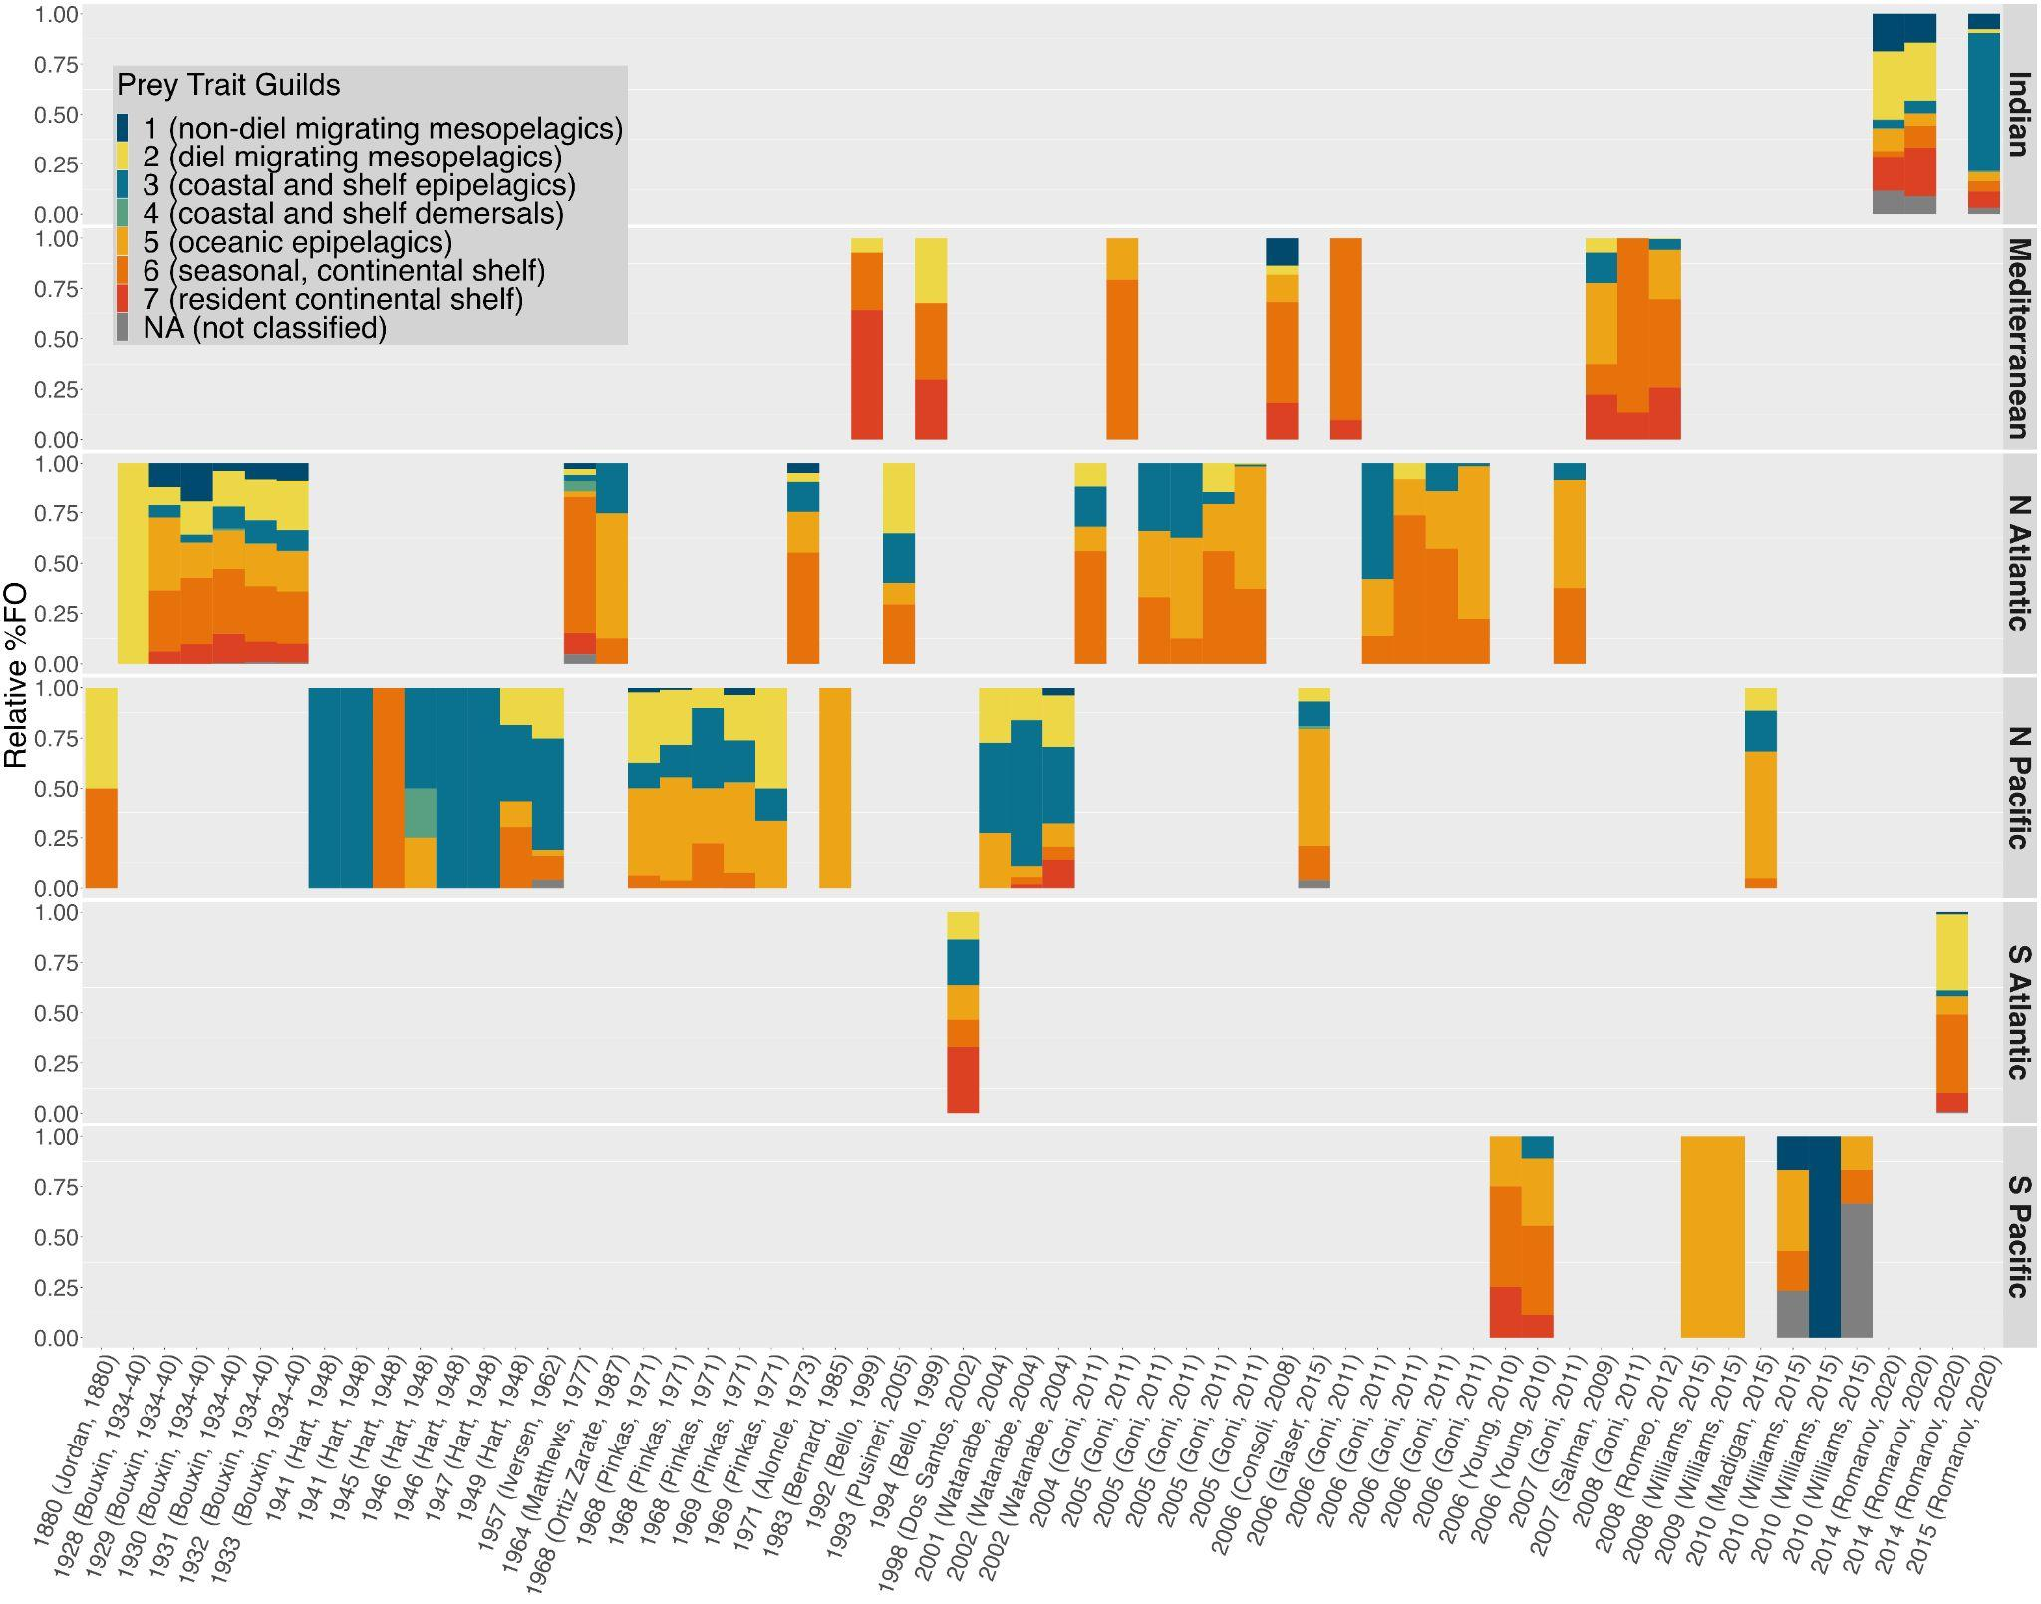

**Figure 4.** Composition of prey trait guilds within historical albacore diets (y axis; relative % frequency of occurrence [FO]) across locations and dates sampled from 1880–2015 (including first author and publication date information). Studies (x axis) are ordered by year (left = oldest). Diet composition is illustrated using a normalised metric of relative contribution to the total frequency of occurrence of all species’ within each trait guild, normalised for each replicate diet observation.

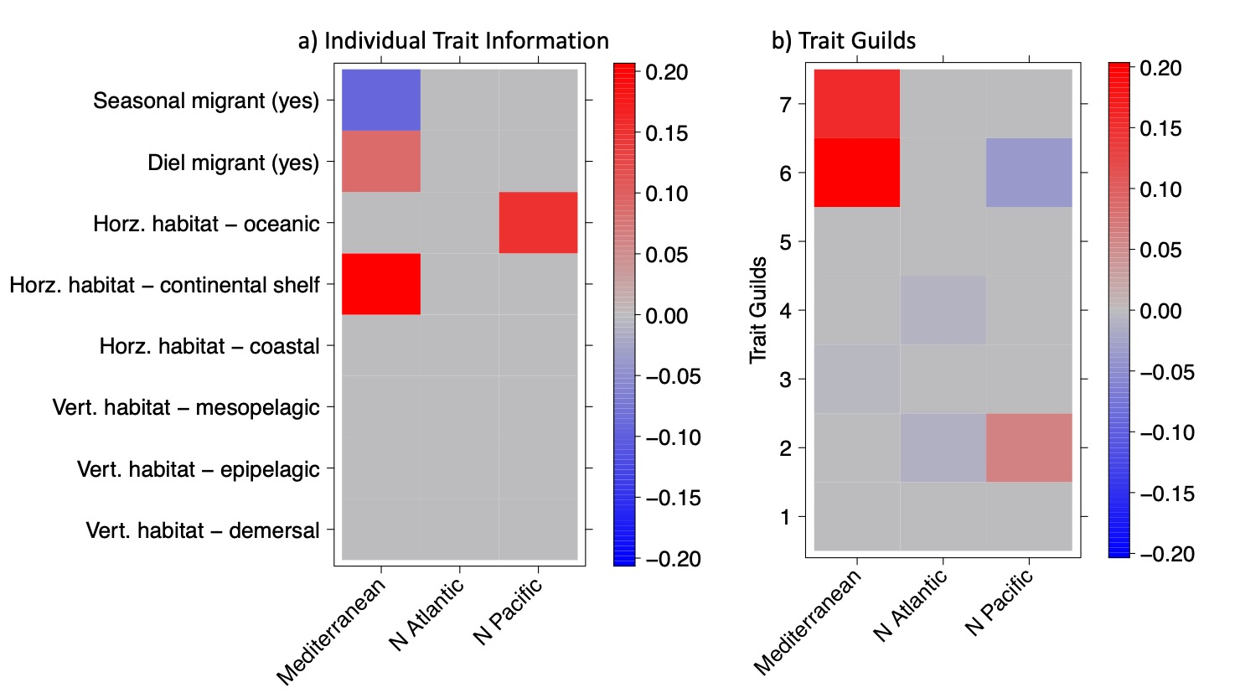

**Figure 5.** Correlation coefficients for the fourth corner solution for a) individual trait information, and b) the trait guilds model and their interaction with the explanatory variable for ocean basin sampled (trait guilds described in Figure 3). Coefficients for all trait-environment interactions are presented using a (GLM)-LASSO model (Brown *et al.* 2014). Significant trait-based relationships between albacore diet composition and geography sampled are coloured in relation to their correlation coefficient, and the strength and direction of the relationship.

## Supplementary Information

* Supplementary Information including text, figures and minimal data: [Albacore_diet_review_supplement](https://docs.google.com/document/d/1VNvPpuBC5vCvFNSpCnemlqkrWDuD7HLUTm8aO33Vzw0/edit)
* Supplementary Data including several larger data tables and outputs of analyses: [Supp Data](https://docs.google.com/spreadsheets/d/1RD1ipsaG7R-PpR3u2hMmHH6MeNsTfaPOLMH0mPvsF7U/edit#gid=588091555)
* [Supplementary Raw data](https://drive.google.com/drive/folders/1D6CHBbTgUrBP0ixQIU07xbsORx3nKzDT) for diet, traits and predator meta-information.
* Dataverse / Repo for digitised PDFs: [currently in Google Drive folder here](https://docs.google.com/spreadsheets/d/1RD1ipsaG7R-PpR3u2hMmHH6MeNsTfaPOLMH0mPvsF7U/edit#gid=588091555).
* [Project GitHub for code](https://github.com/CHANGE-Lab/albacore-diet-global)