Supplemental Information

# 

# Appendix A – Literature Search

**Table S1.** Literature search terms used to identify published papers and historical reports of albacore tuna diets queried from 1900 until 2020 using the Web of Science (Clarivate Analytics, 2020), Aquatic Sciences and Fisheries Abstracts (ASFA, 2020) and Federal Science Library Canada (FSLN, 2020) bibliographic databases. Both the diet research terms and synonymous scientific names for albacore tuna were combined by a Boolean ‘AND’ clause. Note that additional references from the 1880's were cited within older reports were queried and included this meta-analysis.

| **Diet research terms** | **Albacore tuna synonymous scientific names** |
| --- | --- |
| (diet* OR forag* OR prey) AND | ("Thunnus alalunga" OR "Scomber alalunga" OR "Albacora alalonga" OR "Germo alalonga" OR "Germo alalunga" OR "Germo germo" OR "Germo germon" OR "Germo germon steadi" OR "Orcynus alalonga" OR "Orcynus alatunga" OR "Orcynus germo" OR "Orcynus germon" OR "Orcynus pacificus" OR "Scomber alalunga" OR "Scomber alalunga" OR "Scomber alatunga" OR "Scomber albicans" OR "Scomber germo" OR "Scomber germo" OR "Scomber germon" OR "Thunnus alalonga" OR "Thunnus alalunga" OR "Thunnus germo" OR "Thunnus pacificus" OR "Thynnus alalonga" OR "Thynnus alalunga" OR "Thynnus pacificus") |

**Table S2.** Published and historical reports of albacore tuna diet that provided detailed stomach content data. Several older papers, typically prior to the 1980’s, needed to be scanned and digitised to PDF format. These are available upon request and all data digitised from published papers and reports are available in our diet database. For every diet report, we recorded the date range, months and seasons of sampling, the median geographic location of albacore tuna collections, the number of albacore tuna collected, fishing gear and time of day for collections.

| **CiteAuth** | **CiteYear** | **CiteSource** | **CiteTitle** |
| --- | --- | --- | --- |
| Aloncle, H. | 1973 | Thesis | Rythmes alimentaires et circadiens chez le germon *Thunnus alalunga* dans le Nord-Est atlantique |
| Bello, G. | 1999 | Journal of Molluscan Studies | Cephalopods in the diet of albacore, *Thunnus alalunga*, from the Adriatic Sea |
| Bernard et al. | 1985 | CalCOFI Reports | Stomach contents of albacore, skipjack, and bonito |
| Clemens & Iselin | 1963 | FAO World Sci. Meet. Biol. Tunas and Related Species, Sec. 5, Exper. Pap., (30) : 1–13 | Food of Pacific albacore in the California fishery |
| Consoli et al. | 2008 | Marine Biology | Feeding habits of the albacore tuna *Thunnus alalunga* (Perciformes, Scombridae) from central Mediterranean Sea |
| Dos Santos & Haimovici | 2002 | Bulletin of Marine Science | Cephalopods in the Trophic Relations off Southern Brazil |
| Glaser et al. | 2015 | Journal of Marine Systems | Through the stomach of a predator: Regional patterns of forage in the diet of albacore tuna in the California Current System and metrics needed for ecosystem-based management |
| Goni et al. | 2011 | Marine Biology | Variability of albacore (*Thunnus alalunga*) diet in the Northeast Atlantic and Mediterranean Sea |
| Hart, JL | 1948 | Pacific Biological Station | Accumulated Data on Albacore |
| Iversen, RTB | 1962 | Fishery Bulletin | Food of albacore tuna, *Thunnus germo* (Lacepède), in the central and northeastern Pacific |
| Jordan & Gilbert | 1880 | Proceedings of the National Academy of Sciences | Description of two species of scopeloid fishes, *Sudis ringens* and *Myctophum crenulare* from Santa Barbara Channel, California. |
| Joubin & Rouie | 1918 | Bulletin de l'Institut Océanographique de Monaco | Observations sur la nourriture des thons de l'Atlantique (*Germo alalonga* Gmelin) |
| Legendre & Bouxin* | 1934; 1936; 1940 | Blondel la Rougery | La Faune pélagique de l'Atlantique au large du Golfe de Gascogne recueillie dans des estomacs de Germons: première partie: poissons; deuxième partie: céphalopodes; troisième partie: invertébrés (céphalopodes exclus), parasites du germon. |
| Logan et al.‡ | 2013 | Deep Sea Research Part II: Topical Studies in Oceanography | Contribution of Cephalopod prey to the Diet of Large Pelagic Fish Predators in Central North Atlantic Ocean |
| Madigan et al. | 2015 | Proceedings of the National Academy of Sciences | Assessing niche width of endothermic fish from genes to ecosystem |
| Matthews et al. | 1977 | NOAA Technical Report | Food of Western North Atlantic Tunas (*Thunnus*) and Lancetfishes (*Alepisaurus*) |
| McHugh, JL | 1952 | Bulletin of the Scripps Institution of Oceanography | The food of albacore (*Germo alalunga*) off California |
| Ortiz de Zarate, V | 1987 | Instituto Español de Oceanografía | Datos sobre la alimentacion del atun blanco (*Thunnus alalunga*) juvenil capturado en el golfo de vizcaya |
| Pinkas et al. | 1971 | Fish Bulletin | Food habits of albacore, bluefin tuna, and bonito |
| Prince Albert de Monaco | 1888 | Comptes Rendus de l'Académie des Sciences | Sur l'alimentation des naufragés en pleine mer (On the nutrition of castaways in the open ocean) |
| Pusineri et al. | 2005 | Journal of Marine Science | Food and feeding ecology of juvenile albacore, *Thunnus alalunga*, off the Bay of Biscay: a case study |
| Romanov et al. | 2020 | Marine and Freshwater Research | Trophic ecology of albacore tuna (*Thunnus alalunga*) in the western tropical Indian Ocean and adjacent waters |
| Romero et al. | 2012 | Helgoland Marine Research | Pelagic cephalopods of the central Mediterranean Sea determined by the analysis of the stomach content of large fish predators |
| Salman & Karakulak | 2009 | Journal of Marine Biological Association of the United Kingdom | Cephalopods in the diet of albacore, *Thunnus alalunga*, from the eastern Mediterranean |
| Teffer et al.‡ | 2015 | Marine Biology | Trophic niche overlap among dolphinfish and co-occurring tunas near the northern edge of their range in the western North Atlantic |
| Watanabe et al. | 2004 | Fisheries Science | Feeding habits of albacore *Thunnus alalunga* in the transition region of the central North Pacific |
| Williams et al. | 2015 | Deep Sea Research Part II: Topical Studies in Oceanography | Vertical behavior and diet of albacore tuna (*Thunnus alaguna*) vary with latitude in the South Pacific Ocean |
| Young et al. | 2010 | Marine Biology | Feeding ecology and niche segregation in oceanic top predators off eastern Australia |
| *These publications were combined as they consisted of three part publication on the taxonomic composition of albacore diets  ‡These publications met nearly all criteria for review, but are not included in further analyses as prey were reported at Family, Order and Class levels. | | | |

**Table S3.** Meta-information for published papers and reports on location, year, months, seasons of sampling, fishing gear used, depth sampled and time of day, the number of non-empty stomachs (stomachs_used); measured or estimated mean albacore length (pred_flmean) and variation about the mean when measured (pred_flmean_se); albacore minimum (pred_flmin) and maximum (pred_flmax) measured or estimated fork lengths; reported or estimated life stage (pred_life), and descriptiona of our estimation (pred_flest) for albacore life history stage (pred_life_est), age (pred_age_est) and lengths (pred_flmean_est) based on basin-scale fisheries catch data and age and growth work (est_note, est_ref). Note that several papers and reports presented aggregate information for an entire multi-year program. Accessible here: <https://docs.google.com/spreadsheets/d/1soUZX6tkBJ94EL4WZ_m1pixWEmqvXkgv/edit#gid=661663717>

**Table S4.** Reported information for prey species and all reported life stages (pre_age_reported_1_), lengths (maxL) and type of length measurement taken (maxl_type), as well as the associated maximum gape limit (maxGape) for the albacore sampled from the same study as the prey taxa. Appended are the estimated life stage (life_stage) and associated notes used to select the final life stage assigned to each species for selection of appropriate trait information. ***See notes below table for definition of abbreviations. Accessible here: <https://docs.google.com/spreadsheets/d/1soUZX6tkBJ94EL4WZ_m1pixWEmqvXkgv/edit#gid=1070878054>

# Appendix B – Trait-data collection & Analyses

# 

Four trait variables were extracted from a global database of albacore prey traits (Gleiber et al., 2022) for taxa identified to species and for the estimated primary life stage consumed (Supplementary Data, Table S5): (i) vertical and (ii) horizontal habitat association, (iii) presence of diel vertical migration, and (iv) presence of seasonal migration. We used online repositories for species-level information, primarily FishBase (Froese & Pauly, 2020), SeaLifeBase (Palomares & Pauly, 2020), and the IUCN Red List of Threatened Species (IUCN, 2020), and searched for descriptive published literature for each species using Web of Science and Google Scholar. Of the 308 species identified in albacore diets, we obtained complete trait information for 292 species for the life stage consumed, for the four habitat use traits used in this meta-analysis (Supplementary Data, Table S5).

Vertical and horizontal habitat use traits were directly extracted from online repositories and corroborated alongside species distribution maps, reported depth range and typical depth strata inhabited (Gleiber et al., 2022). Where published literature expanded on or differed from a general value reported by species information repositories, we used the published literature and data. For example, if a species is listed as ‘bathypelagic’ in FishBase, but we do not have access to the original data and published papers report their distribution as typically ‘mesopelagic’, we selected their vertical habitat use trait to be ‘mesopelagic’ for the purposes of this analysis. Trait values for the presence and nature of diel vertical migration or seasonal migration behaviour were collected by keyword searching for each of these terms and for the prey species scientific name on Google Scholar (2020), Web of Science (Clarivate Analytics, 2020), Aquatic Sciences and Fisheries Abstracts (ASFA, 2020) and Federal Science Library Canada (FSLN, 2020) bibliographic databases. This task was performed and repeated by up to 6 individual data collectors and values were cross-checked between data collectors, multiple published papers, and datasets.

Of note, we further edited vertical habitat use information for two species, *Janicella spinicauda* (Oplophoroidae) and *Lampanyctus crocodilus* (Myctophidae), which were classified primarily as ‘bathypelagic’ (> 1300 m depth) and appear as such in the database but are also known to occur in the mesopelagic zone listed as secondary habitat in our database. The mesopelagic zone is where these prey were most likely encountered by albacore tuna that are not known to occur in or be able to dive to the bathypelagic depths. Thus for analyses, we relabelled those two species as ‘mesopelagic’ in order to retain them rather than exclude them from analyses.

**Table S5.** For the 308 prey identified to species, and for the primary consumed life stage assessed and assigned in section 2.3 of the methods of this paper, here we include taxonomic information (class, order, family, species), estimated prey life stages (life_stage) and associated notes (life_note). Values for four trait variables that influence the prey encounter (vertical and horizontal habitat use, diel vertical and seasonal migration; respectively labelled: vert_habitat, horz_habitat, diel_migrant_cat and season_migrant_cat) phase of the predation process were downloaded for each species from the publicly available Pelagic Species Trait Database (Gleiber et al., 2022)*. For the 292 species with complete trait information, we used the four traits (vert_habitat, horz_habitat, diel_migrant_cat, season_cat) for building prey functional groups (prey.trait.guild) described in section 2.4 (Table S6). Additional information is included for the maximum frequency of occurrence (maxFO), maximum percent numerical abundance (maxN) and percent mass consumed (maxM) observed across all studies. For multiple species reported as presence absence, these values are '0'. Accessible here: <https://docs.google.com/spreadsheets/d/1soUZX6tkBJ94EL4WZ_m1pixWEmqvXkgv/edit#gid=1573200869>

# Appendix C – Estimation of albacore prey size/age consumed

Of the 308 identified prey recorded to species, 72 (or 23% of species) were reported with associated life stage information reported within their corresponding diet study. Of these, 42 reported as post-larvae, young-of-year, or juveniles, and 37 species consumed as adults, 13 of which overlapped (Supplementary Information, Figure S1; Supplementary Data, Table S4). Albacore rarely consumed larvae (i.e., 11 species in total). Of these 72 species, 13 were reported at multiple life stages in albacore diets; however, one life stage was typically dominant across diet studies (i.e., with an order of magnitude greater frequency of occurrence than any other life stage). For example, of 11 species with reported consumption of the larval life stage, 6 species were typically consumed as juveniles (i.e., across multiple studies) and thus were assigned as juveniles for the purpose of this meta-analysis (Supplementary Data, Table S4; Supplementary Information, Figure S1).

When specific information was not provided, it was necessary to estimate prey life stage from available information on the size and age class of either the predator or prey in a given study (Supplementary Information, Figure S1; Supplementary Data, Table S4). For an additional 15 species (~nearly 5% of species), prey length information was reported but not life stage. Reported total lengths ranged from 1.5–24.5 cm, and these prey species’ life stages were inferred relative to their known length at maturity (Supplementary Information, Figure S1; Supplementary Data, Table S4). The remaining 221 species (72% of the species) were identified in albacore diets without meta-information and assumed to be either juveniles or adults (Supplementary Information, Figure S1). Trait information was often similar between juvenile and adult life stages (Gleiber et al., 2022), thus for 127 of these species (41% of the species), no further estimation of prey life stage was needed (Supplementary Information, Figure S1).

For 94 prey species, we lacked metainformation to assist in their direct life stage estimation and selection of appropriate trait information for juvenile and adult life stages. We corroborated decisions on selection of appropriate trait information among these species using albacore gape length limits calculated from maximum measured or estimated albacore fork lengths and using the equation developed by Ménard et al. (2006) for yellowfin tuna (Lm = 0.0823 FL + 1.758) to estimate gape limits ranging from 6.4–11.5 cm across studies and locations sampled. Here we described how data on measured albacore length information were handled and how we estimated fork length information if this was also not measured or reported (Figure S1).

Out of 26 research papers, 16 measured albacore fork length (FL) range, minima, and maxima (Figure S2). Of these, seven also reported the mean FL and five an estimated age range or life stage for albacore sampled (e.g., adult, juvenile) (Supplementary Data, Table S3). We also estimated mean FL for the 9 studies that reported FL range but not means (Figure S2), and all FL data for the remaining 10 studies that lacked size or life history information using metadata collected on fishing gear used and matched to gear-specific length data from relevant regional fisheries management organisations.

Of the 10 studies that lacked size or life history information for albacore, four reported the method of sampling (i.e., troll, trawl, longline). For these four studies and to complete the missing mean fork length (FL) for 7 studies noted above, we matched gear-specific length data (range and mean FL) from relevant regional fisheries management organisations (ICCAT, 2020; ISC, 2006) to albacore diet studies by year. This was done by matching the range and mean FL for albacore caught given year fished and specified gear type to the year sampled and gear type reported within these 10 studies. We then estimated the likely life stage(s) sampled using region-specific age and growth curves, and reported sizes at maturity (described in detail for each study in Supplementary Data, Table S3).

Finally, six historical studies lacked any information about sampled albacore length or age, did not provide catch method and/or were outside any record-keeping timeframes for fisheries catch data. Here, we estimated the likely life stage(s) for albacore based on studies that sampled the same geographic area (Supplementary Data, Table S3). We confirmed our life-stage estimations using known albacore ontogenetic and migratory behaviours in the large marine ecosystems sampled (Nikolic et al., 2017). Based on the results of a linear regression fit to both measured and reported FLs, there was no significant difference (p-value > 0.05) between the variances of measured or estimated mean, minimum and maximum FL (Figure S2). Overall, we estimate that sampled albacore ranged from 37–119 cm FL with mean estimates of 47–101 cm FL (Supplementary Information, Figure S2).

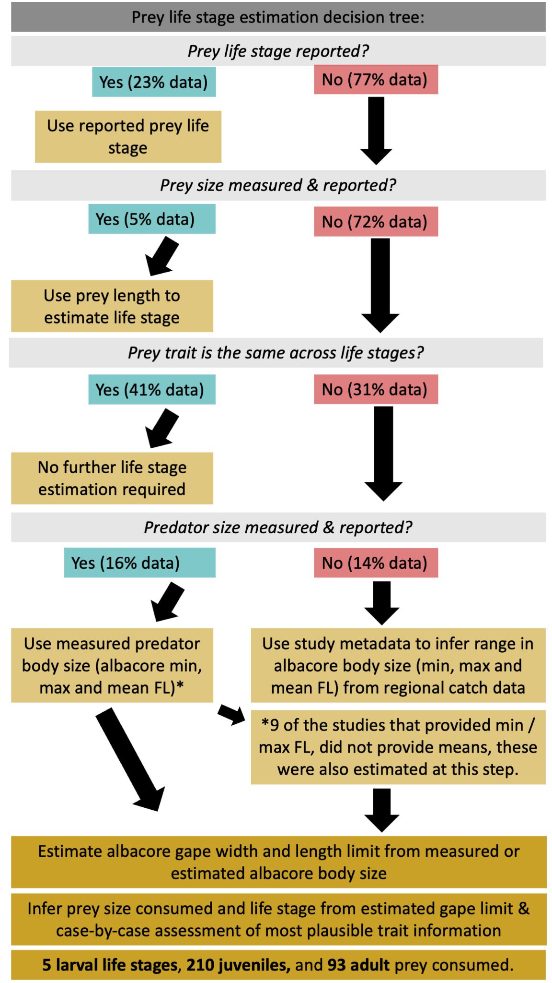

**Figure S1.** Decision tree for prey species life stage estimation process described in section 2.3.

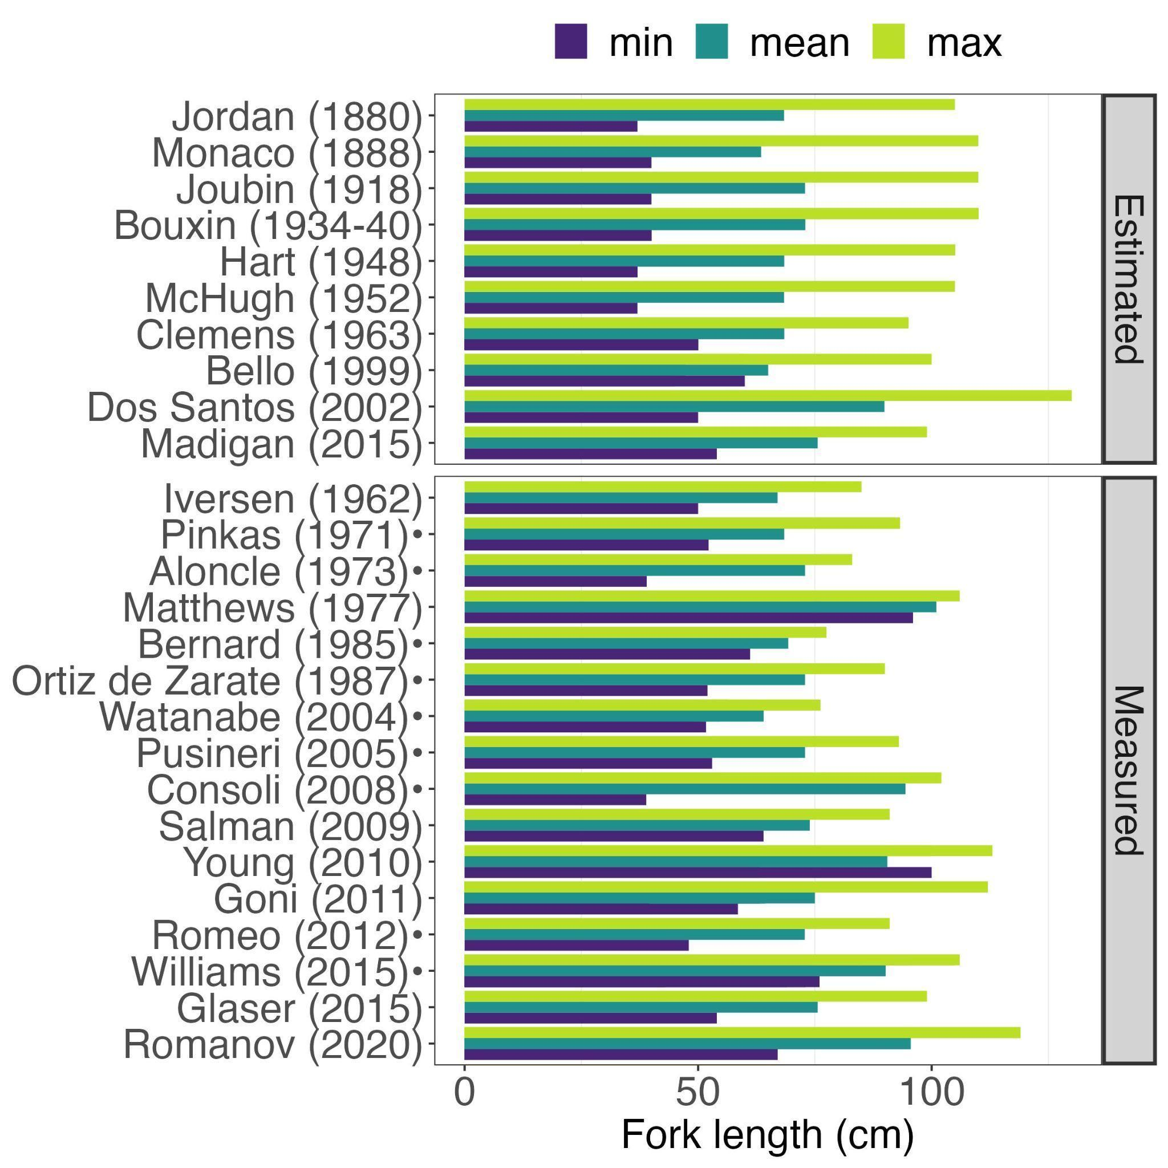

**Figure S2.** Albacore tuna fork length minima (min), mean and maxima (max) obtained from measured and reported data from 16 publications and estimated for another 10 publications. Of the 16 publications reporting length information, 9 publications (annotated with •) did not include a mean. This value was estimated in the protocol described in the methods of this manuscript. Mean, minimum and maximum FLs were not significantly different based on linear regression analysis (p-value >0.05).

# Appendix D – Supplemental Results

All prey taxa identified are provided in Table S7.

**Table S7.** Extended list of taxonomic identifications for prey from albacore stomach contents from published and grey literature from the 1880's to 2020. This table includes all taxonomic identifications made, and includes the authors' level of certainty for inclusion in analyses ('IncludeSP' column), as well as prey taxonomy (class, order, family, species), taxonomic assignment (prey_tax), taxonomic level of identification used for filtering data for analyses (tax_level), common names and reference databases checked for trait and taxonomic information, as well as reported or estimated prey life stages and associated notes on old species names reported. Accessible here:

<https://docs.google.com/spreadsheets/d/1soUZX6tkBJ94EL4WZ_m1pixWEmqvXkgv/edit#gid=176756372>

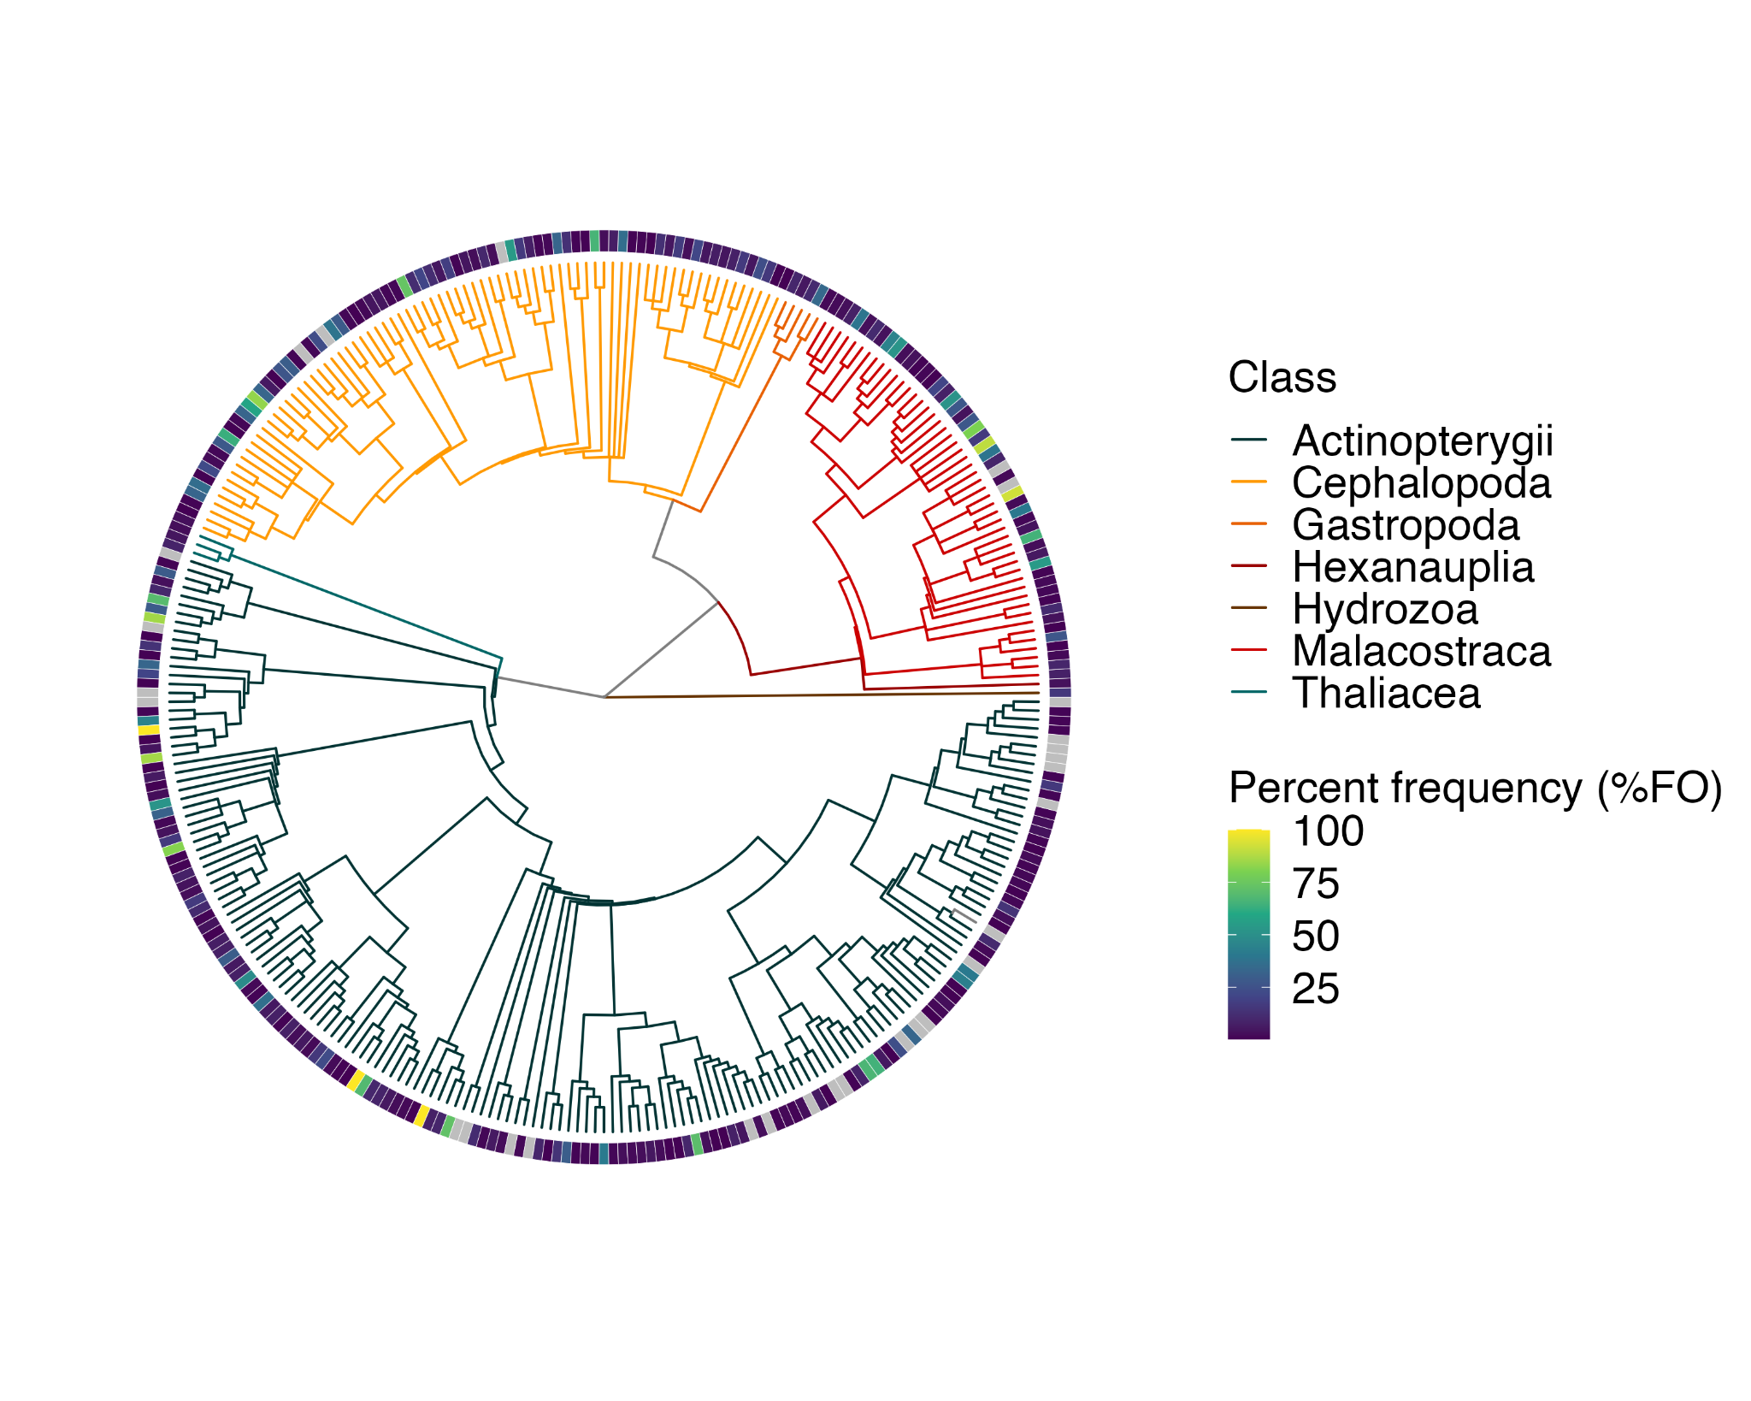

**Figure S3.** The maximum percent frequency of occurrence observed across phylogeny. Grey shading indicates no quantitative diet data were available for a particular species and trait. This illustrated that out of 308 prey species, 201 were observed in < 10% of stomach samples within any study.

We selected 7 clusters by optimising cluster validation outputs: (1) higher average distance between species clusters (Rousseeuw, 1987); (2) lower average distance within species clusters (Handl et al., 2005); (3) high silhouette width coefficient value and Dunny Smith residuals (Dunn†, 1974; Rousseeuw, 1987); and lastly, (4) optimal evenness or balance of cluster composition indicated by the number of species in each cluster (Legendre & Legendre, 1998) (Figure S4; Supplementary Data, Table S6).

**Table S6.** Clustering algorithm statistical output table. We selected 7 clusters by optimising cluster validation outputs: (1) higher average distance between species clusters (Rousseeuw, 1987); (2) lower average distance within species clusters (Handl et al., 2005); (3) high silhouette width coefficient value and Dunny Smith residuals (Dunn†, 1974; Rousseeuw, 1987); and lastly, (4) optimal evenness or balance of cluster composition indicated by the number of species in each cluster (Legendre & Legendre, 1998). Accessible here:

<https://docs.google.com/spreadsheets/d/1soUZX6tkBJ94EL4WZ_m1pixWEmqvXkgv/edit#gid=1573200869>

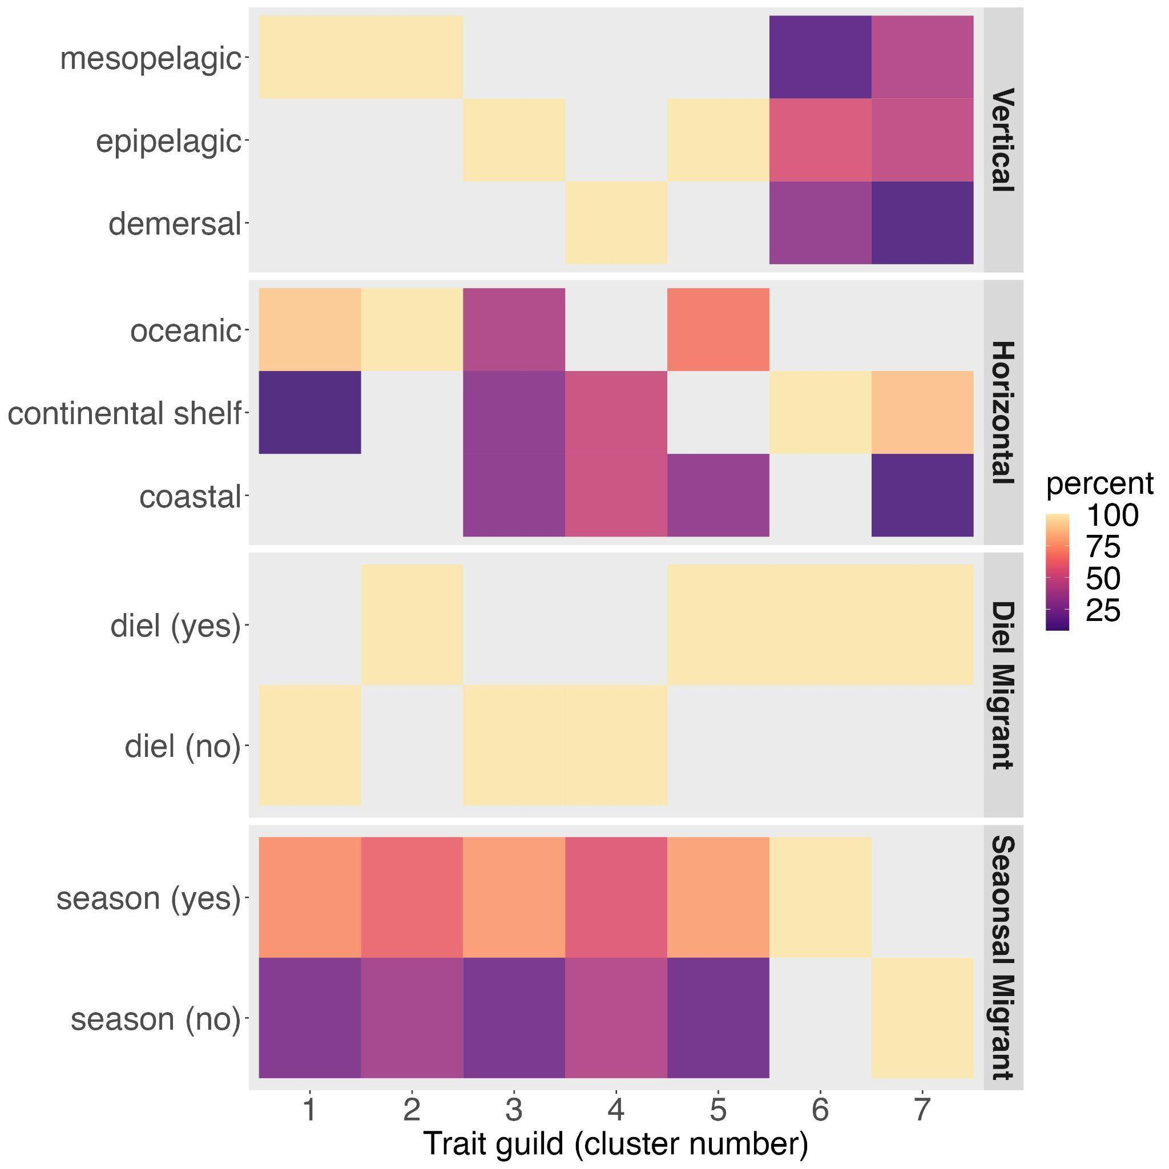

**Figure S4.** Trait heat map illustrating the distribution of trait values within each trait guild (cluster), as a proportion of species within each trait guild associated with each trait value, using hierarchical divisive clustering algorithms (k = 7), for vertical habitat (‘Vertical’), horizontal habitat use (‘Horizontal’), diel vertical migration (‘Diel Migrant’) and seasonal habitat use (‘Seasonal Migrant’).

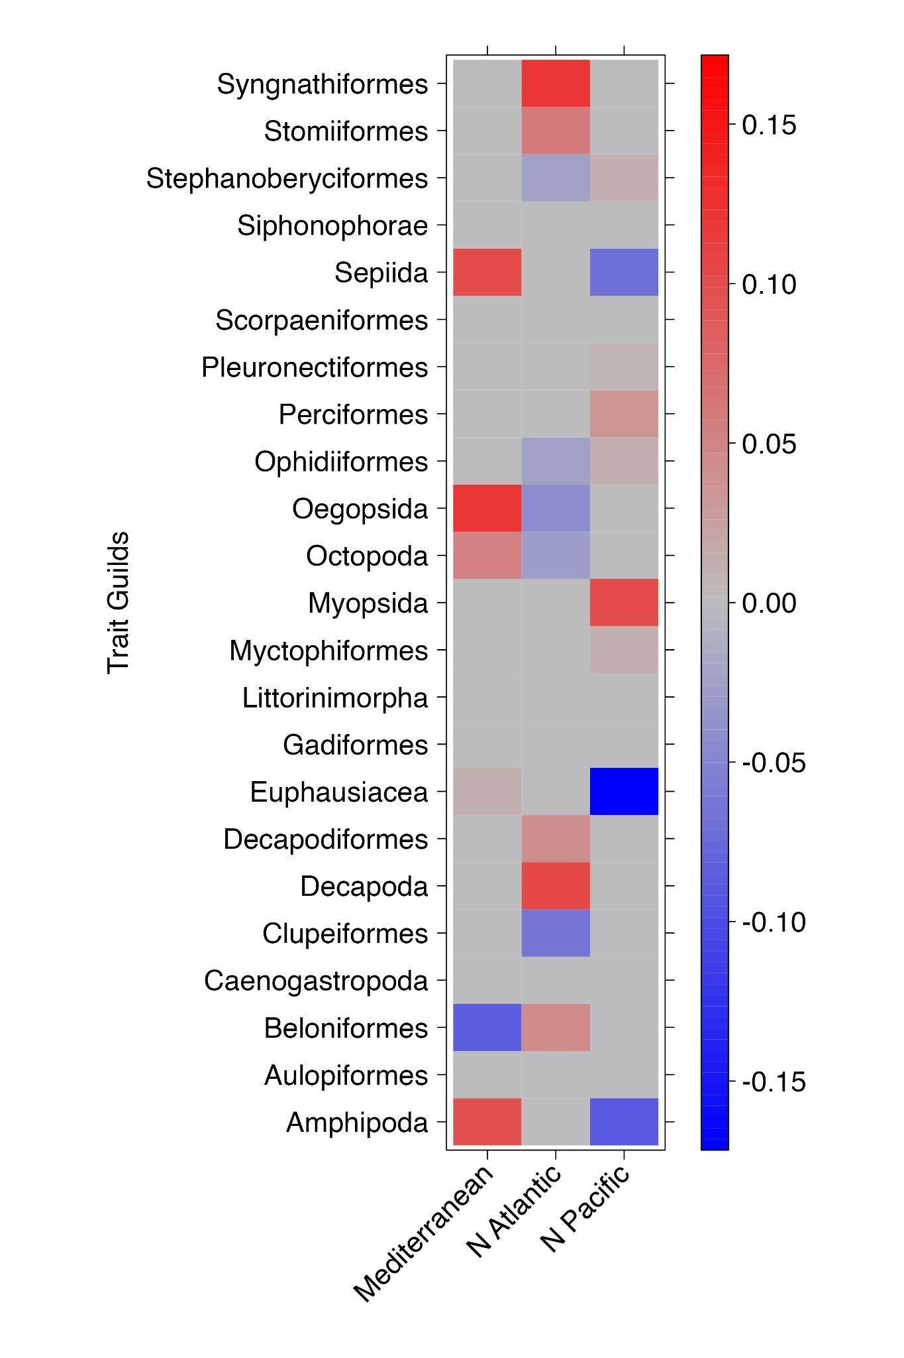

**Figure S5.** Correlation coefficients for the fourth corner solution and significant relationships between taxonomic variability (Order) and ocean basins sampled. Here we aggregate 98 species by their phylogenetic Order to illustrate the results of taxonomic variability. Coefficients for all trait-environment interactions are presented using a (GLM)-LASSO model (Brown *et al.* 2014). Significant trait-based relationships between albacore diet composition and geography sampled are coloured in relation to their correlation coefficient, and the strength and direction of the relationship.

# References

ASFA. (2020). *Aquatic Sciences and Fisheries Abstracts*. World Wide Web electronic publication, accessed 07/2020: http://www.ala.org.au http://www.fao.org/fishery/asfa/en. Accessed July 2020.

Clarivate Analytics. (2020). *Web of Science*. World Wide Web electronic publication, accessed 07/2020: www.webofknowledge.com.

Froese, R., & Pauly, D. (2020). *FishBase*. World Wide Web electronic publication, accessed 07/2020: www.fishbase.org.

FSLN. (2020). *Federal Science Libraries Network*. World Wide Web electronic publication, accessed 07/2020: https://science-libraries.canada.ca/eng/home/

Gleiber, M. R., Hardy, N. A., Roote, Z., Morganson, C. J., Krug-Macleod, A., George, I., Matuch, C., Brookson, C. B., Crowder, L. B., & Green, S. J. (2022). *Pelagic Species Trait Database* [Data set]. Scholars Portal Dataverse. https://doi.org/10.5683/SP3/0YFJED

Google Scholar. (2020). *Google Scholar*. https://scholar.google.com/

ICCAT. (2020). *Albacore (Thunnus alalunga) Task 2 size/weight frequencies from ICCAT (as of Jan/2021) for the period 1956-2019.* Public statistical databases, accessed 07/2020: https://www.iccat.int/en/accesingdb.html

ISC. (2006). *Report of the ISC – Albacore Working Group Stock Assessment Workshop*. National Research Institute of Far Seas Fisheries, Shimizu.

IUCN. (2020). *The IUCN Red List of Threatened Species*. World Wide Web publication, accessed 07/2020: https://www.iucnredlist.org.

Ménard, F., Labrune, C., Shin, Y.-J., Asine, A. S., & Bard, F.-X. (2006). Opportunistic predation in tuna: A size-based approach. *Marine Ecology Progress Series*, *323*, 223–231. https://doi.org/10.3354/meps323223

Nikolic, N., Morandeau, G., Hoarau, L., West, W., Arrizabalaga, H., Hoyle, S., Nicol, S. J., Bourjea, J., Puech, A., Farley, J. H., Williams, A. J., & Fonteneau, A. (2017). Review of albacore tuna, *Thunnus alalunga*, biology, fisheries and management. *Reviews in Fish Biology and Fisheries*, *27*(4), 775–810. https://doi.org/10.1007/s11160-016-9453-y

Palomares, M., & Pauly, D. (2020). *SeaLifeBase*. World Wide Web electronic publication, accessed 07/2020: www.sealifebase.org