 Project Report Template

**INTRODUCTION**

## Overview

My project Name is An-Android-Application-for-Keeping-Up-with-the-Latest-Headlines.This Project is based on the News API key. you can also get API key from the website NewsApi.Org. Our project is starting from the Login/Register page. You can enter my project with your Email and password after You Already Register with My application. After Enter With login you can See a List of Headlines.

These Headlines are Automatically Update Based on the News Api key. You can also Search Certain News for Your purpose. If You Enter My App you should be have a minimal English knowledge.

## Purpose

Using my project you can have a knowledge about World News.

You can Easily Understand My app without effort.

Everyone can Using my app with Email-id.

This application Automatically Updated base on News Api.

This app authenticate the user using Firebas

**Problem Definition & Design Thinking**

## Empathy Map

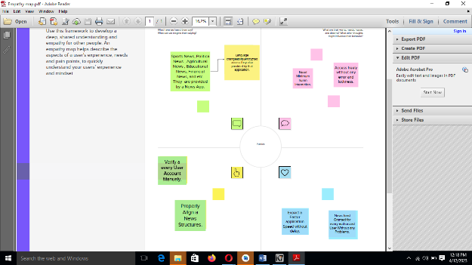

## Ideation& BrainStorming map

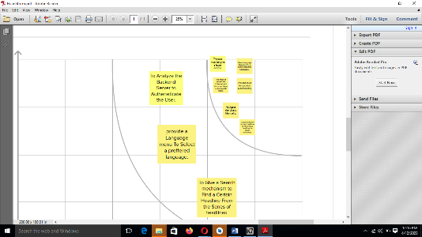 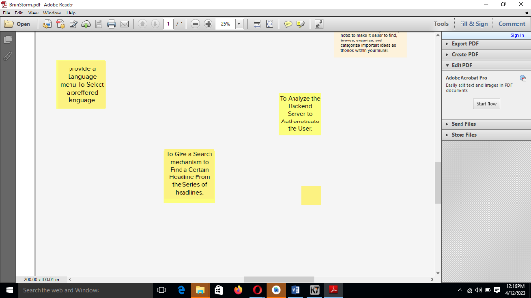

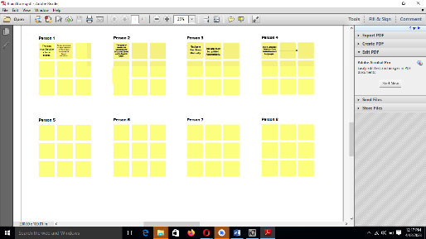 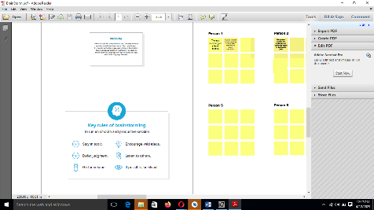

## 

# RESULT:

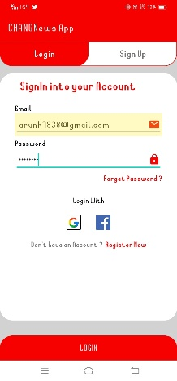 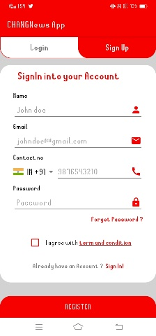 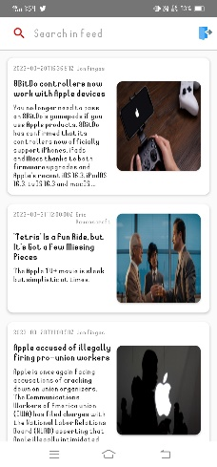

1. Login page b)Signup page c) News page

## ADVANTAGES & DISADVANTAGES:

### Advantages:

* Automtically Updated based on api
* Faster Interaction
* Easily understandable
* Authneticate the users

### Disadvantages:

* We can’t interact with muiple languages
* We got only a headlines an litte description.Can’t read the news briefly.
* All newses are listed single column. Can’t separate it.

## APPLICATIONS

* House
* Institutions
* Schools
* Colleges
* Press
* Hospitals
* media

 Project Report Template

## CONCLUSION

Finally we got a app with news perfectly. This App will run successfully and update a news automatically.

## FUTURE SCOPE

* Multi language support
* Separate a news base on Types

# Appendix

## Source code:

Visit: <https://github.com/CHANGNEWS/An-Android-Application-for-Keeping-Up-with-the-Latest-Headlines>