EMBEDDED SYSTEMS INTERNSHIP
WEEK 1 REPORT
System Requirements Analysis and Block Diagram Design
Project: Smart Environment Monitoring and Alert System
A simulation-oriented embedded system design for indoor room monitoring
Prepared as a Week 1 planning and architecture deliverable

Prepared by: Channabasava Kulageri
Email: channabasavavk16@gmail.com

1. Introduction
An embedded system is basically a small hardware-and-software system built to do a specific job. For this first week, I started with a simple room-monitoring idea and converted it into a detailed system plan before moving to firmware implementation. I selected a Smart Environment Monitoring and Alert System. The device is intended to measure room temperature, humidity and light level, process the readings using an ESP32, show the current values on an OLED display and give an audible warning when a selected limit is crossed. I also kept Wi-Fi in the design so that remote monitoring can be added later, while serial output can be used during development and debugging.
I have kept the project fairly simple because this is my first embedded-systems project, and I want to be able to understand each part instead of adding hardware just to make the project look complicated. I plan to develop it in simulation first. That makes it easier to change sensor values, check timing and test different fault conditions without depending on physical components. Wokwi supports the ESP32 and the peripherals that are useful for this project, including GPIO, ADC, I2C, timers and Wi-Fi, so it is a practical choice for the later implementation and testing stages.

1.1 Problem Statement
Room temperature, humidity and light can change during the day without being obvious to the user. A small monitoring device can keep checking these values and give a warning when something moves outside a chosen range. The main problem for this project is therefore not just reading a sensor. The system also has to handle different types of inputs, make a decision in a predictable amount of time, show useful information and still be simple enough to debug.

1.2 Objectives
- Define the main functions the device must perform and the practical limits it should work within.
- Choose hardware and software blocks that are simple enough to understand and easy to reproduce in simulation.
- Identify the input, output, communication, power and timing needs of the system.
- Show the hardware connections and the main software modules in a clear block diagram.
- Keep the design practical enough to implement in Week 2, debug in Week 3 and integrate and test in Week 4.

2. System Overview
The overall idea is straightforward: the physical environment is sensed, the readings are sent to the microcontroller, the firmware processes them, and the results are sent to the output or communication interfaces. I plan to use a DHT22 for temperature and humidity. For light, an LDR will be connected through a simple voltage-divider circuit so the ESP32 can read the changing voltage using its ADC. The ESP32 will then compare the readings with the selected limits, update the OLED, control the buzzer and, when needed, send data over Wi-Fi. For the prototype, USB power keeps the setup simple.
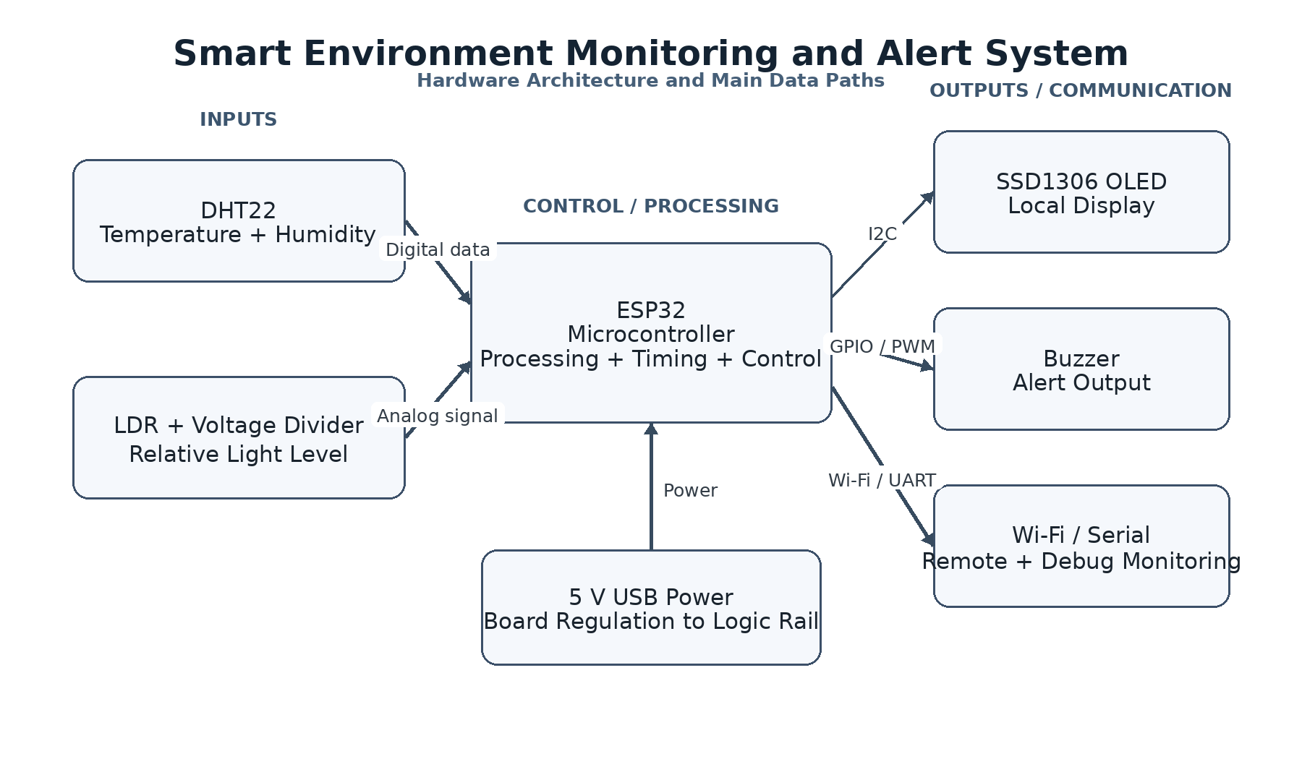
Figure 1. Proposed hardware architecture and major data/power paths.

3. System Requirements Analysis
At this stage, the system idea needs to be converted into requirements that can be verified later. I have written the requirements below so that each important one can be connected to a Week 4 test. The numerical values are design targets for the prototype; they should not be treated as certified accuracy specifications.
ID | Requirement | Primary block | Verification idea
FR-01 | Measure room temperature | DHT22 | Check that the firmware gets a temperature value during each monitoring cycle.
FR-02 | Measure relative humidity | DHT22 | Check that humidity is received along with the temperature reading.
FR-03 | Measure room light level | LDR + ADC | Change the simulated light input and confirm that the ADC value changes.
FR-04 | Display measured values | SSD1306 OLED | Confirm that the OLED shows the current readings and system status.
FR-05 | Generate abnormal-condition alert | Buzzer | Cross the configured threshold and confirm that the buzzer turns on.
FR-06 | Send monitoring data remotely | ESP32 Wi-Fi | Check that readings can be sent through the planned Wi-Fi interface.
FR-07 | Provide development logs | UART/USB serial | Check that useful readings, states and errors appear in the serial log.
FR-08 | Continue monitoring after recoverable sensor errors | Firmware error handling | Give the firmware an invalid reading and confirm that monitoring continues.

3.1 Performance and Timing Requirements
ID | Performance item | Target | Reason
PR-01 | Nominal sensor update interval | 2 s | Gives the prototype a simple and repeatable sampling schedule.
PR-02 | Display refresh | Within one monitoring cycle | The display should show the newest valid readings after each cycle.
PR-03 | Alert response | Within 2.5 s of a sampled threshold violation | Allows the sensing and decision path to complete within one normal cycle.
PR-04 | Prototype operating target | 0-50 deg C, 20-90 % RH | A practical target range for a room-monitoring prototype, not a calibration claim.
PR-05 | Light representation | Relative level / ADC value | Avoids claiming accurate lux values without calibration.

3.2 Interface Requirements
ID | Connection | Interface | Purpose
IF-01 | DHT22 to ESP32 | Digital single-wire data connection | Carries temperature and humidity readings to the ESP32.
IF-02 | LDR to ESP32 | Analog ADC input | Lets the ESP32 read the voltage produced by the LDR divider.
IF-03 | OLED to ESP32 | I2C | Provides the two-wire link used by the OLED.
IF-04 | Buzzer to ESP32 | GPIO/PWM output | Lets the ESP32 switch or drive the alert tone.
IF-05 | Development/remote communication | UART over USB and Wi-Fi | UART is mainly for development logs; Wi-Fi is for later remote monitoring.

3.3 Power Requirements
ID | Item | Requirement | Design decision
PWR-01 | Input source | 5 V USB supply | Keeps the prototype easy to power during development.
PWR-02 | Logic supply | Regulated low-voltage rail from development board | The board and connected modules must receive suitable logic voltage.
PWR-03 | Power management strategy | Active monitoring mode; no battery-saving mode required for Week 1 | Focus first on reliable operation; sleep modes can be added later.

3.4 Real-Time and Reliability Constraints
- The firmware should not get stuck waiting forever for a sensor or communication operation. A failed operation should return control to the main program so that local monitoring can continue.
- I selected a 2-second monitoring cycle for temperature and humidity. It is fast enough for a room-monitoring prototype but still keeps the firmware simple.
- When a limit is crossed, the display should update and the buzzer should respond within about one monitoring cycle.
- Obviously invalid sensor readings should be rejected instead of being displayed or used as if they were real measurements.
- There should also be a simple safe state. The buzzer should start OFF, stale readings should not be mistaken for fresh ones, and a communication failure should be reported without stopping the local sensing and display functions.

4. Hardware Component Selection
Component | Role | Why selected | Integration note
ESP32 development board | Microcontroller | It gives us the controller plus the GPIO, ADC, timers, I2C, UART and Wi-Fi features needed for the project. | The ESP32 platform provides the main interfaces needed by this project and is directly supported by Wokwi simulation. [1][2]
DHT22 | Temperature + humidity sensor | One module provides both temperature and humidity, which keeps the sensor side simple. | Combines two required measurements in one module, keeping the prototype simple.
LDR + resistor divider | Light sensor | It gives us a simple analog input and lets the project include an ADC measurement path. | Introduces a clear analog-to-digital conversion path and provides a useful learning connection to analog electronics.
SSD1306 128x64 OLED | Display | A small I2C display is enough to show the readings without using many MCU pins. | Compact display with I2C support; fewer MCU pins are required than many parallel-display alternatives. [3][4]
Buzzer | Alert output | It provides an immediate and easy-to-test warning output. | Simple output device that is easy to control and easy to verify in simulation.
5 V USB supply | Power | It is convenient for a prototype and avoids battery-management work in Week 1. | Easy to use during prototyping and simulation-oriented development.

4.1 Example Interface / Pin Allocation
Block | Example ESP32 connection | Signal type | Purpose
DHT22 data | GPIO 4 | Digital input | Temperature + humidity data
LDR divider output | GPIO 34 | ADC input | Relative light level
OLED SDA | GPIO 21 | I2C data | Display data
OLED SCL | GPIO 22 | I2C clock | Display clock
Buzzer | GPIO 25 | Digital/PWM output | Alert control
USB serial | USB/UART interface | UART logging | Development and debugging
Wi-Fi | ESP32 internal radio | Wireless | Future remote monitoring

The pin numbers below are a starting point for the prototype. I will verify them again during the Week 2 simulation before treating the mapping as final.

5. Software Architecture
For the firmware, I do not want to put everything into one large loop. Splitting the program into smaller modules should make the code easier to understand and will also give us something useful to work with during the debugging and optimization activities in Weeks 3 and 4.
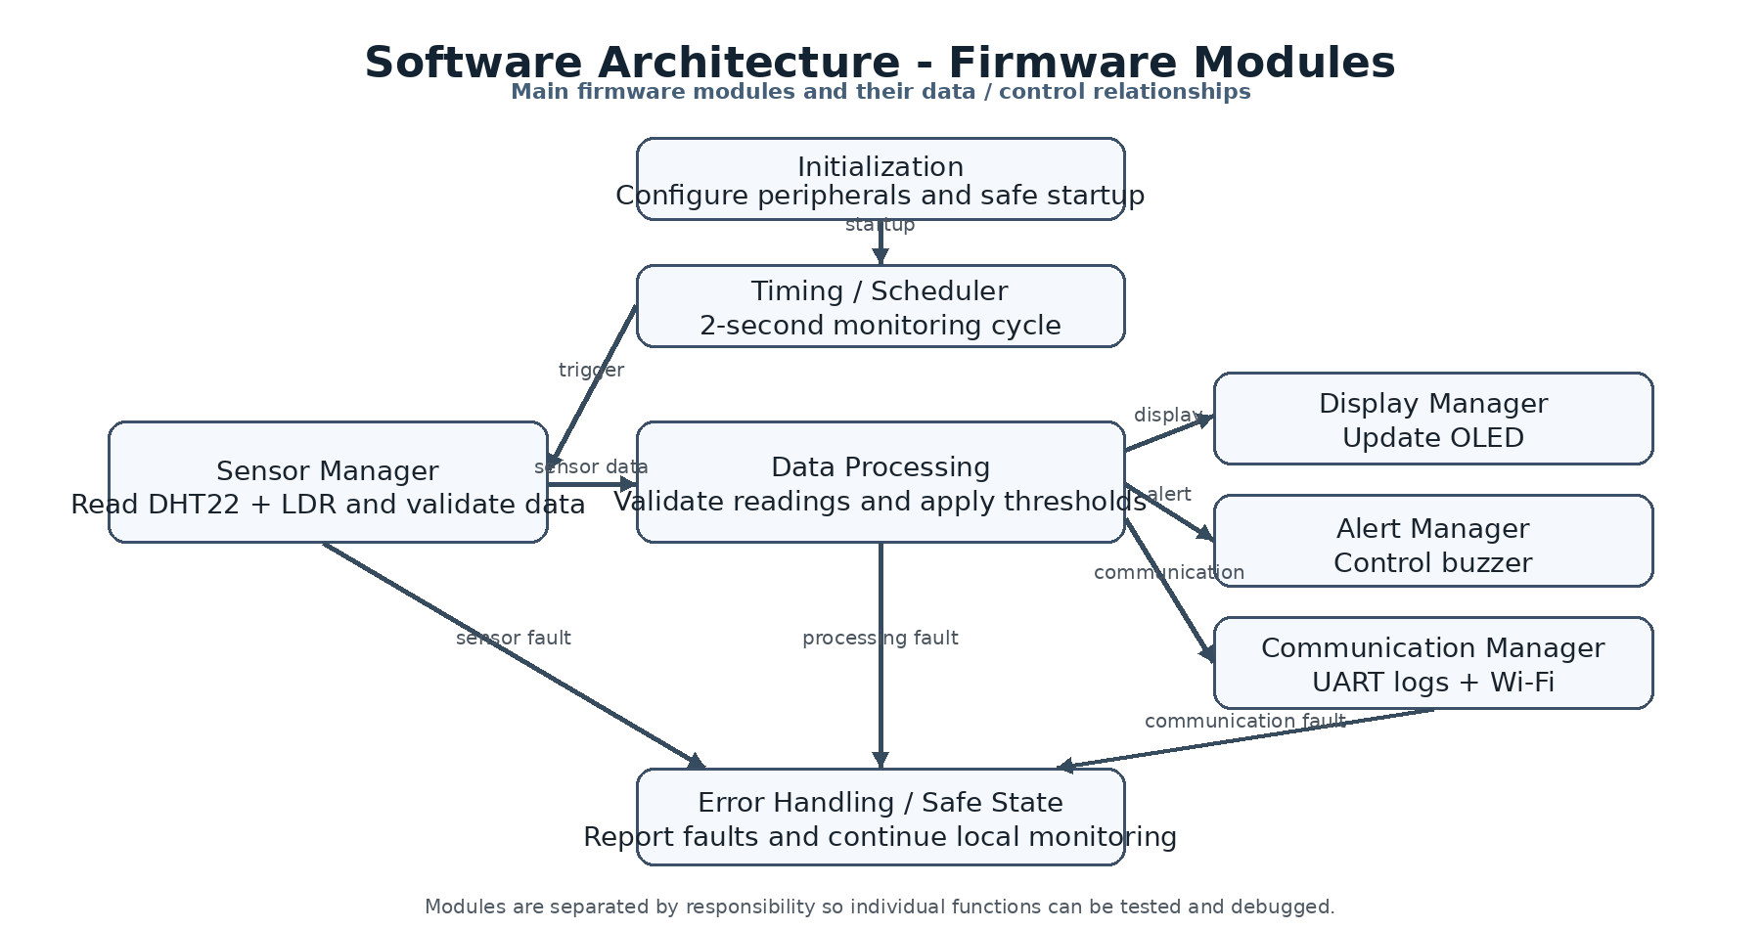
Figure 2. Planned firmware modules and their relationships.
Software module | Responsibility
Initialization | Configure the GPIOs, buses, display, sensor interfaces and safe startup states.
Timing / scheduler | Keep the 2-second monitoring cycle organized and leave room for future changes.
Sensor manager | Read the DHT22 and LDR values and reject clearly invalid data.
Data processing | Check the readings and compare them with the selected thresholds.
Display manager | Format the readings and update the OLED with the current system state.
Alert manager | Control the buzzer according to the current alert state.
Communication manager | Handle Wi-Fi transfer and serial messages used during development.
Error handling | Record errors and bring the system back to a safe state where possible.

6. Functional Data Flow
1. When the device starts, the firmware initializes the required peripherals.
2. The timing section starts the next monitoring cycle.
3. The firmware reads the DHT22 and checks whether the reading is valid.
4. The LDR voltage is read through the ESP32 ADC.
5. The readings are processed and compared with the selected thresholds.
6. The OLED is updated with the latest valid values and the current status.
7. The buzzer is turned on only when an alert condition is present.
8. The readings and status can be sent through Wi-Fi and printed through UART for debugging.
9. The firmware goes back to the timing section and waits for the next cycle.

6.1 Example Decision Logic
For the first firmware version, I plan to keep the decision logic simple and easy to test. For example, if the temperature goes above the selected high-temperature limit, the system state becomes ALERT and the buzzer is turned on. When the reading returns to the normal range, the system can go back to NORMAL. The same idea can later be applied to humidity or light. Keeping the limits configurable will also make it easier to test different cases in simulation.

6.2 Firmware Flow Diagram
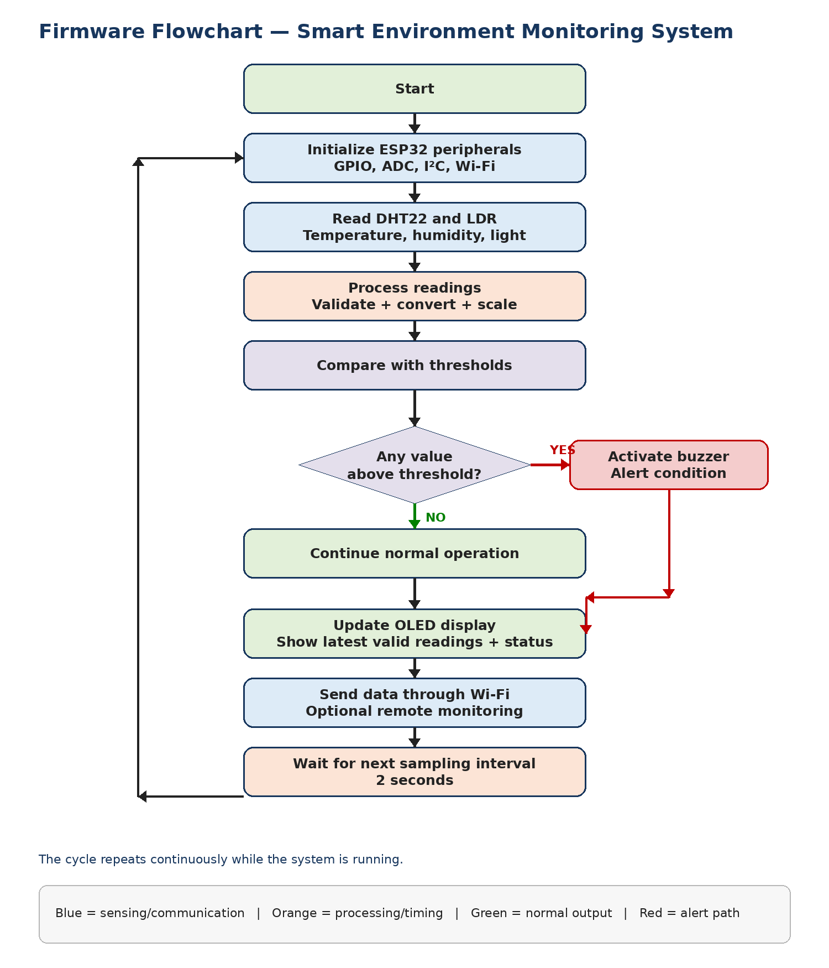
Figure 3. Firmware flow from initialization and sensor reading to threshold checking, display, communication and the next sampling cycle.

7. Design Choices and Justification
Decision | Justification
ESP32 as controller | The project needs several interfaces in one place, and ESP32 gives us GPIO, ADC, timing, serial communication, I2C and Wi-Fi in a beginner-friendly development platform.
DHT22 + LDR combination | Together they give us two useful kinds of inputs: a digital environmental sensor and an analog light signal, without making the circuit complicated.
I2C OLED | The OLED can share the I2C bus using SDA and SCL, so the display does not consume many controller pins.
Buzzer for alerts | A buzzer makes the effect of a threshold event easy to hear and easy to verify during testing.
USB-powered prototype | The first version is more about getting the sensing and firmware right than optimizing battery life, so USB power keeps things straightforward.
Simulation-first development | Simulation makes it easier to repeat tests, change input values and check the firmware before depending on physical hardware.

8. Assumptions, Limitations and Risks
- This is a learning prototype, so it is not intended to be an industrial monitoring instrument.
- I am using the LDR mainly to show relative changes in light. Without calibration against a known light reference, I should not call the result an accurate lux measurement.
- Remote monitoring will depend on a working Wi-Fi connection. The local sensing and display should still work when Wi-Fi is not available.
- Because the prototype is USB powered, battery life is not part of the Week 1 target. Power-saving ideas can be considered later after the basic system works reliably.
- The actual sensor timing and library behavior will be checked in simulation before the firmware design is finalized.
- The final pin assignment may change slightly if the simulator or chosen board variant makes another pin a better choice.

9. Requirements-to-Test Traceability for Later Weeks
Requirement group | Expected evidence | Planned Week 4 test
FR-01 / PR-01 | Temperature is read and shown once during each monitoring cycle. | Functional + timing test
FR-02 / PR-01 | Humidity is read and shown along with temperature. | Functional + timing test
FR-03 | The displayed/processed light value changes when the simulated light input changes. | Input sweep test
FR-04 | The OLED shows temperature, humidity, light level and system state. | Display verification
FR-05 / PR-03 | The buzzer changes state when the selected threshold is crossed. | Boundary/threshold test
FR-06 | The ESP32 connects and sends the expected data. | Communication test
FR-07 | The serial log contains the expected readings and status messages. | Logging test
FR-08 | A simulated error does not permanently stop the monitoring loop. | Fault-recovery test
PWR-01 to PWR-03 | System starts and operates from the planned supply arrangement | Power-up test
RT-01 to RT-03 | No operation remains stuck and alerts occur within target response time | Timing and robustness test

10. Methodology Followed
1. Selected a practical embedded application that can be implemented without advanced hardware.
2. Identified the main inputs, outputs, controller and communication paths.
3. Converted the application idea into functional, performance, interface, power and timing requirements.
4. Chose components based on simplicity, available interfaces and suitability for simulation.
5. Defined provisional pin assignments and data paths.
6. Divided the future firmware into small modules so that later debugging and optimization can be measured.

11. Conclusion
After completing the first stage of the project, I have a clearer picture of what needs to be built and how the different parts will interact. The system uses an ESP32 as the main controller, a DHT22 for temperature and humidity, an LDR for light sensing, an SSD1306 OLED for the local display, a buzzer for alerts, and Wi-Fi/UART for communication and development. I have also defined the main interfaces, power arrangement and timing expectations, and separated the future firmware into smaller modules. The design is intentionally simple because the main aim at this stage is to understand the complete embedded-system flow and create a solid base for the firmware, debugging and integration work in the next three weeks.

12. References
[1] Espressif Systems, “ESP32-DevKitC-1,” Arduino-ESP32 Documentation, https://docs.espressif.com/projects/arduino-esp32/en/latest/boards/ESP32-DevKitC-1.html
[2] Wokwi, “ESP32 Simulation,” Wokwi Documentation, https://docs.wokwi.com/guides/esp32
[3] Adafruit Learning System, “SSD1306 OLED Displays with Raspberry Pi and BeagleBone Black,” https://learn.adafruit.com/ssd1306-oled-displays-with-raspberry-pi-and-beaglebone-black
[4] Adafruit Learning System, “Monochrome OLED Breakouts - Wiring 128x32 I2C Display,” https://learn.adafruit.com/monochrome-oled-breakouts/wiring-128x32-i2c-display
[5] Espressif Systems, “Arduino ESP32 Libraries and APIs,” https://docs.espressif.com/projects/arduino-esp32/en/latest/libraries.html

