EMBEDDED SYSTEMS INTERNSHIP
WEEK 3 REPORT
Debugging and Performance Optimization
Project: Smart Environment Monitoring and Alert System
Prepared by: Channabasava Kulageri
Platform: ESP32 + Arduino framework
Baseline: DHT22 on GPIO 4
UART/USB: 115200 baud
Validation: deterministic host-side checks + Week 2 simulator evidence

Week 3 focuses on finding faults, fixing them, and demonstrating measurable improvement without changing the intended monitoring behavior.

1. Objective and Scope
The objective of Week 3 is to apply a repeatable debugging process to the Week 2 firmware and then optimize the implementation while preserving the original system requirements. The exercise uses controlled faults so that each defect has a clear symptom, cause, fix, and validation method.
- Reproduce an observable firmware problem before making a fix.
- Use serial logging, source inspection, boundary tests, and deterministic checks to isolate the fault.
- Correct one issue at a time and rerun the same test conditions.
- Measure a concrete performance effect of the optimization.
- Improve the code examples and inline comments so that the debugging decisions are easy to trace.

2. Week 2 Baseline
The Week 2 firmware is the baseline for this exercise. It uses an ESP32, a DHT22 connected on GPIO 4, UART serial at 115200 baud, a nominal monitoring interval of 2000 ms, and configurable warning thresholds. The Week 1 design established the 2-second monitoring target and the GPIO 4 sensor interface.
Parameter | Baseline value | Purpose
Controller | ESP32 | Executes firmware
Sensor | DHT22 | Temperature + humidity input
Sensor data pin | GPIO 4 | Digital sensor interface
UART rate | 115200 baud | Debug/status output
Nominal sample interval | 2000 ms | Monitoring requirement
Temperature warning | 35.0 C | Threshold test point
Humidity warning | 80.0 % RH | Threshold test point

3. Debugging Method
The same four-step loop was used for every defect: reproduce -> isolate -> fix -> validate. This avoids changing several variables at once and makes the before/after result traceable.
Stage | Action | Primary evidence | Expected outcome
1. Reproduce | Run the faulty code or deterministic test input. | Serial/log output and test harness | The defect is observable.
2. Isolate | Trace the symptom to timing, boundary logic, or validation. | Source inspection + focused test | Likely fault point is identified.
3. Fix | Change only the defective logic. | Revised source code | Correct behavior without unrelated changes.
4. Validate | Repeat the same inputs and compare results. | Validation log + metrics | Fix passes the intended test.

4. Controlled Bugs Introduced
Three intentionally injected defects represent common embedded-software mistakes. The buggy version is kept separately so the failure can be reproduced without changing the corrected source.
Bug | Injected defect | Expected symptom | Root cause
BUG-01 | Sampling interval changed from 2000 ms to 500 ms. | 20 scheduled samples occur in 10 s instead of 5. | Timing parameter no longer matches the requirement.
BUG-02 | Threshold check changed from >= to >. | Exactly 35.0 C or 80.0 % RH stays NORMAL. | Strict comparison excludes the configured boundary.
BUG-03 | Invalid-reading check removed. | NaN/invalid data reaches the reporting path. | Firmware assumes every sensor reading is valid.

5. Bug 1 - Excessive Sampling
The first defect violates the established 2-second sampling requirement. A 500 ms interval schedules four times as many sensor cycles as a 2000 ms interval. In a 10-second window the buggy scheduler produces 20 events, while the corrected scheduler produces 5 events.
Buggy code excerpt
// BUG: sampling four times faster than the design target.
const unsigned long SAMPLE_INTERVAL_MS = 500;

Corrected code excerpt
// FIX: restore the Week 1/Week 2 monitoring requirement.
const unsigned long SAMPLE_INTERVAL_MS = 2000;

The fixed implementation retains a non-blocking millis()-based scheduler. The loop remains available for other work between measurement events, rather than being held inside a long delay.

6. Bug 2 - Threshold Boundary Error
The prototype rule is inclusive: a measurement exactly at the configured boundary is a warning. The faulty code uses a strict greater-than comparison, so a value equal to the boundary is misclassified.
Buggy code excerpt
// BUG: 35.0 C does not satisfy 35.0 > 35.0.
if (temperature > TEMP_WARNING_C || humidity > HUM_WARNING_PERCENT) {
return "WARNING";
}

Corrected code excerpt
// FIX: inclusive boundary handling.
// Exactly 35.0 C or 80.0 % RH becomes WARNING.
if (temperature >= TEMP_WARNING_C || humidity >= HUM_WARNING_PERCENT) {
return "WARNING";
}

Worked example: at temperature = 35.0 C and humidity = 40.0 %, the buggy expression evaluates to false, so it returns NORMAL. The fixed expression evaluates to true because 35.0 >= 35.0, so it returns WARNING.

7. Bug 3 - Invalid Sensor Data Handling
The DHT22 reading functions can return invalid floating-point values. The controlled bug removes the validity gate and immediately uses the returned values in the status/reporting path. The fix checks both values before threshold processing.
Buggy pattern
// BUG: no validity check before using the sensor values.
float humidity = dht.readHumidity();
float temperature = dht.readTemperature();
Serial.println(evaluateStatus(temperature, humidity));

Corrected code with inline comments
// FIX: reject invalid sensor data before threshold evaluation.
const float humidity = dht.readHumidity();
const float temperature = dht.readTemperature();
if (isnan(humidity) || isnan(temperature)) {
Serial.println("ERROR: Invalid DHT22 reading"); // diagnostic evidence
return; // retry on next cycle
}

The return only ends the current sensor cycle; it does not stop the main monitoring loop. The scheduler therefore remains active and can retry at the next 2000 ms boundary.

8. Code Structure After the Fix
The corrected firmware keeps the control flow simple and separates responsibilities so the fault location is easy to identify. The following excerpt shows the main decision path with inline comments.
Fixed sensor-cycle excerpt
void performSensorCycle(unsigned long elapsedMs) {
sampleCount++;
// Read the two environmental values from the DHT22.
const float humidity = dht.readHumidity();
const float temperature = dht.readTemperature();
// Stop this cycle if either reading is invalid.
if (isnan(humidity) || isnan(temperature)) {
Serial.print("sample=");
Serial.print(sampleCount);
Serial.println(" error=INVALID_DHT22_READING action=RETRY_NEXT_CYCLE");
return;
}
// Only valid data reaches threshold processing.
const char* status = evaluateStatus(temperature, humidity);
reportMeasurement(elapsedMs, temperature, humidity, status);
}

9. Performance Optimization
Two changes were retained in the corrected version. First, the scheduler is restored to 2000 ms, reducing scheduled monitoring events by 75% in the 10-second deterministic comparison. Second, UART output is compacted to one line per valid measurement, with an additional line only when the system state changes. This keeps debugging information while reducing repeated formatting work.
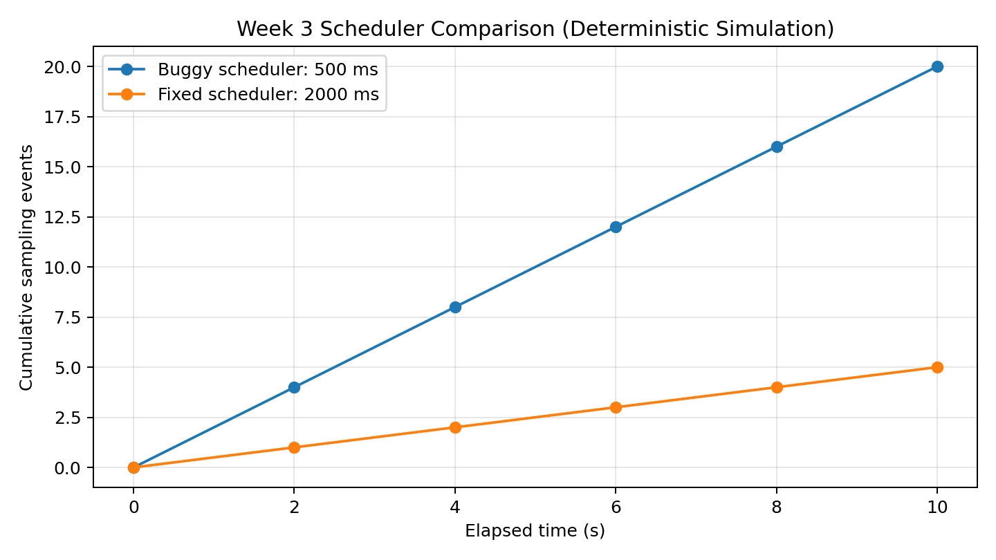
Figure 1. Deterministic scheduler comparison over a 10-second window.
Metric (10 s) | Buggy | Fixed | Interpretation
Scheduled sampling events | 20 | 5 | 75% fewer events
Nominal interval | 500 ms | 2000 ms | Meets Week 2 target
35.0 C boundary | NORMAL | WARNING | Boundary corrected
80.0 % RH boundary | NORMAL | WARNING | Boundary corrected
Invalid reading | Unvalidated | Rejected + retry | Fault path protected
The 75% figure is a deterministic scheduling comparison, not an oscilloscope measurement. It is computed from the defined sampling intervals: 10,000 / 500 = 20 scheduled events and 10,000 / 2,000 = 5 scheduled events; (20-5)/20 = 0.75.

10. Validation Results
The validation harness is a deterministic host-side check of the firmware logic. It verifies scheduling arithmetic, threshold boundaries, invalid-reading handling, and relative monitoring load. It is explicitly presented as supporting logic validation, not as physical-board timing measurement.
Test ID | Input / condition | Expected | Result | Evidence
TIM-01 | 10 s window | 5 fixed events at 2000 ms | PASS | validation_log.txt
THR-01 | 35.0 C, 40.0 % RH | WARNING | PASS | threshold logic check
THR-02 | 25.0 C, 80.0 % RH | WARNING | PASS | threshold logic check
ERR-01 | NaN temperature | ERROR + retry next cycle | PASS | invalid-reading test
OPT-01 | Compare buggy vs fixed sampling count | Fixed < buggy | PASS | 20 -> 5 events

11. Simulator Evidence From Week 2
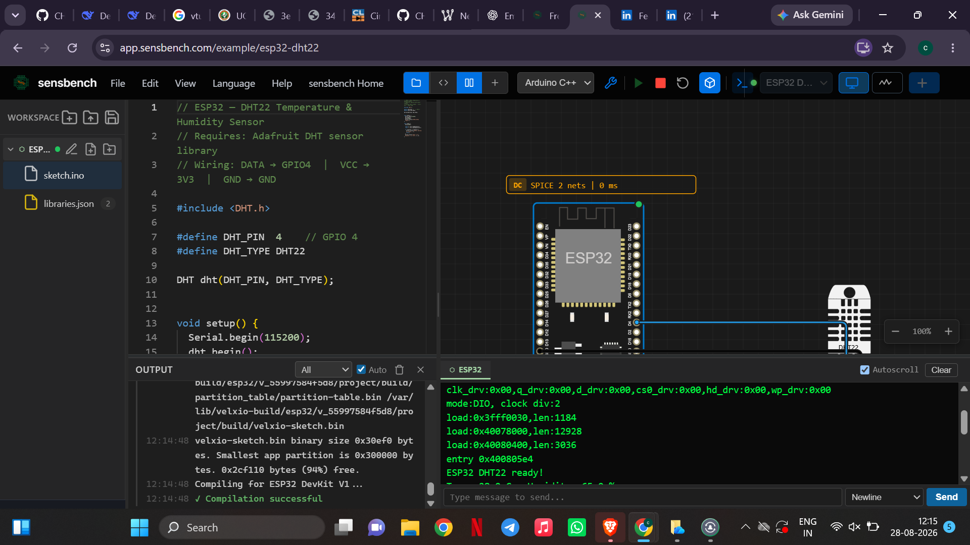
Figure 2. Direct simulator evidence retained from Week 2: successful ESP32 + DHT22 compilation and sensor initialization.
This screenshot is retained as direct simulator evidence for the ESP32/DHT22 environment. The Week 3 deterministic checks are labeled separately so that no host-side result is presented as physical hardware measurement.

12. Traceability to Week 2 Requirements
Week 2 requirement | Week 3 evidence | Status
Periodic monitoring at about 2 s | TIM-01 + corrected scheduler constant | Verified by deterministic check
Sensor validity handling | ERR-01 + isnan() guard | Verified by invalid-input test
Threshold processing | THR-01 and THR-02 | Verified at exact boundaries
UART diagnostics | Compact sample/state-change log | Included in fixed firmware
Maintainable firmware structure | Separate status, sensor-cycle, reporting functions | Implemented

13. Debugging Log
Observation: 20 scheduled samples in 10 s at 500 ms
Interpretation: Interpretation: scheduler is four times faster than required.
Action: Action: restore 2000 ms interval.
Observation: 35.0 C remains NORMAL
Interpretation: Interpretation: strict > comparison excludes the boundary.
Action: Action: use >=.
Observation: 80.0 % RH remains NORMAL
Interpretation: Interpretation: same boundary issue on humidity.
Action: Action: use >=.
Observation: NaN can reach reporting path
Interpretation: Interpretation: no input validation before processing.
Action: Action: add isnan() gate.
Observation: Repeated verbose output
Interpretation: Interpretation: unnecessary serial work.
Action: Action: compact record + state-change logging.

14. Limitations and Assumptions
- The 75% performance figure is a deterministic scheduler/load comparison, not an electrical or oscilloscope measurement.
- Direct simulator evidence retained from Week 2 shows successful ESP32 + DHT22 compilation and initialization; Week 3 additional checks use a deterministic host-side harness.
- The optimization targets sampling load and serial-output overhead while preserving the monitoring behavior defined earlier.
- LDR, OLED, buzzer, and Wi-Fi remain future integration items in this project and are not claimed as tested Week 3 hardware.

15. Conclusion
The Week 3 exercise converts the Week 2 firmware into a controlled debugging case study. Three common embedded defects were introduced, isolated, corrected, and validated: an incorrect sampling interval, a threshold-boundary error, and missing invalid-reading protection. The corrected scheduler reduces scheduled monitoring events by 75% in the 10-second deterministic comparison, while the revised threshold logic correctly treats exact boundary values as warnings and the validity gate prevents invalid sensor data from reaching the decision path. The code excerpts include inline comments so the reasoning behind each fix is visible directly in the firmware, addressing the previous feedback requesting stronger code examples and evidence.

Appendix A - Revised Firmware (Key Complete Version)
Complete corrected firmware supplied separately in fixed_version/main_fixed.ino
// Smart Environment Monitoring and Alert System - Week 3 FIXED/OPTIMIZED VERSION
// Platform: ESP32 + Arduino framework
// Sensor: DHT22 on GPIO 4
// Communication: UART/USB Serial at 115200 baud
// Week 3 focus: debugging, fault handling, timing correction, and output optimization.
#include <DHT.h>
#define DHT_PIN 4
#define DHT_TYPE DHT22
DHT dht(DHT_PIN, DHT_TYPE);
// Corrected timing requirement from Week 1/2.
const unsigned long SAMPLE_INTERVAL_MS = 2000;
const float TEMP_WARNING_C = 35.0f;
const float HUM_WARNING_PERCENT = 80.0f;
unsigned long lastSampleTime = 0;
unsigned long sampleCount = 0;
const char* lastStatus = "INIT";
const char* evaluateStatus(float temperature, float humidity) {
// Inclusive boundary handling: exactly 35.0 C or 80.0 % is a warning.
if (temperature >= TEMP_WARNING_C || humidity >= HUM_WARNING_PERCENT) {
return "WARNING";
}
return "NORMAL";
}
void reportMeasurement(unsigned long elapsedMs,
float temperature,
float humidity,
const char* status) {
// Compact one-line log reduces serial formatting/output overhead.
Serial.print("sample=");
Serial.print(sampleCount);
Serial.print(" time_ms=");
Serial.print(elapsedMs);
Serial.print(" temp_c=");
Serial.print(temperature, 1);
Serial.print(" hum_pct=");
Serial.print(humidity, 1);
Serial.print(" status=");
Serial.println(status);
if (strcmp(status, lastStatus) != 0) {
Serial.print("STATE_CHANGE: ");
Serial.println(status);
lastStatus = status;
}
}
void performSensorCycle(unsigned long elapsedMs) {
sampleCount++;
const float humidity = dht.readHumidity();
const float temperature = dht.readTemperature();
// Fault handling: reject invalid data and continue to the next cycle.
if (isnan(humidity) || isnan(temperature)) {
Serial.print("sample=");
Serial.print(sampleCount);
Serial.println(" error=INVALID_DHT22_READING action=RETRY_NEXT_CYCLE");
return;
}
const char* status = evaluateStatus(temperature, humidity);
reportMeasurement(elapsedMs, temperature, humidity, status);
}
void setup() {
Serial.begin(115200);
dht.begin();
Serial.println("Smart Environment Monitor - Week 3 fixed firmware");
Serial.println("DHT22 GPIO=4 | interval=2000 ms | UART=115200");
Serial.println("TEMP_LIMIT=35.0 C | HUM_LIMIT=80.0 %");
}
void loop() {
// Non-blocking scheduler: loop() remains free between measurement events.
const unsigned long currentTime = millis();
if (lastSampleTime == 0 ||
(currentTime - lastSampleTime) >= SAMPLE_INTERVAL_MS) {
lastSampleTime = currentTime;
performSensorCycle(currentTime);
}
}

Appendix B - How to Reproduce the Validation
# From the Week 3 directory
python validation/validation_sim.py
# Expected final line
All tests passed: True

The validation script is intentionally small and deterministic. It can be run on a standard Python installation and does not require physical hardware.

Appendix C - Week 3 Deliverables
- Buggy firmware: buggy_version/main_buggy.ino
- Fixed/optimized firmware: fixed_version/main_fixed.ino
- Debugging log: debugging_log.md
- Validation script: validation/validation_sim.py
- Validation log: validation/validation_log.txt
- Performance chart: validation/sampling_comparison.png
- Baseline simulation evidence: evidence/week2_simulation.png
- This report: week3_report.docx and week3_report.pdf

