EMBEDDED SYSTEMS INTERNSHIP
WEEK 2 REPORT
Firmware Development and Implementation
Project: Smart Environment Monitoring and Alert System
ESP32 + DHT22 firmware prototype with UART monitoring
Simulation environment: Sensbench

Prepared by: Channabasava Kulageri
Week 2 implementation deliverable

1. Introduction
Week 2 converts the Week 1 architecture into a working firmware layer. To keep development testable, this stage implements the temperature/humidity sensing and serial communication core first. The ESP32 is the controller, the DHT22 provides temperature and relative humidity, and UART/USB serial provides a visible development and debugging interface.
The nominal monitoring interval is 2000 ms (2 seconds). The firmware also validates sensor values so that an invalid reading is reported instead of being treated as a real measurement. The code is deliberately modular because the LDR, OLED, buzzer, and Wi-Fi blocks defined in Week 1 will be integrated in later stages.

1.1 Objectives
- Initialize the ESP32, UART/USB serial interface, and DHT22.
- Acquire temperature and humidity at a nominal 2-second interval.
- Validate sensor values and recover from invalid readings.
- Apply configurable warning thresholds and report NORMAL/WARNING status.
- Keep the code commented and modular for later debugging and integration.

2. Firmware Architecture
Stage | Purpose | Implementation
Initialization | Start UART and DHT22 | setup()
Timing | Schedule ~2000 ms sensor cycles | millis() + SAMPLE_INTERVAL_MS
Sensor acquisition | Read temperature and humidity | performSensorCycle()
Validation | Reject invalid values | isnan() check
Decision | Apply threshold logic | evaluateStatus()
Communication | Print values/status/errors | Serial.print / println

Data path: DHT22 → GPIO 4 → sensor library → validation → threshold decision → UART report. The same controller will later feed the OLED, buzzer, LDR and Wi-Fi functions defined in Week 1.

3. Firmware Implementation

3.1 Hardware Interface and Integration
The DHT22 data signal is mapped to ESP32 GPIO 4, matching the Week 1 provisional allocation. In software, `DHT_PIN` is defined once and passed to the DHT library. This keeps the circuit-to-firmware connection explicit: if the simulated wiring and the firmware pin disagree, sensor communication cannot be trusted.
Integration example: DHT22 sends the temperature/humidity data; the ESP32 reads it through GPIO 4; the firmware checks the returned values; valid data is passed to the decision function; the resulting state and measurements are printed through UART.

3.2 Timing and Sampling
The scheduling constant is `SAMPLE_INTERVAL_MS = 2000`, where 1000 ms equals 1 second. The loop compares the current `millis()` value with the previous sample time. A new cycle is allowed when the elapsed time is at least 2000 ms.
Illustrative time | Action | Reason
0 ms | Initial sensor cycle | First reading after startup
~2000 ms | Next sensor cycle | 2000 ms elapsed
~4000 ms | Next sensor cycle | Another 2000 ms elapsed
~6000 ms | Next sensor cycle | Periodic monitoring continues

Worked example: if `lastSampleTime = 3000 ms` and `currentTime = 5220 ms`, elapsed time is 2220 ms. Because 2220 ≥ 2000, a new sensor cycle runs.

3.3 UART / Serial Communication
UART/USB serial is configured at 115200 baud. The output includes sample number, elapsed time, temperature, humidity and system status, making the firmware behavior directly observable during development.
Illustrative output (example values, not claimed measurements):
Smart Environment Monitor
Week 2 firmware started
DHT22 initialized on GPIO 4
Sampling interval: 2000 ms
Temperature warning: 35.0 C
Humidity warning: 80.0 %
Sample: 1 | Time: 2000 ms
Temperature: 28.4 C | Humidity: 61.2 % | Status: NORMAL

3.4 Threshold Decision Logic
The prototype uses 35.0 C as the high-temperature warning threshold and 80.0 % as the high-humidity warning threshold. The comparison uses greater-than-or-equal-to, so the boundary value itself is considered a warning.
Input example | Evaluation | Expected state
28.4 C, 61.2 % | 28.4 < 35.0 and 61.2 < 80.0 | NORMAL
37.2 C, 63.0 % | 37.2 >= 35.0 | WARNING
28.4 C, 82.0 % | 82.0 >= 80.0 | WARNING

3.5 Error Handling
If the DHT library returns an invalid numeric value (`NaN`) for either temperature or humidity, the firmware prints an error and returns from the sensor-cycle function. The scheduler remains active, so a later cycle can retry the sensor. This prevents a single failed transaction from permanently stopping local monitoring.

4. Code Structure
The complete source is supplied separately as `firmware/main.ino`. The key implementation pieces are summarized below; the separate source file is the authoritative copy used for simulation and GitHub.
const unsigned long SAMPLE_INTERVAL_MS = 2000;
const float TEMP_WARNING_C = 35.0f;
const float HUM_WARNING_PERCENT = 80.0f;
if (lastSampleTime == 0 ||
(currentTime - lastSampleTime) >= SAMPLE_INTERVAL_MS) {
lastSampleTime = currentTime;
performSensorCycle(currentTime);
}
if (isnan(humidity) || isnan(temperature)) {
Serial.println("Invalid DHT22 reading; retrying next cycle.");
return;
}

5. Simulation and Testing
Development was performed using an ESP32 + DHT22 simulation environment. The initial DHT22 example was used to establish a known-good sensor wiring and library environment before substituting the Week 2 firmware. The supplied screenshot provides direct evidence of successful compilation and DHT22 initialization.
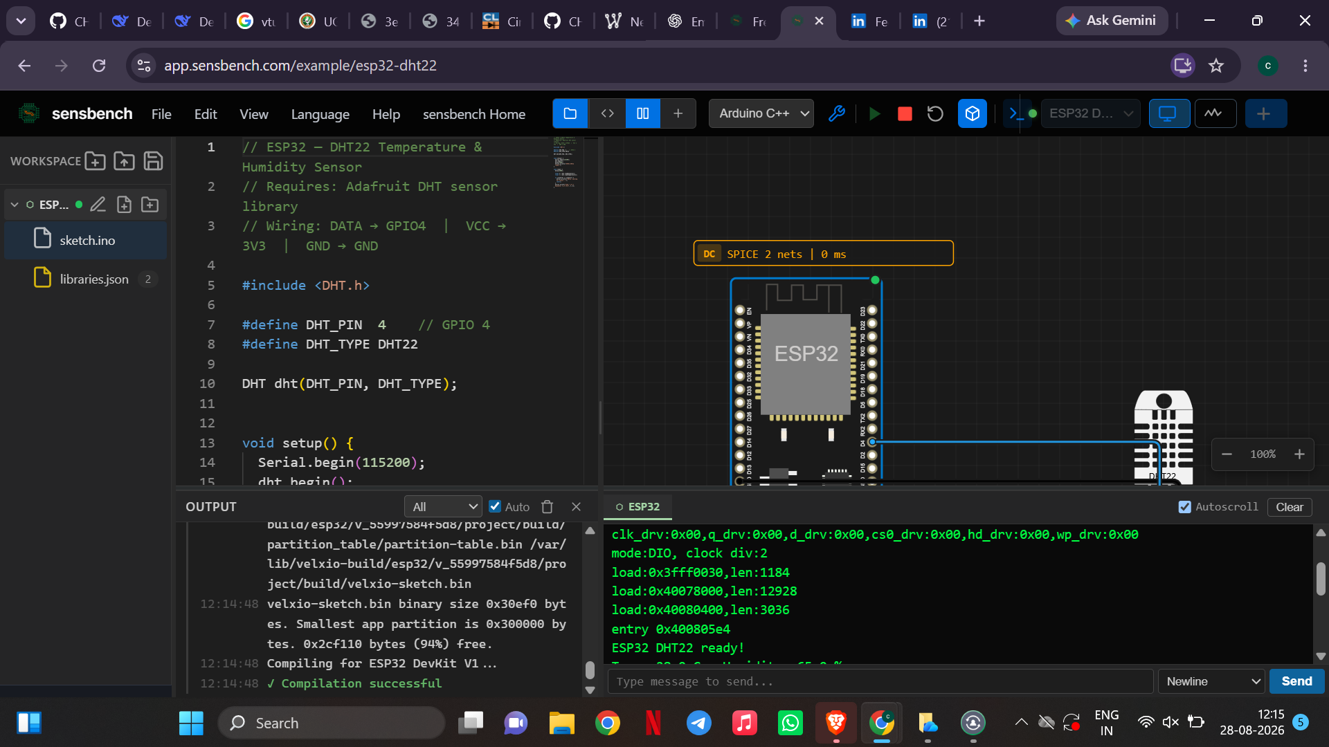
Figure 1. Supplied Sensbench evidence showing successful compilation and DHT22 initialization.

5.1 Test Matrix
ID | Test | Expected result | Evidence status
TC-01 | Compile/start ESP32 + DHT22 | Compilation succeeds and initialization appears | Observed in supplied screenshot
TC-02 | Read valid values | Numeric temperature/humidity printed | Verify in final run
TC-03 | Check interval | New sample approximately every 2000 ms | Implemented; verify timestamps
TC-04 | 37.2 C temperature input | Status = WARNING | Logic implemented; verify in simulation
TC-05 | 82.0 % humidity input | Status = WARNING | Logic implemented; verify in simulation
TC-06 | Invalid/NaN input | Error printed; loop continues | Logic implemented; verify with fault injection

Evidence discipline: only TC-01 is labeled observed because it is directly visible in the supplied simulation screenshot. The other entries are reproducible verification procedures, not fabricated measurements.

6. README / Reproduction Instructions
- Open the ESP32 + DHT22 example in Sensbench.
- Confirm DHT22 DATA is connected to GPIO 4 and the DHT library is available.
- Replace the example sketch with `firmware/main.ino`.
- Run the simulation and open the serial/output console.
- Verify the initialization messages and subsequent sensor reports.
- Change simulated temperature/humidity values and verify NORMAL/WARNING transitions.
- Test the invalid-reading path if fault injection is available.

6.1 Key Functions
Function | Purpose
setup() | Initialize UART and DHT22; print configuration
loop() | Schedule sensor cycles using elapsed time
performSensorCycle() | Read and validate DHT22 values
evaluateStatus() | Apply warning thresholds
reportMeasurement() | Print a structured UART record

7. Design Choices and Integration
Choice | Concrete setting | Integration benefit
ESP32 | Controller platform | Provides the GPIO and UART resources needed now and supports later peripherals
DHT22 | GPIO 4 | Single sensor supplies both required measurements
UART | 115200 baud | Provides visible runtime/debug output
Sampling | 2000 ms nominal | Simple periodic behavior that can be tested from timestamps
Thresholds | 35.0 C / 80.0 % | Creates clear boundary conditions for later debugging/testing
millis() scheduler | Elapsed-time comparison | Avoids a long blocking delay and keeps room for later integration

The remaining LDR, OLED, buzzer and Wi-Fi functions from Week 1 are intentionally deferred. This reduces the number of simultaneous dependencies while the DHT22/UART core is being verified. Their integration will be addressed in later debugging and system-integration work.

8. Conclusion
Week 2 establishes the first working firmware core of the Smart Environment Monitoring and Alert System. The implementation initializes the DHT22 on GPIO 4, schedules sensor acquisition with a nominal 2000 ms interval, validates returned values, applies configurable warning thresholds, and reports measurements and status through UART/USB serial. The implementation is modular and documented so that faults can be isolated in Week 3 and the remaining peripherals can be integrated in Week 4.

9. References
Espressif Systems. Arduino-ESP32 Documentation. https://docs.espressif.com/projects/arduino-esp32/en/latest/
Sensbench. ESP32 simulation environment and DHT22 example used during development.
Adafruit. DHT sensor library documentation and examples.

