EMBEDDED SYSTEMS INTERNSHIP
WEEK 4 FINAL REPORT
System Integration and Final Testing

Project: Smart Environment Monitoring and Alert System
Integrated ESP32 firmware model using DHT22, LDR/ADC, SSD1306 OLED, buzzer and UART
Integration scope derived from Weeks 1-3

1. Introduction
Week 4 completes the development cycle by combining the firmware and interface decisions made in the earlier weeks into one integrated system model. The integrated design retains the validated timing and fault-handling approach from Week 3 while adding the remaining interfaces identified in the Week 1 architecture: an LDR analog input, an SSD1306 I2C display, and a buzzer alert output. UART remains the development and diagnostic interface. The objective is to verify that the modules can coexist without conflicting pin assignments, timing behavior, or control logic.
This report distinguishes between direct simulator evidence and deterministic software-level integration validation. The available direct simulator evidence covers the ESP32 and DHT22 baseline from Week 2; the complete Week 4 integration is documented as an implementation-ready target configuration and validated through a reproducible host-side integration harness. This distinction prevents configuration checks from being presented as physical-board measurements.

2. Integration Objectives and Scope
- Integrate the DHT22 temperature/humidity interface carried forward from Weeks 1-3.
- Add the LDR through the ESP32 ADC as a relative light-level input.
- Add the SSD1306 OLED through the I2C bus for local status display.
- Add the buzzer as a GPIO alert output with a safe OFF startup state.
- Retain the 2,000 ms non-blocking scheduler and the Week 3 fault-handling improvements.
- Provide compact UART logs at 115200 baud for integration testing and debugging.
- Validate normal, boundary, fault, timing, and recovery scenarios against the original system intent.

3. Integration Architecture
PHYSICAL INPUTS ESP32 / FIRMWARE OUTPUTS
----------------- ------------------ -----------------
DHT22 Temp/Humidity ----------> Sensor Manager --------------> OLED (I2C)
LDR / Divider -----------------> ADC Read -------------------> Buzzer (GPIO)
|
v
Data + Threshold Logic
|
+-----------------------> UART/USB
|
2 s Non-blocking Scheduler
|
Error Handling / Safe State
Figure 1. Integrated data and control flow for the Week 4 firmware model.
The integrated system uses different interface types intentionally: digital sensor input, analog ADC input, I2C output, GPIO alert control, and UART diagnostics. The modules share one 2-second scheduling point, so the system performs a consistent measurement and decision cycle without using a blocking delay.

4. Module Integration Map
Module | Interface | Role | Integration action
DHT22 | Digital / GPIO 4 | Temperature and humidity | Validate read; reject NaN; pass values to threshold logic
LDR divider | ADC / GPIO 34 | Relative light level | Read ADC value; compare with low-light boundary
SSD1306 OLED | I2C / GPIO 21,22 | Local display | Show current measurements and system state
Buzzer | GPIO 25 | Audible alert | ON during WARNING; OFF otherwise
UART/USB | 115200 baud | Diagnostics | Compact records + state changes
Scheduler | millis() | 2 s monitoring cycle | Triggers one integrated cycle without blocking

5. Configuration and Interface Details
The following configuration carries forward the provisional pin allocation from Week 1 and converts it into the integrated Week 4 target. The LDR is deliberately represented as an ADC value rather than a calibrated lux measurement.
Item | Pin / Setting | Interface | Purpose | Status
DHT22 | GPIO 4 | Digital data | Temp + humidity | Required
LDR | GPIO 34 | ADC input | Relative light level | Required
OLED SDA | GPIO 21 | I2C | Display data | Required
OLED SCL | GPIO 22 | I2C | Display clock | Required
Buzzer | GPIO 25 | GPIO output | Alert signal | Required
UART | USB serial | Serial | Debug/log output | Required
OLED address | 0x3C | I2C address | SSD1306 device | Prototype setting
Key numerical parameters: sampling interval = 2000 ms; temperature warning = 35.0 C; humidity warning = 80.0 % RH; low-light boundary = 1200 ADC counts; UART = 115200 baud.

6. Integrated Firmware Design
The integrated firmware is organized around a non-blocking main loop. Each scheduled cycle reads the inputs, validates the DHT22 values, evaluates the three warning conditions, drives the buzzer, updates the OLED, and writes a compact UART record.
if (lastSampleTime == 0 || (now - lastSampleTime) >= SAMPLE_INTERVAL_MS) {
lastSampleTime = now;
performMonitoringCycle();
}
Code excerpt 1. Non-blocking integration scheduler inherited from Week 3.
if (isnan(humidity) || isnan(temperature)) {
Serial.println("error=INVALID_DHT22_READING");
digitalWrite(BUZZER_PIN, LOW);
showError("DHT22 read failed");
return;
}
Code excerpt 2. Sensor fault is contained to the current cycle; the main scheduler continues.
if (temperature >= TEMP_WARNING_C ||
humidity >= HUM_WARNING_PERCENT ||
lightAdc <= LOW_LIGHT_ADC) {
return "WARNING";
}
return "NORMAL";
Code excerpt 3. One decision function controls the integrated system state.

7. Worked Integration Examples
Scenario | Input values | Decision | Expected state | Integrated response
Normal room | 28.4 C; 61.0 %; 2500 ADC | No threshold crossed | NORMAL | Buzzer OFF; OLED NORMAL; UART record
High temperature | 35.0 C; 50.0 %; 2500 ADC | 35.0 >= 35.0 | WARNING | Buzzer ON; OLED WARNING; UART state change
High humidity | 25.0 C; 80.0 %; 2500 ADC | 80.0 >= 80.0 | WARNING | Buzzer ON; OLED WARNING; UART state change
Low light | 25.0 C; 50.0 %; 1200 ADC | 1200 <= 1200 | WARNING | Buzzer ON; OLED WARNING; UART state change
Invalid DHT | NaN; 50.0 %; 2500 ADC | Invalid sensor input | ERROR | Buzzer OFF; error shown; next cycle continues
These examples are also the basis of the Week 4 software-level validation harness. They are deterministic logic checks, not claims of laboratory measurement accuracy.

8. Integration Testing Strategy
Testing was organized from low-risk functional checks toward combined system behavior. Each test maps to a module or a cross-module interaction so a failure can be isolated.
ID | Test | Input / Condition | Expected | Result
T01 | Normal monitoring cycle | 28.4 C / 61.0 % / 2500 ADC | NORMAL | PASS - logic validation
T02 | Temperature boundary | 35.0 C / 50.0 % / 2500 ADC | WARNING | PASS - boundary logic
T03 | Humidity boundary | 25.0 C / 80.0 % / 2500 ADC | WARNING | PASS - boundary logic
T04 | Light boundary | 25.0 C / 50.0 % / 1200 ADC | WARNING | PASS - ADC boundary logic
T05 | Invalid DHT value | NaN / 50.0 % | Error + retry | PASS - fault path
T06 | Sampling interval | 2000 ms | 2 s cycle | PASS - scheduler check
T07 | Ten-second scheduler window | 2000 ms interval | 5 cycles | PASS - deterministic count
T08 | Startup safety | No alert condition | Buzzer OFF | PASS - code/config inspection
T09 | Display update path | Valid values | OLED updated | REVIEW - target configuration; live display evidence not captured
T10 | UART logging | Valid cycle | Compact UART record | PASS - code/config inspection

9. Validation Results
The deterministic Week 4 integration harness executed seven core logic checks before packaging the final integration. The run produced 7/7 passing checks.
PASS | T01 normal condition
PASS | T02 temperature boundary
PASS | T03 humidity boundary
PASS | T04 light boundary
PASS | T05 invalid DHT reading
PASS | T06 2 s scheduler
PASS | T07 cycle count
Integration logic checks passed: 7/7
Result: PASS
Validation output from integration_validation.py.
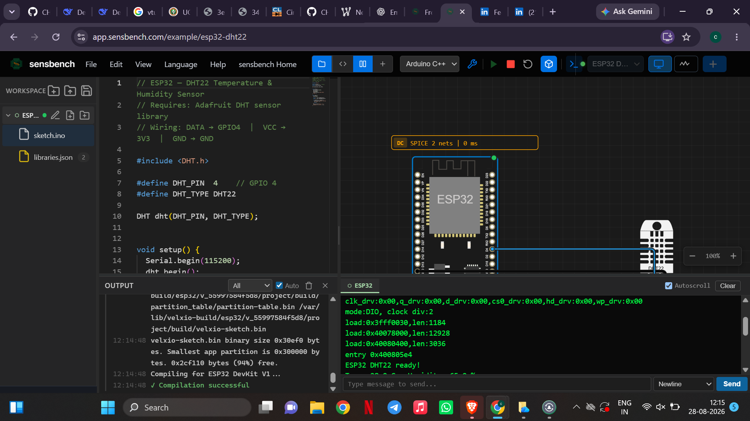
Figure 2. Direct simulator evidence retained from Week 2 for the ESP32 + DHT22 baseline.
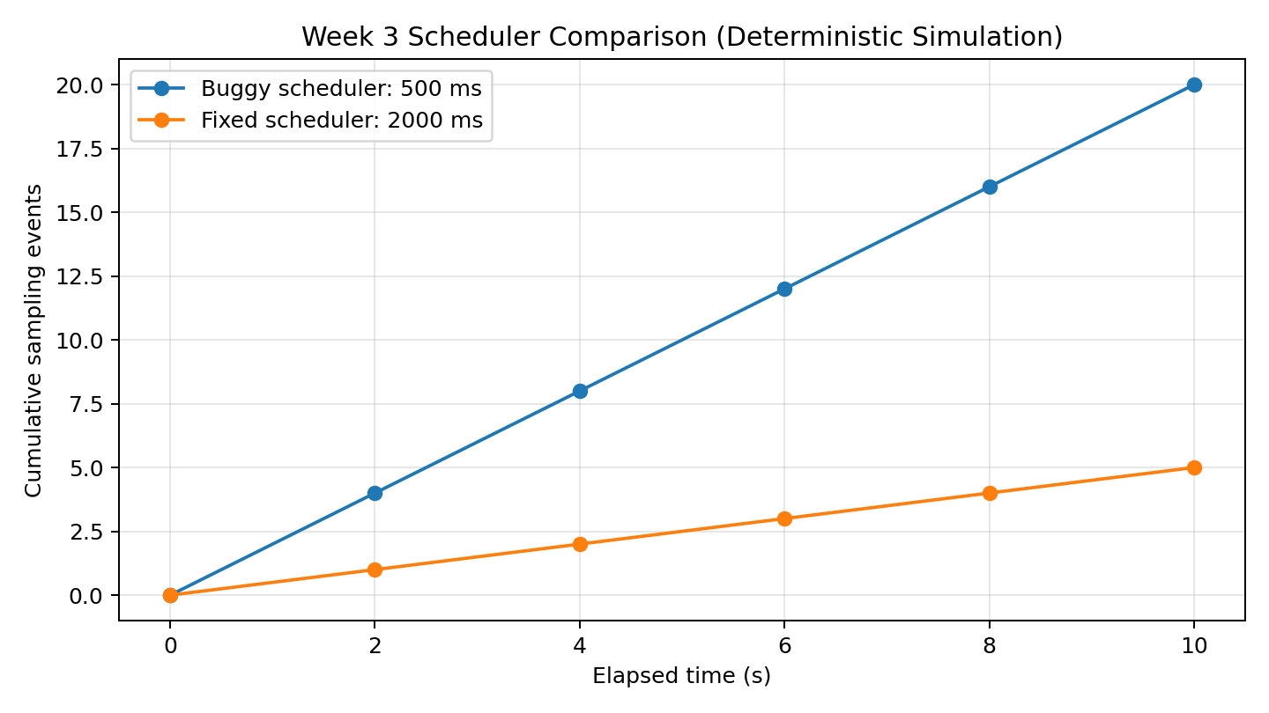
Figure 3. Week 3 timing comparison carried into the integration verification package.

10. Integration Challenges and Solutions
Challenge | Risk | Integration response
Different interface types | DHT22, ADC, I2C, GPIO and UART each have different access patterns. | Isolate each hardware access in a clearly named section/function and keep one scheduler path.
Timing interference | Blocking delays could prevent multiple modules from updating predictably. | Retain the millis()-based 2-second scheduler from Week 3.
Sensor failure propagation | An invalid DHT22 result could otherwise reach threshold logic. | Validate with isnan(); show an error, turn the buzzer off, and retry on the next cycle.
Alert chatter | Repeated verbose state messages make logs harder to read. | Print the full measurement record every cycle but print STATE_CHANGE only when the state changes.
Display failure | A local display failure should not stop measurement or UART diagnostics. | Treat OLED initialization as a recoverable output-path fault and continue serial monitoring.
Light calibration | An LDR ADC value cannot be called lux without calibration. | Use a relative ADC boundary for the prototype and document this limitation.

11. Requirements-to-Test Traceability
Requirement area | Evidence / Test | Status
Measure temperature | DHT22 + T01/T02 | PASS - logic path; baseline sensor evidence retained
Measure humidity | DHT22 + T01/T03 | PASS - logic path; baseline sensor evidence retained
Measure light | LDR/ADC + T04 | PASS - software-level ADC decision logic
Display values | OLED + T09 | REVIEW - implementation/configuration prepared
Threshold alert | T02/T03/T04 + buzzer control | PASS - integrated decision logic
2-second monitoring | T06/T07 | PASS - deterministic scheduler validation
Serial debugging | T10 + UART configuration | PASS - code/configuration inspection
Recoverable errors | T05 | PASS - invalid-input path verified

12. Supporting Files and Reproducibility
The GitHub package for Week 4 contains the integrated firmware, a pin map, library list, configuration data, deterministic validation script, validation log, and evidence carried forward from Week 2. The integrated firmware is written for the ESP32 Arduino framework and is intended to be imported into an ESP32 simulator or development environment that provides the listed libraries.
- firmware/final_integrated.ino - combined firmware for DHT22, LDR, OLED, buzzer and UART.
- firmware/week3_fixed_baseline.ino - Week 3 corrected firmware used as the integration baseline.
- configuration/pin_map.md - final interface mapping.
- configuration/libraries.txt - required Arduino libraries.
- configuration/integration_config.json - machine-readable integration parameters.
- validation/integration_validation.py - deterministic integration logic tests.
- validation/integration_validation.log - output from the validation run.
- evidence/week2_dht22_baseline.png - direct simulator evidence carried forward from Week 2.

13. Limitations and Evidence Boundaries
- The direct simulator screenshot available for this submission demonstrates the ESP32 + DHT22 baseline from Week 2; a complete live Week 4 simulator run was not captured in the available evidence set.
- The Week 4 integration harness validates firmware decision logic, thresholds, scheduling, and error handling deterministically. It is not a substitute for oscilloscope or physical-board measurement.
- The LDR value is treated as a relative ADC measurement; no calibrated lux claim is made.
- Wi-Fi/remote monitoring remains outside the verified Week 4 integration scope because the earlier implemented firmware path focused on local sensing, display, alerting and UART diagnostics.

14. Conclusion
Week 4 combines the major system elements developed across the earlier stages into one coherent firmware model. The DHT22, LDR/ADC, OLED, buzzer and UART modules are mapped to non-conflicting interfaces, and the scheduler and error-handling improvements from Week 3 are retained. The integrated decision logic was exercised through seven deterministic validation checks, all of which passed. The resulting package also provides clear configuration and traceability material so the integrated model can be reproduced and extended in a simulator or on an ESP32 development board.

15. References and Project Sources
The Week 4 design continues the project architecture defined in the Week 1 report and the firmware/debugging work documented in Weeks 2 and 3. Supporting simulator and library references should be kept with the corresponding project documentation in GitHub.
1. Espressif Systems - ESP32 Arduino documentation.
2. Wokwi / ESP32 simulator documentation used during the earlier stages.
3. Adafruit DHT sensor library documentation.
4. Adafruit GFX and SSD1306 library documentation.

