City University of Hong Kong
Department of Electrical Engineering · Final Year Project EE4080 · 2026/27 A
Project Summary and Planning Chart
Reliable Influenza Forecasting over Long Horizons Using Multivariate Time Series Models
A. Student and Project Information
Student No. | 58324980 | Student Name | CHAN Sing Yeung
CityU Email | sychan552-c@my.cityu.edu.hk | Project Code | KHC-04
Supervisor | Prof. CHAN, Katie (KHC) | Programme | BEng (Computer and Data Engineering)
Course | EE4080 | Academic Year / Term | 2026/27 A
B. Project Summary
Reliable influenza forecasting over long horizons is difficult because seasonal patterns and temporal distribution shifts can reduce model generalization in unseen periods. This project develops and evaluates a multivariate framework designed to prevent data leakage, which predicts seven influenza indicators over horizons of 24, 36, 48 and 60 weeks from historical ILI data, supporting seasonal preparedness and capacity planning. Because existing studies follow both lightweight time series and LLM approaches, representative models from both schools are benchmarked under a common protocol with frozen selection. Preliminary independent Test/Holdout evaluation indicates that the lightweight NLinear model generalized better than the selected GPT-2 MIFlu model and a Seasonal Naive reference within the frozen comparison set. Remaining work focuses on interpretation, additional control experiments, reporting, presentation and demonstration.
C. Research Gap and Project Objective
Research gap:
Reliable influenza forecasting over long horizons remains challenging because seasonal patterns and temporal distribution shifts can reduce accuracy in unseen periods. Existing approaches also vary in model complexity and evaluation protocol, making it difficult to determine which methods provide robust multivariate forecasts under a common setting. A consistent framework with controls against data leakage and independent evaluation is therefore needed to assess practical generalization.
Objective:
To develop and evaluate a reliable multivariate framework for forecasting influenza activity over long horizons, using historical ILI indicators and an independent Test/Holdout period to assess generalization. Representative lightweight and LLM forecasting models are benchmarked under a common protocol specified in advance to identify an accurate, robust and reproducible approach.
D. Rationale for Model Comparison
Contemporary influenza and time series forecasting broadly includes two methodological schools: lightweight or dedicated time series models that directly learn temporal patterns, and LLM models that introduce textual knowledge, representation alignment, reprogramming or multimodal mechanisms. These approaches differ in complexity, computational cost and assumptions. Benchmarking representative models from both schools under the same dataset, input/output contract, preprocessing, metrics and independent evaluation therefore helps determine which approach provides the most reliable influenza forecasts in this project setting. The original MIFlu study reports ablations of individual components involving its text prompt, textual input embedder and LoRA adapter (Section VI.E, Table VIII), providing supporting evidence for these components within the reported MIFlu configuration.
E. Dataset and Methodology
Forecasting contract:
- U.S. national ILINet influenza-like illness surveillance data retrieved through the CMU Delphi Epidata API FluView endpoint (1,025 weekly observations and seven selected variables).
- Input: previous 104 weeks; Output: all seven selected variables over horizons of 24, 36, 48 and 60 weeks.
- Chronological train / validation / Test split; normalization fitted using only the training set.
- Validation selects models; the independent Test/Holdout set is used once for final evaluation.
Compared models include Non-LLM models (NLinear, DLinear, PatchTST-inspired, iTransformer), LLM models (GPT-2 MIFlu, Qwen Time-LLM, CALF, TimeCMA), and references (Last Value Naive, Seasonal Naive). All share one dataset, split, scaler, output contract and metric average_MSE_4L (lower is better). Following model selection based on validation performance, the independent Test/Holdout evaluation was restricted to the frozen comparison of three models (NLinear, GPT-2 MIFlu and Seasonal Naive); the eight architectures were not all evaluated on Test/Holdout.
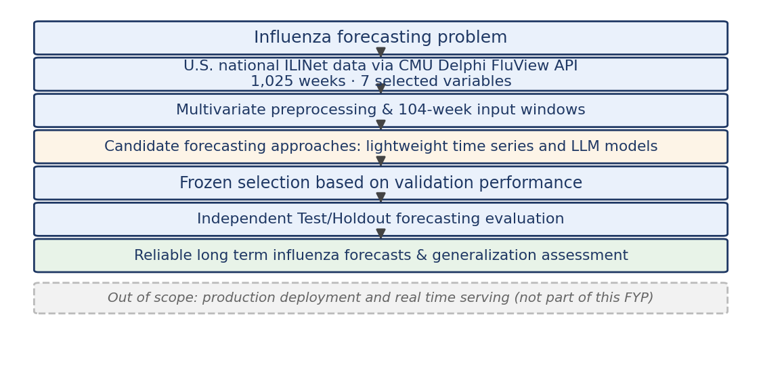
Figure 1. System scope and evidence flow (the shaded band marks items outside the project scope).
F. Current Status and Preliminary Test/Holdout Results
Completed through the independent Test/Holdout evaluation: literature and protocol review, data pipeline with controls against data leakage, model implementation and harmonization, Wave 1 validation and frozen selection. Ongoing: interpretation refinement, additional control experiments, progress and final reports, presentation and demonstration.
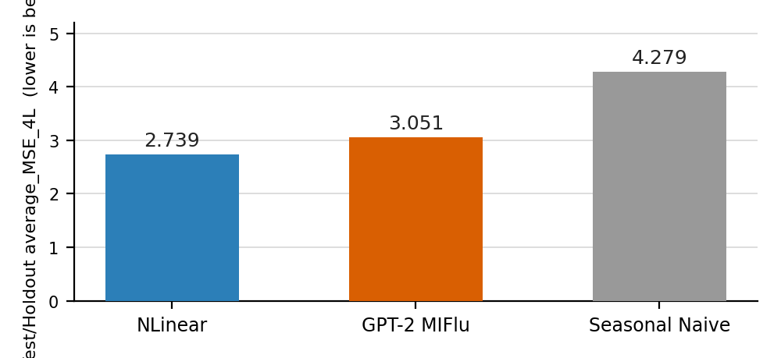
Figure 2. Independent Test/Holdout average_MSE_4L (lower is better).
Within the frozen Test/Holdout comparison of three models, NLinear achieved the lowest error (average_MSE_4L = 2.739), followed by GPT-2 MIFlu (3.051) and Seasonal Naive (4.279). This preliminary finding suggests that the lightweight model provided the most reliable generalization for influenza forecasting on this independent window. The finding is limited to the evaluated models, dataset, protocol and Test/Holdout period and should not be interpreted as a universal conclusion about model families.
G. Conclusion
This project establishes a reproducible framework for multivariate influenza forecasting over long horizons and evaluates generalization on an independent Test/Holdout period. Preliminary results show that NLinear obtained the lowest error within the frozen comparison of three models, while ongoing work will refine the interpretation, run additional control experiments and complete the final project deliverables.
H. Planning Chart / Timeline (September 2026 to April 2027)
Activity | Pred. | Expected time | Critical / Slack | Sep | Oct | Nov | Dec | Jan | Feb | Mar | Apr
T1 Setting project aims & objectives |  | Sep | Y · 0
T2 Background study & literature search | T1 | Sep | Y · 0
T3 Methodology & work approach | T2 | Sep to Oct | Y · 0
T4 Implementation (data + models) | T3 | Sep to Nov | Y · 0
T5 Interpretation of results | T4 | Nov | Y · 0
T6 Iteration (refine / repeat) | T5 | Dec to Jan | N · 2 wks
T7 Progress report + presentation | T5 | 20 Nov | Y · 0
T8 Final report | T6, T7 | Jan to Mar | Y · 0
T9 Conclusion | T8 | Mar | N · 1 wk
T10 Project presentation | T8 | 22 Mar to 9 Apr | Y · 0
T11 Demonstration | T8 | by 9 Apr | Y · 0
T12 Submission of final report | T8, T9 | by 9 Apr | Y · 0
Legend: ■ completed (blue) ■ in progress (amber) ■ planned (grey). Critical / Slack: Y = on critical path, 0 = zero slack; N = buffer (2 wks / 1 wk). Critical path: T1 → T2 → T3 → T4 → T5 → T8 → T10/T11/T12.
Official milestones (2026/27 FYP schedule, per P_Sch_2627B):
ID | Milestone | Official date / window | Status / Basis
M1 | Planning Chart submission | before 25 Sep 2026 | Official
M2 | Assessor assignment announced | 5 to 12 Oct 2026 | Official
M3 | Progress Report + presentation | 20 Nov 2026 | Official
M4 | Sem A title confirmation | 16 to 20 Nov 2026 | Official
M5 | Final title confirmation | before 5 Mar 2027 | Tentative
M6 | Project abstract upload | before 9 Mar 2027 | Tentative
M7 | Presentation / details announcement | 8 to 15 Mar 2027 | Tentative
M8 | Project presentation | 22 Mar to 9 Apr 2027 | Tentative
M9 | Final Report submission (PDF via Canvas) | by 9 Apr 2027 | Tentative
M10 | Demonstration | by 9 Apr 2027 | Tentative
Plagiarism check briefing: 8 to 15 Mar 2027 (exact date, time and venue to be announced).
I. Key References
J. Moon et al., “MIFlu: Large Language Model-Based Multimodal Influenza Forecasting Scheme,” IEEE J. Biomed. Health Inform., vol. 29, no. 10, pp. 7790–7801, 2025.
A. Zeng et al., “Are Transformers Effective for Time Series Forecasting?” in Proc. AAAI, 2023. (NLinear / DLinear)
M. Jin et al., “Time-LLM: Time Series Forecasting by Reprogramming Large Language Models,” ICLR, 2024.
U.S. Centers for Disease Control and Prevention, “FluView / ILINet weekly influenza-like illness surveillance (national),” retrieved through the CMU Delphi Epidata API FluView endpoint, https://cmu-delphi.github.io/delphi-epidata/api/fluview.html. Raw snapshot retrieved 15 July 2026; local copy last updated 18 July 2026. Project snapshot: 1,025 weekly observations and seven selected variables.

