City University of Hong Kong
Department of Electrical Engineering · Final Year Project EE4080 · 2026/27 A
Project Summary and Planning Chart
MIFlu-Based Comparison of Non-LLM and LLM Influenza Forecasting Architectures with Independent Test/Holdout Generalization Evaluation
A. Student and Project Information
Student No. | 58324980 | Student Name | CHAN Sing Yeung
CityU Email | sychan552-c@my.cityu.edu.hk | Project Code | KHC-04
Supervisor | Prof. CHAN, Katie (KHC) | Programme | BEng — Computer and Data Engineering
Course | EE4080 | Academic Year / Term | 2026/27 A
B. Project Summary
Accurate weekly influenza-like-illness (ILI) forecasting supports seasonal preparedness. Recent research embeds large-language-model (LLM) textual knowledge into time-series forecasters; however, it remains unclear whether their added complexity improves independent generalization over lightweight traditional models. This project compares Non-LLM and LLM-based architectures under one reproducible protocol and assesses final generalization on an independent, chronologically shifted Test/Holdout set (accessed once, under frozen model selection).
C. Research Gap and Project Objective
Research gap:
Validation performance alone does not establish that an LLM-based forecasting advantage generalizes to an independent, temporally shifted Test/Holdout period; a fair comparison needs common data, outputs, preprocessing, metrics, and controlled model selection.
Objective:
To determine, through a pre-registered, leakage-controlled comparison, whether LLM-based influenza forecasting retains an accuracy advantage over lightweight Non-LLM architectures once the comparison is fair and evaluated on an independent Test/Holdout window.
D. Dataset and Methodology
Forecasting contract:
- National-Illness ILI dataset (weekly, 1,025 points, seven variables).
- Input: previous 104 weeks; Output: all seven variables over horizons 24 / 36 / 48 / 60 weeks.
- Chronological train / validation / Test split; training-set-only normalization.
- Validation selects models; the independent Test/Holdout set is used once for final evaluation.
Compared models — Non-LLM: NLinear, DLinear, PatchTST-inspired, iTransformer; LLM-based: GPT-2 MIFlu, Qwen Time-LLM, CALF, TimeCMA; References: Last-Value Naive, Seasonal-Naive. All models share one dataset, split, scaler, output contract and primary metric average_MSE_4L (lower is better). The original MIFlu paper reports an ablation study (Section VI.E, Table VIII) removing its text-prompt sections, textual input embedder, and LoRA adapter and finding each removal degrades accuracy.
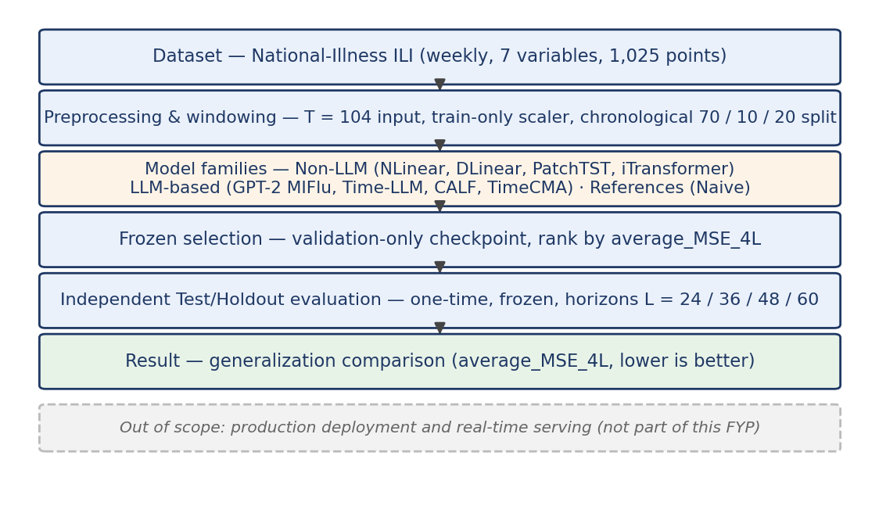
Figure 1. System scope and evidence flow (out-of-scope band shaded).
E. Current Status and Preliminary Test/Holdout Results
Completed: literature/protocol review; leakage-controlled data pipeline; implementation and harmonization of the compared models; Wave-1 validation and frozen selection; independent Test/Holdout evaluation; initial analysis. Ongoing: interpretation refinement, follow-up control analysis, progress report, final report, presentation, and demonstration.
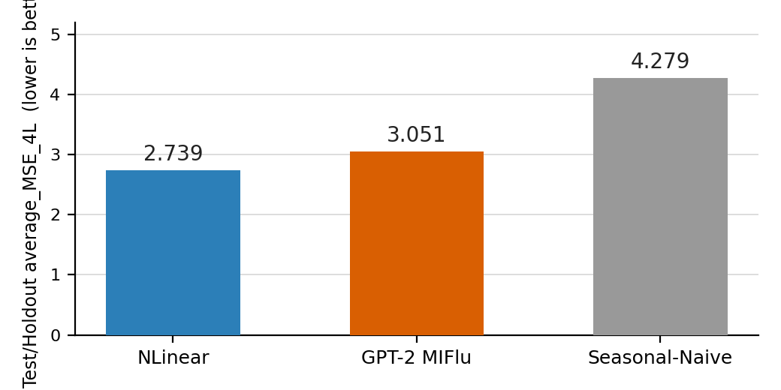
Figure 2. Independent Test/Holdout average_MSE_4L (lower is better).
NLinear achieved the lowest Test error (2.739), followed by GPT-2 MIFlu (3.051) and Seasonal-Naive (4.279). This preliminary result is bounded to the three frozen models, this dataset, protocol, and Test window — not a universal claim about model families.
F. Conclusion
Under a frozen, leakage-controlled protocol with an independent Test/Holdout window, the lightweight NLinear architecture generalized better than GPT-2 MIFlu and the Seasonal-Naive reference (average_MSE_4L: 2.739 vs 3.051 vs 4.279). The conclusion is bounded to the three frozen models and this dataset/protocol/window. Remaining work follows the planning chart in Section G.
G. Planning Chart / Timeline (September 2026 – April 2027)
Activity | Pred. | Expected time | Critical / Slack | Sep | Oct | Nov | Dec | Jan | Feb | Mar | Apr
T1 Setting project aims & objectives | — | Sep | Y · 0
T2 Background study & literature search | T1 | Sep | Y · 0
T3 Methodology & work approach | T2 | Sep–Oct | Y · 0
T4 Implementation (data + models) | T3 | Sep–Nov | Y · 0
T5 Interpretation of results | T4 | Nov | Y · 0
T6 Iteration (refine / repeat) | T5 | Dec–Jan | N · 2 wks
T7 Progress report + presentation | T5 | Nov (Wk 12) | Y · 0
T8 Final report | T6, T7 | Jan–Mar | Y · 0
T9 Conclusion | T8 | Mar | N · 1 wk
T10 Project presentation | T8 | Mar–Apr (Wk 10–12) | Y · 0
T11 Demonstration | T8 | Apr (Wk 11–12) | Y · 0
T12 Submission of final report | T8, T9 | Apr (Wk 12) | Y · 0
Legend: ■ completed (blue) ■ in progress (amber) ■ planned (grey). Critical / Slack: Y = on critical path · 0 = zero slack; N = buffer (2 wks / 1 wk). Critical path: T1 → T2 → T3 → T4 → T5 → T8 → T10/T11/T12.
Official milestones (fixed FYP deadlines):
ID | Milestone | Official window / deadline | Status
M1 | Planning Chart submission | Sem A Wk 4 — on/before 25 Sep 2026, 11:59 pm | Confirmed
M2 | Progress Report + presentation | Sem A Wk 12 — 16–20 Nov 2026 | Confirmed
M3 | Finalize project title (InfoNet) | Sem B Wk 7 | Tentative
M4 | Upload abstract + plagiarism briefing | Sem B Wk 8 | Tentative
M5 | Project presentation | Sem B Wk 10–12 | Tentative
M6 | Demonstration | Sem B Wk 11–12 | Tentative
M7 | Final Report submission | Sem B Wk 12 | Tentative
H. Key References
J. Moon et al., “MIFlu: Large Language Model-Based Multimodal Influenza Forecasting Scheme,” IEEE J. Biomed. Health Inform., vol. 29, no. 10, pp. 7790–7801, 2025.
A. Zeng et al., “Are Transformers Effective for Time Series Forecasting?” in Proc. AAAI, 2023. (NLinear / DLinear)
M. Jin et al., “Time-LLM: Time Series Forecasting by Reprogramming Large Language Models,” ICLR, 2024.

