City University of Hong Kong
Department of Electrical Engineering · Final Year Project EE4080 · 2026/27 A
Project Summary and Planning Chart
Reliable Long-Horizon Influenza Forecasting Using Multivariate Time-Series Models
A. Student and Project Information
Student No. | 58324980 | Student Name | CHAN Sing Yeung
CityU Email | sychan552-c@my.cityu.edu.hk | Project Code | KHC-04
Supervisor | Prof. CHAN, Katie (KHC) | Programme | BEng — Computer and Data Engineering
Course | EE4080 | Academic Year / Term | 2026/27 A
B. Project Summary
Reliable long-horizon influenza forecasting is difficult because seasonal patterns and temporal distribution shifts can reduce model generalization in unseen periods. This project develops and evaluates a leakage-controlled multivariate framework that predicts seven influenza-related indicators over 24-, 36-, 48- and 60-week horizons from historical ILI data, supporting seasonal preparedness and capacity planning. Because existing studies follow both lightweight time-series and LLM-based approaches, representative models from both schools are benchmarked under a common protocol with frozen selection. Preliminary independent Test/Holdout evaluation indicates that the lightweight NLinear model generalized better than the selected GPT-2 MIFlu model and a Seasonal-Naive reference within the frozen comparison set. Remaining work focuses on interpretation, follow-up control analysis, reporting, presentation and demonstration.
C. Research Gap and Project Objective
Research gap:
Reliable long-horizon influenza forecasting remains challenging because seasonal patterns and temporal distribution shifts can reduce accuracy in unseen periods. Existing approaches also vary in model complexity and evaluation protocol, making it difficult to determine which methods provide robust multivariate forecasts under a common setting. A consistent, leakage-controlled framework with independent evaluation is therefore needed to assess practical generalization.
Objective:
To develop and evaluate a reliable multivariate framework for forecasting influenza activity over long horizons, using historical ILI indicators and an independent Test/Holdout period to assess generalization. Representative lightweight and LLM-based forecasting models are benchmarked under a common, pre-specified protocol to identify an accurate, robust and reproducible approach.
D. Model-Comparison Rationale
Contemporary influenza and time-series forecasting broadly includes two methodological schools: lightweight or dedicated time-series models that directly learn temporal patterns, and LLM-based models that introduce textual knowledge, representation alignment, reprogramming or multimodal mechanisms. These approaches differ in complexity, computational cost and assumptions. Benchmarking representative models from both schools under the same dataset, input/output contract, preprocessing, metrics and independent evaluation therefore helps determine which approach provides the most reliable influenza forecasts in this project setting. The original MIFlu study reports component-level ablations involving its text prompt, textual input embedder and LoRA adapter (Section VI.E, Table VIII), providing supporting evidence for these components within the reported MIFlu configuration.
E. Dataset and Methodology
Forecasting contract:
- National-Illness ILI dataset (weekly, 1,025 points, seven variables).
- Input: previous 104 weeks; Output: all seven variables over horizons 24 / 36 / 48 / 60 weeks.
- Chronological train / validation / Test split; training-set-only normalization.
- Validation selects models; the independent Test/Holdout set is used once for final evaluation.
Compared models — Non-LLM: NLinear, DLinear, PatchTST-inspired, iTransformer; LLM-based: GPT-2 MIFlu, Qwen Time-LLM, CALF, TimeCMA; References: Last-Value Naive, Seasonal-Naive. All share one dataset, split, scaler, output contract and metric average_MSE_4L (lower is better). Following validation-based selection, the independent Test/Holdout evaluation was restricted to the frozen three-model comparison set of NLinear, GPT-2 MIFlu and Seasonal-Naive; the eight architectures were not all re-evaluated on Test/Holdout.
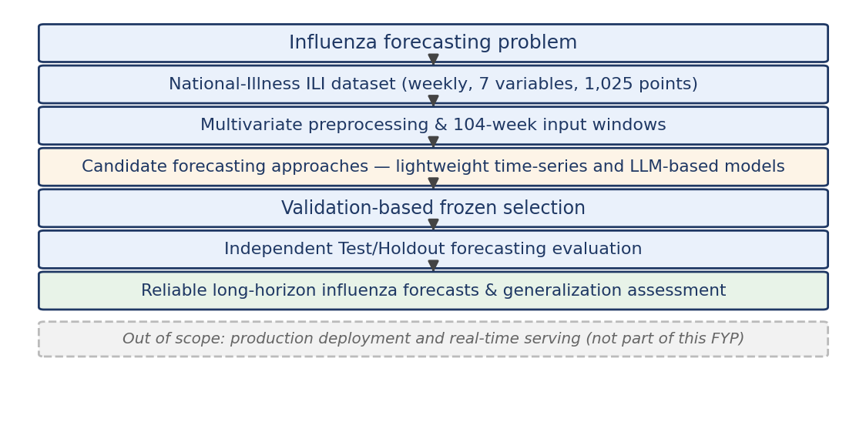
Figure 1. System scope and evidence flow (out-of-scope band shaded).
F. Current Status and Preliminary Test/Holdout Results
Completed through the independent Test/Holdout evaluation: literature and protocol review, leakage-controlled data pipeline, model implementation and harmonization, Wave-1 validation and frozen selection. Ongoing: interpretation refinement, follow-up controls, progress and final reports, presentation and demonstration.
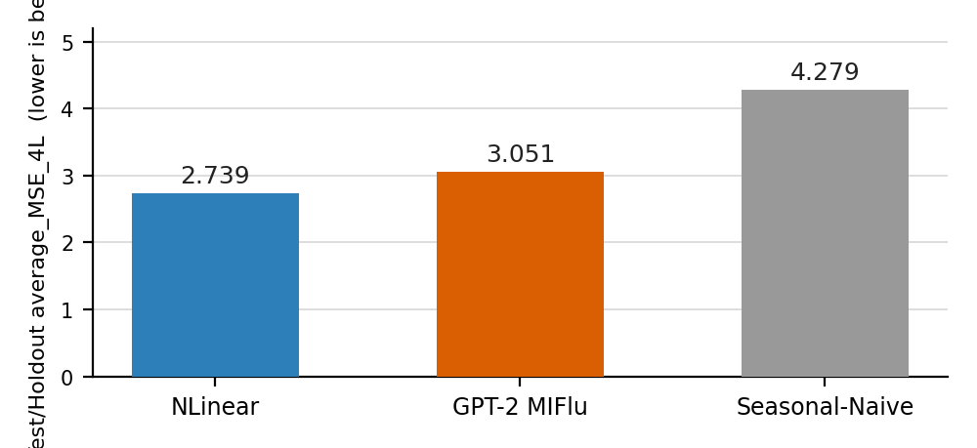
Figure 2. Independent Test/Holdout average_MSE_4L (lower is better).
Within the frozen three-model Test/Holdout comparison, NLinear achieved the lowest error (average_MSE_4L = 2.739), followed by GPT-2 MIFlu (3.051) and Seasonal-Naive (4.279). This preliminary finding suggests that the lightweight model provided the most reliable generalization for influenza forecasting on this independent window. The finding is limited to the evaluated models, dataset, protocol and Test/Holdout period and should not be interpreted as a universal conclusion about model families.
G. Conclusion
This project establishes a reproducible framework for long-horizon multivariate influenza forecasting and evaluates generalization on an independent Test/Holdout period. Preliminary results show that NLinear obtained the lowest error within the frozen three-model comparison, while ongoing work will refine the interpretation, follow-up controls and final project deliverables.
H. Planning Chart / Timeline (September 2026 – April 2027)
Activity | Pred. | Expected time | Critical / Slack | Sep | Oct | Nov | Dec | Jan | Feb | Mar | Apr
T1 Setting project aims & objectives | — | Sep | Y · 0
T2 Background study & literature search | T1 | Sep | Y · 0
T3 Methodology & work approach | T2 | Sep–Oct | Y · 0
T4 Implementation (data + models) | T3 | Sep–Nov | Y · 0
T5 Interpretation of results | T4 | Nov | Y · 0
T6 Iteration (refine / repeat) | T5 | Dec–Jan | N · 2 wks
T7 Progress report + presentation | T5 | 20 Nov | Y · 0
T8 Final report | T6, T7 | Jan–Mar | Y · 0
T9 Conclusion | T8 | Mar | N · 1 wk
T10 Project presentation | T8 | 22 Mar – 9 Apr | Y · 0
T11 Demonstration | T8 | by 9 Apr | Y · 0
T12 Submission of final report | T8, T9 | by 9 Apr | Y · 0
Legend: ■ completed (blue) ■ in progress (amber) ■ planned (grey). Critical / Slack: Y = on critical path, 0 = zero slack; N = buffer (2 wks / 1 wk). Critical path: T1 → T2 → T3 → T4 → T5 → T8 → T10/T11/T12.
Official milestones (2026/27 FYP schedule, per P_Sch_2627B):
ID | Milestone | Official date / window | Status / Basis
M1 | Planning Chart submission | before 25 Sep 2026 | Official
M2 | Assessor assignment announced | 5–12 Oct 2026 | Official
M3 | Progress Report + presentation | 20 Nov 2026 | Official
M4 | Sem A title confirmation | 16–20 Nov 2026 | Official
M5 | Final title confirmation | before 5 Mar 2027 | Tentative
M6 | Project abstract upload | before 9 Mar 2027 | Tentative
M7 | Presentation / details announcement | 8–15 Mar 2027 | Tentative
M8 | Project presentation | 22 Mar – 9 Apr 2027 | Tentative
M9 | Final Report submission (PDF via Canvas) | by 9 Apr 2027 | Tentative
M10 | Demonstration | by 9 Apr 2027 | Tentative
Plagiarism-check briefing: 8–15 Mar 2027 (exact date, time and venue to be announced).
I. Key References
J. Moon et al., “MIFlu: Large Language Model-Based Multimodal Influenza Forecasting Scheme,” IEEE J. Biomed. Health Inform., vol. 29, no. 10, pp. 7790–7801, 2025.
A. Zeng et al., “Are Transformers Effective for Time Series Forecasting?” in Proc. AAAI, 2023. (NLinear / DLinear)
M. Jin et al., “Time-LLM: Time Series Forecasting by Reprogramming Large Language Models,” ICLR, 2024.

