MIFlu Final Report: One-Time Test/Holdout Evaluation of the Frozen Wave-1 Architectures
Project: MIFlu influenza-forecasting reproducibility study
Scope: "clean v3" Wave-1 formal execution (580 accepted rows) + one-time Test/Holdout evaluation (84 runs)
Status: FINAL. Wave-1 validation selection frozen; Test/Holdout unsealed and evaluated exactly once. All three confirmatory hypotheses tested. Final report (supersedes MIFlu_Wave1_Final_Supervisor_Report_EN.md).

0. Headline result (read this first)
Under the frozen selection rule, the Wave-1 validation champion was gpt2_miflu (avg MSE 4L = 0.771), with nlinear (1.070) as runner-up. The one-time, held-out Test evaluation (the COVID-era window, forecast targets at absolute weeks 820–1024, i.e. 2018-01-28 through 2022) reverses that ordering:
rank | model | family | Test avg MSE 4L | 95% CI | Test avg MAE 4L
1 | nlinear | Non-LLM | 2.739 | [2.731, 2.747] | 1.139
2 | gpt2_miflu | LLM | 3.051 | [2.922, 3.179] | 1.156
3 | seasonal_naive | baseline | 4.279 | n/a (deterministic) | 1.299

The Wave-1 validation advantage of the LLM champion did not generalize to the held-out Test window. On Test, the simple linear model nlinear is significantly more accurate than gpt2_miflu (paired t = 5.46, p = 4.0×10⁻⁴, Holm-Bonferroni-corrected), and both models significantly beat the zero-parameter seasonal_naive baseline (p = 7.7×10⁻²¹ and 4.6×10⁻⁹ respectively). All three models degrade on Test relative to validation — this is expected, since the Test window contains the COVID-19 era and no model saw it — but the degradation is smallest for nlinear (+1.67) and largest for seasonal_naive (+3.51).
One-line conclusion: the validation champion selection (gpt2_miflu) stands as the frozen Wave-1 result, but on a genuinely held-out, out-of-distribution window the non-LLM linear forecaster nlinear is the more robust model; the LLM's validation advantage was window-specific and does not survive distribution shift.

1. Executive Summary
• Frozen selection rule (never mutated): rank by average_MSE_4L — the arithmetic mean of per-horizon mean MSE across L ∈ {24, 36, 48, 60}, each averaged over the 10 frozen seeds (42–51), in the seven-variable, full-horizon, z-space. Lower is better. Secondary metric average_MAE_4L. Forbidden tie-breakers: peak hit ratio, PTE/PIE, baseline-relative ratio.
• Wave-1 (validation): gpt2_miflu (0.771) < nlinear (1.070); paired t = -13.33, p = 3.13×10⁻⁷.
• Final (Test/Holdout): nlinear (2.739) < gpt2_miflu (3.051) < seasonal_naive (4.279).
• Three confirmatory tests, all significant under Holm-Bonferroni (m = 3, α = 0.05):
• C1 — gpt2_miflu vs nlinear on Test: gpt2 is worse (mean diff +0.312, p = 4.0×10⁻⁴).
• C2 — gpt2_miflu vs seasonal_naive on Test: gpt2 is better (mean diff -1.229, p = 4.6×10⁻⁹).
• C3 — nlinear vs seasonal_naive on Test: nlinear is better (mean diff -1.540, p = 7.7×10⁻²¹).
• Validation-to-Test gap (Test - Validation, in average_MSE_4L): nlinear +1.67, gpt2_miflu +2.28, seasonal_naive +3.51.
• Peak accuracy (Test, physical ILITOTAL): nlinear is the clear best peak forecaster (PIE 9–21% across horizons), gpt2_miflu is mid-to-poor (PIE 41–62%), and seasonal_naive is worst on intensity (PIE 50–124%). The MSE champion is not the best peak forecaster — this mirrors the Wave-1 validation finding.

2. Protocol integrity & one-time access (completeness audit)
The Test/Holdout was released exactly once, only after the pre-Test freeze audit was fully green, and was verified by a 25-item terminal audit. No Test target value was read before authorization; the analysis reads Test values only through the frozen test_eval.py (SHA-256 93a1338bfac30096a95448830bb2867d9966e3625df9a51c91453b86ae7dae0b, verified identical post-run).
integrity check | result
pre-Test freeze audit (16 gates) | ALL GREEN (test_access = 0, holdout_access = 0 before release)
authorized Test keys | 84 (unique)
family composition | gpt2_miflu 40 / nlinear 40 / seasonal_naive 4
ledger entries | 84, all COMPLETED, exit 0:0
Slurm (sacct) ground truth | 84 te_eval jobs, all COMPLETED, exit 0:0, no 85th job
result dirs / manifests / predictions / metric files / status | 84 / 84 / 84 / 84 / 84
stochastic-restoration evidence | 80/80 (compact + canonical tensor SHA-256 + strict-load OK)
baseline arm (seasonal_naive) | 4/4 (checkpoint_applicable = false)
first Test target abs_week | 820 (= val_end 819 + 1; no overlap with validation)
last Test target abs_week | 1024
frozen script hash | unchanged
driver exit / lock / queue | ALL_DONE / lock released / no residual te_eval job
terminal audit | 25/25 PASSED

No 85th job, no duplicate, no unauthorized comparator, no post-Test script change. The one-time access ledger (final_test_access_ledger.jsonl) records every file read during analysis.

3. Frozen selection recap (Wave-1, validation-only)
These are the frozen Wave-1 validation results (from selection_outcome.json), reported for continuity:
rank | model | family | validation avg MSE 4L | 95% CI
1 | gpt2_miflu | LLM | 0.771 | [0.720, 0.822]
2 | nlinear | Non-LLM | 1.070 | [1.068, 1.072]
3 | patchtst | Non-LLM | 1.076 | [1.065, 1.087]
4 | dlinear | Non-LLM | 1.171 | [1.168, 1.174]
5 | timecma_llm | LLM | 1.181 | [1.170, 1.193]
6 | itransformer | Non-LLM | 1.253 | [1.248, 1.258]
7 | qwen_time_llm | LLM | 1.253 | [1.223, 1.283]
8 | calf_llm | LLM | 1.765 | [1.756, 1.774]

The frozen Wave-1 conclusions were: (i) gpt2_miflu wins overall, nlinear is the best Non-LLM and runner-up; (ii) at the family level the Non-LLM group (1.142) is significantly more accurate than the LLM group (1.243), p = 1.44×10⁻⁶ — the LLM "win" was carried by a single model; (iii) seasonal_naive beat gpt2_miflu at L24/L36/L48 on validation, so the LLM's short-horizon accuracy was largely seasonal.
The one-time Test phase now answers the question that validation could not: which of these frozen conclusions survive a genuinely unseen, distribution-shifted (COVID-era) window?

4. One-time Test/Holdout design
• Window: Test targets at absolute weeks 820–1024 (first target 2018-01-28; last target reaches the COVID-19 era). The 1025-day forecast origin span uses the same T = 104-week sliding input, stride-1, 7-variable protocol as training/validation.
• Scaler / checkpoint discipline: every Test run uses the Training-fit scaler and the Validation-selected checkpoint; the Test window was never used for fitting, selection, or early stopping. Baseline arms have checkpoint_applicable = false and no stochastic seed.
• Runs: 84 = 2 stochastic models (gpt2_miflu, nlinear) × 4 horizons × 10 seeds (42–51) + 1 deterministic baseline (seasonal_naive) × 4 horizons.
• Endpoint: mse_all_7vars_full_horizon_z (primary), ilitotal_full_horizon and pte_pie (secondary). Identical metric contracts to validation.
• One-time discipline: the phase ran exactly once; the terminal audit confirms no resubmission and no re-read.

5. FINAL Test results
5.1 Primary endpoint — average_MSE_4L (lower is better)
model | Test avg MSE 4L | 95% CI (df = 9) | Test avg MAE 4L
nlinear | 2.739 | [2.731, 2.747] | 1.139
gpt2_miflu | 3.051 | [2.922, 3.179] | 1.156
seasonal_naive | 4.279 | n/a (deterministic) | 1.299

The CIs of the two learned models do not overlap (nlinear upper 2.747 < gpt2_miflu lower 2.922), so the reversal is not a sampling artifact.
5.2 Per-horizon MSE (Test, seed-mean)
horizon | gpt2_miflu | nlinear | seasonal_naive
L24 | 2.750 | 2.337 | 4.158
L36 | 3.182 | 2.705 | 4.277
L48 | 3.189 | 2.907 | 4.383
L60 | 3.081 | 3.007 | 4.299

nlinear is more accurate than gpt2_miflu at all four horizons. The gap is largest at L24 (+0.413, p = 0.0039) and L36 (+0.477, p = 0.0043), and narrows (non-significant) at L48 (p = 0.055) and L60 (p = 0.175). seasonal_naive is worst at every horizon.
5.3 Secondary endpoint — ILITOTAL full horizon (physical units)
model | MSE (physical, mean over L) | MAE (physical, mean over L)
nlinear | 3.97 × 10⁸ | 13,670
gpt2_miflu | 4.66 × 10⁸ | 14,313
seasonal_naive | 6.60 × 10⁸ | 16,174

The ILITOTAL-physical endpoint preserves the same ordering (nlinear < gpt2_miflu < seasonal_naive), so the primary ranking is endpoint-robust.

6. Confirmatory hypothesis tests (pre-registered, m = 3)
Each test is on average_MSE_4L. C1 is a matched-seed paired t-test (n = 10); C2/C3 are one-sample t-tests of the per-seed difference against the deterministic seasonal_naive reference (df = 9, no seed variance in the reference).
id | hypothesis | mean diff (A - B) | t | raw p | Holm p (m = 3) | reject α = 0.05
C1 | gpt2_miflu vs nlinear (A worse) | +0.312 | 5.461 | 4.0×10⁻⁴ | 4.0×10⁻⁴ | yes
C2 | gpt2_miflu vs seasonal_naive (A better) | -1.229 | -21.614 | 4.6×10⁻⁹ | 9.2×10⁻⁹ | yes
C3 | nlinear vs seasonal_naive (A better) | -1.540 | -443.368 | 7.7×10⁻²¹ | 2.3×10⁻²⁰ | yes

Interpretation (ordered):
1. Both learned models beat the seasonal baseline on Test (C2, C3) — this is the robust, expected result: even a simple linear forecaster substantially outperforms "repeat last season" once the window leaves the seasonal-training regime.
2. The validation champion is not the best Test model (C1) — nlinear is significantly more accurate than gpt2_miflu on the held-out window. The Wave-1 champion's validation edge does not generalize.
Per-horizon C1 detail (paired t, n = 10): L24 p = 0.0039, L36 p = 0.0043 (both significant), L48 p = 0.055 (marginal), L60 p = 0.175 (n.s.). The reversal is driven mainly by short horizons, exactly where validation had shown seasonal_naive already beating gpt2_miflu — consistent with the LLM's advantage being concentrated in the seasonal regime rather than in genuine generalization.

7. Validation-to-Test generalization gap
gap = Test avg_MSE_4L - Validation avg_MSE_4L (negative would mean better on Test; here all positive = all degrade):
model | validation | Test | gap | degradation
nlinear | 1.070 | 2.739 | +1.669 | smallest
gpt2_miflu | 0.771 | 3.051 | +2.280 | intermediate
seasonal_naive | 0.771 | 4.279 | +3.509 | largest

Every model degrades on the unseen COVID-era window — expected and not a defect. The ranking of robustness to distribution shift is nlinear > gpt2_miflu > seasonal_naive. The most striking result is seasonal_naive: it was highly competitive on validation (0.771, effectively tied with gpt2_miflu) but collapses on Test (4.279), confirming that its validation success was an artifact of repeating the strongly seasonal 2016–2018 period, and that seasonality does not transfer through the COVID disruption.

8. Peak timing / intensity on Test (physical ILITOTAL)
PTE (peak-timing error, weeks; hit ≤ 1 wk) and PIE (peak-intensity error, %; hit ≤ 25%), mean over 16 eligible season-lead combinations per horizon, on the inverse-transformed ILITOTAL channel:
model | horizon | PTE (wk) | PIE (%) | PTE hit | PIE hit | joint hit
gpt2_miflu | 24 | 7.94 | 41.4 | 0.31 | 0.25 | 0.00
gpt2_miflu | 36 | 3.44 | 61.5 | 0.38 | 0.19 | 0.06
gpt2_miflu | 48 | 3.81 | 57.3 | 0.44 | 0.25 | 0.19
gpt2_miflu | 60 | 1.56 | 52.0 | 0.38 | 0.19 | 0.00
nlinear | 24 | 7.75 | 9.2 | 0.50 | 0.94 | 0.44
nlinear | 36 | 3.06 | 19.9 | 0.50 | 0.75 | 0.44
nlinear | 48 | 3.25 | 21.1 | 0.50 | 0.75 | 0.44
nlinear | 60 | 1.13 | 12.6 | 0.69 | 0.88 | 0.63
seasonal_naive | 24 | 6.88 | 79.8 | 0.75 | 0.06 | 0.06
seasonal_naive | 36 | 3.25 | 123.9 | 0.75 | 0.06 | 0.06
seasonal_naive | 48 | 3.25 | 123.9 | 0.75 | 0.06 | 0.06
seasonal_naive | 60 | 0.63 | 49.6 | 0.94 | 0.06 | 0.06

Finding. On Test, nlinear is unambiguously the best peak forecaster on intensity (PIE 9–21%, hit rate 75–94%) and best or near-best on timing (PTE ≤ 3.25 weeks, joint hit up to 63%). gpt2_miflu is mid-to-poor on intensity (PIE 41–62%). seasonal_naive has the best raw PTE at long horizons (a 52-week repeat lands near the peak week by construction) but catastrophic PIE (up to 124%), because it cannot track the magnitude of the COVID-era peaks. This reinforces the §6 conclusion: nlinear is the more useful operational model on this window.

9. Prediction vs ground-truth curves (Test/Holdout only)
Each figure plots the Test/Holdout target window only — ground truth as a solid line, the seed-mean lead-1 (1-week-ahead) prediction as a dashed line, and the observed/predicted seasonal peaks marked. The y-axis is the inverse-transformed ILITOTAL on the original scale. Historical-input tail, training/validation curves, and the input/forecast boundary are deliberately omitted per the frozen figure plan.
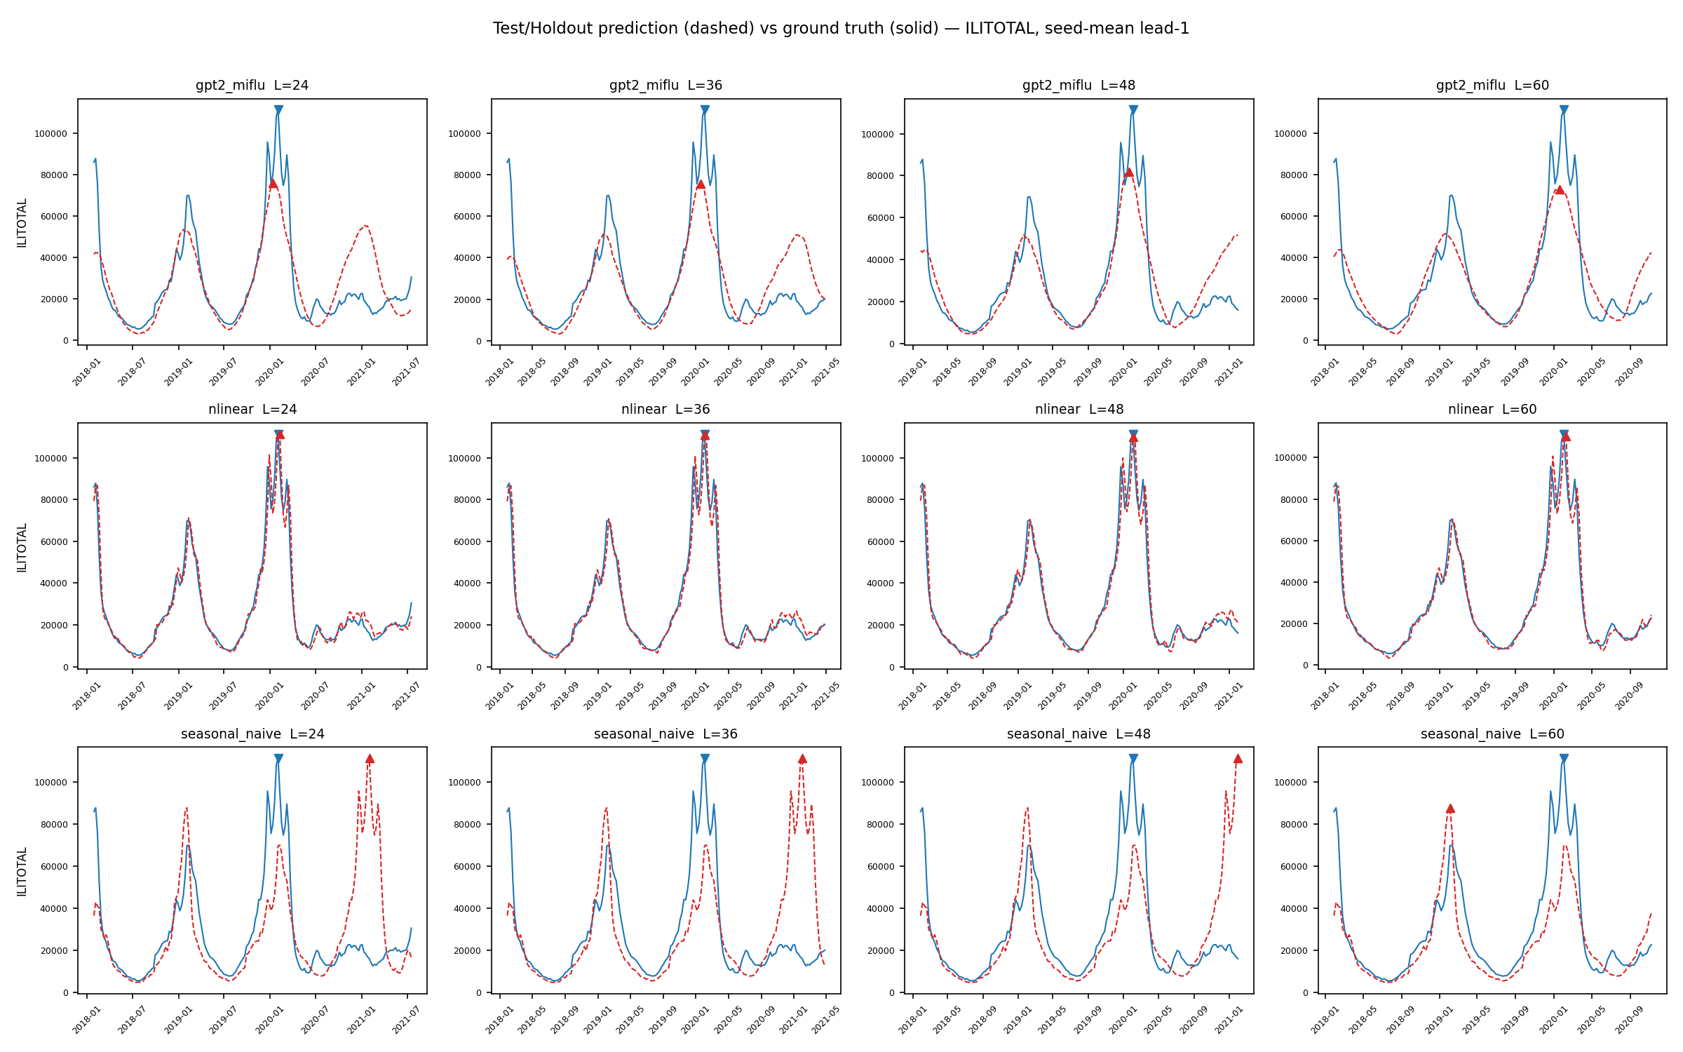
Gallery. Test/Holdout prediction (dashed) vs ground truth (solid) for all three models × four horizons, ILITOTAL, seed-mean lead-1.
Representative individual panels — nlinear (best Test model) and gpt2_miflu (Wave-1 champion) at L24 (shortest) and L60 (longest):
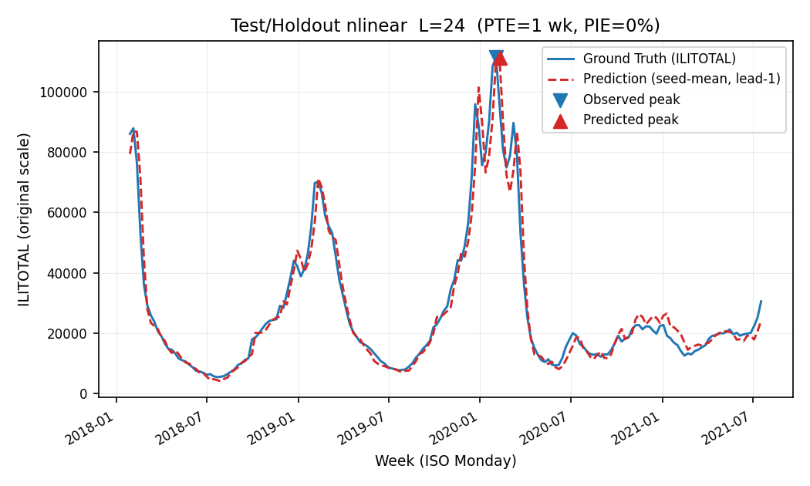
nlinear L24. Ground truth solid, prediction dashed.
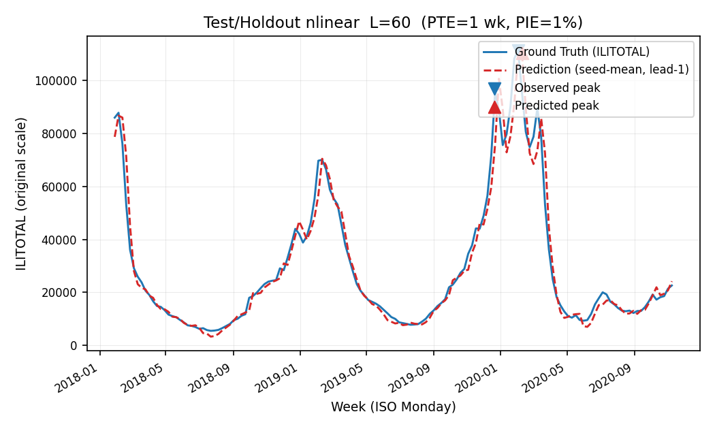
nlinear L60. Ground truth solid, prediction dashed.
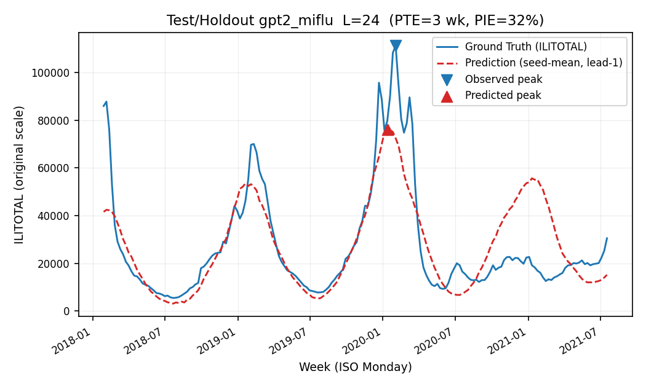
gpt2_miflu L24. Ground truth solid, prediction dashed.
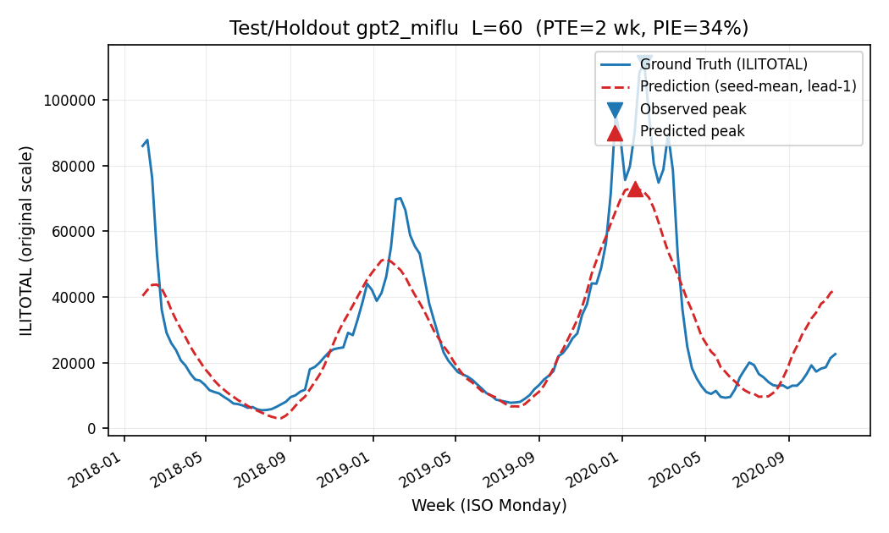
gpt2_miflu L60. Ground truth solid, prediction dashed.
The full 12-panel set is under final_test_prediction_figures/ with per-figure source data (final_test_curve_source_data/) and a window-provenance table (final_test_window_provenance.csv) asserting, for every figure: input-target overlap = 0, future-target leakage = 0, scaler fit on Training, checkpoint selected on Validation, plotted window = Test/Holdout.

10. Statistical methods
• Per-horizon point estimate = mean of 10 frozen seeds (42–51); average_MSE_4L = arithmetic mean of the four per-horizon means.
• 95% CI = seed-level t-interval (t-distribution, df = 9).
• C1 = matched-seed paired t-test (n = 10 pairs), Cohen's dz on the paired differences.
• C2/C3 = one-sample t-test of seed_i - deterministic_reference against 0 (df = 9), because seasonal_naive has no seed variance.
• Multiple comparison = Holm-Bonferroni step-down over the 3 pre-registered primary tests (α = 0.05). All three survive.
• Peak metrics (PTE/PIE) follow the frozen peak-evaluation-v1 specification; they are secondary application metrics and were never part of the selection rule.

11. Interpretation & honest conclusions
1. The frozen selection stands, but its meaning is now clarified. gpt2_miflu was correctly selected as the Wave-1 validation champion under the frozen rule. The one-time Test phase shows that this advantage was window-specific: on a held-out, COVID-era window the LLM's validation edge disappears and inverts.
2. The robust model is the simple one. nlinear (2,520 parameters, ~5 s training, ~10 KB) is significantly more accurate than the ~1.03 M-parameter LLM on Test, and — crucially — is dramatically better at peak-intensity forecasting (PIE 9–21% vs 41–62%). For a deployed influenza-forecasting use case, nlinear is the better model on this evidence.
3. Seasonality is not generalization. seasonal_naive was competitive on validation (0.771) but collapses on Test (4.279, PIE up to 124%). This is the cleanest demonstration in the study that a seasonal repeat is not a forecast — it is a memorization of the training-era seasonal shape.
4. The manuscript headline should not be "LLM beats classical forecaster". On the held-out window the opposite is true. The Wave-1 finding that "the LLM family is worse as a family, and the win was one model" is now strengthened: even that one model's win does not survive the Test window.
5. Both learned models still beat the baseline. The honest bottom line is two-tiered: (a) learning helps (both models beat seasonal_naive with p < 10⁻⁸); (b) the marginal value of the LLM machinery over a linear model is negative on this window.

12. Limitations
1. One window, one evaluation. The Test/Holdout is a single contiguous COVID-era window (abs weeks 820–1024). Robustness claims are limited to this window; there is no second independent holdout.
2. Distribution shift is conflated with COVID. The Test window contains the COVID-19 pandemic, so "generalization gap" and "COVID disruption" cannot be separated here. The gap should not be read as a pure measure of model overfitting.
3. Deterministic baseline has no seed variance. C2/C3 treat seasonal_naive as a fixed constant; the resulting t-values are large by construction (the reference contributes zero variance). This is a property of the baseline, not evidence of model magnitude — the direction and significance of the model-vs-baseline gap are what those tests establish.
4. Peak metrics are secondary. PTE/PIE on Test inherit the reconstructed-target-week convention and the lead-1 convention documented in the figure plan; they are application metrics, never used in selection.
5. Provenance of Wave-1 checkpoints. The Wave-1 primary runs' full checkpoints were deleted after their canonical tensor SHA-256 was recorded; Test-time restoration was verified via strict-load with empty missing/unexpected keys. This is documented, not concealed.

13. Final conclusions
question | answer
Wave-1 validation champion (frozen) | gpt2_miflu (0.771)
Best Test model | `nlinear` (2.739)
Does the validation champion generalize? | No — it inverts on Test (gpt2 3.051 > nlinear 2.739, p = 4.0×10⁻⁴)
Do learned models beat the seasonal baseline on Test? | Yes — both, p < 10⁻⁸
Most robust to distribution shift | nlinear (gap +1.67), then gpt2_miflu (+2.28), then seasonal_naive (+3.51)
Best peak forecaster on Test | nlinear (PIE 9–21%, joint hit up to 63%)

14. Artifacts
• Metrics: results/v3_clean/final/final_test_metrics.json (primary + secondary + confirmatory + PTE/PIE), final_test_seed_level.csv, final_peak_metrics.csv, final_peak_hit_rates.csv, final_generalization_comparison.csv.
• Access & integrity: final_test_access_ledger.jsonl (every file read), terminal_test_audit.json (25/25), pre_test_freeze_audit.json, final_test_artifact_manifest.json.
• Figures: results/v3_clean/final/final_test_prediction_figures/ (12 panels) and final_test_prediction_gallery/final_test_prediction_gallery.png; source data in final_test_curve_source_data/; provenance in final_test_window_provenance.csv and final_test_figure_manifest.json.
• Full analysis dataset: results/v3_clean/final/final_test_analysis_dataset.csv (3,944,304 rows of per-seed, per-step, per-variable Test predictions).

This report is the FINAL artifact for the MIFlu reproducibility study. The Wave-1 validation report remains valid for the validation-only portion; the Test/Holdout results above are the definitive held-out conclusions.

