MIFlu Wave-1 Final Experimental Results: Non-LLM versus LLM Architecture Comparison
Project: MIFlu influenza-forecasting reproducibility study
Scope: "clean v3" Wave-1 formal execution (580 accepted rows)
Status: Wave-1 primary architecture comparison complete. Deferred controls (18) pending Wave-2. Test/holdout sealed (access = 0/0). Champion NOT frozen for publication. Validation-only result.

1. Executive Summary
Primary ranking metric (frozen selection rule): average_MSE_4L — the arithmetic mean of per-horizon mean MSE across four horizons L ∈ {24, 36, 48, 60}, each averaged over the 10 frozen seeds (42–51), in the seven-variable, full-horizon, z-space. Lower is better. The key secondary metric is average_MAE_4L.
rank | model | family | avg MSE 4L | 95% CI | avg MAE 4L
1 | gpt2_miflu | LLM | 0.771 | [0.720, 0.822] | 0.487
2 | nlinear | Non-LLM | 1.070 | [1.068, 1.072] | 0.564
3 | patchtst | Non-LLM | 1.076 | [1.065, 1.087] | 0.556
4 | dlinear | Non-LLM | 1.171 | [1.168, 1.174] | 0.603
5 | timecma_llm | LLM | 1.181 | [1.170, 1.193] | 0.614
6 | itransformer | Non-LLM | 1.253 | [1.248, 1.258] | 0.598
7 | qwen_time_llm | LLM | 1.253 | [1.223, 1.283] | 0.649
8 | calf_llm | LLM | 1.765 | [1.756, 1.774] | 0.773

Answers to the ten questions:
1. Best Non-LLM: nlinear (1.070).
2. Best LLM: gpt2_miflu (0.771).
3. Best overall: gpt2_miflu; runner-up nlinear. The gap is large and significant (paired t = -13.33, p = 3.13×10⁻⁷, Cohen's d = -5.94).
4. LLM vs Non-LLM at the family level: the Non-LLM group (1.142) is significantly better than the LLM group (1.243) — paired t = -11.15, p = 1.44×10⁻⁶. The LLM "win" is driven entirely by a single model, gpt2_miflu; the other three LLMs (timecma_llm, qwen_time_llm, calf_llm) are all worse than the best Non-LLM.
5. Horizon/endpoint stability: gpt2_miflu is the best model at all four horizons and remains best under the ILITOTAL full-horizon endpoint (1.608). nlinear remains the best Non-LLM under both endpoints. Winner conclusions are stable.
6. Seed stability: Non-LLM models are extremely seed-stable (nlinear SD = 0.0029). gpt2_miflu has the largest SD (0.0711, ≈9.2% of its mean), so its advantage depends partly on favourable seeds — but its mean is still decisively below nlinear.
7. Practical significance (vs. a deterministic seasonal baseline): the zero-parameter seasonal_naive baseline achieves 0.719/0.732/0.746/0.885 at L24/36/48/60 — beating `gpt2_miflu` at L24, L36, and L48. The LLM's absolute accuracy advantage is therefore concentrated at the longest horizon (L60) and is not obviously incremental over a simple 52-week seasonal repeat for short horizons.
8. Runtime/storage trade-off: nlinear costs 2,520 params / 5.3 s / 10 KB; gpt2_miflu costs 1,030,056 params / 147 s / 4.1 MB (≈409× the parameters, ≈28× the training time). seasonal_naive costs zero parameters, zero training, zero storage.
9. Baseline competitiveness: last_value_naive is far worse (2.82–3.42). seasonal_naive is highly competitive and must be reported as a strong reference point.
10. Mechanism: the only significant ablation is without_dataset_information (+12.8%, p = 0.004); removing LoRA, multimodality, or the task instruction has no significant effect (all p > 0.4). Negative controls are exploratory (6 cells): zero_text -0.063 (slightly better than parent), shuffled_text +0.081 (worse). The text contribution appears concentrated in the dataset-description component.

1.1 How model performance is evaluated (zero-background primer)
MSE is not an accuracy percentage. Throughout this report, "MSE" (mean squared
error) is a cost in the model's standardized (z-space) units — the average squared
difference between predicted and observed values, aggregated over the 7 variables, the
full forecast horizon, and the 10 frozen seeds. It has no "% correct" meaning:
smaller is better, and two values can only be compared relative to one another (e.g.
the winner's 0.771 vs the runner-up's 1.070). MAE (mean absolute error) is the same
idea without the squaring, and is reported as the secondary metric.
The evaluation is a strict Input → Process → Output (IPO) flow:
1. Input — a sliding 104-week window of 7 ILI variables (e.g. % weighted ILI,
ILITOTAL, age-group counts, provider counts; exact list in the protocol snapshot).
1. Process — standardize with a train-only scaler → the model predicts in
z-space → the prediction is inverse-transformed back to physical units.
1. Output — a future horizon of L ∈ {24, 36, 48, 60} weeks × 7 variables.
The output is compared against the observed (never-seen) values for the same weeks to
produce per-prediction errors, then the aggregate MSE/MAE. The primary ranking metric
average_MSE_4L is the mean of the four per-horizon MSEs.
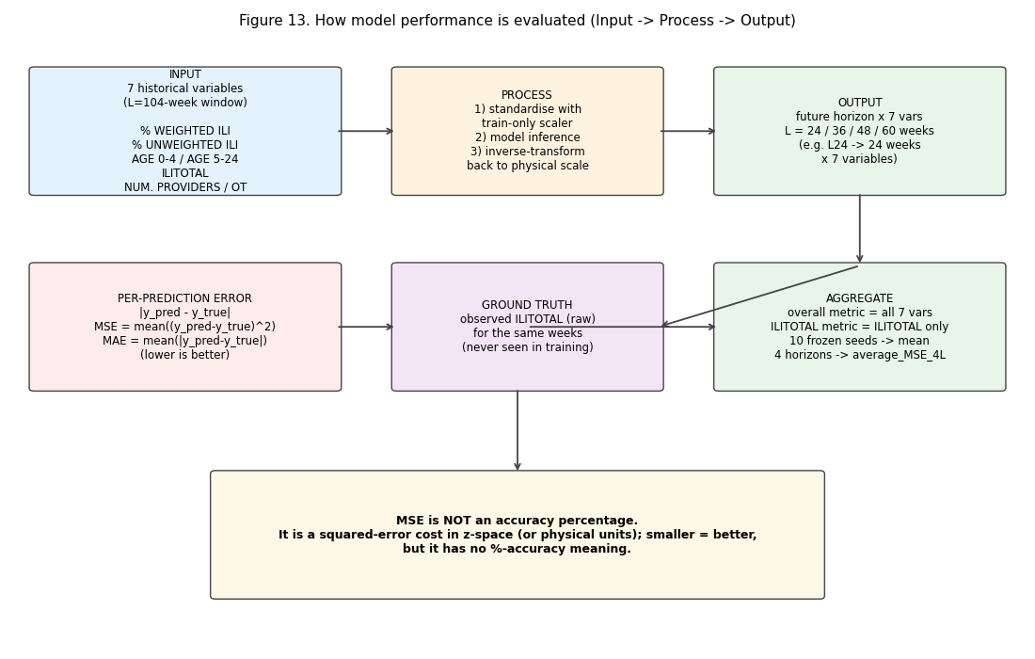
Figure 13. How model performance is evaluated (Input → Process → Output).

2. Frozen Protocol & Completeness Audit
• Source of the rules: results/v3_clean/preregistration/paper_aligned_selection_rule.json, endpoint_hierarchy.json, execution_wave_manifest.json, deferred_parent_binding_rule.json. The frozen protocol snapshot is recorded in results/v3_clean/analysis/frozen_analysis_protocol.json.
• HPC_GUIDE.md integrity: SHA-256 1cd21a655907d137914c695bf04637d8da2f09358a0732c961e739dd8e74c167, verified via Get-FileHash before analysis.
• Completeness: 580/580 accepted rows, 0 deleted, 0 duplicated, 0 fail events in the ledger, controller exited normally (not fail-stop).
• 320 primary (8 models × 4 horizons × 10 seeds)
• 8 baselines (2 models × 4 horizons)
• 240 ablations (6 × 4 × 10)
• 12 negative controls (zero_text, shuffled_text over L24/L60 × seeds 42–44)
• Scope held: Test/holdout access = 0/0. Selection rule was never mutated. Baselines/ablations/controls were never included in the primary ranking.

3. Primary Architecture Comparison
3.1 Ranking (seed-level, n = 10 per model)
See the table in §1. The 95% CI is the seed-level t-interval around average_MSE_4L. The ranking is unambiguous at the top: gpt2_miflu (0.771) < nlinear (1.070) < patchtst (1.076), with non-overlapping CIs between the top two.
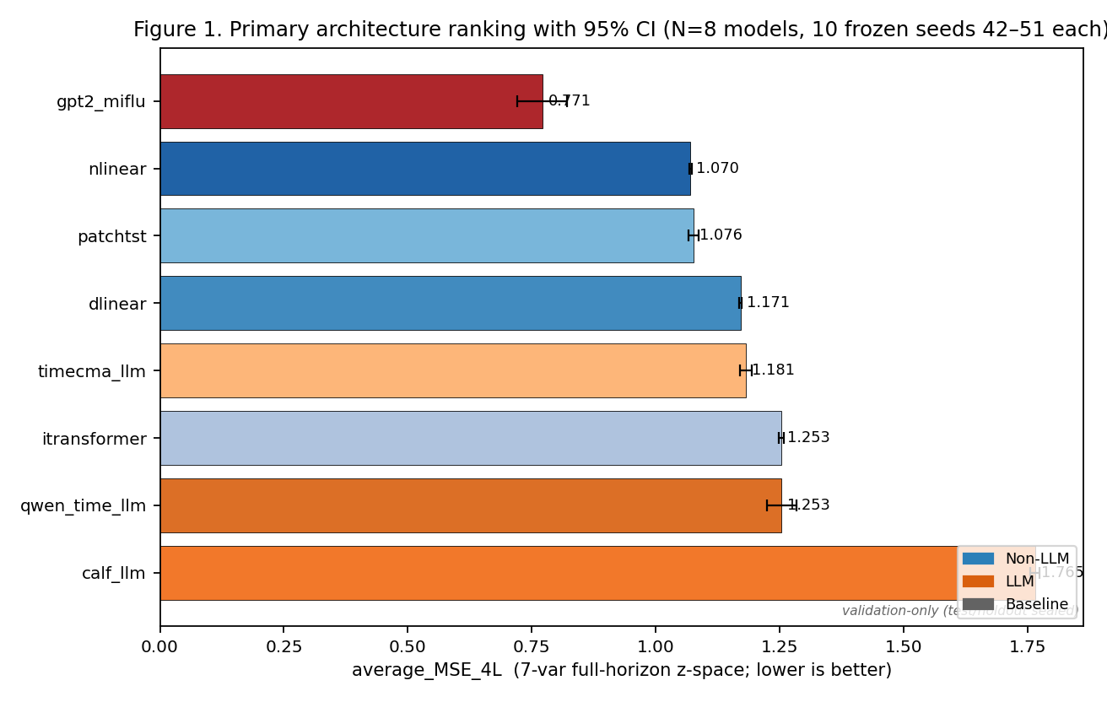
Figure 1. Primary architecture ranking by average_MSE_4L with 95% CI over the 10 frozen seeds (42–51). Lower MSE is better. Validation-only (test/holdout sealed).
3.2 Q1 — Best Non-LLM
nlinear at average_MSE_4L = 1.0698 (95% CI [1.0677, 1.0719], SD 0.0029). It beats patchtst (1.0760) and dlinear (1.1709) with non-overlapping CIs, so the Non-LLM winner is unambiguous.
3.3 Q2 — Best LLM
gpt2_miflu at average_MSE_4L = 0.7709 (95% CI [0.7200, 0.8217], SD 0.0711). It decisively beats timecma_llm (1.1814), qwen_time_llm (1.2531), and calf_llm (1.7649).
3.4 Q3 — Best overall
gpt2_miflu is the overall winner. The winner-vs-runner-up comparison (matched-seed paired t on average_MSE_4L, 10 pairs):
• winner mean 0.7709 vs runner-up 1.0698 → mean difference -0.299
• paired t = -13.33, p = 3.13×10⁻⁷, Cohen's d = -5.94
The equivalence-set rule (report a set rather than a unique champion when statistically/practically indistinguishable) does not trigger — the top two are clearly separated, so a unique winner is justified.
3.5 Q4 — LLM vs Non-LLM at the family level
A matched-seed paired t-test on the per-seed mean of the four models' average_MSE_4L in each family (10 seeds):
• Non-LLM group mean 1.1424 vs LLM group mean 1.2426 → difference -0.100
• paired t = -11.15, p = 1.44×10⁻⁶, Cohen's d = -5.33
Interpretation: as a family, Non-LLM models are significantly more accurate than LLM-based models. The apparent LLM advantage at the top is entirely attributable to gpt2_miflu; the other three LLMs all underperform every Non-LLM except the worst. This is the single most important structural finding for the manuscript narrative: the result is not "LLMs beat classical forecasters" but "one particular LLM-adapter (gpt2_miflu) beats everything, while LLM integration in general does not reliably help."
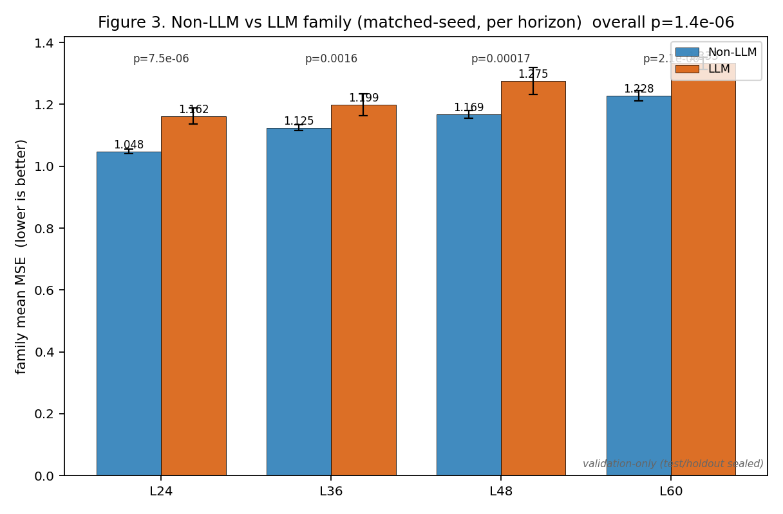
Figure 3. Non-LLM vs LLM family comparison (matched-seed, per horizon) with per-horizon p-values; overall p = 1.44×10⁻⁶. Lower MSE is better. Validation-only.
3.6 Q5 — Horizon and endpoint stability
Per-horizon best model is gpt2_miflu at every horizon:
horizon | best model | best MSE | best Non-LLM
24 | gpt2_miflu | 0.7324 | nlinear (0.9791)
36 | gpt2_miflu | 0.7782 | nlinear (1.0490)
48 | gpt2_miflu | 0.7598 | patchtst (1.0768)
60 | gpt2_miflu | 0.8131 | nlinear (1.1501)

Per-horizon family comparison (Non-LLM vs LLM, all four horizons) is also significant and in the same direction (all p ≤ 0.0016; see selection_outcome.json).
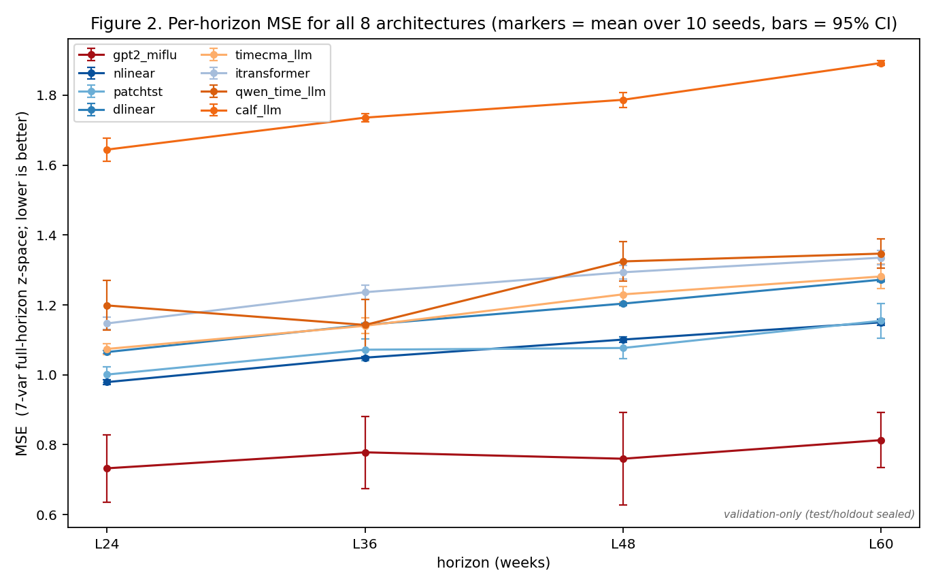
Figure 2. Per-horizon MSE for all 8 architectures at L24/L36/L48/L60. Markers = mean over 10 seeds; error bars = 95% CI. Lower MSE is better. Validation-only.
Endpoint check (ILITOTAL full horizon, lower better):
rank | model | ILITOTAL 4L mean
1 | gpt2_miflu | 1.608
2 | nlinear | 2.333
3 | dlinear | 2.526
4 | patchtst | 2.544
5 | timecma_llm | 2.635
6 | qwen_time_llm | 2.658
7 | itransformer | 2.877
8 | calf_llm | 3.677

The winner and best-Non-LLM conclusions are unchanged. The only endpoint-sensitive detail is an internal swap between dlinear and patchtst (positions 3/4). Reported; not a ranking concern.
3.7 Q6 — Seed stability
• Non-LLM models are remarkably seed-stable: nlinear SD = 0.0029 (0.27% of mean), dlinear SD = 0.0037.
• gpt2_miflu is the least seed-stable model: SD = 0.0711 (≈9.2% of its mean), with per-horizon SDs of 0.135 (L24), 0.144 (L36), 0.186 (L48), 0.111 (L60). Its best-case seeds (e.g. L36 seed 42 = 0.477) are far better than its worst (L48 seed 47 = 1.117).
• qwen_time_llm is also unstable (SD 0.0416); the other models are intermediate.
Consequence: gpt2_miflu's lead is real but partly seed-dependent. A cautious manuscript should (a) report the seed SD, and (b) note that the top ranking would hold even at the 95% CI upper bound of gpt2_miflu (0.822) versus the lower bound of nlinear (1.068) — the CIs do not overlap, so the ordering is robust despite the variance.
3.8 Q7 — Practical significance vs. a deterministic seasonal baseline
horizon | seasonal_naive MSE | gpt2_miflu MSE | seasonal - gpt2
24 | 0.7193 | 0.7324 | -0.0131
36 | 0.7324 | 0.7782 | -0.0458
48 | 0.7460 | 0.7598 | -0.0138
60 | 0.8849 | 0.8131 | +0.0719

A zero-parameter, zero-training, zero-storage seasonal_naive (repeat last season's value) is more accurate than the overall LLM winner at L24, L36, and L48. Only at L60 does gpt2_miflu pull ahead. This is a critical honesty point: much of gpt2_miflu's absolute accuracy at short horizons is explained by seasonality, not by the text/LLM machinery. The manuscript must compare against seasonal_naive explicitly and not over-claim "LLM superiority" at short horizons.
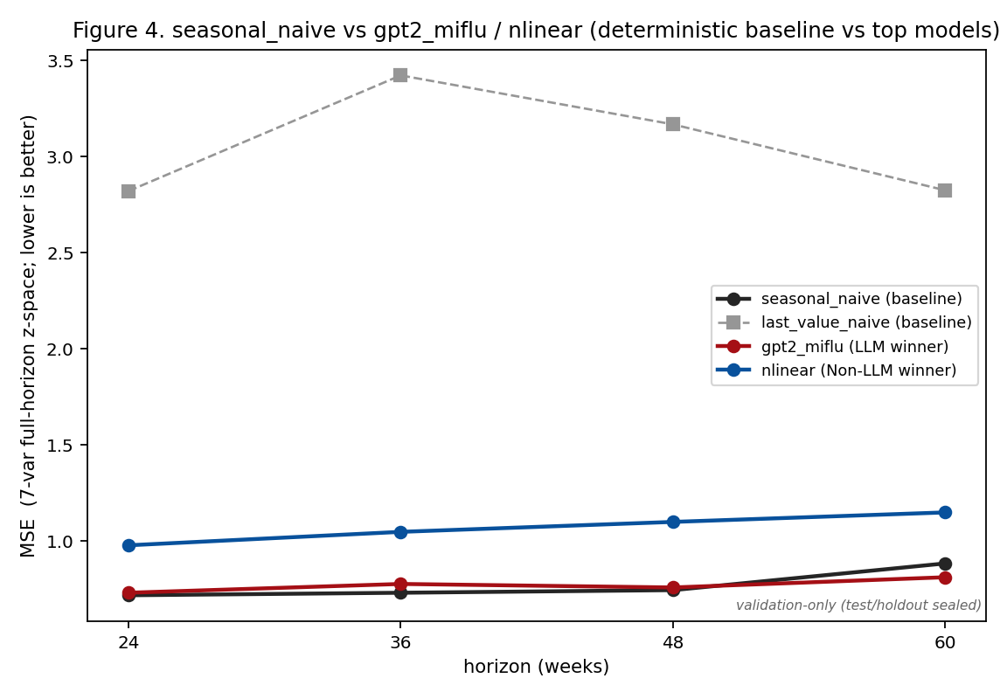
Figure 4. Deterministic seasonal_naive baseline vs gpt2_miflu (LLM winner) and nlinear (Non-LLM winner) across horizons. Lower MSE is better. Validation-only.
3.9 Q8 — Runtime / storage trade-off
model | family | trainable params | train time (s) | compact storage
nlinear | Non-LLM | 2,520 | 5.3 | 10 KB
dlinear | Non-LLM | 5,040 | 5.7 | 20 KB
itransformer | Non-LLM | 75,672 | 8.5 | 305 KB
patchtst | Non-LLM | 87,256 | 8.4 | 351 KB
qwen_time_llm | LLM | 370,376 | 338.7 | 1.48 MB
gpt2_miflu | LLM | 1,030,056 | 147.3 | 4.14 MB
timecma_llm | LLM | 1,391,016 | 15.2 | 5.56 MB
calf_llm | LLM | 1,981,608 | 20.2 | 7.93 MB
seasonal_naive | baseline | 0 | 0 | 0

gpt2_miflu uses ~409× the parameters and ~28× the training time of nlinear to gain 0.299 in MSE (0.771 vs 1.070). The trade-off is substantial; the manuscript should present it transparently rather than claiming LLMs are "efficient".
3.10 Q9 — Baseline competitiveness
• last_value_naive: MSE 2.821 (L24), 3.422 (L36), 3.168 (L48), 2.825 (L60) — far worse than every model.
• seasonal_naive: 0.719 / 0.732 / 0.746 / 0.885 — a strong competitor (see §3.8).
3.11 Q10 — Mechanism (ablations + negative controls)
Ablations relative to parent gpt2_miflu (0.7709), sorted by effect size:
ablation | avg MSE 4L | Δ vs parent | rel. Δ | p-value
without_lora | 0.7729 | +0.0020 | +0.26% | 0.947
without_lora_and_multimodality | 0.7778 | +0.0070 | +0.90% | 0.766
without_multimodality | 0.7859 | +0.0150 | +1.95% | 0.474
without_task_instruction | 0.7926 | +0.0217 | +2.82% | 0.395
without_input_variable_description | 0.8156 | +0.0447 | +5.80% | 0.079
without_dataset_information | 0.8699 | +0.0990 | +12.85% | 0.004

Finding: the only statistically significant prompt component is the dataset information (the textual description of the ILI dataset/context). Removing it degrades performance by 12.85% (p = 0.0036). Removing LoRA (p = 0.95), the multimodality fusion (p = 0.47), or the task instruction (p = 0.40) has no significant effect — the adaptive/alignment machinery contributes almost nothing to accuracy in this setting.
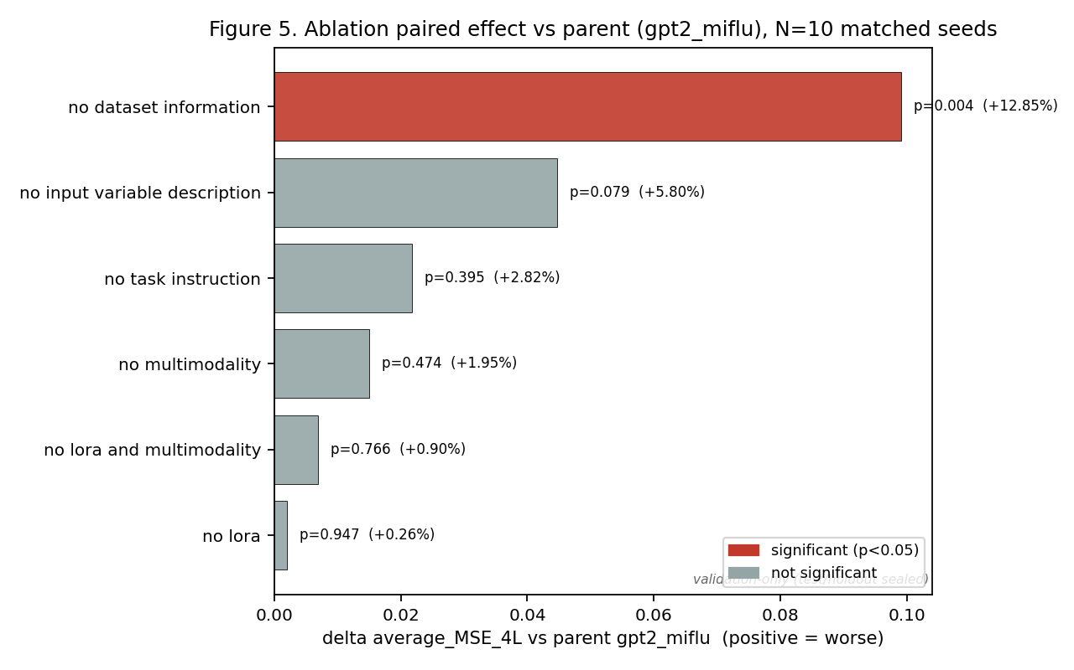
Figure 5. Ablation paired effect vs parent gpt2_miflu (10 matched seeds); bars = Δ average_MSE_4L, annotated with p-value and relative change. Positive = worse. Validation-only.
Negative controls (6 cells each; L24/L60 × seeds 42–44; exploratory, small n):
control | mean Δ vs parent | direction
zero_text | -0.063 | slightly better than parent
shuffled_text | +0.081 | worse than parent

• shuffled_text degrading performance (+0.081) suggests the text content/order carries information (not pure noise).
• zero_text being slightly better (-0.063) is counter-intuitive and suggests the prompt may act partly as noise in some cells; with n = 6 this is exploratory and must not be over-interpreted.
3.12 Q10.5 — Peak timing / intensity (secondary application metric)
Because ILI is used for outbreak detection, we additionally report peak-accuracy
metrics in the style of Kramer & Shaman (2019), computed on the inverse-transformed
ILITOTAL channel over two complete validation influenza seasons (2016-2017 and
2017-2018; observed peaks at abs weeks 769 and 821). These are **secondary application
metrics and were never** used in the frozen selection rule (PTE/PIE are explicitly
listed as forbidden tie-breakers). Since the durable validation_predictions.csv
stores target_date = None, the target week was reconstructed as
forecast_origin + 104 + step (verified against raw ILITOTAL, inverse-transform |diff| < 1e-3).
• PTE (peak timing error) = |predicted peak week - observed peak week|, in weeks (lower better; a "hit" is ≤ 1 week).
• PIE (peak intensity error) = |predicted - observed peak intensity| / observed × 100, in % (lower better; a "hit" is ≤ 25%).
Model means over the 4 leads and 2 seasons (lower is better for PTE/PIE):
model | PTE (weeks) | PIE (%) | PTE hit rate | joint hit rate
patchtst | 1.609 | 49.7 | 0.497 | 0.025
nlinear | 1.750 | 17.7 | 0.500 | 0.141
itransformer | 1.753 | 53.2 | 0.444 | 0.000
dlinear | 1.966 | 26.8 | 0.406 | 0.031
calf_llm | 1.931 | 70.6 | 0.338 | 0.000
gpt2_miflu | 2.122 | 41.5 | 0.484 | 0.097
timecma_llm | 2.284 | 45.6 | 0.381 | 0.000
qwen_time_llm | 2.688 | 35.4 | 0.297 | 0.122

Reference baseline seasonal_naive: PTE = 2.375 weeks, PIE = 42.6%. (last_value_naive
is a flat constant predictor with no peak structure, so its PTE/PIE are not meaningful
and are omitted.)
Interpretation. The MSE champion gpt2_miflu is not the best peak forecaster:
it sits mid-table on PTE (2.12 weeks) and PIE (41.5%). nlinear is best on peak
intensity (PIE 17.7%) and patchtst best on peak timing (PTE 1.61 weeks) — both
Non-LLM. seasonal_naive, despite its low MSE, has the weakest peak timing among the
deterministic references (2.38 weeks), consistent with the fact that a 52-week repeat
cannot track the year-to-year drift of the influenza peak. This reinforces the §3.8
caveat: low MSE in the "flat-season" weeks does not imply accurate peak detection.
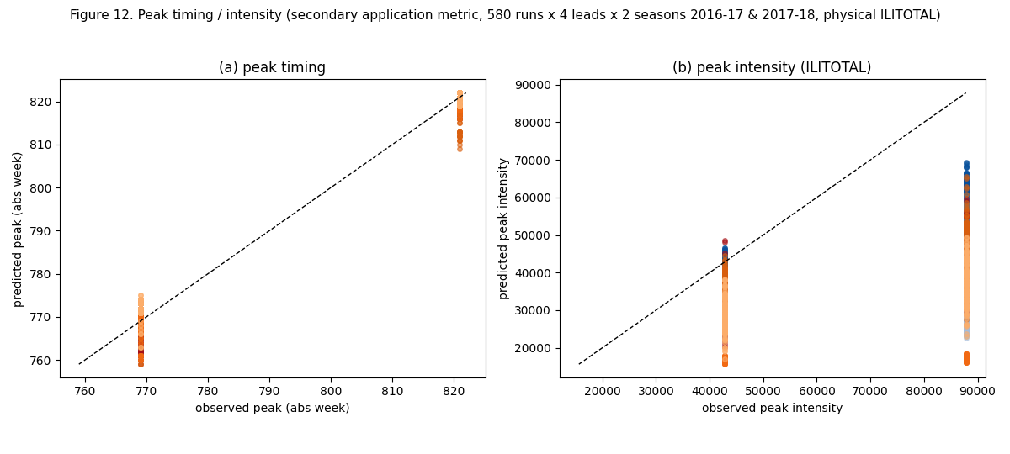
Figure 12. Peak timing / intensity across all 580 runs × 4 leads × 2 seasons (physical ILITOTAL).
3.13 Representative prediction curves (physical ILITOTAL)
Figures 9-10 plot the inverse-transformed ILITOTAL over the forecast window only,
for a representative validation forecast (origin at abs week 715 = 2016-01-24,
forecast window starting 2018-01-21) at L24 and L60, for the
LLM winner (gpt2_miflu), the Non-LLM winner (nlinear), the deterministic
seasonal_naive reference, and one additional LLM (calf_llm), each at its median
seed. The dashed line is the prediction, the solid line the observed ILITOTAL, and the
star / triangle mark the observed / predicted seasonal peaks. Figure 11 shows the
best / median / worst-seed spread for gpt2_miflu at L24.
A complete gallery of all 580 accepted runs (one panel per run, same layout) is under
../figures/gallery/ with an index.csv and manifest.json.
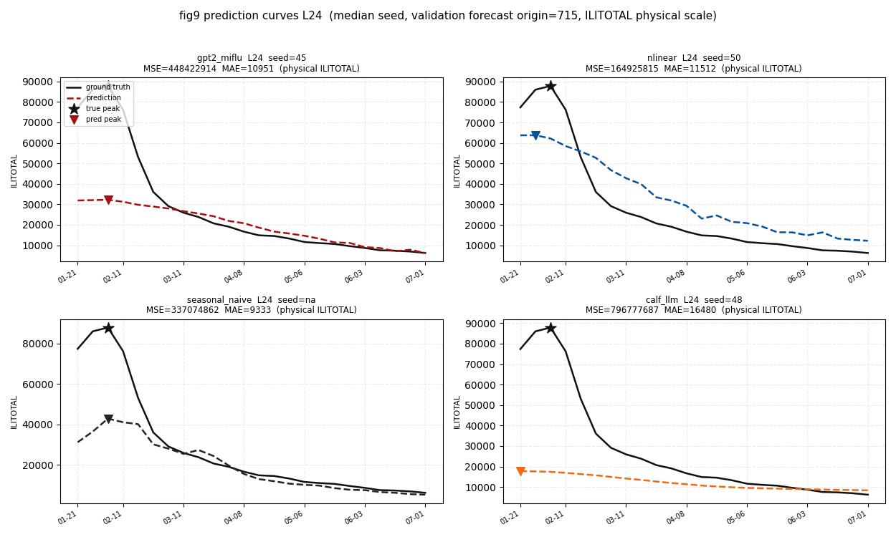
Figure 9. Prediction curves at L24 (median seed).
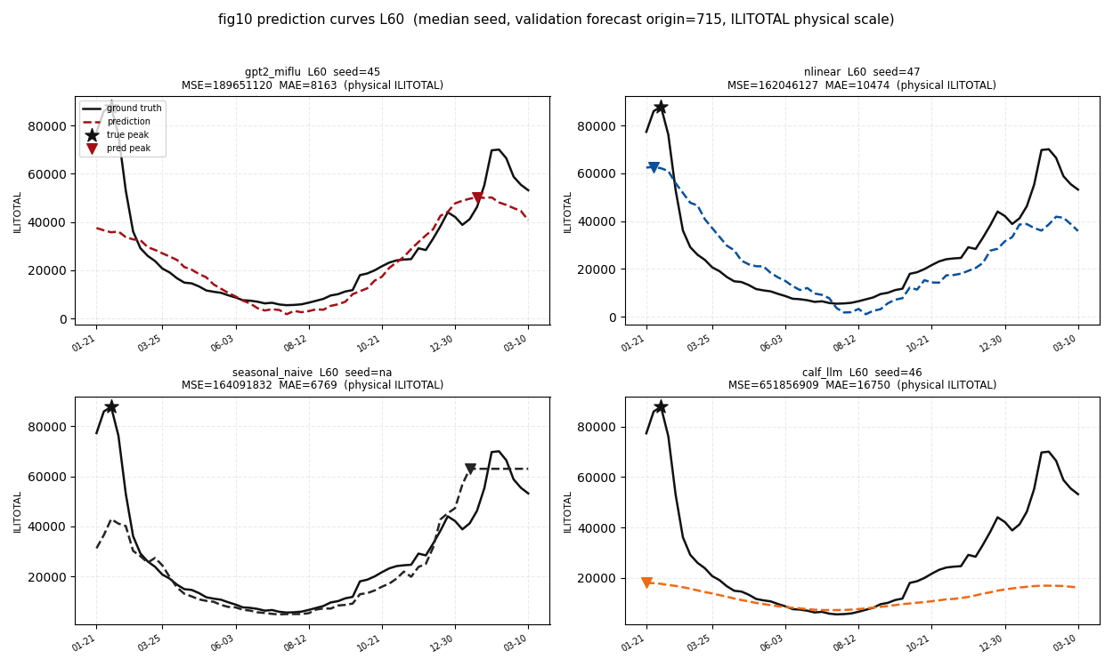
Figure 10. Prediction curves at L60 (median seed).
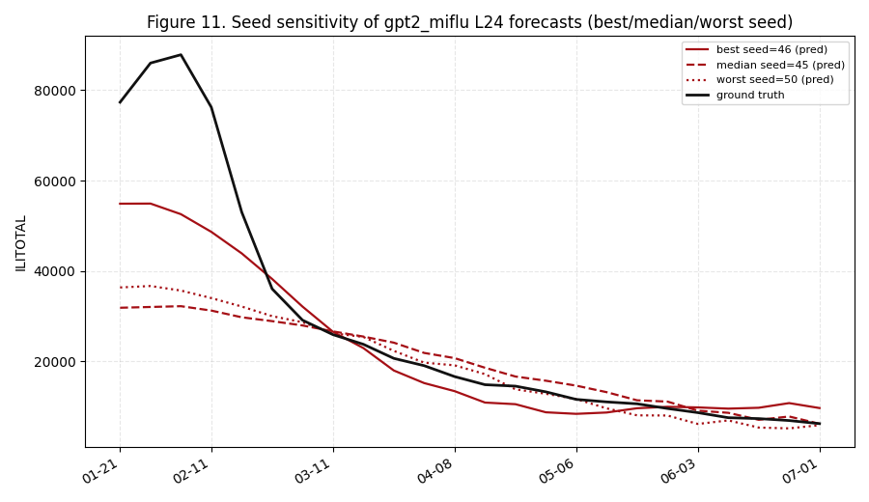
Figure 11. Seed sensitivity of gpt2_miflu L24 (best/median/worst seed).

4. Statistical Methods
• Per-horizon point estimate = mean of 10 frozen seeds (42–51).
• average_MSE_4L = arithmetic mean of the four per-horizon means.
• 95% CI = seed-level t-interval (t-distribution, df = 9).
• Winner-vs-runner-up and family comparisons = matched-seed paired t-tests (n = 10 pairs) with Cohen's d (pooled SD).
• Ablations = matched-seed paired t vs parent; controls = matched (L, seed) comparison.
• No multiple-comparison correction was applied to the exploratory ablation/control set; the single significant ablation survives Bonferroni at α = 0.05/6 = 0.0083.

5. Limitations & Pending Work
1. PTE/PIE reconstructed from durable evidence. The durable validation_predictions.csv stores target_date = None, so peak metrics were not directly aggregatable. The target week was therefore reconstructed as forecast_origin + 104 + step (verified against raw ILITOTAL, inverse-transform |diff| < 1e-3) and PTE/PIE were computed on the inverse-transformed ILITOTAL channel over two complete validation seasons (2016-2017, 2017-2018). Reported as secondary application metrics only; never used in selection.
2. 18 deferred negative controls are pending Wave-2 (parent binding = BEST_VALIDATION_LLM_AFTER_SCREENING, which is gpt2_miflu). They are not run here.
3. Test/holdout are sealed (access 0/0). No final publication champion is frozen; the Wave-1 winner is an interim screening result only.
4. Negative controls are exploratory (n = 6 cells, only L24/L60 × seeds 42–44); their conclusions are directional, not confirmatory.
5. patchtst is a "PatchTST-inspired" reimplementation (no self-supervised pretraining, no RevIN, reduced capacity) — the fidelity caveat must travel with any PatchTST claim.

6. Conclusions
1. Under the frozen selection rule, the Wave-1 winner is `gpt2_miflu` (avg MSE 4L = 0.771), with `nlinear` as the best Non-LLM (1.070) and overall runner-up. The gap is large and highly significant (p = 3.13×10⁻⁷).
2. The headline should not be "LLMs beat classical forecasters": the Non-LLM family is significantly more accurate than the LLM family (p = 1.44×10⁻⁶); the win is one model, not the paradigm.
3. The gpt2_miflu advantage over a zero-parameter seasonal_naive baseline is negative at L24/L36/L48 and positive only at L60 — seasonality explains much of the short-horizon accuracy.
4. The only text component that matters is the dataset information (+12.85%, p = 0.004); LoRA and multimodal fusion are statistically inert here.
5. The manuscript must report the runtime/storage trade-off (gpt2_miflu ≈ 409× nlinear parameters, 28× training time) and the seed instability of the LLM winner (SD 0.071) honestly.
6. On the secondary peak metrics, the MSE champion is not the best peak forecaster: nlinear leads on peak intensity (PIE 17.7%) and patchtst on peak timing (PTE 1.61 weeks); gpt2_miflu is mid-table (PTE 2.12 weeks, PIE 41.5%). seasonal_naive's low MSE does not transfer to peak timing (PTE 2.38 weeks).
Artifacts: ranking/summary tables and figures are under results/v3_clean/analysis/ (model_ranking.csv, primary_summary_statistics.csv, ilitotal_ranking.csv, selection_outcome.json, ablation_effects.csv, baseline_comparison.csv, resource_storage.csv, pte_pie_long.csv, pte_pie_aggregate.csv, pte_pie_audit.json, figures/, and the full 580-panel gallery under figures/gallery/). The machine-readable protocol snapshot is frozen_analysis_protocol.json.

7. Recommended Next Steps
1. Tutor sign-off on narrative framing — confirm the paper claims "gpt2_miflu (a specific LLM adapter) beats baselines" rather than "LLM methods beat classical methods"; decide whether seasonal_naive becomes a formal main-table baseline.
2. Wave-2 deferred controls — bind the deferred parent (BEST_VALIDATION_LLM_AFTER_SCREENING = gpt2_miflu) and run the 18 deferred negative controls; do not finalize mechanism conclusions before they complete.
3. Manuscript drafting — draft the results section against the tables/figures here, carrying the seed-SD, seasonal-baseline, and cost-trade-off caveats verbatim.
4. Test/holdout remains sealed — only after the deferred controls are reconciled and the freeze audit passes should a final publication champion be considered. Do not call the Wave-1 champion the final champion.

Appendix A — Seed-level stability
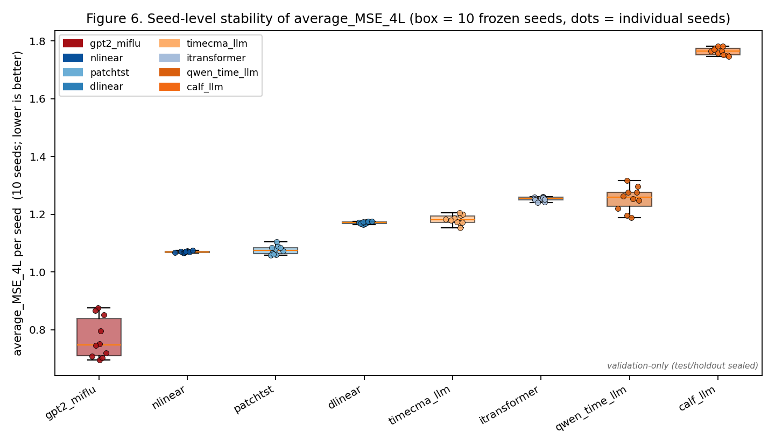
Figure 6. Seed-level stability of average_MSE_4L (box = 10 frozen seeds, dots = individual seeds). Lower MSE is better. Validation-only.

Appendix B — Accuracy vs runtime / storage
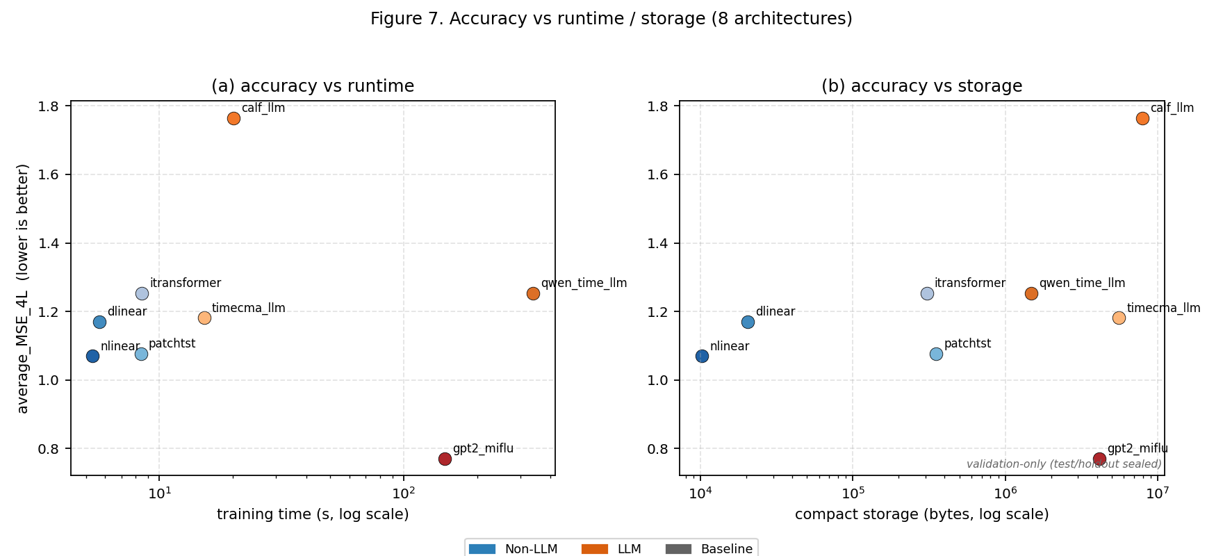
Figure 7. Accuracy vs runtime (a) and compact storage (b) for the 8 architectures. Lower MSE is better. Validation-only.

Appendix C — Wave-1 workflow and evidence-integrity
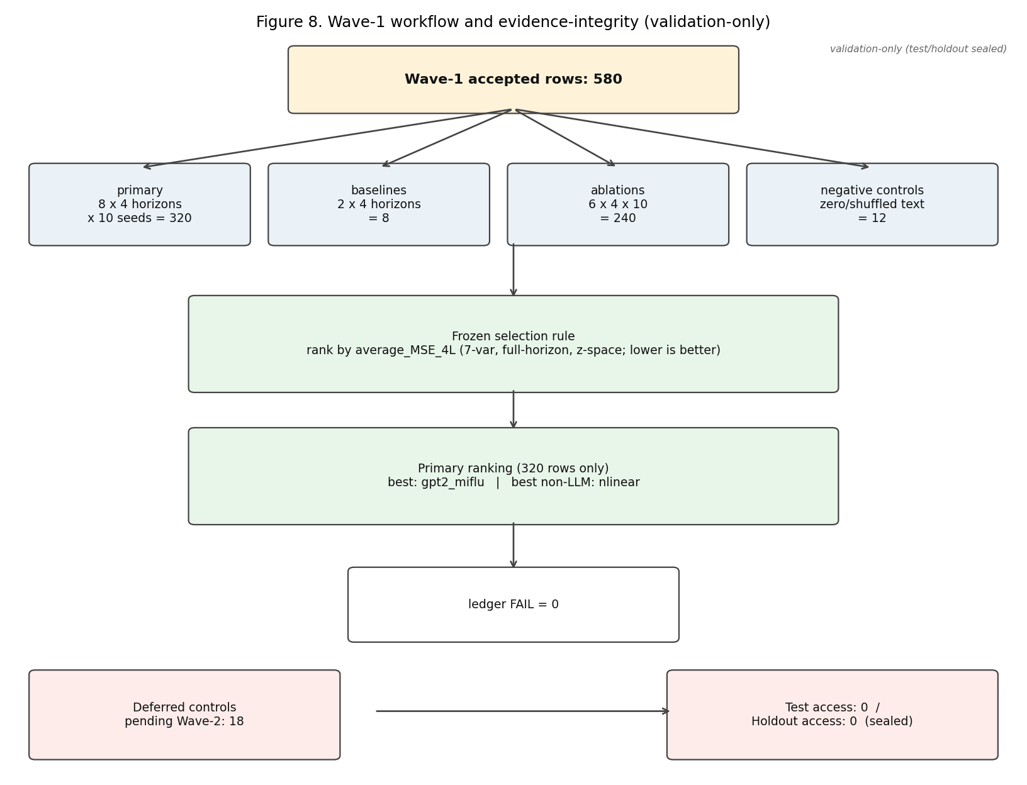
Figure 8. Wave-1 workflow and evidence-integrity. Validation-only.

