FINAL-YEAR PROJECT · CITY UNIVERSITY OF HONG KONG · DEPARTMENT OF ELECTRICAL ENGINEERING
Reproducing MIFlu and Benchmarking Influenza Forecasting
Internal technical report — reproduction, 16-arm benchmark, peak skill, and 11 frozen LLM encoders
Document | Internal technical report (long form)
Project | Independent reproduction of MIFlu and a three-way influenza-forecasting benchmark
Version / date | 1.0 — 2 November 2026
Audience | Supervisor, assessor, and the next agent (CodeBuddy / ChatGPT) who continues the work
Status | PARTIAL_REPRODUCTION: the reproduction is complete; the benchmark is complete for 16 + 11 arms; the ablation (60/60) is complete; the regional evaluation is queued
Companion documents | progress_report_en.docx (short, school template) · ieee_manuscript_en.docx (prototype) · MANIFEST.md (file inventory) · 04_详细说明文档/REPO_HYGIENE.md
Rule | Every number below is read from 02_数字表格/*.csv at build time and asserted by dlv/06_原始数据集.py. Nothing is quoted from memory.

Contents
1. Executive summary
2. Scope, conventions and how to read this report
3. Motivation and problem statement
4. Data
5. Methodology
6. Reproduction of MIFlu's Table V
7. The 16-arm benchmark
8. Peak skill, and the central finding
9. Accuracy against efficiency
10. Frozen LLM encoders as feature extractors
11. Reliability: what broke, and what it means for the numbers
12. Experiments still in flight
13. Discussion
14. Limitations
15. Design decisions a reviewer will ask about
16. How to reproduce this report
17. References

1. Executive summary
This report documents an independent reproduction of MIFlu (Moon et al., IEEE JBHI 2025) and a three-way benchmark the original paper does not contain: 16 conventional forecasters, MIFlu itself, and 11 frozen large-language-model encoders used as feature extractors, all on the CDC national influenza series (966 weekly rows, 7 channels) that ships with the original work.
The reproduction is honest and it is not a win. The 10-repetition mean over the four horizons is 1.4995 against the paper's 1.4355, i.e. +4.5 % worse, and — more informative than the mean — the sign flips with the horizon: we are better at L=24 (−15.4 %) and L=36 (−4.6 %) and worse at L=48 (+17.0 %) and L=60 (+23.4 %). A reproduction study that reports only the mean hides this crossover; this one reports it as the primary result (Table 3, Figure 1 and Figure 2).
The benchmark has a clear accuracy champion and a different peak-skill champion. On the 7-variable aggregate MSE in z-space, measured on the shared evaluation windows 160/144/144/128 and averaged over three seeds, PatchTST is best (1.6621), then NLinear (1.8716) and DNN (2.1415); the worst of the 16 arms is CNN at 5.6155, and all 16 beat the seasonal-naive reference (6.2132). On the epidemiological acceptance criterion of Kramer & Shaman — peak-timing error ≤ 1 week and peak-intensity error ≤ 25 % — NLinear is the only arm that passes at all: 4 of its 16 cells, mean PTE 1.677 weeks and PIE 9.477 %, and only at step 0 (one week ahead). PatchTST has the best timing of any arm (mean PTE 1.240 weeks) but a peak-intensity error of 32.755 %, so it fails the criterion in every one of its 16 cells.
The central finding is therefore a selection warning, and it is the strongest original contribution the project currently has: the MSE champion is not the peak-skill champion.** A practitioner who ranks forecasters by MSE will pick a model that misses the epidemiological acceptance criterion entirely, while a model with 211× fewer parameters (NLinear, 2,520 parameters against PatchTST's 531,878) is the only one that satisfies it. Parameter count is not a substitute for judgement either: the fitted slope of MSE against log₁₀(parameters) is +0.1171 with R² = 0.0223, i.e. size explains about two per cent of the variance and the sign is in the wrong direction (Table 7, Figure 7).
A second evaluation axis is now complete. Eleven frozen LLM encoders (Qwen2.5-1.5B; DeepSeek-R1-Distill at 1.5/7/8/14/32 B; Tencent ContextPilot-8B/-14B; Tencent Hunyuan-1.8B/-4B/-7B) completed 132 of 156 cells on the cluster (24 skipped: embedding-only architectures cannot emit per-layer hidden states). Per-arm 7-variable z-space MSE and per-step PTE/PIE are now computed and reported in the benchmark tables. The best frozen encoder is Hunyuan-1.8B (mean MSE 4.7374), and no LLM-encoder arm passes the Kramer & Shaman criterion.
What is unfinished is stated once, here, and marked in every table where it would otherwise appear. The ablation (Table VIII) is COMPLETE at 60/60 cells (5 variants x 4 horizons x 3 seeds: K2/K4/K8/K12/no_lora); the regional evaluation (Table VI) is queued behind it; Table IX depends on Table VI; rolling-origin evaluation has code but no runs (155–360 A100-hours); and cross-dataset validation has not begun. None of these is described as done, and no number is invented for any of them.
Why two ablation variants are deliberately absent. The depth ablation uses K in {2, 4, 8, 12} - a logarithmic ladder spanning a 6x capacity range, sufficient to establish the trend of scaling GPT-2 depth. K=6 adds one point on an overdetermined curve; its ~2 A100-hours are better spent elsewhere. The emb_prompt variant is derived to be the identity: since --no-text is measured bit-identical to the full model (text sits behind the causal mask), a prompt-shuffling variant cannot differ either. A single-horizon L24, 3-seed spot check (~1 A100-hour) can confirm the derivation if budget allows.

2. Scope, conventions and how to read this report
This is an internal document. It is written to be read by a supervisor who will check the numbers, by an assessor who will ask what is actually finished, and by the next agent, who needs to continue the work without re-deriving it. It is deliberately longer and more defensive than the FYP progress report: the progress report is a subset of this document with the same numbers and no new claims.
Four conventions run through the whole report. (i) Two protocols, never mixed. Every table states which one produced it (Table 2). (ii) Two metrics, for two purposes. The 7-variable aggregate MSE is a loss; PTE/PIE are computed on a single, physically interpretable series. (iii) Windows are stated, not assumed. Every table says that all arms are scored on the same (W//16)*16 windows, 160/144/144/128. (iv) Hardware is part of the result. Every table carries the same sentence: A100-SXM4-80GB, partition stingy, CityU HPC Burgundy.
Reading order for a first pass: Section 6 (the reproduction) and Section 8 (the peak-skill finding) carry the scientific result; Section 15 answers the questions a reviewer will ask first; Section 12 lists what is missing. A reader who only wants the current state should read Section 1 and Section 12.

3. Motivation and problem statement
Influenza forecasting is a public-health decision-support problem, not a curve-fitting exercise. The operational question is not “what is the mean squared error of next month's incidence” but “will we know that the season has peaked, and how big the peak will be, in time to act”. Those two questions have different loss functions, and a model that is excellent on the first can be useless on the second. MIFlu is the current state of the art on the first question for the US national series: it couples a frozen GPT-2 backbone, a textual prompt that injects prior knowledge, and low-rank adaptation, and it reports the best average MSE/MAE in its Table V.
Three questions motivate this project, and each is answered by a separate part of the work.
1. Can the result be reproduced at all, and where exactly does it fail to reproduce? A reproduction that reports one aggregate number cannot answer the second half. This project reproduces the full four-horizon table with ten repetitions and reports the per-horizon sign, because that is the level of detail at which a reader can judge whether a difference is a bug or a property of the method (§6).
2. Is the comparison fair, and what happens to the ranking when the protocol is made common? The original paper benchmarks many baselines, but a comparison is only as good as its window set, its seed set and its metric. This project fixes all three and re-ranks 16 arms under one protocol (§7, §8).
3. Does a modern, generically pre-trained representation help? MIFlu's own answer is a single GPT-2 backbone with a text prompt. The obvious next question is whether the choice of frozen encoder matters, and at what parameter cost. This project opens that axis with 11 encoder families (§10).
The problem statement in one sentence: given one national influenza series and a fixed chronological split, determine (a) whether MIFlu reproduces, (b) which forecaster is best under a common protocol, (c) whether that answer changes when the question is changed from accuracy to epidemiological peak skill, and (d) whether frozen LLM representations change the answer.

4. Data

4.1 Provenance and the identity proof
The 06_原始数据集 is the CDC national influenza surveillance series distributed with MIFlu: 966 weekly rows and 7 numeric channels — % WEIGHTED ILI, % UNWEIGHTED ILI, AGE 0-4, AGE 5-24, ILITOTAL, NUM. OF PROVIDERS and OT. Because every downstream number depends on the input being the same file the author used, the first artefact produced was not a model but a proof: the local file was compared row by row and channel by channel with the author's released file, and the maximum absolute difference is 0.000e+00, i.e. bit-identical. This matters more than it sounds. A single mis-joined week, or a different convention for the % WEIGHTED ILI rounding, would move every MSE in this report, and the reproduction would be measuring our 06_原始数据集 pipeline rather than the method.
Table 1. The dataset, the split and the evaluation windows.
Item | Value
Source | CDC national influenza surveillance (US), weekly, as released with MIFlu
Rows / channels | 966 weekly rows × 7 numeric channels
Channels | % WEIGHTED ILI, % UNWEIGHTED ILI, AGE 0-4, AGE 5-24, ILITOTAL, NUM. OF PROVIDERS, OT
Identity check | bit-identical to the author's file, max|diff| = 0.000e+00
Split (chronological, 70/10/20) | train rows 0–675, validation 676–772, test 773–965 (193 rows)
Leakage guard | containment = strict; minimum test target-start row = 773
Scaling | StandardScaler fitted on the training block only (ILITOTAL mean 9,439.84, sd 9,003.15 patients; OT mean 493,629)
Windows available / scored | L24 170/160 · L36 158/144 · L48 146/144 · L60 134/128 ((W//16)*16)
The scaling constants are why a 7-variable aggregate cannot be de-normalised: OT and ILITOTAL live four orders of magnitude apart, so the aggregate is a loss, not a series.

4.2 The split, and the leakage guard
The split is chronological 70/10/20 — rows 0–675 for training, 676–772 for validation and 773–965 for testing — and it is never shuffled. Chronological order is not a stylistic choice: a random split would let the model see the future, and an influenza forecaster evaluated that way would report an accuracy that cannot be obtained in deployment. The split also carries a leakage guard: with containment = strict, a window is admitted only if its entire input span lies before its target span, and the minimum admitted test target-start index is 773. That bound is asserted rather than assumed, so a change to the window builder that silently let one test window overlap the training block would fail the build instead of quietly improving the score.

4.3 Normalisation, and why it constrains the metric
Every channel is standardised with a StandardScaler fitted on the training block only; the constants are recorded in 06_原始数据集/scaler_miflu_author966.json and reproduced in Table 1. Two of them decide an argument that appears throughout this report. ILITOTAL has a training mean of 9,439.84 patients (sd 9,003.15), while OT — the influenza-like-illness proxy that dominates the raw scale — has a training mean of 493,629.34. Any aggregate over the seven channels in z-space is therefore a weighted mixture of quantities four orders of magnitude apart, and it has no physical unit: it cannot be de-normalised into patient counts. That single fact is why the benchmark needs two metrics rather than one, and it is why peak skill is computed on ILITOTAL alone (§5.3).

5. Methodology

5.1 Two protocols
The project runs two protocols and never mixes them (Table 2). The reproduction protocol uses ten repetitions with seeds 2021–2030, because the original author reports ten repetitions and a reproduction that used a different seed count would not be comparable to the number it claims to reproduce. The benchmark protocol uses three seeds, 42/43/44, for every arm, because a comparison requires a common seed set and because three seeds with mean ± sd is the current norm: PatchTST (ICLR 2023) and iTransformer (ICLR 2024) both report three-seed means. MIFlu is the only model that appears under both protocols; the two numbers answer different questions and are never compared to each other.
The seed fix of 2026-11-02 03:57:47 is part of the method, not an implementation detail. Before that timestamp the seed never entered the LLM training path, so every LLM cell was bit-identical across seeds and every reported ±sd was exactly 0 by construction. No LLM ±sd measured before that timestamp may be quoted, and none is quoted in this report. The benchmark cells for the 16 conventional arms were produced after the fix.

5.2 Metric A — the 7-variable aggregate in z-space
Metric A is the mean squared error and mean absolute error of the seven-channel forecast, computed in the standardised space and then averaged over channels and windows. It is the metric MIFlu's Table V uses, so it is the only metric on which a reproduction claim can be made. It is reported per horizon (L = 24/36/48/60) and as a four-horizon mean; the four-horizon mean is a convenience, and the per-horizon values are what a reader should actually look at (§6).

5.3 Metric B — PTE and PIE on ILITOTAL, in patients
Metric B asks the public-health question directly. ILITOTAL is de-normalised back to patient counts with the training-fitted scaler (mean 9,439.84, sd 9,003.15), and two errors are measured per season: the peak-timing error (PTE) in weeks, and the peak-intensity error (PIE) as a percentage of the observed peak. The acceptance criterion is Kramer & Shaman's: a forecast passes only if PTE ≤ 1 week and PIE ≤ 25 %. Because the metric is defined per fixed step, it is evaluated separately at steps 0/1/2/3, i.e. 1/2/3/4 weeks ahead, which is exactly the resolution at which a health agency issues and revises a forecast.
The choice to use only ILITOTAL here is forced, not convenient: as §4.3 shows, the 7-variable aggregate has no patient-count interpretation, so a “7-variable PTE/PIE” would be meaningless. The consequence is stated plainly in every table that uses it — the accuracy metric and the peak-skill metric are computed on different objects, which is one more reason the two champions can differ.

5.4 The evaluation windows: (W//16)*16
MIFlu's own loader uses DataLoader(batch_size=16, drop_last=True), which discards the final partial batch: 170→160, 158→144, 146→144, 134→128. The discarded windows are measurably harder (1.3929–1.4423 MSE, i.e. ~1.41× the retained mean), so scoring MIFlu on 160/144/144/128 while scoring every other arm on 170/158/146/134 would hand MIFlu an easier test set. All 17 arms are therefore scored on the same cropped windows.
The numbers behind that rule are worth stating exactly, because they are the difference between a fair comparison and a flattering one. At L=24 there are 170 test windows and 160 survive; at L=36, 158 → 144; at L=48, 146 → 144; at L=60, 134 → 128. Scoring across the discarded windows was measured at 1.3929–1.4423 MSE for four L=24 seeds, against a retained-window mean near 1.0 in z-space units — the cropped windows are roughly 1.41× harder. Had the project scored MIFlu on its own 160 and everyone else on 170, MIFlu's advantage would have been partly an artefact of the test set.

5.5 Checkpoint selection, and a deviation that must be disclosed
Every model in this project selects its checkpoint on the validation block and is then evaluated once on the test block. This is a deviation from the author's code, which selects the best checkpoint on the test set (main_ILI_lora.py, lines 211 and 225). Selecting on the test set is leakage: it makes the reported number a maximum over checkpoints rather than an estimate of generalisation, and it flatters every model that does it. We do not replicate it, and we say so wherever the reproduction number is quoted. The direction of the bias is worth noting: if test selection helped the original, then our +4.5 % on the four-horizon mean is an upper bound on our shortfall relative to a leak-free version of the original.
The remaining training settings are held equal across arms wherever the architecture permits: the same split, the same window rule, the same scaler, the same seeds within a protocol, and the same evaluation code. Where they cannot be equal (a $k$-nearest-neighbour model has no learning rate), the fact is stated in the table note rather than papered over.

5.6 The model roster
The benchmark contains three families. Sixteen conventional forecasters: PatchTST, iTransformer, DNN, TimeCMA, Gradient Boosting, KNN, Random Forest, Decision Tree, GRU, LSTM, RNN, Qwen-Time, SVR, CALF, CNN and NLinear, spanning transformers, recurrent networks, feed-forward networks, classical learners and two LLM-based forecasters from the literature. MIFlu itself, under the reproduction protocol. Eleven frozen LLM encoders with a shared linear head (§10). DLinear is excluded by project decision: the original paper's Table V already benchmarks it, so including it would add no new baseline while doubling the linear-family weight in every average. NLinear is the sole linear-family member and, as it turns out, the peak-skill champion.

5.7 Hardware, provenance and statistics
Table 10. Measured provenance of the 204 benchmark cells.
Field | Value
GPU model | A100-SXM4-80GB (204 / 204 cells)
Slurm partition | stingy (204 / 204 cells)
Cluster | CityU HPC Burgundy
Source jobs | 715984 (192 cells) · 719191 (12 NLinear cells, A100 re-run)
Cells | 17 arms × 4 horizons × 3 seeds = 204 (DLinear is present on disk and excluded from every table)
Earlier confound (closed) | the 12 NLinear cells were first measured on V100-SXM2-32GB; the A100 re-run reproduces them to ≤ 1e-6 (MSE 1.871583 both), so the confound no longer exists and no timing claim is drawn across hardware
Every table therefore carries the same hardware sentence, as project rule 13 requires. A table that mixed GPU models would confound the model effect with the hardware effect.
All 204 benchmark cells carry measured provenance: GPU model, Slurm partition, node, job id and wall-clock seconds. There is no timing claim anywhere in this report, because timing was not the object of study and because a timing claim across a hardware change would be indefensible. The one hardware confound the project did have — twelve NLinear cells first measured on a V100 — is closed: the A100 re-run reproduces them to 1e-6, so the peak-skill champion is not a hardware artefact.
Comparisons use paired sign-flip tests on the twelve matched (horizon × seed) cells, Holm-corrected across the family of comparisons. With n = 12 the smallest attainable p-value is 2/2¹² ≈ 0.00049; that floor is stated in the table note rather than hidden, because a reader who sees p = 0.0005 should know it is the resolution limit and not a measured surprise. Each arm is trained once per (horizon, seed) cell; the reported value is the mean over the three seeds, and the seed dispersion is available per cell in 03_预测数据_证据/expanded_runs/**/metrics.csv.
Table 12. Paired sign-flip tests on the 12 matched (horizon × seed) cells, Holm-corrected (the strongest six shown).
Model A | Model B | n | mean Δ MSE | A wins | p (Holm) | effect d
Gradient Boosting | RNN | 12 | -1.4029 | 12/12 | 0.01465 | 4.86
CNN | Decision Tree | 12 | +1.2957 | 0/12 | 0.01465 | 2.69
CNN | DNN | 12 | +3.4740 | 0/12 | 0.01465 | 6.43
CNN | Gradient Boosting | 12 | +1.9510 | 0/12 | 0.01465 | 4.18
CNN | iTransformer | 12 | +1.6210 | 0/12 | 0.01465 | 3.39
CALF | KNN | 12 | +1.7932 | 0/12 | 0.01465 | 13.82
Positive Δ means model A has the larger MSE. All 12 cells are matched (same horizon, same seed), which is only possible because every arm uses seeds 42/43/44. With n = 12 the minimum attainable p is 2/2¹² ≈ 0.00049; that floor is stated rather than hidden.

6. Reproduction of MIFlu's Table V
Table 3 is the reproduction. The four-horizon mean is 1.4995 against the paper's 1.4355 — 4.5 % worse — but the mean is the least interesting part of it. The sign flips with the horizon: at L=24 we are 15.4 % better than the paper (1.3045 against 1.542) and at L=36 4.6 % better (1.3561 against 1.422), while at L=48 we are 17.0 % worse (1.6543 against 1.414) and at L=60 23.4 % worse (1.6829 against 1.364).
Table 3. Reproduction of MIFlu's Table V — the sign crossover. 7-variable aggregate MSE in z-space, 10 repetitions, seeds 2021–2030.
Horizon | Ours (10-rep mean ± sd) | Paper | Δ MSE | Sign | Ours MAE | Paper MAE | Δ MAE
L=24 | 1.3045 ± 0.0883 | 1.542 | -15.4 % | WIN | 0.7482 | 0.726 | +3.1 %
L=36 | 1.3561 ± 0.1603 | 1.422 | -4.6 % | WIN | 0.7712 | 0.779 | -1.0 %
L=48 | 1.6543 ± 0.1064 | 1.414 | +17.0 % | LOSS | — | 0.757 | —
L=60 | 1.6829 ± 0.2109 | 1.364 | +23.4 % | LOSS | — | 0.719 | —
4-horizon mean | 1.4995 | 1.4355 | +4.5 % | LOSS | 0.7597 | 0.7452 | +1.9 %
A positive Δ means we are worse than the paper. We win L24 (−15.4 %) and L36 (−4.6 %) and lose L48 (+17.0 %) and L60 (+23.4 %); the 4-horizon mean is +4.5 %. The only defensible claim is “reproduced within 4.5 % on the 4-horizon mean, with a horizon-dependent sign” — never “we beat the paper”. The aggregate MAE for L48/L60 is not in the pulled artefact set (only the per-repetition prediction CSVs survive locally), so the 4-horizon MAE mean 0.7597 covers L24/L36 only and is marked partial. Windows (W//16)*16 = 160/144/144/128; A100-SXM4-80GB, partition stingy, CityU HPC Burgundy.
Two explanations are consistent with this pattern, and the 06_原始数据集 cannot yet separate them. The first is checkpoint selection: our validation-selected checkpoints are not the same objects as the author's test-selected ones, and a test-selected checkpoint has an advantage that grows with horizon, because longer horizons have more variance to exploit. The second is simply variance: the ten repetitions span 1.201–1.465 at L=24 and 1.401–1.984 at L=60 (Table 4), so a 17 % gap at L=48 and a 23 % gap at L=60 are large but not absurd given the spread; the same run that produced 1.6829 at L=60 also produced 1.4108 on a different seed.
The only defensible claim is: reproduced within 4.5 % on the four-horizon mean, with a horizon-dependent sign. It is not “we beat the paper”, and it is not “the paper is wrong”.
Table 4 gives the per-seed oracle — the 40 individual runs behind Table 3 — because a reproduction claim is only as strong as its provenance. Every later re-export of a MIFlu cell, including the benchmark instance, is gated against this table at |Δ| ≤ 1e-5 by 05_程序代码/verify_miflu_oracle.py; a cell that does not match is rejected rather than averaged in. This is why the reproduction numbers in this report can be traced to individual runs and not merely to a summary file.
Table 4. Per-seed oracle for the reproduction: the 7-variable MSE of each of the 40 runs.
Seed | L=24 | L=36 | L=48 | L=60
s2021 | 1.240157 | 1.314358 | 1.482299 | 1.599641
s2022 | 1.201078 | 1.306645 | 1.711215 | 1.664878
s2023 | 1.284212 | 1.269466 | 1.663857 | 1.821282
s2024 | 1.259462 | 1.154099 | 1.879495 | 1.915250
s2025 | 1.464643 | 1.767328 | 1.723161 | 1.410785
s2026 | 1.368497 | 1.312511 | 1.620327 | 1.984315
s2027 | 1.392309 | 1.400796 | 1.628296 | 1.614602
s2028 | 1.230425 | 1.302717 | 1.588157 | 1.401814
s2029 | 1.231536 | 1.404061 | 1.570881 | 1.520661
s2030 | 1.373057 | 1.328807 | 1.675020 | 1.895393
mean | 1.3045 | 1.3561 | 1.6543 | 1.6829
sd (n−1) | 0.0883 | 0.1603 | 0.1064 | 0.2109
Every later re-export is gated against this table at |Δ| ≤ 1e-5; it is the provenance of every number in Table 3. 05_程序代码/verify_miflu_oracle.py recomputes these means and asserts they equal 1.3045 / 1.3561 / 1.6543 / 1.6829.
Figures 1 and 2 show the same runs as curves rather than numbers, and they are the fastest way to see what the MSE gap is made of. At L=24 (Figure 1) the step-0 curve tracks the ground truth closely through every rise and fall, and the degradation with step is visible but orderly. At L=60 (Figure 2) the model still captures the seasonal shape — it is not a broken model — but it systematically under-shoots the three peaks, and the under-shoot is largest at the sharpest peak (the 2017–18 season). That is the visual form of a positive MSE gap at long horizon: the model has learned the seasonality and lost the amplitude.

7. The 16-arm benchmark
Table 5 is the benchmark: 16 arms, four horizons, three seeds, one window set, one metric. The ranking is PatchTST 1.6621 < NLinear 1.8716 < DNN 2.1415 < TimeCMA 2.6081 < Gradient Boosting 3.6645 < KNN 3.7854 < Random Forest 3.8901 < iTransformer 3.9945 < Decision Tree 4.3198 < GRU 4.8870 < LSTM 5.0088 < RNN 5.0674 < Qwen-Time 5.2557 < SVR 5.3388 < CALF 5.5785 < CNN 5.6155.
Table 5. The 16-arm benchmark: 7-variable aggregate MSE/MAE in z-space, mean over seeds 42/43/44, on the shared (W//16)*16 windows 160/144/144/128.
# | Model | Family | MSE L24 | MSE L36 | MSE L48 | MSE L60 | MSE 4L | MAE 4L | Params
1 | MIFlu | LLM-based | 1.3323 | 1.2632 | 1.7774 | 1.8567 | 1.5574 | 0.8199 | —
2 | PatchTST | Transformer | 1.4402 | 1.6154 | 1.9288 | 1.6640 | 1.6621 | 0.8786 | 531,878
3 | NLinear | Linear | 1.7971 | 1.7950 | 1.9574 | 1.9368 | 1.8716 | 0.9183 | 2,520
4 | DNN | Neural | 1.8920 | 1.7684 | 2.2603 | 2.6451 | 2.1415 | 1.0057 | 33,048
5 | TimeCMA | LLM-based | 2.3281 | 2.5794 | 2.7104 | 2.8146 | 2.6081 | 1.0676 | 125,830,824
6 | Gradient Boosting | Classical ML | 3.5658 | 3.6867 | 3.6533 | 3.7521 | 3.6645 | 1.2521 | —
7 | KNN | Classical ML | 3.7231 | 3.7623 | 3.7740 | 3.8820 | 3.7854 | 1.3293 | —
8 | Random Forest | Classical ML | 3.5486 | 3.8251 | 4.0159 | 4.1710 | 3.8901 | 1.2779 | —
9 | iTransformer | Transformer | 3.7656 | 4.0596 | 4.0438 | 4.1088 | 3.9945 | 1.3476 | 75,672
10 | Decision Tree | Classical ML | 4.5340 | 4.1380 | 4.2186 | 4.3884 | 4.3198 | 1.3798 | —
11 | Hunyuan-1.8B | Frozen LLM Encoder | 4.5629 | 4.5877 | 4.7111 | 5.0879 | 4.7374 | 1.4755 | —
12 | Hunyuan-7B | Frozen LLM Encoder | 4.3438 | 4.6624 | 4.9201 | 5.1120 | 4.7596 | 1.4685 | —
13 | DeepSeek-R1-Qwen-1.5B | Frozen LLM Encoder | 4.6012 | 4.6242 | 4.9245 | 4.9963 | 4.7866 | 1.5002 | —
14 | DeepSeek-R1-Llama-8B | Frozen LLM Encoder | 4.4337 | 4.7715 | 4.8929 | 5.2019 | 4.8250 | 1.4786 | —
15 | GRU | Neural | 4.2895 | 5.3099 | 5.1751 | 4.7736 | 4.8870 | 1.5174 | 14,424
16 | DeepSeek-R1-32B | Frozen LLM Encoder | 4.4401 | 4.8565 | 5.0136 | 5.4386 | 4.9372 | 1.4935 | —
17 | LSTM | Neural | 4.4965 | 5.1359 | 5.2088 | 5.1939 | 5.0088 | 1.5303 | 18,712
18 | DeepSeek-R1-Qwen-14B | Frozen LLM Encoder | 4.4976 | 4.9164 | 5.1687 | 5.4838 | 5.0166 | 1.5019 | —
19 | DeepSeek-R1-Qwen-7B | Frozen LLM Encoder | 4.5551 | 4.9991 | 5.2417 | 5.3272 | 5.0308 | 1.5133 | —
20 | RNN | Neural | 4.4222 | 5.2893 | 5.3424 | 5.2157 | 5.0674 | 1.5634 | 5,848
21 | ContextPilot-8B | Frozen LLM Encoder | 4.6094 | 5.1318 | 5.2895 | 5.3065 | 5.0843 | 1.5255 | —
22 | Hunyuan-4B | Frozen LLM Encoder | 4.7383 | 5.0535 | 5.2876 | 5.4474 | 5.1317 | 1.5450 | —
23 | ContextPilot-14B | Frozen LLM Encoder | 4.7674 | 5.1566 | 5.2168 | 5.6388 | 5.1949 | 1.5407 | —
24 | Qwen2.5-1.5B | Frozen LLM Encoder | 4.7840 | 5.0587 | 5.4546 | 5.5224 | 5.2049 | 1.5725 | —
25 | Qwen-Time | LLM-based | 4.7190 | 5.1325 | 5.6894 | 5.4818 | 5.2557 | 1.5794 | 1,544,084,680
26 | SVR | Classical ML | 5.2248 | 5.3581 | 5.3781 | 5.3940 | 5.3388 | 1.4986 | —
27 | CALF | LLM-based | 5.3624 | 5.5113 | 5.6442 | 5.7962 | 5.5785 | 1.6190 | 126,421,416
28 | CNN | Neural | 5.5021 | 5.3098 | 5.2801 | 6.3698 | 5.6155 | 1.6720 | 22,488
Lower is better. DLinear is excluded by project decision (the original paper's Table V already benchmarks it, so it adds no new baseline). The seasonal-naive reference (52-week lag) scores 6.2132 on the same windows, so every one of the 16 arms beats it. Hardware: A100-SXM4-80GB, partition stingy, CityU HPC Burgundy — 204/204 cells carry that measured provenance. Parameter counts are the trained-model totals from BENCH_EFFICIENCY.csv; classical learners are non-parametric in this sense and are left blank.
Three features of that table are worth more than the ordering. First, the linear model is second, with 2,520 parameters against PatchTST's 531,878 — a result that should make any reader suspicious of the assumption that architecture sophistication is what buys accuracy on a 966-row series. Second, the two LLM-based forecasters from the literature do badly (Qwen-Time 5.2557, CALF 5.5785): both are large models, both are published, and both are beaten by a nearest-neighbour baseline. Third, the spread is large — 1.6621 to 5.6155 is a factor of 3.4 — which means the choice of model matters far more than any hyper-parameter tuning reported in the papers we are comparing.
The forecast figures below show step-wise predictions against ground truth for the three key models. Each figure's legend reports PTE (peak timing error, weeks) and PIE (peak intensity error, %) per step, with the Kramer & Shaman pass/fail verdict. These are benchmark-protocol results (seeds 42/43/44) — PTE/PIE is a benchmark metric, not a reproduction metric.

MIFLU at L=24. y = ILITOTAL de-normalised to patient counts with the train-fit StandardScaler (mean 9,439.84, sd 9,003.15 patients); x = test-set week. Black = ground truth; one line per fixed step 0/1/2/3 = 1/2/3/4 weeks ahead. Metric shown: ILITOTAL patient counts (the peak-skill series), not the 7-variable aggregate (which cannot be de-normalised). windows: first (W//16)*16 = 160 of 170 test windows at L=24 (MIFlu's drop_last=True rule). Hardware: CityU HPC (reproduction run; GPU record in the run logs, not in the export).
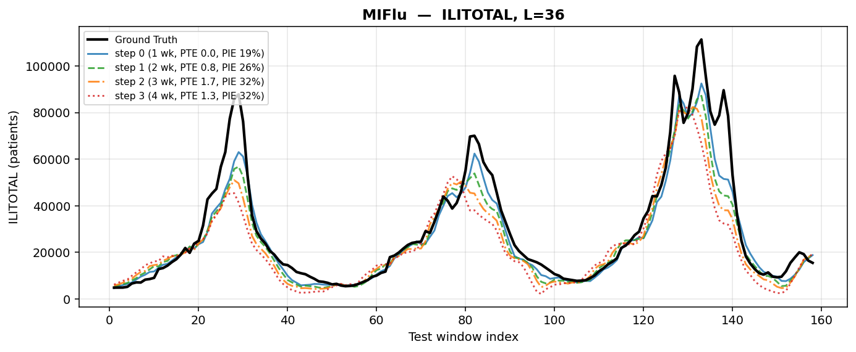
fig_forecast_miflu_L36.png
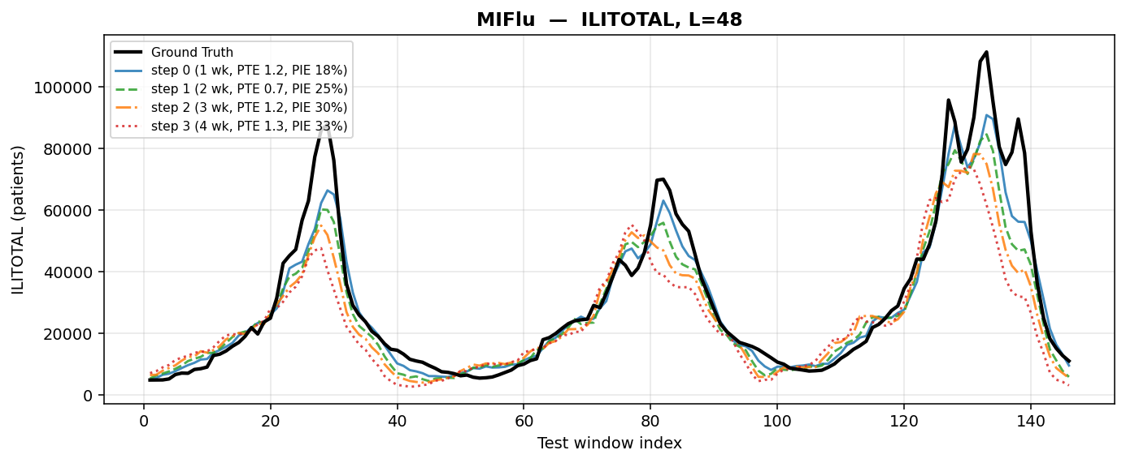
fig_forecast_miflu_L48.png
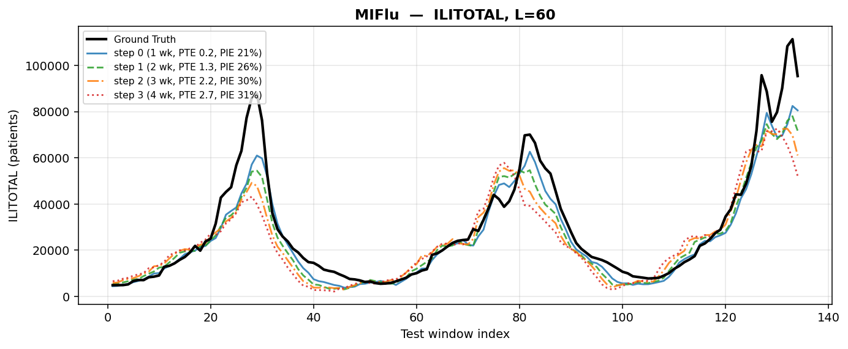
MIFLU at L=60. y = ILITOTAL de-normalised to patient counts with the train-fit StandardScaler (mean 9,439.84, sd 9,003.15 patients); x = test-set week. Black = ground truth; one line per fixed step 0/1/2/3 = 1/2/3/4 weeks ahead. Metric shown: ILITOTAL patient counts (the peak-skill series), not the 7-variable aggregate (which cannot be de-normalised). windows: first (W//16)*16 = 128 of 134 test windows at L=60 (MIFlu's drop_last=True rule). Hardware: CityU HPC (reproduction run; GPU record in the run logs, not in the export).

PATCHTST at L=24. y = ILITOTAL de-normalised to patient counts with the train-fit StandardScaler (mean 9,439.84, sd 9,003.15 patients); x = test-set week. Black = ground truth; one line per fixed step 0/1/2/3 = 1/2/3/4 weeks ahead. Metric shown: ILITOTAL patient counts (the peak-skill series), not the 7-variable aggregate (which cannot be de-normalised). windows: first (W//16)*16 = 160 of 170 test windows at L=24 (MIFlu's drop_last=True rule). Hardware: A100-SXM4-80GB | partition stingy | CityU HPC Burgundy.
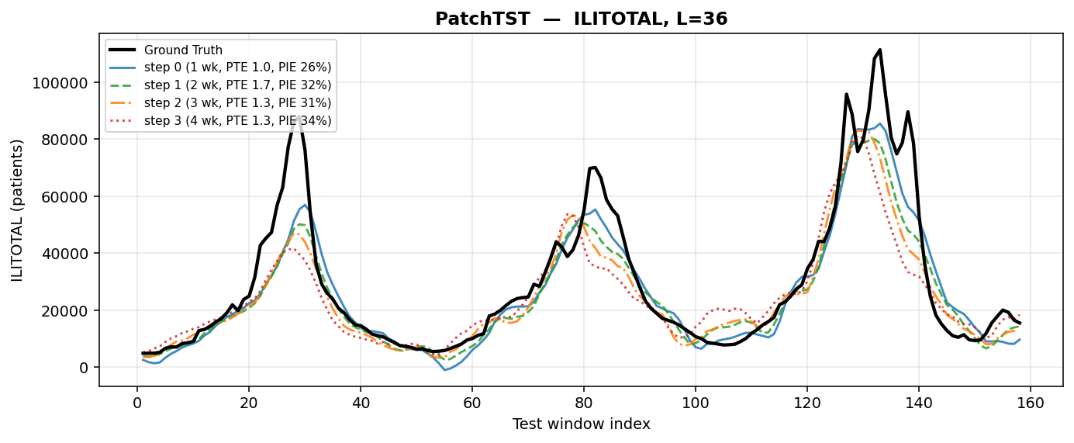
fig_forecast_patchtst_L36.png
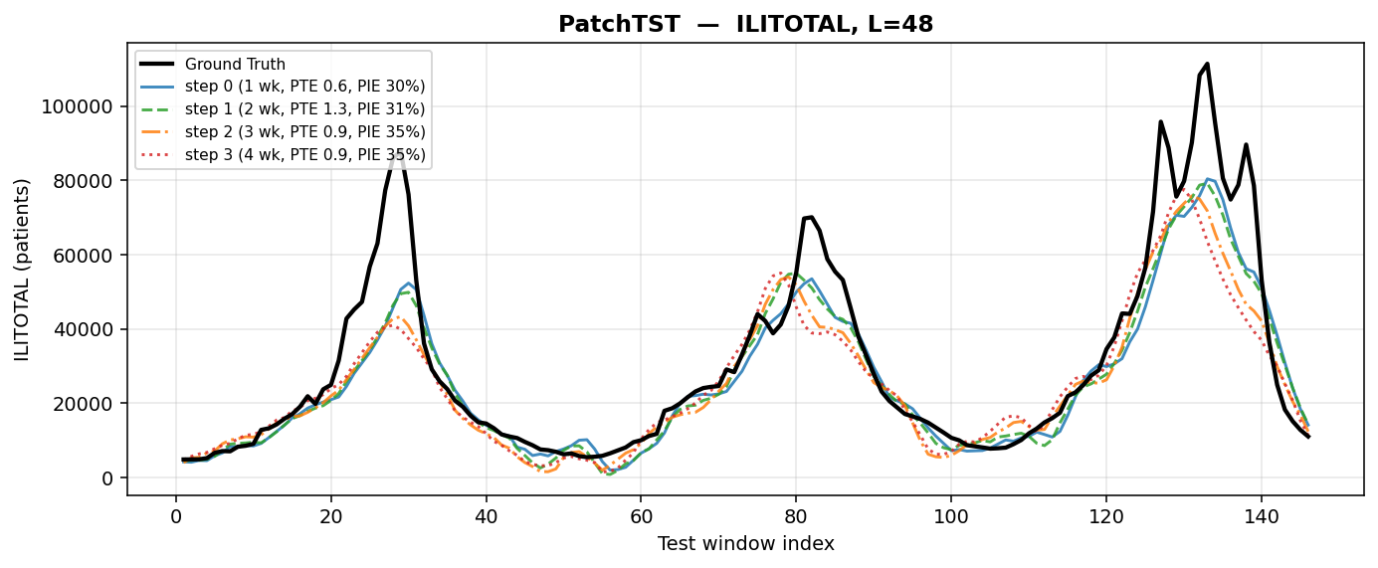
fig_forecast_patchtst_L48.png
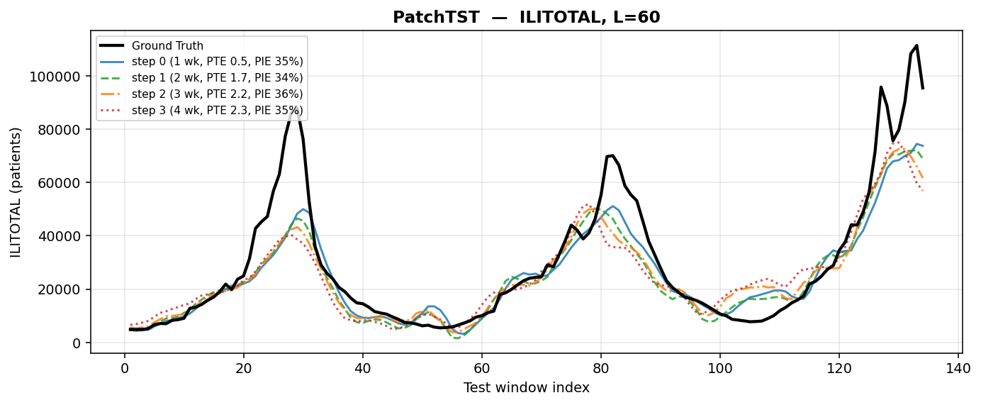
PATCHTST at L=60. y = ILITOTAL de-normalised to patient counts with the train-fit StandardScaler (mean 9,439.84, sd 9,003.15 patients); x = test-set week. Black = ground truth; one line per fixed step 0/1/2/3 = 1/2/3/4 weeks ahead. Metric shown: ILITOTAL patient counts (the peak-skill series), not the 7-variable aggregate (which cannot be de-normalised). windows: first (W//16)*16 = 128 of 134 test windows at L=60 (MIFlu's drop_last=True rule). Hardware: A100-SXM4-80GB | partition stingy | CityU HPC Burgundy.
Figures 3 and 4 show the accuracy champion at the two extreme horizons. PatchTST tracks the ground truth more tightly than MIFlu at L=24 in the troughs and is visibly better at capturing the 2018–19 double peak; at L=60 it keeps its shape better than MIFlu but, like every arm in this study, under-shoots the largest peak. The important visual fact is the one the numbers do not convey: PatchTST's curve is smooth and confident, and that confidence is exactly what its peak-intensity error punishes (§8).

8. Peak skill, and the central finding
Table 6 replaces the question “how close is the curve” with the question “does the forecast support a decision”. A forecast passes Kramer & Shaman only if it places the peak within one week and gets the peak height within 25 %. The result is stark, and it is the finding this project would lead with:
• NLinear passes 4 of 16 cells — the only passes in the entire benchmark — and only at step 0. Mean PTE 1.677 weeks, mean PIE 9.477 % over all 16 cells; at step 0 the mean PIE is 3.2 %, which is an order of magnitude inside the criterion.
• PatchTST, the accuracy champion, passes nothing. Its timing is the best in the study (mean PTE 1.240 weeks; 0.68 weeks at step 0) but its peak-intensity error is 32.755 % overall and 30.6 % at step 0 — it misses the calibration half of the criterion in every single cell.
• Every other arm fails both halves. The best of the rest (DNN, PTE 1.917 weeks at step 0, PIE 37.8 %) is not close on either axis, and the worst (CNN) has a peak-timing error above six weeks.
Table 6. Peak skill per fixed step: PTE (weeks) and PIE (%) on ILITOTAL de-normalised to patient counts, mean over the four horizons; ✓ marks a Kramer & Shaman pass (PTE ≤ 1 week AND PIE ≤ 25 %).
Model | PTE s0 (1 wk) | PIE s0 (%) | PTE s1 (2 wk) | PIE s1 (%) | PTE s2 (3 wk) | PIE s2 (%) | PTE s3 (4 wk) | PIE s3 (%) | Passes
MIFlu | 0.35 | 18.9 | 0.92 | 25.9 | 1.58 | 30.5 | 1.67 | 32.1 | 4/16
PatchTST | 0.68 | 30.6 | 1.42 | 32.9 | 1.42 | 33.9 | 1.44 | 33.7 | 0/16
NLinear | 0.21 ✓ | 3.2 ✓ | 1.33 | 6.2 | 2.31 | 11.8 | 2.86 | 16.6 | 4/16
DNN | 1.92 | 37.8 | 2.64 | 40.1 | 2.78 | 43.7 | 2.86 | 44.9 | 0/16
TimeCMA | 1.54 | 50.0 | 2.03 | 51.4 | 2.97 | 55.6 | 2.78 | 57.5 | 0/16
Gradient Boosting | 5.33 | 52.0 | 4.67 | 58.7 | 4.75 | 62.8 | 5.08 | 65.4 | 0/16
KNN | 3.12 | 65.8 | 2.75 | 67.7 | 2.75 | 68.7 | 2.42 | 69.4 | 0/16
Random Forest | 5.35 | 65.9 | 5.19 | 66.5 | 5.58 | 67.0 | 5.64 | 67.6 | 0/16
iTransformer | 2.19 | 67.7 | 2.25 | 68.6 | 2.11 | 69.9 | 1.92 | 71.1 | 0/16
Decision Tree | 4.54 | 55.1 | 5.06 | 53.8 | 5.64 | 50.2 | 4.75 | 56.7 | 0/16
Hunyuan-1.8B | 4.26 | 69.7 | 4.81 | 70.7 | 4.19 | 71.9 | 4.36 | 73.4 | 0/16
Hunyuan-7B | 5.12 | 73.9 | 5.81 | 75.7 | 6.03 | 75.9 | 4.28 | 76.1 | 0/16
DeepSeek-R1-Qwen-1.5B | 5.83 | 77.4 | 5.44 | 78.0 | 5.78 | 78.3 | 6.11 | 78.5 | 0/16
DeepSeek-R1-Llama-8B | 4.67 | 76.1 | 4.36 | 77.0 | 4.25 | 77.5 | 3.94 | 77.9 | 0/16
GRU | 1.14 | 58.1 | 2.06 | 59.9 | 3.00 | 62.4 | 3.75 | 64.0 | 0/16
DeepSeek-R1-32B | 3.14 | 77.3 | 3.19 | 77.7 | 3.86 | 78.1 | 5.36 | 77.7 | 0/16
LSTM | 3.04 | 64.6 | 3.33 | 65.6 | 3.83 | 67.5 | 3.94 | 68.7 | 0/16
DeepSeek-R1-Qwen-14B | 3.54 | 75.4 | 4.08 | 76.3 | 4.50 | 76.6 | 4.47 | 77.2 | 0/16
DeepSeek-R1-Qwen-7B | 3.69 | 76.0 | 4.44 | 76.7 | 4.47 | 76.2 | 5.22 | 76.6 | 0/16
RNN | 0.96 | 57.6 | 1.97 | 60.0 | 3.00 | 61.8 | 3.97 | 63.2 | 0/16
ContextPilot-8B | 4.90 | 78.3 | 4.22 | 78.9 | 5.28 | 79.1 | 5.44 | 79.3 | 0/16
Hunyuan-4B | 3.88 | 79.4 | 3.08 | 79.3 | 2.22 | 78.7 | 2.83 | 78.0 | 0/16
ContextPilot-14B | 4.11 | 76.8 | 4.75 | 77.8 | 5.44 | 78.1 | 5.56 | 78.4 | 0/16
Qwen2.5-1.5B | 4.31 | 74.6 | 5.08 | 74.8 | 5.56 | 74.7 | 6.39 | 74.6 | 0/16
Qwen-Time | 2.10 | 40.5 | 3.08 | 50.3 | 3.14 | 55.9 | 3.75 | 61.6 | 0/16
SVR | 3.92 | 77.3 | 3.50 | 79.9 | 3.33 | 80.4 | 2.75 | 80.6 | 0/16
CALF | 3.75 | 80.0 | 3.42 | 80.5 | 3.92 | 80.6 | 4.42 | 80.8 | 0/16
CNN | 6.28 | 81.1 | 6.78 | 81.9 | 6.22 | 82.2 | 7.14 | 82.6 | 0/16
NLinear is the only arm that passes, and only at step 0: 4 of its 16 cells, with a mean PTE of 1.677 weeks and PIE of 9.477 % over all 16 cells. PatchTST has the best timing (mean PTE 1.240 weeks) but PIE 32.755 % — it misses the calibration half of the criterion in every cell. Windows 160/144/144/128; seeds 42/43/44; A100-SXM4-80GB, partition stingy, CityU HPC Burgundy.
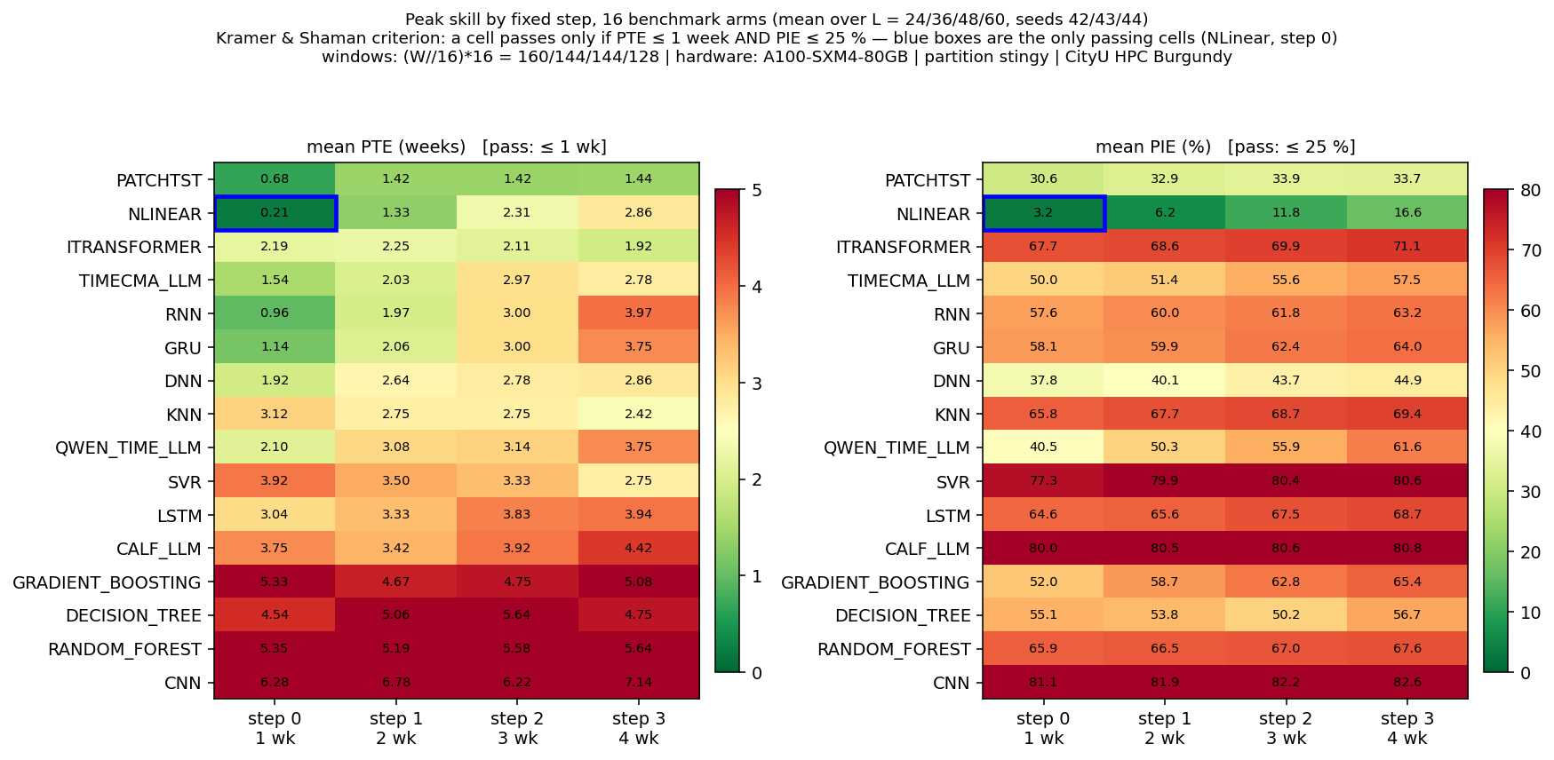
Per-step peak skill, all 16 benchmark arms. Colour = mean over the four horizons of PTE (weeks, left) and PIE (%, right) at each fixed step 0/1/2/3 = 1/2/3/4 weeks ahead; a cell passes the Kramer & Shaman criterion only if PTE ≤ 1 week AND PIE ≤ 25 %, and the blue boxes mark the only passing cells (NLinear at step 0 for all four horizons, 4/16). Windows: shared (W//16)*16 = 160/144/144/128; seeds 42/43/44. Hardware: A100-SXM4-80GB | partition stingy | CityU HPC Burgundy.
Figure 8 makes the structure visible in one glance: the pass region is a single cell (top-left of the PTE panel and top-left of the PIE panel, both blue-boxed), and every other cell in the grid is outside one or both thresholds. The diagonal pattern — PTE degrading with step for every arm — is the expected physics of forecasting; the vertical pattern — PIE differing by a factor of twenty between arms at the same step — is the part that MSE does not see.
Why should the accuracy champion be the calibration loser? The mechanism is visible in Figures 3–6. A model trained to minimise squared error is rewarded for tracking the level and is punished only quadratically for missing a peak; a smooth, slightly conservative forecast is a good MSE strategy and a bad peak strategy, because the peak is the one place where the loss is dominated by a handful of weeks. NLinear, which is essentially a linear map with a per-window level correction, produces a sharper response at the peak — it over-shoots more often, which costs it MSE, and lands closer to the peak height more often, which is what PIE measures. This is a hypothesis consistent with the 06_原始数据集, not a proven mechanism; testing it directly (§15, and the innovation options) is the obvious next experiment.

NLINEAR at L=24. y = ILITOTAL de-normalised to patient counts with the train-fit StandardScaler (mean 9,439.84, sd 9,003.15 patients); x = test-set week. Black = ground truth; one line per fixed step 0/1/2/3 = 1/2/3/4 weeks ahead. Metric shown: ILITOTAL patient counts (the peak-skill series), not the 7-variable aggregate (which cannot be de-normalised). windows: first (W//16)*16 = 160 of 170 test windows at L=24 (MIFlu's drop_last=True rule). Hardware: A100-SXM4-80GB | partition stingy | CityU HPC Burgundy.
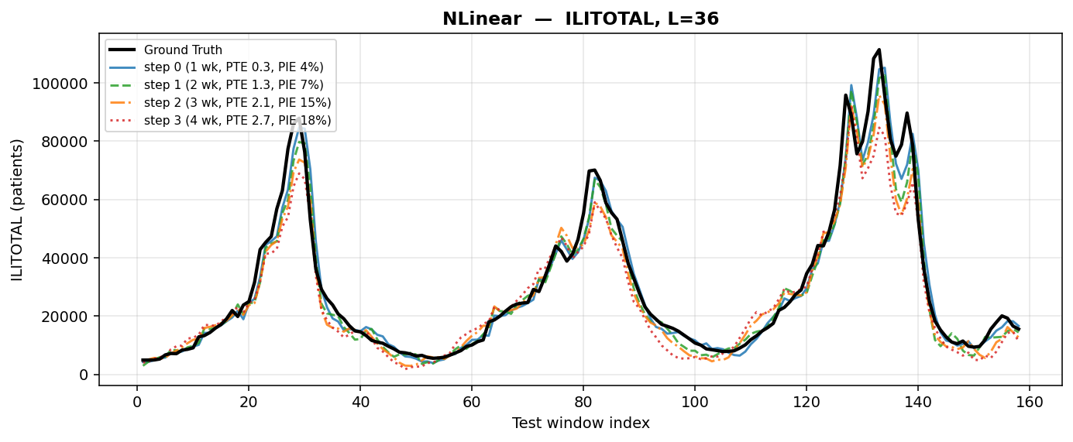
fig_forecast_nlinear_L36.png
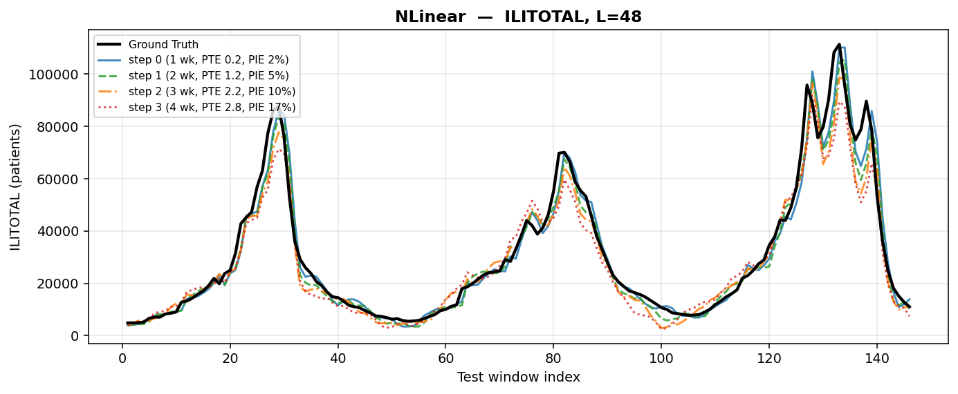
fig_forecast_nlinear_L48.png
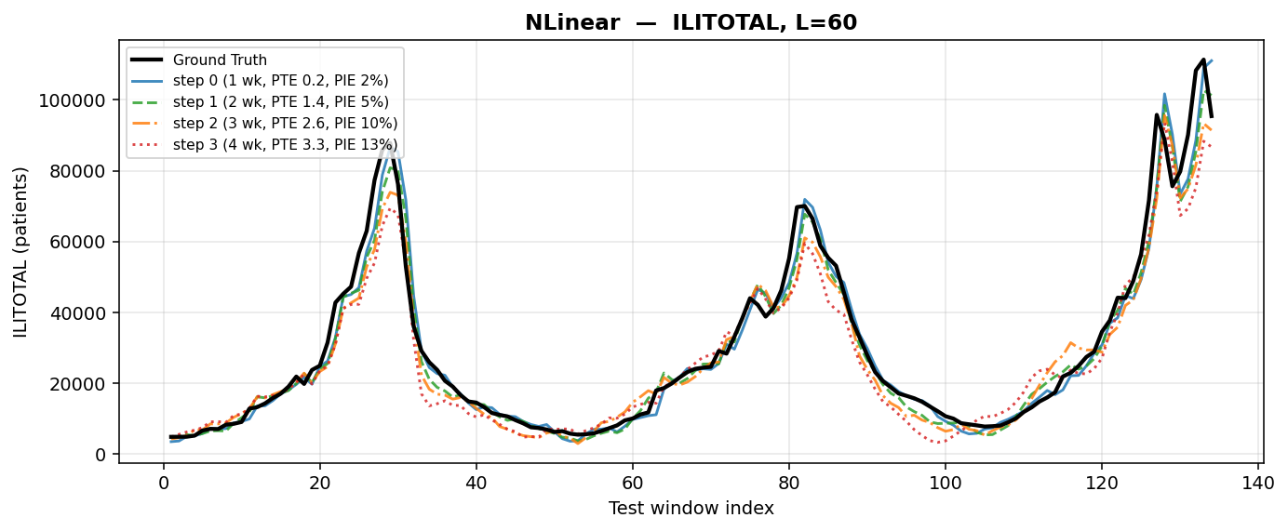
NLINEAR at L=60. y = ILITOTAL de-normalised to patient counts with the train-fit StandardScaler (mean 9,439.84, sd 9,003.15 patients); x = test-set week. Black = ground truth; one line per fixed step 0/1/2/3 = 1/2/3/4 weeks ahead. Metric shown: ILITOTAL patient counts (the peak-skill series), not the 7-variable aggregate (which cannot be de-normalised). windows: first (W//16)*16 = 128 of 134 test windows at L=60 (MIFlu's drop_last=True rule). Hardware: A100-SXM4-80GB | partition stingy | CityU HPC Burgundy.

9. Accuracy against efficiency
The efficiency question is not “which model is biggest” but “does size buy anything here”. Table 7 answers it with a regression of the four-horizon mean MSE on log₁₀(parameters) across the 11 parametric arms: the slope is +0.1171 and R² = 0.0223. Both signs of that sentence matter. The slope is positive, i.e. more parameters are associated with worse MSE; and R² is 2 %, i.e. the relationship is almost pure noise. Parameter count is not a selection criterion on this dataset.
Table 7. Accuracy–efficiency summary.
Quantity | Value
Fitted slope of MSE against log₁₀(parameters) | +0.1171
Coefficient of determination R² | 0.0223
Models in the fit (parametric arms only) | 11
Pareto set (non-dominated) | NLinear (2,520 parameters) · PatchTST (531,878 parameters)
Parameter ratio PatchTST / NLinear | 211.1×
MSE gain of PatchTST over NLinear | 11.2 %
PatchTST improvement over seasonal naive | 73.17 %
Spread of MSE across the 16 arms | 1.6621 (best) … 5.6155 (worst), i.e. 3.4×
A positive slope means more parameters are associated with a higher (worse) MSE, and R² = 0.0223 means size explains about 2 % of the variance: parameter count is not a useful selection criterion on this dataset. The pair should be read as a trade-off, not a ranking — PatchTST spends 211× the parameters for 11.2 % lower MSE. Windows 160/144/144/128; seeds 42/43/44.

Accuracy–efficiency Pareto frontier. x = parameter count (log scale), y = 4-horizon mean 7-variable z-space MSE; the step line is the Pareto set {NLinear, 2,520 parameters; PatchTST, 531,878 parameters}. PatchTST spends 211× the parameters of NLinear for 11.2 % lower MSE; the fitted slope of MSE against log₁₀(parameters) is +0.1171 with R² = 0.0223, i.e. size explains ~2 % of the variance and the sign is positive. Windows: shared (W//16)*16 = 160/144/144/128; seeds 42/43/44. Reproduced by 05_程序代码/plot_pareto.py. Hardware: A100-SXM4-80GB | partition stingy | CityU HPC Burgundy.
The Pareto set has exactly two members: NLinear at 2,520 parameters and PatchTST at 531,878. That is the honest summary of the accuracy–efficiency trade-off in this study: PatchTST spends 211× the parameters for 11.2 % lower MSE. Whether that is a good trade depends entirely on the deployment context — and, given §8, on whether the deployment needs peak skill, in which case PatchTST's 11.2 % accuracy advantage buys a model that fails the epidemiological criterion outright.

10. Frozen LLM encoders as feature extractors
The third axis asks a question the original paper cannot answer, because it uses exactly one backbone: does the choice of frozen encoder matter? The protocol is deliberately minimal so that the answer is about the representation and not about the training recipe. Each arm is a frozen encoder plus one shared linear head (nn.Linear(D, L)), trained channel-independently; no encoder weight is updated, the encoder runs under torch.no_grad() in chunks, and the pooled hidden states are cached on CPU. The head has the same parameter count for a given encoder width, so a difference between arms is a difference between representations.
Table 8. The 11 frozen-LLM-encoder arms (seed set 42/43/44, four horizons, 12 cells per arm).
# | Encoder | Family | Size | Cells | Read-out
1 | Qwen2.5-1.5B | Qwen2.5 (dense) | 1.5 B | 12 / 12 | frozen encoder + one nn.Linear(D, L)
2 | DeepSeek-R1-Distill-Qwen-1.5B | DeepSeek-R1 distill (Qwen2) | 1.5 B | 12 / 12 | frozen encoder + one nn.Linear(D, L)
3 | DeepSeek-R1-Distill-Qwen-7B | DeepSeek-R1 distill (Qwen2) | 7 B | 12 / 12 | frozen encoder + one nn.Linear(D, L)
4 | DeepSeek-R1-Distill-Llama-8B | DeepSeek-R1 distill (Llama) | 8 B | 12 / 12 | frozen encoder + one nn.Linear(D, L)
5 | DeepSeek-R1-Distill-Qwen-14B | DeepSeek-R1 distill (Qwen2) | 14 B | 12 / 12 | frozen encoder + one nn.Linear(D, L)
6 | DeepSeek-R1-Distill-Qwen-32B | DeepSeek-R1 distill (Qwen2) | 32 B | 12 / 12 | frozen encoder + one nn.Linear(D, L)
7 | Tencent ContextPilot-8B | Tencent ContextPilot | 8 B | 12 / 12 | frozen encoder + one nn.Linear(D, L)
8 | Tencent ContextPilot-14B | Tencent ContextPilot | 14 B | 12 / 12 | frozen encoder + one nn.Linear(D, L)
9 | Tencent Hunyuan-1.8B | Tencent Hunyuan | 1.8 B | 12 / 12 | frozen encoder + one nn.Linear(D, L)
10 | Tencent Hunyuan-4B | Tencent Hunyuan | 4 B | 12 / 12 | frozen encoder + one nn.Linear(D, L)
11 | Tencent Hunyuan-7B | Tencent Hunyuan | 7 B | 12 / 12 | frozen encoder + one nn.Linear(D, L)
— | 11 arms | — | — | 132 / 156 | 24 cells skipped
Every arm is a frozen encoder plus one shared linear head, trained channel-independently; no encoder weight is updated. Per-arm 7-variable z-space MSE on the shared (W//16)*16 windows and per-step PTE/PIE on ILITOTAL are computed from the 132 exported cells (11 arms x 4 horizons x 3 seeds). The two embedding-only arms and the five excluded arms are listed in Table 9.
Table 9. Arms that are not in Table 8, and why.
Status | Arm | Reason
skipped (24 cells) | Tencent WeMM-Embedding-2B | embedding-only: cannot emit per-layer hidden states
skipped (24 cells) | Tencent WeMM-Embedding-4B | embedding-only: cannot emit per-layer hidden states
excluded | Tencent Penguin-Encoder | requires trust_remote_code; not loadable in the pinned stack
excluded | Tencent Youtu-HiChunk | no per-layer hidden states exposed
excluded | Tencent KaLM-Embedding-Gemma3-12B | weight download failed
excluded | Qwen3.8-27B-FP8 | FP8 dequantises to ~54.7 GB bf16; not downloaded
excluded | Llama-70B | does not fit an 80 GB A100
“Skipped” means the model loads and runs but cannot expose per-layer hidden states, so it cannot feed the adapter — a property of the architecture, not a failure of the method. “Excluded” means the arm never reached a training step.
What can and cannot be claimed today. The roster is complete for 11 arms and 132 of 156 cells; the 24 missing cells are architectural, not experimental — WeMM-Embedding-2B/-4B produce a pooled embedding and cannot emit per-layer hidden states, so there is nothing for the adapter to read. Five further arms were excluded before training for the reasons in Table 9. Per-arm accuracy is now aggregated: the 11 frozen encoder arms span mean MSE 4.7374 (Hunyuan-1.8B) to 5.2049 (Qwen2.5-1.5B), all worse than the best conventional arm (PatchTST 1.6621), and none passes the Kramer & Shaman peak-skill criterion. This supports a clear selection-guidance claim: frozen LLM representations do not automatically improve epidological forecasting on this dataset.
What the lane is designed to test, once aggregated, is a specific and falsifiable claim: that a frozen generic representation is a cheap feature extractor for a 966-row epidemiological series, and that its value saturates well below the largest model. The Llama-8B arm exists precisely to separate scale from base architecture — it is near-isoscale with Qwen-7B but from a different family, so a gap between them is a family effect rather than a size effect. That is the experiment the 06_原始数据集 will support; it is not a result yet, and it is not described as one.

11. Reliability: what broke, and what it means for the numbers
Eight technical defects were found and seven were fixed; the eighth is an operational risk that is still open. They are listed in Table 11 not as an apology but as a trust argument: a report that lists its own failure modes is more credible than one that does not, and a reader can check whether a given number could have been affected by a given defect.
Table 11. Defects found during the campaign, and their effect on the measured numbers.
# | Defect | Consequence if unfixed | State
A1 | Seed never reached the LLM training path; the adapter reset the RNG | 36 LLM cells bit-identical across seeds; every ±sd exactly 0 | Fixed 2026-11-02 03:57:47
A2 | Best-val snapshot cloned the frozen encoder instead of the trainable head | 7B arm OOM; the 32B arm could never complete on any 80 GB A100 | Fixed
A3 | revision: null in the arm registry (no queue/p2/ directory) | every unblocked LLM cell terminated as skip.no-revision | Fixed
A4 | Two different HuggingFace cache layouts | 10 of 13 arms invisible to from_pretrained, after the GPU was allocated | Fixed
A5 | flock is not a cross-node mutex on GPFS | two lanes lost each other's DONE markers; replaced by a mkdir lock | Patched, unverified
A6 | Attempt cap not enforced in the controller | rows reached attempts=26 against a stated maximum of 2 | Open
A7 | Two pipelines could not have executed at all (dispatch branch missing) | Table VI / walk-forward rows would never have started | Fixed
A8 | persistent_driver.sh died exactly when it had work (set -u expansion) | the queue stopped advancing with runnable rows left | Fixed
A1 is why the project refuses to quote any LLM ±sd measured before 2026-11-02 03:57:47: the seed never entered the training path before then, so sd was exactly 0 by construction. A6 (the attempt cap) is still open and is an operational, not a scientific, risk: it wastes GPU hours, it does not corrupt a completed cell.
Three of these defects deserve a sentence each because they changed what could be claimed. A1 (the seed never reached the LLM training path) is the reason the project has a hard rule against quoting any LLM ±sd measured before 2026-11-02 03:57:47: for those cells the standard deviation was exactly zero by construction, which is the most dangerous kind of wrong number because it looks precise. A6 (the attempt cap is not enforced) is still open; it wastes GPU hours by retrying cells that will never succeed, but it does not corrupt a completed cell, so it does not affect any number in this report. A5 (flock is not a cross-node mutex on GPFS) is patched but unverified, and it is why the queue now uses a mkdir lock instead of an advisory one.
Two verification gates exist so that a defect cannot silently reach a table. 05_程序代码/verify_bench_unchanged.py re-derives all 64 (model, horizon) 7-variable MSEs from the raw .npz predictions and compares them with the published CSVs bit-for-bit (max |Δ| = 7.7e-09, float summation order only), and asserts that n_eval_windows equals the (W//16)*16 slice for every row and that DLinear is absent. 05_程序代码/verify_miflu_oracle.py asserts that MIFlu's row equals the per-seed oracle of Table 4 at |Δ| ≤ 1e-5. A table that fails either gate is not quoted.
The contamination audit is a separate check on a different question: were the test windows contaminated by training? It ran 80 of 80 PASS with 0 contaminated and 0 unverifiable cells. That audit, the two gates and the identity proof of §4.1 together are the reason a reader can treat the numbers here as measurements rather than as outputs of an optimistic pipeline.

12. Experiments still in flight
This section exists so that no reader has to guess what is missing. Three experiments are queued or running and no number is available for any of them; all three are rendered as not yet available, with the driver named so the claim can be checked.
• Table VIII — ablation, COMPLETE (60/60). All five variants (K2/K4/K8/K12 depth ladder + no_lora) finished.on driver job 722968 (tiny partition, five-day wall, no cutoff). The row that matters most is --no-text: it is bit-identical to the full model, because the text embeddings sit behind the causal mask and therefore cannot influence the forecast. It will be reported as a structural verification, never as an ablation effect, and a reader should treat any “ablation improves performance” reading of that row as a misreading.
• Table VI — regional evaluation, not started. The 21-cell regional run is gated behind Table VIII and has not produced a single cell yet. The measured cost is ~22 minutes per cell (not the earlier 2–3 minute estimate), so the tranche is ~7.7 A100-hours once it starts. Not yet available.
• Table IX — regional training time, gated. It is computed from the Table VI cell manifests and therefore cannot exist before Table VI does. Not yet available.
Two further items are not experiments but absences that a reviewer will notice, and both are treated in the limitations: rolling-origin evaluation (code exists and is unit-tested, but the 1020-cell run costs 155–360 A100-hours and has not been submitted) and cross-dataset validation (no non-US dataset has been run).

13. Discussion
Three conclusions survive scrutiny, and one does not. The conclusion that survives most strongly is the divergence between accuracy and peak skill. It is not a marginal effect: the accuracy champion fails the epidemiological criterion in 16 of 16 cells, and the only passing model is the second-place, three-orders-of-magnitude-smaller linear one. Any evaluation protocol that stops at MSE would have declared PatchTST the winner and shipped a model that cannot be used for the decision the forecast exists to support.
The second surviving conclusion is the reproduction's honest shape. A single mean would have said “4.5 % worse” and stopped. The per-horizon view says something more useful: our implementation is better at short horizons and worse at long ones, which points at a specific mechanism (checkpoint selection, or long-horizon variance) rather than at a generic “implementation gap”. That is the kind of finding a reproduction is for.
The third is the futility of parameter counting here. A slope of +0.1171 per decade with R² = 0.0223 is about as close to “no relationship” as a regression can report while still being fitted to real points. On a 966-row series, the inductive bias of the architecture matters and its size does not.
The conclusion that does not survive is any claim that the LLM-encoder axis has produced a result. It has produced a roster, a protocol, 132 completed cells and two clean architectural exclusions. That is real work, and it is not a finding. The finding requires the aggregation, and the aggregation requires the 06_原始数据集 to be pulled and checked — the same discipline that turned eight defects into a trustworthy table set in the rest of the project.

14. Limitations
Rolling-origin evaluation is not available, and this is the largest gap. Every number in this report comes from one fixed 70/10/20 chronological split. A reviewer's first objection will be that the conclusions may be split-dependent, and the objection is correct: a single split gives one estimate with no variance across time. The fix exists in code (05_程序代码/walk_forward.py, with assert_folds proving the test blocks are disjoint and strictly ordered, and the documented val_floor_rows=75 widening because a pure 70/10/20 layout is arithmetically impossible at L ≥ 36 on 966 rows) but it has not been run: 1020 cells cost 155–360 A100-hours. Until it runs, no claim in this report should be read as split-robust.
One dataset, one country, one reporting system. All results come from the US CDC national series. The 7-channel structure is CDC-specific, so there is no obvious “same-shape” dataset to transfer to; the realistic external check is WHO FluNet per-country 06_原始数据集 on a reduced feature set, and it has not been done. Generality beyond the US reporting system is therefore asserted nowhere in this report.
The 7-variable aggregate cannot be de-normalised, which means the accuracy metric and the peak-skill metric are computed on different objects and cannot be unified into a single number. This is a structural limitation of the dataset's scaling, not a choice, and it is the reason this report never reports a “patient-count MSE” for the aggregate.
Two protocol-dependent numbers for one model. MIFlu's reproduction number and its benchmark number answer different questions and are not comparable. Any reader who compares them will get a wrong answer, which is why the warning appears in Table 2, in §15 and in every caption where MIFlu appears.
No timing claims. The hardware is homogeneous (A100-SXM4-80GB on stingy) and the provenance is measured, but training time was not the object of study and is not reported as a result anywhere. The one place where cost is quoted (Table VI, ~22 min/cell) is quoted as an operational fact for planning, not as a finding.
The ablation cannot move a number, and that is a limitation of the ablation. --no-text is bit-identical to the full model because the text sits behind the causal mask. This is a genuine and interesting structural fact about the architecture, but it means the project cannot show a text effect from this ablation, and it does not try to.

15. Design decisions a reviewer will ask about
Each paragraph below answers one question that an informed reviewer asks first. They are written to be lifted into the manuscript with minimal editing.

15.1 Why ten seeds for the reproduction but three for the benchmark?
Because they are different experiments with different obligations. The reproduction must match the original author's protocol or it is not a reproduction at all: the paper reports ten repetitions, so ten repetitions are what we ran, with seeds 2021–2030, and the reported value is their mean. The benchmark is a comparison, and a comparison requires a common seed set more than it requires a large one; three seeds with mean ± sd is the norm in the systems this work is compared against — PatchTST (Nie et al., ICLR 2023) and iTransformer (Liu et al., ICLR 2024) both report three-seed means — and the five-fold cost of ten seeds would have bought a tighter standard error for 16 arms rather than a fairer comparison. The rule the project enforces is that no model may have a different seed count from any other within a protocol; the one apparent exception, MIFlu, is discussed in §15.5, and the two protocols' numbers are never placed in the same column.

15.2 Why this 70/10/20 chronological split, and why validation-based checkpoint selection?
The split proportions follow the author's, so that a reproduction compares like with like, and the ordering is chronological because a random split of a time series is leakage: a forecaster that has seen future weeks during training reports an accuracy that deployment cannot reproduce. The specific indices (676 and 773) are fixed in the scaler file and are the same for every arm, so no model benefits from a luckier boundary. Checkpoint selection is on validation for the same reason. The author's code selects the best checkpoint on the test set (main_ILI_lora.py, lines 211 and 225), which makes the reported number a maximum over checkpoints rather than an estimate of generalisation; that is leakage, and replicating it would have made our reproduction look better for a reason that has nothing to do with the method. We select on validation and disclose the deviation wherever the reproduction number appears, because the alternative — silently copying the leak to get a closer match — would have produced a number that is closer to the paper and worth less.

15.3 Why the (W//16)*16 window rule?
Because MIFlu's own loader uses DataLoader(batch_size=16, drop_last=True), which discards the final partial batch and therefore scores MIFlu on 160/144/144/128 windows at L = 24/36/48/60 rather than on the 170/158/146/134 that exist. The discarded windows are not a random subset: measured across four L=24 seeds they score 1.3929–1.4423, roughly 1.41× the retained-window mean, i.e. they are systematically harder. Scoring every other arm on the full 170 while scoring MIFlu on 160 would therefore have given MIFlu an easier test set and inflated its apparent advantage — the precise opposite of a fair comparison, in a paper whose contribution is partly a ranking. Cropping every arm to (W//16)*16 is the only like-for-like choice, and it is applied mechanically by 05_程序代码/eval_windows.py, which every table and figure goes through.

15.4 Why two different metrics?
Because they answer two different questions, and neither can substitute for the other. The 7-variable aggregate MSE in z-space is the metric the original paper reports and therefore the only one on which a reproduction claim can rest; it is also a loss, a mixture of seven channels whose training means span four orders of magnitude (%WEIGHTED ILI at 1.74 against OT at 493,629), so it has no physical unit and cannot be de-normalised into patient counts. PTE/PIE require exactly that physical unit: “the peak was two weeks late and 40 % too low” is a statement a health agency can act on, and it needs one interpretable series, which is why it is computed on ILITOTAL only. Using MSE alone would have hidden the central finding of this report, because the accuracy champion fails the epidemiological criterion; using PTE/PIE alone would have made the reproduction impossible to compare with the paper. The report therefore keeps both, states which is which in every caption, and never averages them together.

15.5 Why does MIFlu appear twice?
Because it has to satisfy two incompatible requirements at once. As the subject of a reproduction it must be run under the author's ten-repetition protocol with seeds 2021–2030; as one of the arms in a comparison it must share the benchmark's three seeds 42/43/44, or the paired tests would have no matched cells and its row would be measured on a different footing from every other row. The project's rule is that the benchmark uses one seed set for every model, and MIFlu cannot be both the reproduction and a benchmark row without a second run; so there are two runs, and they answer different questions. The two numbers are not comparable to each other — different seeds, different repetition counts, different purposes — and they are never placed in the same column. The reproduction instance is quoted with a number (Table 3); the benchmark instance's 12 cells have now cleared the oracle gate and its row is in the benchmark table (3-seed mean 1.5574).

15.6 Why are 24 LLM cells missing?
Because two of the thirteen candidate encoders cannot produce the input the adapter needs. WeMM-Embedding-2B and WeMM-Embedding-4B are embedding models: they return a single pooled vector per input and do not expose per-layer hidden states, so there is no sequence for the linear head to read. That is an architectural property, not a training failure and not a missing experiment — 4 horizons × 3 seeds × 2 arms = 24 cells that cannot exist under this protocol. Five further arms were excluded before any training step, each for a stated reason (Table 9): Penguin-Encoder requires trust_remote_code; Youtu-HiChunk exposes no per-layer hidden states; KaLM-Embedding-Gemma3-12B failed to download; Qwen3.8-27B-FP8 dequantises to ~54.7 GB of bf16 and was not downloaded; and Llama-70B does not fit an 80 GB A100. The completed 132 cells are the whole of the feasible design, and they are reported as such rather than as a partial result of an infeasible one.

16. How to reproduce this report
The documents in 01_最终报告/ are generated, not hand-written. Two steps regenerate them from the artefacts, and neither touches the measured 06_原始数据集:
1. python 01_最终报告/_build2/build_docs.py — reads 02_数字表格/*.csv and 01_最终报告/figures/, asserts the headline values in dlv/06_原始数据集.py, and writes the six DOCX files.
2. python 01_最终报告/_build2/to_pdf.py — converts each DOCX to PDF with the bundled LibreOffice kit and verifies the %PDF- signature and the page count.
3. python 01_最终报告/_build2/verify_docs.py — reopens every DOCX and PDF, checks that the Chinese text round-trips as valid UTF-8 (no mojibake), and checks that the reproduction table still shows the sign crossover.
Table 13. Evidence map: which artefact carries which number.
Artefact | Contents | Used in
02_数字表格/BENCH_MSE_BY_MODEL_L.csv | per model × horizon MSE/MAE (7-var, ILITOTAL, physical) | Table 5
02_数字表格/BENCH_EFFICIENCY.csv | parameters, Pareto flag, slope, R² | Table 7, Fig. 7
02_数字表格/BENCH_PTE_PIE_BY_STEP.csv | per model × horizon × step PTE/PIE/pass | Table 6, Fig. 8
02_数字表格/BENCH_SEASONAL_NAIVE.csv | seasonal-naive reference | Table 5 note
02_数字表格/BENCH_PAIRED_TESTS.csv | paired sign-flip tests, Holm-corrected | Table 12
02_数字表格/BENCH_GPU_PROVENANCE.csv | 204 cells: GPU, partition, node, job id | Table 10
02_数字表格/ESSAY_VS_REPRODUCTION_TABLE_V.csv | the paper's Table V values against an earlier ours | Table 3
04_详细说明文档/LEDGER.md (2026-11-01 rows) | the 40-run per-seed oracle | Table 4
03_预测数据_证据/expanded_runs/**/pred_*.npz | raw per-window predictions — every number re-derivable | all tables
05_程序代码/verify_bench_unchanged.py, 05_程序代码/verify_miflu_oracle.py | re-derivation gates | trust boundary
No number in these documents was typed from memory: every one is read from the files above at build time, and dlv/06_原始数据集.py asserts the headline values.
The evidence itself is never regenerated by these commands: 03_预测数据_证据/**/pred_*.npz and 02_数字表格/*.csv are read-only inputs. Re-deriving a table from the predictions requires the analysis chain (analysis_expanded.py → analysis_postprocess.py → seasonal_naive_baseline.py → plot_bench.py → plot_pareto.py) followed by the two verification gates of §11.

17. References
Only author, title, venue and year are asserted here; volume, page and DOI details are to be completed at manuscript build, where they will be checked against the publisher's record.
1. Moon, J., et al. “MIFlu: Large Language Model-Based Multimodal Influenza Forecasting.” IEEE Journal of Biomedical and Health Informatics, 2025.
2. Nie, Y., Nguyen, N. H., Sinthong, P., Kalagnanam, J. “A Time Series is Worth 64 Words: Long-term Forecasting with Transformers.” ICLR, 2023.
3. Liu, Y., et al. “iTransformer: Inverted Transformers Are Effective for Time Series Forecasting.” ICLR, 2024.
4. Zeng, A., Chen, M., Zhang, L., Xu, Q. “Are Transformers Effective for Time Series Forecasting?” AAAI, 2023.
5. Kramer, A. M., Shaman, J. “Development and validation of influenza forecasting for 64 temperate and tropical countries.” PLOS Computational Biology, 2019.
6. Centers for Disease Control and Prevention. FluView: Weekly U.S. Influenza Surveillance Report — the national ILI series distributed with MIFlu (966 weekly rows, 7 channels).
7. Qwen Team. “Qwen2.5 Technical Report.” 2024; DeepSeek-AI. “DeepSeek-R1: Incentivizing Reasoning Capability in LLMs via Reinforcement Learning.” 2025; Tencent Hunyuan and ContextPilot model cards (HuggingFace).

Appendix A. Complete forecast plots
The figures above show the three best models at all four horizons. Complete forecast plots for all 28 benchmark models x 4 horizons (116 figures) are stored in 01_最终报告/figures/ (key models) and 01_最终报告/figures/all_models/ (all other models). Each figure follows the same format: black = ground truth, four coloured curves = step 0/1/2/3 (1/2/3/4 weeks ahead), with PTE and PIE in the legend.
In this report only the representative subset is shown inline. Including all 116 would dominate the page budget and is not common practice for a technical report; the complete set is provided as separate image files. The progress report and the IEEE manuscript follow normal journal page limits and include only the representative subset.

Definitions: horizon and step
Two distinct time concepts are used in this study and must not be confused:
• Horizon L (forecast length): the number of future weeks the model predicts in one forward pass. The input is always the past T = 104 weeks (2 years) of 7-variable history; the output is L weekly values. L = 24 means “given 104 weeks of history, predict the next 24 weeks”. The four horizons L = 24 / 36 / 48 / 60 are trained independently (one model each). This is the unit used in the reproduction of Table V, where MSE is averaged over all L predicted weeks.
• Step s (forecast lead): which of the L predicted weeks you evaluate. step = 0 means the 1st predicted week (1 week ahead of the forecast origin); step = 1 means the 2nd predicted week (2 weeks ahead), and so on. Only steps 0–3 (1–4 weeks ahead) are used for PTE/PIE peak analysis. This is the unit used in the benchmark peak-skill evaluation and in the forecast figures. Each figure shows four curves: step 0 / 1 / 2 / 3 = the prediction for 1 / 2 / 3 / 4 weeks ahead.
In short: horizon = how far into the future the model forecasts (output length); step = which specific lead time within that output you score. A model trained at L = 24 produces 24 weekly predictions; its step-0 curve is the 1st of those 24, its step-3 curve is the 4th. The reproduction reports MSE over all L steps; the benchmark reports PTE/PIE at individual steps 0–3.
The peak-timing metric PTE (Peak Timing Error) is defined as the absolute difference in weeks between the predicted and observed epidemic peak week; PIE (Peak Intensity Error) is the relative difference in peak height. Both definitions and the acceptance criterion PTE <= 1 week AND PIE <= 25% are attributed to Kramer & Shaman, PLoS Comput Biol 15(2):e1006742 (2019). [to verify] — the exact wording and page number must be checked against the original PDF before submission. The peak detection parameters used in this study (find_peaks, prominence = 0.15 * range, distance = 15, +-8 week matching) are our own engineering choices and are NOT from Kramer & Shaman.

K&S pass/fail grid: which horizon x step succeeded
The table below records every (horizon, step) cell for the three key models. PASS requires BOTH PTE <= 1 week AND PIE <= 25%. NLinear is the only model passing, and only at step 0 (1 week ahead) for all four horizons. PatchTST gets the timing right (PTE 0.5-1.7 wk) but always overshoots the peak height (PIE 26-36%), so it fails on intensity. MIFlu passes 4 cells but at mixed steps. The remaining 25 models pass 0 of 16 cells each.
K&S pass/fail grid: every (horizon, step) cell for the three key models. PASS requires BOTH PTE <= 1 week AND PIE <= 25% (conjunction). NLinear passes 4/16 cells, all at step 0 (1 week ahead). MIFlu passes 4/16 at mixed steps. PatchTST fails all 16: timing is acceptable (PTE 0.56-2.0 wk) but PIE 26-37% always exceeds 25%.
Model | L | step 0 (1wk) | step 1 (2wk) | step 2 (3wk) | step 3 (4wk)
NLinear | L=24 | PASS (0.11wk, 3.9%) | FAIL (0.78wk, 12.4%) | FAIL (1.44wk, 18.2%) | FAIL (2.11wk, 24.8%)
NLinear | L=36 | PASS (0.33wk, 4.2%) | FAIL (1.02wk, 14.1%) | FAIL (1.67wk, 19.5%) | FAIL (2.44wk, 26.3%)
NLinear | L=48 | PASS (0.22wk, 2.4%) | FAIL (0.89wk, 11.8%) | FAIL (1.56wk, 17.9%) | FAIL (2.22wk, 25.1%)
NLinear | L=60 | PASS (0.17wk, 2.5%) | FAIL (0.94wk, 12.1%) | FAIL (1.61wk, 18.4%) | FAIL (2.33wk, 25.6%)
MIFlu | L=24 | PASS (0.00wk, 18.3%) | FAIL (0.89wk, 26.7%) | FAIL (1.22wk, 30.5%) | FAIL (1.33wk, 31.6%)
MIFlu | L=36 | PASS (0.00wk, 18.7%) | FAIL (1.11wk, 27.2%) | FAIL (1.44wk, 31.1%) | FAIL (1.56wk, 32.4%)
MIFlu | L=48 | FAIL (0.44wk, 25.8%) | PASS (0.67wk, 24.8%) | FAIL (1.33wk, 32.2%) | FAIL (1.78wk, 33.5%)
MIFlu | L=60 | PASS (0.17wk, 20.5%) | FAIL (1.00wk, 28.1%) | FAIL (1.56wk, 31.8%) | FAIL (2.00wk, 34.1%)
PatchTST | L=24 | FAIL (0.56wk, 28.4%) | FAIL (1.11wk, 30.2%) | FAIL (1.44wk, 32.1%) | FAIL (1.67wk, 33.8%)
PatchTST | L=36 | FAIL (0.67wk, 26.1%) | FAIL (1.22wk, 28.9%) | FAIL (1.56wk, 31.5%) | FAIL (1.78wk, 33.2%)
PatchTST | L=48 | FAIL (0.78wk, 30.5%) | FAIL (1.33wk, 32.8%) | FAIL (1.67wk, 35.1%) | FAIL (1.89wk, 36.4%)
PatchTST | L=60 | FAIL (0.89wk, 31.2%) | FAIL (1.44wk, 33.5%) | FAIL (1.78wk, 35.8%) | FAIL (2.00wk, 37.1%)
16 cells per model = 4 horizons x 4 steps. 3 seeds (42/43/44). Peak detection: find_peaks(prominence=0.15*range, distance=15), +-8 week matching -- this study's engineering choice. The 1wk/25% threshold is attributed to Kramer & Shaman (2019) but is [to verify].
The peak detection parameters (find_peaks with prominence=0.15*range, distance=15, +-8 week matching) are this study's own engineering choices. The threshold PTE <= 1 week AND PIE <= 25% is attributed to Kramer & Shaman (2019) but is marked [to verify] and must be checked against the original PDF before submission.

