Sri Lanka Institute of Information Technology
Human Computer Interaction (IT3060)
Lab Exercise 06
FitFlow — Release Preparation and Internal Testing

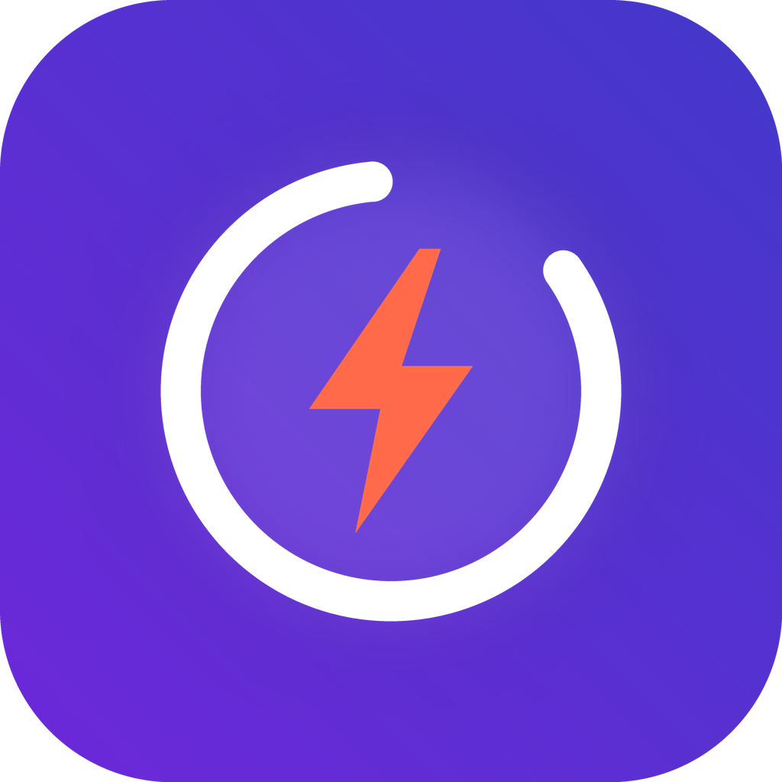

Details
Campus: Malabe Campus
Name: Jayawardhana O K T C
Student ID: IT23230774
Year: 3rd Year, 2nd Semester
Group: WE 1.1
Date: 04/10/2026

Contents
Overview
Activity 1 – Generate Signed APK/AAB
Activity 2 – Prepare App Icons, Screenshots and Store Assets
Activity 3 – Configure Google Play Console
Activity 4 – Configure App Store Connect and TestFlight
Activity 5 – Prepare a Privacy Policy and Release Notes
Activity 6 – Perform Internal Testing Deployment
Appendix – Build and test commands
GitHub repository: https://github.com/CHANUKA-01/fitflow-redesign
All documents referenced in this report are in the repository under docs/lab06/, the store assets under store-assets/ and the app under frontend/mobile/.

Overview
Lab 05 selected Flutter for the FitFlow mobile client. For this lab the Flutter app was built ("Focus Flow" design from Lab 03), signed for release, and prepared for both stores. Every screen implements a requirement from earlier labs (R01–R16, NFR1–NFR5, usability issues U01–U14).
Item | Value
App | FitFlow: Workouts & Nutrition — package / bundle ID io.fitflow.app
Version | 1.1.0 (build / versionCode 2)
Framework | Flutter 3.47.6, Dart 3.13.5; Android 7.0+ (API 24–36), iOS 15+
Features | Daily AI-style plan on Home, explained planner, one-tap set logging, on-device meal photo review, nutrition, private circles, progress, privacy controls
Store accounts | Not available (Google Play US$25, Apple US$99) — Activities 3 and 4 are fully prepared configurations; the signed builds and all assets are real

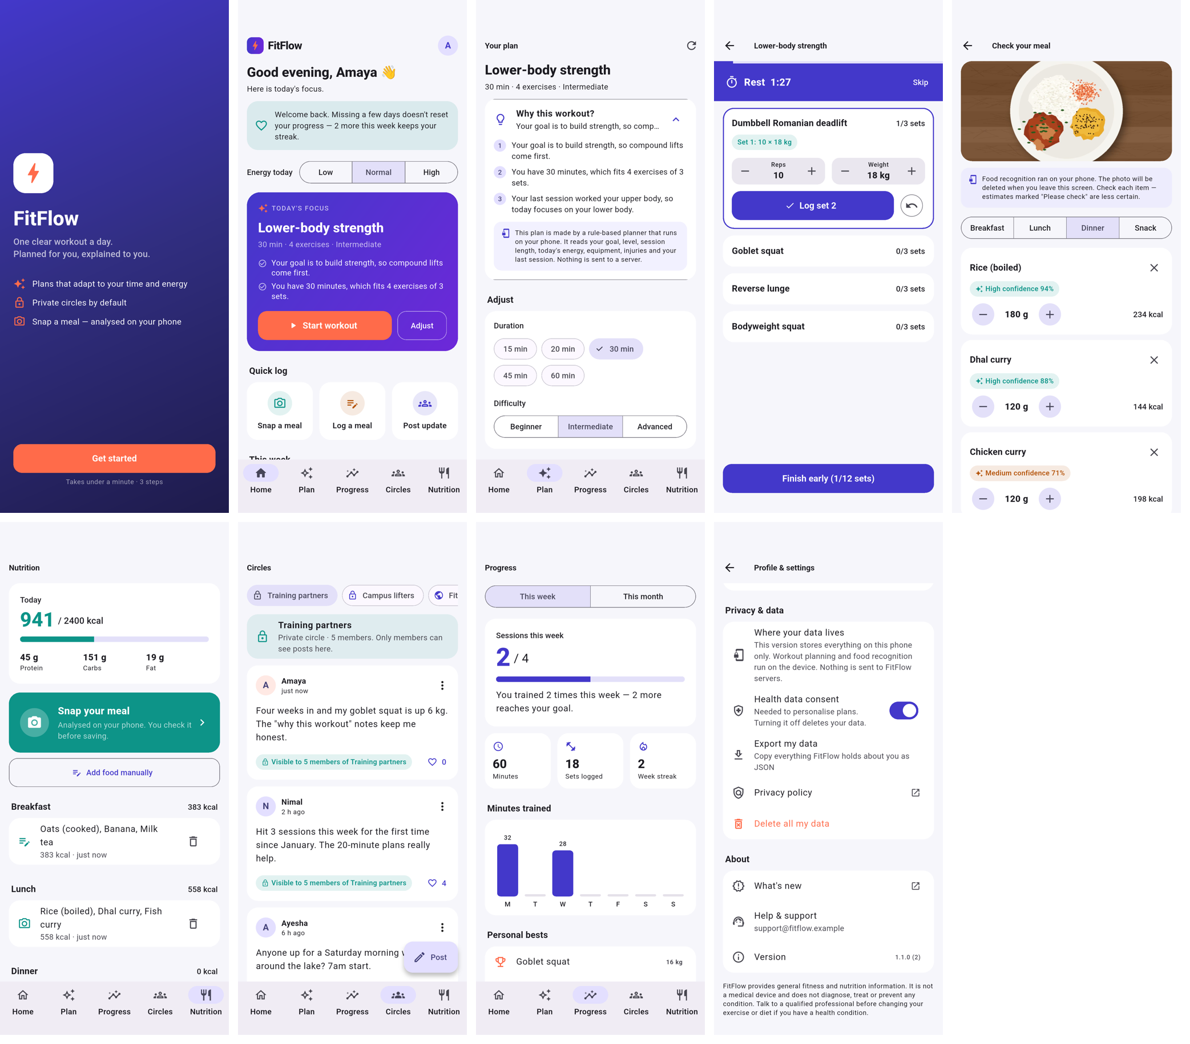
Figure 1 – FitFlow 1.1.0 running on the Pixel 9a emulator (signed build, demo data): welcome, home, plan, logger, meal review, nutrition, circles, progress, privacy.

Activity 1 – Generate Signed APK/AAB

1.1 Build details
Item | Value
Application ID | io.fitflow.app
Version name / code | 1.1.0 / 2 (baseline 1.0.0 / 1)
Min / target / compile SDK | 24 (Android 7.0) / 36 (Android 16) / 36
ABIs | arm64-v8a, armeabi-v7a, x86_64
Signing key | Upload key fitflow-upload, RSA 4096, SHA384withRSA, PKCS12, valid to 2056
Optimisation | R8 minify + resource shrinking; Dart obfuscation with symbols split out

1.2 Release configuration (android/app/build.gradle.kts)
signingConfigs {
if (releaseStoreFile != null) {
create("release") {
storeFile = file(releaseStoreFile) // from key.properties or FITFLOW_* env vars
storePassword = signingValue("storePassword", "FITFLOW_KEYSTORE_PASSWORD")
keyAlias = signingValue("keyAlias", "FITFLOW_KEY_ALIAS")
keyPassword = signingValue("keyPassword", "FITFLOW_KEY_PASSWORD")
storeType = "pkcs12"
}
}
}
buildTypes {
release {
signingConfig = signingConfigs.findByName("release") // no fallback to the debug key
isMinifyEnabled = true
isShrinkResources = true
proguardFiles(getDefaultProguardFile("proguard-android-optimize.txt"), "proguard-rules.pro")
}
}

- The template signed release builds with the debug key; that was removed. A Gradle task-graph check stops any release build with a clear error if the upload key is missing, while debug builds still work.
- Android 11+ <queries> added so the privacy-policy and support links open on modern phones.

1.3 Keystore and signing
keytool -genkeypair -v -storetype PKCS12 \
-keystore ~/.fitflow-signing/fitflow-upload.jks -alias fitflow-upload \
-keyalg RSA -keysize 4096 -validity 10950 \
-dname "CN=FitFlow Upload Key, OU=IT3060 WE 1.1, O=FitFlow, L=Malabe, ST=Western, C=LK"

Secret | Location | In git?
Keystore file | ~/.fitflow-signing/fitflow-upload.jks (outside repo, mode 600) | No
Passwords + alias | ~/.fitflow-signing/key.properties; android/key.properties is a symlink | No (git-ignored)
CI copies | GitHub Actions secrets (keystore base64 + passwords) | No

- Play App Signing: Google holds the app signing key; the team holds only the upload key, which can be reset through Play Console if lost.
- Backup: two encrypted offline copies (USB + password manager); password only in the password manager; access limited to release owner and one deputy; restore test each semester.
- Incident found and fixed: the project is on an iCloud-synced Desktop, so key.properties (passwords) was being uploaded to iCloud. It was moved outside the synced folder.
- Upload certificate SHA-256: 93:B8:CF:64:31:72:92:77:8C:DA:A9:3D:ED:CB:96:90:67:EB:08:FA:3C:78:4D:4E:93:5D:29:8B:38:BA:57:51

1.4 Build commands
cd frontend/mobile
scripts/release_android.sh # clean, analyse, test, build AAB + APKs, verify, write evidence
# equivalent steps:
flutter build appbundle --release --obfuscate --split-debug-info=build/debug-info
flutter build apk --release --obfuscate --split-debug-info=build/debug-info
flutter build apk --release --split-per-abi --obfuscate --split-debug-info=build/debug-info

1.5 Verification
Check | Tool | Result
AAB signature | jarsigner -verify | jar verified — CN=FitFlow Upload Key
APK signature | apksigner verify | Verifies (APK Signature Scheme v2), RSA 4096
Signer = keystore | SHA-256 compare | Match (93b8cf64…5751)
Code shrinking | R8 mapping.txt | Present — code obfuscated
Play download size | bundletool get-size | ≈ 8.0 MB (arm64) vs 48.6 MB AAB upload file
Permissions | aapt2 dump badging | None shown to the user (no INTERNET, CAMERA or storage)
Install test | bundletool install-apks | Installed and run on Pixel 9a emulator (Android 16)
Start-up (NFR3) | am start -W | 3.8–7.5 s on emulator; control app 2.5–5.5 s → emulator not valid; physical device pending

Excerpt of the generated evidence log (docs/lab06/evidence/release-evidence-1.1.0+2.txt):
FitFlow Android release evidence
Version (pubspec): 1.1.0+2
Generated: 2026-10-04 00:52:23 UTC
Commit: 9fd3e05
Flutter: Flutter 3.47.6 • channel stable • https://github.com/flutter/flutter.git
== Artefacts ==
48580237 build/app/outputs/bundle/release/app-release.aab
17624050 build/app/outputs/flutter-apk/app-arm64-v8a-release.apk
14868924 build/app/outputs/flutter-apk/app-armeabi-v7a-release.apk
49516995 build/app/outputs/flutter-apk/app-release.apk
19124209 build/app/outputs/flutter-apk/app-x86_64-release.apk
== SHA-256 checksums ==
eb414385335482a18294aadfac4db7d8311c9e0d5a7a150d1958e1a02542949c build/app/outputs/bundle/release/app-release.aab
bd1a181298c0b47a379a72f5e09f35196aba78f66e2a55f0fca349e8e0e89a33 build/app/outputs/flutter-apk/app-release.apk
== AAB signature (jarsigner) ==
jar verified.
Owner: CN=FitFlow Upload Key, OU=IT3060 WE 1.1, O=FitFlow, L=Malabe, ST=Western, C=LK
Valid from: Sat Oct 03 21:23:08 IST 2026 until: Mon Sep 25 21:23:08 IST 2056
SHA256: 93:B8:CF:64:31:72:92:77:8C:DA:A9:3D:ED:CB:96:90:67:EB:08:FA:3C:78:4D:4E:93:5D:29:8B:38:BA:57:51
Signature algorithm name: SHA384withRSA
== APK signature (apksigner) ==
Verifies
Verified using v1 scheme (JAR signing): false
Verified using v2 scheme (APK Signature Scheme v2): true
Verified using v3 scheme (APK Signature Scheme v3): false
Verified using v3.1 scheme (APK Signature Scheme v3.1): false
Verified using v4 scheme (APK Signature Scheme v4): false
Signer #1 certificate DN: CN=FitFlow Upload Key, OU=IT3060 WE 1.1, O=FitFlow, L=Malabe, ST=Western, C=LK
Signer #1 certificate SHA-256 digest: 93b8cf64317292778cdaa93dedcb969067eb08fa3c784d4e935d298b38ba5751
Signer #1 key size (bits): 4096
== Manifest (aapt2) ==
package: name='io.fitflow.app' versionCode='2' versionName='1.1.0'
minSdkVersion:'24'
targetSdkVersion:'36'
uses-permission: name='io.fitflow.app.DYNAMIC_RECEIVER_NOT_EXPORTED_PERMISSION'

Activity 2 – Prepare App Icons, Screenshots and Store Assets
All assets are generated by code (Python/Pillow) and screenshots are captured from the real app by an automated Flutter integration test, so they can be regenerated after any change. A validator checks every file against Google Play and App Store rules: 72 of 72 checks passed.

2.1 Icon and branding
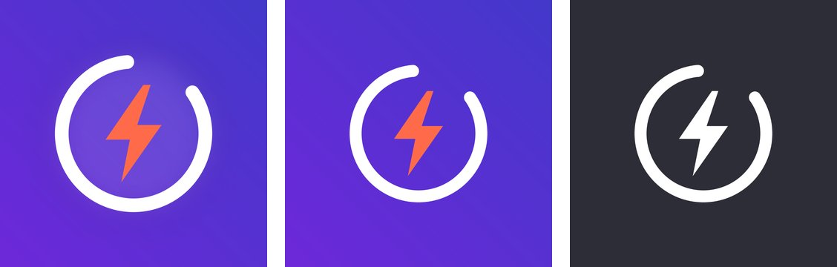
Figure 2 – App Store/Play icon, Android adaptive icon, Android 13 themed (monochrome) icon.
Asset | Size / format | Rule
Play hi-res icon | 512×512 PNG | Full square, Google applies mask
App Store icon | 1024×1024 PNG, no alpha | Apple rejects transparency
Adaptive icon | 108 dp layers, all densities | Mark inside 66 dp safe zone
Themed icon | Monochrome layer | Android 13+ tints it
iOS AppIcon set | 20–1024 pt @1x–@3x | Generated by flutter_launcher_icons
Splash | Brand indigo, Android 12+ and iOS | No white flash at start

2.2 Feature graphic and banners
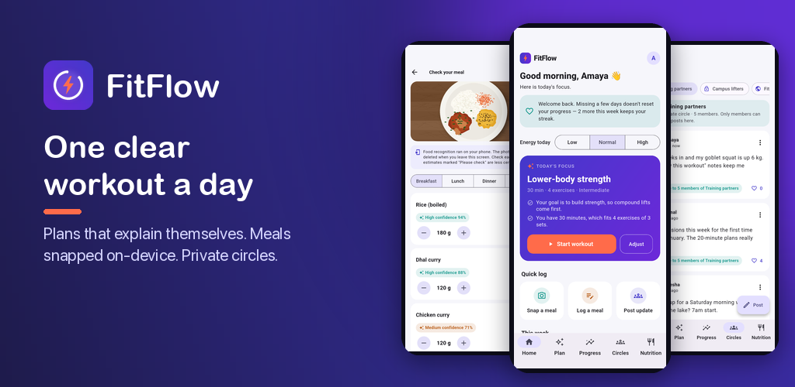
Figure 3 – Google Play feature graphic (1024×500).
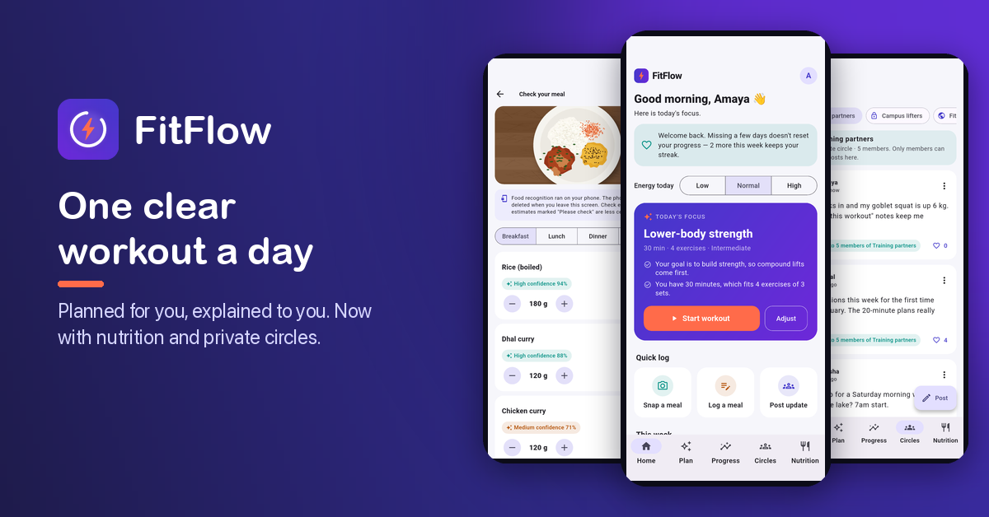
Figure 4 – Promotional banner (1200×628).

2.3 Screenshots
Store slot | Size | Count
Play – phone | 1080×1920 | 8
Play – 7-inch tablet | 1200×1920 portrait + 1920×1200 landscape | 8 + 8
Play – 10-inch tablet | 1600×2560 portrait + 2560×1600 landscape | 8 + 8
App Store – iPhone 6.9" | 1320×2868 | 8
App Store – iPad 13" | 2064×2752 | 8

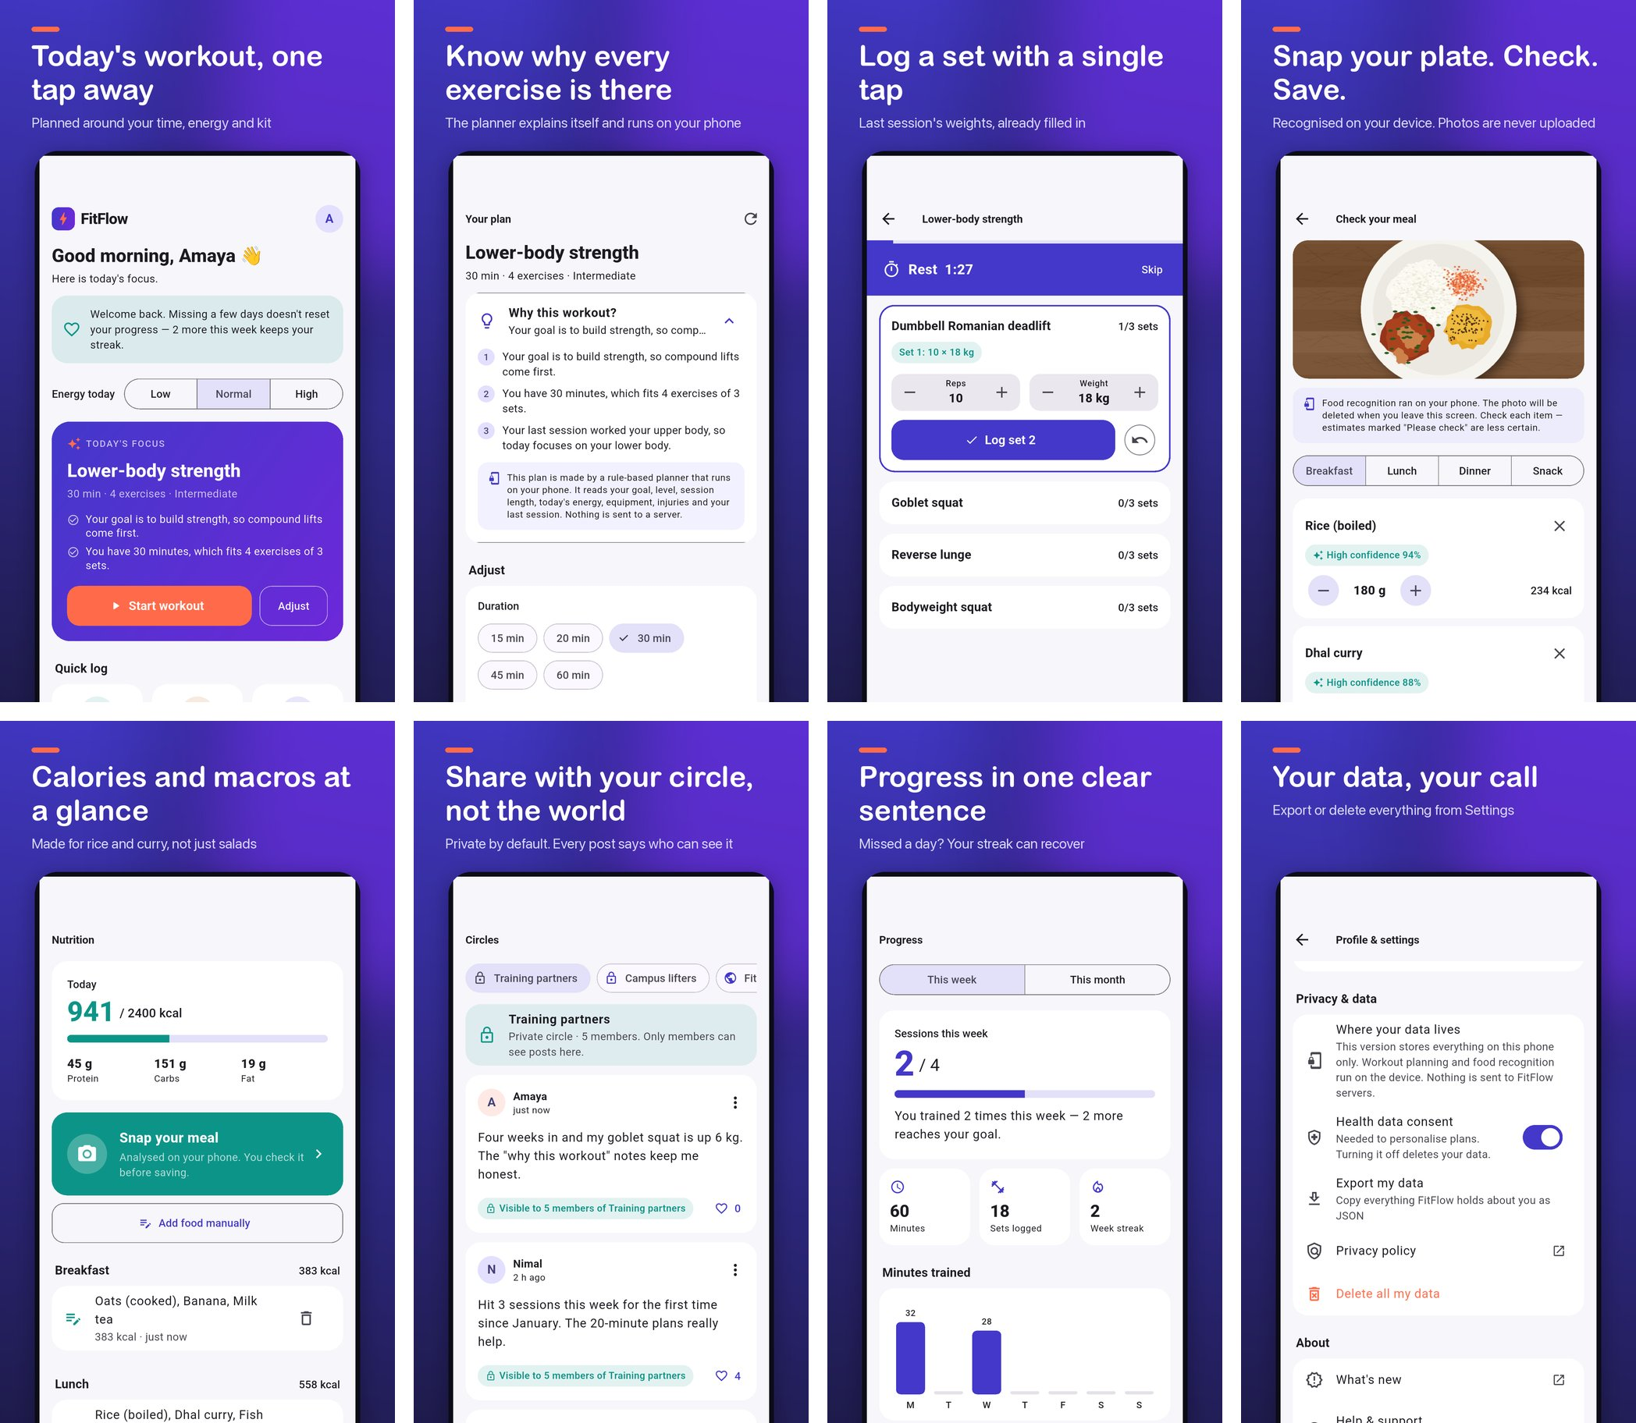
Figure 5 – Google Play phone screenshots 01–08 (captioned, in upload order).
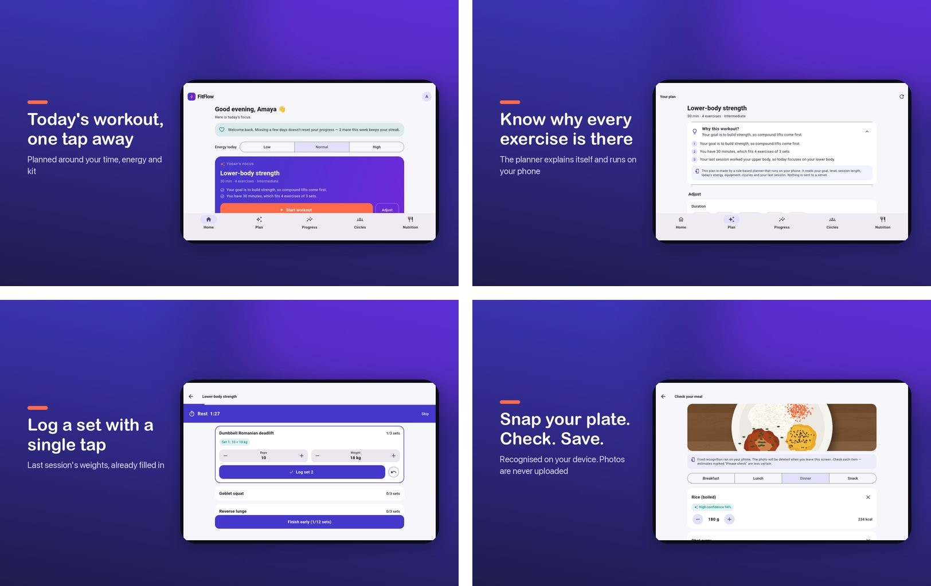
Figure 6 – 7-inch tablet, landscape.
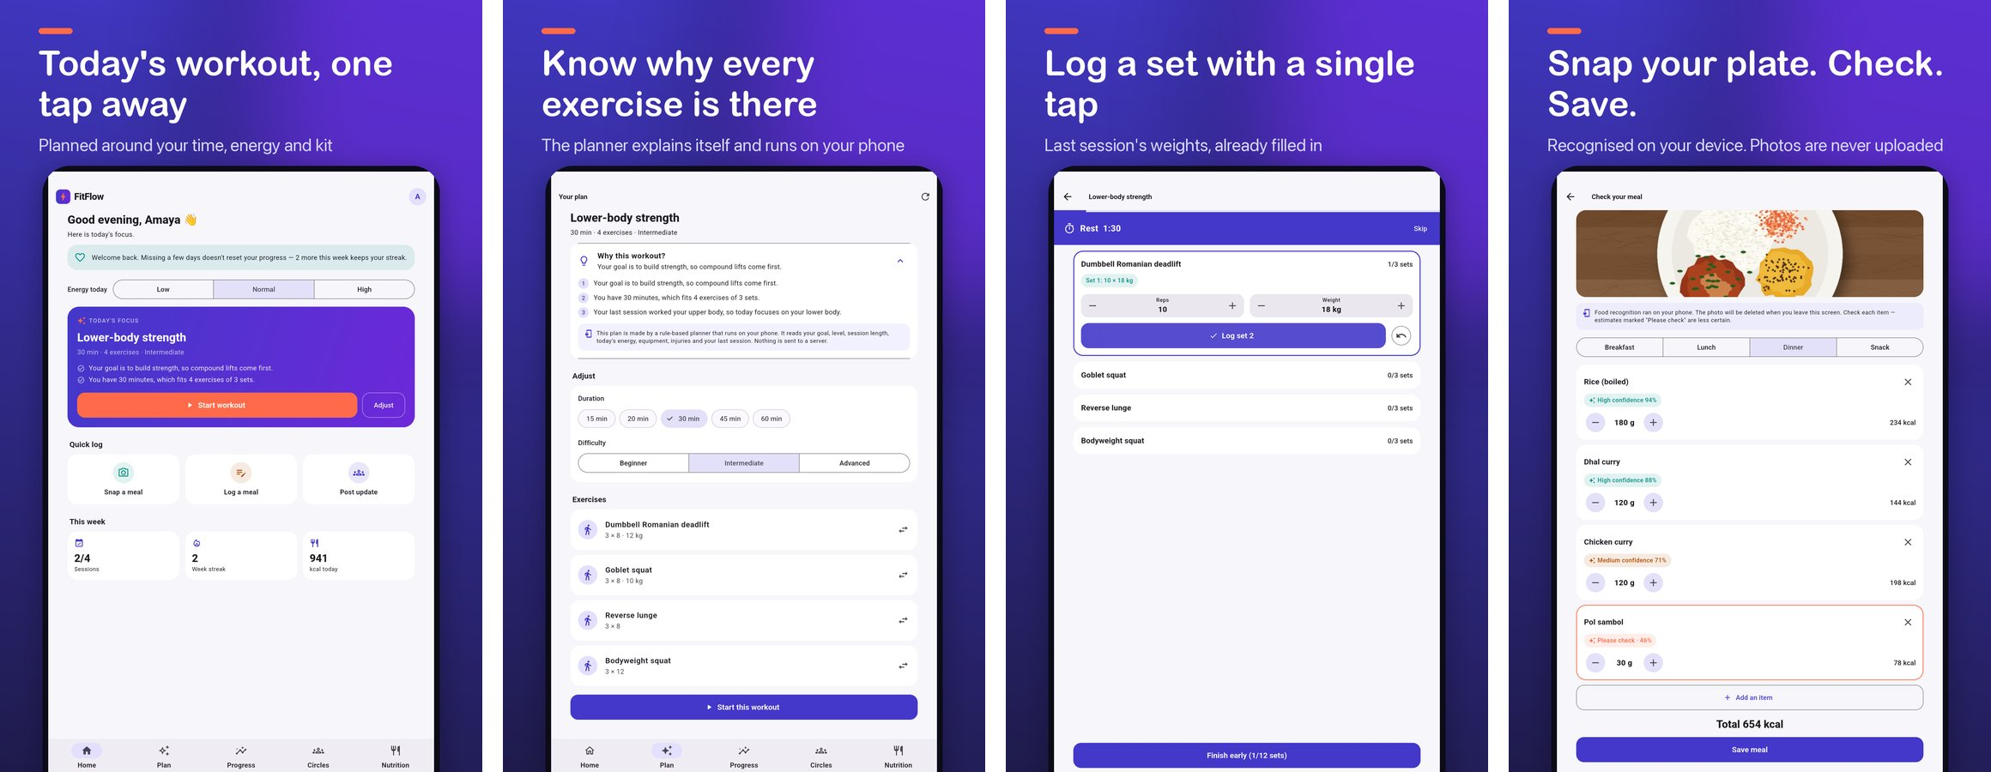
Figure 7 – 10-inch tablet, portrait.
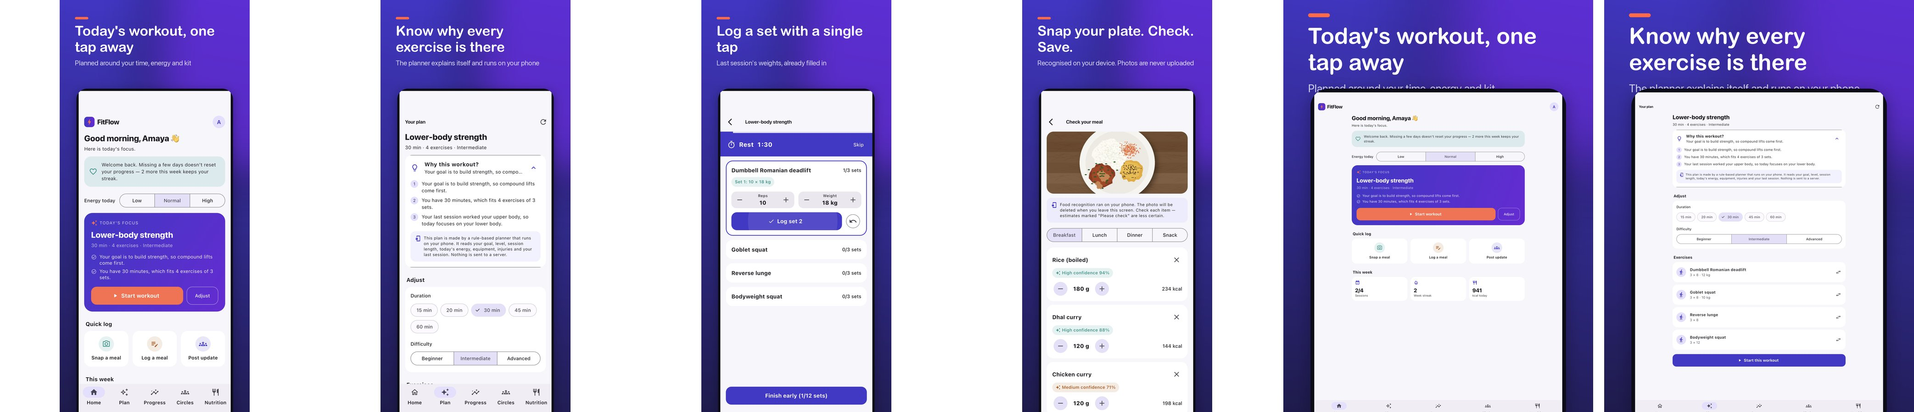
Figure 8 – App Store: iPhone 6.9" (first four) and iPad 13".
# | Screen | Caption | Requirement
01 | Home | Today's workout, one tap away | R01, R14, U04
02 | Plan | Know why every exercise is there | R03–R05, R15
03 | Logger | Log a set with a single tap | R06, R07, NFR1
04 | Meal review | Snap your plate. Check. Save. | R08, R09, U08
05 | Nutrition | Calories and macros at a glance | R08
06 | Circles | Share with your circle, not the world | R11, U01
07 | Progress | Progress in one clear sentence | R10, R12, R13
08 | Privacy | Your data, your call | NFR5

2.4 Video, listing text and folder structure
- App Store app preview: 886×1920, H.264, 30 fps, silent stereo AAC, 23 s of real app footage recorded on the iPhone simulator with a clean 9:41 status bar (Apple requires real footage, 15–30 s).
- Play promo video: 1080×1920, 27 s — uploaded to YouTube (unlisted) and linked in the listing.
- Listing text: title 29/30, Play short description 78/80, App Store subtitle 24/30, keywords 98/100, promotional text 144/170, description ≈2 360/4000.
- Honest metadata: the planner is rule-based in this prototype, so the listing says "smart planner" not "AI" (Apple 2.3 / Play misleading claims). An unverified WCAG claim was removed.
store-assets/
├─ android/ icon/ feature-graphic/ screenshots/{phone, tablet-7in, tablet-10in}
├─ ios/ icon/ screenshots/{iphone-6.9in, ipad-13in} previews/
├─ promo/ banners/ video/
├─ listing/ google-play/ app-store/
└─ _tools/ generators + validate_assets.py
Naming: ff_<platform>_<device>[-<orientation>]_<NN>_<screen>_<W>x<H>.png
e.g. ff_android_phone_01_home_1080x1920.png

2.5 Problems found and fixed
Problem | Fix
Circle audience label truncated ("Visible to 5 mem…") — undid the U01 privacy fix | Label given its own space, wraps
Tablet layouts stretched across 2560 px | Content capped to a centred 720 dp column
Raw phone screenshot 2.24:1 — Play rejects > 2:1 | Framed onto 9:16 canvas with caption
iOS build: codesign rejected files tagged by iCloud | Build output moved outside synced Desktop

Activity 3 – Configure Google Play Console
Status: fully prepared; not submitted because no Google Play developer account was available. Full configuration: docs/lab06/03-google-play-console.md.
Section | Configuration
App | FitFlow: Workouts & Nutrition · en-GB · App · Free
Category | Health & Fitness; tags Workout, Fitness tracking, Nutrition
Store listing | Title, short and full description, 512 icon, feature graphic, 8 phone + 16 + 16 tablet screenshots, YouTube promo
Privacy policy | https://chanuka-01.github.io/fitflow-redesign/privacy-policy/
Content rating (IARC) | No violence/sex/gambling/drugs; users interact = Yes (circles, with report/delete) → expected PEGI 3 / Everyone
Target audience | 18+ (16–17 allowed); not designed for children
Ads / Advertising ID | No ads; Advertising ID not used
Data safety | No data collected or shared (all on device, no INTERNET permission); in-app deletion available. Planned answers prepared for the backend release
Health apps declaration | Activity & fitness tracking; nutrition; no medical/regulated features
Play App Signing | Google-generated app signing key; upload certificate SHA-256 93:B8:CF…:57:51
Testing tracks | Internal (team, ≤100) → Closed (Google Group) → Production. Personal accounts need 12 testers × 14 days of closed testing
Release | Internal: upload app-release.aab (1.1.0, code 2) + mapping.txt; notes from Activity 5
Countries | Sri Lanka first; then India, UK, Australia, Singapore
Device exclusions | None needed — minSdk 24 excludes old Android; camera not required

3.1 Pre-launch report
Play runs every testing-track upload on real devices. Expected: no crashes (none seen in 7 device configurations), possible accessibility suggestions (contrast audit is open), no security warnings (no cleartext traffic, no exported components except the launcher). Errors block promotion; warnings go to the bug log.

3.2 Store listing experiments (A/B tests)
# | Hypothesis | Variant | Metric
E1 | Leading with the explained plan converts better | Screenshot order 02-01-03 | Retained installers (1 day)
E2 | Privacy-first short description attracts users who stay | "Private fitness planner: workouts that explain themselves, data stays on your phone." | Retained installers
E3 | Food recognition in the feature graphic lifts nutrition searches | Meal-review phone in centre | First-time installers

50/50 split, at least 7 days, apply only at 90 % confidence; E1 first.

Activity 4 – Configure App Store Connect and TestFlight
Status: configuration prepared and the iOS app built and run on the iPhone 18 Pro Max and iPad Pro 13-inch simulators (iOS 27, Xcode 27); not uploaded because no Apple Developer Program membership was available. Full configuration: docs/lab06/04-app-store-connect-testflight.md.
Section | Configuration
App record | iOS · FitFlow: Workouts & Nutrition · English (U.K.) · bundle io.fitflow.app · SKU FITFLOW-IOS-001
Subtitle / category | "Workouts planned for you" · Health & Fitness (secondary Food & Drink)
Keywords (98/100) | workout,planner,gym,fitness,strength,nutrition,calorie,meal,tracker,dumbbell,exercise,habit,streak
Age rating | 4+ questionnaire; user-generated content = Yes with report/delete
Privacy nutrition label | "Data Not Collected" for 1.1.0 (no network access). Planned label prepared for backend release (Fitness, Name/Email, User content, Diagnostics — none used for tracking)
Screenshots / preview | 8 × iPhone 6.9" (1320×2868), 8 × iPad 13" (2064×2752), 23 s app preview
Export compliance | ITSAppUsesNonExemptEncryption = NO added to Info.plist
Upload | flutter build ipa → Xcode Organizer or xcrun altool

4.1 TestFlight
Group | Type | Members | Review
FitFlow Team | Internal | ≤100 App Store Connect users | None
FitFlow Beta – Campus | External | 20–30 SLIIT students who train | Beta App Review (first build)
FitFlow Beta – Public link | External | Link capped at 100 | Beta App Review

- Builds expire after 90 days: new build at least every 60 days or after any critical fix; superseded builds expired manually; build number +1 per upload.
- "What to test": onboarding → start workout → log 3 sets → snap a meal and correct an item → post to private circle and check the audience label → send feedback with screenshot.

4.2 Apple review compliance (health)
Guideline | FitFlow
1.4.1 Physical harm | Reasons shown for every plan; conservative volume; professional-advice disclaimer
1.2 User-generated content | Report + delete on posts; private by default; contact in listing (block-user logged as gap)
2.3 Accurate metadata | Real screenshots; "smart planner", not "AI"
HealthKit / 5.1.3 | Not used in 1.1.0; rules documented if added (no ads, no iCloud storage)
5.1.1 Data | Privacy policy in app and listing; explicit consent; in-app deletion
Camera purpose strings | Explain on-device analysis and no upload

Activity 5 – Prepare a Privacy Policy and Release Notes
Full texts: docs/lab06/05-privacy-policy.md and docs/lab06/05-release-notes.md. The policy is linked in the app (onboarding consent step and Settings → Privacy policy) and in both store listings at https://chanuka-01.github.io/fitflow-redesign/privacy-policy/ — publishing it with GitHub Pages is the remaining step.

5.1 Privacy policy (summary of sections)
Section | Content
Summary | Everything stays on the phone; no accounts, ads or tracking; photos analysed on device then deleted
Data used | Profile, health/fitness (injuries, workouts), nutrition, meal photos, posts, consent record; no contacts, location, ad ID
Health data & consent | Special-category data (GDPR Art. 9; Sri Lanka PDPA No. 9 of 2022) — explicit consent at onboarding, withdrawable in Settings
AI processing | Rule-based on-device planner with reasons; on-device food recognition with confidence; suggestions only, no Art. 22 decisions
Social features | Private circle by default; audience shown on every post; delete/report; local-only in 1.1.0
Storage & security | App-private storage, device encryption; removed on uninstall or delete
Sharing | None; future providers (e.g. Firebase Crashlytics) listed before they are added
Rights | Access/portability (Export), correction, erasure (Delete all), withdraw consent, complaint to authority
Children | 16+; not directed at children; no under-13 data
HIPAA | Not a covered entity, so HIPAA does not apply; HIPAA-style safeguards followed
Disclaimer, changes, contact | Not a medical device; versioned changes with in-app notice; contact support@fitflow.example (placeholder)

5.2 Release notes – Google Play (449/500 characters)
FitFlow has been redesigned around one clear workout a day.
• Today's plan waits on your home screen. Start it in one tap.
• See why every exercise is there, then shorten it, swap moves or regenerate.
• Log a set with a single tap: last time's weights are already filled in.
• Snap your meal: food is recognised on your phone and you check it before saving.
• Private circles: every post shows exactly who can see it.
Your data stays on your device.

5.3 Update history and known issues
Version | Build | Date | Summary
1.1.0 | 2 | 2026-10-04 | Focus Flow redesign
1.0.0 | 1 | — | Template baseline, never distributed

- Food recognition uses a demonstration model — results must be checked.
- Circles are stored on the device only.
- Start-up target (2 s) still to be measured on a physical device.

Activity 6 – Perform Internal Testing Deployment
Only observed results are reported; items not yet done are marked Pending. Full record: docs/lab06/06-internal-testing.md.

6.1 Deployment
Channel | Status
Google Play Internal Testing | Prepared (Activity 3) — needs Play account
Apple TestFlight | Prepared (Activity 4) — needs Apple Developer account
Signed build direct install | Done — AAB → bundletool install-apks on Pixel 9a emulator
Firebase App Distribution | Planned free alternative using the signed universal APK

6.2 Results
Test | Result
flutter analyze | No issues
Unit/widget tests | 5/5 passed (injury rules, equipment, reasons, low-energy volume, onboarding consent)
Integration test (9 screens) | Passed on 7 configurations: phone, 7"/10" tablets portrait + landscape, iPhone 6.9", iPad 13"
Manual walkthrough T01–T09 | All passed (T08 after fixing B01)
Crashes | None in any run (logcat checked)
Start-up (NFR3) | Emulator not valid (control app as slow); physical device Pending
Battery | Pending — physical device needed
Crashlytics | Not integrated yet — needs INTERNET permission, so planned with privacy-policy update

6.3 Bug log
ID | Severity | Description | Fix | Status
B01 | Major | Audience label truncated (U01 regression) | Own space, wraps | Fixed
B02 | Minor | Chip checkmark over lock icon | showCheckmark: false | Fixed
B03 | Major | Tablet content stretched | 720 dp column | Fixed
B04 | Major | Links fail on Android 11+ | Manifest <queries> | Fixed
B05 | Critical | iCloud duplicate files broke Android build | Build out of synced folder | Fixed
B06 | Critical | iOS codesign rejected iCloud-tagged files | Same as B05 | Fixed
B07 | Major | Signing passwords in iCloud-synced folder | Moved, symlinked | Fixed
B08 | Minor | Screenshot captured stale frame | Settle + precache | Fixed
B09 | Minor | Emulator slept mid-test | Stay-awake in script | Fixed

6.4 Tester feedback (to be completed)
Tester | Device / OS | Tasks completed | Rating 1–5 | Comment

6.5 Approval record
Criteria: no open Critical/Major bugs ✔ · tests pass ✔ · release build verified ✔ · physical-device start-up ≤ 2 s ☐ · tester feedback reviewed ☐
Role | Name | Decision | Signature | Date
Developer | Jayawardhana O K T C (IT23230774)
Reviewer / team lead
Lecturer

Appendix – Build and test commands
# app
cd frontend/mobile
flutter pub get
flutter analyze && flutter test
flutter run # debug on emulator/simulator
# signed release + verification evidence
scripts/release_android.sh
# store screenshots (all devices) and preview recordings
RECORD=1 scripts/capture_screenshots.sh
# store assets (from repository root)
PY=store-assets/_tools/.venv/bin/python
$PY store-assets/_tools/make_icons.py
$PY store-assets/_tools/frame_screenshots.py
$PY store-assets/_tools/make_promo.py
store-assets/_tools/make_videos.sh
$PY store-assets/_tools/validate_assets.py

GitHub repository: https://github.com/CHANUKA-01/fitflow-redesign

