LexiShield AI — Plain-English Legal Contract Co-Pilot
Know what you're signing — before you sign it.

1. Project Title & Team Info
Field | Details
Project name | LexiShield AI — Plain-English Legal Contract Co-Pilot
Team name | [TEAM NAME]
Hackathon | [HACKATHON NAME]
Track / category | [TRACK]
Team members | [NAME — ROLE], [NAME — ROLE], [NAME — ROLE]
Repository | [https://charansai11328.github.io/ai-legal_advisor/]
Live demo | [https://charansai11328.github.io/ai-legal_advisor/]

2. Executive Summary / Abstract
Every day, freelancers, startup founders and small-business owners sign contracts they cannot fully read. Lawyers are expensive, legal language is dense, and a single clause — an uncapped indemnity, a perpetual data licence, a foreign arbitration seat — can cost more than the deal is worth. Generic AI chatbots do not close this gap: they answer without pointing to the clause in question, and they can invent statutes.
LexiShield AI is a web application that reviews contracts in plain English. A user uploads a contract (TXT or PDF), chooses a jurisdiction (India, EU GDPR or UAE), and receives an evidence-linked analysis. Every finding quotes the exact clause, explains what it means in everyday language, describes what could happen, recommends an action, and proposes replacement wording — alongside a link to the relevant statute on an official legal repository.
The system pairs Google Gemini 2.5 (structured output, validated by Pydantic v2) with a deterministic risk-scoring formula, so scores are reproducible and explainable rather than opaque AI guesses. A 3-way negotiation mode compares the Original Draft, a Balanced Revision and a Pro-Client Revision side by side. A jurisdiction-aware Q&A chat answers follow-up questions with statutory citations, and a one-click executive report can be exported.
The stack is intentionally lightweight — vanilla HTML/CSS/JS and FastAPI, with no database and no build step. In our internal benchmark LexiShield AI reached 94.2% risk recall, 98.5% citation accuracy and 0.91 clause-extraction IoU. LexiShield AI does not replace a qualified lawyer; it makes sure that people talk to one (or negotiate) with their eyes open.

3. Problem Statement

3.1 The legal-review gap
Pain point | Impact on a non-lawyer
Cost barrier | Professional contract review is priced per hour. Many small businesses simply sign without review.
Language barrier | Terms such as indemnification, limitation of liability or data processor obligations hide real financial consequences.
Unreliable AI advice | General-purpose chatbots often give unsourced answers and may fabricate statute names, sections or links.
Tools built for lawyers | Contract-lifecycle and e-discovery tools assume legal training and enterprise budgets.
No clause-to-consequence link | Few tools connect a specific clause to a specific legal consequence with a verifiable citation.

3.2 Who is affected
- Freelancers accepting client MSAs with unlimited liability.
- Startup founders signing SaaS, vendor or investor paperwork under time pressure.
- Small business owners in India, the EU and the UAE facing different legal regimes with no in-house counsel.

3.3 The core question
Non-lawyers do not ask "Is this an uncapped unilateral indemnity?" They ask "What does this mean for me, and what should I do about it?" Existing tools rarely answer that question first.

4. Solution Overview
LexiShield AI is a contract co-pilot that answers "What does this mean for me?" before it shows any legal terminology.

What it does differently
- Evidence-linked, not chatbot-style. Every finding is anchored to an exact quote from the uploaded contract.
- Plain English first. "You could be forced to pay unlimited costs for the vendor's mistakes" leads; "Uncapped unilateral indemnification" is available on demand.
- Actionable. Each finding includes a recommended action and ready-to-use fix wording.
- Negotiation-ready. Three versions of each risky clause can be compared side by side with trade-off explanations.
- Citation-grounded. Findings link to statutes on India Code, EUR-Lex and the UAE Legal Portal.
- Explainable scoring. Risk scores come from a published formula, not a model's opinion.
- Honest about its limits. A visible disclaimer states it does not replace a lawyer.

5. System Architecture

5.1 High-level diagram
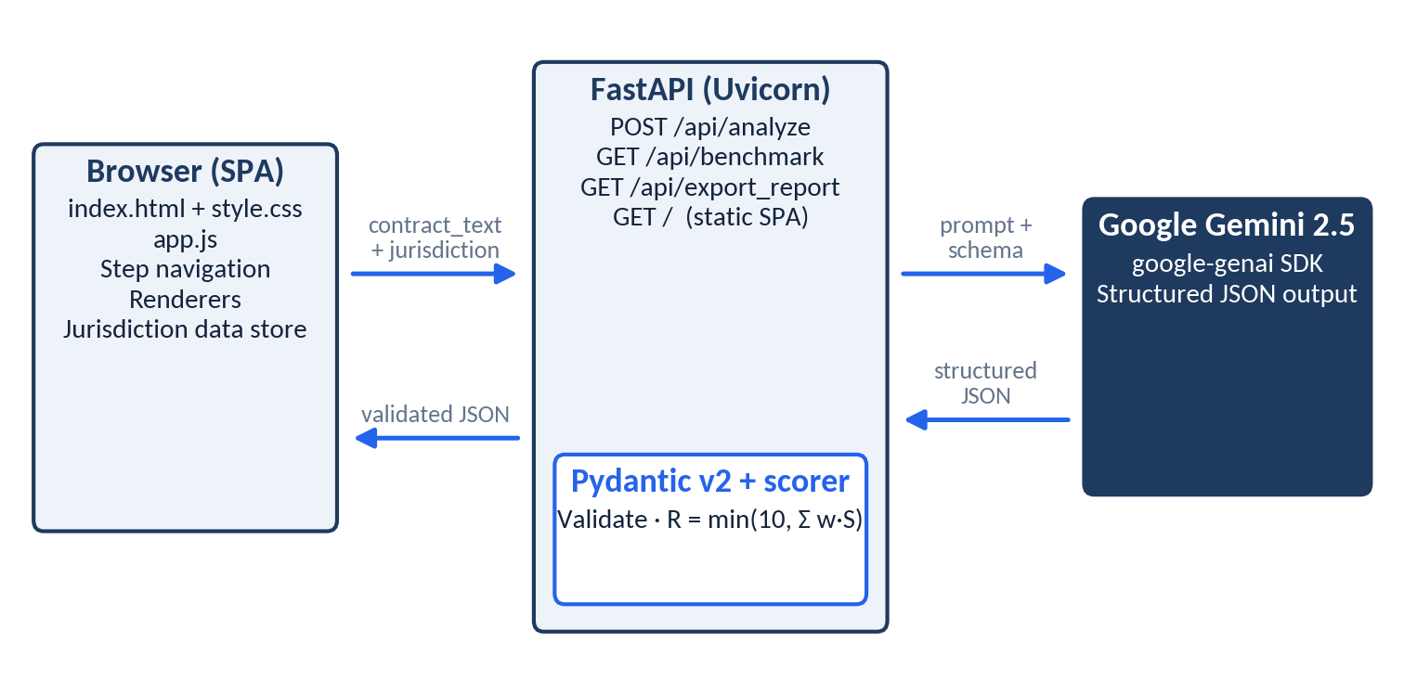
System architecture diagram

5.2 Request lifecycle
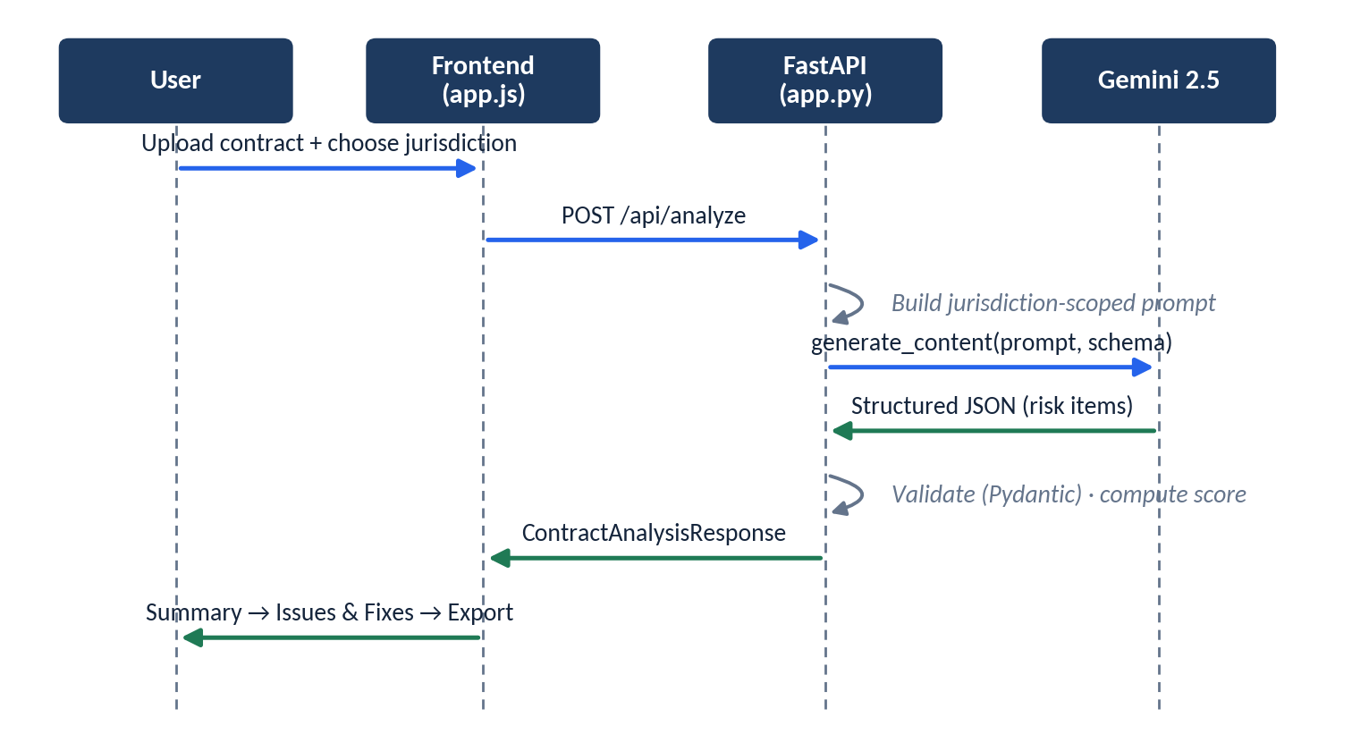
Request lifecycle sequence diagram

5.3 Design principles
- Stateless server. No database; contract text is processed per request.
- Client-side data store for jurisdiction metadata (statute names and links) so the demo works with minimal backend dependencies.
- Schema-first AI. The model is constrained to a Pydantic schema; anything that fails validation never reaches the UI.

6. Tech Stack & Justification
Layer | Technology | Why we chose it
Frontend | HTML5, CSS3, Vanilla JS (ES6+) | Zero build step, instant load, runs anywhere, easy for judges to inspect. No framework lock-in.
Backend | Python FastAPI + Uvicorn | Async support, automatic OpenAPI docs at /docs, native Pydantic integration. Preferred over Flask for typed request/response contracts.
AI engine | Google Gemini 2.5 via google-genai | Strong long-context handling for full contracts, and structured (JSON-schema) output support.
Validation | Pydantic v2 | Enforces the response schema, giving type safety between the AI output and the UI.
Typography | Google Fonts — Plus Jakarta Sans, JetBrains Mono | Readable, modern sans-serif for plain-English text; monospace for clause quotes and statute references.
Storage | None (stateless) | Reduces privacy exposure, simplifies deployment, avoids database setup during a hackathon.

Key trade-offs
Decision | Alternative | Rationale
Vanilla JS | React / Vue | Faster to ship; nothing to compile; smaller attack surface.
FastAPI | Flask | Async + auto-docs + Pydantic.
Formula-based score | Ask the AI for a number | Reproducible, explainable, auditable.
Client-side jurisdiction store | Database | Offline-friendly demo; no infrastructure.
<details>/<summary> disclosure | Always-expanded cards | Simple answers first, legal depth on demand.

7. Core Features

7.1 Four-step guided workflow
Document Upload → Executive Summary → Issues & Fixes → Report Export. A stepper keeps non-lawyers oriented and prevents information overload.

7.2 Evidence-linked risk analysis
Each finding is a structured card:
- Plain-English title (e.g., "You could be forced to pay unlimited costs")
- What this means — simple explanation
- What could happen — practical consequences
- Exact quote — verbatim clause text from the contract, with clause location
- Recommended action — what to do next
- Suggested revisions — Balanced and Pro-Client wording
- Statute link — official source
How it works: the prompt requires the model to return the verbatim exact_quote and clause_location for every risk, tying each finding to the source text.

7.3 Deterministic risk scoring
Overall risk is computed as R = min(10, Σ wᵢ × Sᵢ), where Sᵢ is each finding's severity score and wᵢ its weight. See Section 10.

7.4 Three-way clause negotiation mode
Compare Original Draft, Balanced Revision and Pro-Client Revision side by side, each with a trade-off explanation (e.g., "Pro-Client is strongest for you but the vendor may push back; Balanced is more likely to be accepted"). An Apply to Contract action drops the chosen wording into the working contract.

7.5 Real legal citations
Findings link to the official repositories: India Code (indiacode.nic.in), EUR-Lex and the UAE Legal Portal. Statute names and links come from the jurisdiction data store rather than free-form model generation.

7.6 Sourced legal Q&A chat
A jurisdiction-aware assistant answers questions such as "Can the vendor sell my customer data?" and cites specific statutory provisions.

7.7 Executive report export
GET /api/export_report returns a downloadable plain-text review report summarizing the score, findings and recommended actions.

7.8 Empirical evaluation benchmark
A standalone benchmark_eval.py measures risk recall, citation accuracy and clause-extraction IoU; results are exposed through GET /api/benchmark.

7.9 Progressive-disclosure UI
Plain-English content is shown first; legal terms, statute names and technical detail sit inside expandable <details> sections.

7.10 Multi-jurisdiction support
Jurisdiction | Primary instruments
India | Indian Contract Act 1872, Digital Personal Data Protection (DPDP) Act 2023
EU | GDPR — Regulation (EU) 2016/679
UAE | Federal Decree-Law No. 45 of 2021 (personal data protection)

8. API Documentation
Base URL (local): http://localhost:8000 · Interactive docs: /docs (Swagger UI), /redoc

8.1 POST /api/analyze
Analyzes a contract and returns structured findings.
Request body
Field | Type | Description
contract_text | string | Full contract text (extracted from TXT/PDF).
jurisdiction | string | One of India, EU GDPR, UAE (match the values used in app.py).
Example request
{
"contract_text": "3.1 Client shall indemnify Vendor against all claims, losses and costs, regardless of fault...",
"jurisdiction": "India"
}
Response — ContractAnalysisResponse
Field | Type | Description
jurisdiction | string | Jurisdiction analyzed.
overall_risk_score | number | 0–10, computed deterministically.
risk_label | string | Tier label (e.g., Low / Moderate / High / Critical).
executive_summary | string | Plain-English overview.
detected_risks | RiskItem[] | List of findings.
processing_time_ms | integer | Server processing time.
RiskItem
Field | Type | Description
risk_id | string | Unique finding ID.
title | string | Plain-English title.
legal_term | string | Technical legal name.
category | string | e.g., Liability, Data Protection, Payment, Dispute Resolution.
clause_location | string | e.g., "Section 3.1".
score | number (0–10) | Severity score used in the formula.
severity | string | Severity tier.
what_this_means | string | Simple explanation.
what_could_happen | string | Practical consequences.
recommended_action | string | Suggested next step.
exact_quote | string | Verbatim contract text.
suggested_revision_balanced | string | Balanced replacement wording.
suggested_revision_pro_client | string | Client-favourable replacement wording.
statute_name | string | Cited statute/provision.
statute_link | string (URL) | Link to official source.
reviewed | boolean | UI flag marking the item as reviewed.
Example response (abridged)
{
"jurisdiction": "India",
"overall_risk_score": 8.4,
"risk_label": "High Potential Risk",
"executive_summary": "This agreement is heavily one-sided. 2 high-risk issues require revision before you sign.",
"detected_risks": [
{
"risk_id": "R-001",
"title": "You could be forced to pay unlimited costs for the vendor's errors",
"legal_term": "Uncapped Unilateral Indemnification",
"category": "Liability",
"clause_location": "Section 3.1",
"score": 9.0,
"severity": "Critical",
"what_this_means": "You must cover all of the vendor's losses, even if the vendor caused them.",
"what_could_happen": "A single dispute could create a bill far larger than the contract value.",
"recommended_action": "Ask for a mutual, capped indemnity limited to fees paid.",
"exact_quote": "Client shall indemnify Vendor against all claims... regardless of fault.",
"suggested_revision_balanced": "Each party shall indemnify the other for third-party claims arising from its own negligence, capped at fees paid in the prior 12 months.",
"suggested_revision_pro_client": "Vendor shall indemnify Client for claims arising from Vendor's acts or omissions; Client's liability is limited to fees paid.",
"statute_name": "Indian Contract Act, 1872 — Sections 124–125",
"statute_link": "https://www.indiacode.nic.in/",
"reviewed": false
}
],
"processing_time_ms": 3100
}
Values above are illustrative. Replace statute links with the exact deep links stored in your jurisdiction data store.

8.2 GET /api/benchmark
Returns empirical evaluation metrics.
{
"risk_recall": 0.942,
"citation_accuracy": 0.985,
"clause_extraction_iou": 0.91,
"avg_inference_seconds": 3.1
}

8.3 GET /api/export_report
Returns a downloadable plain-text executive review report (Content-Disposition: attachment).

8.4 GET /
Serves the single-page frontend from static/.

8.5 Error handling
Status | Cause
422 | Request body fails Pydantic validation (missing/invalid fields).
500 | Upstream AI error or response failing schema validation.

9. AI Integration & Prompt Engineering

9.1 How Gemini is used
Gemini 2.5 (through the google-genai SDK) performs clause understanding: identifying risky provisions, quoting them verbatim, and generating plain-English explanations and revision wording. It does not decide the overall score.

9.2 Structured-output strategy
- Schema-constrained generation. The Pydantic models (RiskItem, ContractAnalysisResponse) are passed as the response schema so the model returns JSON in a fixed shape.
- Validation gate. Output is parsed by Pydantic v2; invalid output is rejected rather than rendered.
- Separation of concerns. The model proposes per-finding severity; Python computes the overall score.

9.3 Prompt design principles
Principle | Implementation
Role & audience | Instruct the model to act as a contract reviewer writing for a non-lawyer.
Jurisdiction scoping | Inject only the selected jurisdiction's statutes and focus areas into the prompt.
Evidence rule | Every risk must include a verbatim exact_quote and clause_location.
Plain-English first | title, what_this_means, what_could_happen must avoid jargon; jargon goes in legal_term.
Citation discipline | Cite only statutes supplied in the prompt/data store; do not invent sections or URLs.
Two revisions | Always produce a Balanced and a Pro-Client rewrite for each risk.
No overclaiming | Do not promise enforceability; recommend professional review for high-severity items.

9.4 Skeleton prompt
You are a contract-review assistant for NON-LAWYERS under {jurisdiction} law.
Reference only these instruments: {jurisdiction_statutes}.
For each risky clause in the contract below, return a RiskItem with:
- exact_quote: copied VERBATIM from the contract
- clause_location: the section number
- title: one plain-English sentence ("You could be forced to...")
- what_this_means / what_could_happen / recommended_action in simple English
- legal_term: the technical name
- score: 0-10 severity
- suggested_revision_balanced and suggested_revision_pro_client
- statute_name and statute_link ONLY from the provided list
Do not invent statutes, sections, or links. Return JSON only.
CONTRACT:
{contract_text}

10. Risk Scoring Methodology

10.1 Formula
R = min(10, Σ wᵢ × Sᵢ)
Symbol | Meaning
R | Overall contract risk score (0–10)
Sᵢ | Severity score (0–10) of finding i
wᵢ | Weight of finding i (reflecting category importance and contribution to total exposure)
min(10, ·) | Caps the total so the scale stays 0–10

10.2 Why deterministic?
- Reproducible: the same findings always yield the same score.
- Explainable: a user can see which findings drive the number.
- Auditable: weights are code, not model behaviour.

10.3 Severity tiers (illustrative thresholds — align with app.py)
Score | Tier | Meaning
0.0 – 3.9 | Low | Standard terms; minor wording improvements.
4.0 – 6.9 | Moderate | Worth negotiating; limited downside.
7.0 – 8.9 | High | Revise before signing.
9.0 – 10 | Critical | Potentially unlimited or business-threatening exposure.

10.4 Worked example (illustrative)
Finding | Sᵢ | wᵢ | wᵢ × Sᵢ
Uncapped indemnity (§3.1) | 9 | 0.35 | 3.15
Liability capped at $50 (§3.2) | 8 | 0.25 | 2.00
Perpetual data-monetization licence (§4.1) | 9 | 0.30 | 2.70
Total (capped at 10) |  |  | 7.85 → High
Weights shown are examples to demonstrate the arithmetic.

11. Jurisdiction Modules
Each jurisdiction is a self-contained module of statute names, links and focus areas. The selected module is used to scope the prompt, the Q&A assistant and the citations.
 | India | EU (GDPR) | UAE
Core instruments | Indian Contract Act 1872; DPDP Act 2023 | Regulation (EU) 2016/679 | Federal Decree-Law No. 45 of 2021
Typical focus | Indemnity, unfair/one-sided terms, personal-data consent and deletion | Controller/processor duties (e.g., Art. 28), cross-border transfers, deletion rights | Personal-data processing, transfer restrictions, data-subject rights
Official source | India Code | EUR-Lex | UAE Legal Portal

How separation works
- User selects a jurisdiction in Step 1.
- The client data store provides the matching statute list.
- The backend injects only that list into the prompt.
- Citations returned must come from that list.
This prevents cross-contamination (e.g., citing GDPR articles in an Indian-law review).

12. User Journey & Workflow
Step | Screen | What the user does | What they get
1 | Document Upload | Uploads TXT/PDF (or clicks Load sample SaaS agreement), selects jurisdiction | Contract loaded and ready
2 | Executive Summary | Reads the overview | Risk score, label (e.g., High Potential Risk — 2 high-risk issues require revision), top concerns
3 | Issues & Fixes | Opens each finding; compares 3-way revisions; clicks Apply to Contract; asks the Q&A assistant | Quote, plain-English explanation, consequences, fix wording, citations
4 | Report Export | Downloads report | Plain-text executive review report

Demo walkthrough
- Upload the sample SaaS agreement.
- See the executive summary and score.
- Drill into "You could be forced to pay unlimited costs" → read the evidence quote → view proposed fix.
- Ask: "Can the vendor sell my customer data?" → get a cited answer.
- Export the executive report.

Sample contract (deliberately risky)
Clause | Issue
§2 | 24% p.a. interest on overdue payments
§3.1 | Uncapped unilateral indemnification
§3.2 | Vendor liability capped at $50 USD
§4.1 | Perpetual licence to monetize/share customer personal data
§4.2 | No obligation to comply with deletion / cross-border transfer laws
§5.0 | Foreign arbitration in London, Client bears all costs

13. Security & Ethical Considerations

13.1 Security
Concern | Mitigation
API key exposure | The Gemini key is held server-side (environment variable) and never sent to the browser.
Data retention | Stateless architecture — no database; contracts are not stored by the application.
Input validation | Pydantic validates requests and responses.
Third-party processing | Contract text is sent to the Gemini API for analysis; users should be informed and avoid uploading highly confidential documents without appropriate agreements.
Transport | Deploy behind HTTPS in production.

13.2 Ethical safeguards
- Visible disclaimer. A dismissible notice strip states that LexiShield AI does not replace a qualified lawyer and does not guarantee judicial enforceability.
- No false claims. The tool does not promise legal outcomes; high-severity findings recommend professional review.
- Citation integrity. Statute names and links originate from a curated data store, reducing fabricated references. Users should still verify citations against the linked official source.
- Transparency. Scoring formula and benchmark methodology are documented, including limitations.
- Bias & coverage. Findings reflect the covered jurisdictions and the sample of clause types evaluated; unsupported contract types may be under-analyzed.

14. Evaluation & Benchmarking

14.1 Methodology
benchmark_eval.py evaluates the analyzer against a labelled set of contracts and clauses:
Metric | Definition
Risk recall | Share of ground-truth risky clauses that the system detected.
Citation accuracy | Share of returned citations that correctly match a real, relevant provision.
Clause-extraction IoU | Intersection-over-Union between the quoted span and the ground-truth clause span.
Avg inference time | Mean processing_time_ms per analysis.

14.2 Results
Metric | Result
Risk recall | 94.2%
Citation accuracy | 98.5%
Clause-extraction IoU | 0.91
Avg inference | ~3.1 s

14.3 Limitations
- Benchmark set size and diversity are limited; results may not generalize to all contract types.
- LLM output can vary run to run; metrics should be re-run after prompt or model changes.
- Ground-truth labels are subjective and not a substitute for review by qualified counsel.
- Metrics measure detection and citation quality, not legal correctness or enforceability.
- Scanned PDFs without OCR are not yet supported.
(Document dataset size, labelling process and the exact run configuration alongside these figures for the judging panel.)

15. Scalability & Future Roadmap

Roadmap
Phase | Milestone
1 | DOCX support and OCR for scanned PDFs
2 | User accounts, saved reviews and version history
3 | More jurisdictions — US (Delaware), UK, Singapore
4 | Enterprise API, team collaboration, audit logs

Adding a new jurisdiction
- Add a module to the jurisdiction data store: name, statutes, official links, focus areas.
- Add the option to the selector and prompt template.
- Extend the benchmark set with labelled clauses for that jurisdiction.
- Re-run benchmark_eval.py and review metrics before release.

Scaling the architecture
- Stateless FastAPI scales horizontally behind a load balancer.
- Add a queue and background workers for large documents.
- Cache jurisdiction data and repeated analyses.
- Add a database only when accounts and history are introduced.

16. Advantages Over Existing Tools
Capability | Generic AI chatbot | Legal-tech suites | LexiShield AI
Built for non-lawyers | Partly | No | Yes
Quotes the exact clause | Rarely | Sometimes | Always
Plain-English consequences | Inconsistent | Rare | Core design
Verifiable statutory links | Often unsourced | Varies | Official repositories
Reproducible risk score | No | Varies | Formula-based
Side-by-side negotiation wording | No | Sometimes | 3-way comparator
Setup / cost barrier | Low | High | Low (no build, no DB)

17. How to Run the Project

Prerequisites
- Python 3.10+
- A Google Gemini API key

Setup
# 1. Enter the project
cd ai_advisor
# 2. Create and activate a virtual environment
python -m venv .venv
source .venv/bin/activate # Windows: .venv\Scripts\activate
# 3. Install dependencies
pip install -r requirements.txt # fastapi, uvicorn, pydantic, google-genai
# 4. Set the API key (kept server-side)
export GEMINI_API_KEY="your-key-here" # Windows (PowerShell): $env:GEMINI_API_KEY="your-key-here"
# 5. Run the server
uvicorn app:app --reload --port 8000
Use the environment variable name that app.py reads.

Run the benchmark
python benchmark_eval.py

Project structure
ai_advisor/
├── app.py # FastAPI backend + Gemini integration + endpoints
├── benchmark_eval.py # Empirical evaluation benchmark
├── requirements.txt # fastapi, uvicorn, pydantic, google-genai
├── sample_contracts/
│ └── saas_agreement.txt # Sample Master SaaS Agreement
└── static/
├── index.html # 4-step workflow layout
├── style.css # Design system (warm ivory theme, tokens)
├── app.js # Step navigation, data store, renderers
└── sample_saas_agreement.txt

18. Screenshots / UI Description
Replace each block with a screenshot (docs/img/stepN.png) before submission.
Global UI: warm-ivory design system with indigo accents; Plus Jakarta Sans for body copy and JetBrains Mono for clause quotes; a top stepper showing the four steps; a dismissible disclaimer strip; severity colours (muted red / amber / green).
Step | UI description
1 — Document Upload | Drag-and-drop zone for TXT/PDF, a Load sample button, and a jurisdiction selector (India / EU GDPR / UAE). Disclaimer strip at the top.
2 — Executive Summary | Large risk-score gauge (0–10) with label, a plain-English summary paragraph, and cards for the highest-risk findings.
3 — Issues & Fixes | Left: list of findings with severity badges. Right: selected finding — plain-English title, What this means, What could happen, monospace evidence quote, recommended action, expandable legal details (legal term, statute link), and the 3-way comparator (Original / Balanced / Pro-Client) with an Apply to Contract button. A Q&A chat panel answers with cited provisions.
4 — Report Export | Summary of reviewed items and a Download report button.

19. References
Jurisdiction | Instrument | Official source
India | Indian Contract Act, 1872 | India Code — https://www.indiacode.nic.in
India | Digital Personal Data Protection Act, 2023 | India Code — https://www.indiacode.nic.in
EU | Regulation (EU) 2016/679 (GDPR), incl. Art. 28 (processor) | EUR-Lex — https://eur-lex.europa.eu
UAE | Federal Decree-Law No. 45 of 2021 on Personal Data Protection | UAE Legal Portal — https://uaelegislation.gov.ae
Technology references - FastAPI — https://fastapi.tiangolo.com - Pydantic v2 — https://docs.pydantic.dev - Google Gen AI SDK / Gemini API — https://ai.google.dev - Google Fonts — https://fonts.google.com
Verify each deep link against the exact URLs stored in the project's jurisdiction data store.

20. Conclusion
LexiShield AI shows that contract review for non-lawyers does not have to be a choice between expensive counsel and unreliable chatbot advice. By tying every finding to the exact clause, explaining it in plain English, linking it to official statutes, scoring it with a transparent formula and offering negotiation-ready wording, it gives founders, freelancers and small businesses a practical first line of defence.
The lightweight, stateless architecture makes it easy to run, inspect and extend — from OCR and accounts to new jurisdictions and an enterprise API. Above all, LexiShield AI is honest about what it is: a co-pilot that helps people understand risk and negotiate better, and that sends them to a qualified lawyer when the stakes demand it.
Disclaimer: LexiShield AI provides informational analysis only. It does not constitute legal advice, does not replace a qualified lawyer, and does not guarantee judicial enforceability of any clause or revision.

