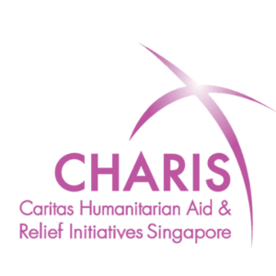
CHARIS SINGAPORE
Digital Platform Transformation
Product Requirements Guide | v1.0
Prepared for: Charis Secretariat & Member Organisations

Executive Summary
CHARIS Singapore currently operates two separate digital properties — the main website (charis-singapore.org) and the donation/fundraising platform (makehopehappen.charis-singapore.org) — alongside a backend volunteer and donor management system that relies on Salesforce and a custom Application using API integration. This fragmentation creates a disjointed experience for donors, volunteers, and member organisations (MOs), while placing unsustainable technical and financial burden on the Secretariat.

This document defines the vision, mission, user requirements, and phased solution roadmap for consolidating all digital capabilities into a single, modern platform that serves Charis, its member organisations, donors, and volunteers.

Vision & Mission

Vision
Platform Vision
A single, unified digital platform that empowers CHARIS and its member organisations to inspire, coordinate, and sustain humanitarian action — giving donors a seamless giving experience, volunteers a meaningful engagement journey, and administrators the tools to manage it all without technical complexity or prohibitive cost.

Mission
Platform Mission
Replace the current fragmented web and CRM infrastructure with one integrated platform that:
- Presents a single, cohesive brand and user experience across all CHARIS digital touchpoints.
- Enables member organisations to independently manage their event content, volunteers, and donors.
- Provides CHARIS with consolidated oversight of all volunteer and donor data across MOs.
- Eliminates the dependency on Salesforce licenses and the custom API integration.
- Is affordable, maintainable, and extensible for the long term.

Problem Statement
The following core problems have been identified through evaluation of the current websites and requirements gathered from the Secretariat, member organisations, and the Volunteer & Outreach committee.

Fragmented User Experience
- Two separate websites with differing visual design and navigation create donor confusion.
- Campaigns and donation workflows are buried behind too many clicks and redundant steps.
- Stale content and poor mobile optimisation undermine donor trust and engagement.
- No unified login or personalised experience for returning donors and volunteers.

Inadequate Content Management
- Member organisations find the current content upload process on the DEP portal slow, error-prone, and unintuitive.
- There is no ability to duplicate or template recurring event or campaign postings.
- MO profiles are not publicly visible, undermining their purpose and impact.
- No notification system alerts MOs when a donor or volunteer responds to a campaign.

Missing Volunteer & Donor Management
- No centralised volunteer management system exists. MOs manage volunteers manually using spreadsheets.
- Donor management relies on Salesforce — a paid platform that exceeds Charis' needs and budget.
- A custom API bridges the current backend and Salesforce, introducing fragility and maintenance overhead.
- MOs cannot currently view their own volunteer or donor records in a self-service manner.
- Donors and volunteers may engage with multiple MOs; the system must handle this many-to-many relationship.

Technical & Financial Sustainability
- Salesforce licenses represent a recurring cost that is not sustainable for a charitable organisation.
- The custom API integration creates a single point of failure and requires ongoing developer maintenance.
- There is no single database of record — data is split across the website CMS, the donation platform, and Salesforce.

Stakeholders & User Roles

Stakeholder | Description | Platform Role
CHARIS Secretariat | Head organisation — Caritas Humanitarian Aid & Relief Initiatives Singapore | Super-admin: full visibility of all MO data, volunteers, donors, content, and system configuration
Member Organisations (MOs) | Catholic humanitarian agencies under CHARIS, e.g. Gebirah, JRS, Focolare | MO Admin: manage own events, volunteers, and donor records only
Donors | Individuals who contribute financially to CHARIS or specific MO campaigns | End user: discover campaigns, donate, view giving history
Volunteers | Individuals who sign up to serve CHARIS or MO events and missions | End user: register, manage profile, sign up for opportunities
Public Visitors | General website visitors — potential donors, partners, media | Read-only: browse campaigns, stories, events, and MO profiles

User Requirements
Requirements are drawn from the Website Evaluation, Requirement Study, and stakeholder input. Priority is expressed using the MoSCoW framework (Must Have / Should Have / Could Have / Won't Have for now).

Website & Public-Facing Experience

ID | Requirement | Source | Priority
W-01 | Single unified website under one domain (charis-singapore.org) with consistent branding, navigation, and UX | Marketing, Secretariat | Must Have
W-02 | Mobile-first, responsive design — optimised for smartphone users across all pages | Focolare, Marketing | Must Have
W-03 | Streamlined donation workflow with minimal clicks — ideally 3 steps from intent to payment | Marketing, Secretariat | Must Have
W-04 | Campaigns and events sorted with active/open listings first; closed/expired listings archived separately | Marketing, Gebirah | Must Have
W-05 | Cookie consent mechanism compliant with PDPA — users must be able to opt in or out explicitly | Marketing | Must Have
W-06 | MO profiles publicly visible to support transparency and community engagement | Gebirah | Must Have
W-07 | Impact stories, activities, and news sortable by date with fresh content visible on the homepage | Marketing | Should Have
W-08 | Prominent trust and security indicators on donation pages (padlock, data privacy, charity registration) | Marketing | Should Have
W-09 | WCAG 2.2 AA accessibility compliance — font sizing, contrast, touch targets, alt text | Marketing | Could Have
W-10 | Offline donation instructions with printable PDF for donors who prefer non-digital methods | Marketing | Could Have
W-11 | Live chat or FAQ bot with escalation to email or social channels | Marketing | Could Have

Content Management for Member Organisations

ID | Requirement | Source | Priority
C-01 | MO administrators can create, edit, and publish their own event and campaign pages independently | Gebirah, Secretariat | Must Have
C-02 | Standardised campaign creation form with preset fields (description, objectives, fund usage, target audience, CTA) | Secretariat | Must Have
C-03 | Ability to duplicate or template recurring campaigns and events to avoid re-entry from scratch | Gebirah, JRS | Must Have
C-04 | Real-time notifications to MO admins when a donor or volunteer responds to their campaign | Gebirah | Must Have
C-05 | HAF (Humanitarian Aid Fund) and individual MO campaigns clearly differentiated in the UI to prevent misdirected donations | Focolare, Secretariat | Must Have
C-06 | MO event pages support multimedia content: images, videos, embedded documents | Focolare | Should Have
C-07 | MOs can post news and activity updates to their public profile page | Gebirah | Should Have

Volunteer Management

ID | Requirement | Source | Priority
V-01 | Centralised volunteer registration where individuals can create a profile with skills, interests, and availability | V&O, JRS, Gebirah | Must Have
V-02 | Volunteers can browse and sign up for opportunities across CHARIS and all MOs from a single interface | V&O | Must Have
V-03 | MO admins can view, manage, and communicate with volunteers who have signed up for their events | V&O, JRS | Must Have
V-04 | CHARIS Secretariat can view all volunteer data across all MOs | V&O, Secretariat | Must Have
V-05 | A volunteer's profile and history is portable across MOs — one volunteer record that links to multiple MO engagements | V&O | Must Have
V-06 | Automated confirmations and reminders sent to volunteers upon sign-up and before an event | V&O | Should Have
V-07 | Volunteer hours and engagement tracked per event per MO for governance and reporting | V&O | Should Have
V-08 | Bulk email/newsletter capability for MO admins to communicate with their volunteer pool | JRS, V&O | Should Have
V-09 | Data analytics dashboard for volunteer engagement: response rates, hours, retention | JRS | Could Have

Donor Management

ID | Requirement | Source | Priority
D-01 | Donors can create and log into a personal account to view their giving history across CHARIS and MOs | Marketing, Secretariat | Must Have
D-02 | Automated acknowledgement and tax receipt issued to donors upon successful donation | JRS, V&O | Must Have
D-03 | MO admins can view and manage donor records for their own organisation only | Secretariat | Must Have
D-04 | CHARIS Secretariat can view all donor data across all MOs | Secretariat | Must Have
D-05 | A donor's record is portable across MOs — one donor record that links to multiple MO donation histories | Secretariat | Must Have
D-06 | Donors can indicate communication preferences (newsletters, event updates) per MO — PDPA compliant | Marketing, Focolare | Must Have
D-07 | Support for recurring donations and project-based giving in addition to one-time donations | Marketing | Should Have
D-08 | Personalised donor dashboard: past donations, supported campaigns, personalised thank-you message | Marketing | Should Have
D-09 | Donation linked to fundraising campaign or event for reporting and reconciliation | JRS | Should Have
D-10 | Donor analytics for MO admins: campaign success rates, amounts raised, donor retention | JRS | Could Have

Technical & Infrastructure

ID | Requirement | Source | Priority
T-01 | Single unified database of record for all volunteer, donor, event, and content data | Secretariat | Must Have
T-02 | Elimination of Salesforce dependency and the custom API integration as a long-term goal | Secretariat | Must Have
T-03 | Role-based access control: CHARIS Secretariat (all data), MO Admin (own data only), End User (own account) | Secretariat | Must Have
T-04 | Standalone volunteer and donor management module deployable independently of the website rebuild | Secretariat | Must Have
T-05 | PDPA-compliant data handling: consent capture, data minimisation, user data deletion on request | Marketing | Must Have
T-06 | System must be affordable to operate — no ongoing per-seat enterprise licensing (e.g. Salesforce) | Secretariat | Must Have
T-07 | Optimised page load performance for mobile users on variable network conditions | Focolare | Should Have
T-08 | SEO-optimised structure with metadata, semantic HTML, and structured data | Marketing | Should Have
T-09 | Designed for future integration with Archdiocesan or cross-agency systems | V&O | Could Have

Proposed Solution
The proposed solution consolidates all digital capabilities into three integrated layers: a unified public-facing website, a self-service MO administration portal, and a shared volunteer and donor management system — all backed by a single database. The solution is designed to be delivered in phases, with the most pressing and self-contained capability (volunteer and donor management) addressed first.

Current Architecture
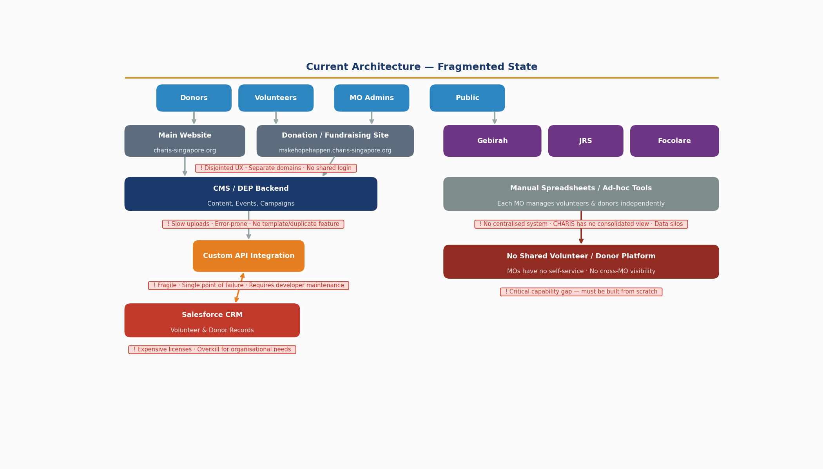

Proposed Architecture Overview

Three-Layer Platform Architecture
Layer 1 — Unified Public Website
- A single, mobile-first website under charis-singapore.org replacing both current sites. All campaigns, events, MO profiles, stories, and donation journeys are surfaced here under a consistent brand experience.
Layer 2 — MO Administration Portal
- A secure, role-based admin interface allowing MO staff to manage their own content, events, volunteer sign-ups, and donor records without Secretariat assistance.
Layer 3 — Volunteer & Donor Management System (VDMS)
- A centralised module — deployable immediately as a standalone system — that manages all volunteer profiles, donor records, and their associations to MOs and campaigns. CHARIS sees all data; MOs see only their own.
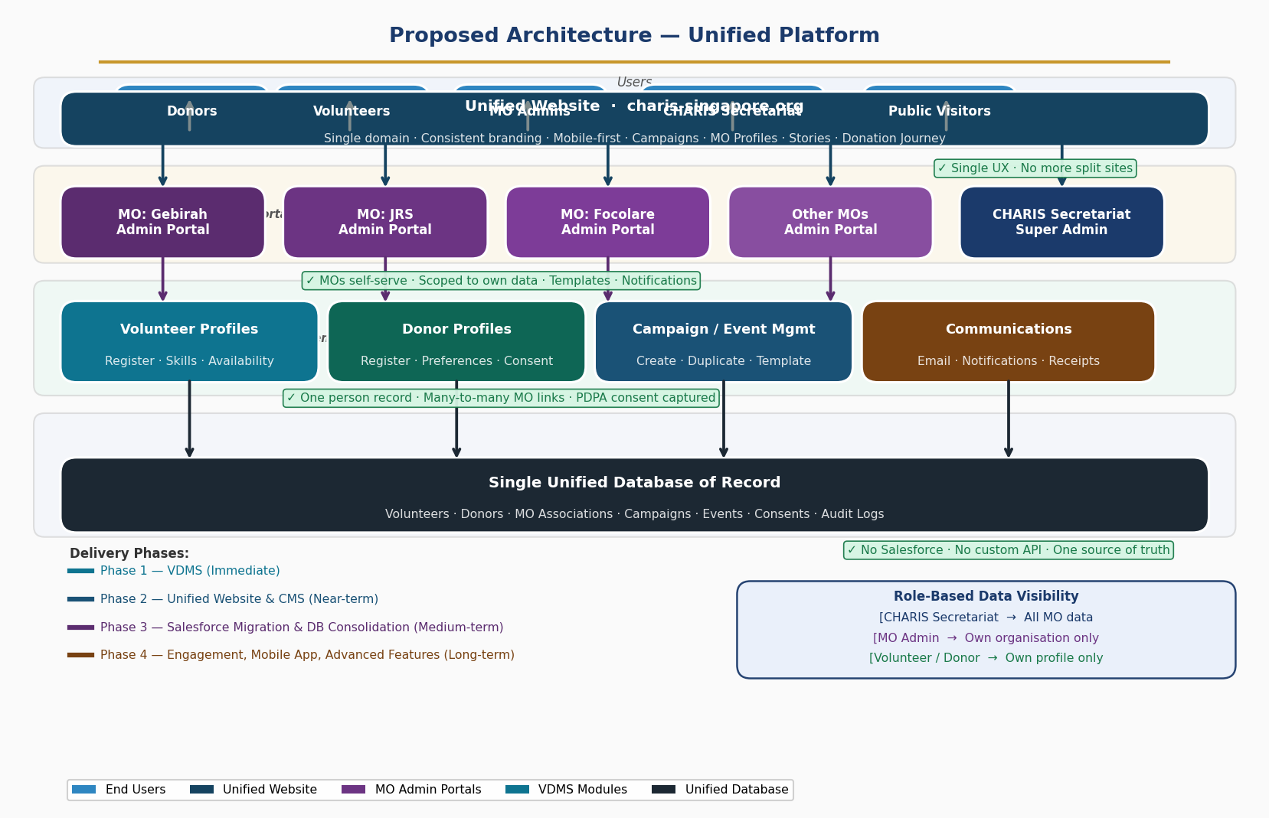

Data Model: Key Design Principles

- One Person Record: A volunteer or donor has a single profile in the system, linked to all MOs they engage with. This prevents duplication and ensures a clean data history.
- Many-to-Many Relationships: A volunteer can serve multiple MOs; a donor can give to multiple MOs. Each engagement is tracked with the originating MO and campaign.
- Scoped Visibility: Data access is enforced at the database level — MO admins can only query records associated with their organisation. CHARIS Secretariat has no such restriction.
- Consent as First-Class Data: Every donor and volunteer record captures communication consent per MO, supporting PDPA obligations.

Salesforce Migration Strategy

The immediate goal is to build the standalone VDMS as the new system of record, running in parallel with Salesforce. Over time, as data is validated and users migrate, Salesforce can be decommissioned.

- Phase 1: VDMS captures all new volunteer and donor data natively.
- Phase 2: Historical data from Salesforce is migrated and reconciled into VDMS.
- Phase 3: The custom API integration is decommissioned once Salesforce is no longer the data source.
- Phase 4: Salesforce licenses are terminated, eliminating the recurring cost.

Donation Workflow (Redesigned)

Proposed Streamlined Donation Flow
- Step 1 — Visitor selects a campaign and clicks Donate
- Step 2 — Enters donation amount (pre-set options + custom)
- Step 3 — Login or Guest checkout (returning donors pre-filled)
- Step 4 — Review + accept T&Cs on a single page
- Step 5 — Redirected to payment gateway (PayNow, card)
- Step 6 — Confirmation page + automated receipt by email
Improvement: Removes 3–4 redundant steps from current 7–8 step flow

Phased Delivery Roadmap
The solution is broken into four phases, prioritising the standalone volunteer and donor management system in the near term, followed by full platform unification.

Phase | Focus | Key Deliverables | Outcome
Phase 1 (Immediate) | Standalone Volunteer & Donor Management System | • Volunteer registration & profile management • Donor registration & profile management • MO-scoped data access with CHARIS super-admin view • Many-to-many MO linkage for volunteers and donors • PDPA consent capture • Basic MO admin dashboard • Automated email confirmations and receipts | MOs can manage volunteers and donors independently. CHARIS has consolidated oversight. Salesforce begins to be bypassed.
Phase 2 (Near-term) | Unified Content & Campaign Management | • New unified website under charis-singapore.org • MO self-service content portal • Campaign creation with standardised templates • Campaign duplication / recurring event support • Notifications to MOs on donor/volunteer response • HAF vs MO campaign clear UI differentiation • Active/archived campaign separation | Single website experience. MOs manage their own content without Secretariat dependency. Donation journey redesigned.
Phase 3 (Medium-term) | Salesforce Migration & Data Consolidation | • Historical Salesforce data migrated to VDMS • Custom API integration decommissioned • Full single-database architecture in production • Donor analytics and reporting for MO admins • Recurring donation support • Personalised donor portal (My Giving Journey) | Salesforce eliminated. Single database of record. Custom API retired. Significant cost reduction achieved.
Phase 4 (Long-term) | Engagement & Experience Enhancement | • Volunteer hours tracking and reporting • Impact dashboard for public (metrics, stories) • Mobile app (iOS/Android) for donors and volunteers • Cross-agency / Archdiocesan integration readiness • Live chat or FAQ bot • Advanced accessibility (WCAG 2.2 AA) | Mature, modern platform serving as the engagement hub for the CHARIS ecosystem. Foundation for mobile-first community building.

Implementation Timeline
The timeline below maps all four phases across a 24-month horizon using an AI-assisted development approach (Cursor + Claude). Phases overlap deliberately to allow parallel running and smooth handover between the outgoing and incoming systems. Estimated durations assume a part-time developer or agency engagement and will need to be validated against available resources.
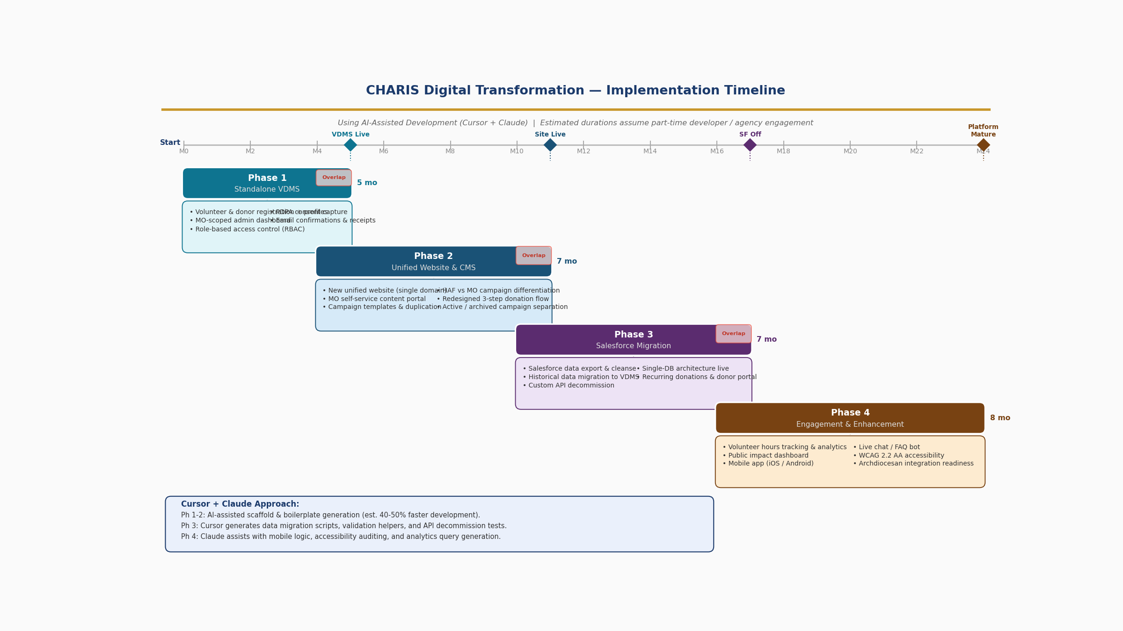

Phase 1 — Standalone VDMS (Months 0–5)
The first phase is a focused, self-contained build that can be started immediately and run entirely independently of the website rebuild. Using Cursor and Claude, the scaffold for the volunteer and donor data models, authentication, and role-based access can be generated in days rather than weeks. The primary goal is to establish the single database of record and give MOs a working admin portal so that Salesforce begins to be bypassed for all new records.

Phase 2 — Unified Website & CMS (Months 4–11)
Phase 2 begins once the VDMS core is stable (around Month 4) and overlaps for one month to allow the website build to connect directly to the new database. Cursor accelerates front-end component generation and CMS integration. The redesigned 3-step donation flow and MO self-service content portal are the key deliverables. This phase retires the separate makehopehappen domain and delivers a single charis-singapore.org experience.

Phase 3 — Salesforce Migration (Months 10–17)
Phase 3 begins while Phase 2 is wrapping up. Claude can generate data migration scripts, validation helpers, and transformation logic for moving historical Salesforce records into the VDMS schema. Salesforce continues to run in read-only mode during migration to prevent data loss. Once data integrity is confirmed and the custom API is decommissioned, Salesforce licenses can be terminated — achieving the single most significant cost reduction of the entire programme.

Phase 4 — Engagement & Enhancement (Months 16–24)
The final phase enriches the platform with engagement features and prepares the foundation for mobile. Claude can assist with accessibility auditing (WCAG 2.2 AA), analytics query generation, and mobile app logic scaffolding. This phase has the most flexibility — deliverables can be sequenced based on organisational priorities and available budget at the time.

How Cursor + Claude Accelerates Delivery
Cursor (the AI-first IDE) paired with Claude (the underlying model) significantly compresses development time across all phases. Key benefits include: (1) database schema and API scaffold generated from natural language descriptions of requirements; (2) boilerplate code for authentication, RBAC, and PDPA consent capture produced in minutes; (3) data migration scripts and validation logic co-authored and iterated in real-time; (4) front-end components built from design specifications without manual CSS; (5) automated test generation to validate each deliverable before release. The estimated 40–50% time saving on routine engineering tasks allows a lean team to deliver a platform that would otherwise require a much larger investment.

Success Metrics

Platform Health
- Reduction in average donation workflow steps from 7 to 4 or fewer.
- Page load time under 3 seconds on mobile (3G equivalent).
- Zero dependency on Salesforce licenses by end of Phase 3.

User Adoption
- MO admins independently publish and manage campaigns without Secretariat support.
- Volunteer registrations captured entirely in VDMS (no more manual spreadsheets).
- Donor records consolidated — no duplication across MOs.

Business Impact
- Measurable reduction in annual IT operating cost following Salesforce decommission.
- Increase in donor conversion rate (tracked via campaign analytics).
- Reduction in administrative effort for event and campaign management across MOs.

Constraints & Assumptions

Constraints
- Budget: Solution must avoid recurring per-seat enterprise licensing. Open-source or flat-fee SaaS preferred.
- Team capacity: CHARIS does not have a dedicated in-house engineering team; solution must be maintainable by non-developers where possible.
- Regulatory: All personal data handling must comply with Singapore's Personal Data Protection Act (PDPA). In addition to a DPO, which we have assigned, all staff (includes part-time and volunteers) need to undergo data protection training.
- Salesforce: The existing Salesforce integration must remain operational until Phase 3 migration is complete to avoid data loss.

Assumptions
- MO administrators will be trained on the new system and are capable of managing their own content with appropriate onboarding.
- CHARIS Secretariat will define and maintain the data governance policy (what data MOs can see and edit).
- Existing donation payment gateway (PayNow and card) will be retained; no change to payment processor is planned in Phase 1 or 2.
- Volunteer and donor records from Salesforce can be exported in a structured format for Phase 3 migration.

Out of Scope (Current Phases)

- Native mobile application (iOS/Android) — identified as Phase 4.
- Centralised payment gateway for event fees and merchandise.
- Cross-agency or Archdiocesan IT integration — identified as Phase 4.
- Cloud storage provision for MO documents (e.g. ACTS request).
- Outreach resource library (V&O request — to be revisited in Phase 4).
- Training and change management programme — to be scoped separately.

Appendix — Source Materials

This requirements guide was developed based on the following source materials:

- Charis Website Evaluation Report (internal document) — covering UX, donation workflow, content, accessibility, and technical observations across both websites.
- Requirement Study Spreadsheet v2.0 — consolidating requirements from Marketing, Gebirah, ACTS, JRS, Focolare, V&O, and the Secretariat.
- Live review of charis-singapore.org and makehopehappen.charis-singapore.org.

Document Owner: CHARIS Secretariat | Version: 1.0 | Status: Draft for Review

