Software Design Specifications

for

<Dewy>

Prepared by:

<Team SyntaxSquad>

Document Information

Title:
Project Manager: | Document Version No:
 | Document Version Date:
Prepared By: Team syntax squad | Preparation Date:

Version History

Ver. No. Ver. Date Revised By Description Filename


Table of Contents

1 INTRODUCTION ............................................................................................................................................................ |  | 4
1.1 | PURPOSE ...................................................................................................................................................................... | 4
1.2 | SCOPE .......................................................................................................................................................................... | 4
1.3 | DEFINITIONS, ACRONYMS, AND ABBREVIATIONS ........................................................................................................ | 4
1.4 | REFERENCES ................................................................................................................................................................ | 4

2 | USE CASE VIEW ............................................................................................................................................................ |  | 4
 | 2.1 | USE CASE ..................................................................................................................................................................... | 4
3 | DESIGN OVERVIEW ..................................................................................................................................................... |  | 4
 | 3.1 | DESIGN GOALS AND CONSTRAINTS ............................................................................................................................. | 5
 | 3.2 | DESIGN ASSUMPTIONS ................................................................................................................................................. | 5
 | 3.3 | SIGNIFICANT DESIGN PACKAGES ................................................................................................................................. | 5
 | 3.4 | DEPENDENT EXTERNAL INTERFACES ........................................................................................................................... | 5
 | 3.5 | IMPLEMENTED APPLICATION EXTERNAL INTERFACES ................................................................................................. | 5
4 | LOGICAL VIEW ............................................................................................................................................................. |  | 5
 | 4.1 | DESIGN MODEL ............................................................................................................................................................ | 6
 | 4.2 | USE CASE REALIZATION .............................................................................................................................................. | 6
5 | DATA VIEW .................................................................................................................................................................... |  | 6
 | 5.1 | DOMAIN MODEL .......................................................................................................................................................... | 6
 | 5.2 | D ATA MODEL (PERSISTENT DATA VIEW)...................................................................................................................... | 6
 | 5.2.1 Data Dictionary.................................................................................................................................................... |  | 6
6 | EXCEPTION HANDLING ............................................................................................................................................. |  | 6
7 | CONFIGURABLE PARAMETERS .............................................................................................................................. |  | 6
8 | QUALITY OF SERVICE ................................................................................................................................................ |  | 7
 | 8.1 | AVAILABILITY.............................................................................................................................................................. | 7
 | 8.2 | SECURITY AND AUTHORIZATION ................................................................................................................................. | 7
 | 8.3 | LOAD AND PERFORMANCE IMPLICATIONS ................................................................................................................... | 7
 | 8.4 | MONITORING AND CONTROL ....................................................................................................................................... | 7

1 Introduction

The AI-Based Dermatology Assistant is an intelligent web-based application designed to assist users in understanding and managing their skin health through the power of artificial intelligence. By allowing users to upload skin images and answer a simple quiz, the system delivers instant, AI-generated predictions about potential skin conditions. It further enhances user care by offering tailored treatment recommendations, safe skincare product evaluations, and personalized dietary advice.

This project integrates cutting-edge technologies such as Convolutional Neural Networks (CNN) for image classification and fuzzy logic for interpreting textual inputs. With a user-friendly interface and a secure backend, the assistant aims to provide accessible and accurate dermatological guidance to users without replacing medical professionals.

The following document outlines the system’s architectural design, use cases, data models, module interactions, and quality of service goals. It is intended to serve as a detailed blueprint for developers, testers, project managers, and other stakeholders involved in the system’s development, deployment, and maintenance.

1.1 Purpose

This Software Design Specification (SDD) defines the architecture and component-level design of the AI-Based Dermatology Assistant, an AI-powered web platform that enables users to upload skin images and submit personal inputs through a quiz to receive accurate skin disease diagnoses. The system provides personalized treatment suggestions, skincare product recommendations, dietary advice, and progress tracking. This document is intended for developers, testers, UI/UX designers, project managers, and other stakeholders involved in implementing, testing, maintaining, or reviewing the system.

1.2 Scope

The scope of this project is to design and develop a web-based AI Dermatology Assistant that helps users identify potential skin conditions through image analysis and quiz-based inputs. The system will allow users to upload skin images and respond to a set of questions about their skin type, age, and concerns. Based on this input, the assistant will use pre-trained AI models to predict possible skin diseases, recommend treatments, suggest skincare routines and diets, and provide a safety check for product ingredients.

The system includes:

Image-based skin condition prediction using a Convolutional Neural Network (CNN).

Quiz-based diagnosis using rule-based logic or fuzzy inference.

Ingredient safety checker to detect comedogenic or harmful components.

Personalized treatment, dietary, and product recommendations.

Report generation and download functionality for user reference.

The project does not include:

Real-time video consultations with dermatologists.

Prescriptive medical treatment or direct diagnosis from certified doctors.

Integration with medical insurance or prescription systems.

The AI-Based Dermatology Assistant is intended to be an informational support tool, not a replacement for professional medical advice.

1.3 Definitions, Acronyms, and Abbreviations

AI Artificial Intelligence – The simulation of human intelligence in machines to perform tasks such as learning, reasoning, and self-correction.

CNN Convolutional Neural Network – A type of deep learning model primarily used for analyzing visual imagery.

NLP Natural Language Processing – A field of AI that enables machines to understand and process human language.

ML Machine Learning – A subset of AI that allows systems to learn and improve from experience without explicit programming.

SDD Software Design Document – A detailed plan describing the architecture and design of a software system.

API Application Programming Interface – A set of rules that allows different software components to communicate.

UI User Interface – The means by which the user interacts with a software application.

JSON JavaScript Object Notation – A lightweight data-interchange format used for transmitting structured data between a server and client.

HIPAA Health Insurance Portability and Accountability Act – A US law designed to protect sensitive patient health information.

GDPR General Data Protection Regulation – A European Union law governing data protection and privacy.

Flask A lightweight Python web framework used to build web applications.

Frontend The visual part of the application users interact with (e.g., HTML, CSS, JavaScript).

Backend The server-side logic and operations that support the frontend, such as processing data and interfacing with databases.

Fuzzy Logic A logic system that allows for approximate rather than fixed reasoning, often used in systems handling imprecise input.

1.4 References

TensorFlow Documentation – https://www.tensorflow.org/

Keras API Documentation – https://keras.io/api/

Scikit-Fuzzy Documentation – https://scikit-fuzzy.github.io/scikit-fuzzy/

Flask Documentation – https://flask.palletsprojects.com/

Pandas Documentation – https://pandas.pydata.org/docs/

ISIC Archive – International Skin Imaging Collaboration Dataset – https://www.isic-archive.com/

JSON Specification – https://www.json.org/

2 Use Case View

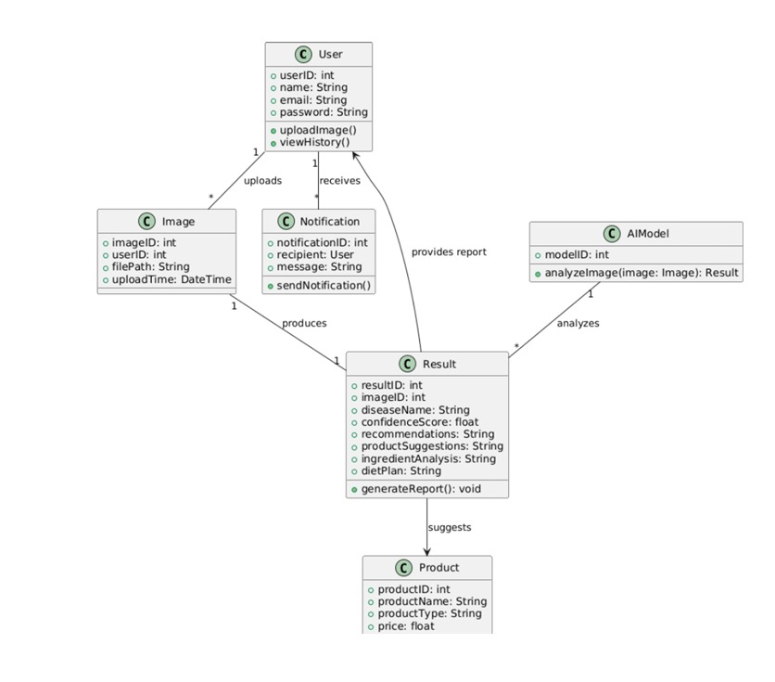

2.1 Use Case 1: AI-Based Skin Diagnosis (Multimodal)

Description:
The user is guided through a short quiz about their skin type, symptoms, and lifestyle. After submitting their answers, they upload a skin image. The system processes both the quiz inputs (text) and image data using AI models to predict the most probable skin condition and return detailed suggestions.
Actors:
- Primary Actor: User (Patient)
- Secondary Actors:
  - Text Analysis Model (for quiz logic)
  - CNN Model (for image analysis)
Steps / Flow:
- User accesses the "AI Diagnosis" section.
- System presents quiz questions (age, skin type, concern, etc.).
- User completes the quiz and uploads a skin image.
- System sends data to the multimodal prediction engine.
- Backend combines quiz and image data to determine likely condition.
- System displays predicted skin disease, confidence score, treatment advice, and diet recommendations.
- User can optionally download a detailed report.

2.2 Use Case 2: Ingredient Safety Checker

Description:
Users input a list of skincare product ingredients. The system checks for comedogenic substances, fragrances, sulfates, and parabens using a curated ingredient database and informs the user about safety.
Actors:
- Primary Actor: User
- Secondary Actor: Ingredient Database / Analyzer Module
Steps / Flow:
- User accesses the "Ingredient Checker" section.
- User enters or uploads a list of product ingredients.
- System scans input against the ingredient safety database.
- System highlights harmful or comedogenic ingredients.
- User receives a safety summary (e.g., acne-safe, fragrance-free).

2.3 Use Case 3: Report Generation & Download

- Description:
After diagnosis, the user can download a structured report including the predicted skin condition, quiz responses, image-based analysis, recommendations, and progress tracking options.
- Actors:
  - Primary Actor: User
  - Secondary Actor: Report Generator
- Steps / Flow:
  - Diagnosis is completed using image + quiz input.
  - System prepares a PDF report summarizing the findings.
  - User clicks “Download Report”.
  - The report is generated and downloaded for personal use or sharing with a dermatologist.

Design Overview
3.1 Design Goals and Constraints

Design Goals
- Accurate Diagnosis
Achieve high accuracy in detecting skin diseases using AI models trained on diverse, real-world dermatological datasets.
- Multimodal Analysis
Combine image analysis (via CNN) with quiz-based text inputs for more comprehensive and reliable predictions.
- Personalized Recommendations
Provide users with tailored skincare product suggestions, treatments, and dietary advice based on their condition and lifestyle.
- User-Friendly Interface
Offer an intuitive and easy-to-use web interface suitable for non-technical users across all device types.
- Real-Time Feedback
Deliver results (prediction, explanation, and advice) within a few seconds to maintain a smooth user experience.
- Extensibility
Design the system in a modular fashion so future features like dermatologist chat, severity tracking, and multilingual support can be easily integrated.

Design Constraints
- Scalability
The system must be able to handle multiple users concurrently without performance degradation.
- Cross-Device Compatibility
The application must work across mobile, tablet, and desktop platforms with responsive design.
- Data Privacy and Security
All personal health data must be stored and transmitted securely, following HIPAA and GDPR regulations.
- Performance Limitations
Image processing models must deliver results quickly (≤ 5 seconds), placing constraints on model size and deployment environment.
- Model Update Management
AI models should be updatable without requiring full redeployment of the application.

3.2 Design Assumptions

•⁠ ⁠Users will have access to devices with a camera, image upload capability, and internet connectivity.
•⁠ ⁠Input images are clear and relevant (well-lit, visible skin region).
•⁠ ⁠Quiz and form responses will follow expected formats.
•⁠ ⁠The AI models (CNN for image analysis, rule-based/Fuzzy logic for text) are trained and tested prior to deployment.
•⁠ ⁠Ingredient, product, and dietary databases are curated and pre-loaded into the backend.

3.3 Significant Design Packages

The system is divided into the following major design packages:
- image_analysis: Responsible for processing uploaded skin images, applying preprocessing steps, and running predictions using a deep learning CNN model. This package ensures accurate classification of skin conditions based on visual features.
- text_analysis: Processes quiz inputs provided by the user (such as age, skin type, and symptoms) and maps them to likely skin conditions using rule-based logic and fuzzy inference. It supports multimodal analysis when combined with image data.
- recommendation_engine: Based on the predicted diagnosis, this module suggests appropriate treatment plans, skincare product recommendations, and dietary guidelines. It tailors advice based on both quiz inputs and diagnosis results.
- ingredient_checker: Analyzes user-submitted skincare product ingredient lists. It flags comedogenic, fragrance-based, paraben, and sulfate ingredients by comparing inputs against a curated ingredient database.
- report_generator: Gathers the outputs of the diagnosis and recommendation modules and compiles them into a structured, downloadable report (typically in PDF format), which includes disease explanation, product suggestions, and dietary recommendations.
- web_interface: Built with HTML, CSS, and JavaScript on the frontend and Flask on the backend, this package manages user interaction, input collection, image upload, and result display. It also ensures a responsive experience across devices.
- api_layer: Exposes RESTful API endpoints that connect the frontend and backend logic. It facilitates data submission (e.g., quiz answers, image uploads) and response delivery (e.g., prediction results, recommendations).
- database_access: Handles secure storage and retrieval of user data, uploaded images, prediction results, and ingredient information. It supports user session management and ensures data integrity across the application.

3.4 Dependent External Interfaces

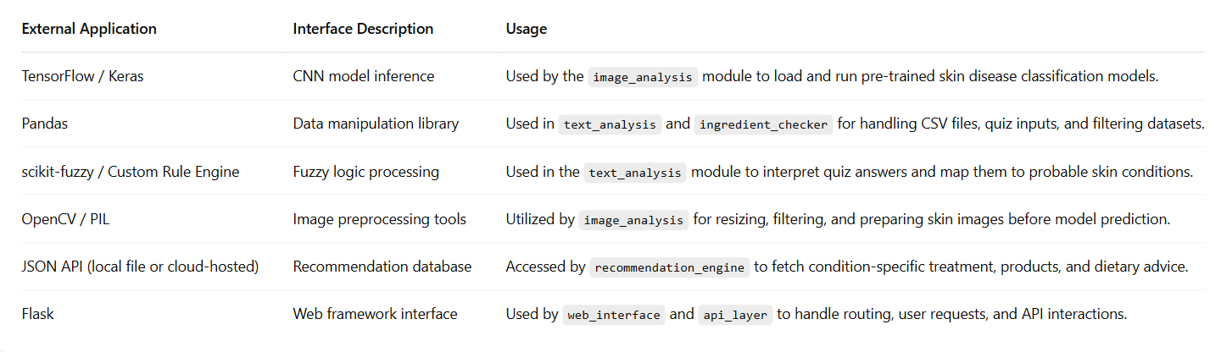

3.5 Implemented Application External Interfaces (and SOA web services)

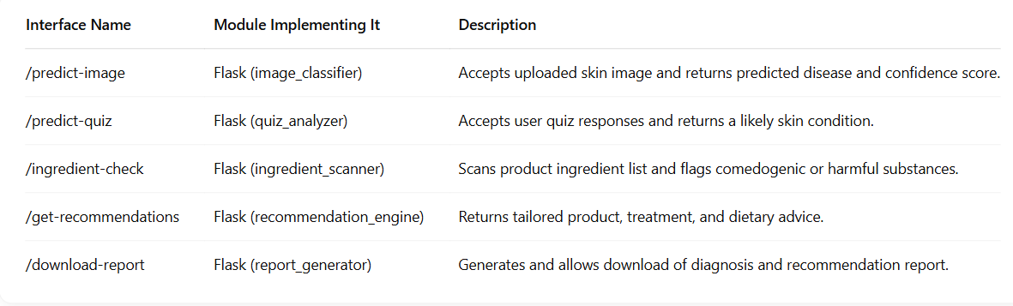

4 Logical View

This section provides a modular and layered design breakdown of the AI-Based Dermatology Assistant system. The architecture follows the Model-View-Controller (MVC) pattern, promoting clear separation of responsibilities between the user interface, business logic, and backend data handling.
Each module in the system is composed of related classes or components that collectively fulfill core use cases such as AI-based diagnosis, ingredient safety analysis, personalized recommendations, and report generation.

4.1 Design Model

Module: Diagnosis Module
- Class: DiagnosisController
  - Responsibilities: Handles skin image upload and form submission containing quiz answers.
  - Methods: uploadImage(), submitQuiz()
- Class: DiagnosisService
  - Responsibilities: Preprocesses the image, sends it to the CNN model, and parses the prediction result.
  - Methods: predictFromImage(), parseResult()
Module: Quiz Analysis Module
- Class: QuizProcessor
  - Responsibilities: Processes quiz responses using rule-based logic or fuzzy inference to support or refine image-based diagnosis.
  - Methods: evaluateQuizInput(), mapToCondition()
Module: Recommendation Module
- Class: RecommendationService
  - Responsibilities: Maps predicted condition to suitable products and dietary suggestions using a structured JSON knowledge base.
  - Methods: getProductsForCondition(), getDietAdvice()
Module: Ingredient Checker Module
- Class: IngredientController
  - Responsibilities: Accepts ingredient list input from the user.
  - Methods: submitIngredientList()
- Class: IngredientScanner
  - Responsibilities: Scans the input list for comedogenic, fragrance-based, sulfate, and paraben ingredients.
  - Methods: scanIngredients(), checkSafetyFlags()
Module: Report Generator Module
- Class: ReportService
  - Responsibilities: Compiles diagnostic results, user responses, and system recommendations into a structured PDF report.
  - Methods: generateReport(), formatToPDF()
Module: User Module
- Class: UserController
  - Responsibilities: Manages user sessions and interactions (optional, if login support is added).
  - Methods: registerUser(), storeDiagnosisHistory()
Module: Web Interface
- Frontend Technologies: HTML, CSS, JavaScript
  - Responsibilities: Collect user inputs, display results, and interact with backend via REST API.
  - Forms: Quiz form, Image upload form, Ingredient input
- Class: FlaskApp (Backend)
  - Responsibilities: Handles all incoming POST requests and routes them to the appropriate service/module.
  - Routes: /predict, /quiz, /ingredients, /report

4.2 Use Case Realization

This section elaborates how each use case is realized through interactions between system components and logic defined in the design. It maps the diagrams (state, activity) and modules to actual functionality within the system.

Activity Diagram:
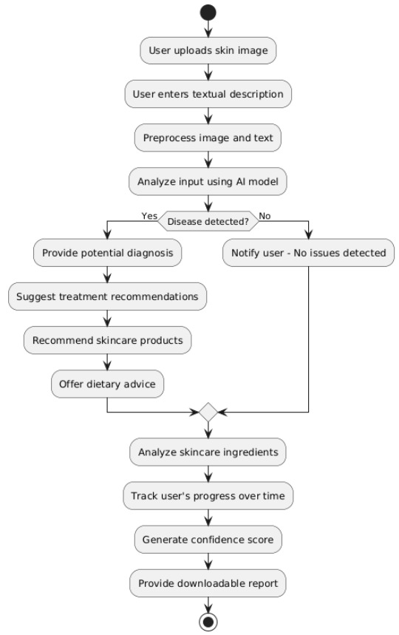
State Diagram:
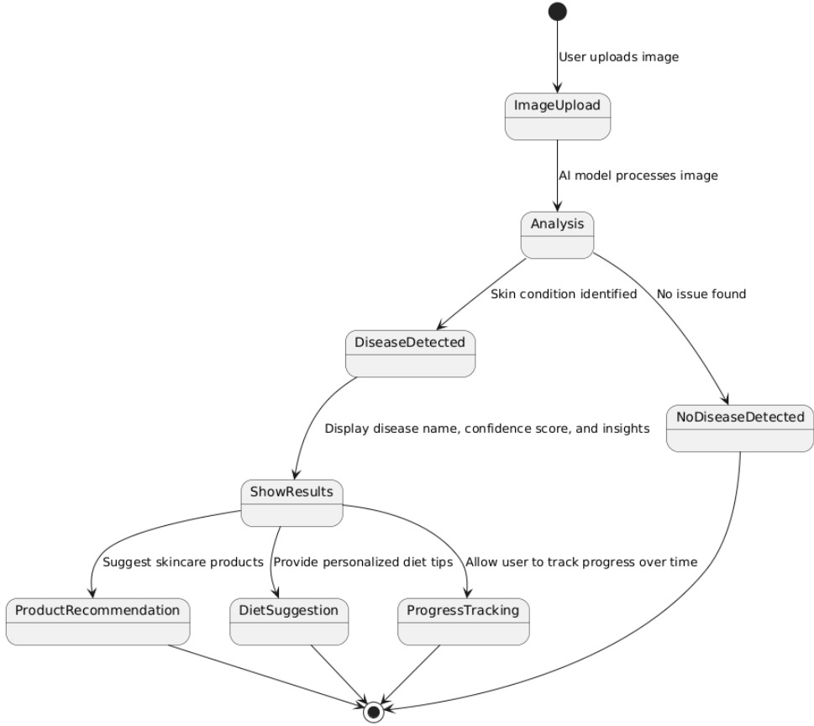
Component Diagram:
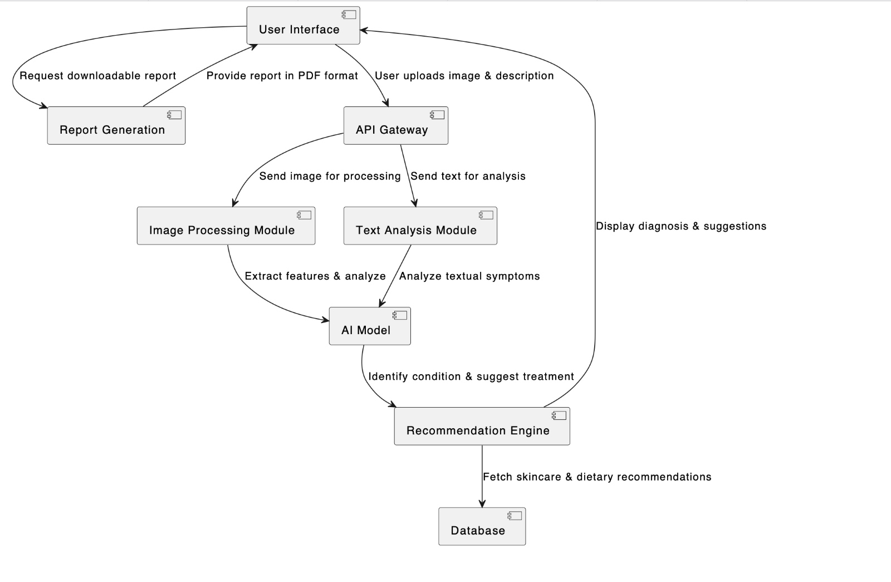

Use Case 1: AI-Based Skin Diagnosis (Multimodal)
- Overview:
Users upload a skin image and complete a quiz with text-based inputs (e.g., age, skin type, symptoms). These are processed together to diagnose possible skin conditions using a Convolutional Neural Network (CNN) along with logic-based decision rules for quiz input.
- Modules Involved:
  - DiagnosisController: Handles API request and routes data.
  - DiagnosisService: Orchestrates the diagnosis process and calls the AI model.
  - QuizProcessor: Preprocesses and structures quiz input for analysis.
  - AI Model: Analyzes both image and text to identify a probable skin condition.
- Activity Flow:
  - User uploads an image and enters quiz info.
  - Data is preprocessed and analyzed.
  - If disease is detected, the system:
    - Provides diagnosis
    - Suggests treatments
    - Recommends skincare products
    - Offers dietary advice
  - Confidence score is generated
  - A report is made available for download
- Related Diagrams:
  - Activity Diagram 1 shows step-by-step data flow (image + text input → analysis → diagnosis → suggestions).
  - State Diagram 1 visualizes how the system transitions from image upload to condition detection, result display, and report generation.

Use Case 2: Ingredient Safety Checker
- Overview:
Users input or scan a list of skincare ingredients. The system parses the list and flags harmful or allergy-triggering components.
- Modules Involved:
  - IngredientController: Accepts ingredient list input.
  - IngredientScanner: Matches ingredients against a safety database and flags risky entries.
- Activity Flow:
  - User submits ingredient list
  - List is parsed and normalized
  - Each item is compared against known harmful substances
  - Risk level is reported to user
- State Behavior:
Transitions include input validation → matching → flag generation → result output.

Use Case 3: Report Generation & Download
- Overview:
After diagnosis, the system provides users a downloadable PDF report summarizing their condition, recommended treatments, skincare products, and dietary suggestions.
- Modules Involved:
  - ReportService: Collects diagnosis results and formats them into a readable report.
- Activity Flow:
  - User requests report
  - Data from diagnosis, products, diet is compiled
  - PDF is generated and served to the user for download
- Integration:
  - Triggered after successful disease detection and result display
  - Linked closely with DiagnosisService and RecommendationEngine

These use case realizations ensure modular, maintainable design while mapping user interactions to actual backend logic and component roles, as represented in the state and activity diagrams.

Let me know if you also need a sequence diagram explanation or component mapping table to match this section!

5 Data View

This section outlines the persistent data storage and the domain model used to represent key entities in the AI-Based Skin Disease Detection & Recommendation System. The system uses a *relational database (e.g., PostgreSQL)* or *cloud-based NoSQL storage (e.g., Firebase)* to manage user profiles, skin images, quiz responses, predictions, and recommendations.

5.1 Domain Model

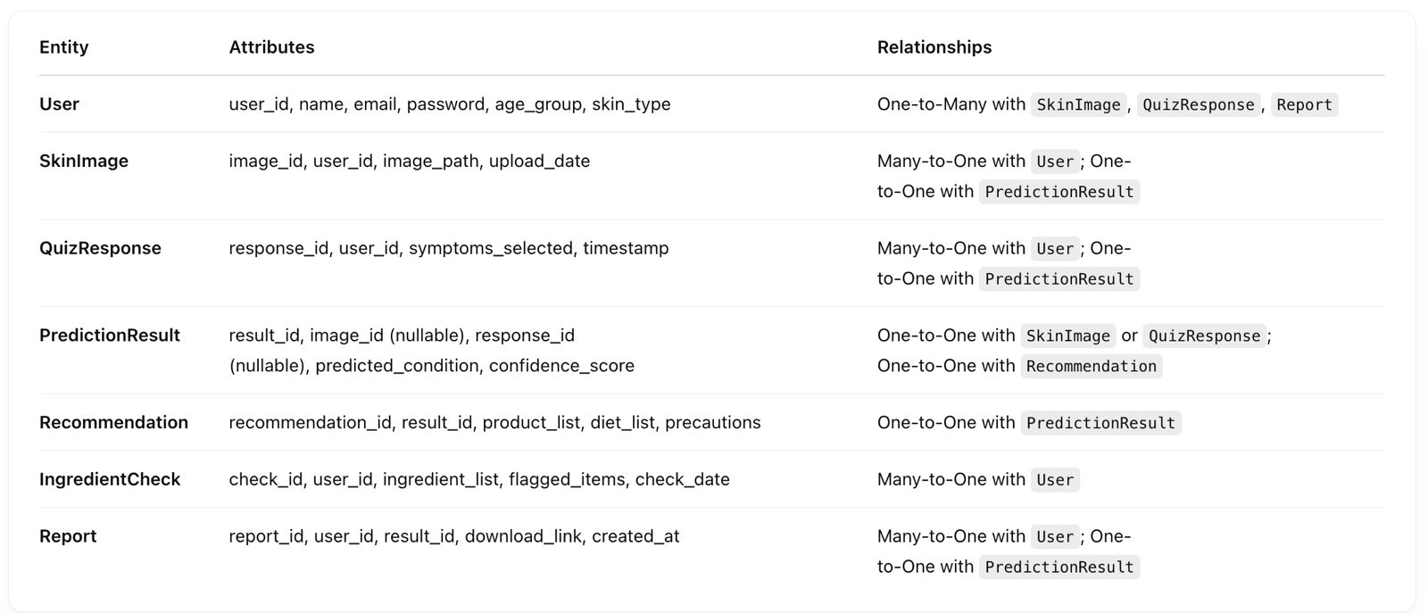

5.2 Data Model (persistent data view)

5.2.1 Data Dictionary

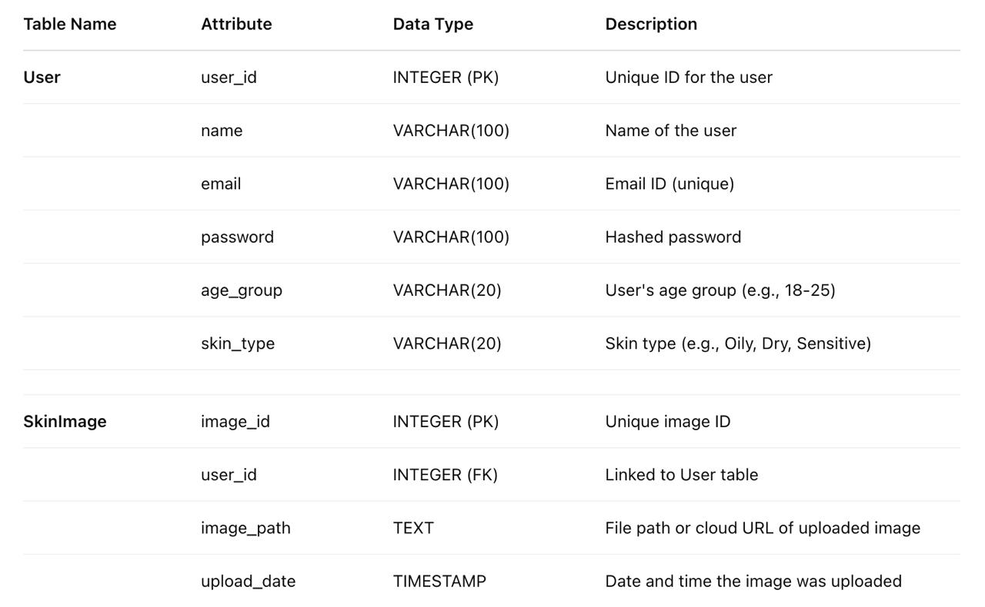
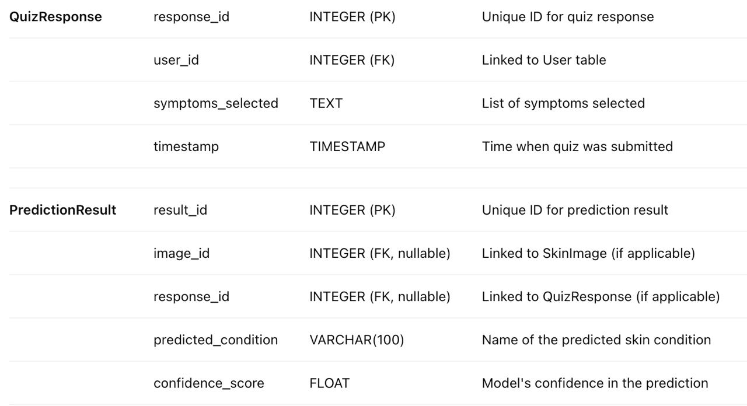

6 Exception Handling

InvalidImageFormatException
Thrown when: The uploaded file is not a valid image format (e.g., not JPG, PNG).
Action: Show error message “Please upload a valid image file (JPG, PNG).” and log the attempt with timestamp and session info.

IncompleteFormException
Triggered when: User submits the quiz form with missing or invalid data.
Action: Highlight missing fields, display message “All fields are required. Please complete the form.”, and prevent form submission.

ModelPredictionException
Occurs when: The AI model fails to return a prediction due to corrupted input or internal error.
Action: Show generic error “Prediction failed. Please try again later.” and log error stack for developer review.

IngredientParsingException
Raised when: Ingredient list is not readable or doesn’t match expected format.
Action: Display “Could not analyze ingredients. Please check the input format.” and log invalid input.

UnauthorizedAccessException
Triggered when: A user tries to access protected content (e.g., admin reports) without permission.
Action: Show “Access Denied.” and redirect to homepage. Attempt is logged for security.

DatabaseConnectionException
Occurs when: The backend cannot connect to the database (e.g., for storing predictions or user logs).
Action: Display a fallback message “Service is temporarily unavailable.” and notify admin through logs.

ReportGenerationException
Happens when: System fails to compile user diagnosis and suggestions into a downloadable report.
Action: Show error “Could not generate your report. Please try again.” and log failure details.

UploadTimeoutException
Raised when: Image or form data takes too long to upload due to poor network.
Action: Prompt “Upload timed out. Please check your connection and try again.” and log timeout duration.

Logging & Follow-up
All major exceptions are logged with timestamp, user session info, and technical error details.

Users see friendly, human-readable error messages to avoid confusion or frustration.

Critical issues are automatically flagged for administrator attention and debugging.

7 Configurable Parameters

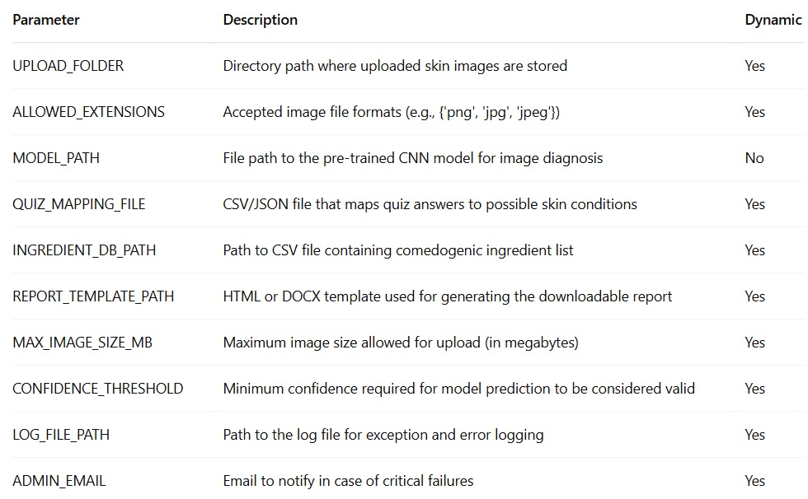

8 Quality of Service

The AI-Based Dermatology Assistant is designed with key quality attributes to ensure reliability, security, and performance in a production environment. The application aims for high availability, with core services hosted on scalable cloud infrastructure to support multiple concurrent users. All user data is encrypted in transit and at rest, ensuring compliance with industry standards such as HIPAA and GDPR for healthcare data protection.
The system is optimized for performance, with model inference (image and text-based) completing within an average of 3–5 seconds. The use of lightweight APIs and asynchronous processes allows smooth interaction without delays. For monitoring and control, the application includes logging, uptime tracking, and error reporting to detect system failures and respond in real-time. These quality measures ensure a secure, responsive, and trustworthy user experience, even under increasing user load.

8.1 Availability
The system is designed to be accessible 24/7, with exception only during scheduled maintenance windows.

Critical modules such as AI-based diagnosis (image & quiz), report generation, and ingredient analysis are prioritized to remain always available.

Any necessary updates to models or databases will be performed during off-peak hours to minimize impact on users.

Cloud deployment ensures high availability and redundancy in case of node or server failures.

8.2 Security and Authorization

Role-based access control is implemented:

Users (Patients): Can upload images, fill quiz, and view personalized reports.

Admins: Full access including model updates, data management, and user analytics.

User data is encrypted both in-transit (via HTTPS) and at-rest using secure storage.

Authentication uses secure session tokens or optional login (for future personalized storage).

Admin interface is accessible only through an authenticated and secure route, protected with two-factor authentication (optional extension).

User-uploaded images are stored temporarily and deleted after generating the result, unless the user opts to save the report.

8.3 Load and Performance Implications
The system is expected to support:

Up to 1,000 concurrent users during peak usage (e.g., product launch, marketing promotions).

AI prediction time:

Image model: < 5 seconds

Quiz & ingredient analysis: < 2 seconds

Backend performance is optimized using:

Asynchronous request handling in Flask

Lightweight CNN model for real-time predictions

Caching frequently accessed data (e.g., ingredient database, skin condition descriptions)

Database indexing and modular architecture ensure low latency and scalability.

8.4 Monitoring and Control

The system maintains detailed logs for:

Prediction requests (timestamped)

Errors or exceptions raised in model or API

Ingredient checks and report downloads

An admin dashboard provides real-time access to:

System health (CPU, memory, uptime)

Model confidence drift and low-accuracy alerts

Usage statistics (most common skin conditions, quiz patterns)

Future extensions include integration with monitoring tools like Prometheus or Grafana for real-time alerting and visualization.

