

CHARMe node Interface Control Document


CHARMe is funded by the EC under its FP7 Research Programme
Document Control
Contributors
Person | Role | Organisation | Contribution
M.Nagni | Developer | STFC | Initial Draft.
A.Wilson | Developer | STFC | Update

Document Approval
Person | Role | Organisation

References
ID | Author | Document Title | Date

Revision History
Issue | Author | Date | Description
0.1 | M.Nagni | 16th Aug 2013 | Initial Draft.
0.2 | M.Nagni | 26th Sept  2013 | Extended examples.  Preliminary integration with OpenSearch.
0.3 | A.Wilson | 09th Jan 2015 | Version 0.7.0 of the code.
Namespaces Used
Prefix | Namespace | Description
cito | http://purl.org/spar/cito/ | Citation Typing Ontology
cnt | http://www.w3.org/2011/content# | Representing Content in RDF
dc | http://purl.org/dc/elements/1.1/ | Dublin Core
dcterms | http://purl.org/dc/terms/ | Dublin Core Terms
dctypes | http://purl.org/dc/dcmitype/ | Dublin Core Metadata Initiative
fabio | http://purl.org/spar/fabio/ | FRBR-aligned Bibliographic Ontology
foaf | http://xmlns.com/foaf/0.1/ | The Friend of a Friend namespace
oa | http://www.w3.org/ns/oa# | The Open Annotation ontology
prov | http://www.w3.org/ns/prov# | The PROV namespace
skos | http://www.w3.org/2004/02/skos/core# | Simple Knowledge Organization System Namespace Document
rdf | http://www.w3.org/1999/02/22/22-rdf-syntax-ns# | The RDF namespace
xsd | http://www.w3.org/2001/XMLSchema# | XML Schema namespace

Table of Contents
1 Node Services 6
2 Creating Annotations 10
2.1 Using annoId and bodyId to Create Annotations 10
2.2 Provenance and Other Annotation Metadata 10
2.3 Using targetID to Create Composite Targets 11
2.4 Tags for Fine Grained Commentary 11
3 OA Examples 12
3.1 Text-based Annotations 12
3.2 Multiple bodies 12
3.3 Empty body 12
3.4 Multiple Targets 12
3.5 Composite Targets 13
3.6 Other formats 13
3.7 Tagging a Dataset 15
3.8 Linking Datasets 16
3.9 Citation 16
4 Calls in More Detail 19
4.1 advance_status 19
5 Open Search 20
5.1 Description Document 20
5.2 Search 20
5.2.1 Examples 20
5.3 Suggest 20
5.3.1 Examples 21
6 Charme Vocabulary 22
7 Security 23
List of Figures
Figure 1: The use of annonID and bodyID 10
Figure 2: Software Agent Provenance Data 10
Figure 3: The use of targetID for Composite 11
Figure 4: Fine Grained Commentary 11
Figure 5: A Text Annotation 12
Figure 6: An Annotation with an External Body 12
Figure 7: An Annotation with Multiple Targets 13
Figure 8: An Annotation with a Composite Target 13
Figure 9: A JSON-LD Representation of a Text Annotation 14
Figure 10: A XML-RDF Representation of a Text Annotation 15
Figure 11: A Semantic Tag Annotation 16
Figure 12: Linked Datasets Annotation 16
Figure 13: Citing a Dataset and adding a Comment 17
Figure 14: An Annotation and Citation 18
Figure 15: Json File Used for the Call advance_status 19
Figure 16: Curl Used to Call advance_status 19

Node Services

- advance_status
Action: Changes an annotation state
HTTP Method: POST
Content-Type: [application/ld+json]
Parameters:
      - annotation – annotation_id
      - toState – ['submitted'|'stable'|'invalid'|'retired']
Returns a HTTP code

- data/(w+)?(format=[xml,turtle,json-ld], depth=[int])
Action: Returns an RDF description of the node resource associated with a given ID
HTTP Method: GET
HTTP Accept: [application/rdf+xml, text/turtle, application/ld+json]
Parameters:
      - format – the mime format of the HTTP Response. This parameter overrides any HTTP Accept
      - depth – an integer greater or equal to zero. Limit the details in the triple description

- endpoint
Implements the SPARQL 1.1 HTTP Graph Store specifications.

- index/[submitted|invalid|stable|retired]?(format=[xml,turtle,json-ld])
Action: Returns the annotation nodes in the specific named graph
HTTP Method: GET
Parameters:
      - format – the mime format of the HTTP Response. This parameter overrides any HTTP Accept

- insert/annotation
Action: Inserts a RDF complaint document in the submitted graph. Provenance data about the user is added to the annotation.
HTTP Method: POST
Content-Type: [application/rdf+xml, text/turtle, application/ld+json]
Accept: [text/plain]
Returns the URI of the new annotation

- modify/annotation
Action: Move the current annotation to retired graph and then insert the RDF complaint document in the submitted graph. Provenance data about the user is added to the annotation and links are created between the submitted and retired annotations.
HTTP Method: POST
Content-Type: [application/rdf+xml, text/turtle, application/ld+json]
Accept: [text/plain]
Returns the URI of the new annotation

- page/(w+)?(depth=[int])
Action: Returns an RDF description of the node resource associated with a given ID
HTTP Method: GET
HTTP Accept: [text/html]
Parameters:
      - depth – an integer greater or equal to zero. Limit the details in the triple description

- resource/(w+)/reporttomoderator/
Action: Email the registered admin for the site where the annotation originated. Include the OPTIONAL content of the PUT in the email. This should be used to explain why this annotation is being reported.
HTTP Method: PUT
HTTP Accept: [text/html]

- resource/(w+)?(format=[xml,turtle,json-ld], depth=[int])
Action: Returns an RDF description of the node resource associated with a given ID
HTTP Method: GET
HTTP Accept: [application/rdf+xml, text/turtle, application/ld+json, text/html]
Parameters:
      - format – the mime format of the HTTP Response. This parameter overrides any HTTP Accept
      - depth – an integer greater or equal to zero. Limit the details in the triple description

- resource/(w+)
Action: Moves the resource to the 'retired' graph
HTTP Method: DELETE

- search/description
Action: Returns an XML document describing the implemented OpenSearch
HTTP Method: GET

- search/[atom]?count={count?}&startPage={startPage?}&startIndex={startIndex?}&bodyType={a0:type?}&citingType={a0:type?}&dataType={a0:type?}&domainOfInterest={a1:domainOfInterest?}&motivation={a1:motivation?}&organization={a2:name?}&target={a1:target?}&title={a3:title?}&userName={a2:accountName?}&status={a1:status?}&depth={a1:depth?}&format={a1:format?}
Action: Searches inside the Annotations
HTTP Method: GET
Parameters:
      - count – the number of search results per page desired by the search client, default 10
      - startIndex – the index of the first search result desired by the search client
      - startPage – the page number of the set of search results desired by the search client
      - bodyType – a URI of a rdf:type of an annotation body
      - citingType – a URI of a rdf:type of an object citing a target
      - dataType – a URI of a rdf:type of an annotation target
      - domainOfInterest – a URI of a domain of interest of an annotation
      - motivation – a URI of a motivation of an annotation
      - organization – a URI of an organization from where a client created an annotation
      - target – a URI of a target of an annotation
      - title – text to search inside the dcterms:title element of a citing entity
      - userName – the user name of the creator of an annotation
      - status – ['submitted'|'stable'|'invalid'|'retired'], default stable
      - depth – an integer greater or equal to zero. Limit the details in the triple description
      - format – the format of the returned elements ['json-ld'|'turtle'|'xml']

- suggest/[atom]?count={count?}&startPage={startPage?}&startIndex={startIndex?}&q={searchTerms}&bodyType={a0:type?}&citingType={a0:type?}&dataType={a0:type?}&domainOfInterest={a1:domainOfInterest?}&motivation={a1:motivation?}&organization={a2:name?}&target={a1:target?}&title={a3:title?}&userName={a2:accountName?}&status={a1:status?}&depth={a1:depth?}&format={a1:format?}
Action: Searches for the values of one or more of the searchTerms. These can be restricted by providing parameter values.
HTTP Method: GET
Parameters:
      - count – the number of search results per page desired by the search client, default 10
      - startIndex – the index of the first search result desired by the search client
      - startPage – the page number of the set of search results desired by the search client
      - q – a space separated list from: ['bodyType'|'citingType'|'dataType'|'domainOfInterest'|'motivation'|'organization'|'*']
      - bodyType – a URI of a rdf:type of an annotation body
      - citingType – a URI of a rdf:type of an object citing a target
      - dataType – a URI of a rdf:type of an annotation target
      - domainOfInterest – a URI of a domain of interest of an annotation
      - motivation – a URI of a motivation of an annotation
      - organization – a URI of an organization from where a client created an annotation
      - target – a URI of a target of an annotation
      - title – text to search inside the dcterms:title element of a citing entity
      - userName – the user name of the creator of an annotation
      - status – ['submitted'|'stable'|'invalid'|'retired'], default stable
      - depth – an integer greater or equal to zero. Limit the details in the triple description
      - format – the format of the returned elements ['json-ld'|'turtle'|'xml']

- sparql
Implements the SPARQL read only endpoint

- sparql.html
The FUSEKI read only GUI

- version
Action: Returns the version of the server
HTTP Method: GET

- vocab
Action: Returns an RDF description of the CHARMe vocabulary
HTTP Method: GET
HTTP Accept: [application/rdf+xml, text/turtle, application/ld+json, text/html]

Creating Annotations
A CHARMe annotation is based on the OpenAnnotation (OA) specifications. As consequence any client implementation is responsible for assembling the annotation according to the OA documentation.

Using AnnoId And BodyId To Create Annotations
The CHARMe node is responsible for creating URIs for annotations and resolving them to specific resources. To achieve this, the submitted annotation should make use of key words in the annotation that will be converted to URIs by the CHARMe node during the ingest process. An annotation written in Turtle should have the general format:
Where annoID is mandatory and bodyID is optional. The OA specification states that an annotation may contain multiple bodies, however when inserting a new annotation to the CHARMe node it should have zero or one body marked as bodyID. Additional bodies may be included provided they reference existing URIs, either internal or external to the node.
Figure 1: The use of annonID and bodyID
The http://localhost/ reference will also be automatically replaced by the node with its own URL.

Provenance and Other Annotation Metadata
Clients MUST provide the motivation for the annotation (oa:motivatedBy), the serialization time stamp (oa:serializedAt) and information about the software agent that created or updated the annotation (oa:serializedBy). An annotation can either point to an existing agent or a client can create a new one. If creating a new agent it MUST include the type prov:SoftwareAgent and foaf:name. For example:
Where agentID is substituted by the node during ingest.
Figure 2: Software Agent Provenance Data
When a new annotation is submitted the node adds additional provenance data, which is based on the token used for the insert. The node creates a new foaf:Person object which contains the user name (foaf:accountName), family name (foaf:familyName) and given name (foaf:givenName). The node also attaches a time stamp (oa:annotatedAt) to the annotation.
All URIs in the submitted annotation MUST be URL encoded, see percent-encoding.

Using TargetID To Create Composite Targets
The use of targetID, which will get substituted by the node during ingest, will create a target resource. However its use is restricted to targets of type oa:Composite and charme:DatasetSubset.

Tags For Fine Grained Commentary
Figure 3: The use of targetID for Composite
A number of tags have been introduced for use by fine grained commentary. The targetID should be used for the DatasetSubset. subsetSelectorID should be used for the subsetSelector. The following tags represent multivalued resources, spatialExtentID, temporalExtentID, variableID, verticalExtentID. Each of these tags may have a prefix in order to disinguish the same instance of a resource, i.e. spatialExtentID-01, spatialExtentID-02.
Figure 4: Fine Grained Commentary

OA Examples

Text-based Annotations
This is the simple case where a user writes a free text comment about a given target. The text is created and attached as a new annotation body. Unstructured plain text is stored as cnt:ContentAsText. Structured content is also possible via cnt:ContentAsXML for representing for example XHTML.
In the next example the body refers to an external resource consequently the client does not need a bodyID.
Figure 5: A Text Annotation

Multiple Bodies
Figure 6: An Annotation with an External Body
This situation may happen when the user wants to refer multiple notes to a single target; in this case is assumed that the user wants to insert zero or one textual while using older/external references for the other bodies.

Empty Body
This situation may happen when the user wants to simply generate a “bookmark” and update it later.

Multiple Targets
The body is considered to be equally related to each target individually, rather than the complete set of targets. This construction may be used so long as dropping any of the targets would not invalidate the annotation's meaning.

Composite Targets
Figure 7: An Annotation with Multiple Targets
Composite is a multiplicity construct that conveys that all of the constituent resources are required for the annotation to be correctly interpreted. There MUST be two or more item relationships (oa:item) for each composite (oa:Composite).
In order to allow the creation of composite resources for a target, a target resource needs to be created. To create a composite resource as a target use targetID, which will get substituted by the node during ingest.

Other Formats
Figure 8: An Annotation with a Composite Target
Figures 5 and 6 show the JSON-LD and XML-RDF representations of the Turtle from figure 3.
Figure 9: A JSON-LD Representation of a Text Annotation

Tagging A Dataset
Figure 10: A XML-RDF Representation of a Text Annotation
Classification of annotations is an important capability primarily to enable users to later discovery information under related thematic areas. OA provides a means to do so via tagging. In this case, an annotation is set with the oa:tagging motivation. The body of the annotation contains the actual tag. A tag may be a simple text-based keyword or a semantic tag, a URI relating to a concept from a vocabulary. Using the OA semantic tags feature allows annotations to be classified with concepts from SKOS collections. Using the NERC Vocabulary Server it is possible to map classification terms from one vocabulary to similar concepts in other vocabularies.
When inserting a semantic tag the client MUST use the URI of the term as the URI of the body. The body MUST have a type of oa:SemanticTag and SHOULD have a skos:prefLabel. The label is for the benefit of faceted searches.

Linking Datasets
Figure 11: A Semantic Tag Annotation
It can often be the case that datasets are somehow related to each other. OA provides a means to associate objects via linking. In this case, an annotation is set with the oa:linking motivation. Both the body and target are URIs of the datasets.

Citation
Figure 12: Linked Datasets Annotation
This differs from the other examples in the fact that it makes use of the CiTO ontology to create a CitationAct and then uses Open Annotation to comment on the citation. The CitationAct links the cited and citing entities and the annotation comments on the CitationAct.

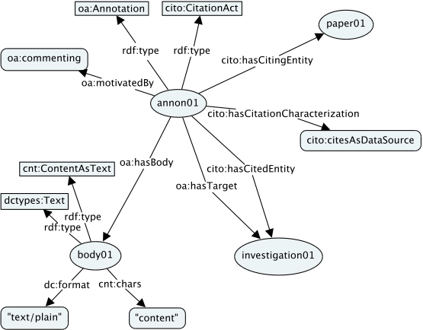Figure 13: Citing a Dataset and adding a Comment
Figure 14: An Annotation and Citation

Calls in More Detail

Advance_status
The advance_status call can be used to change the status of an annotation. Possible states are 'submitted', 'stable', 'invalid' and 'retired'. The states of 'invalid' and 'retired' are considered to be final states, once an annotation has one of these states then its state can no longer be changed.
If the requested is the same as the existing status it is not an error and has no effect, i.e. if an annotation has a status of 'submitted' and you try and update the status to 'submitted' then there will be no change to the underlying data and you will get a return code of 200.
A user can only update an annotation if they are associated with the annotation or they are a member of the 'moderator' group. Where being associated with an annotation means that one of the oa:annotatedBy foaf:Person objects attached to the annotation contains their username.
When an annotation is updated the annotation, and all of the triples with the annotation id as their subject, are moved to the graph for the selected state. The foaf:Person object(s) linked via oa:annotatedBy are unique so they are also moved. The foaf:Organization and prov:SoftwareAgent objects are not necessarily unique to that annotation so they are copied. New provenance data about the person requesting the status change is also written out and the oa:annotatedAt time is updated.
The call should be a POST and contain a json file, see example file below.
It is possible to use curl to post the file, see example below.
Figure 15: Json File Used for the Call advance_status
Possible HTTP return codes include:
Figure 16: Curl Used to Call advance_status
200 – OK, the annotation was updated, or if the requested status was the same as the existing status nothing was changed
400 – User error, i.e. missing parameter from the json file or trying to change the status of an annotation that is already in a final state
403 – You do not have permission to change the status for this annotation
404 – No annotation was found for the given id
405 – Method not allowed, you did not use a POST request
500 – Oops, something has gone wrong with the server

Open Search

Description Document
Currently the templates in description document are not correct. The correct templates are:
search/[atom]?count={count?}&startPage={startPage?}&startIndex={startIndex?}&bodyType={a0:type?}&citingType={a0:type?}&dataType={a0:type?}&domainOfInterest={a1:domainOfInterest?}&motivation={a1:motivation?}&organization={a2:name?}&target={a1:target?}&title={a3:title?}&userName={a2:accountName?}&status={a1:status?}&depth={a1:depth?}&format={a1:format?}
suggest/[atom]?count={count?}&startPage={startPage?}&startIndex={startIndex?}&q={searchTerms}&bodyType={a0:type?}&citingType={a0:type?}&dataType={a0:type?}&domainOfInterest={a1:domainOfInterest?}&motivation={a1:motivation?}&organization={a2:name?}&target={a1:target?}&title={a3:title?}&userName={a2:accountName?}&status={a1:status?}&depth={a1:depth?}&format={a1:format?}

Search
The search will search the graph specified by the value of status, if no value is specified for status then the 'stable' graph will be used. The search results are filtered based on the values of the parameters:
- bodyType
- citingType
- dataType
- domainOfInterest
- motivation
- organization
- target
- title
- userName
If more than one parameter type is provided, i.e. dataType=1&domainOfInterest=2,then the results must match both parameters.

Examples
search/atom?count=20&status=submitted&depth=0&format=turtle
search/atom?count=5&dataType=http://purl.org/dc/dcmitype/Dataset& domainOfInterest=http://vocab.ndg.nerc.ac.uk/term/P220/1/26&status=submitted

Suggest
The suggest will return all of the values for the given search terms from the graph specified by the value of status. The search terms are specified via the q parameter, allowed values are:
- bodyType
- citingType
- dataType
- domainOfInterest
- motivation
- organization
- *
The value for q can be a space separated list e.g. q={dataType motivation}.
The results include the URI and preferred label for each term. The results can be restricted by using values for the parameters listed in 4.2.
N.B. The totalResults refers to the number of different facets found. Currently the number of resources per facet is not reported.

Examples
suggest/atom?q={dataType motivation}&status=submitted
This will return a list of all of the data types and motivations that are in the submitted graph.
suggest/atom?q={domainOfInterest}&dataType=http://purl.org/dc/dcmitype/Dataset&status=submitted
This will return a list of all of the domains of interest that are in the submitted graph where the annotations have a data type of http://purl.org/dc/dcmitype/Dataset.

CHARMe Vocabulary
The CHARMe vocablary is available via the /sparql endpoint on the node and is contained in the graph http://localhost:3333/privateds/data/vocab. It is also available via the vocab endpoint.

Security
The Node security provides two components: the node administration and the client OAuth authentication.
The OAuth administration is responsible to grant access, to external client, to protected resources. The OAuth manages four tables accessible through the django admin
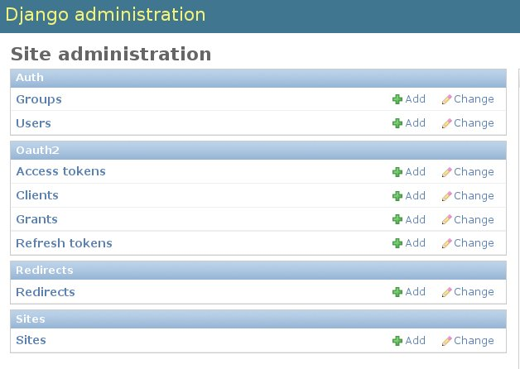Illustration 7.1:

To allow an already registered user to access a specific resource the Node admin insert a new record in the Clients table defining:
- the user authorized to the resource
- the RequiredURL the user want to access
- the URL where the user will be redirected if granted
- the Client ID used to identify the user:RequiredURL pair.

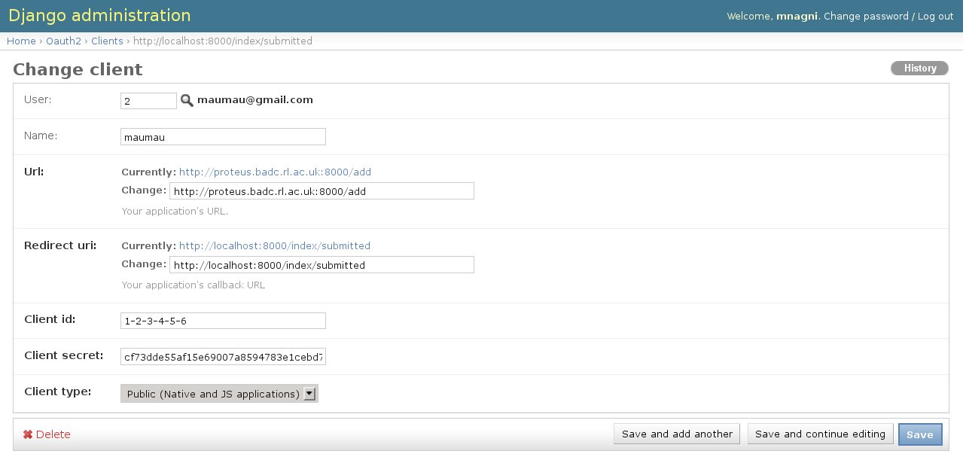Illustration 7.2:
In a typical request request a client requires an HTTP GET with the following parameters:
?client_id=1-2-3-4-5-6&response_type=token&redirect_uri=http:\\localhost:8000\index\submitted

if the user is not authenticated the node requires user/password. Once authenticated the node returns an HTTP 302 conform to OAuth returning a access token, expiration date, type and scope similar to

http://localhost:8000/index/submitted?access_token=58412ba8bf8d225ed8617fda0806f41a3d1428d0&token_type=Bearer&expires_in=2591999&scope=add_annotation

Unfortunately it doesn't work as expected with ajax calls. For calls via XMLHttpRequest (XHR) transparent redirection works only for urls in the same domain ("same origin"). But proxy software returns 302-responses with urls in "Location" header from other domain ("cross-origin"). So when client code sends a GET-request via XHR (an ajax call) and the user agent gets a 302 response (from proxy) XHR fails the request. The result contains absolutely nothing that could help to identify the feailure reason. In a jQuery's "fail" handler we'll get status: 0, responseText:"",statusText:"error".
That's very bad. A conclusion that we can make is that Single Page Applications can be incompatible with reverse proxy software.
One point in the HTTP spec can help here. It states that: So there should be no transparent redirections for POST requests. Our application on getting an error with status=0 can send a POST-request to its server. And the proxy software will not return 302 responses as it can (and will) be ignored by the user agent. Instead it'll return a 401 response asking the user agent to authenticate. So the user will be prompted for credentials and if they're ok the proxy will pass the original request and all subsequent ones. Application continues to work.

http://www.openannotation.org/spec/core/core.html#MultipleBodyTarget
http://vocab.nerc.ac.uk/

