|  |  |  |
| --- | --- | --- |
|  | **NAAN MUDHALVAN** |  |

|  |  |  |
| --- | --- | --- |
|  |  |  |

***AWS-Hosted Virtual Classroom And Learning Platform***

***Project Created by:***

***Project Created Date: 21/Nov/2024***

***College Code: 1106***

***College Name: Indira institute of engineering and technology***

***Team Name:***

**1.Charumathi .R 2.Avitha .P 3.Abinaya .S 4.Jeeva .p**

***BONAFIDE CERTIFICATE***

Certified that this Naan Mudhalvan project report **“AWS-Hosted Virtual Classroom And Learning Platform”** is the bonafide work of __________________ who carried out the project work under my supervision.

**SIGNATURE SIGNATURE**

**Project Coordinator SPoC**

**Naan Mudhalvan Naan Mudhalvan**

INTERNAL EXAMINER EXTERNAL EXAMINER

***ABSTRACT***

***AWS-Hosted Virtual Classroom And Learning Platform***

This project aims to develop a virtual classroom and learning platform hosted on Amazon Web Services (AWS) to provide an interactive and scalable online learning experience. The platform will offer features such as live video lectures, real-time chat, discussion forums, and access to study materials, enabling students and teachers to engage in lessons from anywhere. It will support a variety of content formats, including video, documents, and quizzes, creating a comprehensive learning environment. By leveraging AWS, the platform can handle a large number of users simultaneously, ensuring that it remains reliable and responsive even during peak usage times.

The platform will also incorporate tools for tracking student progress, grading, and feedback, giving teachers the ability to monitor individual and group performance. Cloud-based storage will ensure that all materials and data are secure and easily accessible. The project aims to make education more accessible by providing a flexible and cost-effective solution that can scale with the needs of institutions and learners worldwide. By using AWS services, the platform will be able to adapt to growing user demand while maintaining high-quality performance and availability.

**Project Description**

The project is focused on developing a scalable and interactive virtual classroom and learning platform hosted on Amazon Web Services (AWS). The platform will enable students and instructors to engage in online education through features such as live video streaming, real-time chat, discussion boards, and access to a wide range of educational resources. It will support different content types including video lectures, reading materials, quizzes, and assignments, providing a comprehensive online learning environment. Teachers will be able to create and manage courses, track student progress, provide feedback, and grade assignments efficiently using integrated tools.

By leveraging AWS infrastructure, the platform will be designed to handle a large volume of concurrent users, ensuring high performance and availability even during peak usage times. The platform will be built to be flexible and adaptable, offering features like cloud storage for course materials, secure data management, and customizable user interfaces to meet the needs of different educational institutions. The goal of the project is to create an affordable, user-friendly, and reliable solution that enhances remote learning experiences and makes education more accessible to students around the world, regardless of their location.

**TABLE OF CONTENT**

**CHAPTER NO TITLE PAGE NO**

**1 INTRODUCTION 6**

**2 LITERATURE REVIEW 9**

**3 TECHNOLOGIES USED 12**

**4 PROJECT FLOW 15**

**5 IMPLEMENTATION DETAILS 19**

**6 TESTING AND OPTIMIZATION 20**

**7 CONCLUSION 21**

**8 REFERENCES 23**

**CHAPTER 1**

***INTRODUCTION***

***1.1 Background and Motivation***

**Overview of virtual classroom and learning platforms and Their Growth:** A **virtual classroom** is an online platform where students and teachers interact through live video lectures, discussions, and collaborative tools. It offers flexibility, allowing learners to access education from anywhere, anytime. The growth of virtual classrooms has been accelerated by the COVID-19 pandemic and advances in technology, making online learning more accessible and scalable. As a result, virtual classrooms are now an essential part of modern education, supported by cloud-based infrastructure for enhanced performance and global reach.

**Motivation Behind Virtual classroom:** The motivation behind developing a virtual classroom platform is to create an accessible, flexible, and scalable learning environment that can reach students anywhere in the world. By leveraging technology, the goal is to bridge educational gaps, making learning more inclusive, efficient, and adaptable to diverse needs. With the increasing shift toward online education, this platform aims to enhance the learning experience and provide both students and teachers with the tools they need to succeed in a digital world.

***1.2 Problem Statement***

1. **Limited Access to Education**: Many students, especially in remote or underserved areas, face challenges accessing quality education due to geographical, financial, or infrastructure barriers.
2. **Inefficiencies in Traditional Learning**: Traditional classroom settings often struggle with accommodating different learning styles, managing large classes, and offering flexible schedules, limiting educational opportunities for diverse learners.
3. **Scalability and Reliability Issues**: Existing online learning platforms may lack the scalability to support large numbers of users simultaneously, leading to performance issues and unreliable access during peak times.
4. **Lack of Engagement Tools**: Many online learning platforms fall short in providing interactive features that keep students engaged, making it harder for educators to deliver dynamic lessons and track student progress effectively.

***1.3 Objectives of the Project***

The primary objectives of the **virtual classroom** project are:

1. **Create an Accessible Platform**: Build a virtual classroom that can be easily accessed by students anywhere, anytime.
2. **Offer Flexible Learning**: Provide options for live sessions and on-demand content to suit different learning schedules.
3. **Boost Engagement**: Include interactive tools like chat, quizzes, and group activities to keep students engaged.
4. **Support Learning Management**: Equip instructors with tools to track progress, give feedback, and manage courses efficiently.

***1.4 Scope of the Project***

The scope of this project is focused on the following key areas:

1. **Backend Architecture and Deployment:**

* The platform will use AWS services like **EC2** for hosting, **RDS** for database management, and **S3** for storing course materials, ensuring it can handle large numbers of users and maintain data security.
* **AWS Media Services** will handle *live* video streaming, while **AWS App Sync** or **Web Sockets** will provide real-time communication for chat and collaboration between students and teachers.

1. **Integration of AWS Services:**

* **Hosting and Storage**: AWS **EC2** will host the virtual classroom, and **S3** will store course materials like videos and documents, making them easily accessible.
* **Live Streaming and Communication**: **Amazon IVS** will provide live video streaming for classes, while **Dynamo DB** or **RDS** will manage student data, and **AWS App Sync** will enable real-time chat and interactions.

1. **Limitations:**

* **Cost Management**: Using multiple AWS services, such as EC2 for hosting and S3 for storage, can lead to high operational costs, especially with growing user numbers and data.
* **Complexity in Setup**: Setting up and managing a virtual classroom on AWS may require technical expertise, as configuring services like databases, video streaming, and real-time communication can be complex.

1. **Future Expansion Opportunities:**

Future expansion could include integrating **AI features** for personalized learning and automated feedback. Additionally, offering **mobile apps** and **offline access** would provide more flexibility for students, especially in low-connectivity areas.

***CHAPTER* 2**

***LITERATURE REVIEW***

The increasing adoption of cloud computing in education has transformed traditional learning systems, making them more flexible, scalable, and accessible. Amazon Web Services (AWS), as a leading cloud service provider, plays a pivotal role in enabling virtual classrooms and learning platforms. This literature review covers key subtopics: the role of cloud computing in education, AWS as a preferred platform, its benefits, applications in learning environments, challenges, and future directions.

#### ****1. The Role of Cloud Computing in Education****

Cloud computing is widely regarded as a transformative technology in education.

* **Definition and Models:** Cloud computing provides on-demand access to computing resources such as storage, servers, and databases. Its three primary models—Infrastructure as a Service (IaaS), Platform as a Service (PaaS), and Software as a Service (SaaS)—support diverse educational needs.
* **Educational Impact:** Studies show that cloud computing enhances operational efficiency in educational institutions by enabling remote access to resources, collaboration, and flexibility for students and educators. It also reduces the need for on-premises infrastructure, leading to cost savings.

#### *****2. AWS as a Preferred Platform for Learning*****

AWS is often selected for hosting educational platforms due to its robust features and scalability.

* **Core Services:** Tools like Amazon Elastic Compute Cloud (EC2) for virtual servers, Amazon Simple Storage Service (S3) for storing educational content, and AWS Lambda for server less computing are widely utilized.
* **Content Delivery and Reliability:** AWS employs Amazon Cloud Front, a global content delivery network, to provide fast and reliable access to educational materials, including high-quality videos.

#### *****3. Benefits of AWS-Hosted Virtual Classrooms*****

AWS offers a range of benefits that address the challenges of traditional learning systems.

* **Scalability and Flexibility:** AWS dynamically adjusts resources based on demand, ensuring smooth operation during peak times, such as online exams or virtual events.
* **Cost Efficiency:** Its pay-as-you-go model allows institutions to optimize costs by only paying for the resources they use.
* **Data Security and Compliance:** AWS is compliant with regulations like the Family Educational Rights and Privacy Act (FERPA). Features such as AWS Identity and Access Management (IAM) provide secure access controls, ensuring the safety of student data.

#### *****4. Applications in Learning Platforms*****

AWS supports various use cases in virtual learning environments.

* **Live and On-Demand Classes:** Institutions use AWS to host live virtual classrooms and provide on-demand access to recorded lectures and materials.
* **Learning Management Systems (LMS):** Platforms like Moodle and Blackboard leverage AWS for course materials, facilitating discussions, and tracking student performance.
* **Personalized Learning:** By integrating tools like Amazon SageMaker, AWS enables data-driven insights to customize learning paths and identify struggling students for targeted intervention.

#### *****5. Challenges in Implementation*****

Despite its advantages, AWS-based platforms face some challenges:

* **Learning Curve:** The complexity of AWS services can be daunting for educators and IT teams without prior cloud experience.
* **Initial Setup Costs:** Although cost-effective in the long term, transitioning to AWS may require an upfront investment in training and migration.
* **Internet Dependency:** Reliable internet connectivity is essential for accessing AWS-hosted platforms. This poses challenges in remote or underserved areas with limited access to high-speed networks.

#### *****6. Future Directions*****

The future of AWS-hosted learning platforms lies in further innovation and accessibility.

* **Edge Computing:** Advancements in edge computing are expected to minimize latency, improving real-time interactions in virtual classrooms.
* **Global Collaboration:** AWS's multilingual capabilities and global infrastructure can facilitate international collaboration between students and educators, bridging educational divides.

### *****Conclusion*****

AWS-hosted virtual classrooms and learning platforms represent a transformative shift in education, offering scalability, security, and innovative applications. While challenges such as internet dependency and implementation complexity persist, advancements in cloud computing and immersive technologies promise a bright future. AWS’s robust features and adaptability position it as a key enabler of modern and inclusive education .

**CHAPTER 3**

**TECHNOLOGIES USED**

***3.1 System Architecture***

* **Core Components**: The architecture includes cloud servers for hosting, data storage for course materials, and integrated video conferencing tools for real-time interaction. Learning platforms often use services like AWS EC2 for computing and S3 for secure storage.
* **User Access and Interaction** : Students and teachers access the platform through web browsers or dedicated apps.
* **Security and Scalability**: Security is managed with user authentication and data encryption, while scalability allows the system to handle increased user traffic during peak times.

***Key Components of the Architecture:***

* **Front End**:  
  The front end includes the user interface where students and teachers interact with the platform, often built with web technologies like HTML, CSS, and JavaScript.
* **Back End**:  
  The back end manages application logic, user authentication, and data processing using cloud services like AWS EC2 or server less solutions.
* **Database**:  
  Databases store essential data such as user profiles, course content and student progress.
  1. **AWS Services Used**
* **Amazon Cloud Front**: Delivers course content and media to users with low latency.
* **Amazon S3**: Stores videos, documents, and other learning materials.
* **Amazon API Gateway**: Manages user interactions and routes requests to backend services.
* **AWS Lambda**: Processes real-time user requests and triggers backend functions.
* **Amazon RDS and Dynamo DB**: Handle structured data like user profiles and unstructured data for chat or session tracking.
* **Amazon Chime SDK and IVS**: Enable live video streaming, virtual classes, and interactive sessions.
* **Amazon Cognito**: Provides secure user sign-up, sign-in, and authentication.

***3.3 Backend Development***

1. **AWS Lambda**: Provides serverless computing for scalable, event-driven backend functions. Ideal for processing user actions and handling real-time interactions without managing infrastructure.
2. **Amazon ECS/EKS**: Runs containerized microservices for flexible, scalable backend applications. Ensures that services can scale up or down based on demand, optimizing performance and resource use.
3. **Amazon API Gateway**: Facilitates secure and managed API endpoints for client communication. It routes incoming requests to appropriate backend services while handling authentication and traffic management.
4. **Amazon RDS/Dynamo DB**: Stores and manages structured and unstructured data for user and course management. Amazon RDS is used for relational data, while Dynamo DB supports high-speed, No SQL data operations.
5. **Amazon SQS**: Handles message queuing for asynchronous processing and decoupling of services. Ensures that different backend components can communicate smoothly and reliably without direct dependencies.
   1. ***Deployment Strategy***

* **Blue/Green Deployment**: Minimizes downtime by running two separate environments and switching traffic to the new version after testing.
* **Canary Deployment**: Gradually rolls out updates to a small subset of users before full deployment, ensuring stability and quick rollback if issues occur.
* **Automated CI/CD Pipelines**: Uses services like **AWS CodePipeline** and **AWS Code Deploy** for continuous integration and continuous deployment to streamline updates and maintain consistent code quality.

***CHAPTER* 4**

***PROJECT FLOW***

The project flow of a virtual classroom and learning platform are:

### *1.* *****Landing Page (Homepage)*****

* **User Authentication**: Users are welcomed with options to log in or sign up for an account. **Amazon Cognito** manages user authentication and ensures secure login and sign-up processes with support for social identity providers (e.g., Google, Facebook).
* **Introduction to the Platform**: A brief, engaging overview of the platform’s purpose, highlighting its features like interactive classes, video tutorials, quizzes, and certificates. This section can include a short introductory video or image carousel showcasing platform highlights.
* **Navigation Menu**: Easy-to-use navigation bar with links to the course data log, live classes, user profile, and support page. Quick access buttons guide users to sign up for courses or start a free trial.
* **Announcements & Updates**: Displays a feed of important notifications, new courses, or upcoming events to keep users informed.
* **Testimonials and Reviews**: A section featuring student and instructor testimonials to build trust and credibility.

### *2.* *****Course Cata log Page*****

* **Search and Filter Options**: Users can search for specific courses by keyword, category, instructor, or course difficulty level. Filters allow sorting by rating, course duration, or the number of enrolled students.
* **Course Previews**: Each course entry includes a thumbnail image, course title, a brief description, instructor details, ratings, and the number of enrolled students. A "More Info" button opens a detailed course page with an extended description, syllabus, and sample content.
* **Enrollment Button**: Direct links for students to enroll in the course, triggering a registration process managed by **Amazon API Gateway** and connected to backend services using **AWS Lambda**. This also updates user data in **Amazon RDS** or **Dynamo DB**.
* **User Dashboard Link**: A button or link that takes users to their dashboard or classroom page to access their courses and progress.

* **Recommended Courses**: A section with suggestions for courses based on user interests, past enrollments, or trending topics.

### *3.* *****Classroom Page*****

* **Live Streaming and Class Content**: Utilizes **Amazon Chime SDK** or **Amazon IVS** for real-time video conferencing to conduct live classes.
* This page should include video controls (e.g., mute, start/stop video, screen sharing) for an interactive learning experience.
* **Interactive Tools**:
  + **Chat Box**: Real-time chat functionality where students can ask questions, share comments, or participate in discussions.
  + **Q&A Section**: A dedicated space for asking questions, with moderation features to ensure relevant queries are addressed.
  + **Whiteboard**: A shared virtual whiteboard that instructors can use to draw, write notes, or illustrate concepts in real-time.
* **Course Materials and Resources**: Links to course materials like PDFs, presentations, and supplementary videos stored in **Amazon S3**. These resources can be accessed directly from the classroom page or downloaded for offline use.
* **Class Participation Tools**: Polls or quizzes conducted during the class using **AWS Lambda** to process responses and display results in real-time.
* **Recordings and Playback**: Option to record the live session and store it in **Amazon S3** for future playback. The recording can be made accessible to enrolled users after the session ends.
* **Notifications and Reminders**: Pop-up notifications or in-app alerts for upcoming assignments, due dates, or upcoming live classes.
* **User Progress Tracking**: Displays real-time progress indicators, such as completed modules or scores from quizzes, with data stored in **Amazon Dynamo DB** for quick access and retrieval.

***CHAPTER 5***

***IMPLEMENTATION DETAILS***

***5.1 Introduction***

A virtual classroom and learning platform hosted on AWS provides a scalable, secure, and cost-effective solution for delivering online education. By leveraging AWS services, institutions can create an interactive learning environment with live video streaming, on-demand content, and real-time collaboration. The platform supports seamless user authentication, data management, and resource sharing while ensuring reliability and low latency. Below are the key components and implementation details for such a system.

* **Cloud Hosting**: Use Amazon EC2 for scalable virtual servers and Elastic Load Balancing for distributing user traffic.
* **Storage**: Utilize Amazon S3 for secure and scalable storage of course
* **Database**: Implement Amazon RDS or Dynamo DB for managing user data and interactions.
* **Media Streaming**: Use Amazon IVS or Cloud Front for low-latency live and on-demand video streaming.
* **Authentication**: Enable secure user login with AWS Cognito for user management and authentication.
* **Server less Functions**: Employ AWS Lambda for event-driven tasks like assignment grading and notifications.
* **Monitoring**: Use Cloud Watch for real-time performance tracking and alerting.
* **AI Integration**: Leverage Amazon Recognition for content moderation and AWS AI services for personalized recommendations.

**CHAPTER 6**

**TESTING AND OPTIMIZATION**

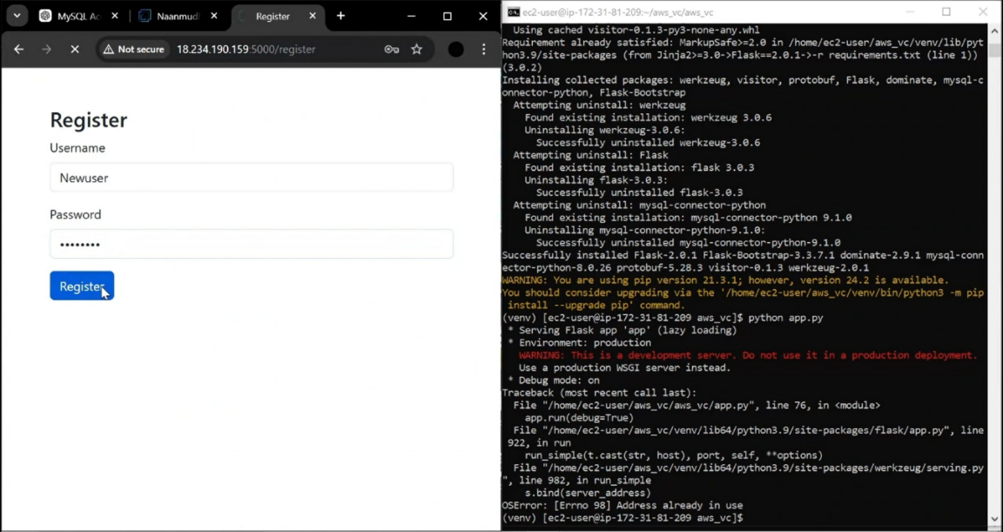

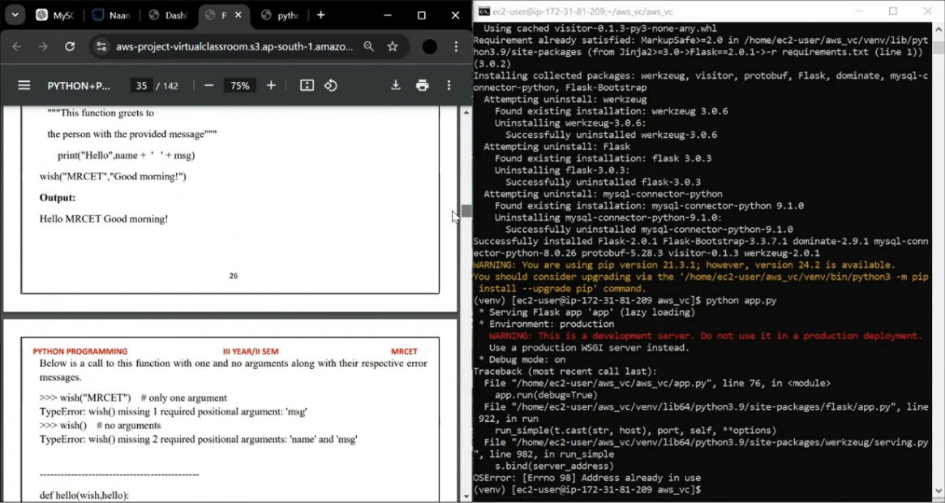

***CHAPTER* 7**

***CONCLUSION***

This project aimed to design and implement a virtual classroom and learning platform using AWS cloud services. The goal was to create a robust, scalable, and cost-effective solution for online education. With the increasing demand for remote learning, the platform offers a flexible and reliable environment to connect educators and learners globally.

***Achievements of the Project***

* **Scalability and Performance**:  
  By leveraging AWS services such as EC2, S3, and Elastic Load Balancing, the platform ensures consistent performance even during peak usage. Auto-scaling allows the system to handle increased traffic without interruptions.
* **Ease of Use and Accessibility**:  
  The platform was designed with user-friendly interfaces for students and teachers. It is accessible from multiple devices, ensuring inclusivity and convenience for users worldwide.
* **Data Security and Privacy:**  
  AWS services like IAM, RDS encryption, and CloudTrail were utilized to secure user data and maintain privacy. This ensures compliance with educational data protection standards.
* **Cost Efficiency**:  
  AWS's pay-as-you-go model allowed us to optimize costs while delivering high-quality services. Resources are only used as needed, reducing unnecessary expenses.
* **Interactive Features**:  
  Features like live video classes, chat, file sharing, and assessments were implemented. These tools provide a collaborative learning experience, mimicking traditional classroom interactions.

***Key Learnings***

Through this project, we learned the importance of cloud-based solutions in addressing modern education challenges. AWS provided the flexibility and tools needed to build a highly functional platform. Moreover, we understood the value of integrating advanced technologies like video conferencing and analytics to enhance the learning experience.

***Future Improvements***

Although the platform successfully meets current requirements, there is potential for further development. Incorporating AI-driven analytics, adaptive learning paths, and advanced reporting tools could improve user engagement and outcomes. Additionally, adding multilingual support would expand its reach to a broader audience.

***Final Thoughts***

The AWS-hosted virtual classroom project demonstrates how technology can bridge gaps in education, making quality learning accessible to all. With its scalability, security, and reliability, this platform is a solid foundation for future advancements in online education. It empowers educators and learners to connect seamlessly, ensuring that education remains a priority, no matter the circumstances.

**References**

* + **AWS Account Setup:** [**https://youtu.be/CjKhQoYeR4Q?si=ui8Bvk_M4FfVM-Dh**](https://youtu.be/CjKhQoYeR4Q?si=ui8Bvk_M4FfVM-Dh)
  + **Web Application Stack : FLask || MySQL Connector using flask || HTML/JS/CSS**
  + **AWS EC2 Instance:** [**https://www.youtube.com/results?search_query=aws+ec2+oneshot**](https://www.youtube.com/results?search_query=aws+ec2+oneshot)
  + **RDS Database:** [**https://www.youtube.com/results?search_query=rds+oneshot**](https://www.youtube.com/results?search_query=rds+oneshot)
  + **MySQL:** [**https://www.youtube.com/results?search_query=mysql+tutorial**](https://www.youtube.com/results?search_query=mysql+tutorial)

.