Lab Assignment # 1

Name of Student : CHATHARABOINA SAGAR
Enrollment No. : 2303A51522
Batch No. : 22

Task 1: AI-Generated Logic Without Modularization (Factorial without
Functions)

Prompt:-
Write a Python Code to calculate the factorial of a number
# entered by the user using loops only. Do not use any functions
# The entire logic should be written in one place, making it easy for beginners to understand.

Code:-
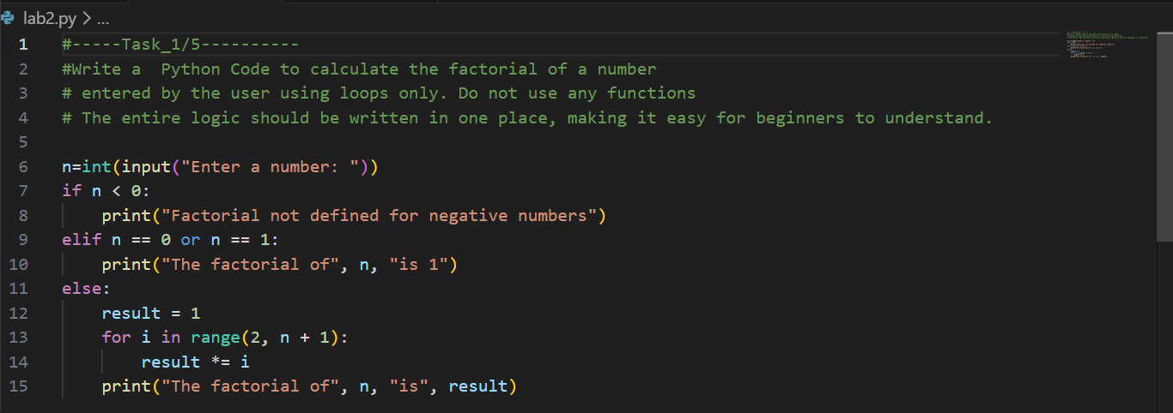

Output:-

Justification:-
This program solves the problem in a clear and straightforward way by writing all the logic in one place without using functions. It is easy for beginners to understand and suitable for small tasks. However, since functions are not used, the code is not reusable or flexible for larger programs.

Task 2: AI Code Optimization & Cleanup (Improving Efficiency)

Prompt:-
#-----Task_2/5----------
#Write a Python Code to calculate the factorial of a number
#Simplify and clean the factorial program to make it more readable and efficient by removing unnecessary parts.

Code:-
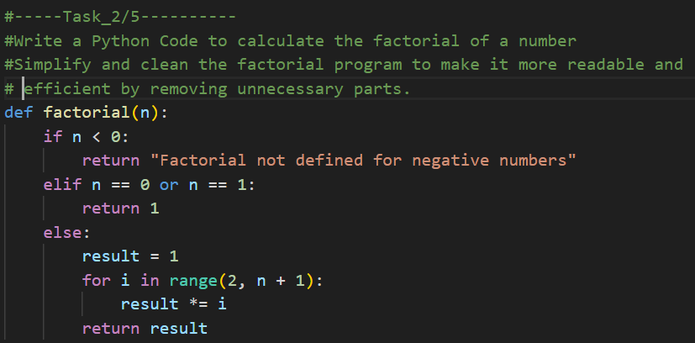

Output:-

Justification:-
This improved version of the code is cleaner and easier to read. By removing unnecessary parts and keeping only essential logic, the program becomes easier to understand, debug, and maintain, especially when working on larger projects or with a team.

Task 3: Modular Design Using AI Assistance (Factorial with Functions)

Prompt:-
#-----Task 3/5----------
#Write a Python program to calculate the factorial of a number using a function.
# The factorial logic should be placed inside a separate function to make the program more
# structured, reusable, and professional. This approach should clearly separate the main program flow from the logic,
# making it easier to modify and suitable for larger programs.

Code:-
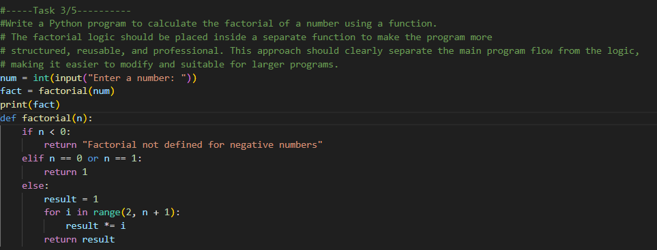

Output:-

Justification:-
Using a function makes the program more organized and professional. It separates the factorial logic from the main code, allowing the logic to be reused and easily modified, which is useful for larger programs.

Task 4: Comparative Analysis – Procedural vs Modular AI Code (With vs
Without Functions)

Prompt:-
#-----Task 4/5----------
#Compare factorial programs written with and without functions.
# Explain which approach is better for understanding, reusability, debugging, and use in large projects,
# and present the comparison in a small table

Code:-
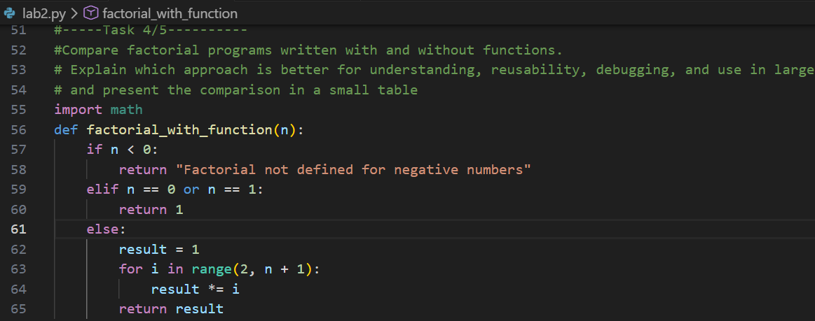

Output:-
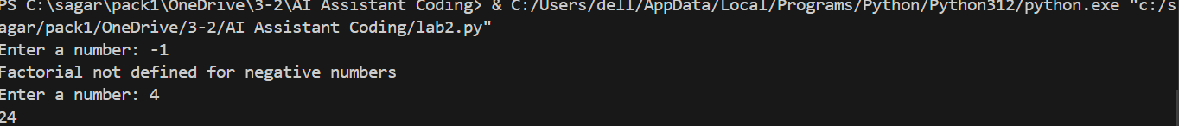

Justification:-

Comparing both approaches helps understand the advantages of using functions. It shows why modular code is easier to understand, reuse, debug, and manage in large projects compared to procedural code written without functions.

Task 5: AI-Generated Iterative vs Recursive Thinking

Prompt:-

#Write a Python program to calculate factorial using both iterative and recursive methods.
# Explain how each method works and compare them based on readability, memory usage, performance, and limitations.

Code:-
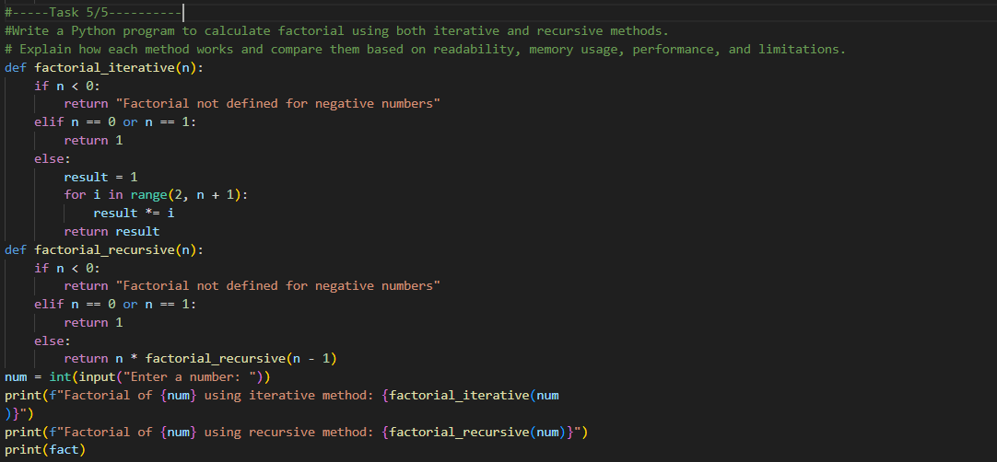

Output:-
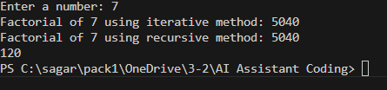

Justification:-

This task helps understand the difference between iterative and recursive approaches. By comparing both methods, it becomes easier to see their strengths, weaknesses, and when each method should be used in real programs.

