# **UC-010/UC-013 Back Office User Management – Sub module level access**

This requirement is to enhance existing “Manage Profile” BOS functionality whereby PPG users would have the ability to define sub-module level access to various types of users. As of now below type of users exist in the system:

1. Master Admin
2. Admin
3. Supervisor
4. Front Office Manager
5. Reporting
6. Restricted

For the above mentioned roles below modules can be configured to either allow or not allow access permissions for individual users. Each user may have the right to:

1. Complete access of a particular module
2. Only Edit rights for a particular module
3. Only view rights for a particular module
4. No rights to access a given module

At present PPG users profile created under “User Management” in BOS can have access to following BOS modules only:

1. Dashboard
2. Property Setup
3. Availability and Pricing
4. Bookings
5. My Account
6. Reporting
7. Distribution Manager

In the future state authorised PPG users would be able to grant access to users up to sub-module also. At present only module level access is granted by Master Admin.

Below section defines BOS Modules and their corresponding Sub Modules for which Master Admin user would be able to grant rights to different users based on requirement:

For Aerotel & PPL following sub-modules are available for which access can be granted to different PPG users based on their role:

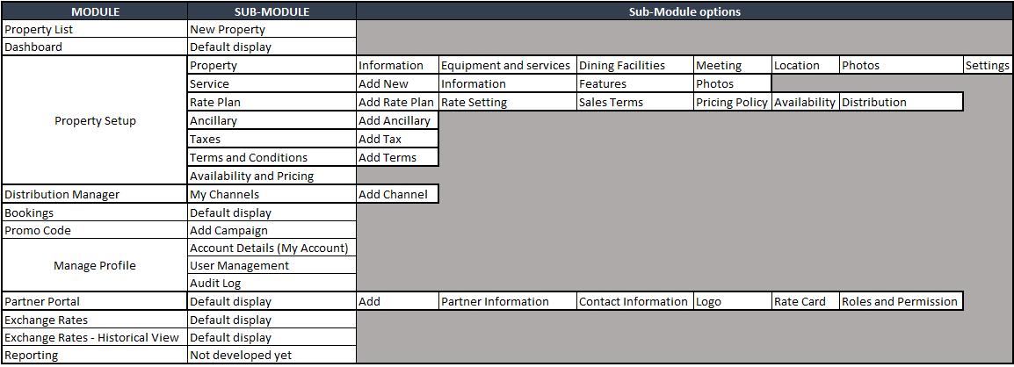



**AS IS USER MANAGEMENT BACK OFFICE DISPLAY**

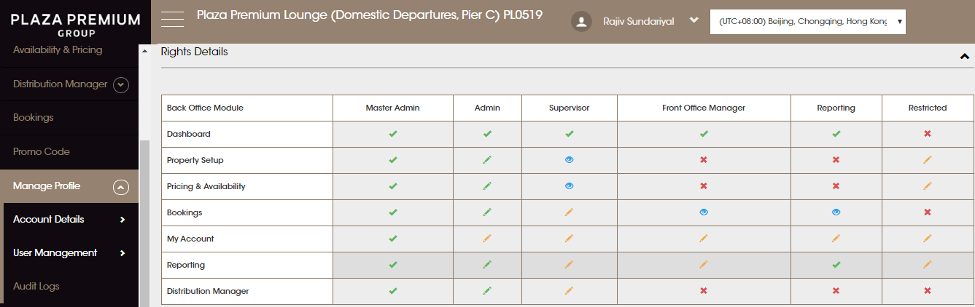

**TO BE USER MANAGEMENT BACK OFFICE DISPLAY**

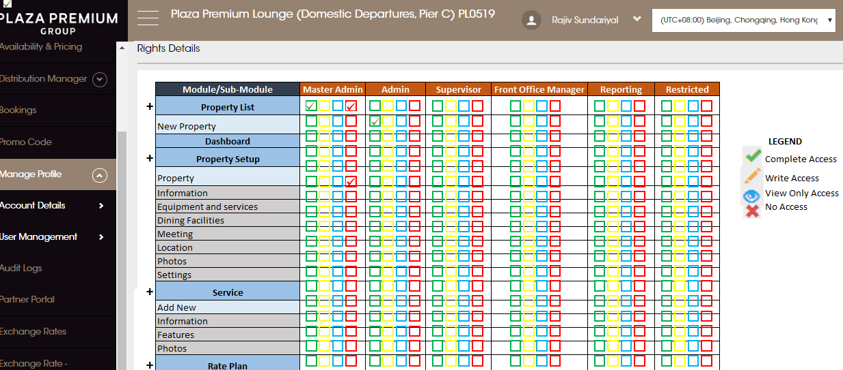

# **Adding New User roles in BOS**

A new option “Add Role” would be added under “User Management” that would allow PPG users to add a new role.

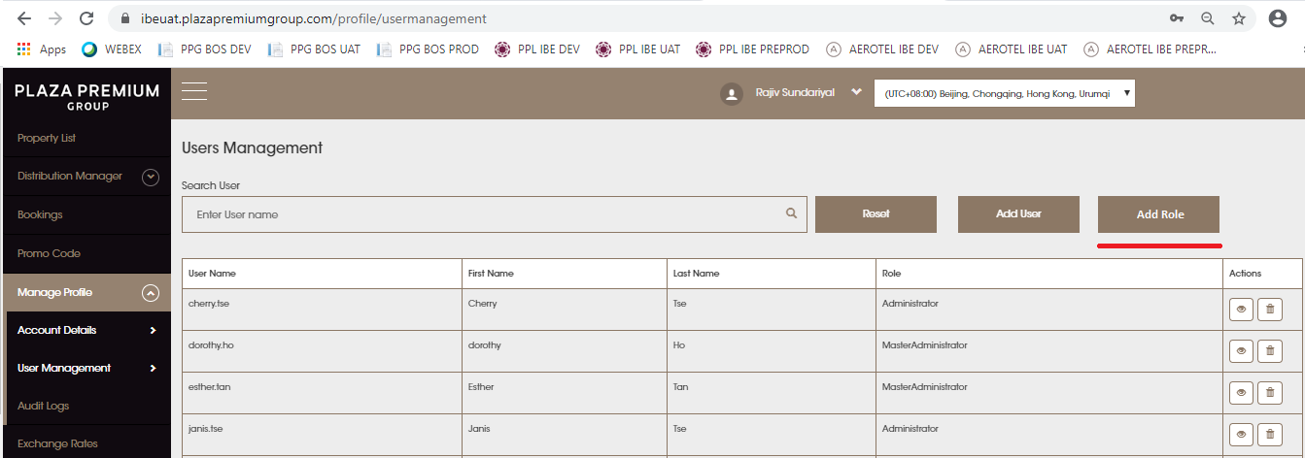

Once the user clicks on “Add Role” option then below screen would be displayed. User would be able to perform below actions on this screen:

1. Add a new role
2. Search a role / View a role
3. Delete a role

**ADD NEW ROLE**

To add a “New Role” the user would be required to enter the new user role name under “Enter New Role Name” and then click on “Add”.

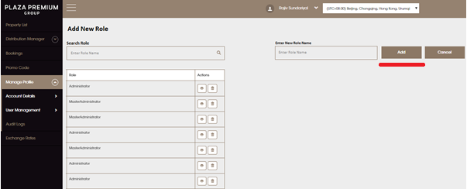

After clicking on the “Add” button all the modules and their corresponding sub module level access would be displayed to the user. The user would be able to select as to for the newly created role what all access is to be provided to the new user. The user would select all relevant module/sub-modules for which access for the new role is to be granted and then the user would clicks on “Save”. Upon clicking on the “save” option the new role would be created and all the assigned permission at module/sub—module level would be assigned to the user.

**Note**: If a role name entered already exists then the user would get an alert that would say “This Role already exists”. An ok button would be provided to the user on this alert box. Duplicate user roles would not be allowed to be created.

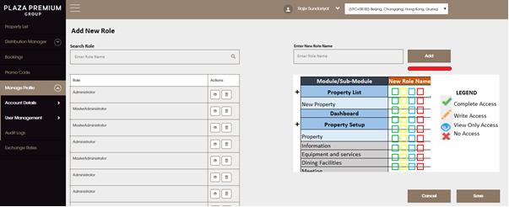

**SEARCH/ VIEW USER ROLE**

To view a role, a user would be able to enter the “Role Name” under “Search Role” and search for a specific role. After this the user could click on the “Eye” icon next to any of the role names displayed to view a specific roles permissions at module and sub module level. By clicking on the “Eye” icon corresponding access levels would be displayed on the right hand side. User would be able to make any changes to a specified role access and click on “Save”.

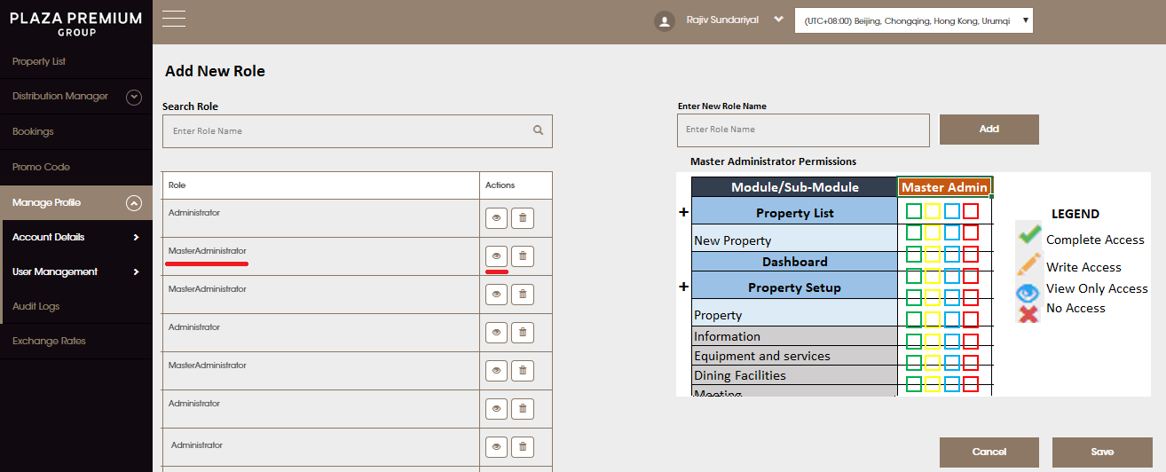

**DELETE USER ROLE**

To delete a role the user could either search for a specific role and then click on the “Bin” icon present next to the role name or user could search for a specific user role and then click on “Bin” icon to delete a role. One clicking on the “Bin” icon next to a role an alert box would be displayed to the user stating “Do you want to delete “Use Role Name”. This alert box would contain two options for the user to choose from. One would be “Yes” and other would be “No”. If the user clicks on yes then the specified user role would be deleted and if user clicks on “No” then the specified user role would not be deleted and that the user would remain on the same “Add new Role” page. Once a profile is deleted the data related to that profile would remain in the database. Its only that the profile would be not viewable anymore in the BOS module.

