On Eclipse

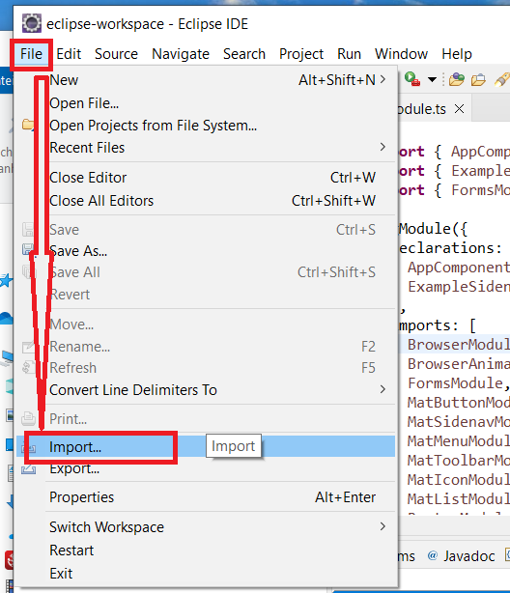

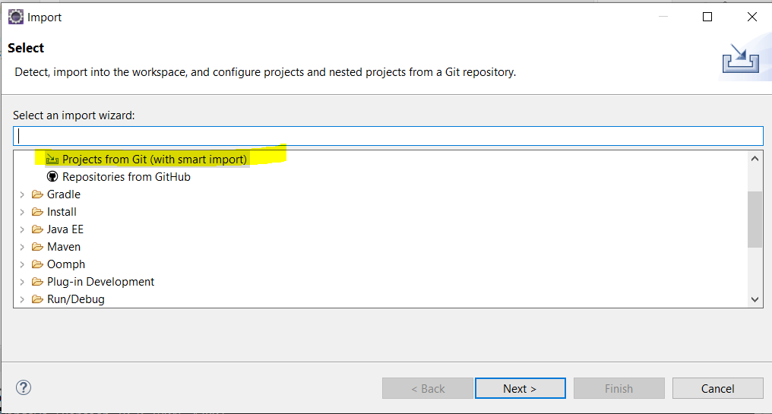

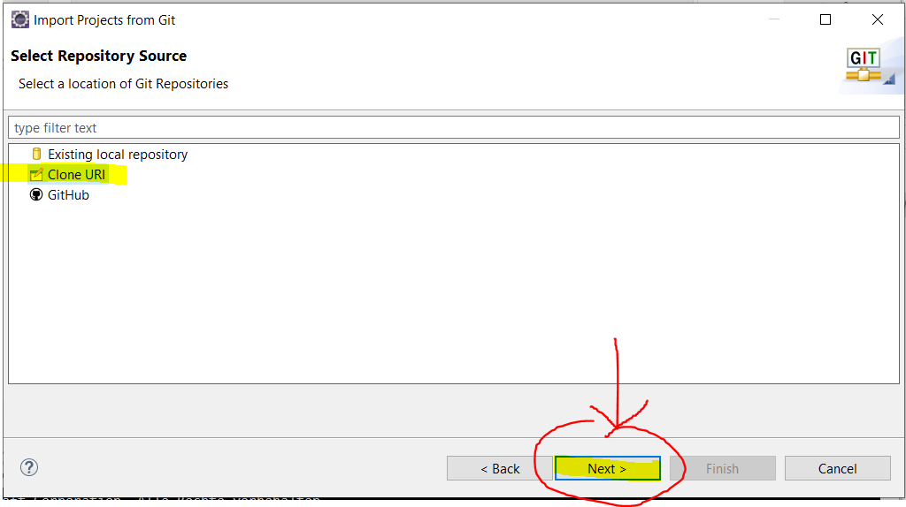

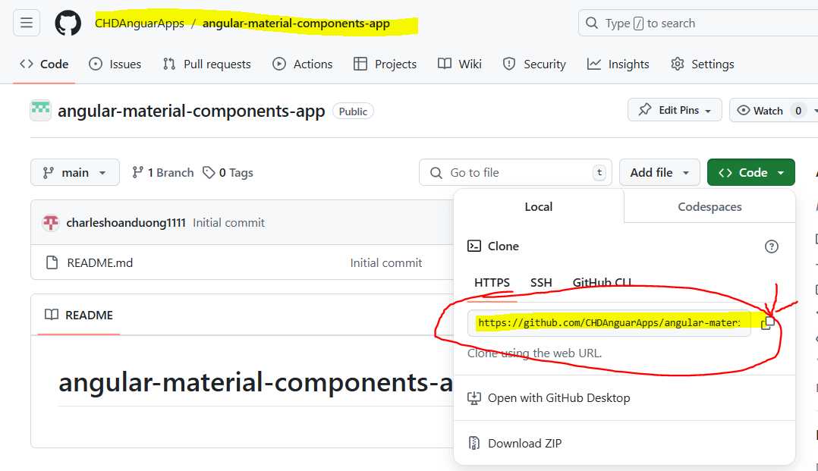

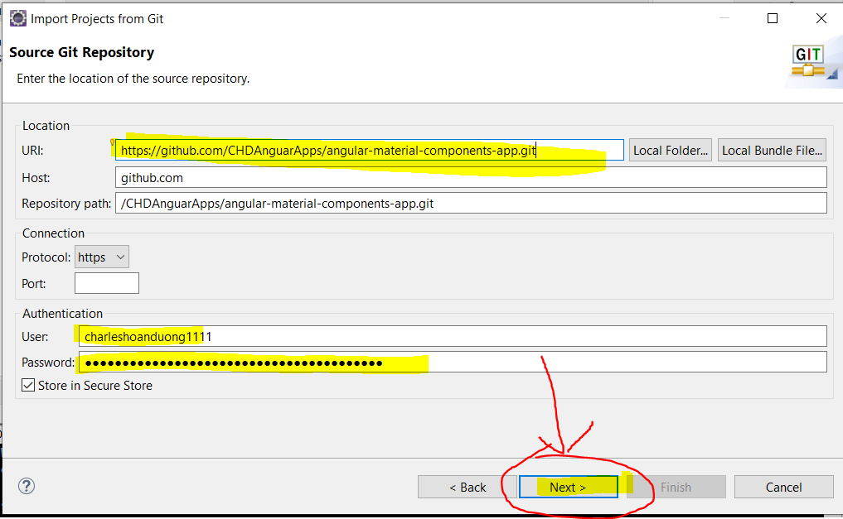

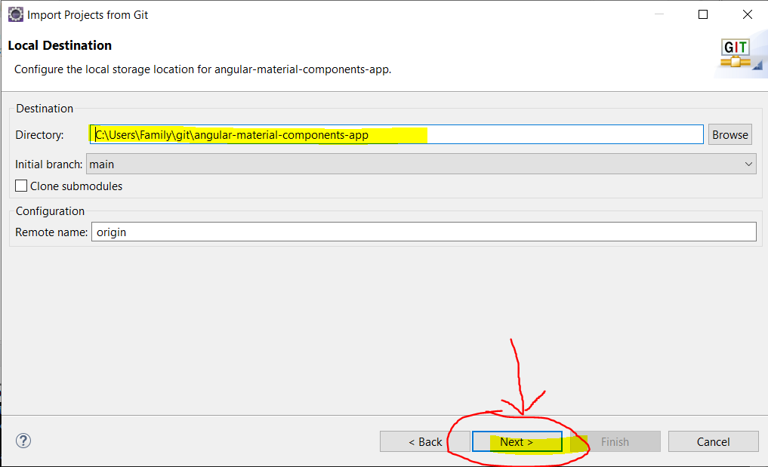

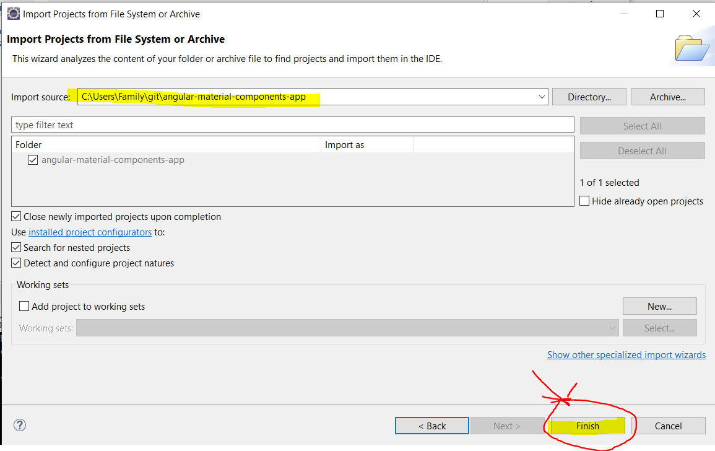

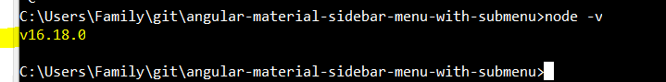



**INFO**

npm install -g @angular/cli@16.2.10

ng add @angular/material

npm i browser-module

npm i angular-animations

npm i material-icons

npm i @angular/forms

npm i @angular/router

**INSALL AND RUN**

* npm install



* ng serve

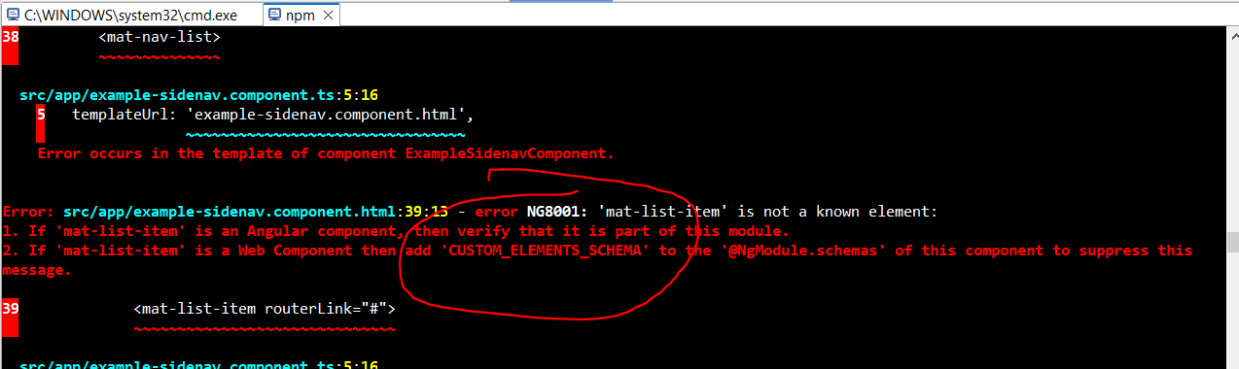

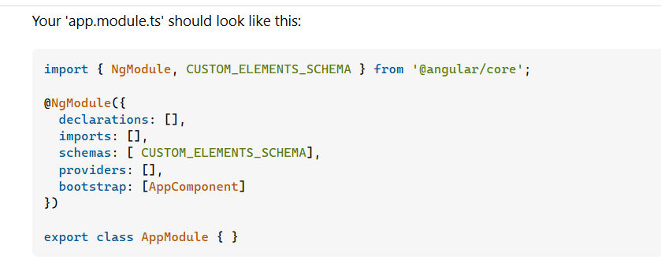

import { NgModule, CUSTOM_ELEMENTS_SCHEMA } from '@angular/core';

@NgModule({

declarations: [],

imports: [],

schemas: [ CUSTOM_ELEMENTS_SCHEMA],

providers: [],

bootstrap: [AppComponent]

})

export class AppModule { }



* ng serve

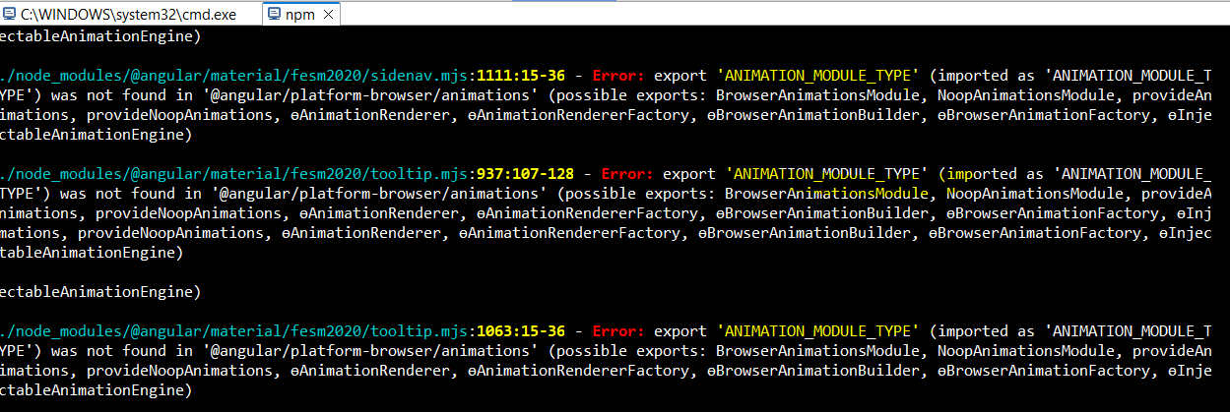

ng cache disable

ng cache off

ng serve

ng cache clean was the solution for me on the machine:

Angular CLI: 16.0.6

Node: 20.11.1

Package Manager: npm 10.2.4

OS: darwin arm64

Angular: 16.2.8

After cleaning the cache I could successfully run ng serve

