**Prisma**

Start from scratch with Prisma ORM using JavaScript and MySQL (15 min) | Prisma Documentation 🡪 <https://www.prisma.io/docs/getting-started/setup-prisma/start-from-scratch/relational-databases-node-mysql>

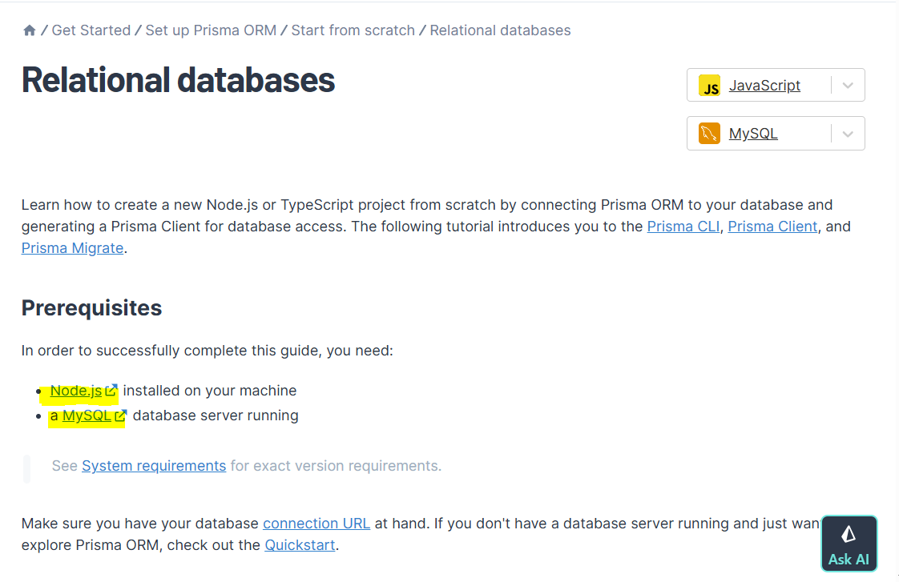

Node.js

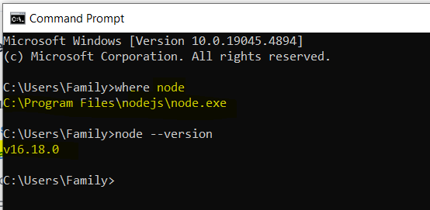

Window 10 🡪 MySQL

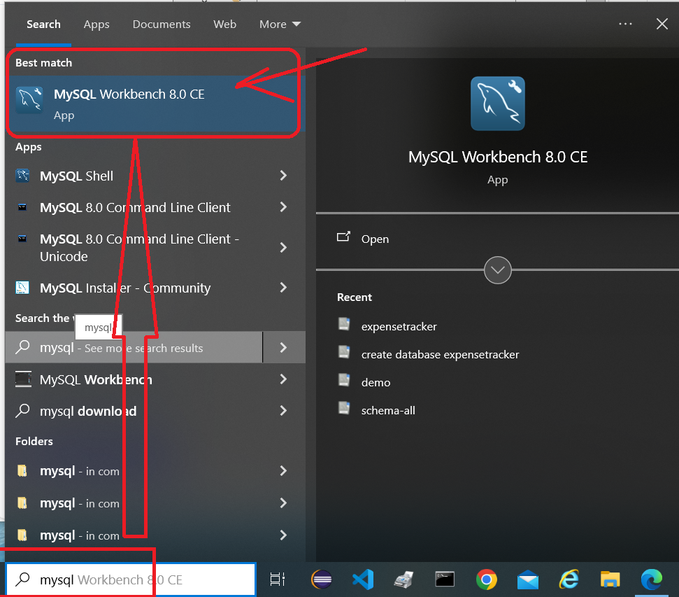

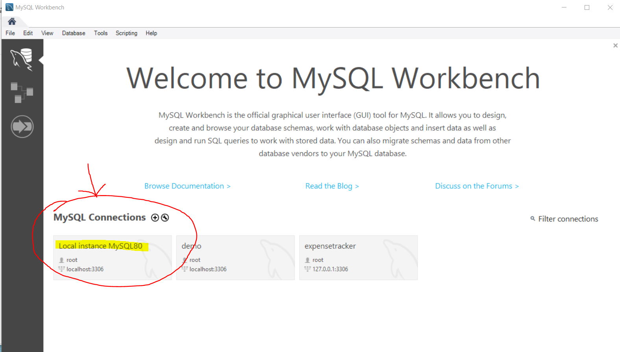

Manage Connections…

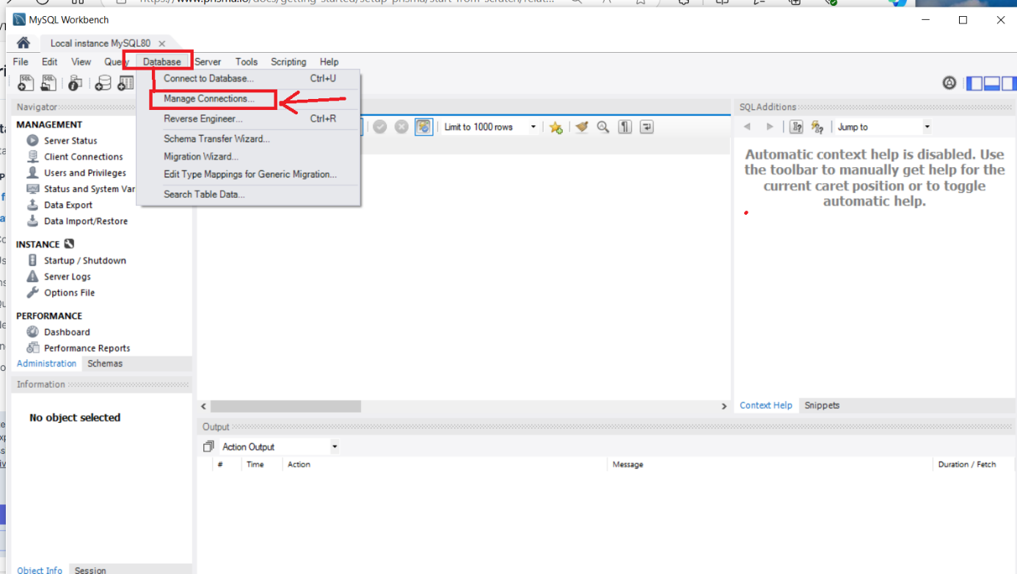

Click New 🡪 Connection Nam=PrimaDBDemo 🡪 Click Test Connection

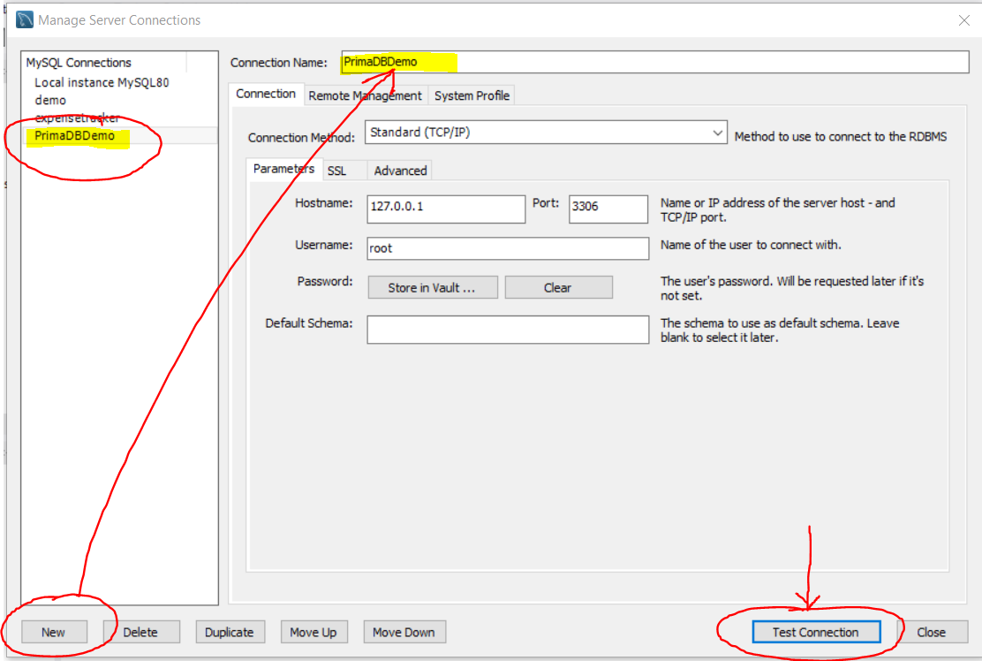

Password: root 🡪 Click OK

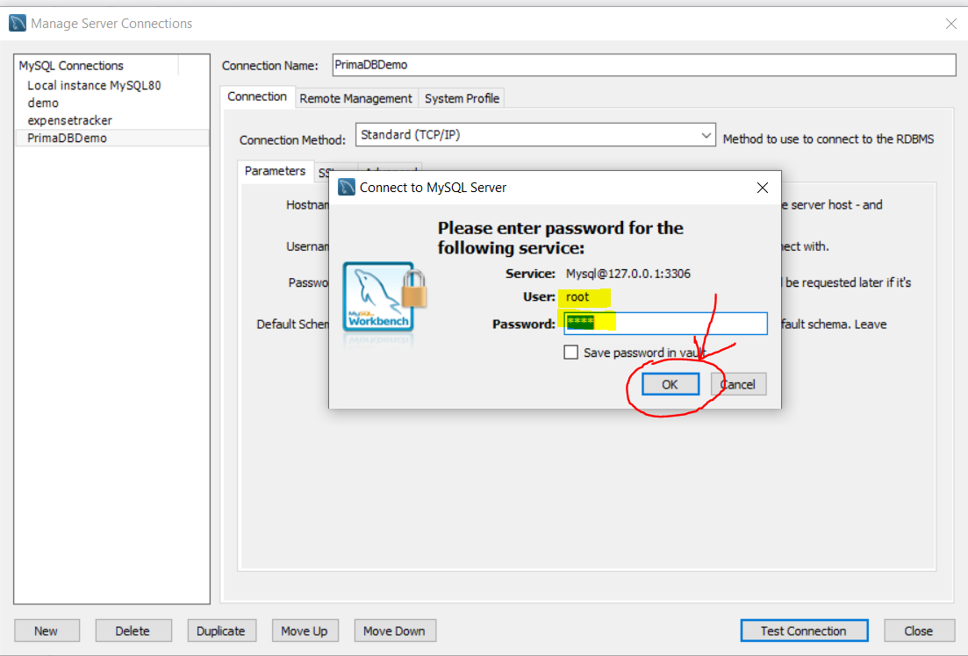

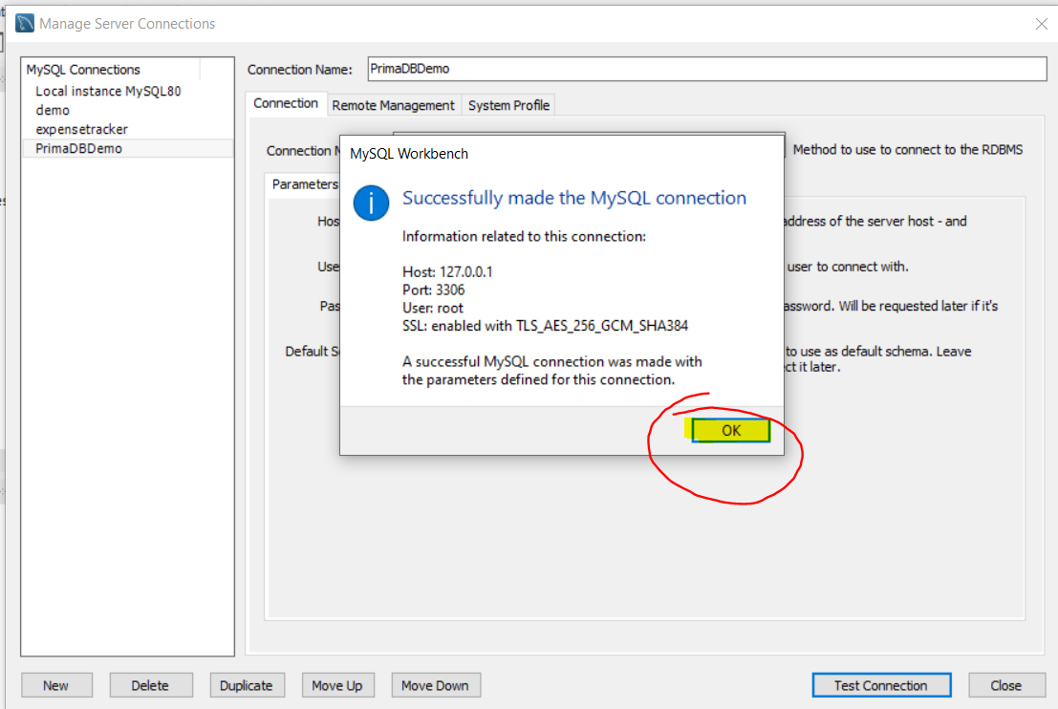

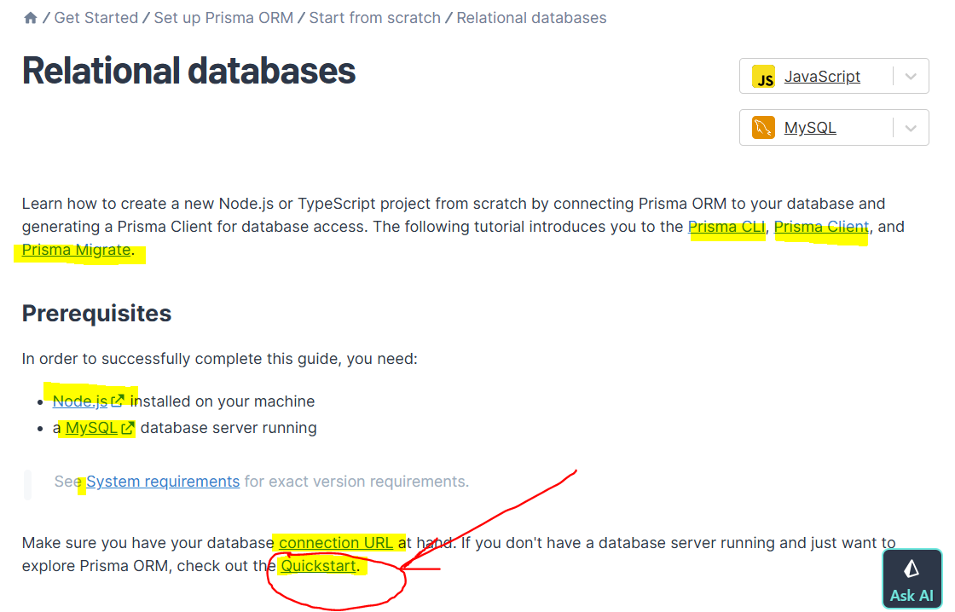

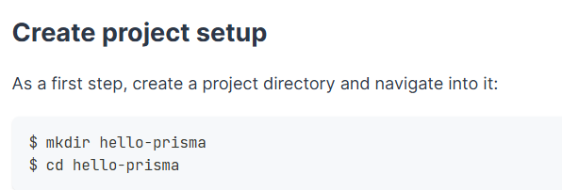

mkdir hello-prisma  
cd hello-prisma

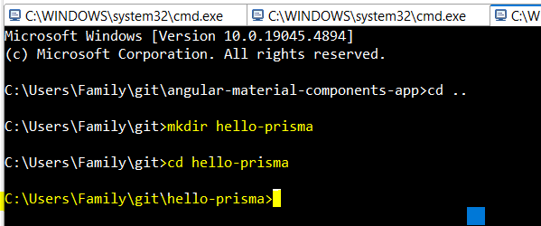

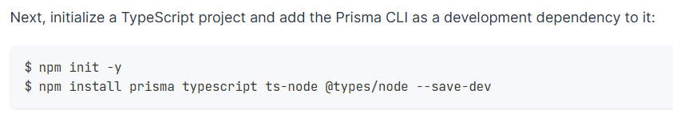

npm init -y

npm install prisma typescript ts-node @types/node --save-dev

C:\Users\Family\git\hello-prisma>npm init -y

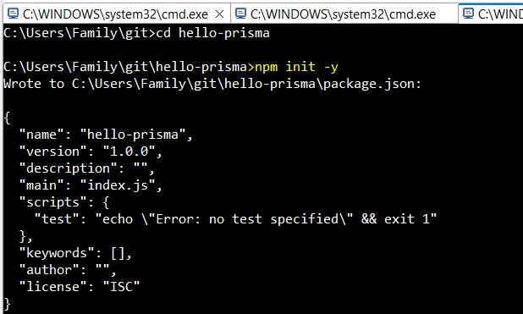

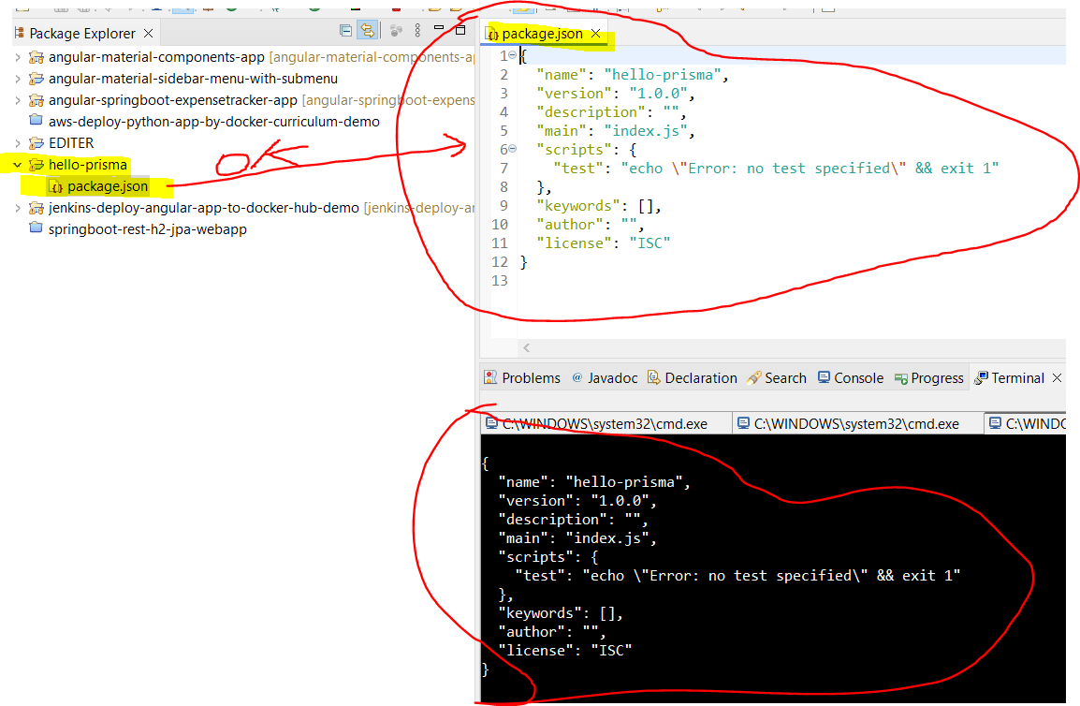

C:\Users\Family\git\hello-prisma>npm install prisma typescript ts-node @types/node --save-dev

