For periodic signal a[n], let its period be T.

Suppose T is an integer & it has N = CT points.

(In this project, # of points usually >> period, so I assume that T is integer & T | N)

A[k] = FFT of a[n] = $\sum_{n=0}^{CT-1}{a}$ [n]WCTnk = [n] exp(-j 2πnk / (CT))

= $\sum_{n=0}^{T-1}{[a}$ [n] $\sum_{c=0}^{C-1}{e}$ xp(-j 2π(cT + n)k / (CT))]

exp(-j 2π(cT + n)k / (CT)) = exp(-j2πck / C) \* exp(-j2πnk / (CT))

$\sum_{c=0}^{C-1}{e}$ xp(-j 2π(cT + n)k / (CT))] = exp(-j2πnk / (CT)) $\sum_{c=0}^{C-1}{e}$ xp(-j2πck / C)

= exp(-j2πnk / (CT)) \* (1 - exp(-j2πk)) / (1 - exp(-j2πk / C))

A[k] = (1 - exp(-j2πk)) / (1 - exp(-j2πk/C)) $\sum_{n=0}^{T-1}{a}$ [n] exp(-j2πnk/(CT))

remark:

1)

whenever k →multiple of C, [(1 - exp(-j2πk))/(1 - exp(-j2πk/C))] → C, which can be quite a large number. This is shown by L'Hopital' s rule:

$\lim_{k→αC}$ (1 - exp(-j2πk)) = 0 = $\lim_{k→αC}$ (1 - exp(-j2πk/C))

$\lim_{k→αC}$ [(1 - exp(-j2πk))/(1 - exp(-j2πk/C))]

= $\lim_{k→αC}$ {[d(1 - exp(-j2πk))/dk]/[d(1 - exp(-j2πk/C))/dk]}

= $\lim_{k→αC}$ [(2πjexp(-j2πk))/( 2πjexp(-j2πk/C) / C)] = C

2)

Since [(1 - exp(-j2πk))/(1 - exp(-j2πk/C))] = $\sum_{c=0}^{C-1}{e}$ xp(-j2πck / C),

|(1 - exp(-j2πk)) / (1 - exp(-j2πk/C))| <= xp(-j2πck / C)| = C.

Hence, C is the global maximum of |(1 - exp(-j2πk)) / (1 - exp(-j2πk/C))|.

3)

At k = 0, A[k] = C $\sum_{n=0}^{T-1}{a}$ [n].

For oscillations such as sinusoidal with no dc term (sound waves belong to this category), the summation = 0, which implies A[0] = 0.

Observation

1)

if k = αC (α is an integer), A[k] = C $\sum_{n=0}^{T-1}{a}$ [n] exp(-j2πnα/T)

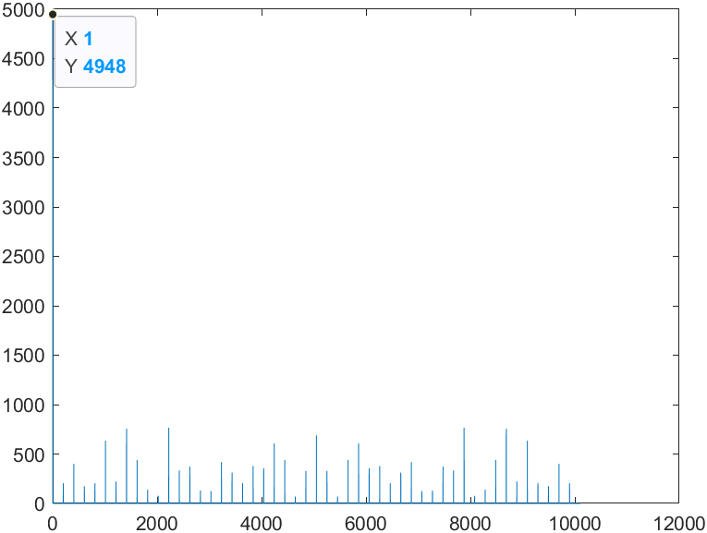%

a = rand(50,1); A = cat(1,a, a);

for i = 1:200

A = cat(1, A, a);

end

AA = fft(A); plot(abs(AA))

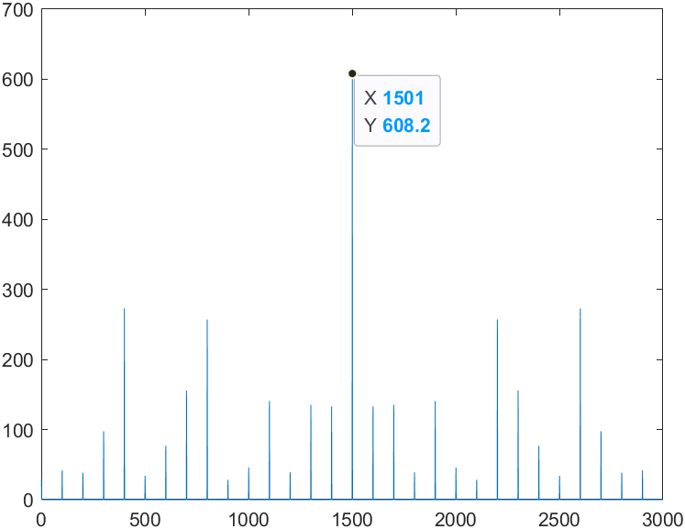%

b = rand(30,1) - 0.5; A = b;

for i = 1:99

A = cat(1, A, b);

end

AA = fft(A); plot(abs(AA));

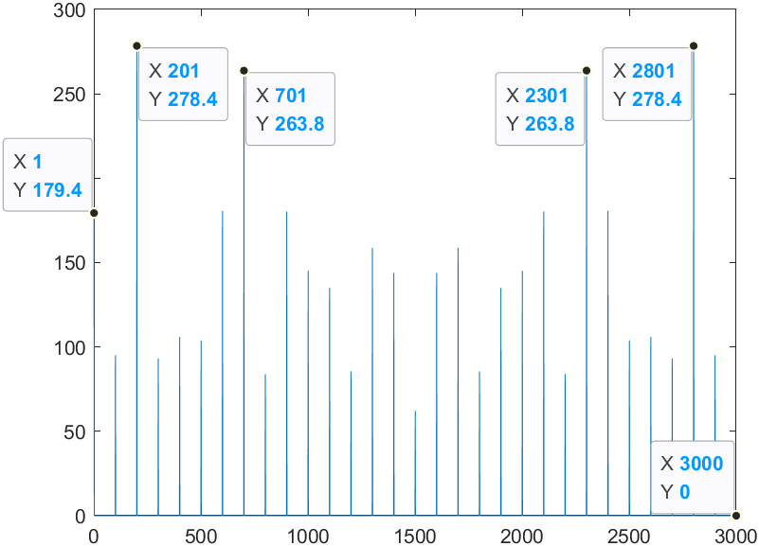%

c = rand(30,1) - 1/exp(1); A = c;

for i = 1:99

A = cat(1, A, c);

end

AA = fft(A); plot(abs(AA));

Obviously, if no constraints are put, then the locations & numbers of peak may not have an easy-to-see limitation.

If we say, $\sum_{n=0}^{T-1}{a}$ [n] = 0?　(which is followed by good enough approximation of sound waves)

%

a = randn(20,1); A = a;

for i = 1:99

A = cat(1, A, a);

end

AA = fft(A); plot(abs(AA));