<關於泛音>

% do some simple study

n = [0:10000];

bn = 0\*n;

for i = 1:10

bn = bn + sin(2 \* pi / 300 \* i \* n);

end

Bk = fft(bn);

plot(abs(Bk));

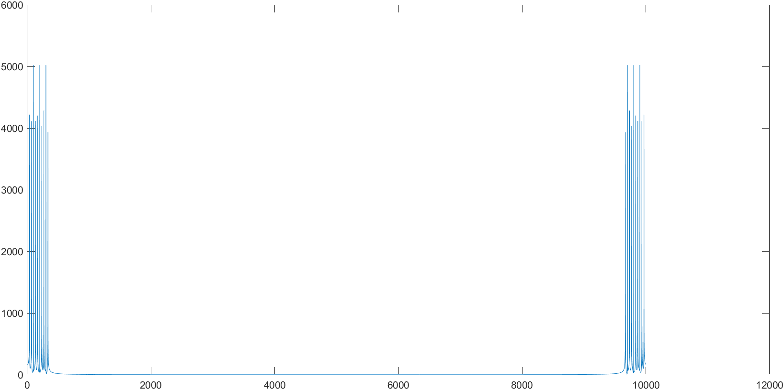

It is interesting that:

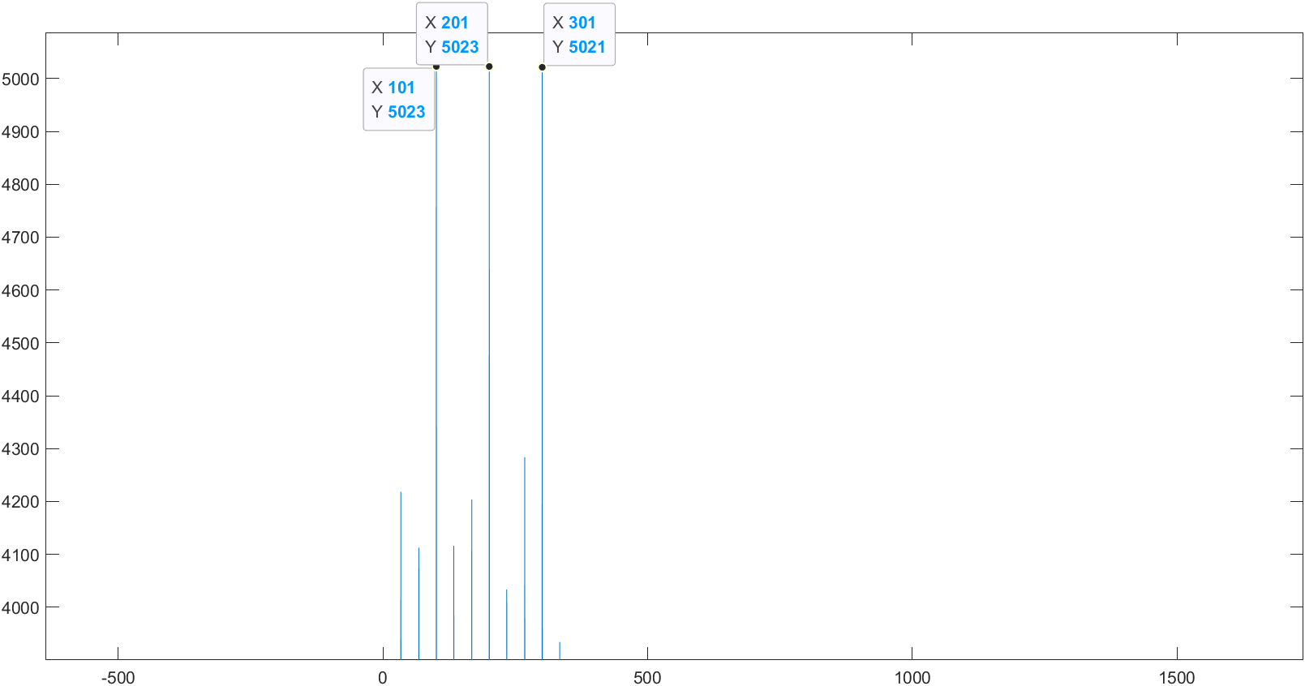

i = 1, 4, 7, 10 have deceasing amplitudes.

i = 2, 5, 8 have increasing amplitudes.

i = 3, 6, 9 have highest amplitudes compared to theirs neighbours.

If we increase range of i:

bn = 0\*n;

for i = 1:100

bn = bn + sin(2 \* pi / 300 \* i \* n);

end

Bk = fft(bn);

plot(abs(Bk));

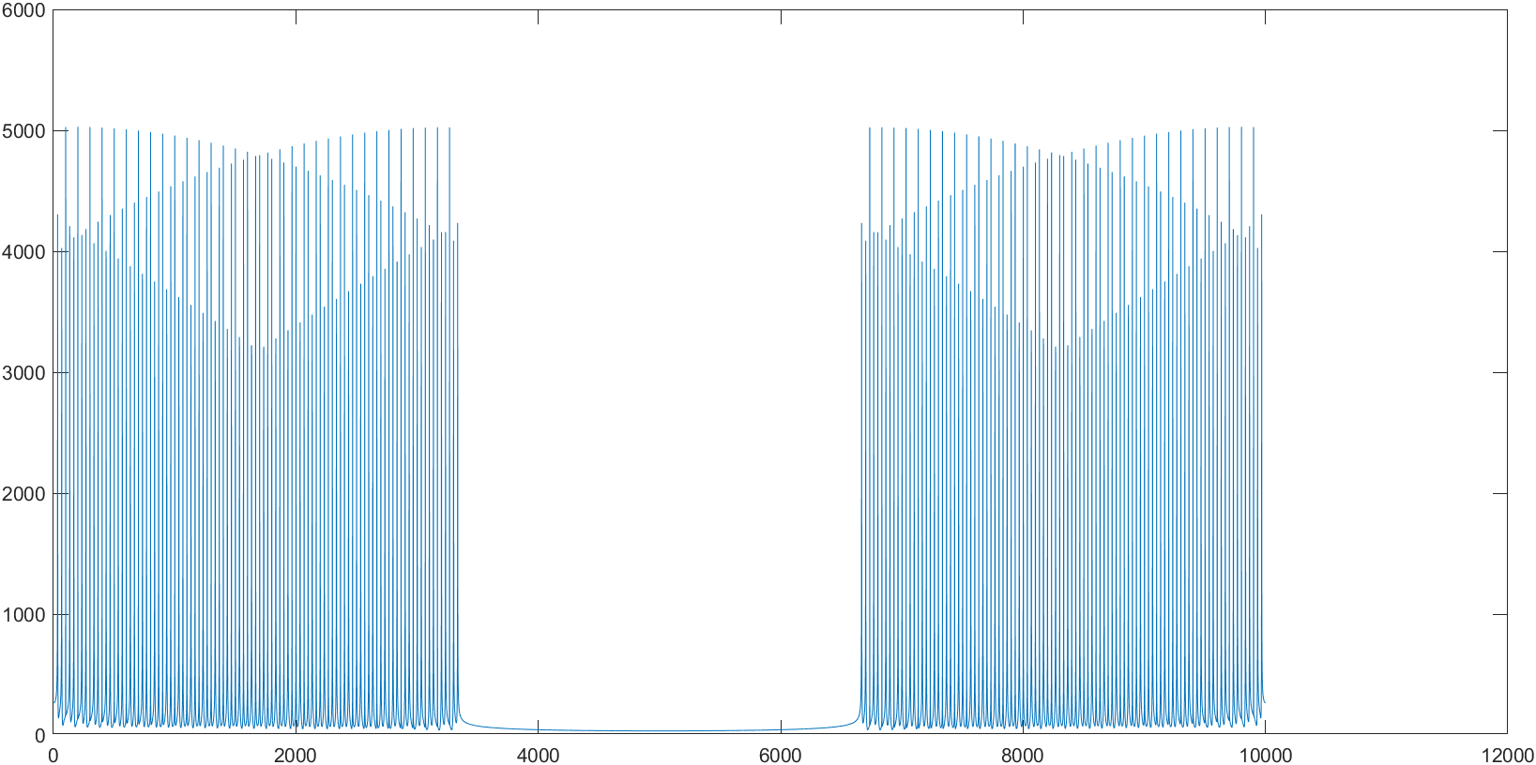

It is more clear in this plot that amplitudes are divided in to 3 groups.

Let's make a guess:

Let p be the smallest integer s.t. (T0 / p) | N, where N is # of points, T0 is the period of the lowest frequency.

(1) the 1st peak appears at i=p, i.e. among the first p amplitudes, the i=p term is their maximum.

(2) amplitudes are divided into p groups

% test

n = [0:10000];

bn = 0\*n;

for i = 1:20 % by the guess, the i=1 should be the peak

bn = bn + sin(2 \* pi / 200 \* i \* n);

end

Bk = fft(bn);

plot(abs(Bk));

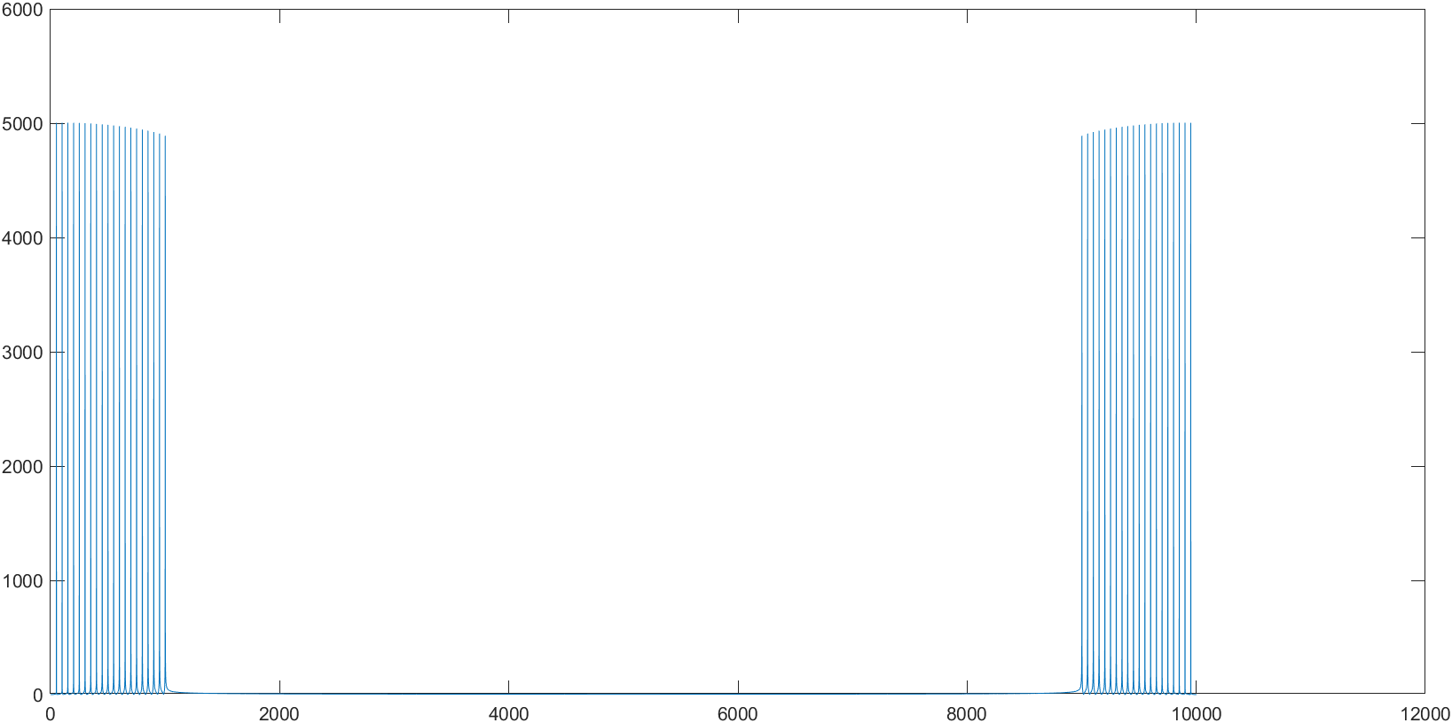

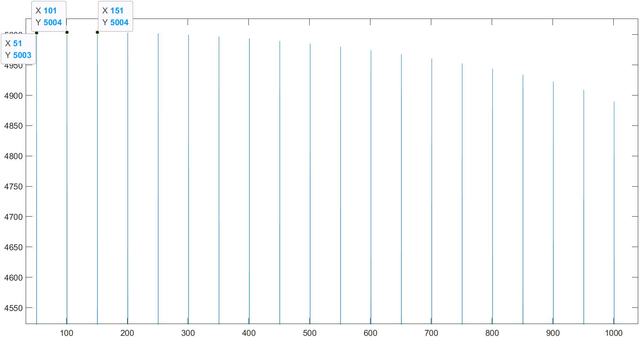

the peak is actually at i=2, 3. But i=1 has approximately same height, and the amplitudes is only divided into 1 group.

n = [0:10000];

bn = 0\*n;

for i = 1:30 % by the guess, the i=7 should be a peak

bn = bn + sin(2 \* pi / 175 \* i \* n);

end

Bk = fft(bn);

plot(abs(Bk));

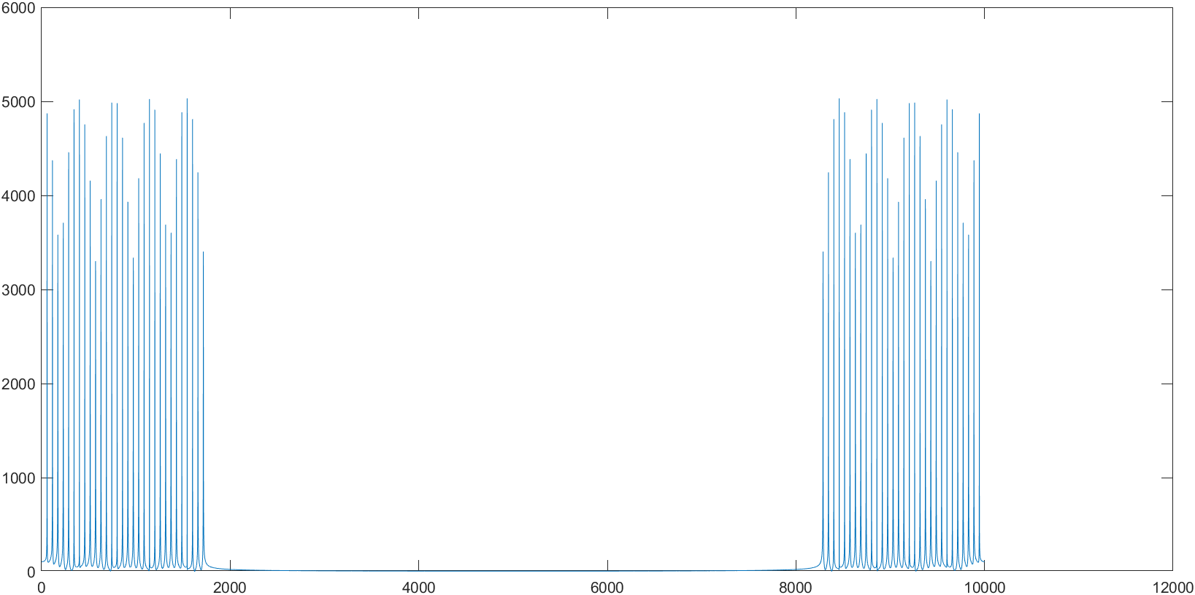

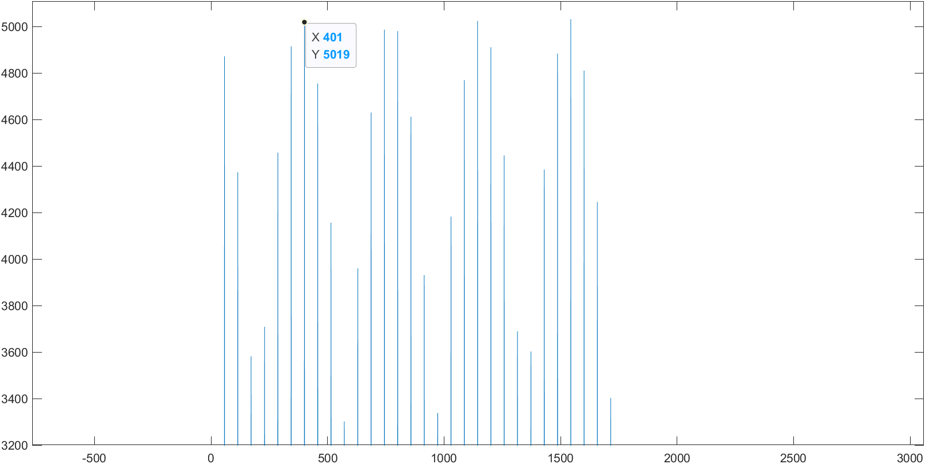

The i=7 is really a peak. Also, maybe not so obvious, it is divided into 7 groups.

