PHASE 2 RESULTS:

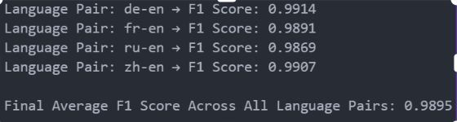



PHASE 3 RESULTS:

Task3 : speareman corelation

These are the individual language spearman Correlation

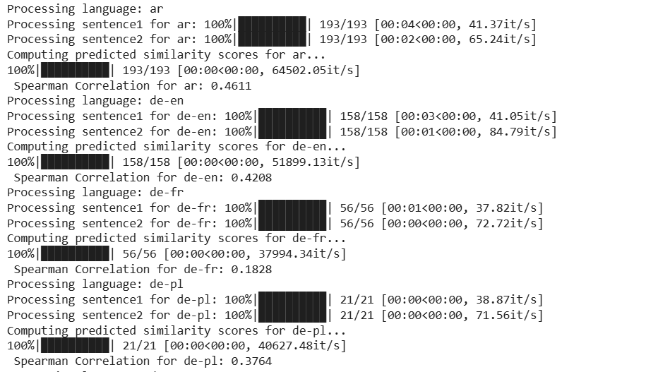

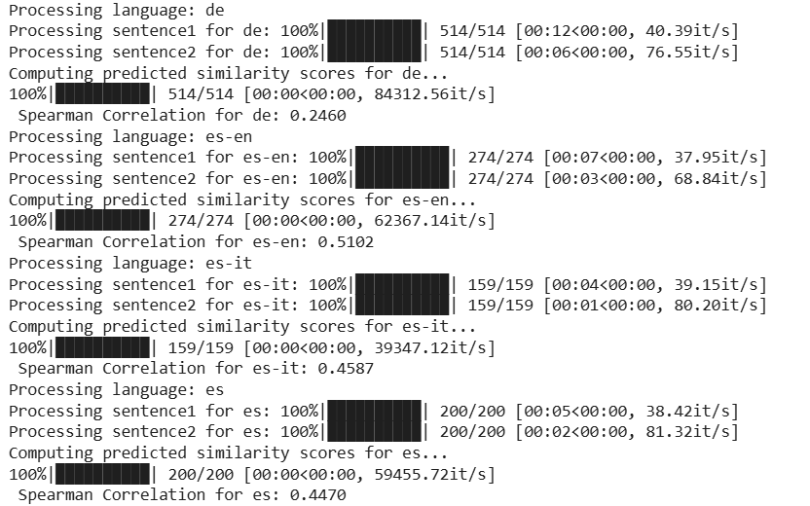

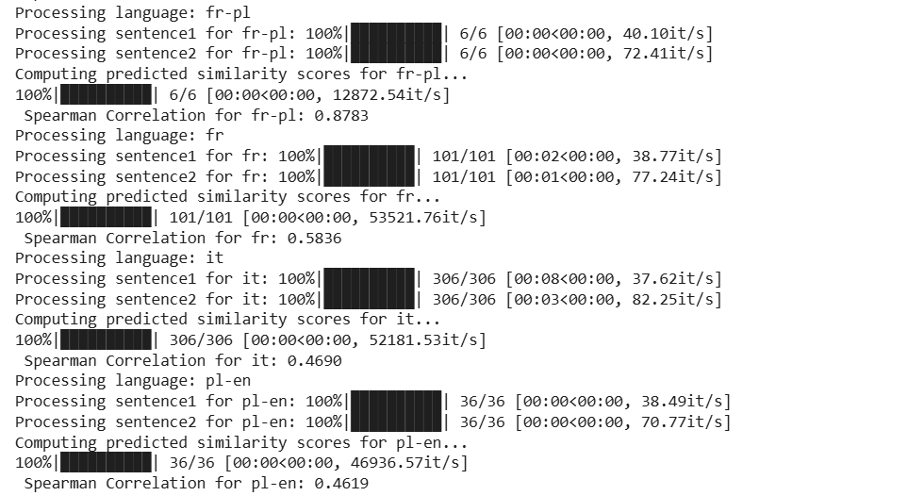

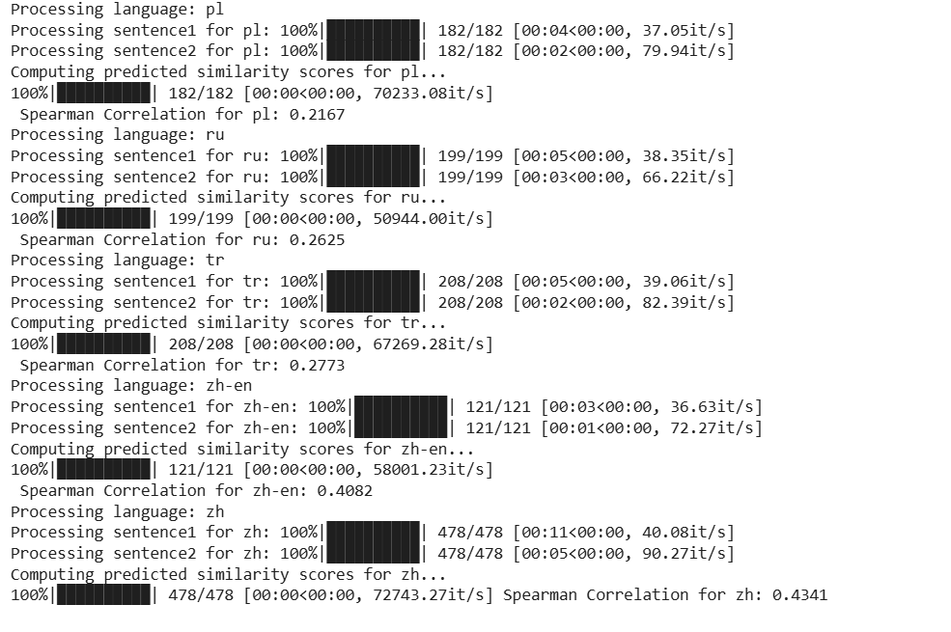

The Average Spearman Correlation

across all languages is = 0.4163

