batch随机抽样
说明：目前一个batch是当日所有股票，在计算wpcc也是对今日所有股票进行排序计算损失。为了训练模型在复杂情况下的打分能力，尝试将一个batch内的数据弄的更加丰富一些。例如随机从全样本（date，Code）中抽取1000条数据组成一个batch。

实现：主要修改了训练集的数据加载相关的代码：
def collate_train(datas):
data_X, data_y, data_time, code_value, data_liquid = [], [], [], [], []
for data in datas:
data_X.append(data[0])
data_y.append(data[1])
data_time.append(data[2])
code_value.append(data[3])
data_liquid.append(data[4])

data_X = torch.stack(data_X, dim=0)
data_y = torch.stack(data_y, dim=0)
data_liquid = torch.stack(data_liquid, dim=0)
return data_X, data_y, data_time, code_value, data_liquid

class DLDataset(torch.utils.data.Dataset):

def __init__(self, date_list, stage='train'):
self.date_list = date_list
self.stage = stage

if self.stage == 'train':
X_list, y_list, liquid_list = [], [], []
time, code_values = [], []
for date in self.date_list:
if date == 'out_sample':
continue
data = params.all_data.loc[date].copy()
data_X, data_y, code_value, data_liquid = normed_data(data, date, stage=self.stage)

# 数据处理并收集
X_list.append(torch.nan_to_num(data_X, nan=0, posinf=0, neginf=0))
y_list.append(torch.nan_to_num(data_y, nan=0, posinf=0, neginf=0).reshape(-1, 1))
liquid_list.append(torch.nan_to_num(data_liquid, nan=0, posinf=0, neginf=0).reshape(-1, 1))
time.extend([date] * len(data_y))
code_values.extend(code_value)
# 拼接
self.X = torch.cat(X_list, dim=0)
self.y = torch.cat(y_list, dim=0)
self.liquid = torch.cat(liquid_list, dim=0)
self.time = time
self.code_values = code_values
# 打乱
n = len(self.y)
perm = torch.randperm(n).tolist()

def reidx(lst):
return [lst[i] for i in perm]

self.X = reidx(self.X)
self.y = reidx(self.y)
self.liquid = reidx(self.liquid)
self.time = reidx(self.time)
self.code_values = reidx(self.code_values)

def __getitem__(self, index):
if self.stage == 'train':
return self.X[index], self.y[index], self.time[index], self.code_values[index], self.liquid[index]
else:
date = self.date_list[index]
if date == 'out_sample':
return ['out_sample'], ['out_sample'], ['out_sample'], ['out_sample'], ['out_sample']
data = params.all_data.loc[date].copy()
train_X = []
train_y = []
train_time = []

train_code_value = []
train_liquid = []
data_X, data_y, code_value, data_liquid = normed_data(data, date, stage=self.stage)
train_X.append(torch.nan_to_num(data_X, nan=0, posinf=0, neginf=0))
train_y.append(torch.nan_to_num(data_y, nan=0, posinf=0, neginf=0))
train_liquid.append(torch.nan_to_num(data_liquid, nan=0, posinf=0, neginf=0))
train_time.append(date)
train_code_value.append(code_value)
return train_X, train_y, train_time, train_code_value, train_liquid

def __len__(self):

if self.stage == 'train':
return len(self.time)
else:
return len(self.date_list)

验证：
这是800时的总数
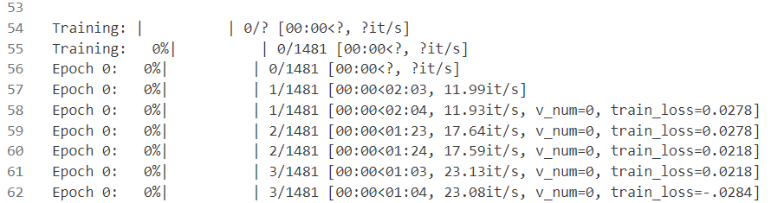
这是batchsizesize = 8000 时的总数
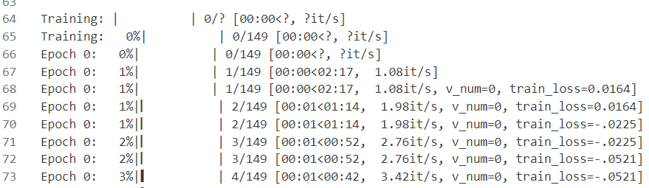
符合预期。

结果：当前一天的股票数约为3000。
batchsize | IC | ICIR | label_ret | stability | loss_train | corr | IC_mix | ICIR_mix | label_ret_mix | stability_mix
16000 | 0.1145 | 1.2166 | 0.2470 | 0.4021 | -0.3552 | 0.8030 | 0.1276 | 1.2568 | 0.2709 | 0.4448
12000 | 0.1134 | 1.1738 | 0.2422 | 0.3944 | -0.3449 | 0.8179 | 0.1271 | 1.2481 | 0.2592 | 0.4309
8000 | 0.1134 | 1.1354 | 0.2402 | 0.4010 | -0.3326 | 0.8020 | 0.1275 | 1.2431 | 0.2645 | 0.4350
4000 | 0.1134 | 1.1487 | 0.2320 | 0.3761 | -0.3384 | 0.8105 | 0.1273 | 1.2419 | 0.2609 | 0.4281
2000 | 0.1156 | 1.1738 | 0.2440 | 0.4051 | -0.3151 | 0.8108 | 0.1277 | 1.2483 | 0.2647 | 0.4311
1000 | 0.1150 | 1.1608 | 0.2544 | 0.4282 | -0.3152 | 0.8105 | 0.1276 | 1.2464 | 0.2683 | 0.4495
800 | 0.1154 | 1.1626 | 0.2541 | 0.4290 | -0.3084 | 0.8144 | 0.1276 | 1.2459 | 0.2690 | 0.4439
400 | 0.1125 | 1.1464 | 0.2314 | 0.3782 | -0.3389 | 0.7855 | 0.1276 | 1.2446 | 0.2659 | 0.4366
200 | 0.1149 | 1.1598 | 0.2340 | 0.4061 | -0.3209 | 0.7971 | 0.1279 | 1.2488 | 0.2676 | 0.4440

结论：batchsize大约为1000时效果最好

