**a. Constuct the network**

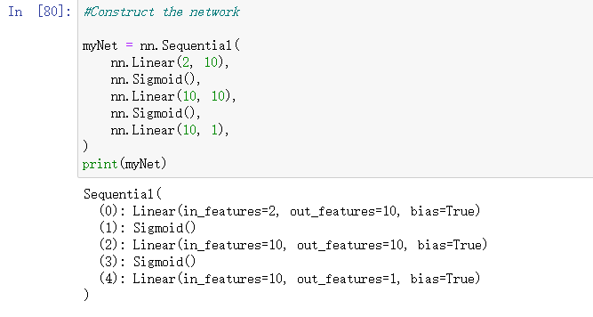

**b. Generate x and y**

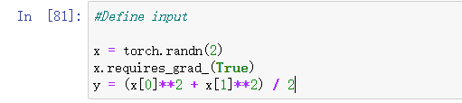

**c. Implement loss function**

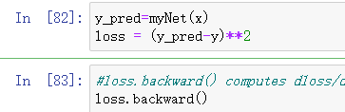

Here, loss.backward() computes dloss/dx for every parameter x which has requires_grad=True. These are accumulated into x.grad for every parameter x

**d. Get the result (will show in second page)**

**e. Without using pytorch autograd**

1. Get the list for w and b, define sigmoid function and get the list for partial derivation

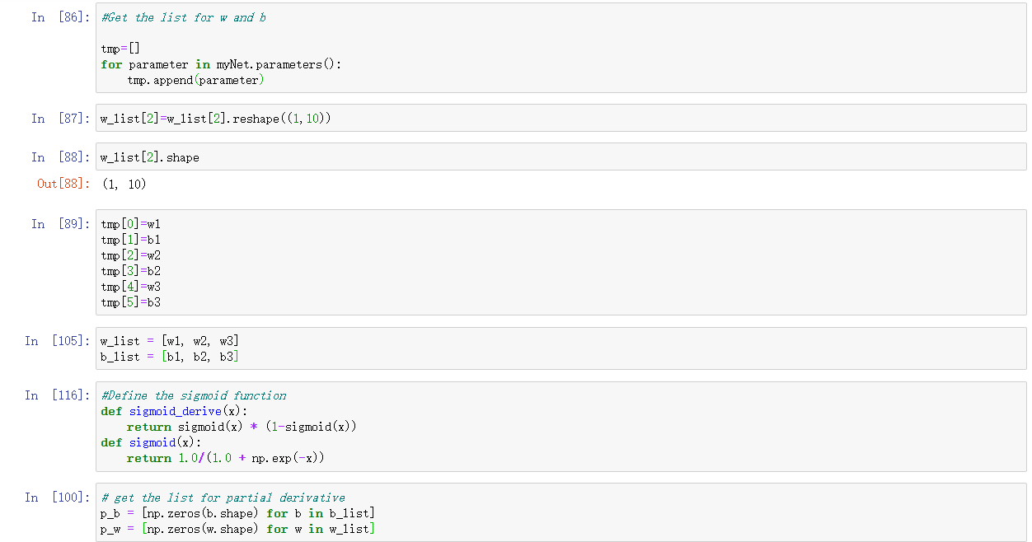

2. Perform forward propagation and compute gradient for layers

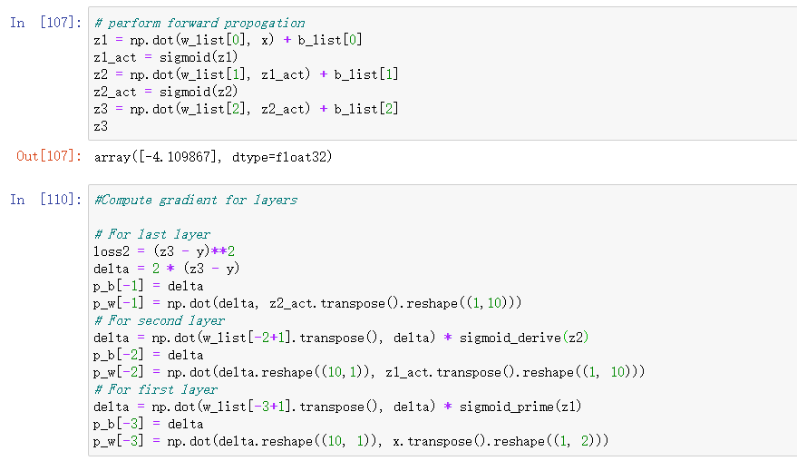

3. Compare the result

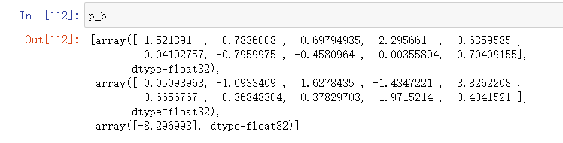

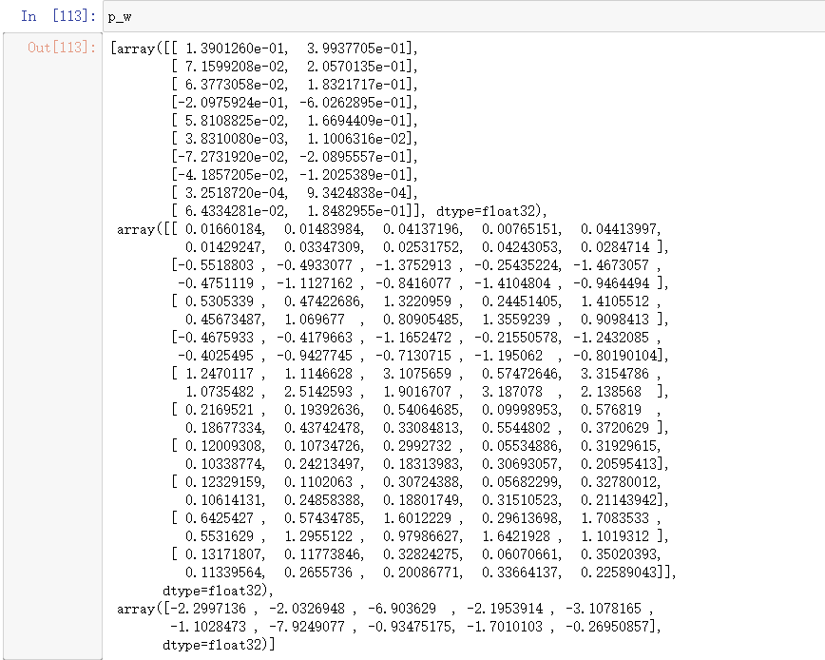

Previous result

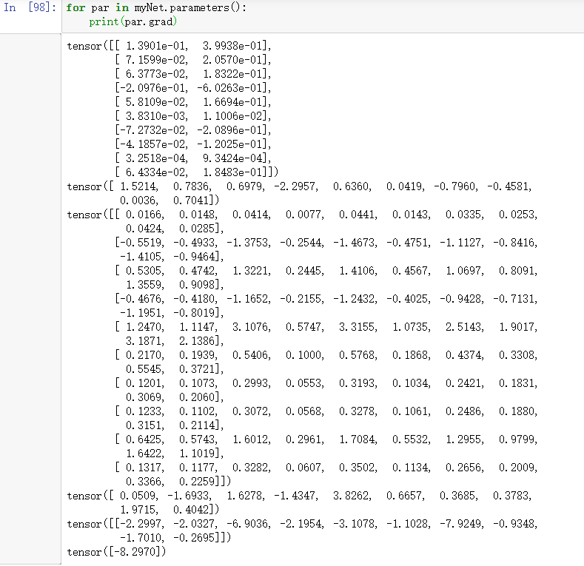

It can be seen that results are almost the same