# 报告001

## Attractions

Attraction Name List

|  |  |  |  |  |  |  |
| --- | --- | --- | --- | --- | --- | --- |
| No. | Code | Name | Address | Grade | Business Hours | Recent Flow |
| 1 | 102 | 上海国际旅游度假区 |  |  | ~ | 14287 |
| 2 | 15 | 上海世纪公园 | 浦东 | 4A | 7:00~18:00 | 5277 |
| 3 | 37 | 上海欢乐谷 | 林湖路888号 | 4A | 9:00~21:00 | 5117 |

## Chart with single data

Visitor flow chart of 上海国际旅游度假区

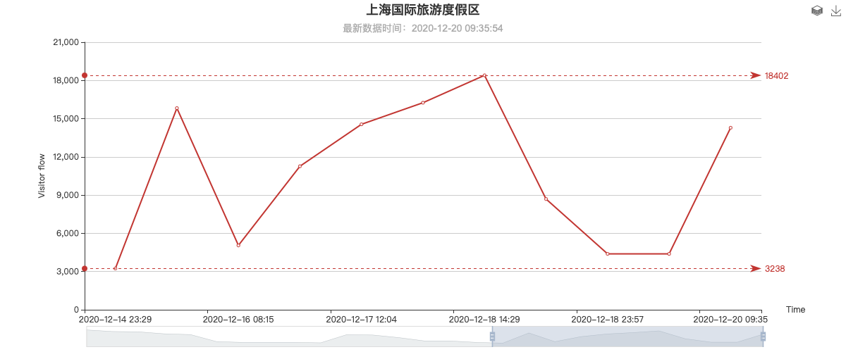

Visitor flow chart of 上海世纪公园

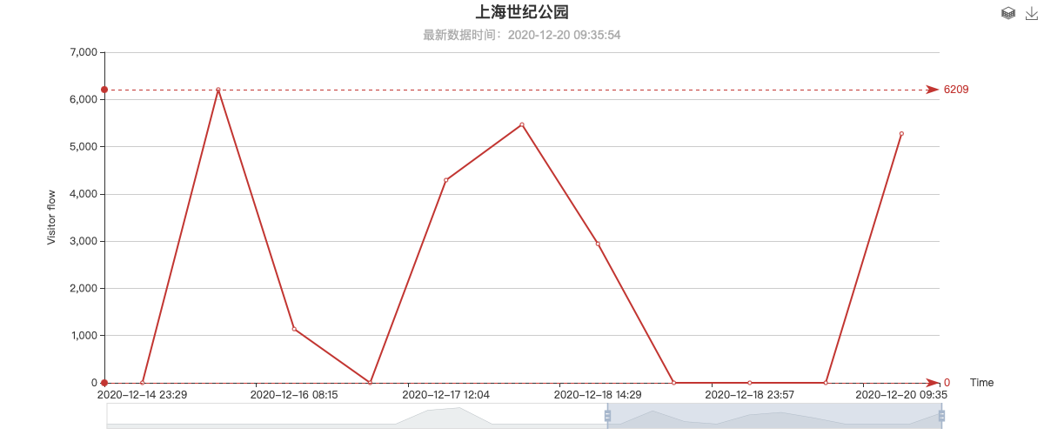

Visitor flow chart of 上海欢乐谷

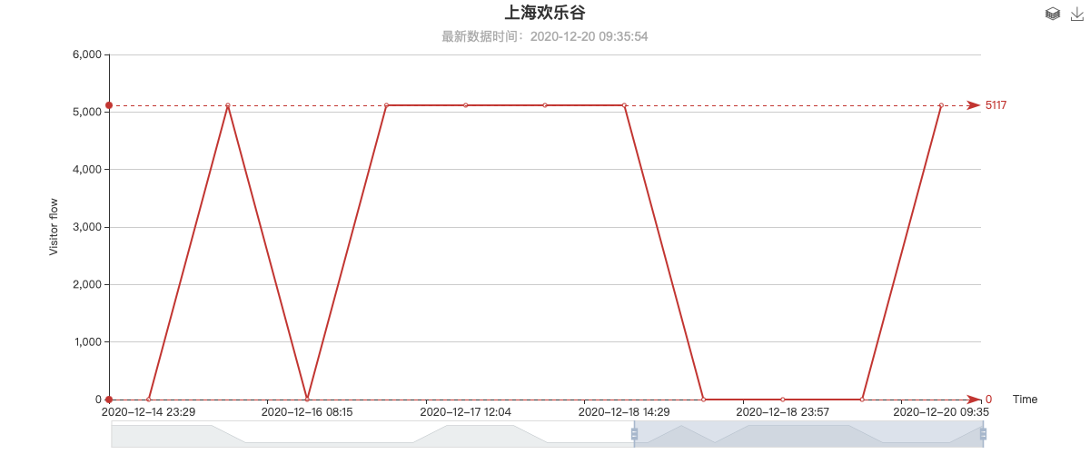

Visitor flow chart of Chart with mutiple spot data

## Multi-attraction data comparison

