# 报告002

## Attractions

Attraction Name List

|  |  |  |  |  |  |  |
| --- | --- | --- | --- | --- | --- | --- |
| No. | Code | Name | Address | Grade | Business Hours | Recent Flow |
| 1 | 102 | 上海国际旅游度假区 |  |  | ~ | 18541 |
| 2 | 37 | 上海欢乐谷 | 林湖路888号 | 4A | 9:00~21:00 | 5117 |
| 3 | 284 | 上海长泰广场 | 上海市浦东新区金科路2889弄 | 3A | 10:00~22:00 | 4969 |

## Chart with single data

Visitor flow chart of 上海国际旅游度假区

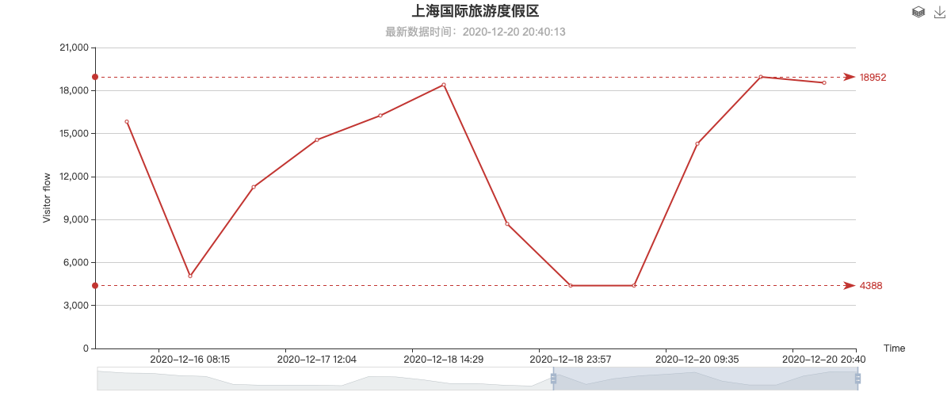

Visitor flow chart of 上海欢乐谷

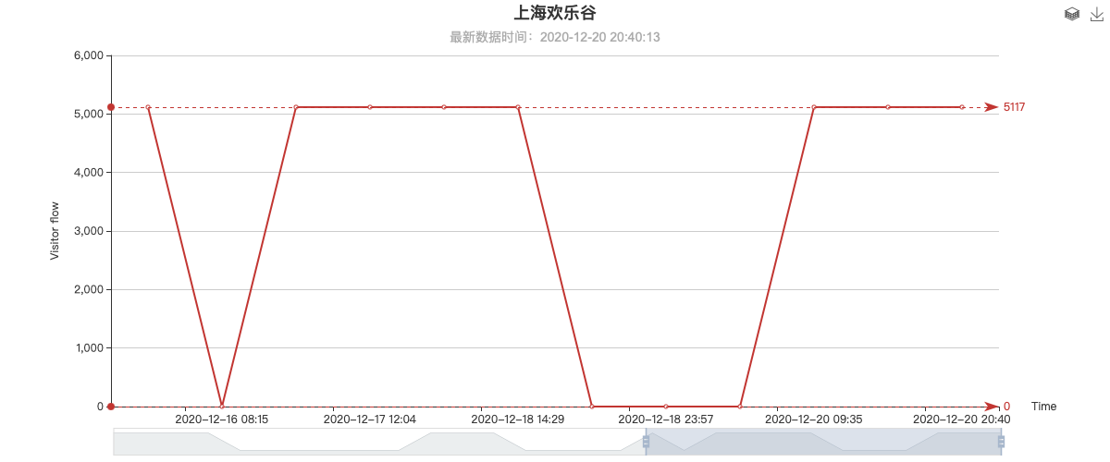

Visitor flow chart of 上海长泰广场

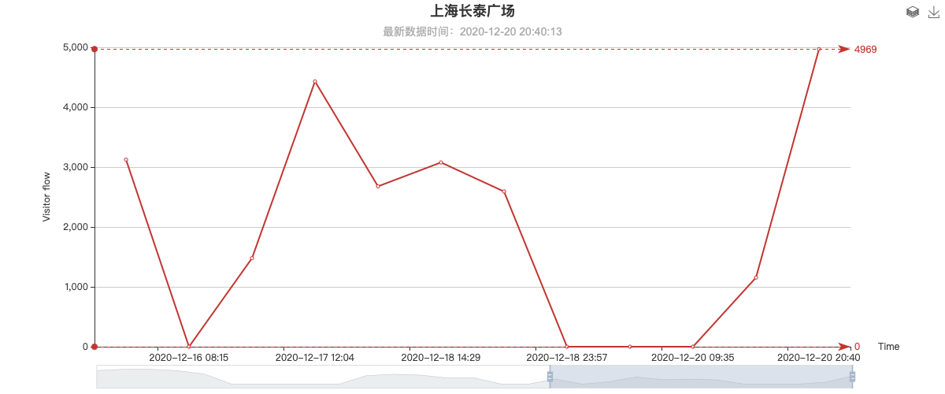

Visitor flow chart of Chart with mutiple spot data

## Multi-attraction data comparison

