# 报告003

## Attractions

Attraction Name List

|  |  |  |  |  |  |  |
| --- | --- | --- | --- | --- | --- | --- |
| No. | Code | Name | Address | Grade | Business Hours | Recent Flow |
| 1 | 102 | 上海国际旅游度假区 |  |  | ~ | 18541 |
| 2 | 37 | 上海欢乐谷 | 林湖路888号 | 4A | 9:00~21:00 | 5117 |
| 3 | 284 | 上海长泰广场 | 上海市浦东新区金科路2889弄 | 3A | 10:00~22:00 | 4969 |
| 4 | 50 | 上海汽车博览公园 | 嘉定 | 4A | 5:30~21:00 | 2199 |

## Chart with single data

Visitor flow chart of 上海国际旅游度假区

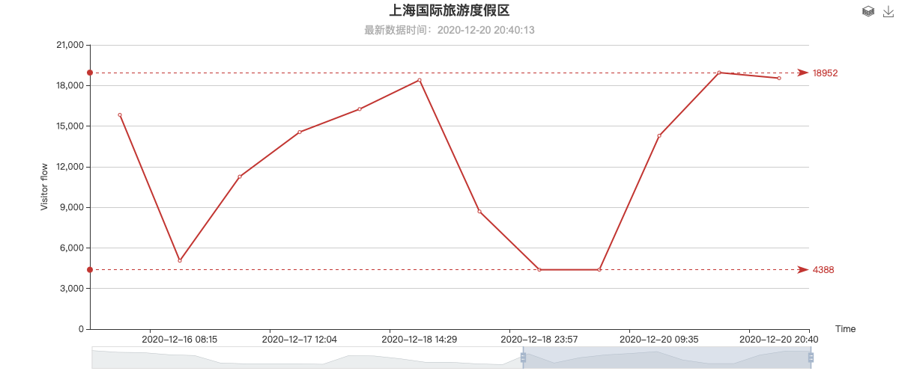

Visitor flow chart of 上海欢乐谷

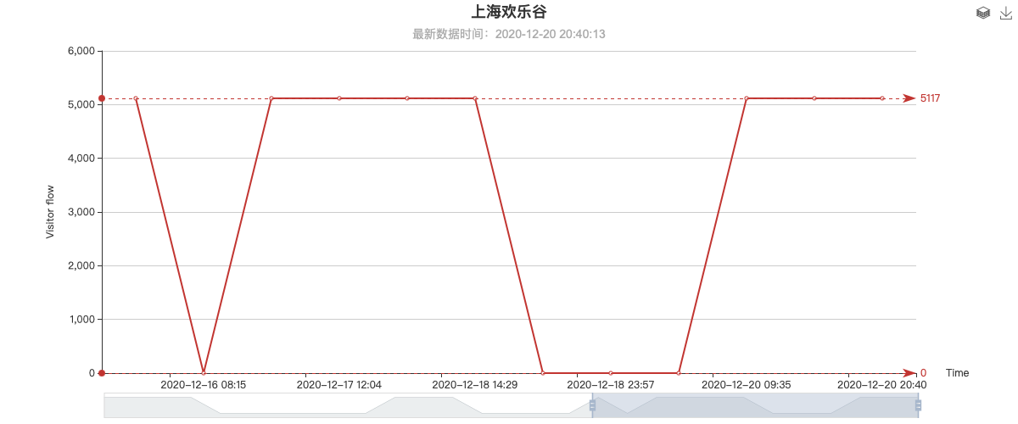

Visitor flow chart of 上海长泰广场

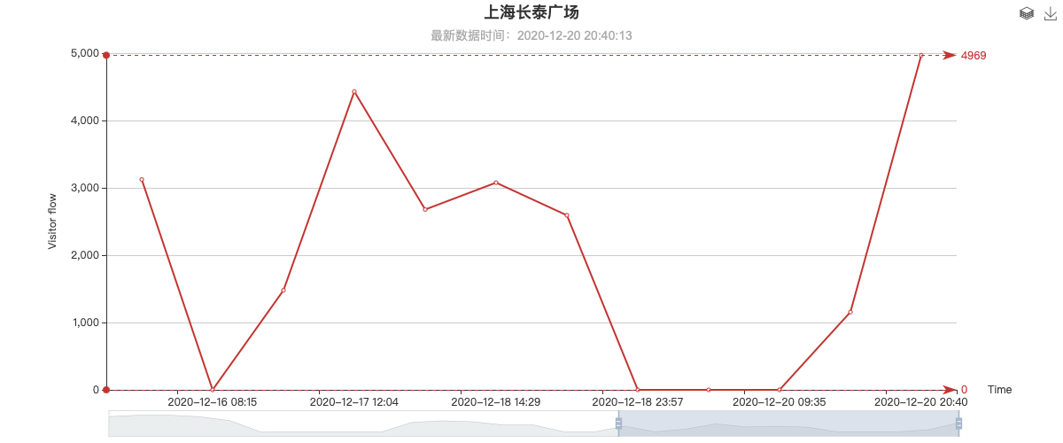

Visitor flow chart of 上海汽车博览公园

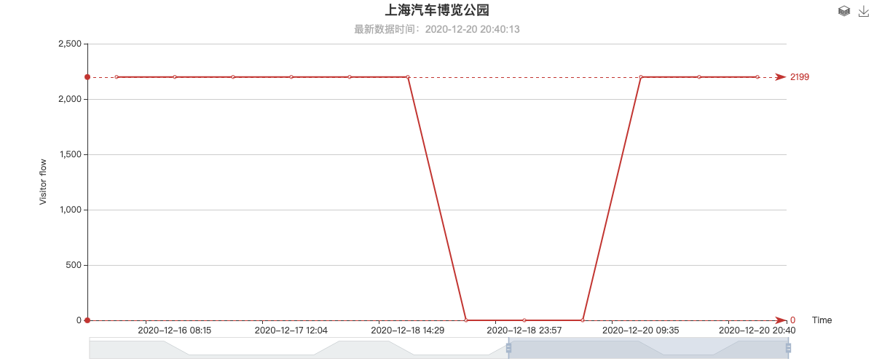

Visitor flow chart of Chart with mutiple spot data

## Multi-attraction data comparison

