南京信息工程大学 实验（实习）报告
实验（实习）名称 Linux安装和编译 日期 2021.11.22 得分 指导老师 岳键
学院 应用技术学院 专业 软件工程 年级 19软工 班次 3班 姓名 陈冰 学号 201933070085
一、实验目的
（1）理解System V IPC通信机制工作原理
（2）掌握和使用共享主存实现进程通信
（3）掌握和使用消息队列实现进程通信
（4）掌握和使用信号量实现进程同步
二、实验内容
（1）消息队列实现进程间通信
（2）信号量实现进程同步
（3）共享主存实现进程通信
三、实验步骤
（1）消息队列实现进程间通信
实验说明：利用消息队列解决客户及服务进程之间的通信问题
解决方案：服务进程进程首先需要创建一个消息队列，随后客进程可以打开消息队列，从而实现消息的发送和接收。
代码实现：
创建消息队列（msg_create.c）
#include <sys/types.h>
#include <sys/ipc.h>
#include <sys/msg.h>
#include <sys/stat.h>
#include "tlpi_hdr.h"

static void /* Print usage info, then exit */
usageError(const char *progName, const char *msg)
{
if (msg != NULL)
fprintf(stderr, "%s", msg);
fprintf(stderr, "Usage: %s [-cx] {-f pathname | -k key | -p} "
"[octal-perms]\n", progName);
fprintf(stderr, " -c Use IPC_CREAT flag\n");
fprintf(stderr, " -x Use IPC_EXCL flag\n");
fprintf(stderr, " -f pathname Generate key using ftok()\n");
fprintf(stderr, " -k key Use 'key' as key\n");
fprintf(stderr, " -p Use IPC_PRIVATE key\n");
exit(EXIT_FAILURE);
}

int
main(int argc, char *argv[])
{
int numKeyFlags; /* Counts -f, -k, and -p options */
int flags, msqid, opt;
unsigned int perms;
long lkey;
key_t key;

/* Parse command-line options and arguments */

numKeyFlags = 0;
flags = 0;

while ((opt = getopt(argc, argv, "cf:k:px")) != -1) {
switch (opt) {
case 'c':
flags |= IPC_CREAT;
break;

case 'f': /* -f pathname */
key = ftok(optarg, 1);
if (key == -1)
errExit("ftok");
numKeyFlags++;
break;

case 'k': /* -k key (octal, decimal or hexadecimal) */
if (sscanf(optarg, "%li", &lkey) != 1)
cmdLineErr("-k option requires a numeric argument\n");
key = lkey;
numKeyFlags++;
break;

case 'p':
key = IPC_PRIVATE;
numKeyFlags++;
break;

case 'x':
flags |= IPC_EXCL;
break;

default:
usageError(argv[0], "Bad option\n");
}
}

if (numKeyFlags != 1)
usageError(argv[0], "Exactly one of the options -f, -k, "
"or -p must be supplied\n");

perms = (optind == argc) ? (S_IRUSR | S_IWUSR) :
getInt(argv[optind], GN_BASE_8, "octal-perms");

msqid = msgget(key, flags | perms);
if (msqid == -1)
errExit("msgget");

printf("%d\n", msqid);
exit(EXIT_SUCCESS);
}
发送消息（send_msg.c）
#include <sys/types.h>
#include <sys/msg.h>
#include "tlpi_hdr.h"

#define MAX_MTEXT 1024

struct mbuf {
long mtype; /* Message type */
char mtext[MAX_MTEXT]; /* Message body */
};

static void /* Print (optional) message, then usage description */
usageError(const char *progName, const char *msg)
{
if (msg != NULL)
fprintf(stderr, "%s", msg);
fprintf(stderr, "Usage: %s [-n] msqid msg-type [msg-text]\n", progName);
fprintf(stderr, " -n Use IPC_NOWAIT flag\n");
exit(EXIT_FAILURE);
}

int
main(int argc, char *argv[])
{
int msqid, flags, msgLen;
struct mbuf msg; /* Message buffer for msgsnd() */
int opt; /* Option character from getopt() */

/* Parse command-line options and arguments */

flags = 0;
while ((opt = getopt(argc, argv, "n")) != -1) {
if (opt == 'n')
flags |= IPC_NOWAIT;
else
usageError(argv[0], NULL);
}

if (argc < optind + 2 || argc > optind + 3)
usageError(argv[0], "Wrong number of arguments\n");

msqid = getInt(argv[optind], 0, "msqid");
msg.mtype = getInt(argv[optind + 1], 0, "msg-type");

if (argc > optind + 2) { /* 'msg-text' was supplied */
msgLen = strlen(argv[optind + 2]) + 1;
if (msgLen > MAX_MTEXT)
cmdLineErr("msg-text too long (max: %d characters)\n", MAX_MTEXT);

memcpy(msg.mtext, argv[optind + 2], msgLen);

} else { /* No 'msg-text' ==> zero-length msg */
msgLen = 0;
}

/* Send message */

if (msgsnd(msqid, &msg, msgLen, flags) == -1)
errExit("msgsnd");

exit(EXIT_SUCCESS);
}
接收消息（msg_receive.c）
#define _GNU_SOURCE /* Get definition of MSG_EXCEPT */
#include <sys/types.h>
#include <sys/msg.h>
#include "tlpi_hdr.h"

#define MAX_MTEXT 1024

struct mbuf {
long mtype; /* Message type */
char mtext[MAX_MTEXT]; /* Message body */
};

static void
usageError(const char *progName, const char *msg)
{
if (msg != NULL)
fprintf(stderr, "%s", msg);
fprintf(stderr, "Usage: %s [options] msqid [max-bytes]\n", progName);
fprintf(stderr, "Permitted options are:\n");
fprintf(stderr, " -e Use MSG_NOERROR flag\n");
fprintf(stderr, " -t type Select message of given type\n");
fprintf(stderr, " -n Use IPC_NOWAIT flag\n");
#ifdef MSG_EXCEPT
fprintf(stderr, " -x Use MSG_EXCEPT flag\n");
#endif
exit(EXIT_FAILURE);
}

int
main(int argc, char *argv[])
{
int msqid, flags, type;
ssize_t msgLen;
size_t maxBytes;
struct mbuf msg; /* Message buffer for msgrcv() */
int opt; /* Option character from getopt() */

/* Parse command-line options and arguments */

flags = 0;
type = 0;
while ((opt = getopt(argc, argv, "ent:x")) != -1) {
switch (opt) {
case 'e': flags |= MSG_NOERROR; break;
case 'n': flags |= IPC_NOWAIT; break;
case 't': type = atoi(optarg); break;
#ifdef MSG_EXCEPT
case 'x': flags |= MSG_EXCEPT; break;
#endif
default: usageError(argv[0], NULL);
}
}

if (argc < optind + 1 || argc > optind + 2)
usageError(argv[0], "Wrong number of arguments\n");

msqid = getInt(argv[optind], 0, "msqid");
maxBytes = (argc > optind + 1) ?
getInt(argv[optind + 1], 0, "max-bytes") : MAX_MTEXT;

/* Get message and display on stdout */

msgLen = msgrcv(msqid, &msg, maxBytes, type, flags);
if (msgLen == -1)
errExit("msgrcv");

printf("Received: type=%ld; length=%ld", msg.mtype, (long) msgLen);
if (msgLen > 0)
printf("; body=%s", msg.mtext);
printf("\n");

exit(EXIT_SUCCESS);
}
运行截图：
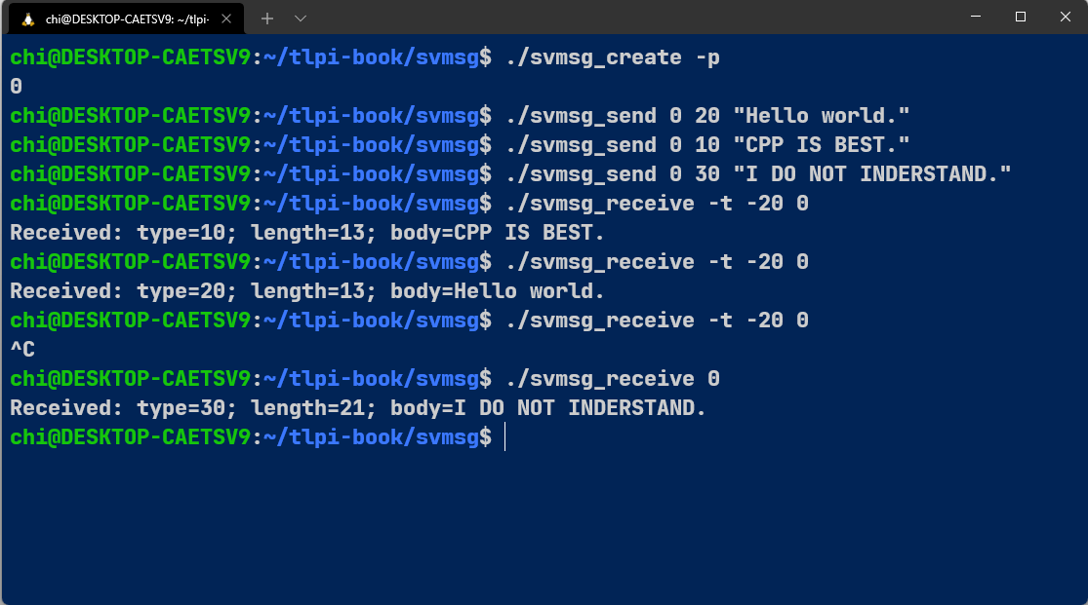
（2）信号量实现进程同步
实验说明：利用信号量解决生产者-消费者问题
解决方案：生产者-消费者问题是典型的进程同步问题，其本质是如何控制并发进程对有界共享区的访问生产者进程生产产品，然后将产品放置在一个空缓冲区中供消费者进程消费
代码实现：
生产者server.c
#include <stdio.h>
#include <string.h>
#include <stdlib.h>
#include <unistd.h>
#include <errno.h>
#include <sys/types.h>
#include <sys/ipc.h>
#include <sys/shm.h>
#include <sys/sem.h>

#include "shm_sem.h"

#if 0
struct sembuf
{
unsigned short sem_num; /*0-nsems-1*/
short sem_op; /*negative, 0, pasitive*/
short sem_flg; /*0 IPC_UNDO IPC_NOWAIT*/
}
#endif

int main(void)
{
int ret;
int shmid;
int semid;
void *ptrShm = NULL;
struct shmid_ds shm_ds;
struct semid_ds sem_ds;
char buf[1024] = {0};
union semun arg;
unsigned short semvalArr[SEM_NUM] = {1, 0};

memset(&shm_ds, 0x00, sizeof(shm_ds));
memset(&sem_ds, 0x00, sizeof(sem_ds));

/*semget*/
semid = semget((key_t)SEM_KEY, SEM_NUM, 0660 | IPC_CREAT | IPC_EXCL); /*int semget(key_t key, int nsems, int flag);*/
if (semid == -1)
{
if (errno == EEXIST) /*no need to init sem*/
{
printf("semget() warning: %s\n", strerror(errno));
semid = semget((key_t)SEM_KEY, 0, 0660 | IPC_CREAT); /*nsems can be 0 when semid already exists*/
if (semid == -1)
{
printf("semget() error: %s\n", strerror(errno));
return -1;
}
printf("semget() success. semid=[%d]\n", semid);
}
else
{
printf("semget() error: %s\n", strerror(errno));
return -1;
}
}
else /*need to init sem*/
{
printf("semget() success. semid=[%d]\n", semid);

/*semctl(): init sem, set semvalArr[0]=1 semvalArr[1]=0*/
arg.array = semvalArr;
ret = semctl(semid, 0, SETALL, arg); /*int semctl(int semid, int semnm, int cmd [, union semun arg]); semnum between 0~nsems-1*/
if (ret == -1)
{
printf("semctl() SETALL error: %s\n", strerror(errno));
printf("init sem error.\n");

/*semctl IPC_RMID*/
ret = semctl(semid, 0, IPC_RMID);
if (ret == -1)
{
printf("semctl() error: %s\n", strerror(errno));
}
printf("semctl() success. Sem is deleted.\n");
return -1;
}
printf("semget() success.\n");
}
printf("init sem success. semval[0]=[%d] semval[1]=[%d].\n", get_semval(semid, 0), get_semval(semid, 1));

/*shmget*/
shmid = shmget((key_t)SHM_KEY, SHM_SIZE, 0660 | IPC_CREAT | IPC_EXCL); /*int shmget(key_t key, size_t size, int flag);*/
if (shmid == -1)
{
if (errno == EEXIST)
{
printf("shmget() warning: %s\n", strerror(errno));
shmid = shmget((key_t)SHM_KEY, SHM_SIZE, 0660 | IPC_CREAT);
if (shmid == -1)
{
printf("shmget() error: %s\n", strerror(errno));
return -1;
}
}
else
{
printf("shmget() error: %s\n", strerror(errno));
return -1;
}
}
printf("shmget() success. shmid=[%d]\n", shmid);

/*shmat*/
ptrShm = shmat(shmid, NULL, !SHM_RDONLY); /*void *shmat(int shmid, const void *shmarr, int flag);*/
if (ptrShm == NULL)
{
printf("shmat() error: %s\n", strerror(errno));
goto FAILED;
}
printf("shmat() success.\n");

/*Begin to write*/
printf("Begin to write shared memory.\n");
while (1)
{

/*input*/
memset(&buf, 0x00, sizeof(buf));

printf("server: ");
if (fgets(buf, sizeof(buf) - 1, stdin) < 0)
{
printf("fgets() error\n");
fflush(stdin);
continue;
}
fflush(stdin);

/*P*/
ret = sem_p(semid, 0);
if (ret == -1)
{
printf("sem_p() error\n");
goto FAILED;
}

/*write into shm*/
memset(ptrShm, 0x00, SHM_SIZE);
memcpy((char *)ptrShm, buf, strlen(buf));

/*V*/
ret = sem_v(semid, 1);
if (ret == -1)
{
printf("sem_v() error\n");
goto FAILED;
}
if (memcmp(buf, "exit", 4) == 0)
{
break;
}
}

/*shmdt*/
ret = shmdt(ptrShm);
if (ret == -1)
{
printf("shmdt() error: %s\n", strerror(errno));
}
printf("shmdt() success.\n");

return 0;

FAILED:
/*shmctl IPC_RMID*/
ret = shmctl(shmid, IPC_RMID, &shm_ds);
if (ret == -1)
{
printf("shmctl() error: %s\n", strerror(errno));
}
printf("shmctl() success. Shm is deleted.\n");

/*semctl IPC_RMID*/
ret = semctl(semid, 0, IPC_RMID);
if (ret == -1)
{
printf("semctl() error: %s\n", strerror(errno));
}
printf("semctl() success. Sem is deleted.\n");

return -1;
}
消费者client.c
#include <stdio.h>
#include <string.h>
#include <stdlib.h>
#include <unistd.h>
#include <errno.h>
#include <sys/types.h>
#include <sys/ipc.h>
#include <sys/shm.h>
#include <sys/sem.h>

#include "shm_sem.h"

int main(void)
{
int ret;
int shmid;
int semid;
void *ptrShm = NULL;
struct shmid_ds shm_ds;
struct semid_ds sem_ds;
char buf[1024] = {0};
union semun arg;
unsigned short semvalArr[SEM_NUM];

memset(&shm_ds, 0x00, sizeof(shm_ds));
memset(&sem_ds, 0x00, sizeof(sem_ds));

/*semget*/
semid = semget((key_t)SEM_KEY, SEM_NUM, 0660 | IPC_CREAT | IPC_EXCL); /*int semget(key_t key, int nsems, int flag);*/
if (semid == -1)
{
if (errno == EEXIST) /*no need to init sem*/
{
printf("semget() warning: %s\n", strerror(errno));
semid = semget((key_t)SEM_KEY, 0, 0660 | IPC_CREAT); /*nsems can be 0 when semid already exists*/
if (semid == -1)
{
printf("semget() error: %s\n", strerror(errno));
return -1;
}
printf("semget() success. semid=[%d]\n", semid);
}
else
{
printf("semget() error: %s\n", strerror(errno));
return -1;
}
}
else /*need to init sem*/
{
printf("semget() success. semid=[%d]\n", semid);

/*semctl(): init sem, set semvalArr[0]=1 semvalArr[1]=0*/
semvalArr[0] = (unsigned short)1;
semvalArr[1] = (unsigned short)0;
arg.array = semvalArr;
ret = semctl(semid, 0, SETALL, arg); /*int semctl(int semid, int semnm, int cmd [, union semun arg]); semnum between 0~nsems-1*/
if (ret == -1)
{
printf("semctl() SETALL error: %s\n", strerror(errno));
printf("init sem error.\n");

/*semctl IPC_RMID*/
ret = semctl(semid, 0, IPC_RMID);
if (ret == -1)
{
printf("semctl() error: %s\n", strerror(errno));
}
printf("semctl() success. Sem is deleted.\n");
return -1;
}
printf("semget() success.\n");
}
printf("semval[0]=[%d] semval[1]=[%d].\n", get_semval(semid, 0), get_semval(semid, 1));

/*shmget*/
shmid = shmget((key_t)SHM_KEY, SHM_SIZE, 0660 | IPC_CREAT | IPC_EXCL); /*int shmget(key_t key, size_t size, int flag);*/
if (shmid == -1)
{
if (errno == EEXIST)
{
printf("shmget() warning: %s\n", strerror(errno));
shmid = shmget((key_t)SHM_KEY, SHM_SIZE, 0660 | IPC_CREAT);
if (shmid == -1)
{
printf("shmget() error: %s\n", strerror(errno));
return -1;
}
}
else
{
printf("shmget() error: %s\n", strerror(errno));
return -1;
}
}
printf("shmget() success. shmid=[%d]\n", shmid);

/*shmat*/
ptrShm = shmat(shmid, NULL, SHM_RDONLY); /*void *shmat(int shmid, const void *shmarr, int flag);*/
if (ptrShm == NULL)
{
printf("shmat() error: %s\n", strerror(errno));
goto FAILED;
}
printf("shmat() success.\n");
printf("Begin to read shared memory.\n");

//防止消费者在生产者之前启动，导致死锁
while (1)
{
/*test semvalArr[0]*/
ret = get_semval(semid, 1);
if (ret < 0) /**/
{
printf("get_semval() error.\n");
goto FAILED;
}
else if (ret == 0) /*It suggests that the server hasn't start yet*/
continue;
else
break;
}

/*Begin to read*/
while (1)
{
/*P*/
ret = sem_p(semid, 1);
if (ret == -1)
{
printf("sem_p() error\n");
goto FAILED;
}

/*read shm*/
memset(&buf, 0x00, sizeof(buf));
memcpy(buf, (char *)ptrShm, sizeof(buf));

/*V*/
ret = sem_v(semid, 0);
if (ret == -1)
{
printf("sem_v() error\n");
goto FAILED;
}

printf("client: %s", buf);
if (buf[0] == '\0')
printf("\n");

if (memcmp(buf, "exit", 4) == 0)
{
break;
}
}

/*shmdt*/
ret = shmdt(ptrShm);
if (ret == -1)
{
printf("shmdt() error: %s\n", strerror(errno));
}
printf("shmdt() success.\n");

/*shmctl IPC_RMID*/
ret = shmctl(shmid, IPC_RMID, &shm_ds);
if (ret == -1)
{
printf("shmctl() error: %s\n", strerror(errno));
}
printf("shmctl() success. Shm is deleted.\n");

/*semctl IPC_RMID*/
ret = semctl(semid, 0, IPC_RMID);
if (ret == -1)
{
printf("semctl() error: %s\n", strerror(errno));
}
printf("semctl() success. Sem is deleted.\n");

return 0;

FAILED:
/*shmctl IPC_RMID*/
ret = shmctl(shmid, IPC_RMID, &shm_ds);
if (ret == -1)
{
printf("shmctl() error: %s\n", strerror(errno));
}
printf("shmctl() success. Shm is deleted.\n");

/*semctl IPC_RMID*/
ret = semctl(semid, 0, IPC_RMID);
if (ret == -1)
{
printf("semctl() error: %s\n", strerror(errno));
}
printf("semctl() success. Sem is deleted.\n");

return -1;
}
运行截图：
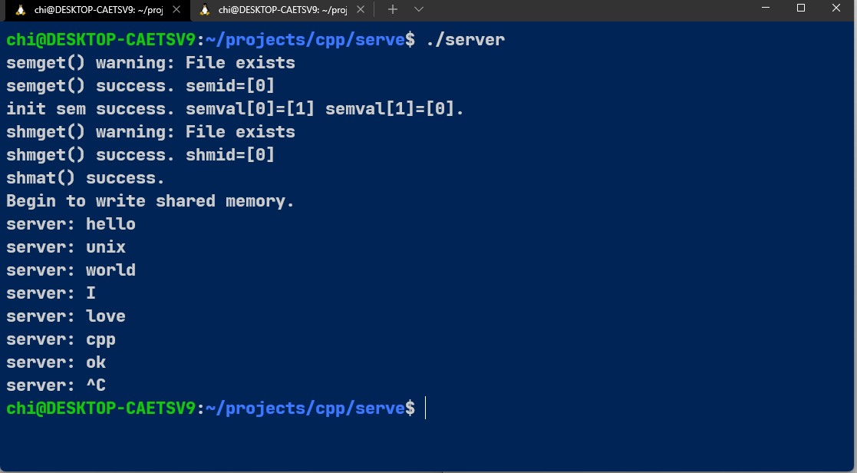
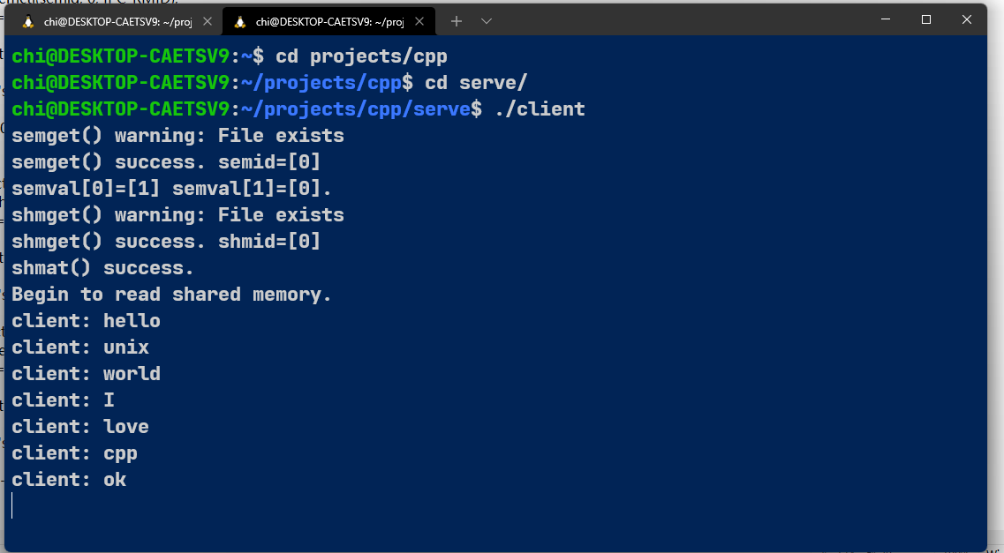
（3）共享主存实现进程通信
利用共享主存解决读者-写问题、要求由写者创建一个共享注册呢，并向其中写入数据，读者进程随后从改共享区中访问数据
代码实现
读者read.c
#include <unistd.h>
#include <stdlib.h>
#include <string.h>
#include <stdio.h>
#include <sys/shm.h>
#include "shmdata.h"

int main()
{
int running = 1; //程序是否继续运行的标志
void *shm = NULL; //分配的共享内存的原始首地址
struct shared_use_st *shared; //指向shm
int shmid; //共享内存标识符
//创建共享内存
shmid = shmget((key_t)1234, sizeof(struct shared_use_st), 0666 | IPC_CREAT);
if (shmid == -1)
{
fprintf(stderr, "shmget failed\n");
exit(EXIT_FAILURE);
}
//将共享内存连接到当前进程的地址空间
shm = shmat(shmid, 0, 0);
if (shm == (void *)-1)
{
fprintf(stderr, "shmat failed\n");
exit(EXIT_FAILURE);
}
printf("\nMemory attached at %ld\n", (intptr_t)(int *)shm);
//设置共享内存
shared = (struct shared_use_st *)shm;
shared->written = 0;
while (running) //读取共享内存中的数据
{
//没有进程向共享内存定数据有数据可读取
if (shared->written != 0)
{
printf("You wrote: %s", shared->text);
sleep(rand() % 3);
//读取完数据，设置written使共享内存段可写
shared->written = 0;
//输入了end，退出循环（程序）
if (strncmp(shared->text, "end", 3) == 0)
running = 0;
}
else //有其他进程在写数据，不能读取数据
sleep(1);
}
//把共享内存从当前进程中分离
if (shmdt(shm) == -1)
{
fprintf(stderr, "shmdt failed\n");
exit(EXIT_FAILURE);
}
//删除共享内存
if (shmctl(shmid, IPC_RMID, 0) == -1)
{
fprintf(stderr, "shmctl(IPC_RMID) failed\n");
exit(EXIT_FAILURE);
}
exit(EXIT_SUCCESS);
}
写write.c
#include <unistd.h>
#include <stdlib.h>
#include <stdio.h>
#include <string.h>
#include <sys/shm.h>
#include "shmdata.h"

int main()
{
int running = 1;
void *shm = NULL;
struct shared_use_st *shared = NULL;
char buffer[BUFSIZ + 1]; //用于保存输入的文本
int shmid;
//创建共享内存
shmid = shmget((key_t)1234, sizeof(struct shared_use_st), 0666 | IPC_CREAT);
if (shmid == -1)
{
fprintf(stderr, "shmget failed\n");
exit(EXIT_FAILURE);
}
//将共享内存连接到当前进程的地址空间
shm = shmat(shmid, (void *)0, 0);
if (shm == (void *)-1)
{
fprintf(stderr, "shmat failed\n");
exit(EXIT_FAILURE);
}
printf("Memory attached at %ld\n", (intptr_t)(int *)shm);
//设置共享内存
shared = (struct shared_use_st *)shm;
while (running) //向共享内存中写数据
{
//数据还没有被读取，则等待数据被读取,不能向共享内存中写入文本
while (shared->written == 1)
{
sleep(1);
printf("Waiting...\n");
}
//向共享内存中写入数据
printf("Enter some text: ");
fgets(buffer, BUFSIZ, stdin);
strncpy(shared->text, buffer, TEXT_SZ);
//写完数据，设置written使共享内存段可读
shared->written = 1;
//输入了end，退出循环（程序）
if (strncmp(buffer, "end", 3) == 0)
running = 0;
}
//把共享内存从当前进程中分离
if (shmdt(shm) == -1)
{
fprintf(stderr, "shmdt failed\n");
exit(EXIT_FAILURE);
}
sleep(2);
exit(EXIT_SUCCESS);
}
运行截图：
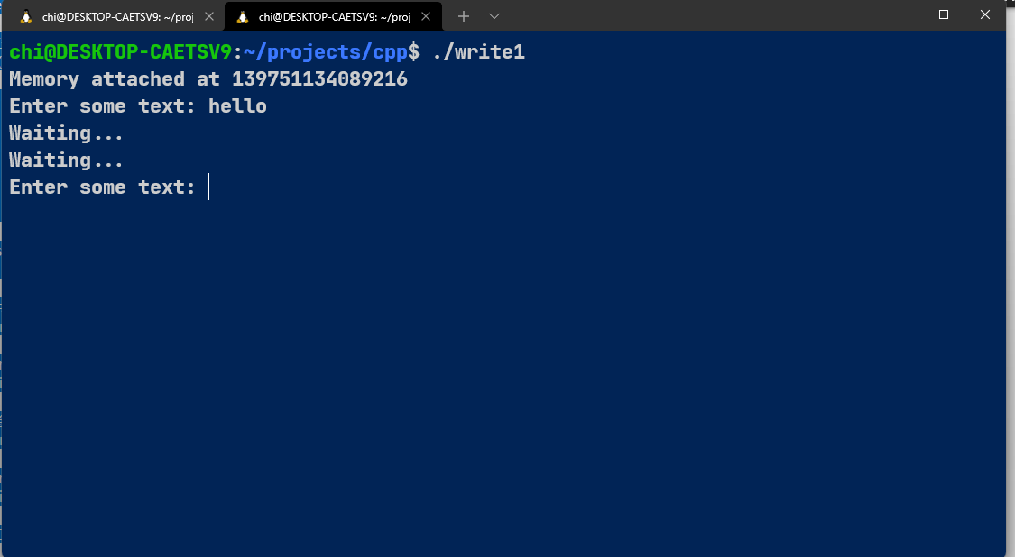
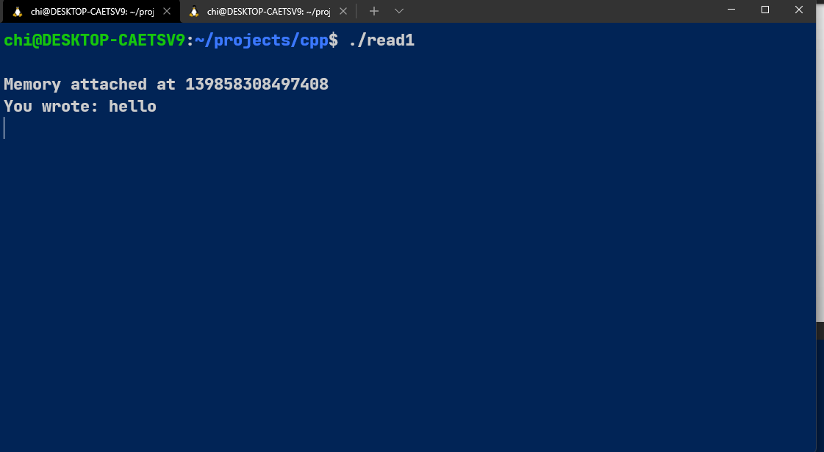
四、实验小结
System V 信号量允许进程同步它们的动作。这在当一个进程必须要获取对某些共享资源
（如一块共享内存区域）的互斥性访问时是比较有用的。
信号量的创建和操作是以集合为单位的，一个集合包含一个或多个信号量。集合中的每
个信号量都是一个整数，其值永远大于或等于0。semop()系统调用允许调用者在一个信号量
上加上一个整数、从一个信号量中减去一个整数、或等待一个信号量等于0。后两个操作可能
会导致调用者阻塞。
信号量实现无需对一个新信号量集中的成员进行初始化，因此应用程序就必须要在创建
完之后对它们进行初始化。当一些地位平等的进程中任意一个进程试图创建和初始化信号量
时就需要特别小心以防止因这两个步骤是通过单独的系统调用来完成的而可能出现的竞争
条件。

