**A Portfolio**

**to enhance your skills**

**Application on**

**Innovation Smart Systems – ISS**

Overview

Part A: GENERALITY 2

Part B: DESCRIPTIVE PART 5

Part C: TECHNICAL PART 12

Part D: ANALYTICAL PART 17

Annexes 18

# Part A: GENERALITY

A.I. PRESENTATION of PORTFOLIO

This document must make explicit with reference to the competency framework of this training, the knowledge and skills acquired by your experiences. It revolves around three modes of demonstration of your experience:

1. a descriptive part about your experiences connected to this training; the expected level of description is not a simple enumeration of tasks or facts but a real appreciation of the context in which you carried out these activities.

2. a technical part based on the presentation of problem situations demonstrating all of your knowledge in the field of this training

3. an analytical part that will be the result of the work carried out and which will present all the skills acquired.

In addition to the supporting documents requested, any other document that you consider relevant may be attached to the portfolio

The portfolio will be submitted to the jury. An oral defense of your portfolio and an exchange will be held with the same jury that will seek the adequacy between your achievements and the requirements of this training.

The construction of this portfolio, through the work of explanation, taking back and projection it requires, is a real training project.

*We hope that this new experience is for you the most interesting possible.*

A.II. Some recommendations:

The elements of this portfolio are recorded over time, they are the result of a process that is consistent throughout the training but may incorporate earlier elements.

Be specific and append significant documents.

Focus on the diversity of the documents presented (media, publication, observation report, etc.) and the multiplicity of sources of information (peers, training managers, etc.).

The points listed constitute a possible frame but can be adapted to the situation of each one.

Do not hesitate to seek advice and support from your teachers to formalize this portfolio.

A.III. GLOSSARY

This glossary is provided to help you identify the relevance of certain concepts to your learning.

* **Acquired experience:** various types of resources (theoretical and technological knowledge, knowledge of the professional context, operational know-how, intellectual approaches ...) that have been acquired through the exercise of activities during your career. The term "acquired" means that they result from learning and are not innate dispositions or personality traits.
* **Theoretical and technological knowledge:** knowledge (concepts, laws, theories, operating modes ...) to understand, analyze or interpret a situation, a phenomenon, a problem and to communicate with a specialist in the field. It may be the knowledge of operating modes but not the ability to implement them. This knowledge is expressed in terms of content.

Examples: electronic circuits, resistance of materials, construction technology, genetic engineering, differential equations, technical regulations ...

* **Operational skills:** ability to use instruments, techniques, methods or procedures. They express themselves with action verbs.

Examples: designing a heat exchanger for a given application, using a CAD software, defining a network configuration, performing a microbial count, conducting a problem study meeting, giving a presentation explaining a research project, working in a team and in network ...

* **Relational skills:** the different ways of being, specific to a personality, adapted to a given situation in order to cooperate effectively with others. This know-how is expressed by the verbs "to be or to have" or by verbs of the relational field.

Examples: being communicative, being creative, having a team spirit, having a sense of listening ...

* **Competences:** set of resources acquired by a subject to act appropriately in a field of constraints and resources (technical, human, financial, logistical, temporal, ...) for a specific issue.
* **Tasks:** sequence of manual and intellectual operations constituting a basic unit of work. An activity groups together several tasks for a given mission. A job is described from a list of activities.

Examples: employment: production manager; mission: to ensure the manufacture of a product; activity: driving a production line; tasks: establish the chronology of the production steps / write the data sheets / manage the supply of production / ensure the operational safety of the production system.

A.IV. PRESENTATION OF Your CURRICULUM

*A.III.1. IDENTIFICATION*

**Personal Information:**

Last name First Name: Chen Ting

Age: 22 years old

Mail: [t_chen@etud.insa-toulouse.fr](mailto:t_chen@etud.insa-toulouse.fr)

*A.III.2. CURRICULUM VITAE*

It is a question of adding in the body of the file your synthetic CV (1 page) allowing a global vision of your course.

*A.III.3. YOUR ACQUIRED TRAINING*

This part must explain in as much detail as possible your training course.

**Quote trainings or lessons most related to the PTP**

|  |  |  |  |
| --- | --- | --- | --- |
| **Entitled** | **Organism** | **Year** | **Duration (in number of hours)** |
| **Smart Devices** | **INSA** | **5th** | **60.25** |
| Sensors Introduction |  |  | 11.25 |
| Microcontroller and Open-Source Hardware (M&OSH) |  |  | 27.5 |
| Optical Sensors |  |  | 7.5 |
| CDA, manufacturing and integration of nanotechnology sensors |  |  | 14 |
| **Communication** | **INSA** | **5th** | **63.75** |
| Protocol for Connected Objects |  |  | 33.25 |
| Digital Wireless Communication for Connected Objects |  |  | 5 |
| Energy for Connected Objects (recovery, transfer) |  |  | 7.5 |
| Security for Network of connected objects |  |  | 7.5 |
| Emerging Network (SDN, NGN) |  |  | 10.5 |
| **Middleware and Service** | **INSA** | **5th** | **62** |
| Service Architecture |  |  | 31 |
| Middleware for Internet of Things |  |  | 14.75 |
| Adaptability: Cloud and automatic management |  |  | 16.25 |
| **Analysis and Data Processing, Business Applications** | **INSA** | **5th** | **37.5** |
| Software Engineering |  |  | 6.25 |
| Semantic Data |  |  | 8 |
| Big Data |  |  | 15 |
| SPOC/Hackathon/Seminaries |  |  | 8.25 |
| **Innovative project** | **INSA** | **5th** | **80.75** |
| Innovative project |  |  | 37.75 |
| Portfolio |  |  | 8.25 |
| English |  |  | 35 |
| **Innovation and Humanity** | **INSA** | **5th** | **95.5** |
| Innovation/Social Acceptability/Business Development |  |  | 20 |
| Creativity Methods/TRIZ Method |  |  | 20.5 |
| Team Management |  |  | 20 |
| Sport |  |  | 25 |
| Individualized Professional Development |  |  | 10 |

# Part B: DESCRIPTIVE PART

B.I. PRESENTATION OF EXPERIENCES LINKED TO THE TRAINING

You will present ALL of your possible experiences (internships, projects, ...). This is to mention only the date, duration, frame and role occupied.

In the next section (B.II), you will describe the experiences that you think highlight the knowledge and skills of the training.

The purpose of this descriptive part is to understand in what context (s) you have evolved and how the development of your skills within this particular context (s) has occurred.

Please mention the experience (s) that will be the object of your development:

In this part I will present an overview of the experiences that I found relevant to my studies this year and the years before. It will mainly contain projects and internship.

|  |  |  |  |
| --- | --- | --- | --- |
| **Summary table of the whole course** | | | |
| **DATE** | **DURATION** | **CONTEXT** | **FUNCTION(S)** |
| 10/01/2018 to 11/30/2018 | 2 months | Smart Devices: Conception of an Arduino Uno board. | Conception of the PCB, schematics and routing. |
| 10/04/2018 to 01/22/2019 | 4 months | Innovative Project: Realization of a platform in real time to measure the air pollution in big cities. This project is collaborated with University of Wollongong in Australia. | Devoted to data analysis, visualization through a map and web development for the user interface. |
| 11/08/2018 to 11/09/2018 | 2 days | Hackathon: Aquarium to make children protect the environment. | Brainstorming for choosing the most creative idea, preparation for distributed images and coding for the interface. |
| 11/26/2010 to 12/21/2018 | 1 month | Big Data: Analysis of a dataset about Olympic games. | Implementation and interpretation of four graphs in order to deduce the parameters for winning a medal. |
| 12/18/2018 to 01/28/2019 | 1 month | Service Architecture |  |

**NOTES (to be deleted later)**

*Proposed frame:*

In this part, I will present with more details the experiences listed above. I will start with an explanation about the context and the environment of those experiences.

I will also highlight the aspects that I found linked with my learning plan. This will be accompanied with an explanation about my functions and the development of my skill during those experiences.

B.II. Smart Devices

*B.II.1. The environment and context*

During this last year of studies, I have followed a course called microcontroller and open-source hardware. It was the first time for me to learn about Arduino. From this course I have learned about open source, Arduino and using of KiCad.

At the end of this course, we have to create our Arduino Uno extension board, by designing the PCB and routing the circuit. The purpose of the board is to adapt the impedance of a gas sensor in order to connect it to the Arduino Uno. Then the Arduino Uno has to send the data of the gas sensor to a LoRa module and the LoRa module will send this data to The Things Network.

*B.II.2. your function*

We worked in pairs and my partner and I worked on the same things. Firstly, we have created the LTC1050 symbol and the RN_Breakout2483 symbol. Secondly, we have designed the circuit diagram. We used a resistor for the gas sensor, the LTC1050 for the adaptation of the impedance and the RN_Breakout2483 for the LoRa module. Lastly, we have drawn the routing in red and green.

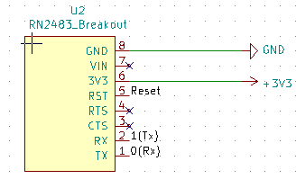

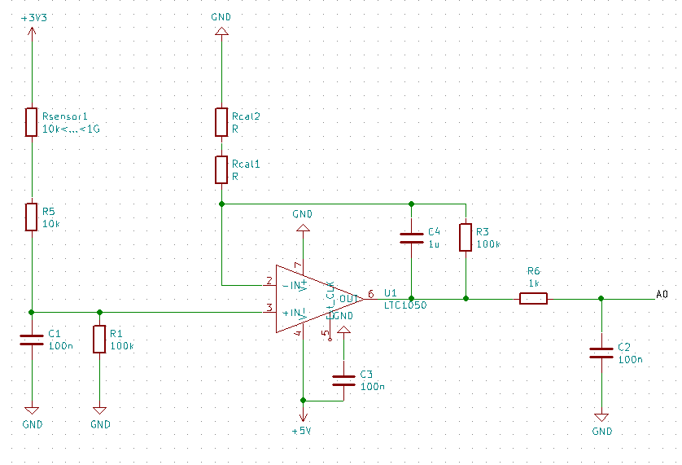

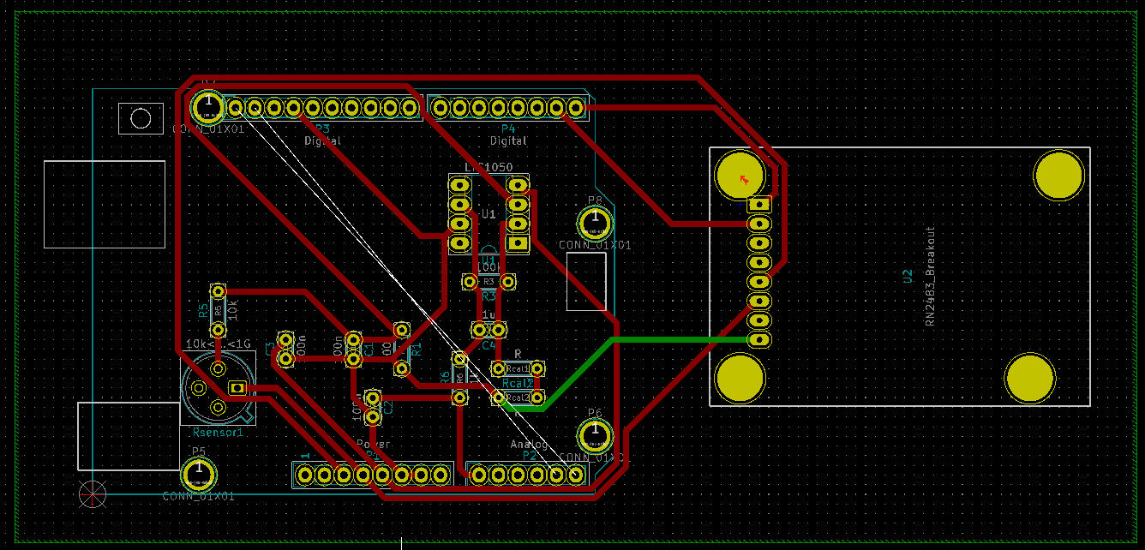

B.III. Innovative Project

*B.III.1. The environment and context*

Nowadays, big cities have various nuisance which impact on the health and the comfort of citizen. The University of Wollongong in Australia has proposed a project on designing an embedded sensor platform to be deployed by non-scientific people. This platform has to collect data about the quality of the air in a city by using mobile or fixed sensors, analyze these data and display them by a user interface as website.

This project is the main project for the Innovative Smart System training as it combines electronic and computer science skills. For this project, our team is composed of five students: two from electronic domain and three from the computer science domain. We divided the project into two parts: an electronic part and a software part.

*B.III.2. your function*

Because I am a computer science student, I worked in the computer science team. Our mission was to develop a web user interface and to analyze data measured by the air quality sensor in order to interpret them and show them on the interface through graphs and map. We have decided to use the Framework Angular to develop our website because it is supported by Google and what’s more, one of team member has already used it. I mainly worked in developing website using Angular.

B.IV. Hackathon

*B.IV.1. The environment and context*

We have been to Banyuls sur mer during the beginning of November. We have chosen an idea which is relevant to aquarium and we have worked on it during two days in a group of five. Actually, I was the only one study computer science and the other four all major in electronic.

This project mainly used the knowledge of electronic, such as Arduino, sensor, etc. Our project was to do a new aquarium for children to throw the garbage into the dustbin. Every time a child throws a garbage into the dustbin, the image in the aquarium, which is showed by a big screen, will be more and more clean. That tells children do not throw the garbage anywhere in the earth and just throw it in the dustbin. So we can make children protect environment.

We putted an ultrasonic sensor in the dustbin so that we can use this sensor to detect if there is a garbage coming. Every time the sensor detects something, we can change the image in the screen. Finally, the image becomes more and more beautiful and clean.

We would want to do a garbage classification for children to throw the different kind of garbage to the different dustbin. But we didn’t have enough time to do that and we didn’t have all kind of sensors.

*B.IV.2. your function*

During two days of Hackathon, we worked in a group of five. Firstly, we have done the brainstorming to choose a new and creative idea for our project. After choosing the idea, we have begun coding for the project. Because all other four students come from electronic, they were familiar than me to program the board Arduino. I have done something with the image, such as choosing an original image, adding some dirty garbage in the image and deleting the garbage step by step to make the image more and more clean. What’s more, I have helped them when they needed some helps. And I have done the most part of the PowerPoint for the second day’s presentation. Finally, our group has won the third prize.

B.V. Big Data

*B.V.1. The environment and context*

I have learned a course called big data last year. It was the first time that I had learned the language R in order to analyze the data and draw graph to show the data analysis. At the end of the course, we need to choose a data set, define the problem that we want to analyze about the data set and draw four graphs to show the data analysis. Many websites provide free data set. And we have chosen one data set from the website kaggle about the history of the Olympic Games since Athens 1896. We want to know which parameters impact on the winning a medal at the Olympic Games.

*B.V.2. your function*

We have done this project in pairs and my partner and I have done the same things. We want to analyze which parameters impact on the winning of a medal at the Olympic Games. From the first and second graphs, we can see that the USA has the most medals and the most athletes. But the number of medals doesn’t have the positive ratio with the number of athletes. So only with the number of athletes, we can’t determine the number of medals. Then we analyzed if the age range has an impact on the winning of a medal. From the third graph, we can know that the most of medals are gathered between 18 to 30 years old. Lastly, we can observe from the fourth graph that the BMI of women is between 20 and 22 and the BMI of men is between 23 and 25 approximately.

We can deduce that the number of athletes, the age and the BMI have an impact on the winning of a medal.

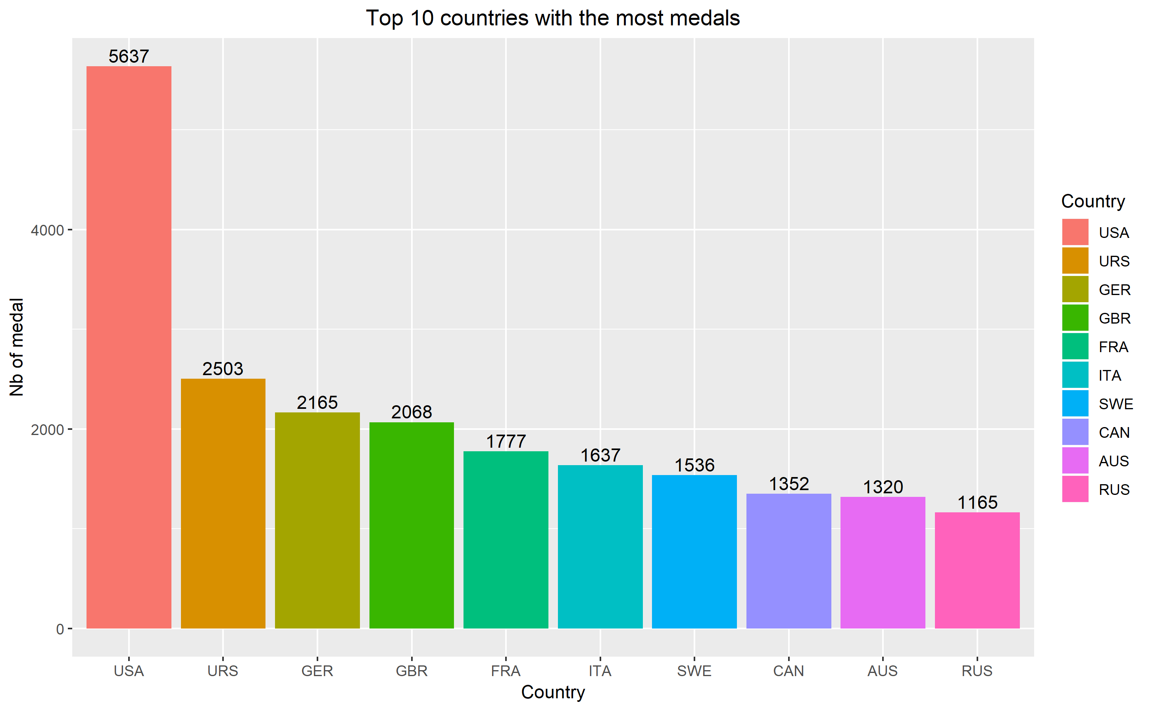

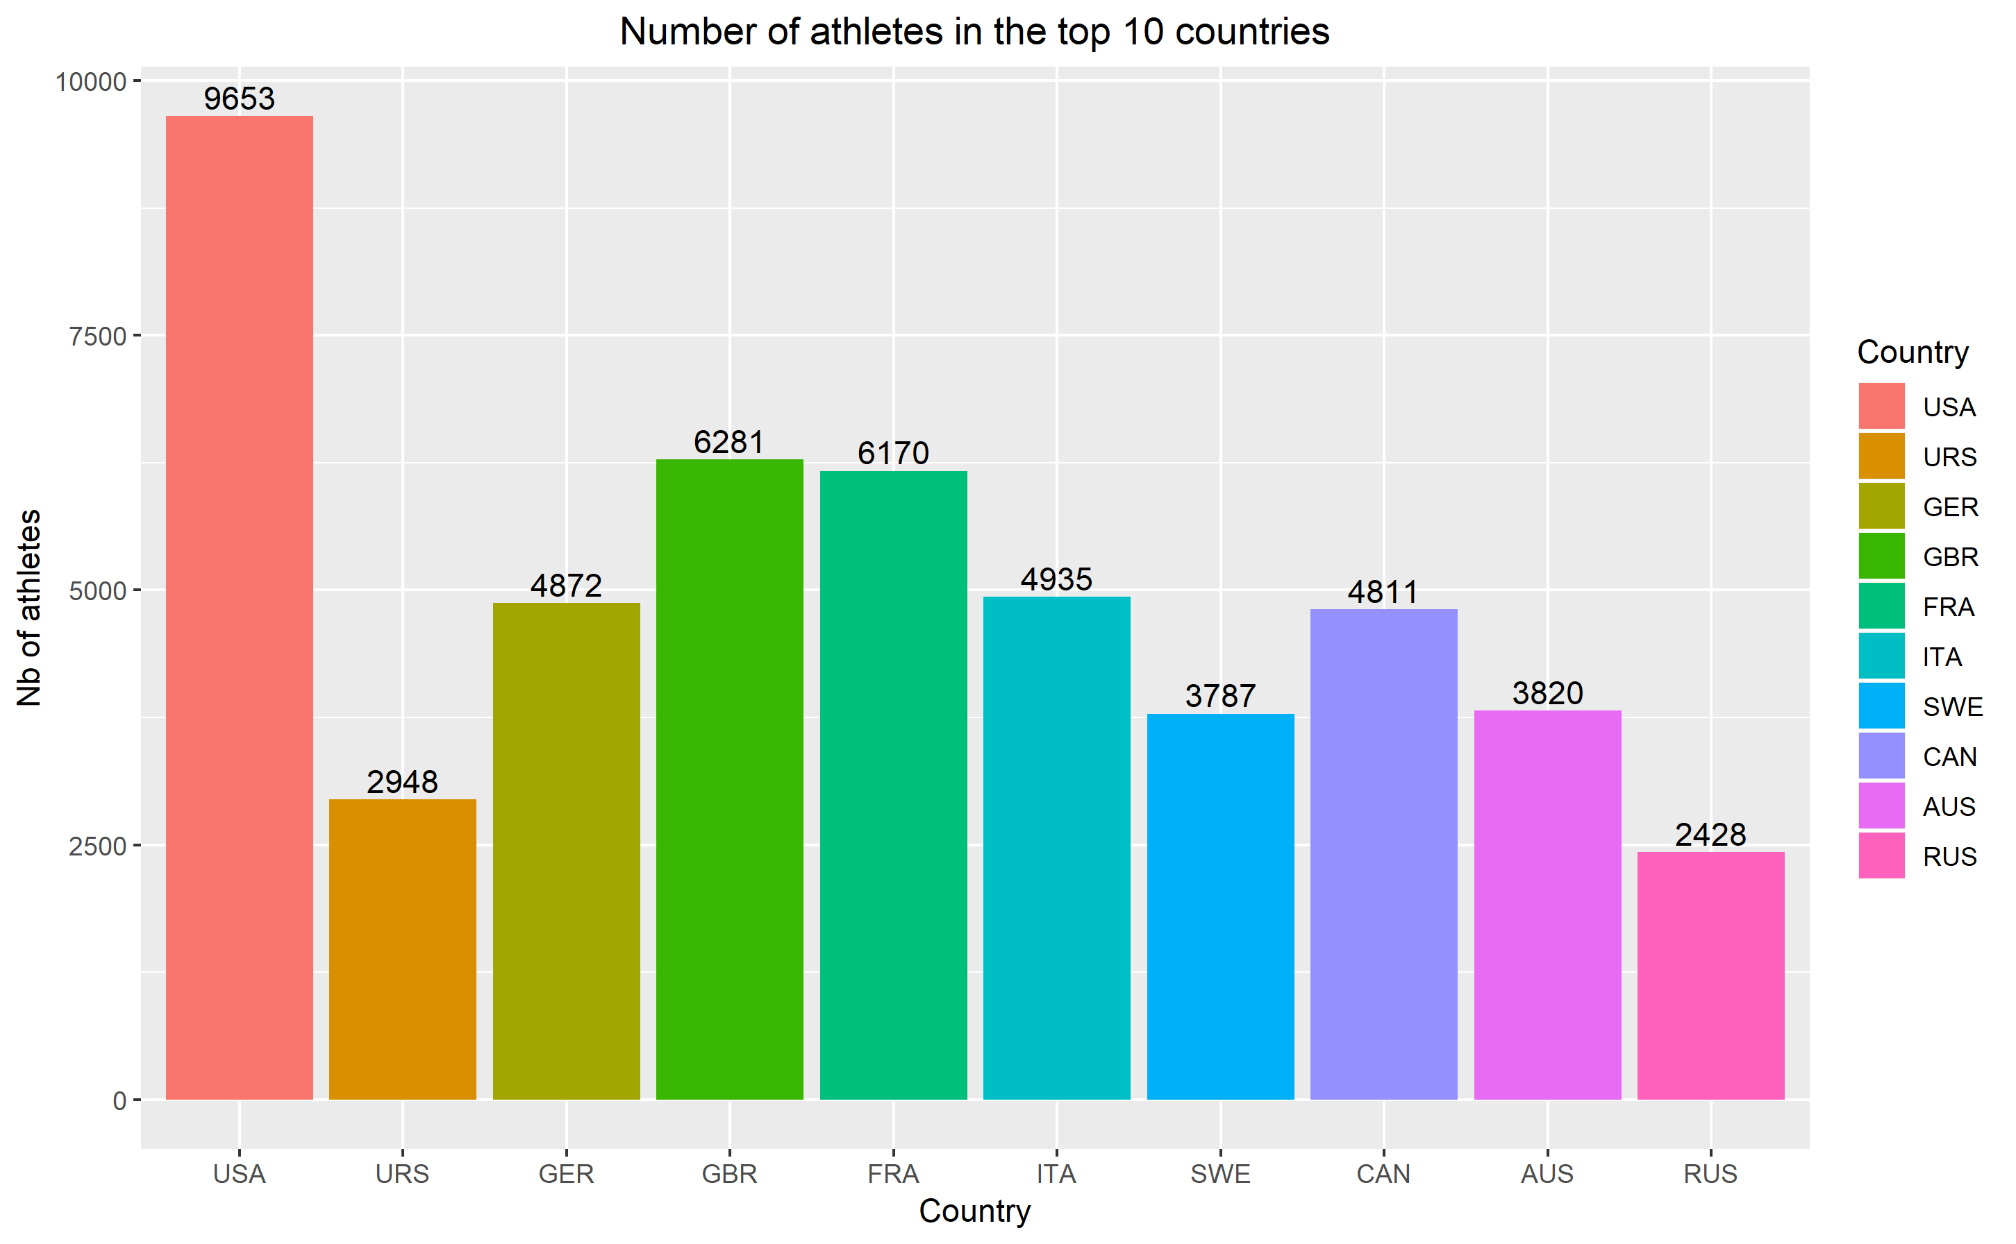

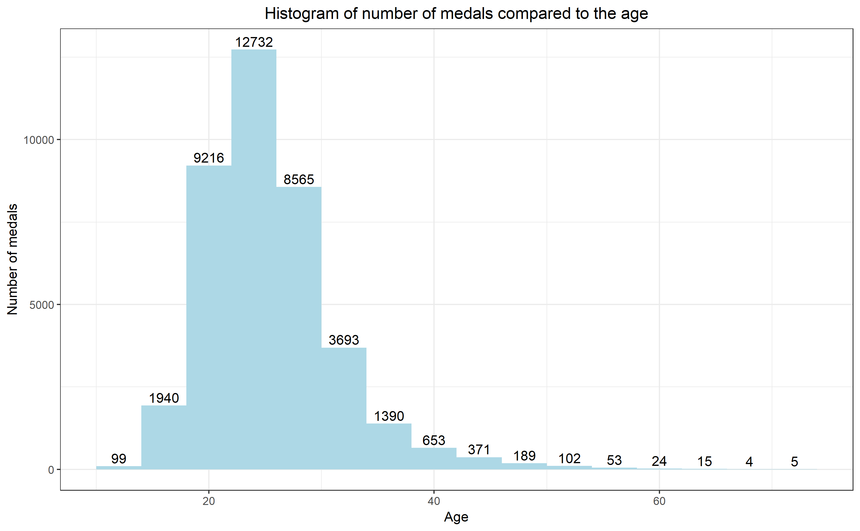

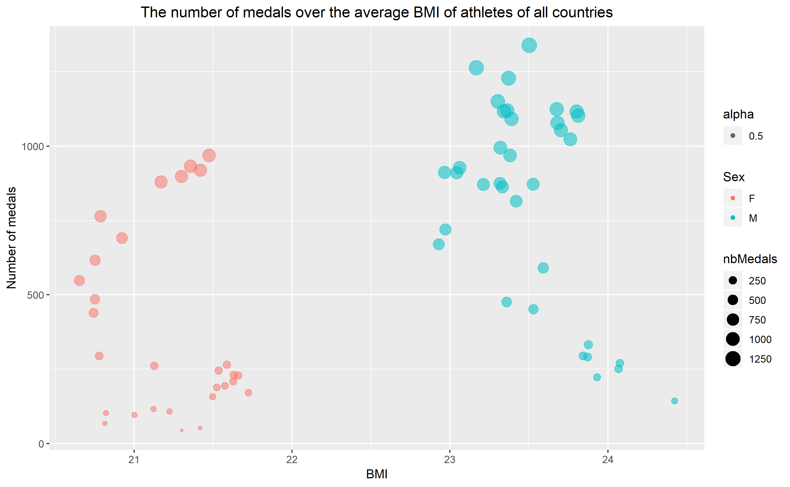

**END OF INSTRUCTIONS (to be deleted later)**

# Part C: TECHNICAL PART

**NOTES (to be deleted later)**

During your journey, you were confronted with problem situations (technical problem solving, strategic choices ...) during which you had to implement a relevant practice to achieve a desired result.

We propose to describe these situations that you had to solve. The chosen problem situations must highlight the technical knowledge you have developed in direct relation to the Training.

Express yourself in terms of "I": "I started with, I searched, I tried to". You will reproduce the proposed frame for each problem situation developed:

During this year of learning at the INSA de Toulouse, I have been confronted to situations where I had to solve problems. This let me to improve my skills and wider my global science knowledge.

In the following points, I will describe these situations and highlight the technical skills that I used to solve the encountered problems.

This will be done by going over every course that I had this year, as I think they all brought me lot of problems and skills.

In the first part, I will present the different courses that I followed for each block of competences. Then I will talk about the issues that we encountered and what we learned during this course can answer those problems. This will lead me to the skills that I learned. Then I will do a little synthesis about what I thought about the block of competences.

C.I Smart Devices

**C.I.1 Presentation**

It is hard for me to learn this module because there are many things from the hardware domain. And I’m a computer science student from the software domain and I had never done electronic, so it’s difficult to study the hardware. Firstly, I needed to use the software KiCad. Actually, it was the first time that I had heard about this software. I didn’t know how to use it. What’s more, I didn't know how to draw circuit diagram with this software. When I did the Arduino Uno project with my partner, we needed to make all the tracks in the same side. But we didn’t success. We have tried so many times, but every time there was always one track in another side. Because all the tracks can’t cross each other is a big constraint. So it was really difficult for us.

**C.I.2. Resolution of problem**

I had never used KiCad before. So I have followed what the teacher explained during the course to start using the kiCad. The teacher usually made an example in the screen, so I could learn about how to use KiCad. Sometimes the teacher did examples really quick so that I couldn't follow him. Then I found a specification about KiCad in the Internet. When I did the project Arduino Uno with my partner, this specification helped us a lot. So I think that listening to teacher and finding more information in the Internet both are useful. Last problem is to make all tracks in the same side. However, we have done it many times. But each time we can’t make that. Because all the tracks can’t cross each other. Finally, there was a track in another side.



**C.I.3. The knowledge and skills mobilized**

During this modules, the skills I mobilized are mainly operational knowledge. The theoretical and technological skills that I have acquired concerning the electronic part. From all courses of this module, I can learn some knowledge about electronic, open-source and hardware. What’s more, during the Arduino Uno project with my partner, we have learned how to draw the circuit diagram, import a library and draw the routing. So I have acquired mainly about the electronic part and the operation of circuit.

**C.I.4. Summary and Review**

I think this module is useful because I have learned some knowledge about the electronic part which I had never known. Actually, it’s the first time for me to know about the electronic and the Arduino. My partner and me have almost overcome all the difficulties during the project. I think the best way to learn is solving the problem by yourselves. As we come from computer science, we had many difficulties during this module. So we always ask the teacher, ask the peers and search in the Internet to solve the problems.

C.II Digital Wireless Communication for connected objects

**C.II.1 Presentation**

In the module of Communication, my project group and me had to calculate the exercise about how far a ZigBee wireless transmitter could transmit without exceeding the threshold of detection for the receiver. At first, without interference and then with interference of the second transmitter Wi-Fi. It was then necessary to do the similar exercise but to calculate the maximum distance between the Wi-Fi disturber and ZigBee transmitter for a fixed distance between the transmitter and the receiver. This goal is to keep the power of the signal in reception always above the threshold of detection of a signal. We had two weeks to do this exercise.

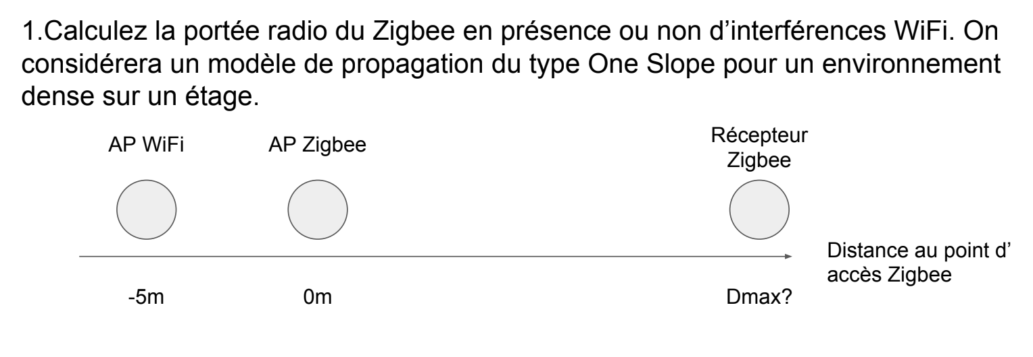

**C.II.2. Resolution of problem**

For me it’s really difficult to resolve this exercise, because I had never learned about the telecommunication. To realize this calculations, firstly I needed to understand the formulas in the slide. Then I have chosen to use the model of propagation of type One Slop with my project group to do this exercise. We have done a table to calculate the Path loss during this transmission with interference of Wi-Fi.

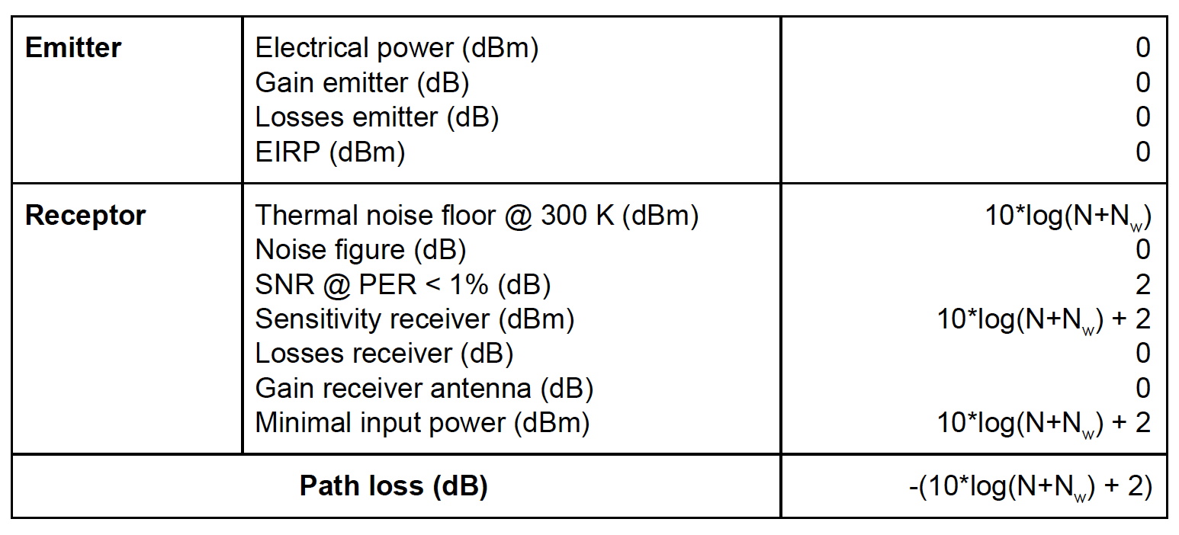

Then we have calculated the interference of Wi-Fi and we can deduce the loss of power from formula given in the table of the calculation. What’s more, the model One Slop gives us the formula to calculate the loss power between the transmitter and the receiver.

The second question is the reverse of the first one. We know the distance between the transmitter and the receiver and we need to calculate the maximal distance between the ZigBee transmitter and the Wi-Fi. We have calculated the power of the received signal ZigBee. Then we can calculate the interference of Wi-Fi with the formula. Lastly, we can calculate the maximal distance.

We have ridden the slide of the teacher to know the formula and to understand the course better. When we did the exercise, we have also searched information in the web. Because we didn’t know clearly how to calculate the maximal distance while giving a fixed distance. What’s more, the calculations are not easy as there are many math formulas.

I also think the best way to learn is to do the exercise by yourselves. Before this course I had known nothing about the wireless communication. After listening to the course and doing the exercise, I knew better about that.

**C.II.3. The knowledge and skills mobilized**

This exercise mainly allowed me to acquire theoretical skills on wireless communication. I know how to use the model of propagation of type of One Slop. I understand the formulas which for calculating these two questions. This course has broadened my knowledge in the telecommunication domain.

**C.II.4. Summary and Review**

I think I have clearly understood the given problem and answered the questions even if I have spent a lot of time in it than necessary. I find it quite entertaining and I have some knowledge about the wireless communication for the connected objects.

C.III Protocol for connected objects

**C.III.1 Presentation**

This year at INSA, I have taken the course of protocol for connected objects. I have learned about UMTS, GSM, 3G, 4G, 5G, LoRa, ZigBee, Sigfox, NB-IoT, MAC Layer, etc. I think it’s interesting because I have learned about protocols for connected objects on several levels. After that, we did research for the report of given title and we had also presentations during this course.

**C.III.2. Resolution of problem**

Actually, during this course I had to prepare the presentation about **5G in developing countries**, my partner and me we have done the report about the NB-IoT, and I have done the report to compare the different MAC Layer protocols. So I had many things to look for in the web, write the report and prepare for the presentation. Firstly, I identified the definition on Wikipedia, that gives me a little idea about the knowledge. Then I found article resources that contain the information for each work. Finally, to go faster, I looked the articles and wrote the useful information into report or prepare for the presentation.

**C.III.3. The knowledge and skills mobilized**

This course has helped me improve my skills in protocols domain. All those things were learned thanks to lectures, researches, reading and discussions. You will be able to consult the work I did on this course in the annexes below.

**C.III.4. Summary and Review**

Searching information for 5G, NB-IoT and MAC Layer and editing the report is really a good way to learn. I sensed that I learned a lot. Because each time, I prepared and looked for the information in the Internet. I need to understand and write the report. Then we came to class and we discussed with other students and our teacher, which allowed me broaden my knowledge in the telecommunication network domain.

C.IV Energy for connected objects

**C.IV.1 Presentation**

During last year, I have followed a course called energy for connected objects. An embedded system is an electronic system benefiting from limited resources in term of signal processing and of limited energy resources. In this course, I have learned about the electrochemical energy storage, the electrostatic storage and energy harvesting.

**C.IV.2. Resolution of problem**

Actually there nearly didn’t have encountered problem during this course. The only thing to do is to listen and understand during each lecture. This course allowed me to understand other problems in other subjects. Such as the main project in ISS, social network for pollution, when the question about the energy source of sensors came up, I wondered that our sensors can get energy from solar panel.

**C.IV.3. The knowledge and skills mobilized**

The knowledge that I have acquired in this course is mainly theoretical and on the term of storage of energy.

**C.IV.4. Summary and Review**

Normally we should have a QCM for this course said by the teacher but we actually don’t have. For this course, I have learned the knowledge about the storage of energy and the the energy harvesting. That have improved my skills in the domain of the energy.

C.V Security for network of connected objects

**C.V.1 Presentation**

Present the situation by specifying the context, the field of responsibilities, the actor (s), the objectives to be reached, the resources and the constraints (human, material, financial, informational ...), the duration and the dates.

**C.V.2. Resolution of problem**

Explain the chosen solution by answering the following three questions:

"What": the description of the solution; "How": the way to go about it and "Why": the justification of your choice

**C.V.3. The knowledge and skills mobilized**

What new skills did you have to mobilize and develop to solve this problem? How did you acquire them (reading, training, peers)?

**C.V.4. Summary and Review**

Make a synthetic summary of the situation-problem. To conclude, it is a question of taking stock by answering the following questions: what lessons have you learned from this experience? Today with hindsight, what analysis of the proposed solution do you make?

C.VI Emerging network (SDN, NGN)

**C.VI.1 Presentation**

During this course I have done two exercises. The first one is about LISP (Locator Identifier Separation Protocol).

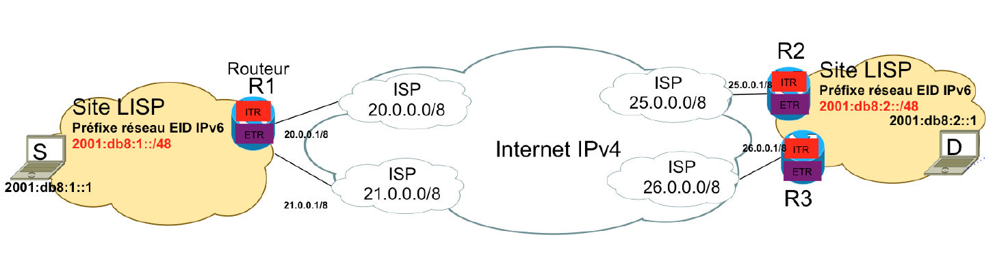

The question is how an IPv6 packet leaving S can reach its destination D, then detail the flow of actions that follows a loss of IP connectivity due to a failure of router R2 interface. The second one is about SDN (Software Defined Network).

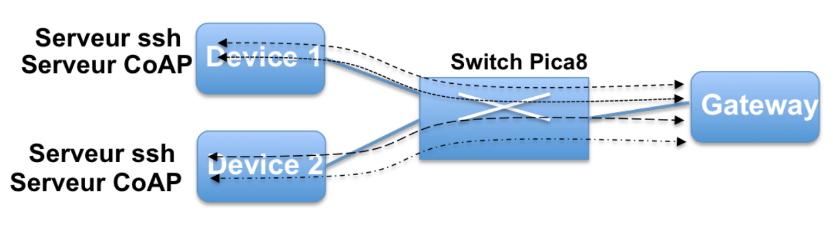

The question is that what are the necessary openflow rules to install on the SDN switch to let the UDP CoAP traffic flow from the Gateway to Device 1 and let the Gateway open the ssh session on both devices.

**C.VI.2. Resolution of problem**

Explain the chosen solution by answering the following three questions:

"What": the description of the solution; "How": the way to go about it and "Why": the justification of your choice

**C.VI.3. The knowledge and skills mobilized**

I have acquired theoretical skills during each lecture and operational skills during the two labs. I have learned about the SDN and LISP and that has broadened my knowledge in the domain of network and the openflow. For the two labs, I have really configured the network by myself and I had a better understand about what I learned during this course.

**C.VI.4. Summary and Review**

I think this course is interesting, especially the two labs. We just had two labs and I wonder it’s not enough. Because when I finished the first lab, I didn’t have much time to do the second one. Maybe I have taken so much time for the first one. Anyway, this course has improved my skills about network knowledge and configuration about network.

C.VII Innovation/Social Acceptability/Business Development

**C.VII.1 Presentation**

This course brought me general knowledge about team leading, project management and market studies. During this course, I was able to discuss topics such as design thinking, anticipating technological developments, spreading innovation, management, etc. It shows that many inventions do not reach the status of innovations for marketing issues, marketing not well planned or because the public is not yet ready to receive them. So they will not succeed and disappear in market. Because there are some key constraints for product diffusion. What’s more, we have to manage our group and project well. If we have a conflict in group, we need to fix as soon as possible. Before we begin to work, we need to know about each other well.

**C.VII.2. Resolution of problem**

Explain the chosen solution by answering the following three questions:

"What": the description of the solution; "How": the way to go about it and "Why": the justification of your choice

**C.VII.3. The knowledge and skills mobilized**

The skills that I have acquired is more about relationship and management in a group. It seems to me that what have been done during this course will be directly reusable in the work. That is what I’m going to do now.

**C.VII.4. Summary and Review**

I think this course is interesting. I have learned about the group management, the difference between invention and innovation, business, etc. This course has improved my knowledge in the design thinking, innovation and business domain.

C.VIII Creativity Methods/TRIZ Method

**C.VIII.1 Presentation**

As we talk about creativity and innovation, learning about TRIZ method is a kind of way to know about creativity and innovation. During this course, I have thought about several evolution of systems, such as the bike or the calculator. And then I have been demanded to use the nine laws and the cycle model by my project, Social Network for Pollution.

**C.VIII.2. Resolution of problem**

Explain the chosen solution by answering the following three questions:

"What": the description of the solution; "How": the way to go about it and "Why": the justification of your choice

**C.VIII.3. The knowledge and skills mobilized**

The skills that I have learned during this course is mainly theoretical and practical. I have learned about the cycle model on biological systems, from birth to decline, and nine laws about evolution. I have known about the contradiction model and resolution methods/tools. If we didn’t have contradiction, we would not have problem.

**C.VIII.4. Summary and Review**

Make a synthetic summary of the situation-problem. To conclude, it is a question of taking stock by answering the following questions: what lessons have you learned from this experience? Today with hindsight, what analysis of the proposed solution do you make?

In summary, this course brought me a good knowledge in the creativity and innovation domain. During this course, we just know a little about TRIZ method so there still are many potential things need to learn. It’s good that we know more about TRIZ method so that we can practice it during future work.

C.IX Adaptability: Cloud and Autonomic management

**C.IX.1 Presentation**

Present the situation by specifying the context, the field of responsibilities, the actor (s), the objectives to be reached, the resources and the constraints (human, material, financial, informational ...), the duration and the dates.

**C.IX.2. Resolution of problem**

Explain the chosen solution by answering the following three questions:

"What": the description of the solution; "How": the way to go about it and "Why": the justification of your choice

**C.IX.3. The knowledge and skills mobilized**

What new skills did you have to mobilize and develop to solve this problem? How did you acquire them (reading, training, peers)?

**C.IX.4. Summary and Review**

Make a synthetic summary of the situation-problem. To conclude, it is a question of taking stock by answering the following questions: what lessons have you learned from this experience? Today with hindsight, what analysis of the proposed solution do you make?

**END OF INSTRUCTIONS (to be deleted later)**

# Part D: ANALYTICAL PART

D.I. ANALYSIS OF SKILLS

You have presented the significant experiences related to the training. You also presented several problem situations where you explained the acquired knowledge and the skills mobilized to solve these problems.

In this last part, it is for you to make an exhaustive analysis of all the knowledge and skills acquired during these different experiences.

In the table below, for each activity, specify your level of execution corresponding to the appropriate figure using the following criteria:

**AP- level of application:** follow-up of instructions or procedures

**AN- level of analysis:** improvement or optimization of solutions or proposals

**M - level of proficiency:** program design or specification definitions

**EX - level of expertise:** definition of orientations or strategies

|  |  |  |  |
| --- | --- | --- | --- |
| **Activities** | **Acquired experience in terms of**  1. theoretical, technological knowledge,  2. operational know-how, and relational,  3. intellectual steps  4. other skills related to a given position | **Modes[1]** | **Level**  **(AP to EX)** |
|  |  |  |  |

**D.II. SELF EVALUATION**

* Make a summary of the skills you think you can use with the training.

............................................................................................................ ...

* Possibly what skills are still missing?

............................................................................................................ ...

**D.III. BALANCE SHEET**

* What contributions do you draw from the in-depth analysis of your experiences in building your portfolio?

............................................................................................................ ...

**D.IV. COMPLEMENTARY ELEMENTS**

* Are there additional elements that you wish to communicate to the jury?

…………………………………………………………………………………………….......

# Annexes

1. Main acquisition methods: Initial training (IT), peer exchange (PE), self-training (ST), professional practice (PP)