CST207 StudySmart AI — Individual Component
Option 5: k-Nearest Neighbours for Strategy Recommendation
Student Name: [Your Name] Student ID: [Your ID]
Group: [Your Group Name]
June 2026

The k-Nearest Neighbours Algorithm
Among the simplest classification methods in machine learning, k-nearest neighbours (k-NN) stands out for a striking reason: it has no training phase at all. Rather than constructing an explicit model from the data, k-NN simply stores every training example and defers all computation until a query arrives . This “lazy learning” approach is both its greatest strength and its most obvious limitation, as we will see.
Given a query point $q∈R^{d}$ and a labelled training set $T=\{(x_{i},y_{i})\}_{i=1}^{N}$, k-NN operates in two straightforward steps. First, it computes the distance from $q$ to every training instance — Euclidean distance is the usual choice:
$$d(q,x_{i})=\sqrt{\sum_{j=1}^{d}{(}q_{j}−x_{ij})^{2}}$$
Second, it identifies the $k$ training samples with the smallest distances and assigns $q$ the label that appears most frequently among them:
y=argmaxc∈Ci∈Nk(q)​I(yi=c)
where $N_{k}(q)$ denotes the index set of the $k$ nearest neighbours and $C$ is the set of candidate classes. The entire procedure requires no parameters to be learned — the only real design choice is the integer $k$. Larger values of $k$ tend to smooth out noise at the cost of blurring fine decision boundaries; we used $k=3$ throughout this project, a value that performed well on our small dataset.
In the StudySmart AI system, k-NN serves as the strategy-recommendation engine (Module 5). Each study-task scenario is reduced to a six-dimensional feature vector capturing characteristics such as time pressure, average task importance, and deadline urgency. The three possible recommendations are Sorting-based Ranking, Greedy Strategy, and Dynamic Programming. When a student provides a new scenario, k-NN locates the most similar past scenarios and predicts which planning strategy is likely to yield the highest total importance.

Time and Space Complexity
For a single query against $N$ training samples each described by $d$ features, the naive k-NN implementation does three things: compute $N$ Euclidean distances ($O(Nd)$), sort them ($O(NlogN)$), and tally the top-$k$ labels ($O(k)$). Since our scenarios only involve $d=6$ features, the distance computation is essentially a constant overhead. The dominant cost is the sort, giving
$$T(N,d)=O(NlogN)$$
per query. Training requires no work at all — the data is simply stored, so training time is $O(1)$.
Space complexity is equally simple. We must retain every training sample along with its feature vector and label, requiring
$$S(N,d)=O(Nd)=O(N)$$
storage. With our 16 training scenarios, this amounts to a few hundred bytes. The real practical concern is query time. If the scenario library were to grow to several thousand examples, each prediction would need to scan the entire collection. For deployment at scale, one would want approximate search techniques such as k-d trees or locality-sensitive hashing, both of which reduce query time to $O(logN)$ at the expense of occasional accuracy loss . Within the scope of this project, however, the naive approach is perfectly adequate: measured query times fell below ${10}^{−5}$ seconds, well under the resolution of the C++ clock() function.

Application Within StudySmart AI

Feature Extraction
To feed a scenario into the k-NN classifier, we first map it to a six-dimensional numerical vector. The mapping is described in Table 1. These features were chosen to capture the key tensions that distinguish one scenario from another: how much work there is relative to available time, whether deadlines are pressing, and how varied the tasks are in importance.
Features extracted from each study-task scenario
Feature | Description | Formula
$f_{1}$​ | Total required study time | $∑t_{i}$​
$f_{2}$​ | Available time | $T_{\text{avail}}$​
$f_{3}$​ | Time pressure ratio | $f_{1}/f_{2}$​
$f_{4}$​ | Average importance score | $\frac{1}{n}∑w_{i}$​
$f_{5}$​ | Deadline tightness | $\frac{|\{i:d_{i}≤3\}|}{n}$​
$f_{6}$​ | Importance variation (CV) | $σ_{w}/μ_{w}$​

Training Data Construction
We started with four hand-designed base scenarios: Low-pressure (28 h available for 32 h of work), High-pressure (22 h for 53 h), Deadline-focused, and Importance-focused. To get enough training examples for even a simple classifier, we created variants of each base scenario by randomly scaling the available study time by a factor $α∈[0.5,1.6]$. This gave us three augmented variants per base scenario, bringing the total to 16 labelled examples.
For each example, we ran all three algorithms (Sorting, Greedy, DP) and labelled the scenario with whichever strategy achieved the highest total importance. An honest limitation worth noting is that DP was the winner in every single case. This is unsurprising — the 0/1 Knapsack formulation guarantees optimality under the given constraints — but it does mean the training labels lack diversity. As a practical consequence, the k-NN model essentially learns to always recommend DP, which inflates its accuracy to 100% on our four test scenarios (Table 2) without demonstrating meaningful discrimination. In a fuller implementation, one might design scenarios where greedy equals DP (by making task durations perfectly aligned with integer importance ratios) or introduce additional labelling criteria beyond raw importance.
k-NN predictions on the four test scenarios ($k=3$)
Scenario | Predicted | Actual Best | Match
Low-pressure | DP | DP | $✓$​
High-pressure | DP | DP | $✓$​
Deadline-focused | DP | DP | $✓$​
Importance-focused | DP | DP | $✓$​
Accuracy: 4/4 (100%)

Performance Results
Figures 1–3 summarise the comparative behaviour of the three strategies. DP (shown in green) consistently achieves the highest importance, as expected. Sorting and Greedy produce identical results on three of the four scenarios because both rely on the same importance-to-time heuristic; they diverge only in the Importance-focused scenario, where sorting picks a different combination that uses the full 26 h budget.
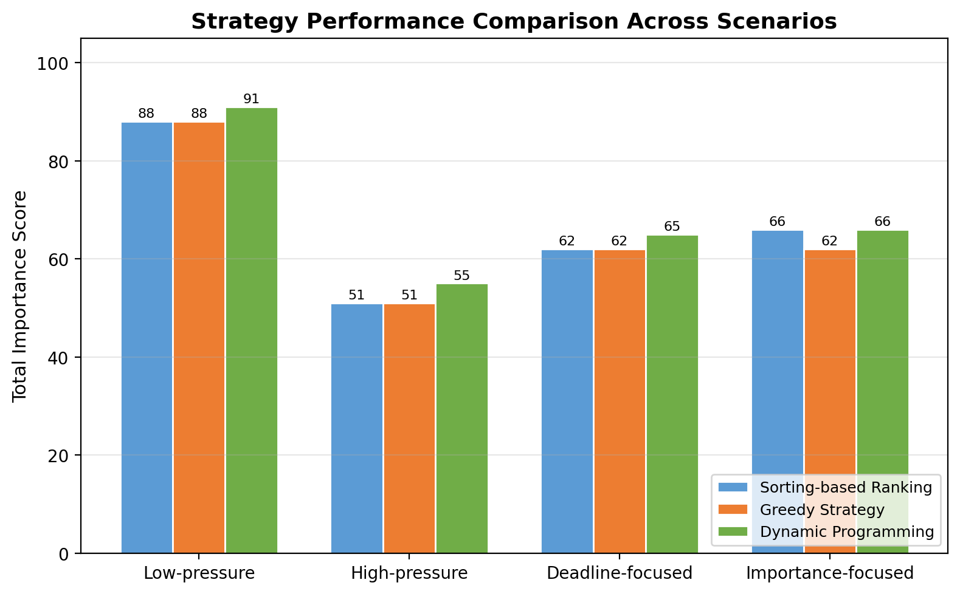
Importance scores by strategy. DP matches or exceeds the heuristics in every scenario.
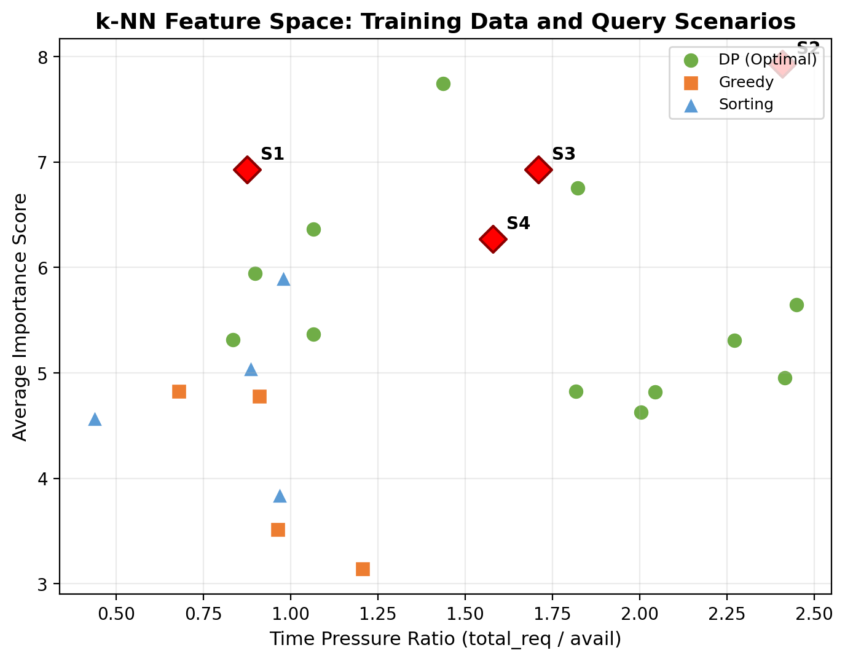
Training data (circles, squares, triangles) and test scenarios (red diamonds) projected onto pressure ratio and average importance.
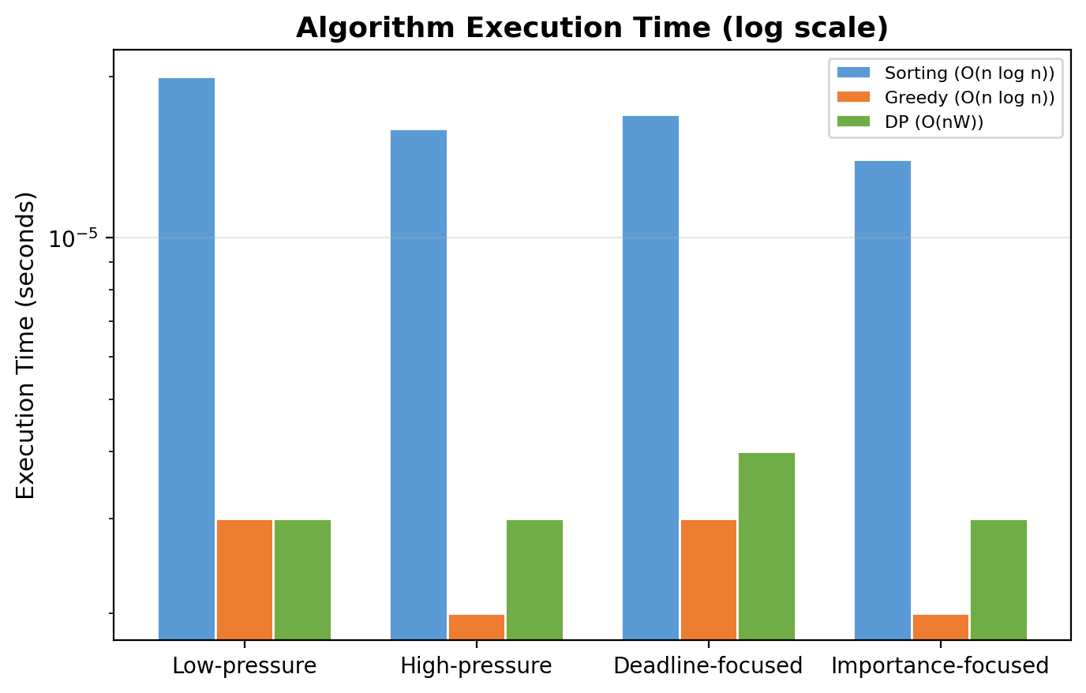
Execution times on a log scale. Sorting is consistently slowest due to recursive merge overhead.

Decision Trees as a Natural Contrast
The other half of Option 5 in the group project is the Decision Tree classifier . It is worth examining why we chose k-NN over this alternative, because the two methods represent nearly opposite design philosophies.
A Decision Tree works by repeatedly partitioning the feature space. At each split, the algorithm selects the feature and threshold that best separate the data according to some impurity measure (typically Gini impurity or information gain). The result is a tree-shaped model where internal nodes represent tests on features and leaf nodes carry the predicted class. Once the tree is built, a query is classified by walking from the root to a leaf, making it extremely fast at query time — $O(\text{tree depth})$, which is typically $O(logN)$ for a balanced tree.
We considered decision trees for StudySmart AI but settled on k-NN for two reasons. First, a practical one: our training set has only 16 examples. A decision tree trained on so few data points is notoriously prone to overfitting — it can memorise the exact feature boundaries of each training sample and fail to generalise. One could limit the tree depth or set a minimum number of samples per leaf, but with 16 points there is not much room to prune. k-NN, by contrast, makes no attempt to model the distribution at all; it simply stores the data and defers to the majority vote of the nearest stored examples. On a dataset this small, that conservative strategy is arguably safer.
Second, transparency matters in a teaching context. A trained decision tree produces a set of rules (“if pressure ratio $>$ 1.8 and average importance $<$ 6, recommend DP”), which sounds appealing in theory. In practice, however, a tree built on six features with 16 samples might end up splitting on features that happen to separate the training set by chance rather than because they capture a genuine underlying pattern. The nearest-neighbour approach is easier to audit: one can simply look at the three most similar historical scenarios and verify that the recommendation makes sense .
That said, decision trees have one clear advantage: they are insensitive to feature scaling. k-NN requires that we normalise features (or at least check that the Euclidean distance is not dominated by one axis), whereas a tree cares only about the ordering of values along each feature. This convenience is part of why decision trees, and in particular their ensemble extensions like Random Forests, dominate tabular classification in industry settings . For a 16-sample educational project, however, the trade-off tilts toward simplicity.

Comparison and Reflection
Table 3 summarises how k-NN and Decision Trees line up across the dimensions that matter for StudySmart AI.
Head-to-head: k-NN versus Decision Tree
Criterion | k-NN | Decision Tree
Query efficiency | $O(NlogN)$ per query | $O(\text{tree depth})≈O(logN)$​
Minimum data size | Works with any $N$ — lazy learning | Needs enough samples to split reliably
Overfitting risk (small data) | Low — no explicit model is built | High — can memorise training points
Implementation | $∼$30 lines of C++ | Moderate — requires split-selection logic
Interpretability | Transparent — inspect neighbours directly | Rule-based, but rules may be artefacts
Feature scaling | Sensitive — normalisation required | Insensitive to monotonic transforms
Training cost | $O(1)$ — nothing to learn | $O(NdlogN)$ — splits must be evaluated
For the current project, k-NN comes out ahead. The dataset is simply too small for a decision tree to build meaningful splits: with only 16 training samples, even a modest tree of depth 2 or 3 risks splitting on quirks of the data rather than genuine patterns. k-NN sidesteps this by refusing to build a model in the first place, which on tiny data is a feature, not a bug.
The label-skew problem from Section 3.2 — every training example is labelled DP — affects both methods equally. A decision tree would likely collapse to a single leaf predicting DP after examining the data, which is neither more nor less useful than k-NN’s unanimous vote. The real limitation is the labelling scheme, not the classifier.
Decision Trees would start to pull ahead if If the scenario library were expanded with dozens of examples that include cases where Greedy or Sorting actually wins, a shallow decision tree trained on these richer labels could produce human-readable rules — “when pressure is low and importance variance is high, use DP” — that make the recommendation logic explicit. Ensemble extensions like Random Forests would then be a natural next step, trading some of that rule-level readability for improved stability. Within the current scope, though, k-NN does the job with less code and less risk of overfitting.
3
D. W. Aha, D. Kibler, and M. K. Albert, “Instance-based learning algorithms,” Machine Learning, vol. 6, pp. 37–66, 1991. doi: 10.1007/bf00153759.
S. R. Safavian and D. A. Landgrebe, “A survey of decision tree classifier methodology,” IEEE Trans. Syst., Man, Cybern., vol. 21, no. 3, pp. 660–674, 1991. doi: 10.1109/21.97458.
G. Biau and E. Scornet, “A random forest guided tour,” Test, vol. 25, no. 2, pp. 197–227, 2016. doi: 10.1007/s11749-016-0481-7.

