

Course Name: IBMS10008 Integrative Biomedical Sciences Research Project

Project Title: Decoding Age-Associated States in Muscle Stem Cells Using a Single-Cell Reference Atlas and Aging Classifier
Clock

Roll Number: 2137

Word count (excluding references): 4992

Have you used generative AI (large language models) in your assessment

No | 🗸
Yes

Statement of originality (Delete the example text and add your own description as necessary)

I hereby declare that to the best of my knowledge the content of this dissertation is my own work.


- The content was written in English without the use of a translator: No  Yes
- The dissertation contains AI-generated text, images or other material: No  Yes  (specify below)
- Contributions of others to this project: No  Yes  (specify below)

  - Name(s) of contributor(s):

Lu Yang, PhD student.

  - Nature of contribution (e.g., data collection, laboratory work, analysis, interpretation):

Lu Yang offered some critical biological insights in MuSC.

- Part of the work was performed prior to the course start: No  Yes  (specify below)

  - Description of material/data not generated during the specified project period:

  - Justification for inclusion:

I certify that all the assistance received in preparing this dissertation and the relevant sources, including AI use, as well as the content acquired outside the specified period of my research project have all been properly indicated also in the parts of the dissertation where these are included.

Student’s name: Yiru Chen

Student’s signature:  Date: 2026-04-17

Acknowledgement

First and foremost, I would like to express my sincere gratitude to my supervisors, Prof. Di Wang and Prof. Zhexu Chi, for their invaluable guidance, critical feedback, and unwavering support throughout this project. I am also indebted to the other professors and instructors at the ZJU-UoE Institute whose courses and advice shaped the foundation of this work. My thanks go to the senior researchers and colleagues in the lab for their patient mentorship, stimulating discussions, and generous sharing of expertise. I am equally grateful to my classmates for the collaborative spirit and mutual encouragement that made this journey so memorable. Finally, I wish to thank my family and friends for their constant encouragement and patience, without which this dissertation would not have been possible. I also acknowledge the researchers who generated and shared the public datasets and computational resources that made this work possible.

Abstract

Skeletal muscle regeneration depends on muscle stem cells (MuSCs), but aging reshapes these cells across a heterogeneous regenerative continuum, making age-associated dysfunction difficult to resolve within single-cell data. This dissertation developed a donor-aware single-cell framework to decode age-associated MuSC states. Public mouse scRNA-seq datasets were integrated into a purified MuSC reference atlas, and an interpretable Elastic-Net classifier was trained on bootstrap metacells to distinguish young-like from old-like transcriptional states. A local pseudotime-aware extension was used to test whether age-associated signals changed along the regenerative continuum, and the framework was further applied to post-injury data and a small human proof-of-concept analysis. By examining gene-weight contributions from the classifier, the analysis showed that age-associated programs were not fixed, but changed dynamically across pseudotime. State-resolved differential, pathway, and regulatory analyses showed that aging- associated programs were distributed across quiescent, activated, and differentiating/proliferating MuSC states rather than confined to a single compartment. Young-like states retained developmen- tal, metabolic, and RNA-processing programs, whereas old-like states were enriched for stress- associated, inflammatory, and remodeling-linked signals. Overall, this work establishes an atlas- anchored age-state classifier for MuSC aging and supports a view of aging as state-dependent redistribution rather than a single static old-cell signature.

Lay Abstract

Muscle stem cells are essential for helping skeletal muscle regenerate and repair itself. As muscle ages, these cells changes in heterogeneous ways. Instead, aging alters multiple stages of the regeneration pathway, from more resting stem cells to more activated and differentiating cells, along the dynamic trajectory. This makes muscle aging difficult to study using simple young-versus- old comparisons even with state annotation. In this project, I combined several public mouse single-cell datasets to build a reference map of muscle stem cells and then trained an interpretable statistical learning model to distinguish young-like from old-like cell states. The analysis showed that aging-related changes were spread across the regenerative pathway rather than confined to one single cell type or one static old state. Younger-like states were linked to development, metabolism, and efficient regeneration, whereas older-like states showed more stress, inflamma- tion, and tissue-remodeling signals. When the model was applied to injured muscle, older groups remained in old-like states for longer during recovery. A smaller human analysis suggested that the same overall strategy may also be useful beyond mouse data in the future translation. Overall, this study provides a practical way to study muscle stem cell aging through changing cell states.

Keywords

muscle stem cells; scRNA analysis; regenerative continuum atlas; age-state classifier

Contents

List of Figures and Tables | v
List of Abbreviations | vi
1 Introduction | 1
1.1 Biology of Muscle Stem Cells and Aging . . . . . . . . . . . . . . . . . . . . . . . . . | 1
1.2 Current State of Molecular Aging Models . . . . . . . . . . . . . . . . . . . . . . . . . | 2
1.3 The Biological and Analytical Gap . . . . . . . . . . . . . . . . . . . . . . . . . . . . . | 3
1.4 Aims . . . . . . . . . . . . . . . . . . . . . . . . . . . . . . . . . . . . . . . . . . . . . . | 3
2 Materials and Methods | 4
2.1 Data Collection and Study Inclusion . . . . . . . . . . . . . . . . . . . . . . . . . . . . | 4
2.2 Construction, Purification, and Annotation of the Integrated Mouse MuSC Atlas . . . | 4
2.3 Donor-Aware Partitioning . . . . . . . . . . . . . . . . . . . . . . . . . . . . . . . . . . | 5
2.4 Baseline Elastic-Net Age-State Classifier . . . . . . . . . . . . . . . . . . . . . . . . . | 5
2.5 Local Pseudotime-Aware Modeling . . . . . . . . . . . . . . . . . . . . . . . . . . . . | 6
2.6 Human Proof-of-Concept Extension . . . . . . . . . . . . . . . . . . . . . . . . . . . . | 7
2.7 Code and Data Availability . . . . . . . . . . . . . . . . . . . . . . . . . . . . . . . . . | 7
3 Results | 9
3.1 Construction and Purification of the Mouse MuSC Reference Atlas . . . . . . . . . . | 9
3.2 State-Resolved Age-Associated Programs in the Reference Atlas . . . . . . . . . . . | 10
3.3 Baseline Elastic-Net Age-State Classifier . . . . . . . . . . . . . . . . . . . . . . . . . | 11
3.4 Local Pseudotime-Aware Age-State Classifier . . . . . . . . . . . . . . . . . . . . . . | 13
3.5 Application to Post-Injury Regeneration . . . . . . . . . . . . . . . . . . . . . . . . . . | 13
3.6 Human Proof-of-Concept Extension . . . . . . . . . . . . . . . . . . . . . . . . . . . . | 14
4 Discussion | 17
4.1 Overview . . . . . . . . . . . . . . . . . . . . . . . . . . . . . . . . . . . . . . . . . . . | 17
4.2 Biological Interpretation . . . . . . . . . . . . . . . . . . . . . . . . . . . . . . . . . . . | 17
4.3 Methodological Strengths . . . . . . . . . . . . . . . . . . . . . . . . . . . . . . . . . . | 18
4.4 Limitations . . . . . . . . . . . . . . . . . . . . . . . . . . . . . . . . . . . . . . . . . . | 19

4.5 Future Directions 19
5 Conclusion 21
References 22
- Supplementary Material 31
  - Supplementary Figures 31
  - Supplementary Tables 33
  - Word Counts 35

List of Figures and Tables

Figures

- MuSC state progression and niche context 2

- Mouse MuSC atlas workflow 9

- Age-state classifier schematic 10
- Bioinformatic analysis for state-resolved age programs 11
- Baseline age-state classifier 12
- Local pseudotime-aware model 14
- Post-injury age-state exploratory application 15
- Human MuSC proof of concept 16

Supplementary Figures 31
S1 Donor-linkage and marker support 31
S2 Supplementary regulon architecture summary 31
S3 Local classifier and post-injury mapping support 32

Tables

2.1 Summary of mouse MuSC source datasets 4

Supplementary Tables 33
S1 Detailed mouse MuSC source datasets 33
S2 Trainable atlas composition by source 33
S3 Age-state classifier settings 34
S4 Core software versions 34

List of Abbreviations

ECM Extracellular matrix
FAP Fibro-adipogenic progenitor MuSC(s) Muscle stem cell(s)
AUC Area under the receiver operating characteristic curve dpi Days post injury
Elastic-Net Elastic Net regularized logistic regression GO Gene Ontology
HVG(s) Highly variable gene(s)
PCA Principal component analysis
QC Quality control
scRNA-seq Single-cell RNA sequencing
UMAP Uniform manifold approximation and projection

Introduction

Biology of Muscle Stem Cells and Aging

Muscle stem cells (MuSCs) reside between the basal lamina and the sarcolemma of mus- cle fibers, and are responsible for postnatal growth, repair, and regeneration (Relaix et al., 2021; Sousa-Victor et al., 2022). In uninjured muscle, most MuSCs remain quiescent in an actively main- tained state that preserves stemness, limits exhaustion, and enables rapid entry into regeneration when required (Ancel et al., 2021; van Velthoven and Rando, 2019; Tumpel and Rudolph, 2019; Chen et al., 2020).
Single-cell studies indicate that MuSC biology is better described as a continuum than as a series of discrete compartments (De Micheli et al., 2020; Kedlian et al., 2024; Chi et al., 2024). Upon activation, MuSCs proliferate and differentiate, either fusing into regenerating fibers or self- renewing to replenish the stem-cell pool — making quiescence control central to lifelong tissue maintenance (Tidball, 2017; Murphy et al., 2011; Blau et al., 2015) (Figure 1).
Aging disrupts this system at several levels (The Tabula Muris Consortium et al., 2020; Walter et al., 2024; Brunet et al., 2022; Chakkalakal et al., 2012; Blau et al., 2015). Aged MuSCs show impaired activation and self-renewal, while the niche becomes temporally disordered and immuno- logically remodeled (Sousa-Victor et al., 2022; Sousa et al., 2024). Single-cell analyses further show that old and geriatric muscle accumulates senescence/̄like and stress/̄associated myogenic states within regeneration zones, rather than reducing overall stem-cell numbers. Aging appears to reshape the entire regenerative landscape.
Consequently, interpreting MuSC aging is difficult because the compartment itself is hetero- geneous. Low-cycling or dormant transcriptional states in deep quiescence are not inherently pathological — they serve to preserve long-term cellular resilience. Similarly, during activation, stress-like transcriptional programs are often part of a normal physiological response rather than a direct symptom of aging, even though aging exacerbates stress responses. A key challenge is therefore to distinguish these reversible, protective states from older MuSC states, where cellular identity erodes and regenerative competence declines.
Moreover, the effects of aging vary across the stem-cell functional pool. Aging affects MuSCs differently depending on their current state, making dynamic age-related changes best framed as a continuous shift along the regenerative continuum rather than rigid state annotations. Single-cell studies indicate that cells occupying similar functional states tend to be affected similarly. Inte-

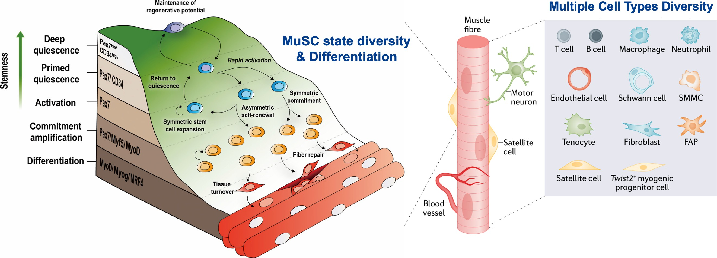
Figure 1: Overview of muscle stem-cell quiescence, activation, differentiation, and surrounding niche diver- sity during regeneration, adapted from Ancel et al. (Ancel et al., 2021) and Sousa-Victor et al. (Sousa-Victor et al., 2015).

grating pseudotime trajectory into the analysis may therefore help to capture how aging impacts MuSCs in transition.

Current State of Molecular Aging Models

Aging clocks were originally developed to summarize high-dimensional molecular data into quantitative measures of chronological or biological age. The foundational paradigm in this field was established by classical epigenetic clocks, which use DNA methylation profiles to construct chronometers across diverse tissues. While epigenetic clocks perform well in predicting chronolog- ical time and capturing stable, long-term molecular marks, they do not always reflect the immediate functional state of a cell. The field has therefore expanded to include transcriptional clocks. Be- cause they rely on RNA sequencing data, transcriptional clocks are sensitive to dynamic functional changes, shifts in cellular identity, and transient environmental stress. The framework developed in this dissertation sits within that transcriptional tradition and is intended to decode these functional state transitions. Transcriptional aging models are not uniform in their architecture. Some models regress chronological age directly, some act as biological-age proxies by capturing physiological divergence from chronological time, and others classify cells into age-associated states without estimating absolute age at all (Buckley et al., 2022; Mao et al., 2023).
Within this transcriptional framework, aging models have already been developed for bulk skeletal muscle, such as SkeletAge (Ali et al., 2025). While bulk muscle aging models can success- fully recover age-associated programs at the tissue level, they average signals across myofibres, immune cells, and other resident cell types. Consequently, they cannot cleanly isolate MuSC- specific aging states (Ali et al., 2025). Single-cell transcriptional models are far better suited to this

problem, but only if the stem-cell compartment is first purified, then organized along a biologically meaningful trajectory, and finally modeled in a donor-aware manner (Buckley et al., 2022; Kedlian et al., 2024; Walter et al., 2024; Setty et al., 2019; Kimmel et al., 2021; Kurland et al., 2023).

The Biological and Analytical Gap

Overall, this background reveals two significant gaps. At the biological level, existing studies show that MuSC aging is state dependent, but its transcriptional programs still need to be resolved more explicitly across the regenerative continuum. At the modeling level, existing aging models rarely account for populations moving along a dynamic developmental trajectory, and there is cur- rently no single-cell RNA-based age-state classifier specifically designed for MuSCs.
Recent murine muscle-related atlases have successfully recovered transitional myogenic states that are essential for interpreting regeneration (Kedlian et al., 2024; Walter et al., 2024; Kimmel et al., 2021; Kurland et al., 2023). Human skeletal muscle atlases likewise show that aging perturbs stem cells and the wider tissue microenvironment across species (Kedlian et al., 2024). While these rich datasets provide the necessary foundation for an interpretable MuSC age-state classifier, a MuSC-focused framework for training such a model to distinguish young-like from old-like MuSC transcriptional states remains missing.

Aims

The overall aim of this dissertation is to decode age-associated MuSC states while preserving the biological structure of the regenerative continuum. Because the available public datasets are heterogeneous, unevenly sampled across age, and drawn from multiple studies, the main mouse model is framed as a binary classifier of young-like versus old-like MuSC transcriptional states, rather than a continuous chronological-age regressor for individual cells.
The main contribution of this dissertation is a biologically grounded analytical workflow rather than a purely novel predictive architecture. It combines cross-study mouse MuSC atlas assembly, MuSC purification, interpretable Elastic-Net age-state modelling, and a human proof-of-concept extension to quantify age-associated MuSC states while preserving the biological structure of the myogenic continuum. Elastic-Net models combined with pseudotime trajectory modelling offer a robust and interpretable way to capture dynamic transcriptional variation in single-cell RNA se- quencing data, and this provides a strong methodological basis for the analytical strategy adopted here.

Materials and Methods

Data Collection and Study Inclusion

The mouse MuSC reference was assembled from six public single-cell sources drawn from three study-level datasets and three Tabula Muris subsets (Table 2.1). Together, these sources pro- vided MuSC profiles spanning homeostatic and regenerative muscle, multiple ages, and multiple sequencing platforms.
The initial included compendium contained 137,962 cells across these six sources. After source-specific MuSC filtering and cross-study harmonization, 11,251 cells entered the integrated MuSC atlas stage. Subsequent purification and broad state annotation yielded a 10,329-cell ref- erence manifold (Figure 2). Study-level identifiers and reported age structures are summarized in Table 2.1 and in the detailed Supplementary Table S1. Donor-group contributions are summarized in Supplementary Table S2.
Table 2.1: Summary of source datasets used for construction of the mouse MuSC training at- las (Walter et al., 2024; Oprescu et al., 2023; Kedlian et al., 2024; The Tabula Muris Consortium et al., 2020).

Source study | Raw cells | MuSC-retained | Young | Old | Used in trainable atlas
Walter et al. aging-regeneration atlas | 6,015 | 6,015 | 0 | 1,871 | Yes
Oprescu et al. Sox11 dataset | 838 | 838 | 342 | 496 | Yes
Kedlian et al. skeletal muscle atlas | 96,529 | 3,947 | 2,987 | 960 | Yes
Tabula Muris limb 10x | 28,867 | 2,055 | 846 | 1,209 | Yes
Tabula Muris limb Smart-seq2 | 3,855 | 1,833 | 535 | 1,298 | Yes
Tabula Muris diaphragm Smart-seq2 | 1,858 | 892 | 441 | 451 | Yes

Construction, Purification, and Annotation of the Integrated Mouse MuSC Atlas

To construct a unified reference manifold for cross-study MuSC aging analysis, source-specific annotations were used to retain MuSC and early myogenic populations before integration. Walter et al. (Walter et al., 2024) was filtered more broadly to include MuSC- and myoblast-annotated cells so that early myogenic states were not lost at input, whereas the other sources were restricted to lo- cal MuSC or satellite-cell labels. Gene identifiers and core metadata were then harmonized across studies, ages were binarized into shared young and old classes, and the retained subsets were con- catenated on their shared genes before restriction to cells assigned to the harmonized age groups. Age was binarized into young (approximately less than 8 months) and old (approximately greater than 18 months) based on source-reported cohort definitions. Specific age-cohort-to-binary-label

mappings were as follows: Oprescu et al. used 3–4 months as young and greater than 20 months as old; Tabula Muris used 3 months as young and 18–24 months as old; Walter et al. used approx- imately 5 months as young and 20–26 months as old; and Kedlian et al. classified approximately 3 months as young and approximately 19 months as old.
Latent representations were learned with scVI using donor-aware batch correction, followed by neighborhood graph construction, Leiden clustering, and UMAP visualization (Wolf et al., 2018; Lopez et al., 2018). To improve MuSC purity and annotation quality, the integrated atlas then under- went an additional purification stage before downstream biological interpretation. Only MuSC-like populations were retained at input, and noise-associated mitochondrial, ribosomal, metallothionein, and heat-shock genes were removed before manifold learning. Two iterative rounds of highly vari- able gene selection, scVI integration, Leiden clustering, and cluster-level filtering were then applied. After purification, highly variable genes were recomputed, canonical myogenic markers were re- tained for subtype annotation, and a final integrated manifold was generated for downstream in- terpretation (Wolf et al., 2018; Lopez et al., 2018). The purification stage removed an additional 878 cells and yielded the cleaned donor-aware atlas used for biological analysis and downstream classifier training.

Donor-Aware Partitioning

To prevent leakage in downstream split-aware analyses, donor identity was handled conser- vatively. One donor definition was used for bootstrap metacell construction, whereas a second, linkage-aware donor definition was used for train and evaluation partitioning across sources. In the current atlas build, 61 unique standardized sample identifiers were observed, of which eight recurred across two sources. All cross-source linkages occurred within the paired Tabula Muris Smart-seq2 subsets, so the maximum number of sources per linked sample was two. This pre- vented repeated biological donors from being separated across training and evaluation partitions simply because they appeared in different source files. Source-level donor-group contributions and the linked-donor summary are listed in Supplementary Table S2. This partitioning strategy supported donor-disjoint benchmarking and the explicit source-holdout evaluation based on the Kedlian atlas.

Baseline Elastic-Net Age-State Classifier

To train an interpretable donor-aware age-state classifier, the purified reference atlas was aggregated into bootstrap metacells before model fitting. Metacells were built with a target of

15 cells per aggregate and 1,000 bootstrap iterations, with donor-aware balancing across age and state bins to reduce single-cell noise while limiting overrepresentation of individual donors (Buckley et al., 2022). After expression filtering, normalization, log transformation, and selection of 1,500 highly variable genes, the training data were fit with Elastic-Net logistic regression implemented in scikit-learn (Pedregosa et al., 2011). For a bootstrap metacell with expression profile x, the model estimated the probability of an old-like state as:

P (old-like | x) =
1
1 + exp[−(β₀
+ x⊤β)] .

The optimization target was:
β 2
2

min
β₀,β

Llogistic + λ

((1 − α) 2

+ α β ₁) .

Here, x denotes the expression profile of one bootstrap metacell; β₀ and β denote the intercept and gene coefficients; λ is the regularization strength; and α controls the L1/L2 balance in the Elastic- Net penalty. Model selection was performed across a small grid of regularization and calibration settings using donor-disjoint inner splits, and the operating threshold was selected from the training branch by maximizing balanced accuracy. Key metacell-construction, preprocessing, and model- selection settings are provided in Supplementary Table S3.
Primary evaluation was performed at metacell level within donor-disjoint train and test par- titions derived from the linkage-aware donor structure described above, and an explicit source- holdout analysis treated the Kedlian atlas as an external transfer set. Thresholds were derived from the training branch and then applied unchanged to held-out metacells so that ranking perfor- mance and threshold calibration could be evaluated separately.

Local Pseudotime-Aware Modeling
To account for trajectory-dependent aging effects, a local pseudotime-aware model was de- veloped as an extension of the baseline classifier. Reference pseudotime from a Monocle3-based trajectory workflow was used to define five overlapping windows across the MuSC continuum (Cao et al., 2019). Each metacell contributed to these windows through Gaussian memberships, and window-specific Elastic-Net models were combined through membership-weighted inference rather than a single global decision boundary. For pseudotime window k, the local model estimated:

P_{k}(old-like | x) =
1
.
1 + exp[−(β^{(k)} + x⊤β(k))]
0

The final trajectory-conditioned score was computed as:
local old-like | x, t) = ∑k w_{k}(t)P_{k}(old-like | x) .
∑

P (
k
w_{k}(t)

Here, t denotes reference pseudotime, w_{k}(t) is the Gaussian membership of the metacell in window k, and β^{(k)} and β^{(k)} are window-specific coefficients. This allowed age-state scoring to vary along the regenerative trajectory while preserving the same underlying expression space as the baseline model. Key window-definition and membership-weighting settings are provided in Supplementary Table S3.
0
For post-injury application, query MuSC cells were mapped into the reference latent space with a scVI or scArches-based reference-mapping workflow (Lopez et al., 2018; Lotfollahi et al., 2022). Reference pseudotime was then transferred to the mapped cells, query metacells were generated, and the resulting metacells were scored with either the baseline whole-reference classifier or the lo- cal pseudotime-aware model. This enabled direct comparison of global and trajectory-conditioned scoring during regeneration (Kurland et al., 2023).

Human Proof-of-Concept Extension

A separate human branch was used to test whether the framework transferred to human skele- tal muscle data (Kedlian et al., 2024). The Kedlian et al. atlas classified approximately 3 months as young and approximately 19 months as old. The human input was first restricted to MuSCs, metadata were standardized, and the training cohort was limited to a male-only donor set with at least 50 raw MuSC cells per donor. Under this design, the retained donor pool contained nine male donors and yielded 18 candidate donor-disjoint young versus old holdout pairs.
The human branch used the same general metacell and Elastic-Net strategy as the mouse baseline model. Metacells were generated independently within train and holdout branches, and the feature space was restricted to 1,500 highly variable genes after removal of known confounds such as cell-cycle, mitochondrial, and sex-linked genes. Because no candidate split passed the full donor-quality gate, one screened donor-disjoint split was retained for qualitative illustration. The human analysis was therefore treated as a proof-of-concept extension rather than as a definitive large-cohort benchmark.

Code and Data Availability

Code and workflow materials for the dissertation are available at https://github.com/ CHENyiru3/BS_thesis_workflow. For reproducibility, deterministic seeds were propagated across

the workflow, including the Python, NumPy, PyTorch, and scVI random number generators. Run- level metadata were recorded for each atlas-cleaning run, and intermediate atlas states were preserved throughout the cleaning workflow. Mouse source datasets used for atlas construction and age-state modelling are listed in Table 2.1, with detailed source metadata in Supplementary Table S1. The human dataset used for the proof-of-concept analysis was taken from the Human skeletal muscle aging atlas (Kedlian et al., 2024).

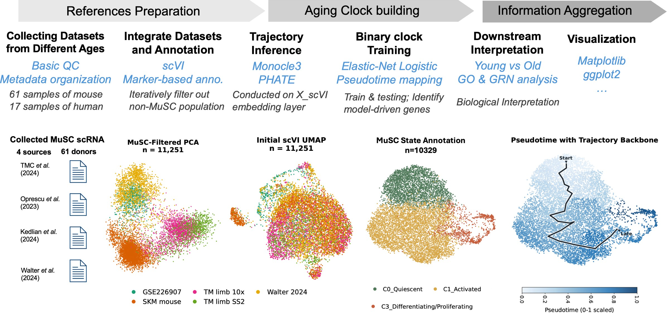

Figure 2: Workflow overview of building the mouse MuSC reference atlas. The top row traces the progres- sion from reference preparation through age-state classifier building to downstream information aggregation. The bottom row covers views from raw datasets to finalized annotated reference.

Results

Construction and Purification of the Mouse MuSC Reference Atlas

We assembled a purified mouse MuSC reference atlas from six included public sources span- ning 61 standardized donor identifiers. Cross-study integration retained 11,251 candidate MuSCs, and iterative purification produced a final 10,329-cell reference atlas with broad state annotation (Figure 2). Canonical marker distributions supported the expected myogenic structure of the atlas, with stable Pax7 retention alongside more localized Myod1 and Myog enrichment in later regions of the manifold (Supplementary Figure S1). Consequently, the annotated atlas resolved a contin- uous regenerative landscape linking quiescent, activated, and differentiating/proliferating MuSC states.
Monocle 3 reconstructed the expected progression across this manifold, providing the shared pseudotime backbone used for all subsequent trajectory-aware analyses (Figure 2) (Lopez et al., 2018; Cao et al., 2019).

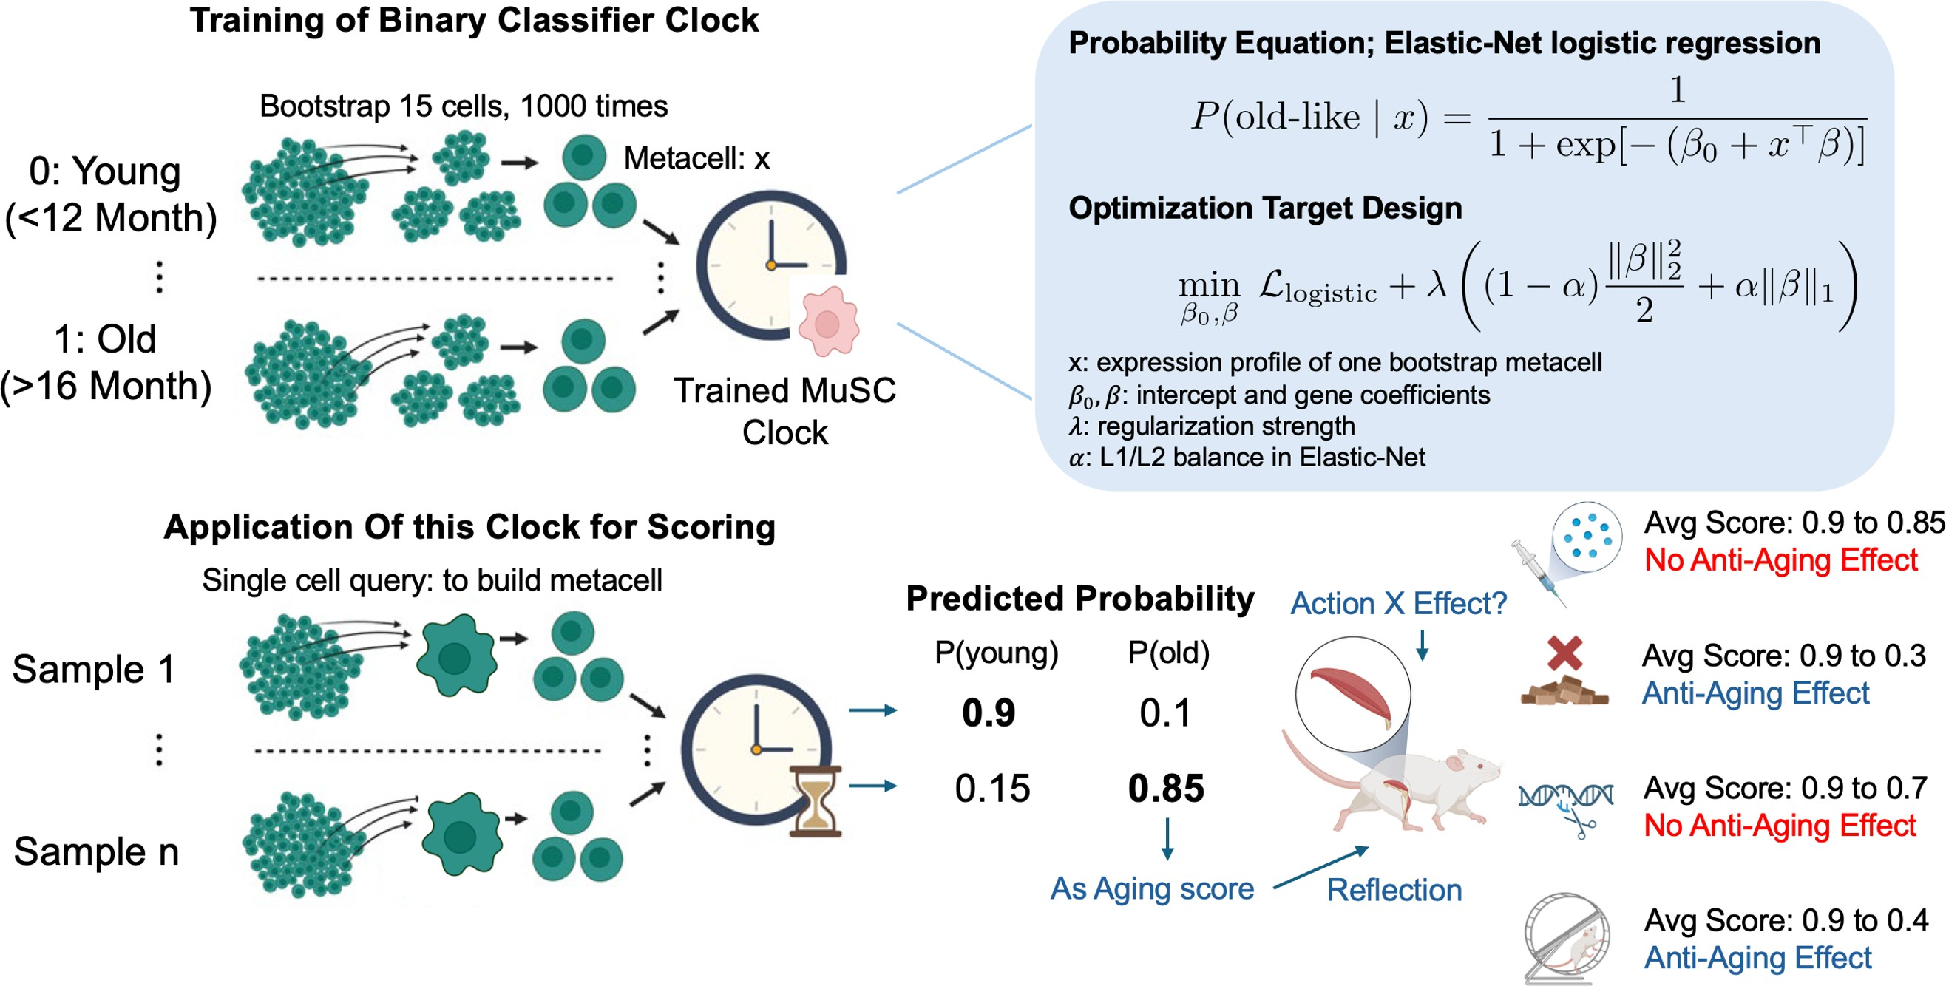
Figure 3: Baseline age-state classifier schematic for the mouse MuSC reference atlas. Bootstrap metacell generation, Elastic-Net logistic regression training, and the probability model used to score old-like MuSC states.

State-Resolved Age-Associated Programs in the Reference Atlas

State-resolved differential, pathway, and regulatory analyses showed that age-associated pro- grams were distributed across the MuSC regenerative continuum rather than confined to a sin- gle compartment. Within each annotated state, directional Wilcoxon contrasts identified young- associated genes such as Malat1, Meg3, and Thy1, whereas old-associated contrasts recovered stress-associated and fate-shifted genes including Runx2, Abcg1, and Hpgd (Figure 4). Gene Ontology (GO) enrichment confirmed a coherent functional shift across states: young cells were enriched for muscle development, aerobic respiration, and RNA-processing terms, consistent with biosynthetically active cells primed for proliferation and differentiation; old cells were enriched for programmed cell death, wound-associated pathways, altered cytoskeletal organization, and stress- related functions, suggesting that old-like cells divert toward maladaptive repair programs rather than productive regeneration (Kedlian et al., 2024; De Micheli et al., 2020; Walter et al., 2024; Hong et al., 2022; Baker et al., 2022; Zeng et al., 2023; Liu et al., 2020; Kimmel et al., 2021; Kurland et al., 2023; Haroon et al., 2022; Sousa-Victor et al., 2022).
Regulatory summaries supported the same age contrast at the network level. Across quies- cent, activated, and differentiating/proliferating states, young cells generally retained more regu- lons, broader target burdens, and higher network density than old cells, with the strongest differ- ences in the quiescent and activated compartments — the states most sensitive to aging at the stem-cell level. Young-enriched regulon targets were linked to RNA metabolism and biosynthetic

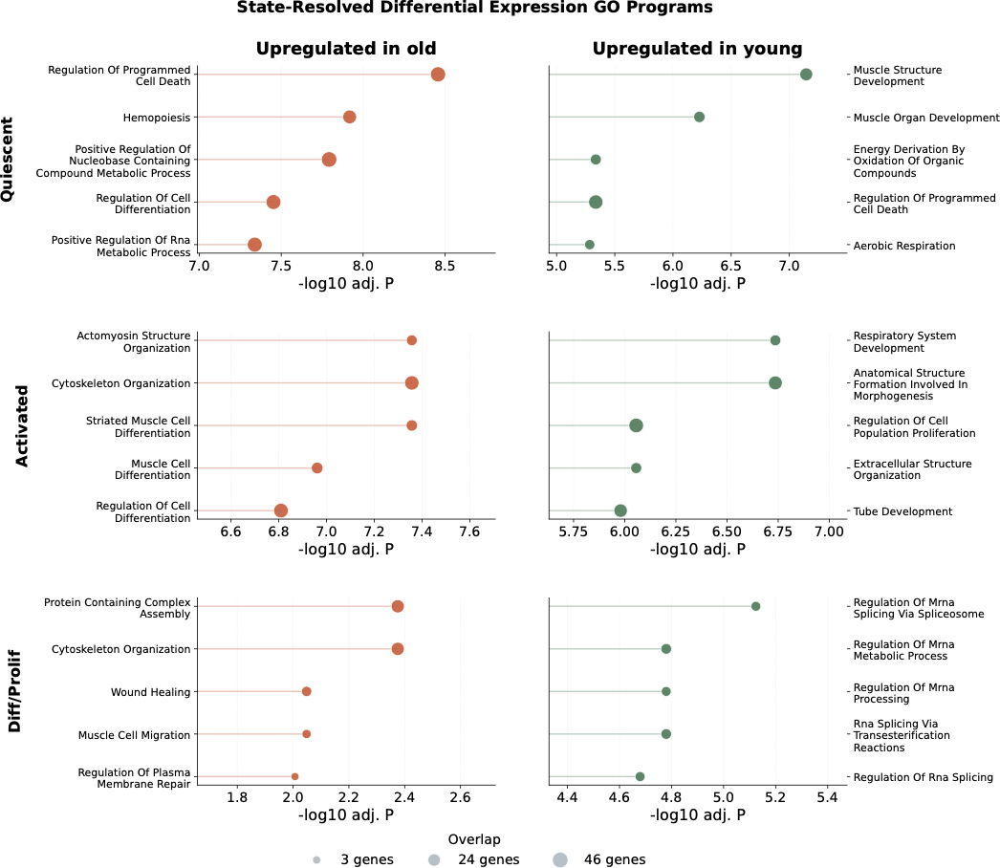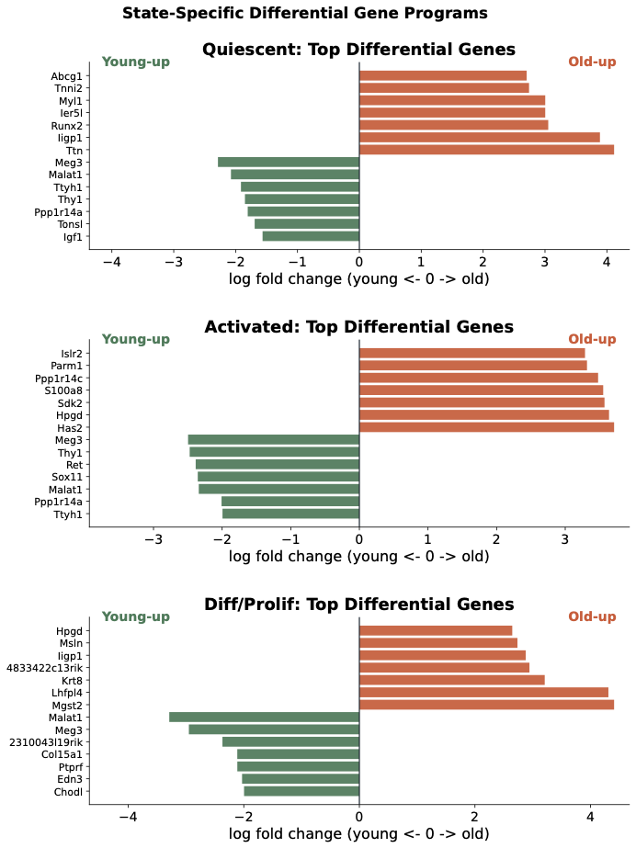
a.
b.

Figure 4: Bioinformatic analysis for state-resolved age-associated programs across the mouse MuSC refer- ence atlas. (a) Top state-specific differential expression contrasts between young and old MuSCs in quies- cent, activated, and differentiating/proliferating states, with negative log fold changes indicating young-up genes and positive log fold changes indicating old-up genes. (b) State-resolved GO enrichment for genes upregulated in old (orange, left) and young (green, right) states. The x-axis shows − log₁₀ adjusted P values, and bubble size indicates GO-term gene overlap.

control, reinforcing a picture of broad transcriptional preparedness; old-enriched targets empha- sized regulatory and stress-associated programs, indicating that the transcriptional machinery in old cells is increasingly directed toward damage management rather than productive lineage pro- gression (Supplementary Figure S2). Together, these results indicate regulatory rewiring rather than a uniform collapse: aging does not simply silence the MuSC transcriptional program, but re- shapes it toward a stress-adapted, repair-oriented configuration that reduces regenerative fidelity.

Baseline Elastic-Net Age-State Classifier

We trained a baseline whole-reference age-state classifier on donor-aware bootstrap meta- cells derived from the purified atlas (see Materials and Methods). Using 1,500 highly variable tran- scriptomic features, the Elastic-Net model estimated the probability that each metacell occupied an old-like MuSC state. The classifier showed strong discrimination in donor-disjoint evaluation, with a held-out metacell AUC of 0.999. Accordingly, the selected threshold of aproximatley 0.47 was interpreted as a dataset-specific operating point for downstream comparisons, not as a universal biological cutoff.
Despite this threshold fragility, the fitted coefficients encoded a highly interpretable, program-

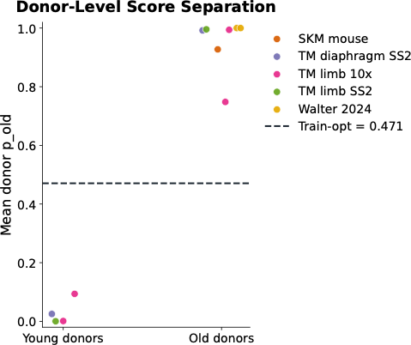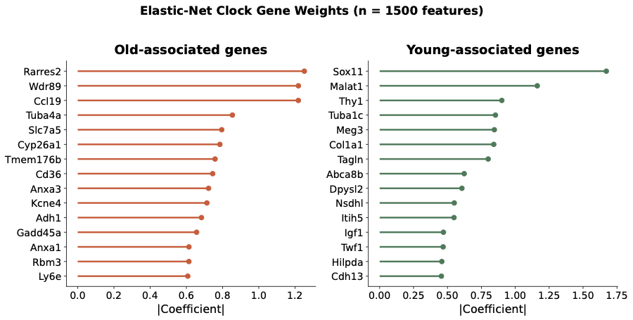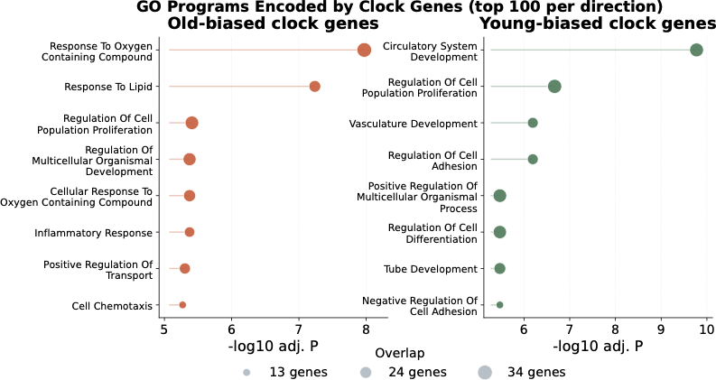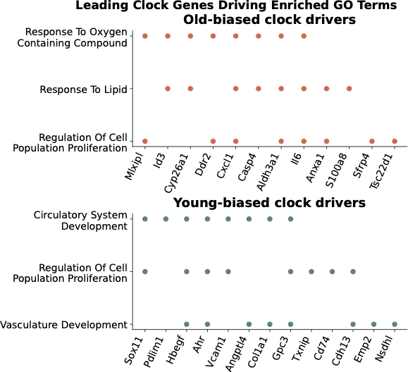
a.
b.
c.
d.
Figure 5: Baseline Elastic-Net age-state classifier performance and biological interpretation. (a) Donor-level score separation between young and old donors with training threshold. (b) Elastic-Net gene weights for old- associated and young-associated genes (n = 1,500 features). (c) GO programs encoded by top classifier genes in each direction. (d) Leading classifier genes driving selected enriched GO terms. The panels capture the shift from regenerative and adhesion-linked programs toward stress-associated, inflammatory, and lipid-response programs.

level contrast between young-like and old-like MuSC states. Young-associated features were an- chored by genes with roles in differentiation and regenerative competence. Sox11 supports activa- tion and myogenic commitment; Igf1 and Cdh13 reflect adhesion-linked and niche-coupled regen- erative support; and Malat1 and Meg3 provide broader transcriptional-state maintenance (Oprescu et al., 2023; Relaix et al., 2021; You et al., 2023). Old-associated features pointed to stress, inflammation, and matrix remodeling. Cd36 indicates lipid-response and metabolic remodeling; Gadd45a marks DNA-damage and stress-response programs; Rarres2 and Ly6e are linked to in- flammatory and interferon-context signals; and Col1a1 reflects an ECM- and fibrogenic-context signature (Choo et al., 2017; Tanaka et al., 2019; Wang et al., 2024; Boesch et al., 2022; Gallay et al., 2022). GO analysis of the strongest classifier genes reinforced this pattern, confirming a dis- tinct shift from regenerative, developmental, and adhesion-linked programs in young states toward oxygen-response, inflammatory, lipid-response, and chemotactic programs in old states (Figure 5).

Local Pseudotime-Aware Age-State Classifier

Because age-associated MuSC states are embedded within a regenerative trajectory, we next tested whether the baseline classifier could be resolved along reference pseudotime. Rather than treating pseudotime as an additional scalar covariate, the local model fitted five overlapping Elastic- Net classifiers across the MuSC continuum and combined their predictions through Gaussian win- dow memberships. This design preserved the interpretability of the baseline model while allowing the contribution of individual genes to vary between quiescent, activated, and differentiating/prolif- erating regions of the atlas.
The local model showed similar ranking performance to the whole-reference classifier. In donor-disjoint evaluation, held-out metacell AUC remained 0.999, and in the explicit SKM_mouse_raw source holdout the metacell AUC was 0.992. However, balanced accuracy on the source holdout increased from 0.50 to 0.60, suggesting that local trajectory weighting modestly improved threshold transfer even when global ranking performance was already saturated. Thus, the main value of the pseudotime-aware model was not higher discrimination, but improved resolution of where age- state signals were expressed along the regenerative continuum.
Coefficient dynamics showed that the age-associated program was partly stable but not fixed. Some features retained consistent old-like or young-like directionality across windows, whereas others changed their relative contribution as metacells moved through pseudotime. For exam- ple, Sox11, Myl4, and Postn showed window-dependent changes in predictive weight, indicating that the genes most informative of age state depended on local regenerative context. This sup- ports a trajectory-aware interpretation of MuSC aging: old-like identity is not encoded by a single uniform signature, but by a changing balance of gene programs across the regenerative path (Fig- ure 6) (Oprescu et al., 2023; Kedlian et al., 2024; De Micheli et al., 2020).

Application to Post-Injury Regeneration

We next tested whether the model could be applied in an exploratory post-injury setting by scoring an independent MuSC dataset (Walter et al., 2024).
This analysis projected the reference-defined age-state models onto active regenerative stress dynamics. Both scoring modes recovered a shared temporal structure across young, old, and geri- atric groups: an early score increase immediately following injury, an intermediate decline during recovery, and a later return toward baseline (Figure 7).
scArches-based mapping placed these post-injury cells onto the reference manifold prior to scoring, therefore each cell can have its own position in the model (Supplementary Figure S3). Day-

a. Pseudotime-awared mode b. Pseudotime-awared mode
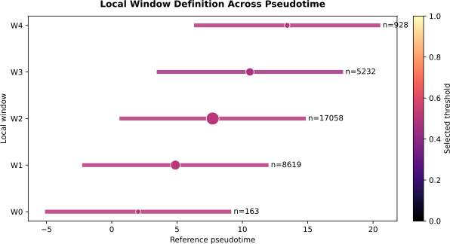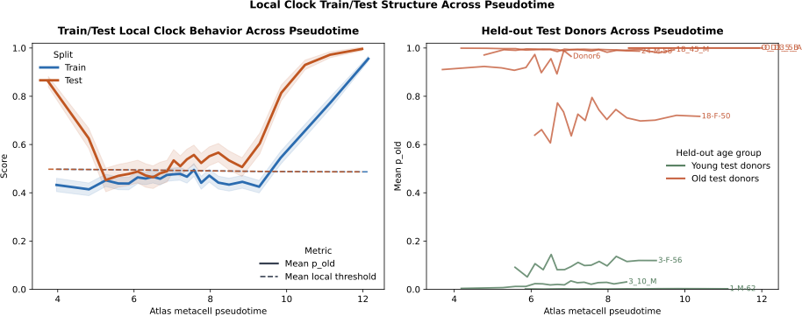
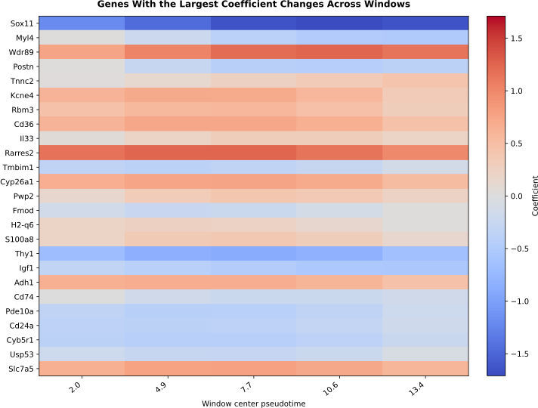
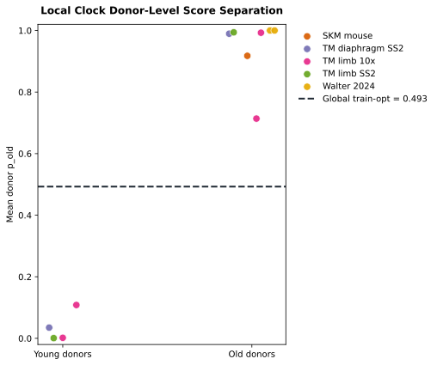
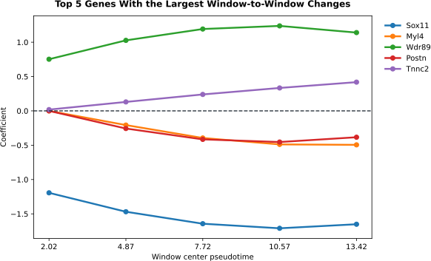
c. Windown-Averged Donor-level Score d. Gene coefficient Changes
e.
Top 5 Gene Changes Across windows

Figure 6: Local pseudotime-aware classifier construction and window-dependent gene behavior. (a) Def- inition of five local windows (W0–W4) across reference pseudotime with sample counts per window. (b) Local classifier train and test behavior across the trajectory, and held-out donor score trajectories across pseudotime. (c) Window-averaged donor-level scores with a global decision threshold. (d) Gene coefficient heatmap dynamics across window centers, and top five gene coefficient trajectories across windows. Age- associated gene importance changes along the regenerative path, rather than remaining fixed across the reference atlas.

resolved summaries showed that old-like scores peaked early and declined during recovery, with young groups returning toward baseline substantially faster than old and geriatric groups, which remained elevated for longer.
Pseudotime-resolved scoring sharpened this temporal pattern. Early post-injury states, par- ticularly between days 1 and 3.5, occupied the highest-scoring regions of the reference trajec- tory, whereas uninjured and late-recovery cells scored much lower. Older and geriatric groups remained elevated for longer across this mapped continuum, consistent with delayed resolution of stress-associated MuSC states during aged regeneration (Walter et al., 2024; Blanc et al., 2020; McArthur et al., 2020; Sousa et al., 2024; Moiseeva et al., 2023; Riparini et al., 2025; Zhu et al., 2025; Kurland et al., 2023). These transiently elevated scores are therefore best interpreted as age-state burden under regenerative demand rather than as literal acceleration of chronological aging.

Human Proof-of-Concept Extension

We finally tested whether the reference-construction and interpretable age-state modeling strategy could be transferred to human skeletal muscle. A staged analytical branch produced a

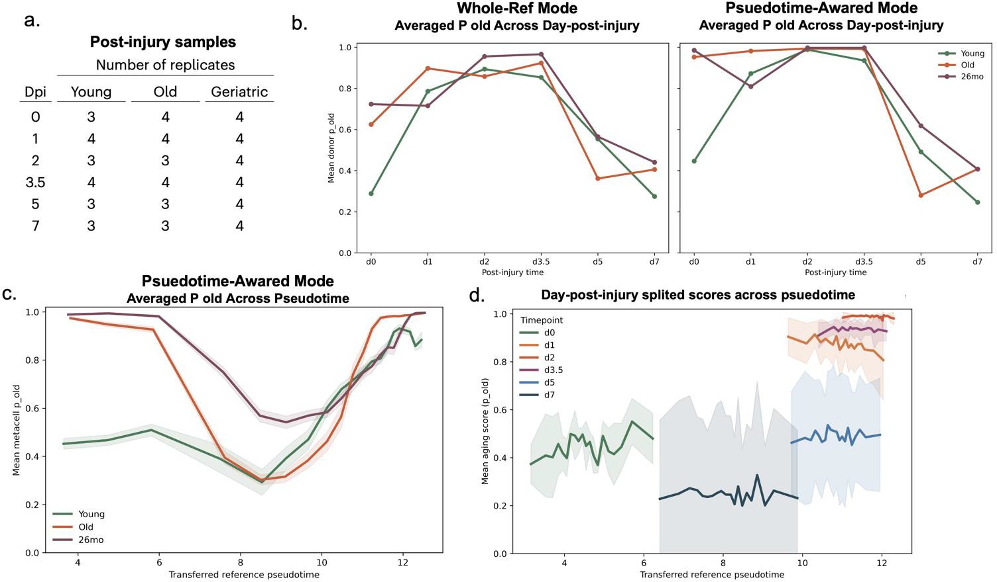

Figure 7: Post-injury age-state exploratory application of whole-reference and pseudotime-aware classifier modes to post-injury MuSC data. (a) Replicate counts across post-injury days for young, old, and geriatric groups. (b) Mean donor p_{o}ld across post-injury days in whole-reference and pseudotime-aware modes. (c) Averaged p_{o}ld across transferred reference pseudotime for each age group. (d) Day-specific score trajec- tories across transferred reference pseudotime. Regeneration transiently increases old-like transcriptional scores, with older groups remaining elevated for longer during recovery.

moderate-sized human MuSC reference derived from male donors only, with at least 50 MuSC cells per donor as a minimum quality threshold. Despite this, the retained donor pool was small, and no candidate donor-disjoint split fully passed the quality gate for robust benchmarking. One screened split was therefore retained for qualitative illustration only (Figure 8). This integration recovered a coherent manifold preserving age and donor structure, and the preliminary Elastic-Net program ex- tracted structured age-associated signals: old-associated weights included MTRNR2L8, TAGLN, CFD, and CRLF1, whereas young-associated weights featured IER3, PEG10, CTGF, and DLK1, consistent with the young-old functional contrast seen in the mouse atlas. GO pathway enrichment further supported the same direction, confirming that the atlas-plus-classifier architecture can re- cover age-associated programs in human MuSCs. The human branch is therefore presented as a proof-of-concept rather than a validated benchmark: larger and more balanced human MuSC cohorts are needed before the framework can be rigorously evaluated in a cross-species context.

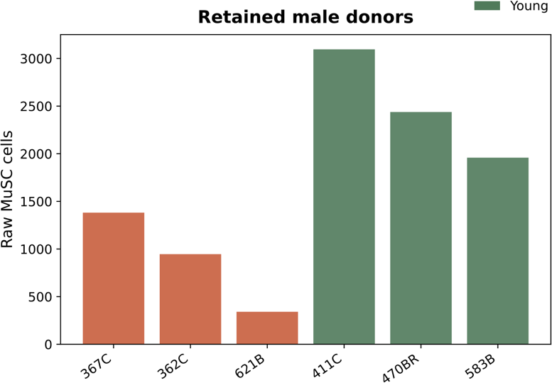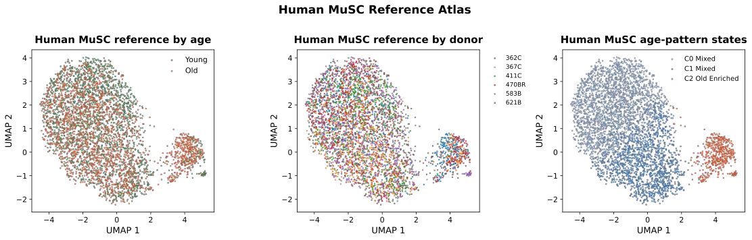
a. Human MuSC references Collection b.
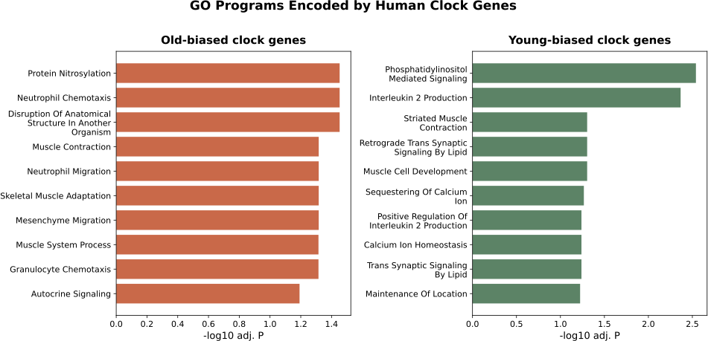
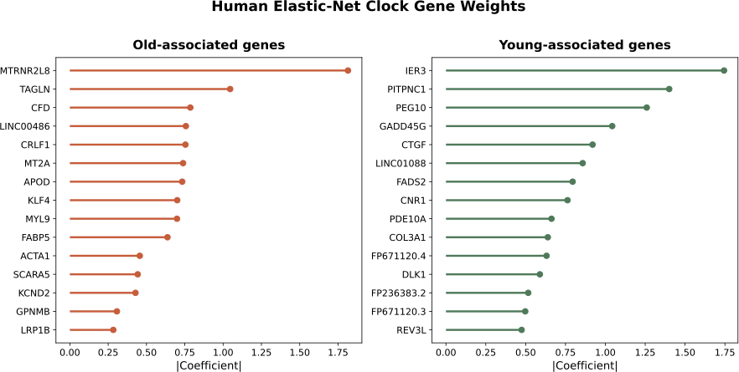
c.
d.
Figure 8: Human MuSC proof-of-concept extension. (a) Retained male donor cell counts by age group. (b) Human reference atlas colored by age, donor, and broad age-pattern state. (c) Human Elastic-Net gene weights for old-associated and young-associated genes. (d) GO programs encoded by human classifier genes for old-biased and young-biased gene sets. This suggests the atlas-plus-interpretable-classifier ap- proach can be transferred to human MuSC data.

Discussion

Overview

The mouse reference atlas, the baseline age-state classifier, and the pseudotime-aware exten- sion point to the same conclusion: MuSC aging is better understood as a redistribution of young-like and old-like transcriptional states across the regenerative continuum than as a single static signa- ture of old cells. Aging appears through shifts in state composition, trajectory position, and the balance between stress-associated and regenerative programs, rather than through one uniform transcriptional endpoint.
The main contribution of this dissertation is an interpretable age-state classifier built on a curated single-cell MuSC reference atlas, not a universal biological-age clock. The framework is designed to identify and localize old-like transcriptional states within a biologically structured manifold. The framework developed here addresses the more immediate problem of resolving age-associated heterogeneity within the MuSC compartment.

Biological Interpretation

The reference atlas and classifier support a view of MuSC aging as a state-dependent reor- ganization across the regenerative continuum. Young-like states retained stronger developmen- tal, metabolic, and RNA-processing programs, whereas old-like states were enriched for stress- associated, inflammatory, and remodeling-linked programs. The clearest divergence appeared in the earlier MuSC compartments, suggesting that aging is closely tied to quiescence depth, activa- tion readiness, and the maintenance of a functionally competent reserve state (Ancel et al., 2021; Sousa-Victor et al., 2022; van Velthoven and Rando, 2019; Tumpel and Rudolph, 2019; Chen et al., 2020; Chakkalakal et al., 2012; Blau et al., 2015).
This pattern argues against treating old-like MuSCs as simply inactive cells. Quiescence it- self can be protective, and transient stress-like programs can also arise during normal regener- ation (Young et al., 2022; Walter et al., 2024). What distinguished the old-like side of the atlas was not low activity alone, but the combination of reduced developmental preparedness with in- creased stress, inflammatory, and remodeling-associated programs. Recent atlas-scale studies support the same view: MuSC dysfunction becomes clearest when state occupancy and regenera- tive timing are considered together (Kedlian et al., 2024; De Micheli et al., 2020; Walter et al., 2024;

Kimmel et al., 2021; Kurland et al., 2023). This suggests that futher researh into state-resolved age modeling may yield additional insights into the regenerative potential of aged MuSCs.
The pathway structure also places MuSC aging in a broader tissue context. Young-like states aligned more closely with preserved metabolic competence and regenerative niche coupling. Old- like states pointed more strongly toward inflammatory and extracellular-matrix remodeling con- texts (Murphy et al., 2011; Verma et al., 2018; Lukjanenko et al., 2019; Moiseeva et al., 2023; Riparini et al., 2025; Stearns-Reider et al., 2017; Zhou et al., 2019; Hong et al., 2022; Baker et al., 2022; Zeng et al., 2023; Liu et al., 2020; Haroon et al., 2022). The regulon summaries were direc- tionally consistent with the same picture, supporting regulatory rewiring and reduced coordination in old-like states rather than a simple, uniform collapse of all regulatory networks.
The post-injury application extended this picture into a dynamic setting: older groups remained in old-like transcriptional territory for longer during repair, but this reflects projection of a reference- derived age-state model onto regenerative stress dynamics rather than a direct measure of biolog- ical age during injury.

Methodological Strengths

One of the main strengths of the study is the order of operations. Rather than fitting a su- pervised model directly on heterogeneous public data, the analysis first assembled and purified a MuSC-centered reference atlas and harmonized donor and age metadata before training the classifier. This atlas-first strategy reduced the risk that apparent age prediction would be driven by non-myogenic contamination, study composition, or donor leakage.
The model design also matched the biological question. Because aging-associated differ- ences were distributed across correlated genes and across multiple MuSC states, a multivariate model was needed. At the same time, interpretability mattered more than architectural novelty. For that reason, the study prioritized Elastic-Net logistic regression over more complex black-box models. This choice allowed the decision boundary to remain traceable to genes, pathways, and state structure in the reference atlas while still achieving strong discrimination between young-like and old-like metacell profiles.
The pseudotime-aware extension also added biological resolution. Although the local win- dowed model only modestly improved source transfer, it showed that some age-associated sig- nals remained stable across the regenerative continuum whereas others were strongly trajectory- dependent.

Limitations

The scope of the dissertation is shaped by several limitations. The analysis depends on pub- lic datasets that differ in age coverage, sampling design, annotation vocabulary, and technical origin. As a result, batch effects remain an important challenge for transferable thresholding and cross-source calibration. This issue is particularly difficult here because biological interpretation requires gene-level input for classifier training. Methods such as scVI can remove batch effects effectively in latent space, but they compress the gene-feature axis and therefore reduce direct gene-level interpretability. This study instead used log-transformed gene-expression matrices, to- gether with MuSC-focused purification and pseudotime-windowed modeling, to reduce these ef- fects while retaining interpretable coefficients. Even so, batch-related calibration error cannot yet be fully eliminated.
The model should also be interpreted as an age-state classifier rather than as a calibrated molecular measure of absolute biological age. It distinguishes young-like and old-like MuSC tran- scriptional programs, but does not yet establish a continuous age scale for individual cells or donors. This limitation is especially important in regenerative and cross-species settings, where score shifts may reflect altered state occupancy, stress burden, or niche exposure in addition to chronological aging (Buckley et al., 2022; Mao et al., 2023; Voisin et al., 2020; Trapp et al., 2021). In post-injury data specifically, injury-associated stress remains a major confounder.
Finally, the study remains primarily associative rather than causal. The atlas, classifier, and downstream pathway analyses identify transcriptional programs and state distributions associated with aging, but they do not by themselves establish which genes or pathways are causal drivers of MuSC dysfunction.

Future Directions

Cross-source calibration should be strengthened in future work.cross-source through larger age-balanced MuSC cohorts and more standardized preprocessing. A larger and more uniformly curated reference would stabilize donor-level thresholds and provide a stronger basis for continu- ous age prediction instead of the current binary young-like versus old-like framing. Cross-species expansion and prospective human validation would further strengthen generalizability.
The framework should also move toward causal interpretation. The classifier identifies genes and programs informative of old-like states, but cannot yet determine which actively drive MuSC ag- ing. Recurrent young-associated and old-associated features could be prioritized for perturbational follow-up in primary MuSC systems or in vivo injury models to distinguish causal regulators from

correlates of state shifts. Therefore, wet-lab validation is essential to verify the results. Transcrip- tomic predictions require experimental confirmation through targeted marker validation, functional assays of activation and self-renewal, and regeneration assays following candidate-gene pertur- bation to move these predictions toward functional confirmation.

Conclusion

In this study, we developed a donor-aware, single-cell analytical framework to decode tran- scriptional states in aging skeletal muscle stem cells. By integrating public mouse datasets into a reference atlas and training an Elastic-Net classifier on donor-aware metacells, we obtained an age-state model directly linked to the regenerative continuum.
Biologically, the data show MuSC aging not as a uniform static signature but as a state- dependent shift across the myogenic trajectory, pushing cells toward maladaptive, stress- associated, and inflammatory transcriptional states. This pattern was supported by state-resolved differential expression, Gene Ontology enrichment, regulatory network analyses, and the fitted classifier coefficients. The Elastic-Net model achieved robust metacell-level discrimination in donor-disjoint evaluation. Its coefficients map directly to specific genes and pathways, making the biological basis of age-state scoring interpretable rather than opaque.
The local pseudotime-aware extension did not outperform the baseline model in ranking, but it captured dynamic transcriptional signals that the baseline cannot. By tracking gene weights across trajectory windows, this extension showed that the age-associated program is not fixed. Instead, the genes most informative of an old-like state shift depending on the cell’s local regenerative context. This provides biological resolution beyond the baseline: the aging signature evolves as cells transition through the regenerative continuum, while the extension also modestly improved threshold transfer between data sources.
The human proof-of-concept showed that the same framework recovers age-associated sig- nals in human MuSCs, though the donor pool is currently too small for rigorous cross-species validation.
Key limitations include the fragility of cross-study threshold transfer when applying the clas- sifier to unseen datasets, and the binary young-versus-old framing imposed by uneven age cov- erage in public data. Future work should prioritize assembling larger, age-balanced cohorts with standardized metadata to move beyond binary classification toward continuous age prediction. Im- proved cross-source calibration methods would reduce batch-related error and stabilize threshold transfer between studies. Prospective validation on larger human skeletal muscle datasets would test whether the atlas-plus-classifier architecture generalizes beyond mouse models.

References

Muhammad Ali, Fei Li, and Manpreet Katari. Skeletage: Transcriptomics-based aging clock identifies 26 new targets in skeletal muscle aging, 2025. URL https://doi.org/10.1101/2025.07.28.667277.

Sara Ancel, Pascal Stuelsatz, and Jerome N. Feige. Muscle stem cell quiescence: Controlling stemness by staying asleep. Trends in Cell Biology, 31(7):556–568, 2021. ISSN 09628924. doi: 10.1016/j.tcb.2021.02.006. URL
https://linkinghub.elsevier.com/retrieve/pii/S0962892421000313.

Nicole Baker et al. The mitochondrial protein OPA1 regulates the quiescent state of adult muscle stem cells. Cell Stem Cell, 2022. doi: 10.1016/j.stem.2022.07.010. URL https://doi.org/10.1016/j.stem.2022.07.010.

Romeo S. Blanc, Jacob G. Kallenbach, John F. Bachman, et al. Inhibition of inflammatory CCR2 signaling promotes aged muscle regeneration and strength recovery after injury. Nature Communications, 2020. doi: 10.1038/s41467-020-17620-8. URL https://doi.org/10.1038/s41467-020-17620-8.

Helen M. Blau, Benjamin D. Cosgrove, and Aaron T. V. Ho. The central role of muscle stem cells in regenerative failure with aging. Nature Medicine, 21:854–862, 2015. doi: 10.1038/nm.3918.
URL https://doi.org/10.1038/nm.3918.

Julia Boesch, Elodie Pierrel, Carole Lambert, Anne Doelemeyer, Jennifer Kreider, Nathalie Accart, and Serge Summermatter. Chemokine-like receptor 1 plays a critical role in modulating the regenerative and contractile properties of muscle tissue. Frontiers in Physiology, 13:1044488, 2022. doi: 10.3389/fphys.2022.1044488. URL https://doi.org/10.3389/fphys.2022.1044488.

Anne Brunet, Margaret A. Goodell, and Thomas A. Rando. Ageing and rejuvenation of tissue stem cells and their niches. Nature Reviews Molecular Cell Biology, 2022. doi: 10.1038/s41580-022-00510-w. URL https://doi.org/10.1038/s41580-022-00510-w.

Matthew T. Buckley, Eric D. Sun, Benson M. George, Ling Liu, Nicholas Schaum, Lucy Xu,
Jaime M. Reyes, Margaret A. Goodell, Irving L. Weissman, Tony Wyss-Coray, Thomas A. Rando,

and Anne Brunet. Cell-type-specific aging clocks to quantify aging and rejuvenation in neurogenic regions of the brain. Nature Aging, 3(1):121–137, 2022. ISSN 2662-8465. doi: 10.1038/s43587-022-00335-4. URL https://www.nature.com/articles/s43587-022-00335-4.

Junyue Cao, Malte Spielmann, Xiaojie Qiu, Xingfan Huang, Daniel M. Ibrahim, Andrew J. Hill, Fan Zhang, Stefan Mundlos, Lena Christiansen, Frank J. Steemers, Cole Trapnell, and Jay Shendure. The single-cell transcriptional landscape of mammalian organogenesis. Nature, 2019. doi: 10.1038/s41586-019-0969-x. URL https://doi.org/10.1038/s41586-019-0969-x.

Jacqueline V. Chakkalakal, Katherine M. Jones, M. Albert Basson, and Andrew S. Brack. The aged niche disrupts muscle stem cell quiescence. Nature, 490:355–360, 2012. doi: 10.1038/nature11438. URL https://doi.org/10.1038/nature11438.

Weicheng Chen, Dan Datzkiw, and Michael A. Rudnicki. Satellite cells in ageing: use it or lose it. Open Biology, 10:200048, 2020. doi: 10.1098/rsob.200048. URL https://doi.org/10.1098/rsob.200048.

Zhexu Chi, Sheng Chen, Dehang Yang, Wenyu Cui, Yang Lu, Zhen Wang, Mobai Li, Weiwei Yu, Jian Zhang, Yu Jiang, Ruya Sun, Qianzhou Yu, Tianyi Hu, Xiaoyang Lu, Qiqi Deng, Yidong Yang, Tianming Zhao, Mengfei Chang, Yuying Li, Xue Zhang, Min Shang, Qian Xiao, Kefeng Ding, and Di Wang. Gasdermin d-mediated metabolic crosstalk promotes tissue repair. Nature, 634(8036): 1168–1177, 2024. ISSN 0028-0836, 1476-4687. doi: 10.1038/s41586-024-08022-7. URL
https://www.nature.com/articles/s41586-024-08022-7.

Hyo-Jung Choo, James P. Canner, Katherine E. Vest, Zachary Thompson, and Grace K. Pavlath. A tale of two niches: differential functions for VCAM-1 in satellite cells under basal and injured conditions. American Journal of Physiology-Cell Physiology, 313:C392–C404, 2017. doi: 10.1152/ajpcell.00119.2017. URL https://doi.org/10.1152/ajpcell.00119.2017.

Andrea J. De Micheli, Emily J. Laurilliard, Charles L. Heinke, Hiranmayi Ravichandran, Paula Fraczek, Sharon Soueid-Baumgarten, Iwijn De Vlaminck, Olivier Elemento, and Benjamin D. Cosgrove. Single-cell analysis of the muscle stem cell hierarchy identifies heterotypic communication signals involved in skeletal muscle regeneration. Cell Reports, 30(10): 3583–3595.e5, 2020. ISSN 22111247. doi: 10.1016/j.celrep.2020.02.067. URL
https://linkinghub.elsevier.com/retrieve/pii/S2211124720302357.

Laure Gallay, Cécile Fermon, Lola Lessard, Michèle Weiss-Gayet, Sébastien Viel, Nathalie

Streichenberger, Armelle Corpet, Rémi Mounier, Cyril Gitiaux, Guy Mouchiroud, and Bénédicte Chazaud. Involvement of type I interferon signaling in muscle stem cell proliferation during dermatomyositis. Neurology, 98(20):e2108–e2119, 2022. doi: 10.1212/WNL.0000000000200271. URL https://doi.org/10.1212/WNL.0000000000200271.

Mohammad Haroon, Heleen E. Boers, Astrid D. Bakker, et al. Reduced growth rate of aged muscle stem cells is associated with impaired mechanosensitivity. Aging, 14, 2022. URL https://www.aging-us.com/article/203830/text.

Xiaotong Hong, Joan Isern, Silvia Campanario, et al. Mitochondrial dynamics maintain muscle stem cell regenerative competence throughout adult life by regulating metabolism and mitophagy. Cell Stem Cell, 29(9):1298–1314.e10, 2022. doi: 10.1016/j.stem.2022.07.009. URL
https://doi.org/10.1016/j.stem.2022.07.009.

Veronika R. Kedlian, Yaning Wang, Tianliang Liu, Xiaoping Chen, Liam Bolt, Catherine Tudor, Zhuojian Shen, Eirini S. Fasouli, Elena Prigmore, Vitalii Kleshchevnikov, Jan Patrick Pett, Tong Li, John E. G. Lawrence, Shani Perera, Martin Prete, Ni Huang, Qin Guo, Xinrui Zeng, Lu Yang, Krzysztof Polański, Nana-Jane Chipampe, Monika Dabrowska, Xiaobo Li, Omer Ali Bayraktar, Minal Patel, Natsuhiko Kumasaka, Krishnaa T. Mahbubani, Andy Peng Xiang, Kerstin B. Meyer, Kourosh Saeb-Parsy, Sarah A. Teichmann, and Hongbo Zhang. Human skeletal muscle aging atlas. Nature Aging, 4(5):727–744, 2024. ISSN 2662-8465. doi: 10.1038/s43587-024-00613-3.
URL https://www.nature.com/articles/s43587-024-00613-3.

Jacob C. Kimmel, Nelda Yi, Margaret Roy, David G. Hendrickson, and David R. Kelley. Differentiation reveals latent features of aging and an energy barrier in murine myogenesis. Cell Reports, 2021. doi: 10.1016/j.celrep.2021.109046. URL https://doi.org/10.1016/j.celrep.2021.109046.

Jesse V. Kurland, Alicia A. Cutler, Jacob T. Stanley, Nicole Dalla Betta, Ashleigh Van Deusen, Brad Pawlikowski, Monica Hall, Tiffany Antwine, Alan Russell, Mary Ann Allen, Robin Dowell, and Bradley Olwin. Aging disrupts gene expression timing during muscle regeneration. Stem Cell Reports, 2023. doi: 10.1016/j.stemcr.2023.05.005. URL https://doi.org/10.1016/j.stemcr.2023.05.005.

Yuguo Liu, Yangjun Luo, Lei Shen, Ruochen Guo, Zheng Zhan, Ningyang Yuan, Rula Sha, Wenju Qian, Zhenzhen Wang, Zhiqin Xie, Wenwu Wu, and Ying Feng. Splicing factor SRSF1 is

essential for satellite cell proliferation and postnatal maturation of neuromuscular junctions in mice. Stem Cell Reports, 2020. doi: 10.1016/j.stemcr.2020.08.004. URL https://doi.org/10.1016/j.stemcr.2020.08.004.

Romain Lopez, Jeffrey Regier, Michael B. Cole, Michael I. Jordan, and Nir Yosef. Deep generative modeling for single-cell transcriptomics. Nature Methods, 2018. doi: 10.1038/s41592-018-0229-2. URL https://doi.org/10.1038/s41592-018-0229-2.

Mohammad Lotfollahi, Mohsen Naghipourfar, Malte D. Luecken, Mina Khajavi, Maren Buttner, Ziga Avsec, Adam Gayoso, Nir Yosef, Marta Interlandi, and Fabian J. Theis. Mapping single-cell data to reference atlases by transfer learning. Nature Biotechnology, 2022. doi: 10.1038/s41587-021-01001-7. URL https://doi.org/10.1038/s41587-021-01001-7.

Laura Lukjanenko, Sonia Karaz, Pascal Stuelsatz, et al. Aging disrupts muscle stem cell function by impairing matricellular WISP1 secretion from fibro-adipogenic progenitors. Cell Stem Cell, 2019. doi: 10.1016/j.stem.2018.12.014. URL https://doi.org/10.1016/j.stem.2018.12.014.

Shulin Mao, Jiayu Su, Longteng Wang, Xiaochen Bo, Cheng Li, and Hebing Chen. A transcriptome-based single-cell biological age model and resource for tissue-specific aging measures. Genome Research, 2023. doi: 10.1101/gr.277491.122. URL https://www.genome.org/cgi/doi/10.1101/gr.277491.122.

Simon McArthur, Gaetan Juban, Thomas Gobbetti, et al. Annexin A1 drives macrophage skewing to accelerate muscle regeneration through AMPK activation. Journal of Clinical Investigation, 130 (3):1156–1167, 2020. doi: 10.1172/JCI124635. URL https://doi.org/10.1172/JCI124635.

Victoria Moiseeva et al. Senescence atlas reveals an aged-like inflamed niche that blunts muscle regeneration. Nature, 2023. doi: 10.1038/s41586-022-05535-x. URL https://doi.org/10.1038/s41586-022-05535-x.

Meghan M. Murphy, James A. Lawson, Shahragim J. Mathew, David A. Hutcheson, and Gabrielle Kardon. Satellite cells, connective tissue fibroblasts and their interactions are crucial for muscle regeneration. Development, 138:3625–3637, 2011. doi: 10.1242/dev.064162. URL https://doi.org/10.1242/dev.064162.

Stephanie N. Oprescu, Nick Baumann, Xiyue Chen, Qiang Sun, Yu Zhao, Feng Yue, Huating Wang, and Shihuan Kuang. Sox11 is enriched in myogenic progenitors but dispensable for

development and regeneration of the skeletal muscle. Skeletal Muscle, 13(1):15, 2023. ISSN 2044-5040. doi: 10.1186/s13395-023-00324-0. URL
https://skeletalmusclejournal.biomedcentral.com/articles/10.1186/s13395-023-00324-0.

Fabian Pedregosa, Gael Varoquaux, Alexandre Gramfort, Vincent Michel, Bertrand Thirion, Olivier Grisel, Mathieu Blondel, Peter Prettenhofer, Ron Weiss, Vincent Dubourg, Jake Vanderplas, Alexandre Passos, David Cournapeau, Matthieu Brucher, Matthieu Perrot, and Edouard Duchesnay. Scikit-learn: Machine learning in python. Journal of Machine Learning Research, 12:2825–2830, 2011. URL https://jmlr.org/papers/v12/pedregosa11a.html.

F. Relaix, M. Bencze, M. J. Borok, A. Der Vartanian, F. Gattazzo, D. Mademtzoglou,
S. Perez-Diaz, A. Prola, P. C. Reyes-Fernandez, A. Rotini, and V. Taglietti. Perspectives on skeletal muscle stem cells. Nature Communications, 12(1):692, 2021. ISSN 2041-1723. doi: 10.1038/s41467-020-20760-6. URL https://www.nature.com/articles/s41467-020-20760-6.

Giulia Riparini, Morgan Mackenzie, Faiza Naz, Stephen Brooks, Kan Jiang, Anshu Deewan, Brittany Dulek, Shamima Islam, Kyung Dae Ko, Wanxia L. Tsai, Massimo Gadina, Stefania Dell’Orso, and Vittorio Sartorelli. Epigenetic dysregulation in aged muscle stem cells drives mesenchymal progenitor expansion via IL-6 and Spp1 signaling. Nature Aging, 2025. doi: 10.1038/s43587-025-01002-0. URL https://doi.org/10.1038/s43587-025-01002-0.

Manu Setty, Vaidotas Kiseliovas, Jacob Levine, Adam Gayoso, Linas Mazutis, and Dana Pe’er. Characterization of cell fate probabilities in single-cell data with palantir. Nature Biotechnology, 37(4):451–460, 2019. ISSN 1087-0156, 1546-1696. doi: 10.1038/s41587-019-0068-4. URL
https://www.nature.com/articles/s41587-019-0068-4.

Neuza S. Sousa, Marta Bica, Margarida F. Brás, Ana C. Sousa, Inês B. Antunes, Isabel A. Encarnação, Tiago M. Costa, Inês B. Martins, Nuno L. Barbosa-Morais, Pedro Sousa-Victor, and Joana Neves. The immune landscape of murine skeletal muscle regeneration and aging. Cell Reports, 43(11):114975, 2024. ISSN 22111247. doi: 10.1016/j.celrep.2024.114975. URL
https://linkinghub.elsevier.com/retrieve/pii/S2211124724013263.

Pedro Sousa-Victor, Sara Gutarra, Laura García-Prat, Javier Rodriguez-Ubreva, Laura Ortet, Verónica Ruiz-Bonilla, Marta Jardí, Esteban Ballestar, Sara González, Manuel Serrano, Eusebio Perdiguero, and Pura Muñoz-Cánoves. Muscle stem cell aging: regulation and rejuvenation.
Trends in Endocrinology & Metabolism, 26(6):287–296, 2015. ISSN 1043-2760. doi:

10.1016/j.tem.2015.03.006. URL https://doi.org/10.1016/j.tem.2015.03.006.

Pedro Sousa-Victor, Laura García-Prat, and Pura Muñoz-Cánoves. Control of satellite cell function in muscle regeneration and its disruption in ageing. Nature Reviews Molecular Cell Biology, 23(3):204–226, 2022. ISSN 1471-0072, 1471-0080. doi: 10.1038/s41580-021-00421-2.
URL https://www.nature.com/articles/s41580-021-00421-2.

Kristen M. Stearns-Reider, Antonio D’Amore, Kevin Beezhold, Benjamin Rothrauff, Loredana Cavalli, William R. Wagner, David A. Vorp, Alkiviadis Tsamis, Sunita Shinde, Changqing Zhang, Aaron Barchowsky, Thomas A. Rando, Rocky S. Tuan, and Fabrisia Ambrosio. Aging of the skeletal muscle extracellular matrix drives a stem cell fibrogenic conversion. Aging Cell, 16(3): 518–528, 2017. doi: 10.1111/acel.12578. URL https://doi.org/10.1111/acel.12578.

Yoshimitsu Tanaka, Shunbun Kita, Hitoshi Nishizawa, Shiro Fukuda, Yuya Fujishima, Yoshinari Obata, Hirofumi Nagao, Shigeki Masuda, Yuto Nakamura, Yuri Shimizu, Ryohei Mineo, Tomoaki Natsukawa, Tohru Funahashi, Barbara Ranscht, So-ichiro Fukada, Norikazu Maeda, and Iichiro Shimomura. Adiponectin promotes muscle regeneration through binding to T-cadherin. Scientific Reports, 9:16, 2019. doi: 10.1038/s41598-018-37115-3. URL
https://doi.org/10.1038/s41598-018-37115-3.

The Tabula Muris Consortium, Nicole Almanzar, Jane Antony, Ankit S. Baghel, Isaac Bakerman, Ishita Bansal, Ben A. Barres, Philip A. Beachy, Daniela Berdnik, Biter Bilen, Douglas Brownfield, Corey Cain, Charles K. F. Chan, Michelle B. Chen, Michael F. Clarke, Stephanie D. Conley, Spyros Darmanis, Aaron Demers, Kubilay Demir, Antoine De Morree, Tessa Divita, Haley
Du Bois, Hamid Ebadi, F. Hernán Espinoza, Matt Fish, Qiang Gan, Benson M. George, Astrid Gillich, Rafael Gòmez-Sjöberg, Foad Green, Geraldine Genetiano, Xueying Gu, Gunsagar S. Gulati, Oliver Hahn, Michael Seamus Haney, Yan Hang, Lincoln Harris, Mu He, Shayan Hosseinzadeh, Albin Huang, Kerwyn Casey Huang, Tal Iram, Taichi Isobe, Feather Ives, Robert C. Jones, Kevin S. Kao, Jim Karkanias, Guruswamy Karnam, Andreas Keller, Aaron M. Kershner, Nathalie Khoury, Seung K. Kim, Bernhard M. Kiss, William Kong, Mark A. Krasnow, Maya E. Kumar, Christin S. Kuo, Jonathan Lam, Davis P. Lee, Song E. Lee, Benoit Lehallier,
Olivia Leventhal, Guang Li, Qingyun Li, Ling Liu, Annie Lo, Wan-Jin Lu, Maria F. Lugo-Fagundo, Anoop Manjunath, Andrew P. May, Ashley Maynard, Aaron McGeever, Marina McKay, M. Windy McNerney, Bryan Merrill, Ross J. Metzger, Marco Mignardi, Dullei Min, Ahmad N. Nabhan, Norma F. Neff, Katharine M. Ng, Patricia K. Nguyen, Joseph Noh, Roel Nusse, Róbert Pálovics,

Rasika Patkar, Weng Chuan Peng, Lolita Penland, Angela Oliveira Pisco, Katherine Pollard, Robert Puccinelli, Zhen Qi, Stephen R. Quake, Thomas A. Rando, Eric J. Rulifson, Nicholas Schaum, Joe M. Segal, Shaheen S. Sikandar, Rahul Sinha, Rene V. Sit, Justin Sonnenburg, Daniel Staehli, Krzysztof Szade, Michelle Tan, Weilun Tan, Cristina Tato, Krissie Tellez, Laughing Bear Torrez Dulgeroff, Kyle J. Travaglini, Carolina Tropini, Margaret Tsui, Lucas Waldburger, Bruce M. Wang, Linda J. Van Weele, Kenneth Weinberg, Irving L. Weissman, Michael N. Wosczyna, Sean M. Wu, Tony Wyss-Coray, Jinyi Xiang, Soso Xue, Kevin A. Yamauchi,
Andrew C. Yang, Lakshmi P. Yerra, Justin Youngyunpipatkul, Brian Yu, Fabio Zanini, Macy E. Zardeneta, Alexander Zee, Chunyu Zhao, Fan Zhang, Hui Zhang, Martin Jinye Zhang, Lu Zhou, and James Zou. A single-cell transcriptomic atlas characterizes ageing tissues in the mouse.
Nature, 583(7817):590–595, 2020. ISSN 0028-0836, 1476-4687. doi:
10.1038/s41586-020-2496-1. URL https://www.nature.com/articles/s41586-020-2496-1.

James G. Tidball. Regulation of muscle growth and regeneration by the immune system. Nature Reviews Immunology, 17(3):165–178, 2017. ISSN 1474-1733, 1474-1741. doi:
10.1038/nri.2016.150. URL https://www.nature.com/articles/nri.2016.150.

Alexandre Trapp, Csaba Kerepesi, and Vadim N. Gladyshev. Profiling epigenetic age in single cells. Nature Aging, 2021. doi: 10.1038/s43587-021-00134-3. URL https://doi.org/10.1038/s43587-021-00134-3.

Silke Tumpel and K. Lenhard Rudolph. Quiescence: good and bad of stem cell aging. Trends in Cell Biology, 29:672–685, 2019. doi: 10.1016/j.tcb.2019.05.002. URL
https://doi.org/10.1016/j.tcb.2019.05.002.

Cindy T. J. van Velthoven and Thomas A. Rando. Stem cell quiescence: dynamism, restraint, and cellular idling. Cell Stem Cell, 24:213–225, 2019. doi: 10.1016/j.stem.2019.01.001. URL https://doi.org/10.1016/j.stem.2019.01.001.

Mayank Verma, Yoko Asakura, Bhavani Sai Rohit Murakonda, Thomas Pengo, Claire Latroche, Bénédicte Chazaud, Linda K. McLoon, and Atsushi Asakura. Muscle satellite cell cross-talk with a vascular niche maintains quiescence via VEGF and Notch signaling. Cell Stem Cell, 23(4): 530–543.e9, 2018. doi: 10.1016/j.stem.2018.09.007. URL
https://doi.org/10.1016/j.stem.2018.09.007.

Sarah Voisin, Nicholas R. Harvey, Larisa M. Haupt, Lyn R. Griffiths, Kevin J. Ashton, Vernon G.

Coffey, Thomas M. Doering, Jamie-Lee M. Thompson, Christian Benedict, Jonathan Cedernaes, Malene E. Lindholm, Jeffrey M. Craig, David S. Rowlands, Adam P. Sharples, Steve Horvath, and Nir Eynon. An epigenetic clock for human skeletal muscle. Journal of Cachexia, Sarcopenia and Muscle, 11(4):887–898, 2020. ISSN 2190-5991, 2190-6009. doi: 10.1002/jcsm.12556. URL
https://onlinelibrary.wiley.com/doi/10.1002/jcsm.12556.

Lauren D. Walter, Jessica L. Orton, Ioannis Ntekas, Ern Hwei Hannah Fong, Viviana I. Maymi, Brian D. Rudd, Iwijn De Vlaminck, Jennifer H. Elisseeff, and Benjamin D. Cosgrove.
Transcriptomic analysis of skeletal muscle regeneration across mouse lifespan identifies altered stem cell states. Nature Aging, 4(12):1862–1881, 2024. ISSN 2662-8465. doi:
10.1038/s43587-024-00756-3. URL https://www.nature.com/articles/s43587-024-00756-3.

Juan Wang, Dong-Lin Li, Lang-Fan Zheng, Su Ren, Zi-Qin Huang, Ying Tao, Ziyu Liu, Yanxia Shang, Dejian Pang, Huiling Guo, Taoling Zeng, Hong-Rui Wang, He Huang, Xingrong Du, Haobin Ye, Hai-Meng Zhou, Peng Li, and Tong-Jin Zhao. Dynamic palmitoylation of STX11 controls injury-induced fatty acid uptake to promote muscle regeneration. Developmental Cell, 2024. doi: 10.1016/j.devcel.2023.12.005. URL
https://doi.org/10.1016/j.devcel.2023.12.005.

F. Alexander Wolf, Philipp Angerer, and Fabian J. Theis. SCANPY: large-scale single-cell gene expression data analysis. Genome Biology, 2018. doi: 10.1186/s13059-017-1382-0. URL https://doi.org/10.1186/s13059-017-1382-0.

Wenjing You, Shiqi Liu, Jianfei Ji, Defeng Ling, Yuang Tu, Yanbing Zhou, Wentao Chen,
Teresa G. Valencak, Yizhen Wang, and Tizhong Shan. Growth arrest and DNA damage-inducible alpha regulates muscle repair and fat infiltration through ATP synthase F1 subunit alpha. Journal of Cachexia, Sarcopenia and Muscle, 14(1):326–341, 2023. doi: 10.1002/jcsm.13134. URL https://doi.org/10.1002/jcsm.13134.

Laura V. Young, Georgia Wakelin, Alexander W. R. Cameron, Sarah A. Springer, Jennifer P. Ross, Glenn Wolters, John P. Murphy, Mary G. Arsenault, Sarah Ng, Nicolas Collao, Michael De Lisio, Vladimir Ljubicic, and A. P. W. Johnston. Muscle injury induces a transient senescence-like state that is required for myofiber growth during muscle regeneration. FASEB Journal, 36(22):e22587, 2022. doi: 10.1096/fj.202200289RR.

Wenshu Zeng, Wenxin Zhang, Erin H. Y. Tse, et al. Restoration of CPEB4 prevents muscle stem

cell senescence during aging. Developmental Cell, 2023. doi: 10.1016/j.devcel.2023.05.012. URL https://doi.org/10.1016/j.devcel.2023.05.012.

Jiajian Zhou, Karl K. So, Yuying Li, Yang Li, Jie Yuan, Yingzhe Ding, Fengyuan Chen, Yile Huang, Jin Liu, Wayne Lee, Gang Li, Zhenyu Ju, Hao Sun, and Huating Wang. Elevated H3K27ac in aged skeletal muscle leads to increase in extracellular matrix and fibrogenic conversion of muscle satellite cells. Aging Cell, 18(5):e12996, 2019. doi: 10.1111/acel.12996. URL https://doi.org/10.1111/acel.12996.

Pei Zhu, Eric M Pfrender, Adam W T Steffeck, Colleen R Reczek, Yalu Zhou, Abhishek Vijay Thakkar, Neha R Gupta, Ariana Kupai, Amber Willbanks, Richard L Lieber, Ishan Roy,
Navdeep S Chandel, and Clara B Peek. Immunomodulatory role of the stem cell circadian clock in muscle repair. Science Advances, 2025. doi: 10.1126/sciadv.adq8538. URL https://doi.org/10.1126/sciadv.adq8538.

Supplementary Material

Supplementary Figures

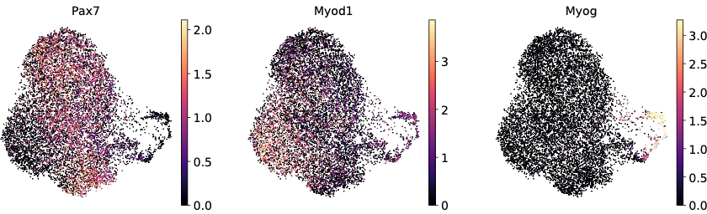
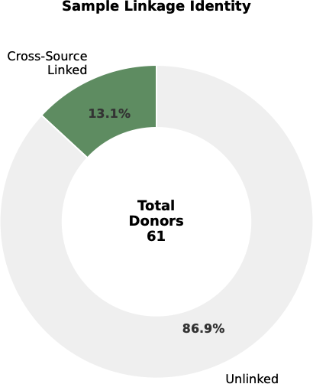
a. b.

Supplementary Figure S1: (a) Linked donor and sample structure across integrated sources. (b) Feature maps for Pax7, Myod1, and Myog on the reference manifold, supporting interpretation of quiescent, acti- vated, and later myogenic states.

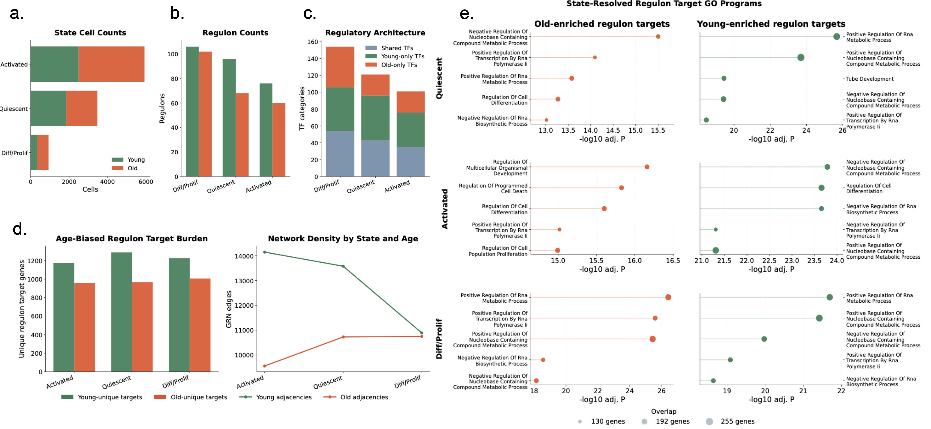
Supplementary Figure S2: Supplementary regulon architecture summary across the mouse MuSC refer- ence atlas. (a) State cell counts partitioned by young and old cells for quiescent, activated, and differentiat- ing/proliferating states. (b) Regulon counts by state and age group. (c) Regulatory architecture decomposed into shared, young-only, and old-only transcription-factor categories for each state. (d) Age-biased regulon target burden and network density by state and age. (e) State-resolved GO enrichment for old-enriched and young-enriched regulon targets.

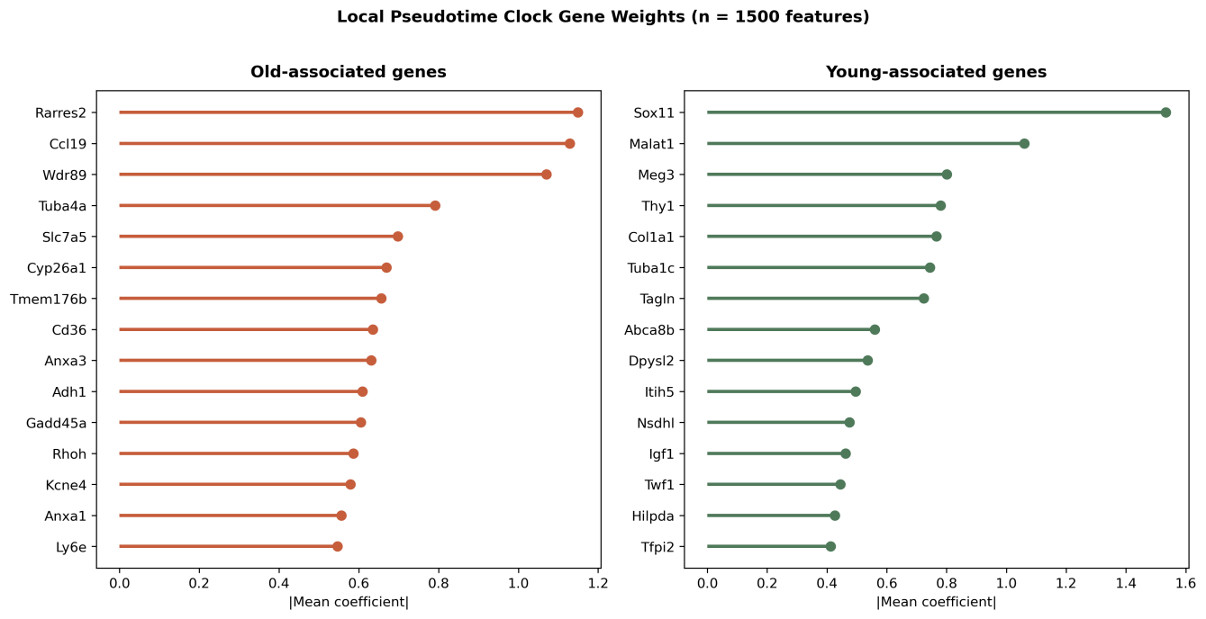
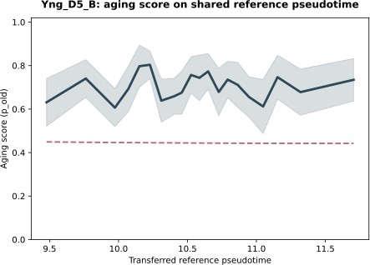
b.
a.

c.
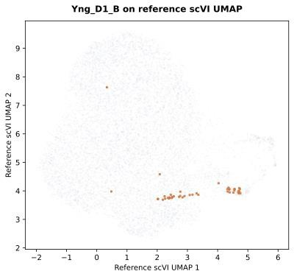
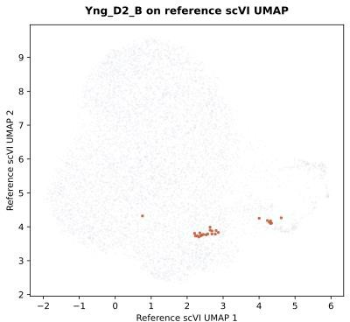
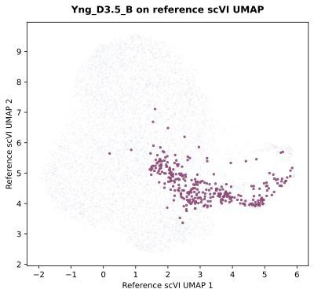
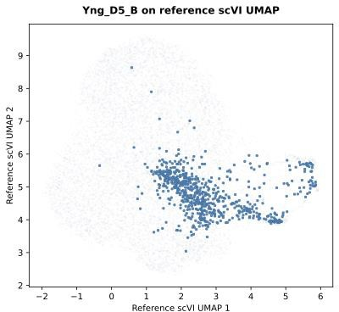
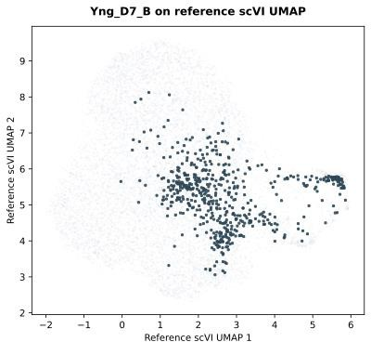
Mapping Cells to References scVI space via scArches (young as example)
Day 1 Day 2 Day 3.5 Day 5 Day 7

Supplementary Figure S3: Additional panels for the local pseudotime-aware classifier and post-injury refer- ence mapping. (a) Dominant old-associated and young-associated gene weights on the local pseudotime- aware classifier. (b) Example age-state score profile along shared reference pseudotime. (c) Example scArches mappings of post-injury MuSCs into the reference scVI manifold from day 1 to day 7. Elevated scores during repair are interpreted as age-state burden under regeneration rather than as direct measures of biological age, since the current design does not fully disentangle injury-stage and age-group effects.

Supplementary Tables

Supplementary Table S1: Detailed mouse source datasets used for atlas construction and age- state modelling.

Source alias Study / identifier Assay or subset Reported ages in
source study

walter2024_main Walter et al. (Walter et al., 2024);
integrated source reported together with GEO accessions GSE143437, GSE159500, GSE162172, and GSE232106
GSE226907_wt Oprescu et al. (Oprescu et al., 2023);
GEO GSE226907
Integrated skeletal muscle scRNA-seq atlas of home- ostasis and regeneration

10x scRNA-seq of young and old regenerating hindlimb muscle
Approximately 5,
20, and 26 months
across 0–7 dpi

Young 3–4 months and old greater than 20 months at 7 dpi

SKM_mouse_raw Kedlian et al. (Kedlian et al., 2024) Integrated skeletal muscle
scRNA-seq atlas
Source file carried binary age labels mapped to young and old

TabulaMuris_limb_ 10x TabulaMuris_limb_ smartseq2
Tabula Muris Senis (The Tabula Muris Consortium et al., 2020) Tabula Muris Senis (The Tabula Muris Consortium et al., 2020)
Limb 10x subset 3m, 18m, and 24m Limb Smart-seq2 subset 3m, 18m, and 24m

TabulaMuris_ diaphragm_ smartseq2
Tabula Muris Senis (The Tabula Muris Consortium et al., 2020)
Diaphragm Smart-seq2 sub- set
3m, 18m, and 24m

Supplementary Table S2: Trainable atlas composition by source after MuSC filtering, age restric- tion, and donor linkage.

Source alias | Young cells | Old cells | Donor split groups | Bootstrap groups
GSE226907_wt | 342 | 496 | 2 | 2
SKM_mouse_raw | 2,987 | 960 | 8 | 8
TabulaMuris_diaphragm_smartseq2 | 441 | 451 | 8 | 8
TabulaMuris_limb_10x | 846 | 1,209 | 16 | 16
TabulaMuris_limb_smartseq2 | 535 | 1,298 | 14 | 14
walter2024_main | 0 | 1,871 | 21 | 21

Supplementary Table S3: Key settings for the baseline and local age-state classifier branches.

Component Setting

Baseline metacell construction Bootstrap metacells contained 15 cells per aggregate and were
generated over 1,000 iterations with donor-aware balancing across age and state bins

Baseline preprocessing and model selection
Low-count and mitochondrial genes were removed, expression val- ues were normalized and log transformed, 1,500 highly variable genes were retained, and Elastic-Net logistic regression was tuned with donor-disjoint inner splits

Local window layout Five overlapping windows were defined across the reference pseu-
dotime range, with Gaussian memberships allowing each metacell to contribute smoothly across neighboring windows
Local inference rule Final old-like scores and thresholds were computed as
membership-weighted combinations of the five local models

Supplementary Table S4: Core software used in the mouse and human MuSC workflows (Wolf et al., 2018; Lopez et al., 2018; Lotfollahi et al., 2022; Cao et al., 2019; Pedregosa et al., 2011; Fang et al., 2023; Zhu and Slonim, 2024; Aibar et al., 2017).

Tool Role in workflow Version

Scanpy Atlas preprocessing, highly variable gene selection, 1.11.5 clustering support, and marker visualization
scvi-tools / scVI Donor-corrected latent representation learning 1.4.1
scArches Reference mapping of query cells onto the fixed atlas 0.6.1

Monocle3 trajectory workflow
Reference pseudotime inference and export R 4.4.1; mono-
cle3 1.4.25

scikit-learn Elastic-Net logistic regression and threshold diagnos- 1.8.0 tics
GSEApy GO and pathway enrichment analysis 1.1.11
SCENIC / pySCENIC Regulon-oriented network pruning and activity analy- 0.12.1 sis
RegDiffusion Gene regulatory edge inference 0.2.0

Word Counts

Section | Words
Abstract | 195
Lay Abstract | 197
Introduction | 847
Materials and Methods | 1242
Results | 1247
Discussion | 945
Conclusion | 319
Main dissertation total | 4992

