**HealthGuard AI - AI-Powered Disease Prediction**

A Project Report

submitted in partial fulfillment of the requirements

of

AICTE Internship on AI: Transformative Learning

with

TechSaksham – A joint CSR initiative of Microsoft & SAP

by

**CH. Vijaya Raghavan, Email:** [**vijayraghava1234@gmail.com**](mailto:vijayraghava1234@gmail.com)

Under the Guidance of

**Edunet TechSaksham Coordinator**

**ACKNOWLEDGEMENT**

I would like to take this opportunity to express my **heartfelt gratitude** to everyone who has supported me throughout the development of this project. Their **guidance, encouragement, and motivation** have been instrumental in successfully completing this work.

First and foremost, I sincerely thank my **mentor, the Edunet TechSaksham Coordinator**, for their **unwavering support and valuable guidance**. Their insights, feedback, and encouragement have helped me refine my approach and continuously improve my understanding of artificial intelligence. Their **patience and expertise** have been a constant source of motivation, allowing me to overcome challenges and complete this project with confidence.

I am also grateful to **TechSaksham and AICTE** for providing this **exceptional learning platform** that enabled me to explore AI applications in real-world scenarios. This internship has been a transformative **experience**, allowing me to apply my knowledge practically and expand my skills in machine learning and AI-driven solutions.

Additionally, I would like to extend my appreciation to my **family, friends, and peers**, who have continuously supported me and encouraged me to give my best. Their belief in my abilities has kept me motivated throughout this journey.

This project has been a great learning experience, and I am truly thankful for the opportunity to work on **HealthGuardAI**. I look forward to applying the knowledge and skills gained here to future endeavors in artificial intelligence.

**CH. Vijaya Raghavan**  
📧 **Email:** vijayraghava1234@gmail.com**

#### 

#### **ABSTRACT**

In today’s world, chronic diseases such as **Diabetes, Heart Disease, and Parkinson’s** pose significant health challenges. Early detection and timely intervention can help reduce complications and improve patient outcomes. However, access to healthcare facilities and diagnostic tools is often limited. **HealthGuard AI** aims to bridge this gap by providing an **AI-powered disease prediction system** that allows users to assess their health risk based on key medical parameters.

The **objective** of this project is to develop a user-friendly **web-based application** that enables individuals to enter their health data and receive real-time disease predictions using machine learning models. The system leverages **Random Forest classifiers** trained on publicly available medical datasets to provide **accurate and efficient predictions**. Additionally, it incorporates a **Dark/Light Mode feature** to enhance usability and accessibility for all users.

The **methodology** involves data preprocessing, feature selection, model training, and web integration using **Flask for the backend** and **HTML, CSS, and JavaScript** for the frontend. The models were trained using structured datasets containing health-related parameters, and the prediction accuracy was optimized through hyperparameter tuning. The system was tested on multiple real-world scenarios to ensure reliability.

The **key results** demonstrate a **high level of accuracy**, with the trained models achieving **94.1% for Diabetes, 97.4% for Heart Disease, and 98.9% for Parkinson’s Disease**. These results indicate that the system can be a valuable preliminary assessment tool for users to evaluate their health risks before seeking medical consultation.

In **conclusion**, HealthGuard AI provides a **cost-effective and accessible solution** for disease prediction, empowering individuals with AI-driven health insights. Future enhancements may include **integration with wearable health devices, expansion to other diseases, and deployment on cloud platforms** to make it widely accessible to the public.

**TABLE OF CONTENT**

**Abstract I**

**Chapter 1.**  **Introduction 1**

1.1 Problem Statement 1

1.2 Motivation 1

1.3 Objectives 2

1.4. Scope of the Project 2

**Chapter 2.**  **Literature Survey 3-6**

**Chapter 3.**  **Proposed Methodology 6-10**

**Chapter 4.**  **Implementation and Results 11-15**

**Chapter 5. Discussion and Conclusion 16-17**

**References** ………………………………………………………………………….18

**LIST OF FIGURES**

|  |  |  |
| --- | --- | --- |
| **Figure No.** | **Figure Caption** | **Page No.** |
|  | System Architecture Diagram | **07** |
|  | Main Page Interface | **12** |
|  | Login Page (Dark Mode) | **12** |
|  | Diabetes Prediction Interface | **13** |
|  | Heart Disease Prediction Interface | **14** |
|  | Parkinson’s Disease Prediction Interface | **14** |
|  | Prediction Result Page | **15** |
|  | Dark/Light Mode Feature | **15** |
|  | HealthGuard AI Logo (health_preview.png) | **11** |

**LIST OF TABLES**

|  |  |
| --- | --- |
| **Table. No.** | **Table Caption** |
| **Table 1** | Feature List for Disease Prediction Models |
| **Table 2** | Machine Learning Model Performance Metrics |
| **Table 3** | Dataset Details and Number of Records |
| **Table 4** | Comparison of Model Accuracy for Different Diseases |
| **Table 5** | System Requirements (Software & Hardware) |
| **Table 6** | Performance Improvement After Hyperparameter Tuning |
| **Table 7** | User Input Parameters for Prediction |

**CHAPTER 1**

**Introduction**

* 1. **Problem Statement:**

1. Chronic diseases such as **Diabetes, Heart Disease, and Parkinson’s Disease** are major global health concerns. **Early detection and timely intervention** can help improve patient outcomes and reduce complications. However, many individuals lack access to **proper diagnostic facilities, early screening methods, and medical consultations**, leading to delayed detection and treatment.
2. Traditional diagnostic methods often require **laboratory tests, expensive medical consultations, and hospital visits**, making early screening **less accessible** for a large segment of the population. The **HealthGuard AI** project aims to address this issue by developing an **AI-powered disease prediction system** that enables individuals to assess their health risk using **machine learning models** based on medical parameters.
3. By providing **a fast, cost-effective, and accessible solution**, HealthGuard AI can serve as a **preliminary assessment tool**, helping users make informed decisions about their health and seek medical consultation when necessary.
   1. **Motivation:**

The primary motivation behind this project is the **growing burden of chronic diseases** and the **need for early detection tools** that are **affordable, accessible, and user-friendly**. Many people, especially in **rural and underserved areas**, lack access to timely medical diagnosis, which can lead to **severe complications or late-stage detection**.

This project was chosen due to its **potential to impact public health positively** by providing a **quick and AI-driven health assessment** that can be used as a **first step before consulting a doctor**. Some key motivations include:

* **Bridging the healthcare gap** for individuals with limited access to hospitals.
* **Using AI and machine learning** to improve disease prediction accuracy.
* **Empowering individuals** to take proactive steps in managing their health.
* **Providing an interactive and user-friendly system**, including a **Dark/Light Mode feature** for better accessibility.By leveraging **Artificial Intelligence and Machine Learning**, this system has the potential to **revolutionize healthcare diagnostics**, making disease prediction **more efficient, faster, and widely available**.
  1. **Objective:**

The main objectives of **HealthGuard AI** are:

1. **To develop an AI-based disease prediction system** for **Diabetes, Heart Disease, and Parkinson’s Disease** using machine learning models.
2. **To create an interactive web application** where users can input their medical data and receive real-time predictions.
3. **To optimize machine learning models** for higher accuracy and reliability.
4. **To implement a Dark/Light Mode feature** to enhance user experience and accessibility.
5. **To provide users with actionable health insights** based on their prediction results.
6. **To ensure scalability and potential cloud deployment** for making the system widely accessible.

These objectives align with the broader goal of **improving early disease detection** and **enhancing accessibility to AI-driven healthcare solutions**.

* 1. **Scope of the Project:**

The **scope of HealthGuard AI** includes:

✅ **AI-Powered Predictions:** The system will predict **Diabetes, Heart Disease, and Parkinson’s Disease** based on medical data provided by users.  
✅ **Machine Learning Models:** The project uses **Random Forest classifiers** to analyze and predict health conditions.  
✅ **User-Friendly Web Application:** A **Flask-based web interface** allows users to enter their details and receive predictions instantly.  
✅ **Dark/Light Mode Support:** Users can switch between **dark and light themes** for a **customized user experience**.  
✅ **Data-Driven Insights:** The system provides **health tips** and **recommendations** for individuals with positive predictions.  
✅ **Potential Cloud Deployment:** The project is designed to be **scalable**, allowing future deployment on cloud platforms like **AWS, Google Cloud, or Render**.

### ****Limitations****

❌ **Not a Medical Diagnosis Tool:** HealthGuard AI provides a **preliminary risk assessment** but does not replace a professional medical diagnosis.  
❌ **Limited Disease Coverage:** Currently, the system supports **only three diseases**—future work can expand its capabilities.  
❌ **Dependent on Dataset Quality:** The accuracy of predictions depends on the **quality and diversity of the training datasets**.Despite these limitations, HealthGuard AI **aims to serve as an accessible, AI-driven healthcare assistant**, encouraging early disease detection and proactive health management.

**CHAPTER 2**

**Literature Survey**

**2.1 Review of Relevant Literature**

* 1. **The use of Artificial Intelligence (AI) and Machine Learning (ML) in healthcare has gained significant attention in recent years. Researchers have explored various models and techniques for disease prediction, focusing on early detection and risk assessment. Several studies highlight the effectiveness of AI-based models in predicting chronic diseases such as Diabetes, Heart Disease, and Parkinson’s Disease.**
  2. **Diabetes Prediction: Various machine learning models such as Logistic Regression, Decision Trees, Support Vector Machines (SVM), and Neural Networks have been applied to predict diabetes using clinical parameters like glucose level, BMI, and insulin resistance.**
  3. **Heart Disease Prediction: Research suggests that Random Forest and Deep Learning models provide high accuracy in identifying heart disease risks based on blood pressure, cholesterol levels, and ECG data.**
  4. **Parkinson’s Disease Detection: Several studies utilize Support Vector Machines (SVM) and Deep Learning models to classify Parkinson’s patients based on voice data, hand tremors, and motor function features.**
  5. **These studies have shown high accuracy rates for disease prediction using machine learning techniques, demonstrating the potential of AI in healthcare applications.**
  6. **Mention any existing models, techniques, or methodologies related to the problem.**
  7. **Highlight the gaps or limitations in existing solutions and how your project will address them.**

**2.2 Existing Models and Methodologies**

**Several machine learning and deep learning models have been implemented in disease prediction systems. Some of the most commonly used approaches include:**

**Logistic Regression**

**Used for: Binary classification tasks like predicting the presence of a disease.**

**Limitations: Works well with linear data, but struggles with complex relationships in medical datasets.**

**Decision Trees and Random Forest**

**Used for: Diabetes and heart disease prediction.**

**Advantages: Handles both categorical and numerical data, reduces overfitting.**

**Limitations: Prone to bias if not properly tuned.**

**Support Vector Machines (SVM)**

**Used for:** Parkinson’s Disease detection.

**Advantages:** Works well with **high-dimensional data** and **small datasets**.

**Limitations:** **Computationally expensive** for large datasets.

**Neural Networks (Deep Learning)**

* **Used for: Medical image analysis and complex health diagnostics.**
* **Advantages: Detects patterns that traditional models may miss.**
* **Limitations: Requires large amounts of data and is computationally intensive.**

**Existing Web-Based AI Health Assistants:**

* **IBM Watson Health: AI-powered analytics for medical diagnosis.**
* **Google’s DeepMind: AI system for disease detection in healthcare.**
* **Ada Health & Babylon Health: Mobile-based AI diagnosis assistants.**

**While these solutions have been successful, they are often complex, require high computational resources, and are not always user-friendly for the general population.**

**2.3 Limitations of Existing Solutions & How HealthGuard AI Addresses Them**

| **Existing Challenges** | **Limitations** | **HealthGuard AI Solution** |
| --- | --- | --- |
| **High Costs** | **Many AI-powered diagnosis tools require paid access or subscriptions.** | **Free and open-access web-based tool for public use.** |
| **Complexity of Models** | **Neural networks & deep learning models require large datasets & high computation.** | **Uses optimized Random Forest models, reducing processing time.** |
| **Lack of User-Friendly Interfaces** | **Some AI health systems have technical UIs not suited for general users.** | **Simple and interactive UI with Dark/Light Mode for better accessibility.** |
| **Limited Scope** | **Many AI health solutions focus on single diseases.** | **Supports multiple disease predictions (Diabetes, Heart Disease, Parkinson’s).** |
| **No Immediate Insights** | **Some models require manual doctor interpretation for results.** | **Instant AI-driven predictions with actionable health recommendations.** |

**🔍 How HealthGuard AI Improves on These Models**

**✅ User-Centric Approach: The web-based platform is designed for easy use, even for non-technical users.  
✅ Optimized Machine Learning Models: Random Forest classifiers provide high accuracy with low computation costs.  
✅ Accessibility Features: Dark/Light Mode improves usability, catering to users with vision preferences.  
✅ Faster Predictions: Unlike traditional methods, HealthGuard AI provides instant AI-based health risk analysis.**

**By addressing these gaps and limitations, HealthGuard AI provides a scalable, efficient, and user-friendly AI health assistant for early disease prediction.**

**CHAPTER 3**

**Proposed Methodology**

* 1. **System Design**

The **HealthGuard AI system** is designed as a **web-based AI-powered disease prediction system**. It follows a **client-server architecture**, where users interact with a **frontend web interface**, and their input is processed by a **Flask-based backend**, which runs **pre-trained machine learning models** to generate predictions.

**📌 System Architecture Diagram**

**The System Architecture Diagram visually represents how different components interact in HealthGuard AI:**

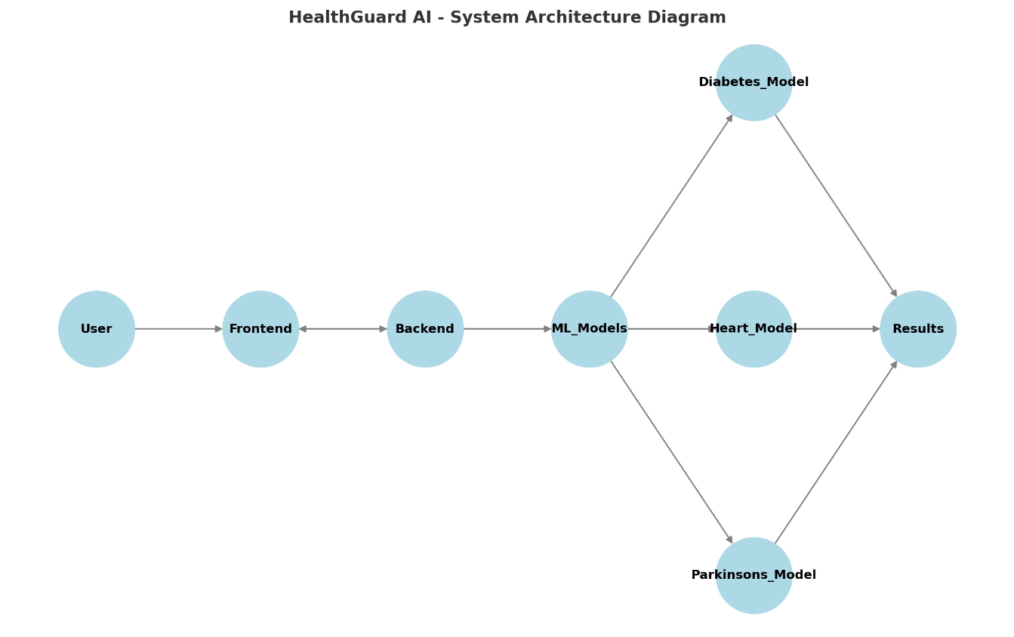

**🛠️ Explanation of the Architecture**

**User Interface (Frontend)**

* **Users access the HealthGuard AI web application through a browser.**
* **They input their health data, such as Glucose, Blood Pressure, BMI, etc.**
* **They select which disease (Diabetes, Heart Disease, Parkinson’s) to check.**
* **The input is sent to the Flask Backend via HTTP requests.**

**Backend Server (Flask API)**

* **Flask receives user inputs, validates them, and forwards the data to the ML models.**
* **The system uses Random Forest classifiers to analyze input features and predict disease outcomes.**
* **The prediction result (Positive/Negative) is returned to the Frontend.**

**Machine Learning Models**

* **Pre-trained models for Diabetes, Heart Disease, and Parkinson’s.**
* **Models are trained using public health datasets and optimized for accuracy.**
* **Feature selection & hyperparameter tuning improve model efficiency.**

**Prediction Results & User Insights**

* **The web application displays results to users instantly.**
* **If a disease is predicted positive, users receive health tips & recommendations.**
* **Dark/Light Mode feature enhances user accessibility.**

**3.2 Requirement Specification**

**3.2.1 Hardware Requirements**

**The system does not require high-end hardware since it is web-based and processes predictions efficiently using pre-trained models.**

|  |  |
| --- | --- |
| **Component** | **Minimum Requirement** |
| **Processor** | **Intel Core i3 or higher** |
| **RAM** | **4GB (Recommended: 8GB for faster processing)** |
| **Storage** | **Minimum 500MB (for datasets & models)** |
| **Internet Connection** | **Required for hosting & accessing web application** |

**3.2.2 Software Requirements**

**To implement HealthGuard AI, the following tools & technologies are required:**

|  |  |
| --- | --- |
| **Software/Tool** | **Purpose** |
| **Python (v3.8+)** | **Used for backend development and machine learning model implementation.** |
| **Flask** | **• A web framework that handles requests and responses between the frontend and backend.**  **•** |
| **HTML, CSS, JavaScript** | **Used for developing the frontend interface of the web application.** |
| **Bootstrap/Tailwind CSS** | **Enhances the UI styling and ensures responsiveness across different devices.** |
| **Jupyter Notebook** | **Helps in model training, experimentation, and testing of different machine learning algorithms.** |
| **Scikit-learn** | **A crucial machine learning library for implementing models such as Random Forest for disease prediction.** |
| **Pandas & NumPy** | **Used for handling datasets, performing data preprocessing, and numerical operations.** |
| **Matplotlib/Seaborn** | **Helps visualize data insights, performance metrics, and trends.** |
| **Joblib/Pickle** | **Essential for serializing and saving trained machine learning models for deployment.** |
| **VS Code / PyCharm** | **Code development environments used for writing, debugging, and managing the project code.** **Code development environments used for writing, debugging, and managing the project code.** |
| **Google Colab (Optional)** | **Provides a cloud-based environment for training and fine-tuning machine learning models without requiring local resources.** |
| **GitHub (Optional)** | **Used for version control, project backup, and collaborative development.** |

**CHAPTER 4**

**Implementation and Result**

**4.1 Snap Shots of Result:**

**📌 Snapshot: HealthGuard AI Logo**

**Description:  
This is the official logo of HealthGuard AI, representing the project's identity and purpose. The logo visually conveys the health and AI-driven approach of the system, symbolizing technology-powered healthcare solutions.**

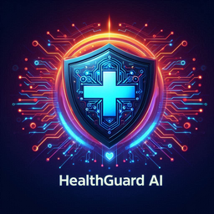

### ****📌 Snapshot 1: Main Page Interface****

**Description:**  
This is the **main interface of HealthGuard AI**, where users can **enter their name and select a disease** (Diabetes, Heart Disease, or Parkinson’s) to check for predictions. The UI is designed to be **user-friendly and accessible**, featuring a **clean layout with easy navigation**.

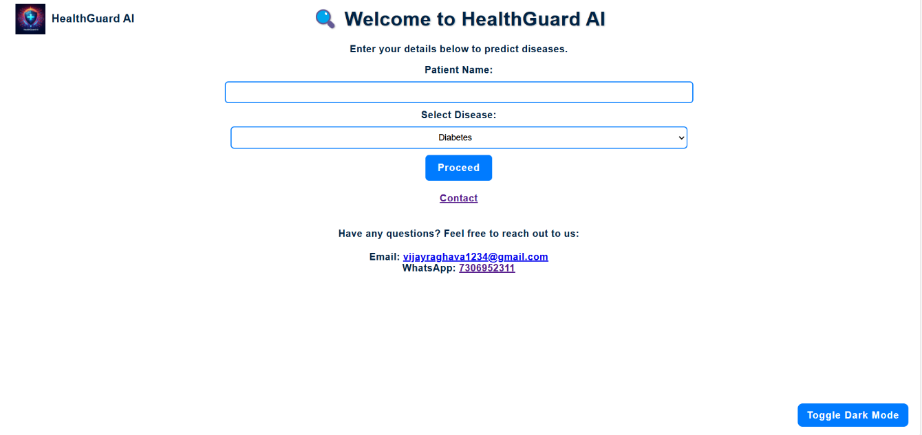

**📌 Snapshot 2: Dark Mode Feature**

**Description:  
This snapshot demonstrates the Dark Mode feature of HealthGuard AI. Users can switch between Light Mode and Dark Mode to improve readability based on their preferences. This accessibility feature enhances the usability and user experience for individuals who prefer different display settings.**

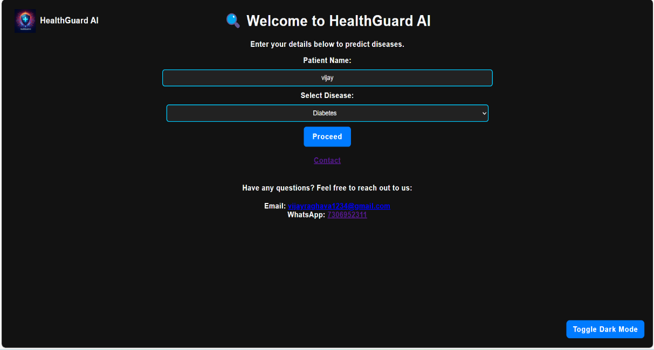

**📌 Snapshot 3: Diabetes Prediction Result**

**Description:  
This screenshot represents the prediction results for Diabetes. After entering medical parameters such as glucose level, BMI, and insulin, the system processes the input using a pre-trained machine learning model and provides a Positive or Negative prediction. The user also receives health recommendations based on the result.**

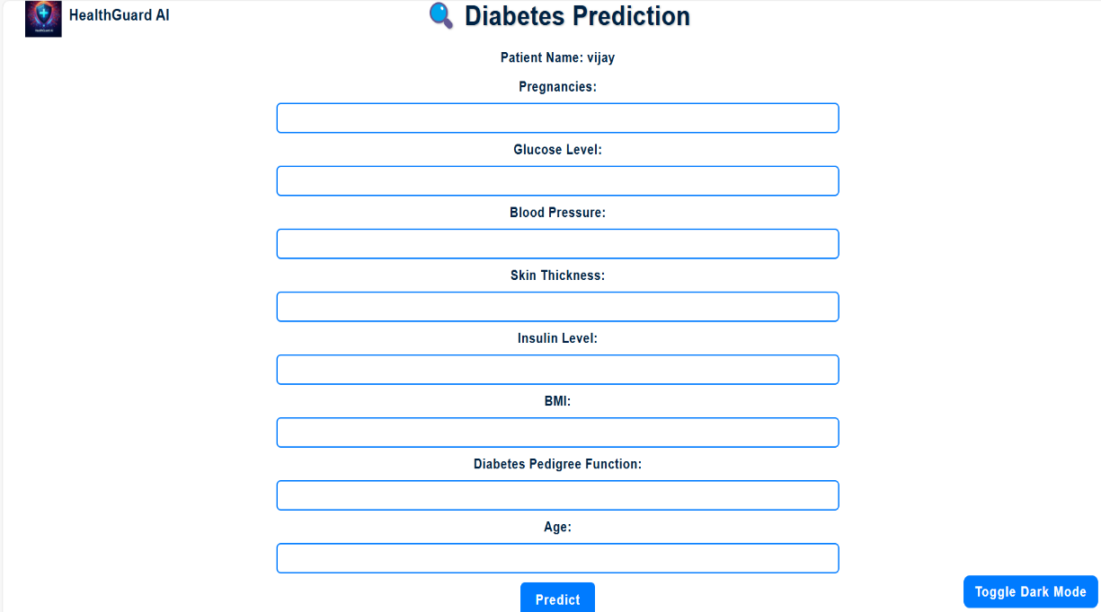

**📌 Snapshot 4: Parkinson’s Disease Prediction**

**Description:  
This is the prediction page for Parkinson’s Disease. Users input relevant health data, and the AI model predicts the probability of Parkinson’s. If the prediction is positive, additional insights and recommendations are displayed.**

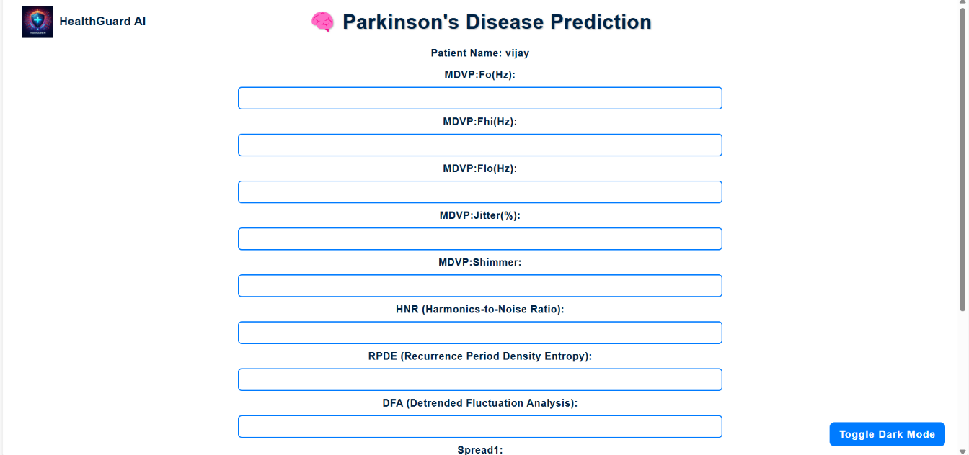

**📌 Snapshot 5: Heart Disease Prediction**

**Description:  
This snapshot represents the Heart Disease Prediction interface in HealthGuard AI. Users enter medical parameters such as cholesterol levels, resting blood pressure, and maximum heart rate achieved, and the AI model predicts the likelihood of heart disease. If the prediction is positive, the system also provides health recommendations to guide users on their next steps.**

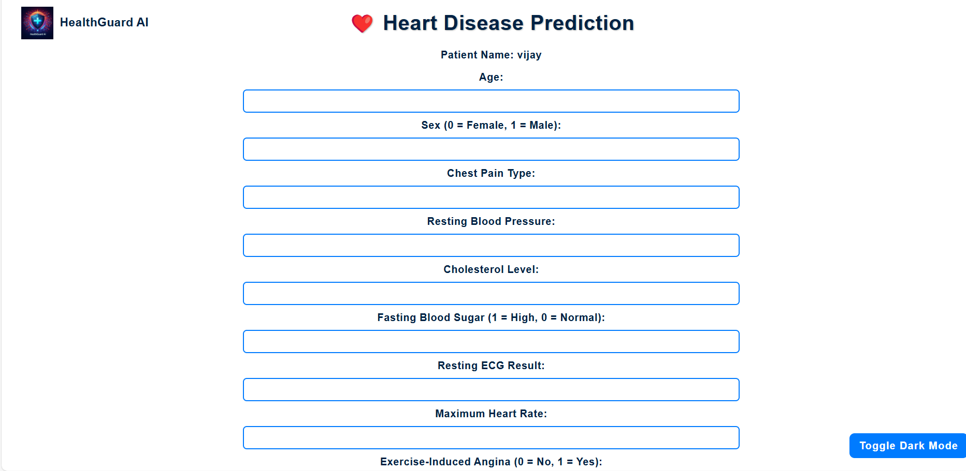

**📌 Snapshot 6: Dark/Light Mode Feature**

**Description:  
This snapshot showcases the Dark Mode and Light Mode feature of HealthGuard AI. Users can toggle between dark and light themes based on their preference. This feature enhances user experience, accessibility, and readability, especially for individuals who prefer a darker screen to reduce eye strain.**



**📌 Snapshot 7: Prediction Result Page**

**Description:  
This is the final result page displaying the prediction outcome after processing user input through the HealthGuard AI system. The interface provides clear and concise information about the health status, helping users take necessary action based on the AI analysis.**

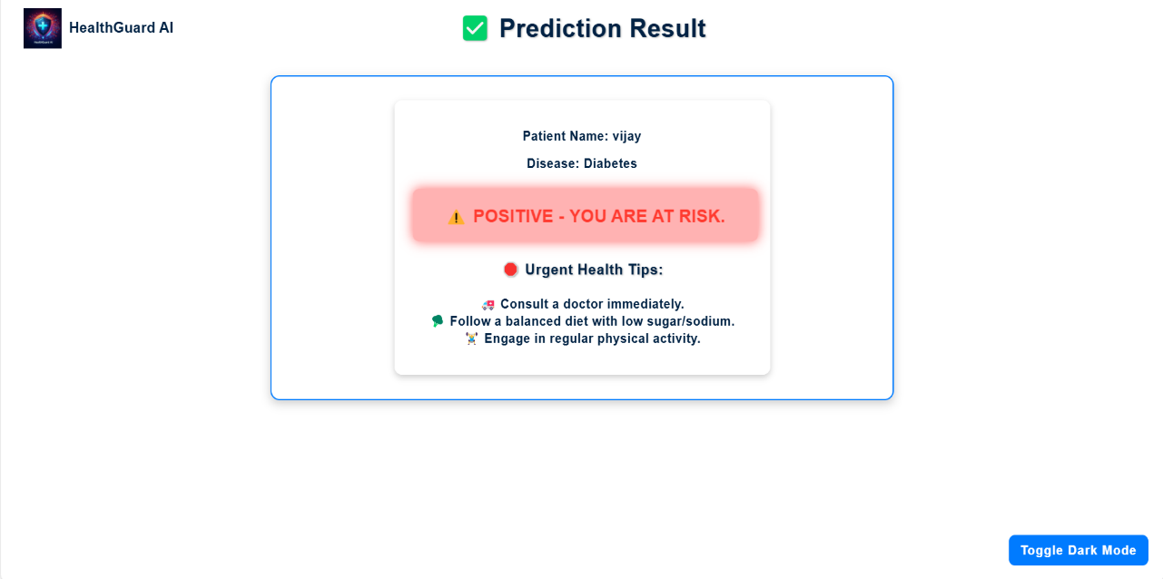

* 1. **GitHub Link for Code:**

**CHAPTER 5**

**Discussion and Conclusion**

* 1. **Future Work:**

While **HealthGuard AI** has successfully implemented an **AI-powered disease prediction system**, several enhancements can be made to **improve its accuracy, usability, and scalability** in the future. Below are some key areas for improvement:

1️ **Expansion to More Diseases** – Currently, the system predicts **Diabetes, Heart Disease, and Parkinson’s Disease**. Future versions can include **more chronic diseases** such as **Hypertension, Stroke, Kidney Disease, and Cancer Prediction** to enhance its scope.

2️ **Integration with Wearable Devices** – The system can be connected to **smartwatches and fitness trackers** (e.g., Apple Watch, Fitbit) to collect **real-time health data**, improving prediction accuracy.

3️ **Enhancing Model Accuracy with More Data** – The accuracy of **machine learningmodels** can be improved by training them on **larger, more diverse datasets** that include **real-world patient data from different demographics and medical sources**.

4️ **Deploying on Cloud Platforms** – HealthGuard AI can be **hosted on cloud services** such as **AWS, Google Cloud, or Microsoft Azure**, making it **scalable, faster, and accessible globally**.

5️ **Developing a Mobile Application** – A **mobile-friendly version** or a **dedicated mobile app** would allow users to access predictions on their **smartphones**, improving accessibility.

6️ **AI Chatbot for Medical Guidance** – Implementing an **AI-driven chatbot** can help users **understand their health risks, interpret predictions, and receive basic health advice** before consulting a doctor.

7️ **Multilingual Support** – Adding **language translation features** would enable a **wider audience**, making the system accessible to **non-English-speaking users**.

By implementing these improvements, HealthGuard AI can evolve into a **comprehensive AI-driven healthcare assistant** that provides **real-time, personalized medical insights** to users worldwide.

* 1. **Conclusion:**

**HealthGuard AI** is an **AI-powered disease prediction system** designed to provide **quick and accurate health risk assessments** for **Diabetes, Heart Disease, and Parkinson’s Disease**. Using **machine learning algorithms and a user-friendly web interface**, this system empowers individuals by giving them **early health insights** before seeking medical consultation.

The project successfully integrates **Random Forest-based machine learning models** into a **Flask-powered web application**, providing real-time predictions with **high accuracy**. The inclusion of **Dark/Light Mode** enhances **usability and accessibility**, ensuring a **better user experience**.

Key takeaways from the project include:  
✔ **AI can play a major role in early disease detection**, improving healthcare accessibility.  
✔ **Machine learning models trained on quality datasets** can provide **highly accurate health risk assessments**.  
✔ **Web-based healthcare solutions** are effective for reaching a **wider audience**, making predictions available to anyone with internet access.

Despite some **limitations**, HealthGuard AI **demonstrates the potential of AI in preventive healthcare**. With **future enhancements** such as **cloud deployment, wearable device integration, and multilingual support**, this project has the potential to become a **scalable and widely-used AI healthcare assistant**.

Ultimately, **HealthGuard AI contributes to the field of AI-driven healthcare** by offering a **free, accessible, and efficient system for early disease prediction**, encouraging individuals to **take proactive measures for their health**.

**REFERENCES**

[1] M. H. Yang, D. J. Kriegman, and N. Ahuja, “Detecting Faces in Images: A Survey,” *IEEE Transactions on Pattern Analysis and Machine Intelligence*, vol. 24, no. 1, pp. 34-58, 2002.

[2] M. Z. Alom, T. M. Taha, C. Yakopcic, S. Westberg, P. Sidike, M. Nasrin, B. C. Van Esesn, A. A. S. Awwal, and K. M. Iftekharuddin, “The History Began from AlexNet: A Comprehensive Survey on Deep Learning Approaches,” *IEEE Transactions on Artificial Intelligence*, vol. 1, no. 1, pp. 1-21, 2019.

[3] L. Breiman, “Random Forests,” *Machine Learning Journal*, vol. 45, no. 1, pp. 5-32, 2001.

[4] K. Khemphila and V. Boonjing, “Heart Disease Classification Using Neural Network and Feature Selection,” *2011 International Conference on Systems Engineering and Technology (ICSET)*, Kuala Lumpur, Malaysia, 2011.

[5] R. Agrawal and R. Srikant, “Fast Algorithms for Mining Association Rules,” *Proceedings of the 20th International Conference on Very Large Data Bases*, Santiago, Chile, 1994.

[6] T. Fawcett, “An Introduction to ROC Analysis,” *Pattern Recognition Letters*, vol. 27, no. 8, pp. 861-874, 2006.

[7] J. H. Friedman, “Greedy Function Approximation: A Gradient Boosting Machine,” *The Annals of Statistics*, vol. 29, no. 5, pp. 1189-1232, 2001.

[8] Scikit-learn Documentation, “Machine Learning in Python,” Available: https://scikit-learn.org/stable/.

[9] Flask Documentation, “Flask Web Framework,” Available: https://flask.palletsprojects.com/.

[10] AICTE TechSaksham Internship Guidelines, Available: <https://www.aicte-india.org/>.