**DEVELOPMENT OF A WEB-BASED PORTAL FOR PESO LOS BANOS CONVERGING THE MAN-POWER SUPPLY AND**

**DEMAND, E-LEARNING AND OFW MIGRATION**

**MONITORING**

A Capstone Project presented to the Faculty, College of Computer Studies

Laguna State Polytechnic University

Los Baños Campus

Los Baños, Laguna

# 

# 

In partial fulfillment of the requirement for the degree

Bachelor of Science in Information Technology

*Specialized in Web and Mobile Application*

*Development*

Mercado, Mark Lawrence A.

Castalone, Mhark Angel C.

De Guzman, Patrick P.

Guevarra, Jervin B.

Loyd S. Echalar

Date

**APPROVAL SHEET**

The capstone project entitled **“DEVELOPMENT OF A WEB-BASED PORTAL FOR PESO LOS BANOS CONVERGING THE MAN-POWER SUPPLY AND DEMAND, E-LEARNING AND OFW MIGRATION MONITORING”** prepared and submitted by **Mark Lawrence A. Mercado, Mhark Angel C. Castalone, Patrick P. De Guzman, and Jervin B. Guevarra** in partial fulfillment requirements for the degree, Bachelor of Science in Information Technology specialized in Web and Mobile Application Development is hereby recommended for approval and acceptance.

**LOYD S. ECHALAR**

Adviser



Approval and Acceptance by the Committee on Oral Examination with a grade of on .

**MIKE PHILIP T. RAMOS**

Subject Expert

**MYRA V. PAICAGLINO**

Technical Editor

**SHERWIN B. SAPIN**

Statistician

**JONARDO R. ASOR**

Research Coordinator

Accepted and approved in partial fulfillment of the requirements for the degree of **Bachelor of Science in Information Technology.**

**LOYD S. ECHALAR**

**Dean, College of Computer Studies**

**OFELIA B. MANINGAS, EdD**

Chairperson, Research and Development Office Date Signed

|  |  |
| --- | --- |
| **RESEARCH CONTRIBUTION NO.** |  |

**CHAPTER 1**

**INTRODUCTION**

# PROJECT CONTEXT

In our digital era, where the internet has become an integral part of almost every aspect of our lives, implementing web-based systems offers significant advantages for organizations. In particular, web-based systems prove highly beneficial for government organizations that focus on assisting and serving citizens (Department of Labor and Employment, 2020). The Public Employment Service Office (PESO) is a prime example of a government institution that is crucial in providing job opportunities in the Philippines. PESO also offers vocational training programs to enhance skills and provides essential support for overseas Filipino workers. In cases where an OFW encounters challenges or difficulties, seeking assistance from PESO becomes a viable option.

Online job hiring platforms have already become widespread in our society (Smith, 2021). These technological advancements bring numerous advantages, particularly for individuals facing employment challenges. However, PESO's reliance on manual processes leads to inefficiencies and data-related issues. For instance, the risk of data loss and destruction is higher, potentially compromising important information (Ortiz & Castillo, 2021). The current manual approach also hampers efficient communication between companies, applicants, and PESO when recommending suitable jobs. Managing employee records and job vacancies becomes more challenging, and data analysis for job seekers may be prone to errors (Diaz, 2022).

Unemployment remains a significant concern in the Philippines, as indicated by the recent increase in jobless Filipinos. The unemployment rate rose to 4.5% in January 2024 (Mapa, 2024). Reflects the difficulties individuals face in finding suitable employment. These challenges underscore the need for effective strategies to address unemployment and create more job opportunities. Furthermore, between April and September 2023, the number of Overseas Filipino Workers (OFWs) rose by 7.6% to 1.96 million, compared to 1.83 million in the same period of 2022 (Philippine Statistics Authority [PSA], 2024).

PESO encounters difficulties in effectively managing skills training and e-learning programs. The manual tracking of students participating in these programs poses challenges, making it harder to monitor their progress and ensure their successful completion. Statistics show that the manual tracking system has significantly decreased completion rates, with only 65% of students successfully completing their skills training programs (Salazar & Guevara, 2021). In the case of e-learning, using video recordings and modules as teaching tools can lead to confusion among students, hindering effective learning.

Aquino and Castillo's (2022) research indicates that communication barriers between students and instructors can arise, negatively impacting the overall learning experience. The study found that 42% of students reported difficulties clarifying doubts or seeking instructor feedback in the e-learning environment.

To overcome these challenges, this research proposes developing a web-based system for PESO. This system incorporates various modules to enhance the organization's processes. The employment module enables companies, organizations, and employers to post job vacancies and hiring notices, while job seekers and employees can apply for positions based on their expertise and skills (Diaz & Reyes, 2021). PESO assumes the responsibility of handling and analyzing job seeker and employee information, providing recommendations when necessary, and verifying the legitimacy of employers and companies to ensure job security (Cruz et al., 2022).

The system features an online skills training program. Instructors upload modules, videos, and instructions while students complete quizzes and exams for each module. Progress authentication grants access to subsequent modules upon passing exams, culminating in certificates issued by the PESO Office upon completion. Moreover, this research aims to create an online complaint system for overseas Filipino workers (OFWs). This system allows OFWs to submit complaints and concerns, and it can differentiate between registered and non-registered OFWs. Non-registered cases are forwarded to appropriate government organizations for resolution, ensuring that all complaints are addressed promptly.

The proposed web-based system for PESO aims to address the challenges the current manual processes pose. By leveraging technology and streamlining operations, PESO can enhance its effectiveness in providing job opportunities, managing skills training programs, and supporting OFWs. A web-based system creates a more efficient, transparent, and inclusive employment ecosystem in the Philippines.

# PROJECT OBJECTIVES

The main objective of this research project is to develop a web-based portal comprising manpower supply and demand, E-learning, and OFW migration, enhancing the operation of PESO Los Baños, Laguna.

1. Develop a module to identify the supply and demand of manpower the industries and employers need.
2. Provide an E-learning module for training, certifications, and livelihood.
3. Design a process for OFW migration monitoring the status of employment.

# PROJECT PURPOSE

This research project aims to develop a web-based system for PESO Los Baños, Laguna, that aligns with and contributes to achieving the 17 Sustainable Development Goals (SDGs). The selection of specific SDGs, namely SDG 1 (No Poverty), SDG 4 (Quality Education), SDG 8 (Decent Work and Economic Growth), and SDG 10 (Reduced Inequalities), is based on their relevance and significance in addressing the pressing challenges faced by the community. SDG 1 (No Poverty) is a crucial goal to eradicate poverty in all its forms and dimensions. By providing job opportunities through the developed program, we aim to empower individuals and uplift them from poverty, ensuring their economic well-being and enhancing their quality of life. SDG 4 (Quality Education) emphasizes the importance of inclusive and equitable education. By incorporating E-learning platforms in the web-based system, we aim to provide accessible and high-quality educational opportunities to individuals, equipping them with relevant skills and knowledge necessary for their desired careers. This promotes lifelong learning and enhances employability in a rapidly evolving job market. SDG 8 (Decent Work and Economic Growth) promotes sustained, inclusive, sustainable economic growth, full and productive employment, and decent work. By matching job vacancies with job seekers and providing a streamlined recruitment process, the web-based system creates a conducive environment for job creation, ensures decent work opportunities, and fosters economic growth within the community. SDG 10 (Reduced Inequalities) underscores the importance of reducing inequalities within and among countries. The project aims to provide equal job opportunities regardless of formal qualifications, promoting inclusivity and fairness. By addressing the barriers that limit access to employment and training, we strive to reduce inequalities and create a more equitable society. By aligning with these SDGs, the project aims to make a positive and sustainable impact on the community of PESO Los Baños, Laguna. Through the development and implementation of the web-based system, we aim to empower individuals, promote economic development, enhance educational opportunities, and create a more inclusive and resilient community.

**Job seekers:** The web-based system benefits job seekers by providing a user-friendly platform with increased job market visibility and access to a wide range of job postings. The system matches job vacancies with the applicant's expertise, enhancing the job search process and increasing the likelihood of finding suitable employment

**OFW:** The system offers a dedicated online complaint system for OFWs, allowing them to submit concerns and have them addressed promptly. It differentiates between registered and non-registered OFWs, ensuring appropriate case resolution and enhancing the overall welfare and protection of OFWs.

**Employers:** Employers benefit from an intuitive online job posting portal that reaches a broader pool of candidates. The system's merit-based mechanism ensures applications from qualified candidates, improving workforce quality. Data analysis reports provide valuable insights for informed hiring decisions and streamlined recruitment processes.

**Trainees:** The web-based system also caters to trainees by offering various modules that allow them to acquire specific skills. Trainees can choose from various available modules based on their interests and career goals. The system provides comprehensive learning materials, interactive exercises, and assessments to facilitate skill development. Upon completing each module, trainees receive a certificate, validating their mastery of the acquired skills. This feature promotes continuous learning and professional growth, enhancing trainees' career prospects and employability.

**Peso Los Banos:** PESO Los Banos gains automation and efficiency in managing job vacancies and applicant records. The system provides data analysis modules for tracking and visualizing hiring trends, enhancing PESO's ability to provide job opportunities and effectively support job seekers and employers.

# SCOPE AND LIMITATION OF THE STUDY

The scope of this study encompasses the development of a comprehensive web-based system for PESO Los Baños, Laguna. The system includes modules for online job hiring, e-learning, and online complaints inquiries, aiming to improve the efficiency and effectiveness of PESO's operations and services.

**Job Portals**

This module within the web-based system provides a user-friendly platform that empowers employers to post job vacancies and efficiently hire qualified individuals effortlessly. Simultaneously, it offers job seekers a seamless experience to browse through available positions and submit applications based on their expertise. To ensure the credibility of companies and referrals, the system incorporates thorough oversight from PESO, guaranteeing that job opportunities are legitimate and reliable. Furthermore, the module grants authorized users access to applicant reports, enabling employers to make informed decisions and enhance their recruitment efforts during the hiring process.

**E-Learning**

The E-Learning module within the web-based system is a comprehensive platform for disseminating educational content. It offers users convenient access to various resources, including engaging videos, interactive modules, detailed instructions, and assessments. This extensive collection of educational materials enables users to acquire knowledge and enhance their skills at their own pace and convenience. Additionally, the module provides a valuable feature of certificate issuance through the E-Learning website, recognizing and validating the users' successful completion of training programs and courses. This promotes skill development and enhances users' professional credentials and employability in their respective fields.

**OFW Migration Survey**

This module is crucial in empowering OFWs by giving them a reliable and accessible means to voice their concerns, seek assistance, and find solutions. By facilitating efficient processing and forwarding of these reports to relevant authorities, the system aims to contribute to the well-being and welfare of OFWs, enhancing their working conditions and ensuring their rights are protected.

The web-based system has certain limitations that should be considered. Firstly, it may face accessibility issues and be unable to connect with the websites of the Department of Labor and Employment (DOLE) and other relevant agencies. Additionally, the system relies on internet connectivity, which means it cannot be accessed offline. Resource and content limitations may also affect the availability and depth of educational materials in the e-learning module. Lastly, compatibility issues and potential limitations in user support services could impact the overall user experience. These limitations should be considered when evaluating the system's capabilities and potential challenges.

**CHAPTER 2**

**THEORETICAL FRAMEWORK OF THE PROJECT**

**REVIEW OF RELATED LITERATURE, STUDIES, AND SYSTEMS**

The employment process has changed significantly in the current digital era due to the rise of online platforms, which have revolutionized it for companies and job seekers. With the rise of online job recruitment platforms, the job market is now more accessible and convenient than ever. People can now look for jobs from the comfort of their homes, and employers can effectively connect with a large talent pool worldwide.

This review specifically looks at the influence of social media on hiring procedures, the growth of remote work opportunities, web-based hiring, and the best ways for companies and job seekers to use online platforms efficiently.

# Hiring on social media

These days, recent graduates frequently search the internet for work. With the development of technology, more people are looking for jobs online rather than through job fairs or by going directly to employers. Human resource representatives at the company sometimes post prerequisites and job openings for entry-level roles online**.** Employees are a significant source of competitive advantage for businesses. However, competition among enterprises to attract and retain workers with the necessary skills and competencies is growing due to an aging workforce and an increasingly knowledge-based economy in many nations worldwide (Ployhar et al., 2017). As a result, academics and practitioners alike are becoming more interested in hiring practices and employer branding (Banerjee et al., 2018). As a result, research on how potential employees responded to recruitment and selection processes discovered that their impressions of these processes might affect how attractive the company was to them as an employer. Research indicates that there are geography and competency mismatches in the labor market in China, which is the context of the study (Athukorala & Wei, 2017). Due to these mismatches, many companies find it challenging to draw in the best human resources.

Researchers have been paying close attention to how the rising popularity of online job search and recruitment has affected unemployment. From a theoretical perspective, it is unclear if the growth of the Internet would result in more successful search results. On the one hand, the Internet streamlines the hiring and job search process by allowing employers and job seekers to evaluate more possible candidates faster and at a lesser cost (Choi, 2023).

# Growth of remote work opportunities

Due to advancements in digital technology, online recruitment has become increasingly important in modern hiring procedures. This shift has replaced traditional methods like newspaper job ads, allowing firms to publicize openings and communicate with potential applicants. The use of e-recruiting, cyber-recruiting, and internet recruiting has revolutionized the hiring process, with terms such as e-recruiting, cyber-recruiting, and internet recruiting being used. Lim et al. (2015) noted that applicants now fill out extensive digital forms and take tests, with applications screened using keyword-matching algorithms.

Haan, K. (2023) reported that 12.7% of full-time workers would work remotely in 2023, while 28.2% would use a hybrid approach. Despite the increased remote work, 59.1% of workers work in offices. An estimated 32.6 million Americans, or around 22% of the workforce, are expected to work remotely by 2025, with prospects for remote work appearing bright.

Employees' preference for remote work is supported by 98% of employees, who prefer remote work at least occasionally. Employers also intend to hold remote job interviews, showing readiness to adapt to remote working practices. Just 16% of businesses operate entirely remotely, demonstrating the viability of these models and opening the door for others to follow. The shift towards remote work and online recruitment is a significant trend in the modern hiring landscape.

# Best ways for companies and job seekers to use online platforms efficiently

The rise of online job searches and recruitment has garnered attention regarding its impact on unemployment rates. The most critical measure of the effectiveness of the employment function is typically the quality of employees made, but, in some cases, hiring speed may significantly impact hiring quality. A successful hiring process involves more than just placing an advertisement in the newspaper, setting up chairs and tables on the designated day, and collecting resumes for further consideration. A hiring event aims to connect with potential candidates and bring in the particular kind of experiences and abilities the company needs, particularly those that cannot be developed internally.

The traditional hiring procedure, which starts with posting job openings and ends with selecting the most qualified candidates, has flaws. Just posting job openings online could be problematic. Advertising in print media, such as newspapers or magazines, is expensive. As a result, job openings can only be posted and advertised for a limited time. Additionally, the applicant must physically present themselves in order to turn in their resume via the submission method. This makes it more difficult for qualified but remote job seekers to apply. It is important to remember that the Philippines is an archipelago of 7,100 islands. For this reason, outdated hiring procedures might not be appropriate in today's competitive job market.

Throughout the past few decades, the development of technical solutions has most likely helped recruitment and selection the most. Early in the new millennium, research on electronic human resources initially surfaced (Karakanian, 2000; Stanton & Coovert, 2004). These studies projected the positive effects of technology on various HR functions.

Topics like using the intranet, e-learning, virtual teams, HR Information Systems, etc., were the main focus back then. On the other hand, online career and employment boards, online psychological testing, and online recruitment were all at the forefront of those early studies and projections of how technology will alter the field of recruiting and selection research and practice.

Twenty years after these stories were initially published, today, Things have advanced significantly; technology has greatly advanced in all spheres of social and professional life. In particular, technology has impacted every step of the recruitment and selection process. The subsequent sections will delineate several technological advancements that have impacted the four primary phases of the Attraction, screening, selection, and onboarding steps in the recruitment and selection process.

The Automated Hiring Platform (AHP), used by retailers like Target, is an example of the sociotechnical phenomenon known as platform authoritarianism, as defined by Ajunwa, Crawford, and Ford (2016). Target job candidates must undergo several lengthy procedures on the AHP, such as providing their work history, availability, and personally identifiable information, conducting background checks, and finishing personality and skill tests, all of which are swiftly processed and analyzed by the platform. The AHP interface, designed according to Target's specifications, offers candidates few alternatives; open text fields, for example, limit employment descriptions to 32 characters per previous position. This platform structure drastically restricts the autonomy of applicants while providing businesses with deep insights into potential employees. Such platforms are common because of the data-driven reorganization of the workplace, which is based on workforce science inherited from Fordism and Taylorism (Ajunwa, 2018). Despite efforts to gamify participation through rewards rather than punishment, automated hiring platforms continue to act as coercive forces in the workplace (Cohen, 2015). Ultimately, AHP providers first set the hiring firms' priorities, determining the procedures and final goals. Platforms like AHPs symbolize a new kind of control and regulation in the labor market and reflect a dramatic change in employment practices. Traditional methods often fall short in reaching remote candidates and addressing the dynamic needs of the job market. Automated hiring platforms, while efficient, raise questions about autonomy and control, reflecting broader shifts in employment practices.

# Emergence and adoption of online platforms in government job recruitment

Online recruitment has become popular for job seekers, offering a technology-driven approach to hiring employees. This method matches job seekers' data with the organization's requirements, making it effective from an organization's perspective. However, job seekers' perceptions of online recruitment vary, focusing on accessibility, suitability, relevance, and cost. Despite job seekers' preference for online recruitment, it has not yet been fully explored at a macro level due to insecurities related to internet-related avenues. Job portals must educate candidates about the benefits and ease of online recruitment. Chaitra V H (2018).

# Career Choice

In the realm of employment, employee job switching poses a significant concern. Job search, an essential activity in the labor market, is undertaken by both employed and unemployed individuals. Research on "reference-based utility" indicates that individuals prioritize changes over states, with losses carrying more weight than gains, deterring risky changes unless assured of a positive outcome. Nevertheless, some employees opt to change positions, often driven by dissatisfaction with their current role and aspirations for a better one. Notably, job insecurity and dissatisfaction with the nature of work tend to outweigh dissatisfaction with salary as primary drivers for employment changes. This study investigates factors influencing the duration of job search, determinants affecting the likelihood of job switching, and the importance of job satisfaction. Job satisfaction, a crucial component, provides employees with energy, stress management, and relaxation and fosters creativity. It also offers a sense of fulfillment and accomplishment independent of financial compensation (Factors affecting job search length and job switching in Davao City).

People go through a significant process in their lives while choosing a career, especially those who wish to be happy in their jobs. According to a notion put forth by John Holland (2017), personality and environment interact to shape careers. According to Holland's Theory of Career Choice, people often fall into one of six personality types: Conventional, Social, Investigative, Artistic, Realistic, or Enterprising.

As a result, people typically favor occupations where they can work among others who possess similar traits. People seek settings where they may express their personalities and ideals while contributing to their newly learned skills and abilities. Understanding and aligning individual preferences with suitable career paths can enhance job satisfaction and well-being. As individuals navigate their career journeys, the interplay between personality and environment shapes occupational preferences and job satisfaction levels.

In summary, this chapter comprehensively explores the multifaceted changes reshaping the employment landscape. By understanding the dynamics of social media in hiring, the growth of remote work opportunities, efficient use of online platforms, and factors influencing career choice, employers and job seekers can navigate the evolving job market effectively.

# Efficiency and cost-effectiveness

The researcher showed that an online algorithm can make hiring, firing, and outsourcing decisions, leading to cost savings for alternatives. These cost savings are more striking when the hiring and salary costs are low because then hiring becomes an attractive option; the tasks exhibit high coherence, i.e., consecutive tasks are similar to each other, and the time horizon is long enough that we can find a core pool of workers to stay hired and satisfy a large fraction of the skills required by incoming tasks. Anagnostopoulos, Castillo, Fazzone, Leonardi, and Terzi (2020).

The study proposes probabilistic models to estimate freelancer hiring probability in online labor markets. Tested on oDesk.com, the models outperformed a baseline model. Key factors correlated with higher hiring probability included previous collaboration, profile information, skills, and application speed. Faster application time, higher reputation, and previous hires positively impacted hiring probability. The models could help employers and freelancers improve their chances of getting hired and recommend suitable candidates for open jobs. Kokkodis, Papadimitrio, and Ipeirotis (2015).

Based on the context provided, the key benefits of E-Recruitment through job portals and social media networks include: - Wider reach and scope - Using online platforms allows recruiters to post jobs to a large, global audience and reach both active and passive job seekers. This expands the potential candidate pool. - Cost-effectiveness - E-recruitment channels like job boards and social networks are more affordable than traditional recruiting methods like print ads. It reduces recruitment costs. The online application and screening process is faster than paper-based applications. Candidates can apply from anywhere at any time. This speeds up the recruitment cycle. Ramkumar A. (2018).

The author discusses using the internet in recruitment, specifically E-recruitment, which aims to provide job seekers with an ideal candidate search platform. E-recruitment has been beneficial for organizations in terms of saving time and cost and providing an extensive horizon for candidate search. The study aims to understand how E-recruitment can make the hiring procedure attractive, reduce operational costs, and enhance its significance in the future. Respondents agree that E-recruitment is an ideal platform for job seekers, offering updated information and saving time and cost compared to traditional methods. Ahlawat & Sangeeta (2016).

# Widening access to job opportunities

A good job portal shares information and experiences with its members/users. This saves time and effort, and better decisions can be made [12]. Job opening requirements can be matched to an applicant’s qualifications and skills. In this way, job portals return precise matches and similar matches. The members of the European Commission (EC) stated that online job portals should have quite similar characteristics that include an online searchable database of positions for job searchers, facilities to send CVs to the website, email alerts of jobs that match the user's profile; extra instruction, for example, about working in foreign countries or career guidance; the capability to manage job applications; employers must have the ability to publish and manage job positions, search the CV database; and have online contact with potential job seekers. Mansourvar and Yasin (2014).

This can help with matching, but candidates also reveal personal information online that employers may not legally be able to use. - While employers say they use social media to find job-relevant information, it is unclear if they use it in a way that leads to hiring discrimination based on personal traits. No field data has shown the impact of online information on hiring. - The EEOC has warned companies about the risks of online searches, and some states have proposed bills limiting access to candidate information. However, it is an open question if bias results from personal info posted online. Alessandro Acquisti and Christina Fong (2020).

The study explores using E HRM, specifically E-recruitment, as a new era for hiring employees. E-recruitment is an ideal platform for pooling potential candidates for job applications, as it helps organizations search for candidates on a larger scale. However, the quality of candidates hired through this platform is not guaranteed. With the widespread use of social networking, organizations cannot solely rely on E-recruitment, and potential candidates can find ideal jobs through various recruitment avenues. E-portals offer an added advantage for job seekers, saving time and money compared to other sources in the industry. Sakinah Mat Zin (2016).

The study explores the effectiveness of online recruitment in attracting job applicants and its benefits compared to other recruitment methods. It emphasizes the importance of website richness, employer familiarity, employer reliability, and job information on the website. The study found that the richness of the website and familiarity with the employer significantly influence applicants' attraction toward online recruitment. In contrast, other factors like employer reliability and job information have a negligible impact. The study concludes that organizations can effectively utilize online recruitment by making their sites attractive, regularly updating information, and ensuring authenticity. Toresh&Almari (2015).

It finds evidence of discrimination against immigrant and minority ethnic groups. Groups like Asians, Africans, and Middle Easterners face significantly lower contact/interview request rates from recruiters compared to native Swiss citizens, even after controlling for jobseeker characteristics. - Within-day variations in discrimination suggest it cannot entirely be explained by conscious prejudice. Discrimination increases later in the day when recruiters spend less time evaluating each profile, pointing to a role for implicit biases.- Significant occupational variation exists in gender discrimination. On average, there is no gender penalty, but women face penalties in male-dominated occupations, while men face penalties in female-dominated occupations. Dominik Hangartner, Daniel Kopp & Michael Siegenthaler (2021).

**Literature Matrix**

|  |  |  |
| --- | --- | --- |
| Author/ Year | Title | Findings |
| Haan, K. (2023) | Remote Work Statistics and Trends in 2023 | In 2023, 12.7% of full-time workers plan to work remotely, with 28.2% using hybrid methods. By 2025, 22% of the American workforce is expected to work remotely. |
| Choi, M. (2023) | The impact of online job search on unemployment rates: A theoretical perspective | The Internet streamlines job search by offering a larger candidate pool and quicker evaluations. However, the overwhelming information can be challenging to find relevant results. The reliance on algorithms raises concerns about biases and filtering based on preconceived criteria. The Internet's influence on search outcomes depends on user proficiency. |
| Diaz, L. (2022) | Challenges of manual data management in public employment services | Managing employee records and job vacancies becomes more challenging, and data analysis for job seekers may be prone to errors |
| Cruz, A., Reyes, M., Ortiz, J., & Diaz, L. (2022) | Transforming public employment services through technology-driven solutions. | Highlight the effectiveness of the employment module in the web-based system. It enables seamless communication between employers and job seekers, providing a platform for posting job vacancies, receiving applications, and matching candidates based on their qualifications and skills. |
| Salazar, P., & Guevara, A. (2021) | Challenges in tracking student progress in government-led training initiatives. | Statistics show that the manual tracking system has resulted in a significant decrease in completion rates, with only 65% of students successfully completing their skills training programs |
| Smith, J. (2021) | The growth of online job platforms in the digital age | The rise of online job platforms has significantly impacted the job market, providing a convenient and efficient way for job seekers to find employment opportunities. These platforms have expanded the reach of job postings, connecting employers with a larger pool of potential candidates and streamlining the hiring process. |
| Chaitra, V. H. (2018) | Perceptions of online recruitment: An exploratory study. | Online recruitment is widely adopted by organizations due to its effectiveness in matching job seekers' qualifications with job requirements. Job seekers' perceptions of online recruitment vary based on factors like accessibility, suitability, relevance, and cost. Job portals should address internet-related insecurities and educate candidates about the benefits of using online recruitment effectively. |
| Ramkumar, A. (2018) | Benefits of E-Recruitment: A Comprehensive Analysis. | The online application and screening process is faster than paper-based applications. Candidates can apply from anywhere at any time. This speeds up the recruitment cycle |
| Banerjee, A., Saini, J., & Kalyanaram, G. (2018) | Employer branding: a strategic tool for talent management. Journal of Strategic Human Resource Management. | There is a growing interest among academics and practitioners in hiring practices and employer branding, emphasizing its strategic importance as a tool for talent management (source). Organizations recognize the need to effectively promote their brand to attract and retain top talent in today's competitive job market. |
| Ajunwa, I. (2018) | Algorithmic Labor and Information Asymmetries: A Case Study of Uber's Drivers. Berkeley Journal of Employment & Labor Law. | The study on algorithmic labor platforms, specifically focusing on Uber's drivers, revealed that such platform structures restrict the autonomy of applicants while providing businesses with extensive insights into potential employees. These platforms have become common due to the data-driven reorganization of the workplace, drawing from principles derived from Fordism and Taylorism. The findings highlight the power dynamics and information asymmetries embedded within algorithmic labor platforms. |
| Athukorala, P., & Wei, X. (2017) | Geography and competency mismatches in the labor market in China. Labour Economics. | Research in the context of the labor market in China indicates that potential employees' perceptions of recruitment and selection processes play a crucial role in determining the attractiveness of a company as an employer. Moreover, there are identified geography and competency mismatches within the labor market (source). These findings emphasize the importance of aligning job requirements with the skills and location of job seekers to effectively attract and retain qualified talent in China. |
| Ployhar, D., Schmitt, N., & Tippins, N. (2017). | Talent Management in the 21st Century:  Academic Research Reveals Key Features of Effective Practices. | Employees are recognized as a significant source of competitive advantage for businesses in the 21st century. The growing competition among enterprises to attract and retain skilled workers is driven by factors such as an aging workforce and the transition to a knowledge-based economy (source). This underscores the importance of implementing effective talent management practices to gain a competitive edge in the evolving labor market. |
| Sakinah, M. Z. (2016). | The role of E HRM in modern recruitment: A case study analysis. | The study explores the impact of E HRM, specifically E recruitment, on modern employee recruitment and selection. Online recruitment offers a diverse pool of candidates, but ensuring quality is a challenge. Organizations must adopt a diversified recruitment strategy beyond online recruitment to provide candidates with multiple job opportunities. |
| Ajunwa, I., Crawford, K., & Ford, J. (2016) | Platform authoritarianism: The implications of automated hiring for the future of work. New Media & Society | The Automated Hiring Platform (AHP) by retailers like Target is a prime example of platform authoritarianism, where automated platforms have control over users and their data. Candidates must undergo lengthy procedures, including work history, background checks, and personality tests, which are quickly processed and analyzed. This structure restricts applicants' autonomy while providing businesses with valuable insights. AHPs are prevalent due to the data-driven workplace restructuring and represent a shift in employment practices, particularly in remote recruitment. Despite their efficiency, these platforms raise questions about autonomy and control. |
| Kokkodis, A., Papadimitrio, A., & Ipeirotis, P. (2015) | Understanding hiring behavior on online labor markets: Insights from probabilistic models. | The study introduces probabilistic models for estimating freelancer hiring probability in online labor markets. Tested on oDesk.com, the models showed superior performance, with factors like previous collaboration, detailed profile information, specific skills, and quick application speed correlated with higher hiring probability. These models could help employers and freelancers improve their chances of hiring. |
| Toresh, S., & Almari, R. (2015) | Factors influencing effectiveness of online recruitment: A comparative study. Journal of Applied Human Resource Management | The study explores the attraction of online recruitment to job applicants, highlighting the importance of website design, interactive features, employer reputation, and job details. It suggests organizations can enhance recruitment by emphasizing website appeal, consistent information updates, and credibility. |
| Lim, S., Lee, A., & Lee, Y. (2015) | Changes in job applicant qualifications due to online recruitment. Journal of Applied Psychology. | Online platforms have become crucial in modern hiring procedures due to digital advancements. They replace traditional methods like newspaper ads and bulletin boards, allowing firms to reach a wider candidate pool, increase efficiency, and streamline the recruitment process. |
| Mansourvar, M., & Yasin, S. (2014). | Enhancing Job Portal Effectiveness: Recommendations from the European Commission. Journal of Employment Strategies. | Online job portals simplify the job search process, allowing for more informed decision-making. They align job requirements with applicants' qualifications and skills, offering similar matches. The European Commission recommends these portals have a searchable database, CV submission facilities, email alerts, career advice, application management, and online contact with potential job seekers. |
| Karakanian, 2000 Stanton & Coovert, 2004 | The impact of electronic human resource management on human resource management. International Journal of Human Resource Management | Research studies reveal that technology has significantly improved HR functions, making recruitment more efficient and cost-effective. Implementing applicant tracking systems and online job boards has revolutionized talent attraction and hiring, reducing time-to-hire and recruitment costs. Digital assessments and video interviews enhance candidate evaluation and cultural fit. |

Table 1. Literature Matrix

**Conceptual framework**

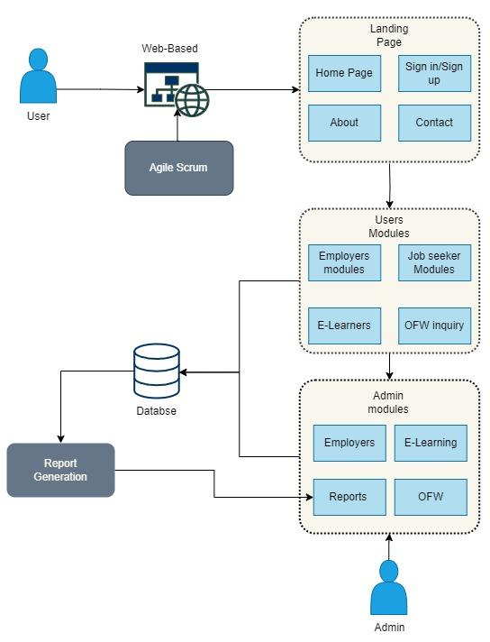

**Figure 1.** Conceptual Framework

This figure shows the conceptual framework of the peso online portal system; this shows the process by which users interact with the web-based system, going to the admin response with the system. The framework starts with the users going to the website and signing in or signing up for an account, then viewing web-based services, such as job hiring, job application, e-learners, and OFW inquiry. Once the user uses the services, the data they send will go to the database and be sent to the admin. The admin will respond with the user needs and then send it again to the users.

**CHAPTER 3**

**METHODOLOGY**

This chapter covers project design and development and the software and hardware prerequisites necessary for system development.

**Project Design**

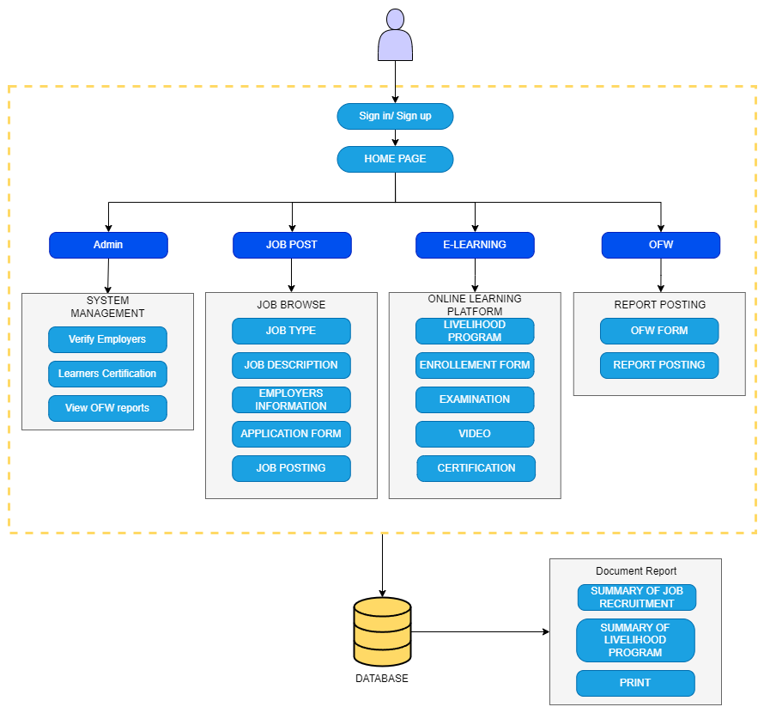

**Figure 2.** System Architecture Diagram

The figure above shows the system architecture of the PESO website. The figure shows the people who will be using the website, which are the public users, employers, companies, or organizations that are hiring, and lastly, the admin, which is for members of the PESO. The normal users can be people looking for a job, wanting to take a vocational course, or needing help from OFW. The system will consist of three main modules: one for job portals, one for e-learning, and one for OFW. Employers can post job openings in the job portal, but first, they need to be verified by the PESO to see if they are legitimate. The PESO can post different learning materials for the user to view and study. They can also give tests and examinations for the users, and if they pass the examination, they will receive a certificate for finishing the courses. In the OFW section, users currently working overseas and facing difficulties can ask for help on the PESO website. The PESO will provide support and resources for OFWs in need, such as legal assistance, counseling services, and information on their rights as overseas workers. The platform will also have a forum where OFWs can connect, share their experiences, and offer advice and support. Overall, the PESO website aims to be a comprehensive and user-friendly platform that caters to job seekers, learners, and overseas workers' needs.

**Flowchart**

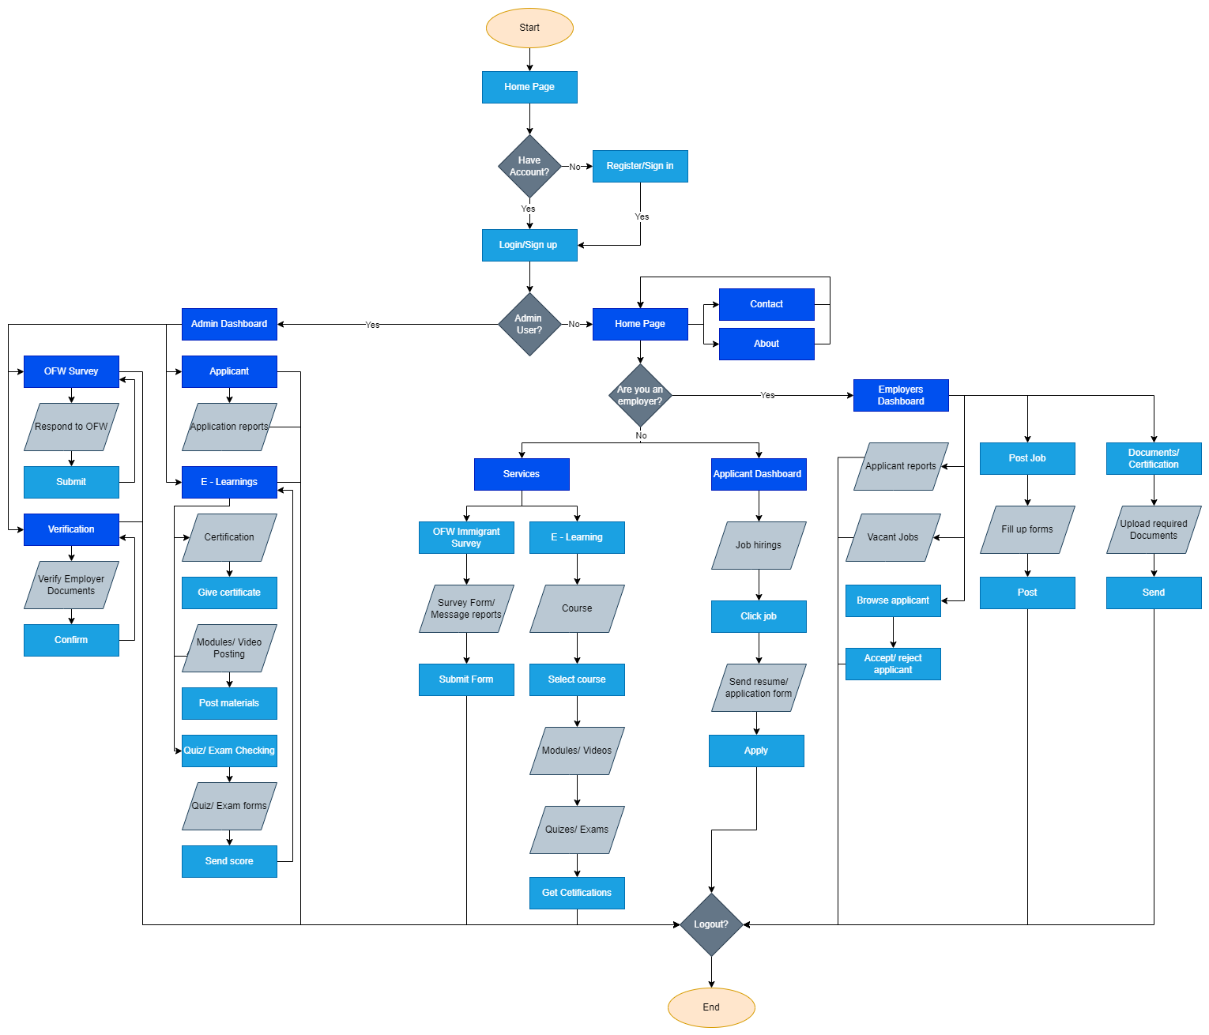

**Figure 3.** System Flow chart

This figure shows the flow of the system. It started with the system's home page or landing page, then the different login pages for users. First, the public users. After they log in, they can choose which they want to use the website for. For example, they can go to the job portal if they are looking for a job. If they want to enroll in the job portal and if they want to enroll in a vocational course that PESO offers, they can go to E-Learning to get a certificate that they can show when applying for a job. However, if they are OFW and have a problem with their work, they can go to the OFW page to make a report about their situation.

The PESO, who is also the system administrator, will help the system users. Just like on the OFW page, they help the OFWs with problems. If they can solve the issue, they can fix it by themselves, but if not, the PESO will hand the case to a much higher government agency. In the job portal, the PESO validates and authenticates if the employer and employees are valid for applying for and posting for a job. This will make the system more trustworthy and usable for users.

Then we have the employers, the users who can post and create job openings. PESO allows three types of employers in the system: companies, organizations, and individual employers. However, PESO still requires the user to verify as an employer.

**Software Development Life cycle**

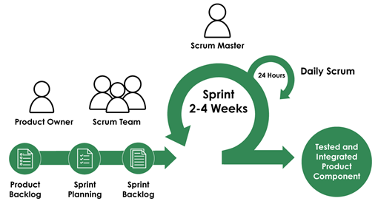

**Figure 4.** Agile development model

The Agile Scrum Methodology improves the development of the PESO online platforms by enabling continuous improvement and adaptability to evolving requirements. The approach highlights user involvement and the consistent incorporation of feedback, which simplifies the process of improving the system's functionality and interface. This technique guarantees that the system maintains its relevance by properly integrating new features and mandates from the law. The Agile Scrum methodology enables the development of an adaptable and responsive system that consistently exceeds or meets user expectations in the current environment.

**Product Backlog**

In this phase, the research determines the system's requirements and features. This includes a list of things that need to be developed, beginning with the project's product backlog, which is the list of procedures needed for creating the software.

**Table 2.** Product Backlogs

| **Priority** | **Item** |  | **Estimated hour/s (per day)** |
| --- | --- | --- | --- |
| **Admin** |  |  |  |
| **1** | As an Administrator, I want to Login in the system. |  | 1-2 Minutes |
| **2** | As an Administrator, I want to authenticate the users. |  | 30-60 Minutes |
| **3** | As an Administrator, I want to manage users |  | 1-2 Hours |
| **4** | As an Administrator, I want to provide a certificate for the user who pass the e-learning |  | 1-2 Hours |
| **5** | As an Administrator, I want to be able to view OFW inquiries. |  | 5-10 Minutes |

This table outlines the system's admin capabilities and the corresponding usage time. The admin accesses the admin dashboard, where he can go to the different sections of the system depending on what he needs to do. The admin can verify the documents that employers submitted, check the E-learning site and provide certificates for those who finish the modules, or view the reports of the OFW workers.

**Table 3.** Product Backlogs

|  |  |  |  |
| --- | --- | --- | --- |
| **Priority** | **Item** |  | **Estimated hour/s (per day)** |
| **User** |  |  |  |
| **1** | As a User, I want to browse job |  | 5-10 Minutes |
| **2** | As a User, I want to apply for a job. |  | 1 Hour |
| **3** | As a User, I want to enroll in online learning |  | 1 Hour |
| **4** | As a User, I want to get certificate |  | 1-24 Hours |
| **5** | As a User, I want to make an inquiry |  | 1 Hour |
| **6** | As a User, I want to post job vacancies |  | 2 Hours |

Table 2 shows the product backlog for users. It shows the user's capabilities in the system and the allotted time for each function. There are many things that the user can do in the system. They can post job vacancies, browse and apply for a job, register as a learner, enroll in a livelihood program, and get a certificate. If they are OFWs and need any assistance, they can go to the OFW section.

**Sprint Planning**

This research presents the priorities and discusses the sprint goals. The team will collaborate on it. This research also creates a sprint backlog and selects the tasks that must be completed to develop the project.

**Table 4.** Sprint Backlogs.

|  |  |  |  |  |
| --- | --- | --- | --- | --- |
| **Priority** | **Item** | **Task** |  | **Estimated hour/s (per day)** |
| **Admin** |  |  |  |  |
| **1** | As an Administrator, I want to access dashboard to see report on how many user have been employed and how many job vacancies are available | Design and develop the dashboard to show reports |  | 24-48 Hours |
| **2** | As an Administrator, I want to verify the employers and employees, by checking their identity and credibility | Design and develop a page for view employer and employees information |  | 48-96 Hours |
| **3** | As an Administrator, I want to check the users that are  taking E-Leanings program and if the user has passed | Develop and design the page for managing the learner information and printing of certificates |  | 96-192 Hours |
| **4** | As an Administrator, I want to manages the OFW inquiries and provides assistance for them | Design a page for managing OFW reports and information |  | 48-96 Hours |

The table shows the features and the admin needs to enhance the system. Admin needs to see the statistical report of job vacancies, accepted applicants, passed learner, and OFW reports. Also the admin can verify the employer information and provide certification to the passers of the livelihood program and also help the OFW workers

**Table 5.** Sprint Backlogs.

|  |  |  |  |  |
| --- | --- | --- | --- | --- |
| **Priority** | **Item** | **Task** |  | **Estimated hour/s (per day)** |
| **User** |  |  |  |  |
| **1** | As a User, I want to browse jobs and apply | Design and develop the page for the list of jobs and application form |  | 96-192 Hours |
| **2** | As a User, I want to post job vacancies that are available to the public. identity and credibility | Design and develop a form for putting in job vacancies |  | 96-192 Hours |
| **3** | As a User, I want to enroll for an online learning course. | Design and develop E-learning. |  | 96-192 Hours |
| **4** | As a User, I want to make an inquiry to ask for help | Design and develop a page for posting an inquiry |  | 96-192 Hours |

This sprint backlog shows the essential features, and user needs to enhance the system's functionality. Such as job browsing and application, job posting, enrolling for livelihood programs, posting a repost, or asking for help as OFW workers.

**Use Case**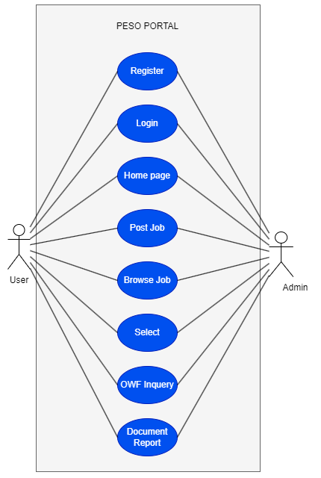

**Figure 5**. Use case

The use case diagram shows all the different modules included in the system. It also shows the user connected to each module and how the admin accesses different system pages. The primary users of the system are jobseekers, learners, OFW workers, and employers. The system has three main modules: the Job Corner, the e-learning program, and the OFW service. There are also other modules, such as the landing page and the Job posting page for the employers section. user can sign - in/sign up as a regular user or as an employer. The admin or the PESO handles the verification, certification, and report analysis.

**Materials**

**Software**

**VISUAL STUDIO CODE** will be used as the development tool of the web application. This will be useful for the development process by offering a user-friendly interface and a wide range of extensions that enhance productivity and support various programming languages, and tools commonly used in web development.

**HTML** is used to create the structure and content of web pages. It defines the elements and their placement to ensure proper rendering in web browsers. HTML also serves as the backbone of web pages, defining elements such as headings, paragraphs, lists, and links.

**JAVASCRIPT** will serve as a fundamental tool in developing the web-based portal system. It played a crucial role in crafting interactive features essential for user engagement, including animations, pop-up menus, and clickable buttons.

**BOOTSTRAP.** Bootstrap is a library of reusable HTML, CSS, and JavaScript code that forms the foundation for our e-justice system. It provides a flexible front-end programming framework, extensive pre-built components, and adaptable design elements that simplify development. Bootstrap ensures a user-friendly experience, improves consistency and reliability, and speeds up development.

**PHP** will be the backend programming language to connect the web-based system to the server, enabling dynamic content generation, database interaction, and server-side processing. With PHP, developers can create reliable backend functionality for user authentication, data storage, and retrieval.

**MySQL**, this tool, will serve as the system's database. It is a relational database that organizes data into tables consisting of rows and columns. This will be efficient for the system.

**Hardware**

**Table 6**. Hardware Specification

|  |  |
| --- | --- |
| **Components** | **Specification** |
| Random Access Memory(RAM) | 8gb |
| CPU | AMD Ryzen 3 |
| Operating System(OS) | Windows 10 Home |

The table shows the specifications of the computer used to develop the system. The working computer is running Windows 10 Home with 8 GB installed RAM and using AMD Ryzen 3 with built-in Radeon Vega Graphics.

**Table 7.** Minimum Requirements for PC/Laptop.

|  |  |
| --- | --- |
| **Components** | **Specification** |
| Random Access Memory | 4gb |
| CPU | At Least Ryzen 3/Core i5 |
| Storage | At Least 4gb Storage |
| Operating System(OS) | Windows (32-bit or 64-bit) |

The table shows the minimum requirements for a PC or laptop to run the system smoothly. These specifications are put in place to ensure that the system will run without problem for the majority of users.

**Table 8.** Minimum Requirements for Mobile

|  |  |
| --- | --- |
| Components | Specification |
| Random Access Memory | 4gb |
| Processor | At Least Quad Core |
| Storage | At Least 3gb Storage |
| Android OS | Atleast Android 8 |

The table shows the minimum requirements for mobile phones to run the system smoothly. These specification requirements are put in place to ensure the system will run without problems for most users.

**Project Testing and Debugging**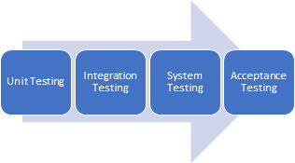

**Figure 6**.Project Testing and Debugging

In Project Testing and Debugging, the researcher utilizes different tests to create this project. These tests are used to identify bugs and avoid failure before delivering the system.

The researcher will use various tests, including Unit Testing, Integration Testing, System Testing, and Acceptance Testing, to assure the project's quality and dependability.

**Unit Testing**

**Figure 7**. Unit Testing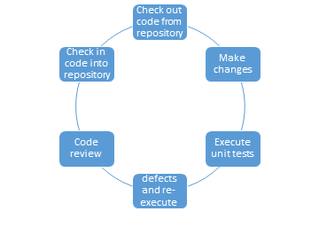

Unit testing is a technique for testing individual units or components of a software program. The researcher specializes in testing specific components or units of code, such as functions, methods, and classes, to ensure that they are working appropriately.

**Integration Testing**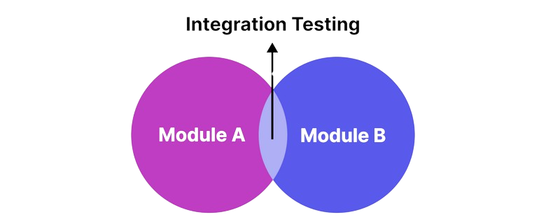

**Figure 8**.IntegrationTesting

An integration system is software testing in different types of units, where the different modules or units are tested.

**Compatibility Testing**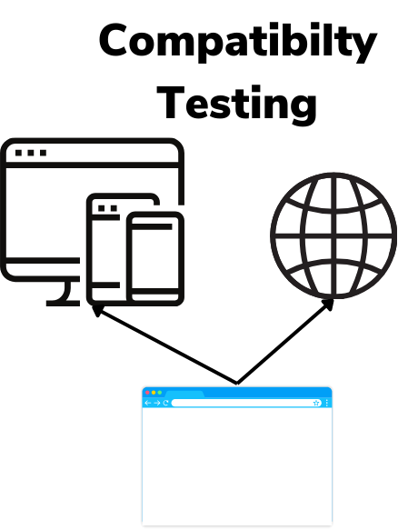

**Figure 9**.Compatibility Testing

This research will check the compatibility of systems on various devices, including Android, and with different browsers, such as Firefox, Chrome, and others.

**System Testing**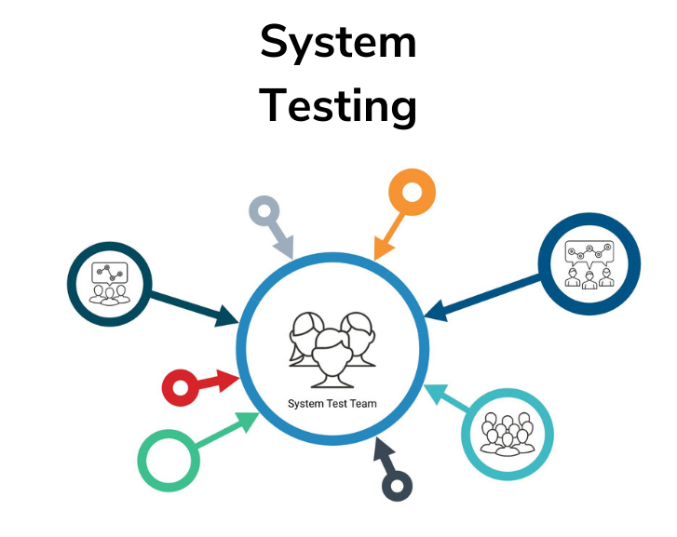

**Figure 10**. System Testing

**Load testing.** This is where the researcher will test the system's performance to check for performance issues such as system crashes and slow response time and how fast it can be processed.

**Stress testing.** In stress testing, the researcher accepts multiple users to test the website's ability to handle the number of users.

**Acceptance Testing**

This is testing that researchers will use to ensure that the user will approve the system. The researcher deploys the software to the user, collects the feedback, and implements the improvements to the system.

**Evaluation Procedure** 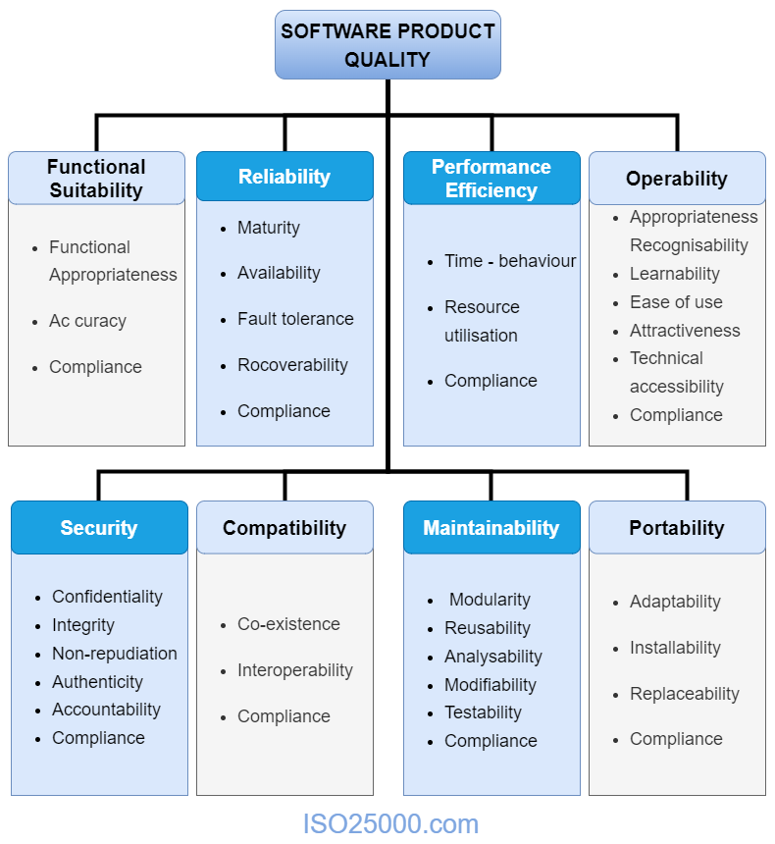

**Figure 11**. ISO 25010 Software Quality Model Characteristics

The image presents a structured overview of the ISO 25010 standard that provides a framework for evaluating the attributes that make software reliable, secure, usable, and meet the requirements of clients and users. It is used to guide the development and assessment of software throughout its lifecycle, ensuring it satisfies quality standards. The model categorizes software quality into eight main factors:

**Functional Suitability** is one of the most essential components of software since it must meet the user's requirements and expectations. The researchers can show the system and address the issue identified by the user, leading to the user's confirmation that the system is successful and efficient.

**Performance Efficiency**. The system must assure consumer pleasure by checking whether the site can operate correctly in various browsers, operating systems, and systems.

**Usability.** The user must understand how to use and benefit from the software. Software designers must consider a wide range of concerns, including the system's user interface, navigation, terminology, and general design. An important component of usability is ensuring that the software's usage and usefulness are quickly clear to users. This indicates that the system must be basic and uncomplicated, with conspicuous navigation menus, easily identifiable buttons and icons, and simple, straightforward methods.

**Reliability**. During a certain period, users correctly use a system's functions. There is a chance that a system will execute its intended function successfully for a specified amount of time or will run without failure in a specific environment. Determine the possibility of any operational disruption to your systems.

**Maintainability** is the possibility of executing a successful repair process within a certain time. This technique attempts to increase the effectiveness and efficiency of maintenance for users. It also describes how fast the system can be repaired, which influences the downtime patterns.

**Portability**. The system is simple to use for all users. It helps anyone transfer new software versions across environments by saving time and mental strain.

**Population of the Study**

The project study includes various individuals who will interact with the web-based portal in different ways. The primary users are community members, including job seekers, learners, and overseas Filipino workers (OFWs). These individuals use the system to access job opportunities, engage with e-learning resources, and report relevant information about overseas work.

Employers or companies will also use the portal to post job openings, review applications, and connect with potential candidates. These include job recruiters and HR personnel from different businesses within Los Baños and the surrounding areas.

The administrators and trainers from PESO Los Baños are crucial in managing the system. Administrators oversee system operations, managing the data across different parts of the website, while trainers upload e-learning modules, conduct video training, and provide certificates to successful learners.

While the system is primarily designed for authorized personnel, interest from the general public is recognized. People may view the system to explore job listings, learn about local training opportunities, and access resources for OFWs. However, access is limited to ensure the system's integrity and security, protect sensitive information, and maintain operational efficiency. The approach seeks to balance openness and security, catering to the needs of the system's public and authorized users.

**Sampling Design**

The survey will utilize purposive sampling, a non-probability technique that carefully selects participants based on their assessment and accessibility. It will include 15 participants: 10 job seekers, 5 employers, and 5 IT experts knowledgeable about the web-based system under investigation. Purposive sampling was chosen to ensure that the survey captured insights from these specific groups, allowing for target data collection and a comprehensive understanding of the research topic.

|  |  |
| --- | --- |
| **CATEGORY OF RESPONDENTS** | **SAMPLE** |
| Job seekers | 10 |
| Employees | 5 |
| IT experts | 5 |
| **Total** | **20** |

**Table 9.** Respondents of the Research Project

Table 9 displays the composition of respondents engaged in assessing the system. This table categorizes the respondents into three groups: IT Experts, employers, and job seekers, with a sample size of 5 IT Experts, 5 employers, and 10 job seekers, totaling 20 participants. The evaluation procedure will be undertaken by these respondents to examine the feasibility, performance, and features of the proposed web-based system. Specifically, IT Specialists, with their skill in web-based systems, will critically analyze the system's functionality, contributing to a complete assessment of its technical capabilities.

**Data Collection Instrument**

The data for the project's results will be collected through a survey and questionnaire. The web-based system will be constructed using the information gathered from respondents in a developer questionnaire survey. The development of the web-based system will rely on data gathered from respondents through a questionnaire survey distributed by developers, guaranteeing a solid foundation for project outcomes.

Interviews will be conducted in addition to surveys to gather data for the study. The interview questions will be formulated to create a plan that will suit the users' requirements and preferences. These questions will focus on those aspects to ensure that the web-based system's features and design satisfy end-user needs. Surveys will be distributed among the participants to assess the system. The first set will have five questions, focusing on how well the program meets user demands. Design portability, accessibility, data relevance, and the portal's easily identifiable interface will be examined in these questions. The criteria and attributes listed in the ISO 25010 software evaluation will be the foundation for the second set of questions. Physical copies, as well as Google Form surveys, will be employed.

**Statistical Treatment**

The collected data from the target respondent pool underwent analysis using a combination of population and purposive sampling techniques. This approach will enable a comprehensive evaluation of the system's functionality and overall performance during development. By employing both population and purposive sampling, a representative sample from the target respondent pool will be obtained, allowing for a thorough examination of diverse perspectives. This method is expected to facilitate the testing and evaluating the system's functionality and performance while providing valuable insights into specific user preferences and requirements. These insights will be crucial in informing a more tailored and user-centric development approach.

**REFERENCES**

Haan, K. (2023, June 12). 2024 Forecasts and Statistics for Remote Work. Advisor for Forbes.

A survey on skill identification from online job ads | IEEE journals ... (n.d.). <https://ieeexplore.ieee.org/abstract/document/9517309>

Choi, E. J. (2023). Does the internet help the unemployed find jobs? Information Economics and Policy, 62, 101017.

[https://doi.org/10.1016/j.infoecopol.2023.101017](https://doi.org/10.1016/j.infoecopol.2023.101017?fbclid=IwAR32y0PWFSW3xr6YOMR0k2LRj_BCit1xKdGJctOOKJjT4NgiknFLFIptngc)

Haan, K. (2023, June 12). Remote Work Statistics and Trends in 2024. Forbes Advisor. <https://www.forbes.com/advisor/business/remote-work-statistics/>

Ajunwa, I., Crawford, K., & Ford, J. (2016). Platform authoritarianism: The implications of automated hiring for the future of work. New Media & Society.

Alessandro Acquisti and Christina Fong (2020). The Economics of Privacy. Journal of Economic Literature.

Athukorala, P., & Wei, X. (2017). Geography and competency mismatches in the labor market in China. Labour Economics.

Banerjee, A., Saini, J., & Kalyanaram, G. (2018). Employer branding: a strategic tool for talent management. Journal of Strategic Human Resource Management.

Chaitra, V. H. (2018). Perceptions of online recruitment: An exploratory study. International Journal of Internet Research.

Choi, M. (2023). The impact of online job search on unemployment rates: A theoretical perspective. Journal of Economic Theory.

Factors affecting length of job search and job switching in Davao City. (n.d.). Journal of Davao City Employment Studies.

Deluna, R., & Berdos, K. (2015). Factors affecting length of job search and job switching in Davao City, Philippines. RePEc: Research Papers in Economics.

[https://EconPapers.repec.org/RePEc:pra:mprapa:68802](https://econpapers.repec.org/RePEc:pra:mprapa:68802?fbclid=IwAR0RxdmRILtb_nxzE9FAUOrt00eBQZ02NCzIjiImZVfVsOyIec6uBGlKSXo)

Karakanian, N. (2000). The impact of electronic human resource management on human resource management. International Journal of Human Resource Management.

Lim, S., Lee, A., & Lee, Y. (2015). Changes in job applicant qualifications due to online recruitment. Journal of Applied Psychology.

Mansourvar, M., & Yasin, S. (2014). Enhancing Job Portal Effectiveness:

Recommendations from the European Commission. Journal of Employment Strategies.

Ployhar, D., Schmitt, N., & Tippins, N. (2017). Talent Management in the 21st Century:

Academic Research Reveals Key Features of Effective Practices. Journal of Applied Psychology.

Sakinah, M. Z. (2016). The role of E HRM in modern recruitment: A case study analysis. International Journal of Organizational Management.

Toresh, S., & Almari, R. (2015). Factors influencing effectiveness of online recruitment: A comparative study. Journal of Applied Human Resource Management.

Kokkodis, A., Papadimitrio, A., & Ipeirotis, P. (2015). Understanding hiring behavior on online labor markets: Insights from probabilistic models. Journal of Human.

Ramkumar, A. (2018). Benefits of E-Recruitment: A Comprehensive Analysis. International Journal of Human Resource Management.

Sakinah, M. Z. (2016). The role of E HRM in modern recruitment: A case study analysis. International Journal of Organizational Management.

Toresh, S., & Almari, R. (2015). Factors influencing effectiveness of online recruitment: A comparative study. Journal of Applied Human Resource Management

Smith, J. (2021). The growth of online job platforms in the digital age. Journal of Employment Studies.

Diaz, L. (2022). Challenges of manual data management in public employment services. International Journal of E-Government Studies.

Aquino, R., & Castillo, M. (2022). Improving communication in distance learning

programs. International Journal of Education and Development using Information and Communication Technology,

Department of Labor and Employment (2020). Overview of the Public Employment Service Office (PESO) program. <https://www.dole.gov.ph/peso-program/>

Acme Research Group (2023). Proposal for a web-based system to modernize PESO operations. Unpublished manuscript.

Cruz, A., Reyes, M., & Ortiz, J. (2022). Improving public employment service delivery through data-driven decision making. Journal of Public Administration and Policy Research.

Aquino, R., & Guevara, A. (2022). Enhancing online training programs in public sector organizations. International Journal of Public Sector Training and Development

Cruz, A., Reyes, M., Ortiz, J., & Diaz, L. (2022). Transforming public employment services through technology-driven solutions. Journal of Public Administration and Policy Research.

Reyes, C., & Diaz, L. (2021). Improving complaint management for overseas Filipino workers. International Journal of Migration and Border Studies.

Salazar, P., & Guevara, A. (2021). Challenges in tracking student progress in government-led training initiatives. International Review of Research in Open and Distributed Learning.