A Project Report on
INTEGRATED SMART SAFETY SYSTEM FOR TRAFFIC MANAGEMENT
Submitted in partial fulfillment of the required for the award of the course of

DIPLOMA
In
Electronics and Communication Engineering

By

V. CHETANA SAI KRISHNA | 22411-EC-065
P. PHANI KUMAR | 23411-EC-049
P. NAGA VENKATA SATISH | 23411-EC-050
P. VINAY VISHAL | 23411-EC-052
P. RAJA GOPAL | 23411-EC-053
P. NAGA VARDHAN | 23411-EC-055

Under the guidance of
Smt. J. T. V. TEJA, _{B. Tech}

Lecturer, ECE.

...Empowering minds

Sri Vasavi Institute of Engineering & Technology
2nd Shift Polytechnic
(Approved by AICTE, New Delhi & Affiliated to SBTET, A.P)
NANDAMURU, PEDANA MANDAL, KRISHNA DIST, A.P

2023-2026

Department of Electronics & Communication Engineering
Sri Vasavi Institute of Engineering & Technology
2nd shift Diploma Courses
NANDAMURU, PEDANA MANDAL, KRISHNA DIST, A.P
(Accredited by NAAC & NBA & Affiliated to SBTET, A.P)
...Empowering minds
CERTIFICATE
​This is to certify that the project entitled "INTEGRATED SMART SAFETY SYSTEM FOR TRAFFIC MANAGEMENT" is a record of bona fide work carried out by:
V. CHETANA SAI KRISHNA | 22411-EC-065
P. PHANI KUMAR | 23411-EC-049
P. NAGA VENKATA SATISH | 23411-EC-050
P. VINAY VISHAL | 23411-EC-052
P. RAJA GOPAL | 23411-EC-053
P. NAGA VARDHAN | 23411-EC-055
​ In partial fulfillment of the requirements for the award of a Diploma in Electronics & Communication Engineering from State Board of Technical Education & Training, A.P. The results in this project report have not been submitted to any other institution for the award of any Diploma.
PROJECT GUIDE | HEAD OF THE DEPARTMENT
Smt. J.T.V. TEJA, B.Tech. | Smt. G.N.P. JYOTHI, M.Tech.
EXTERNAL EXAMINER
​ACKNOWLEDGEMENT
​First and foremost, we express our sincere gratitude to our esteemed institution, Sri Vasavi Institute of Engineering & Technology (SVIET), Nandamuru, for giving us the opportunity to fulfill our aspirations and for the successful completion of our diploma.
​We would like to express our thanks to the Principal Mr. N. V. K. PRASAD for his constant and valuable support in every step of our project, and for providing all the facilities for our project work.
​We articulate our gratitude from the depths of our hearts to Smt. G. N. P. JYOTHI, Head of the Department, Electronics and Communication Engineering, who is a source of inspiration and continuous encouragement. Indeed, we are ever indebted to her for her able supervision and indispensable help.
​We have immense pleasure in expressing our thanks and deep sense of gratitude to our project guide Smt. J. T. V. TEJA, B.Tech., Lecturer, Department of ECE, for her valuable guidance and constant encouragement throughout the project.
​Our utmost thanks to all the faculty members and Non-Teaching staff of the Department of Electronics and Communication Engineering for their support throughout our project work.
​We owe a deep sense of gratitude to our family members and friends for their loving encouragement, timely suggestions, and constant support in finishing this project within the stipulated time.

V. CHETANA SAI KRISHNA | 22411-EC-065
P. PHANI KUMAR | 23411-EC-049
P. NAGA VENKATA SATISH | 23411-EC-050
P. VINAY VISHAL | 23411-EC-052
P. RAJA GOPAL | 23411-EC-053
P. NAGA VARDHAN | 23411-EC-055

ABSTRACT
​This project presents a smart infrastructure prototype that integrates density-based traffic control, blind curve safety warnings, and automated street lighting. Using an Arduino UNO and IR sensors, the system monitors real-time vehicle density to dynamically adjust traffic signal timings, optimizing traffic flow and reducing congestion. Additionally, it detects vehicles at low-visibility curves to provide advanced warnings, significantly enhancing road safety. Finally, an LDR-based circuit automates streetlights according to ambient light levels to conserve energy. This combined approach offers a cost-effective, scalable solution for improving urban mobility, preventing accidents, and minimizing power consumption.
Key components:
- ​Arduino UNO Board
- ​IR sensors
- ​LDR sensor
- ​LEDs
- ​BC547 Transistor
- ​Resistors & Connecting wires
- ​Single digit 7 segment displays
- ​74HC595 shift registers
- ​Traffic light LED modules
- ​Battery Pack and Regulator

LIST OF FIGURES

FIGURE NO. | NAME OF THE FIGURE | PAGE NO
1.1 | Project block diagram | 2
3.2 | Arduino UNO board | 6
3.3 | IR sensor | 8
3.4 | LDR sensor | 8
3.5 | LED | 9
3.6 | BC547 Transistor | 10
3.7 | Resistor | 11
3.8 | Connecting wires | 12
3.9 | Single digit 7 segment display | 12
3.10 | 74HC595 shift registers | 13
3.11 | Traffic light LED module | 14
3.12 | Battery pack and regulator module | 15
5.1 | Launch the Arduino IDE | 19
5.2 | Connect the Board | 19
5.3 | Select the Board | 20
5.4 | Select the Serial Port | 20
5.5 | Compile the Code | 20
5.6 | Upload the Code | 21
10.1 | Overall system setup showing the Arduino, shift registers, and intersections. | 31
10.2 | Traffic lights changing dynamically based on the IR sensor density detection. | 31
10.3 | The LDR circuit activating the street lights in a dark environment. | 32
10.4 | The blind curve warning LED glowing when an object is placed near the curve IR sensor. | 32

LIST OF TABLES
TABLE NO. | NAME OF THE TABLES | PAGE NO
3.1 | LIST OF MATERIALS | 5
4.1 | Arduino Pin Connection Mapping | 16
4.2 | Shift Register Cascade Configuration | 16

LIST OF CONTENTS
CONTENTS | PAGE NO
LIST OF MATERIALS 6
INTRODUCTION 1
CHAPTER 1: IMPLEMENTATION OF PROJECT 2
​1.1 Block Diagram 2
​1.2 Explanation of each block: 2
​1.2.1 Arduino UNO: 2
​1.2.2 IR Sensors: 3
​1.2.3 LDR & Transistor Circuit: 3
​1.2.4 Shift Registers & Displays: 3
CHAPTER 2: LITERATURE SURVEY 4
​2.1 Traffic Management Systems 4
​2.2 Blind Curve Safety Mechanisms 4
​2.3 Automated Street Lighting 4
CHAPTER 3: HARDWARE COMPONENTS 5
3.1. LIST OF MATERIALS 5
3.2. Arduino UNO board 6
​3.2.1. Arduino UNO Structure Description 6
​3.2.2. Applications of Arduino UNO 7
​3.2.3. Features of Arduino UNO Board 7
​3.3. IR SENSOR 8
​3.3.1. Pin Configuration of IR Sensor 8
​3.3.2. Features of IR Sensor 8
​3.3.3. Applications of IR Sensor 8
3.4. LDR SENSOR 9
​3.4.1. Features of LDR Sensor 9
​3.4.2. Applications of LDR Sensor 9
​3.5. LED 10
​3.5.1. Specifications of LED 10
​3.5.2. Features and Applications 10
3.6. BC547 TRANSISTOR 11
​3.6.1. What is a BC547 TRANSISTOR? 11
​3.6.2. BC547 Transistor Pin Configuration 11
​3.7. RESISTORS 12
3.8. CONNECTING WIRES 12
​3.9. SINGLE DIGIT 7 SEGMENT DISPLAYS 13
3.9.1. Features of single digit 7 segment display 13
3.10. 74HC595 SHIFT REGISTERS 14
3.10.1. Features of 74HC595 shift register 14
3.11. TRAFFIC LIGHT LED MODULES 15
​3.12. BATTERY PACK AND REGULATOR MODULE 15
CHAPTER 4: CIRCUIT IMPLEMENTATION 16
4.1 Arduino Pin Connection Mapping 16
4.2 Shift Register Cascade Configuration 16
4.3 STEP-BY-STEP ASSEMBLY GUIDE 17
4.4 TESTING & CALIBRATION 17
CHAPTER 5: SOFTWARE TOOLS 19
CHAPTER 6: PROGRAM CODE 22
6.1 Code Explanation and Logic 28
CHAPTER 7: ADVANTAGES AND APPLICATIONS 29
7.1 Advantages 29
7.2 Applications 29
CHAPTER 8: RESULT AND CONCLUSION 30
8.1 RESULT 30
8.2 CONCLUSION 30
CHAPTER 9: FUTURE SCOPE 31
CHAPTER 10: OUTPUT 32
CHAPTER 11: REFERENCES 34

INTRODUCTION
​Rapid urbanization has led to a significant increase in vehicle density, causing severe traffic congestion and a higher risk of accidents, particularly at low-visibility blind curves. Furthermore, the continuous operation of conventional streetlights throughout the night, regardless of traffic presence or ambient light, leads to immense energy wastage. Traditional pre-programmed traffic light systems are highly inefficient because they do not adapt to real-time traffic volume, often causing unnecessary delays at empty intersections.
​To address these challenges, this project introduces a cohesive "Integrated Smart Safety System for Traffic Management." Utilizing an Arduino UNO microcontroller, the system actively monitors real-time vehicle density using IR sensors to dynamically allocate green light timings. Additionally, it features an automated warning system for hazardous blind curves and an LDR-based automated street lighting circuit. The primary objective of this prototype is to enhance urban mobility, significantly improve road safety, and promote energy conservation through a cost-effective, automated approach.

CHAPTER 1: IMPLEMENTATION OF PROJECT

​1.1. Block Diagram
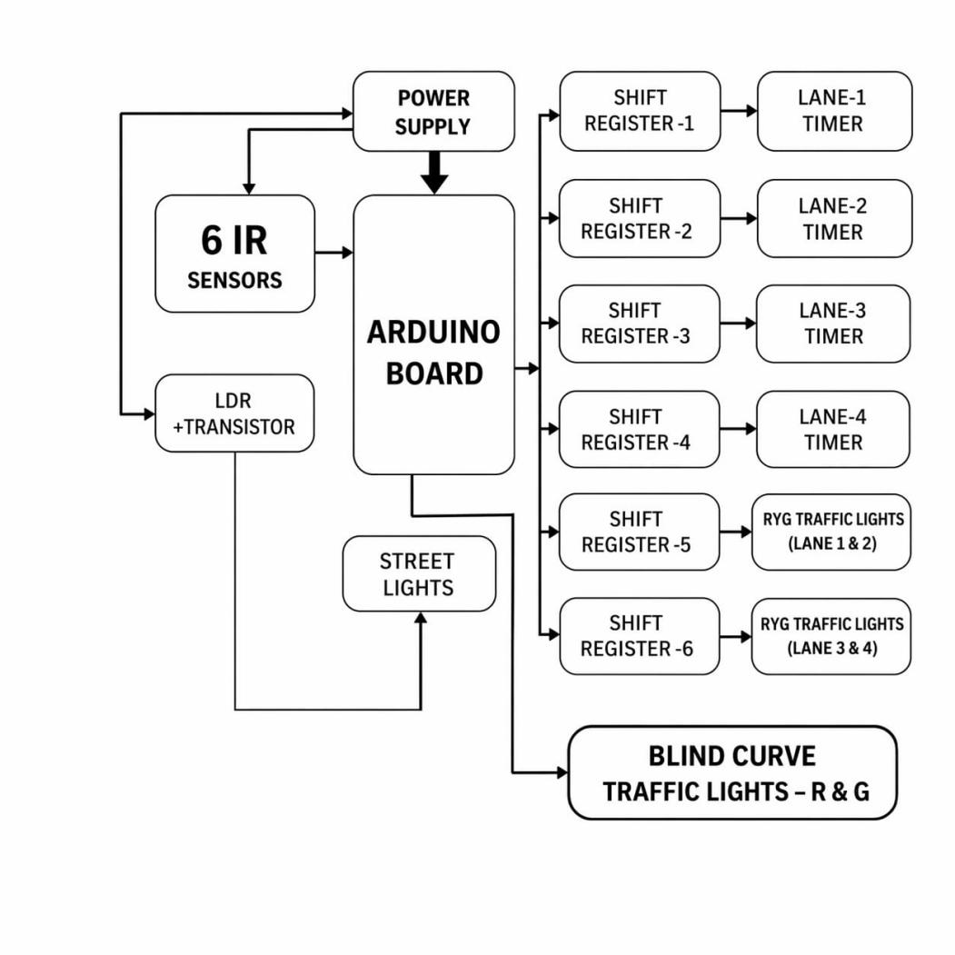
Fig 1.1 Block Diagram of integrated smart safety system for traffic management

​1.2. Explanation of each block:

​1.2.1. Arduino UNO:
The Arduino UNO features an ATmega328P chip. It acts as the brain of the system, receiving inputs from all the sensors (IR and LDR), processing the data based on the programmed logic, and sending execution commands to the output devices (Shift registers, LEDs).

​1.2.2. IR Sensors:
A set of IR sensors are placed at each lane and at the blind curve. These sensors emit infrared light to detect the presence and density of vehicles. They send digital signals (HIGH/LOW) to the Arduino to calculate how long the green light should stay on.

​1.2.3. LDR & Transistor Circuit:
The Light Dependent Resistor (LDR) continuously monitors the ambient sunlight. When it gets dark, the LDR's resistance changes, triggering the BC547 transistor to act as a switch, which automatically turns on the white street LEDs.

​1.2.4. Shift Registers & Displays:
To manage multiple lanes, six 74HC595 shift registers are cascaded. They take a serial input from just 3 Arduino pins and convert it into parallel outputs to drive four 7-segment display timers and the red/yellow/green traffic light LED modules simultaneously.

CHAPTER 2: LITERATURE SURVEY

​2.1. Traffic Management Systems
Existing traffic management heavily relies on fixed-timer traffic signals. While simple to implement, studies show they lead to increased wait times and fuel consumption when traffic is unevenly distributed across lanes. Several recent papers have proposed dynamic systems using image processing or RFID tags; however, these are often computationally expensive and complex to install. IR sensor-based detection offers a highly reliable and cost-effective alternative for density measurement.

​2.2. Blind Curve Safety Mechanisms
Traditionally, convex mirrors are installed at sharp bends to provide drivers with a view of oncoming traffic. However, literature indicates these mirrors are often ineffective during nighttime, heavy rain, or fog. More advanced active warning systems using radar or ultrasonic sensors have been explored, but integrating them directly with a central traffic management system is rarely implemented in standard infrastructure.

​2.3. Automated Street Lighting
Conventional street lighting systems operate either manually or via fixed timers, both of which fail to account for seasonal variations in daylight or unpredictable weather. Research into energy-efficient smart cities strongly advocates for the use of Light Dependent Resistors (LDRs) and microcontrollers to automate lighting based on actual environmental brightness, proving to save substantial amounts of electricity. This project builds upon these individual concepts by integrating them into a single, unified smart city prototype.

CHAPTER 3: HARDWARE COMPONENTS

3.1. LIST OF MATERIALS
The following table outlines the 15 essential components required for the prototype, including quantities for a standard academic project budget.
S.No | Component Name | Quantity | Specifications
1 | Arduino UNO R3 | 1 | ATmega328P Microcontroller
2 | IR Obstacle Sensors | 6 | 3.4V-5V DC, 3cm-80cm range
3 | 74HC595 Shift Registers | 6 | 8-bit Serial-In Parallel-Out
4 | Single Digit 7-Segment Display | 4 | Common Cathode/Anode
5 | Traffic light module | 4 | Red, Yellow, Green LEDs
6 | LDR (Light Dependent Resistor) | 1 | 5mm Photoresistor
7 | BC547 Transistor | 1 | NPN Bipolar Junction
8 | White LEDs | 22 | High-brightness (for street lights)
9 | Resistors (220Ω) | 60 | Current limiting for LEDs
10 | 5V Voltage Regulator (LM7805) | 1 | Stable 5V DC output
11 | 12V Battery Pack | 1 | Rechargeable or alkaline
12 | Jumper Wires (M-M/M-F/F-F) | 200 | Prototyping connections
13 | Breadboard (Full Size) | 3 | 830 tie-point
14 | Red/Green LEDs (Curve) | 2 | Individual signal LEDs
15 | DC Power Jack | 1 | 2.1mm Female

3.2. Arduino UNO board
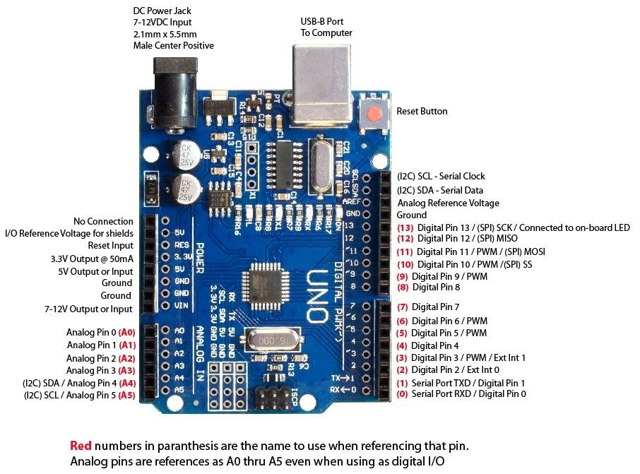
Fig 3.2 Arduino UNO

​3.2.1. Arduino UNO Structure Description
The Arduino UNO is a microcontroller board based on the ATmega328P microchip. It is one of the most popular and widely used boards.
- ​Microcontroller: The brain of the board, the ATmega328P, controls the input/output operations and the execution of the program.
- ​Digital I/O Pins: It has 14 digital pins (0-13) for communication with external devices.
- ​Analog Input Pins: The board features 6 analog input pins (A0-A5).
- ​Power Supply: The board can be powered via USB or an external power adapter (7-12V).
- ​USB Interface: For programming and communication with a PC.

​3.2.2. Applications of Arduino UNO
- ​Robotics: Widely used in the development of robotic systems, from simple line-following robots to complex autonomous robots.
- ​Home Automation: Automates home systems like lights, fans, and doors.
- ​IoT Projects: Serves as the base for Internet of Things projects when combined with wireless communication modules.

​3.2.3. Features of Arduino UNO Board
- ​Microcontroller: ATmega328P (8-bit AVR RISC-based microcontroller).
- ​Clock Speed: Operates at 16 MHz.
- ​Operating Voltage: 5V.
- ​Flash Memory: 32 KB.
- ​SRAM: 2 KB.
- ​PWM Pins: 6 of the digital pins support Pulse Width Modulation.

​3.3. IR SENSOR
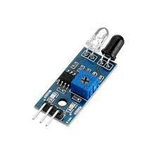
Fig 3.3 IR Sensor

​3.3.1. Pin Configuration of IR Sensor
An IR sensor typically consists of a transmitter and a receiver. The common pin configuration includes:
- ​VCC Pin: Connects to the 5V power supply.
- ​GND Pin: Connects to the ground.
- ​OUT Pin: Outputs a digital signal (HIGH or LOW) depending on the detection of IR light.

​3.3.2. Features of IR Sensor
- ​Infrared Light Emission: Emits and receives non-visible infrared radiation to detect objects.
- ​Detection Range: Varies typically between 3 cm to 80 cm.
- ​Low Power Consumption: Ideal for continuous monitoring.

​3.3.3. Applications of IR Sensor
- ​Object Detection & Proximity Sensing in robotics.
- ​Automated Doors and security systems.
- Counting items in industrial automation.

3.4. LDR SENSOR
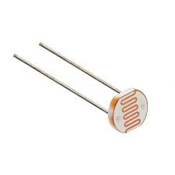
Fig 3.4 LDR Sensor

​3.4.1. Features of LDR Sensor
- ​Light Sensitivity: The main feature of an LDR is that its resistance decreases as the intensity of light hitting the sensor increases.
- ​Variable Resistance: Under bright light, resistance falls to a few hundred ohms, while in darkness, it rises to several megaohms.
- ​Simple and Low-Cost: Does not require complex circuitry.

​3.4.2. Applications of LDR Sensor
- ​Automatic Street Lighting systems.
- ​Light-sensitive Alarm Systems.
- ​Solar Tracking Systems to maximize energy collection.

​3.5. LED
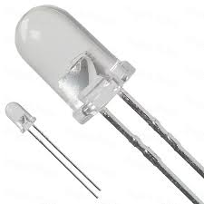
Fig 3.5 LED

​3.5.1. Specifications of LED
- ​Forward Voltage (VF): Typically between 1.8V to 3.4V depending on the color.
- ​Current Rating (If): Usually around 20mA.
- ​Lifespan: LEDs typically last between 25,000 to 50,000 hours.

​3.5.2. Features and Applications
- ​Energy Efficiency: Highly energy-efficient, using less power with low heat emission.
- Applications: Used in traffic signals, home lighting, automotive lighting, and indicators for devices.

3.6. BC547 TRANSISTOR
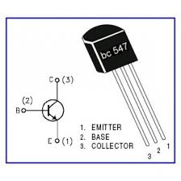
Fig 3.6 BC547 Transistor

​3.6.1. What is a BC547 TRANSISTOR?
The BC547 is a general-purpose NPN bipolar junction transistor (BJT) widely used in low-power amplification and switching applications.

​3.6.2. BC547 Transistor Pin Configuration
- ​Emitter (E): Connected to the ground or negative side.
- ​Base (B): Used to control the transistor by applying a small current.
- ​Collector (C): Where the current flows out, typically connected to a load.

​3.7. RESISTORS
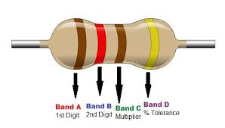
Fig 3.7 Resistor
- ​Resistors: A passive electronic component that limits or controls the flow of electrical current. Resistance is calculated using Ohm's Law (R=V/I)

3.8. CONNECTING WIRES
- ​Connecting Wires: Facilitate the flow of electrical current. Jumper wires (Male-to-male, Female-to-female) are used for building circuit prototypes without soldering.

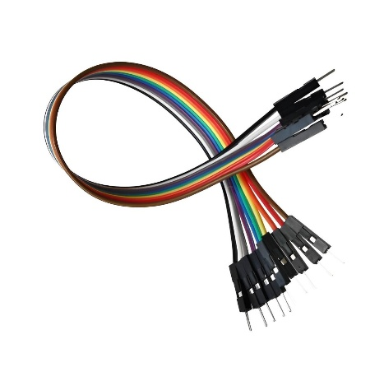
Fig 3.8 CONNECTING WIRES

​3.9. SINGLE DIGIT 7 SEGMENT DISPLAYS
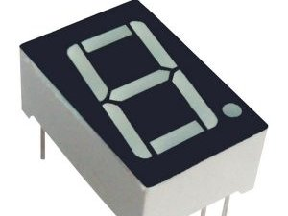​
Fig 3.9.SINGLE DIGIT 7 SEGMENT DISPLAYS

3.9.1. Features of single digit 7 segment display
- ​Consists of 7 segments (a-g) plus an optional decimal point (dp). Each segment is an individual LED.
- ​Available in Common Cathode (all cathodes connected to GND) and Common Anode (all anodes connected to VCC).
- ​Requires a current-limiting resistor (220-330 ohms) to protect the LEDs.

3.10. 74HC595 SHIFT REGISTERS
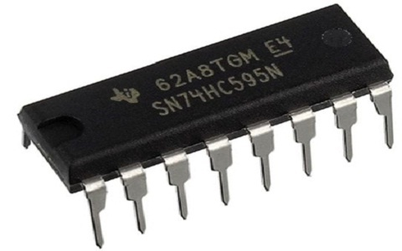
​Fig 3.10. 74HC595 SHIFT REGISTERS

3.10.1. Features of 74HC595 shift register
The 74HC595 is an 8-bit serial-in, parallel-out shift register widely used to expand microcontroller output pins.
- ​Accepts serial data input (1 bit at a time) and provides 8 parallel output pins (Q0-Q7).
- ​Requires only 3 microcontroller pins: Data (DS), Clock (SH_CP), and Latch (ST_CP).
- ​Multiple ICs can be cascaded together to expand to 16, 24, or 32+ outputs.

3.11. TRAFFIC LIGHT LED MODULES
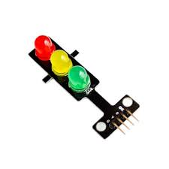
Fig 3.11 Traffic light LED module
Contains Red, Yellow, and Green LEDs arranged like a real traffic signal on a small PCB. Usually has 4 pins (R, Y, G, GND) and includes built-in resistors. Perfect for microcontroller simulation.

​3.12. BATTERY PACK AND REGULATOR MODULE
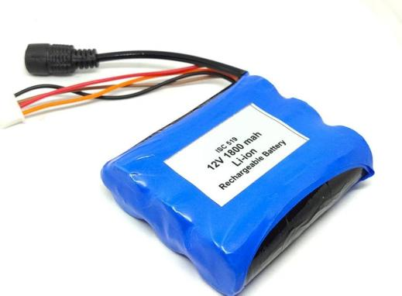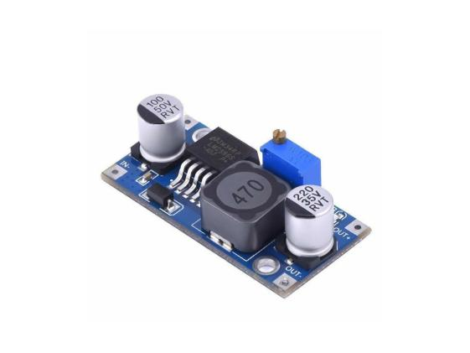
Fig 3.12 Battery pack and regulator module
Provides a stable 5V output from a 12V battery input to safely power the Arduino and sensors, protecting electronics from voltage fluctuations.

CHAPTER 4: CIRCUIT IMPLEMENTATION

4.1. Arduino Pin Connection Mapping
The following table maps the physical connections between the Arduino UNO and the system sensors and controllers based on the project source code.
Arduino Pin | Component / Function | Connection Detail
A0 - A3 | Lane IR Sensors | Digital/Analog Input for Lane 1-4
Pin 2 | Curve Sensor A | IR Sensor (Entrance)
Pin 3 | Curve Sensor B | IR Sensor (Exit)
Pin 4 | Data Pin (DS) | Shift Register Serial Data
Pin 5 | Latch Pin (ST_CP) | Shift Register Latch
Pin 6 | Clock Pin (SH_CP) | Shift Register Clock
Pin 7 | Curve LED A (Red) | Warning Signal Red
Pin 8 | Curve LED A (Grn) | Warning Signal Green
Pin 9 | Curve LED B (Red) | Warning Signal Red
Pin 10 | Curve LED B (Grn) | Warning Signal Green

4.2. Shift Register Cascade Configuration
To drive 40+ outputs with only 3 pins, the registers are cascaded.
IC Stage | Driven Component | Data Source
IC 1-4 | 7-Segment Display (Lanes 1-4) | Cascaded from Arduino Pin 4
IC 5 | Traffic Modules (Lanes 1 & 2) | Provides bits for RYG sequence
IC 6 | Traffic Modules (Lanes 3 & 4) | Provides bits for RYG sequence

4.3. STEP-BY-STEP ASSEMBLY GUIDE
- Power Setup: Connect the 12V battery to the 7805 regulator to provide a stable 5V rail for the Arduino and sensors.
- Sensor Placement: Mount six IR sensors: four at lane entrances for density and two at the blind curve.
- LDR Circuit: Build the voltage divider with the LDR and 10k Ohm’s resistor, connecting it to the BC547 transistor base to automate street LEDs.
- Shift Register Cascade: Chain the six 74HC595 ICs on the breadboard, connecting VCC, GND, and common Latch/Clock pins.
- Display Wiring: Connect the parallel outputs (Q0-Q7) of ICs 1-4 to the 7-segment display segments (a-g).
- Traffic Signal Wiring: Connect ICs 5 and 6 to the Traffic Light LED modules.
- Curve Warning Setup: Connect four Curve LEDs (2 Red, 2 Green) to Arduino pins 7-10.
- Arduino Interfacing: Connect all sensor OUT pins and the Shift Register control pins (4, 5, 6) to the Arduino.
- Code Upload: Connect the Arduino to a PC via USB and upload the "Integrated Smart Traffic" sketch using the Arduino IDE.

4.4. TESTING & CALIBRATION
- IR Sensor Calibration: Adjust the onboard potentiometer on each IR sensor so it triggers (LOW) only when a vehicle-sized object is within 10cm of the lane entrance.
- LDR Threshold: Test the street lighting in varied ambient light. If LEDs turn on too early, adjust the resistor value in the voltage divider.
- Module Testing Checklist:
- [ ] Does the 7-segment display show a "0" during idle?
- [ ] Do the curve LEDs switch to RED when an object passes Sensor A?
- Full Integration Test: Run the system and verify that the green light duration changes based on the number of objects passed in the 10-second observation window.

​The implementation of the Integrated Smart Safety System involves interconnecting the Arduino UNO with multiple sensor modules and output displays:
- ​Traffic Density Sensing: The six IR sensors are placed at designated lanes and connected to the Arduino's analog/digital input pins (e.g., A0, A1, A2, A3). Their VCC and GND are powered by the 5V regulator module.
- ​Display & LED Control: To conserve Arduino pins, six 74HC595 shift registers are cascaded. The Arduino sends serial data via Digital Pin 4 (Data), Pin 5 (Latch), and Pin 6 (Clock). The parallel outputs of these registers are wired to the four 7-Segment displays (to show countdowns) and the Traffic Light LED modules.
- ​Blind Curve Warning: Two additional IR sensors detect approaching vehicles on sharp bends and directly trigger the dedicated warning LEDs (connected to Digital pins 7, 8, 9, 10).
- ​Automated Lighting: The LDR is configured in a voltage divider circuit. Its output controls the base of the BC547 NPN transistor. When ambient light falls, the transistor switches ON, allowing current to flow and illuminate the white street LEDs.

CHAPTER 5: SOFTWARE TOOLS
​Arduino IDE Software:
The Arduino IDE is an open-source software used to write and upload code to Arduino boards. It supports C and C++ programming languages. The code written in the Arduino IDE is often called a sketch.
​Steps to write and compile the program:
- ​Launch the Arduino IDE: Open the software on your desktop. You will see the code editor screen with void setup() and void loop() functions.
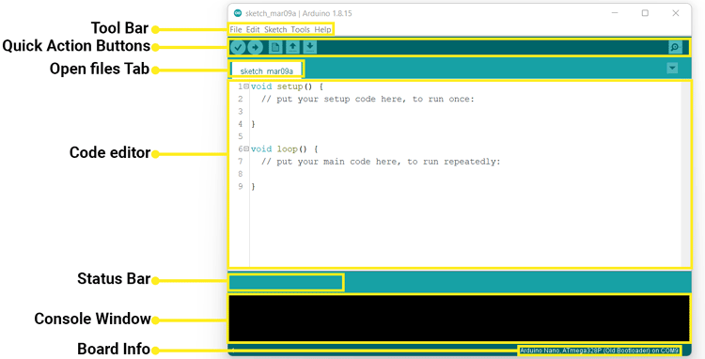
Fig 5.1 Launch the Arduino IDE
- ​Connect the Board: Connect your Arduino UNO board to the PC via a USB cable. The green power LED should glow.
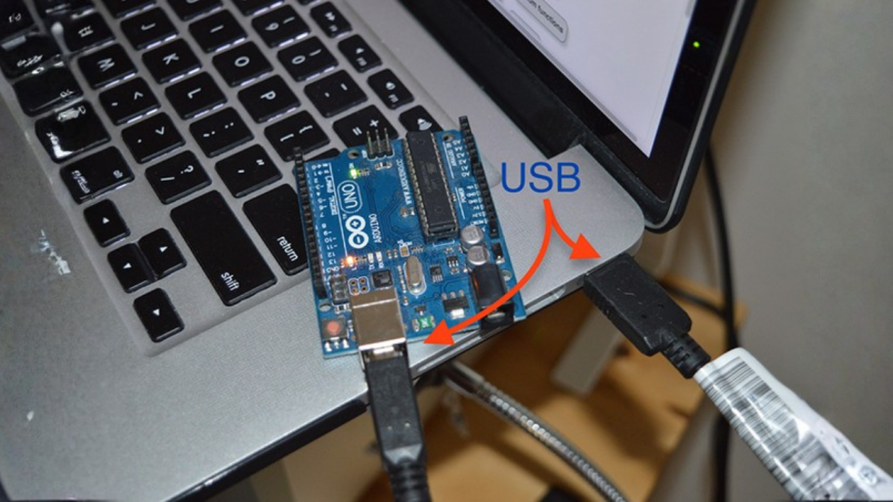
Fig 5.2 Connect the Board
- ​Select the Board: Go to the "Tools" menu, select "Board", and choose "Arduino UNO" from the list.
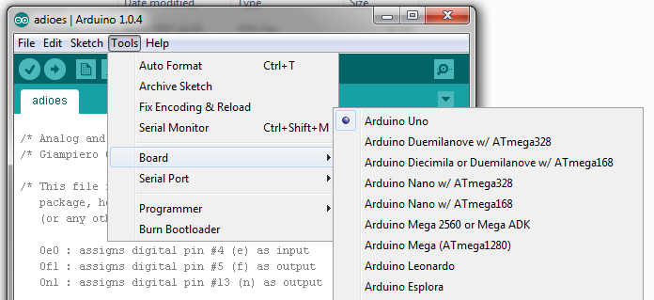
Fig 5.3 Select the Board
- ​Select the Serial Port: Go to "Tools" > "Port" and select the COM port that corresponds to your connected Arduino.
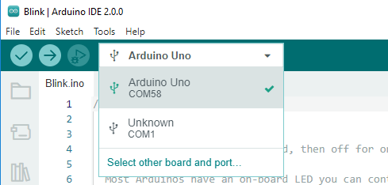
Fig 5.4 Select the Serial Port
- ​Compile the Code: Write your C++ code in the text editor. Click the tick-mark button at the top-left to compile. The compilation progress will show at the bottom, alerting you of any syntax errors.
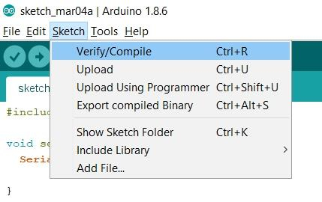
Fig 5.5 Compile the Code
- ​Upload the Code: Click the right-arrow Upload button. The RX and TX LEDs on the board will blink rapidly, indicating the code is being successfully transferred.
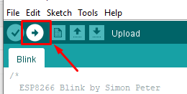
Fig 5.6 Upload the Code

CHAPTER 6: PROGRAM CODE
/* ========================================================
INTEGRATED SMART TRAFFIC & BLIND CURVE SYSTEM
======================================================== */

const int dataPin = 4;
const int latchPin = 5;
const int clockPin = 6;
const int laneSensors[4] = {A0, A1, A2, A3};
const int curveSensA = 2;
const int curveSensB = 3;
const int ledA_Red = 7;
const int ledA_Grn = 8;
const int ledB_Red = 9;
const int ledB_Grn = 10;

byte digits[] = {0x3F, 0x06, 0x5B, 0x4F, 0x66, 0x6D, 0x7D, 0x07, 0x7F, 0x6F};

int pendingVehicles[4] = {0, 0, 0, 0};
bool lastSensorState[4] = {HIGH, HIGH, HIGH, HIGH};
unsigned long curveTimer = 0;
int curveState = 0;

void updateShiftRegisters(byte d1, byte d2, byte d3, byte d4, byte ic5, byte ic6);
void checkBlindCurve();
void countVehiclesDelay(unsigned long ms);
void setCurveLights(int mode);
byte getBits(int s);
void runTrafficSequence(int current, int nextActive, int duration);

void setup() {
pinMode(dataPin, OUTPUT);
pinMode(latchPin, OUTPUT);
pinMode(clockPin, OUTPUT);
for (int i = 0; i < 4; i++) pinMode(laneSensors[i], INPUT);
pinMode(curveSensA, INPUT);
pinMode(curveSensB, INPUT);
pinMode(ledA_Red, OUTPUT); pinMode(ledA_Grn, OUTPUT);
pinMode(ledB_Red, OUTPUT); pinMode(ledB_Grn, OUTPUT);
updateShiftRegisters(0, 0, 0, 0, 0x09, 0x09);
setCurveLights(0);
delay(1000);
}

void loop() {
int totalPending = pendingVehicles[0] + pendingVehicles[1] + pendingVehicles[2] + pendingVehicles[3];
if (totalPending == 0) {
updateShiftRegisters(0, 0, 0, 0, 0x09, 0x09);
countVehiclesDelay(10000);
}
for (int i = 0; i < 4; i++) {
int currentLane = i;
int runTime = 0;
if (pendingVehicles[currentLane] == 0) continue;
else if (pendingVehicles[currentLane] > 9) {
runTime = 9;
pendingVehicles[currentLane] = pendingVehicles[currentLane] - 9;
}
else {
runTime = pendingVehicles[currentLane];
pendingVehicles[currentLane] = 0;
}
int nextActiveLane = -1;
for (int j = 1; j < 4; j++) {
int checkLane = (currentLane + j) % 4;
if (pendingVehicles[checkLane] > 0) {
nextActiveLane = checkLane;
break;
}
}
runTrafficSequence(currentLane, nextActiveLane, runTime);
}
}

void runTrafficSequence(int current, int nextActive, int duration) {
for (int t = duration; t >= 0; t--) {
byte d[4] = {0, 0, 0, 0};
d[current] = digits[t];
int status[4] = {0, 0, 0, 0};
if (t > 0) status[current] = 2;
else status[current] = 1;
if (t <= 2 && t > 0 && nextActive != -1) status[nextActive] = 1;
byte ic5 = (getBits(status[1]) << 3) | getBits(status[0]);
byte ic6 = (getBits(status[3]) << 3) | getBits(status[2]);
updateShiftRegisters(d[0], d[1], d[2], d[3], ic5, ic6);
countVehiclesDelay(1000);
}
}

void countVehiclesDelay(unsigned long ms) {
unsigned long start = millis();
while (millis() - start < ms) {
checkBlindCurve();
for (int i = 0; i < 4; i++) {
bool currentState = digitalRead(laneSensors[i]);
if (currentState == LOW && lastSensorState[i] == HIGH) {
pendingVehicles[i]++;
delay(20);
}
lastSensorState[i] = currentState;
}
}
}

void checkBlindCurve() {
if (curveState == 1 || curveState == 2) {
if (millis() > curveTimer) {
setCurveLights(3);
curveTimer = millis() + 2000;
curveState = 3;
}
return;
}
else if (curveState == 3) {
if (millis() > curveTimer) {
setCurveLights(0);
curveState = 0;
}
return;
}
if (digitalRead(curveSensA) == LOW) {
setCurveLights(1);
curveTimer = millis() + 6000;
curveState = 1;
}
else if (digitalRead(curveSensB) == LOW) {
setCurveLights(2);
curveTimer = millis() + 6000;
curveState = 2;
}
}

void setCurveLights(int mode) {
if (mode == 0) {
digitalWrite(ledA_Red, LOW); digitalWrite(ledA_Grn, HIGH);
digitalWrite(ledB_Red, LOW); digitalWrite(ledB_Grn, HIGH);
}
else if (mode == 1) {
digitalWrite(ledA_Red, LOW); digitalWrite(ledA_Grn, HIGH);
digitalWrite(ledB_Red, HIGH); digitalWrite(ledB_Grn, LOW);
}
else if (mode == 2) {
digitalWrite(ledA_Red, HIGH); digitalWrite(ledA_Grn, LOW);
digitalWrite(ledB_Red, LOW); digitalWrite(ledB_Grn, HIGH);
}
else if (mode == 3) {
digitalWrite(ledA_Red, HIGH); digitalWrite(ledA_Grn, LOW);
digitalWrite(ledB_Red, HIGH); digitalWrite(ledB_Grn, LOW);
}
}

byte getBits(int s) {
if (s == 2) return 0b100;
if (s == 1) return 0b010;
return 0b001;
}

void updateShiftRegisters(byte d1, byte d2, byte d3, byte d4, byte ic5, byte ic6) {
digitalWrite(latchPin, LOW);
shiftOut(dataPin, clockPin, MSBFIRST, ic6);
shiftOut(dataPin, clockPin, MSBFIRST, ic5);
shiftOut(dataPin, clockPin, MSBFIRST, d4);
shiftOut(dataPin, clockPin, MSBFIRST, d3);
shiftOut(dataPin, clockPin, MSBFIRST, d2);
shiftOut(dataPin, clockPin, MSBFIRST, d1);
digitalWrite(latchPin, HIGH);
}

6.1. Code Explanation and Logic
Observation Mode: The system utilizes a 10-second observation window using the countVehiclesDelay(10000) function. During this period, the system continuously reads the IR sensors laneSensors to check for incoming vehicles. If a vehicle passes, the pendingVehicles counter for that specific lane increases.
Execution Mode: The system evaluates the pendingVehicles array. To prevent traffic starvation, the maximum green light duration for any lane is capped at 9 seconds (runTime = 9). If a lane has fewer vehicles, the green light will only stay on for that exact duration, saving time.
Shift Register Implementation: Because the Arduino UNO has limited digital pins, the updateShiftRegisters function uses shiftOut() to send data serially to the 74HC595 shift registers.
Advanced Blind Curve Logic: The checkBlindCurve() function runs continuously using millis() and prioritized checks, allowing the Arduino to multitask. It grants a 6-second crossing window, followed by a mandatory 2-second safety clearance mode (All Red).

CHAPTER 7: ADVANTAGES AND APPLICATIONS

7.1. Advantages
Improved Traffic Safety: Reduces accidents by monitoring vehicle density and controlling traffic lights dynamically. Alerts drivers and pedestrians in real-time about dangerous conditions at blind curves.
Efficient Traffic Flow: Adaptive traffic lights reduce congestion and waiting times by optimizing signals based on real-time traffic data, rather than fixed timers.
Reduced Environmental Impact: Minimizes idling time, lowering fuel consumption and air pollution. Supports eco-friendly initiatives with automated street lights.
Cost-Effective in the Long Run: Reduces accidents and energy waste. Less manpower is needed for monitoring and manual traffic control.
Scalability and Flexibility: Modular design allows easy upgrades for future smart city technologies.

7.2. Applications
Real-Time Traffic Control: Adaptive traffic signals adjust timing based on real-time traffic flow during peak hours.
Accident and Hazard Detection: Detects approaching vehicles at blind curves and sends visual alerts to nearby drivers.
Urban Planning and Analytics: Collects traffic data for city planning to predict traffic hotspots and suggest road expansions.
Environmental Monitoring: Supports eco-friendly traffic policies in smart cities by lowering fuel consumption and automating street lights using LDRs.

CHAPTER 8: RESULT AND CONCLUSION

8.1. RESULT
The hardware prototype of the Smart Density-Based Traffic Management System was successfully assembled and tested. The system operated reliably across all three of its primary functions. The array of six IR obstacle sensors accurately detected varying vehicle densities across different lanes. The Arduino UNO, successfully interfaced with the six 74HC595 shift registers, processed this data to dynamically adjust the LED traffic signals and update the 7-segment display countdowns in real-time, eliminating unnecessary wait times.
The blind curve detection mechanism successfully identified approaching objects in low-visibility zones, triggering immediate visual warnings to simulate alerting oncoming drivers. Additionally, the independent LDR-based circuit functioned exactly as intended, consistently toggling the street LEDs on when ambient light dropped below a specific threshold and turning them off during well-lit conditions.

8.2. CONCLUSION
The development of this multi-functional prototype demonstrates a highly effective, low-cost approach to modernizing road infrastructure. By successfully integrating dynamic traffic signal control, proactive blind curve warnings, and automated street lighting into a cohesive unit, this project addresses three critical urban challenges: severe traffic congestion, road safety hazards at sharp bends, and immense energy waste from continuous street lighting. The reliable performance of accessible components like the Arduino UNO, IR sensors, and shift registers proves that scalable, smart-city solutions are both technically viable and economically feasible for widespread implementation.

CHAPTER 9: FUTURE SCOPE
- IoT Integration & Cloud Monitoring: Connecting the microcontroller to a Wi-Fi module (such as an ESP8266 or ESP32) to send real-time traffic density data to a central city database for remote monitoring and long-term traffic pattern analysis.
- Emergency Vehicle Preemption: Integrating acoustic sensors or RF receivers to detect the sirens of ambulances or fire trucks, allowing the system to automatically force a green light and clear the intersection for emergency services.
- Computer Vision Upgrade: Transitioning from IR obstacle sensors to AI-powered cameras (like OpenCV on a Raspberry Pi) for more precise vehicle counting, classification (e.g., distinguishing between cars and heavy trucks), and pedestrian detection.
- Solar Power Implementation: Powering the entire system, particularly the automated street lights, using dedicated solar panels and battery storage to make the infrastructure completely self-sustaining and independent of the main power grid.
In addition to IoT and Computer Vision upgrades, the system can be expanded through:
- Multi-Intersection Coordination: Networking multiple Arduino nodes to synchronize "Green Waves" across consecutive city blocks to further reduce travel time.
- Mobile App Integration: A "Smart Traffic" app for drivers to receive real-time alerts about blind curve hazards or congestion levels ahead.
- Pedestrian Detection: Adding PIR or ultrasonic sensors at crossings to prioritize pedestrian safety, extending red lights when elderly or disabled individuals are crossing.

CHAPTER 10: OUTPUT
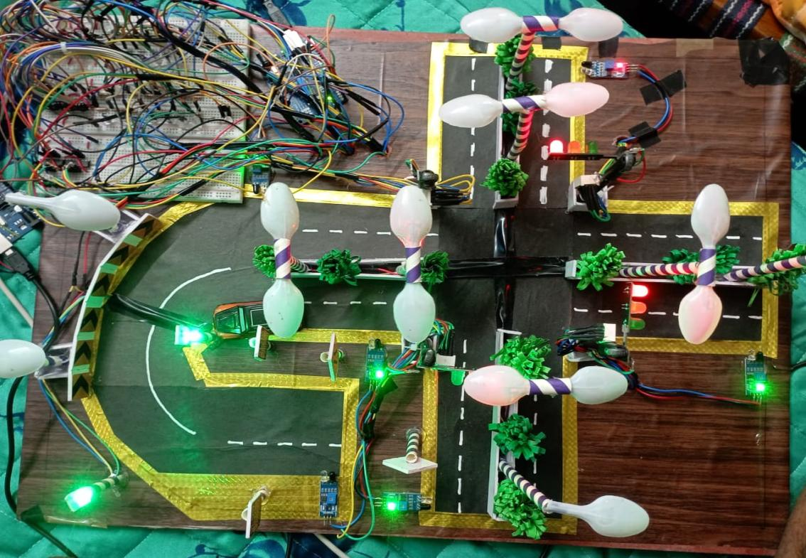
Fig 10.1: Overall system setup showing the Arduino, shift registers, and intersections.
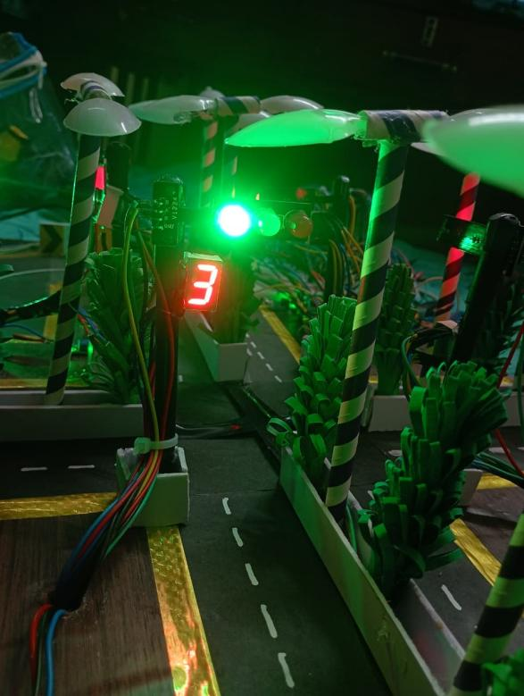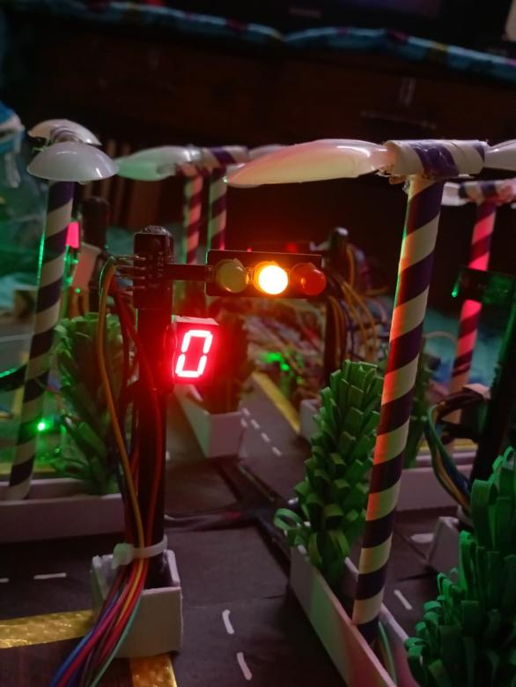
Fig 10.2: Traffic lights changing dynamically based on the IR sensor density detection.
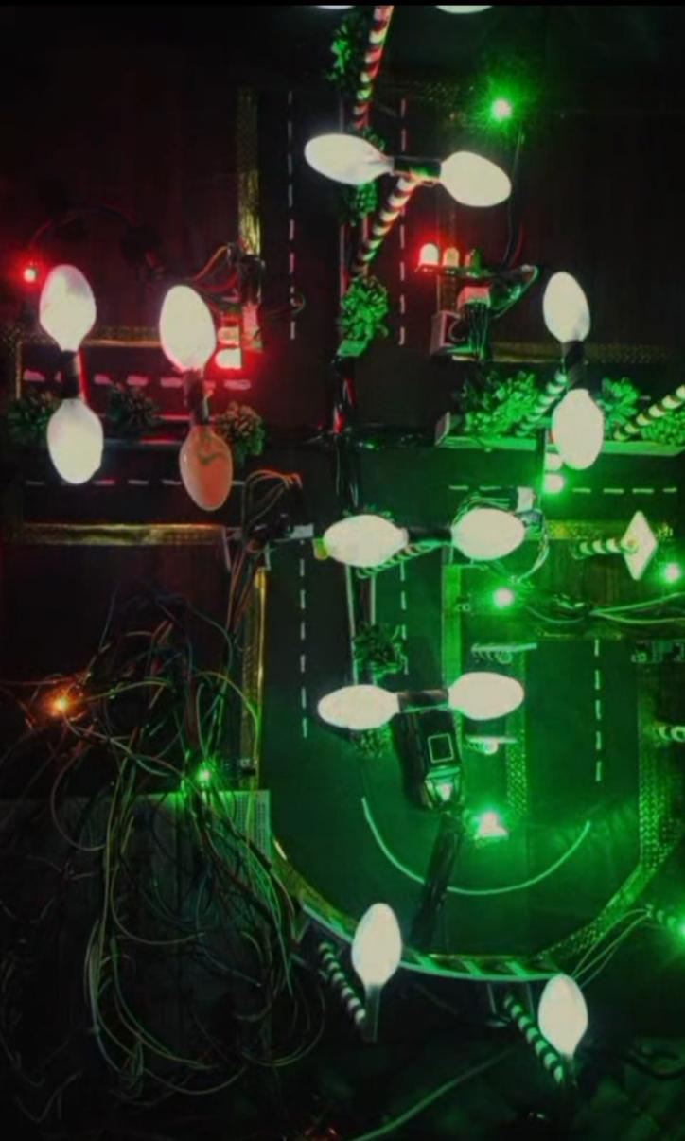
Fig 10.3: The LDR circuit activating the street lights in a dark environment.
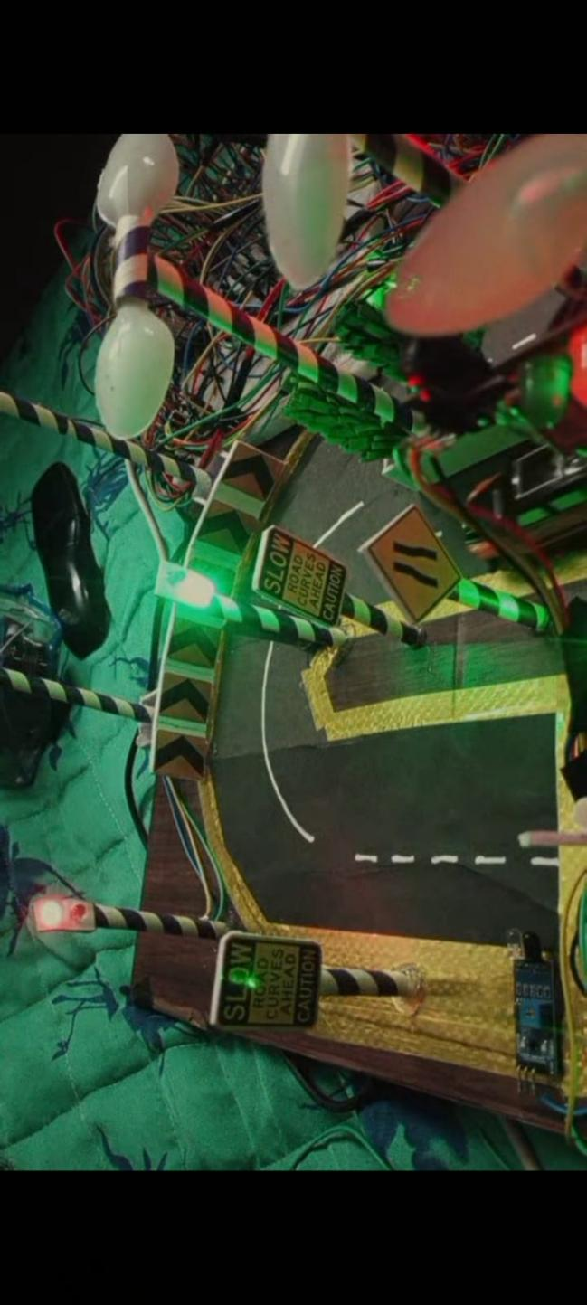
Fig 10.4: The blind curve warning LED glowing when an object is placed near the curve IR sensor.

CHAPTER 11: REFERENCES
- ATmega328P Microcontroller Datasheet, Microchip Technology Inc.
- 74HC595 8-Bit Serial-In, Parallel-Out Shift Register Datasheet, Texas Instruments.
- Arduino Official Documentation and Language Reference. (https://www.arduino.cc)
- BC547 NPN Epitaxial Silicon Transistor Technical Specifications, Fairchild Semiconductor.
- "Intelligent Traffic Light Control System Using IR Sensors", International Journal of Engineering Research & Technology (IJERT).

