A Comparative Study of Preconditioning Techniques for Gradient-Based Linear Least-Squares Optimization
Chetana Pandey
Independent Researcher
Varanasi, Uttar Pradesh, India
Email: chetanapandey1308@gmail.com

Abstract
Linear least-squares optimization is a fundamental problem in numerical linear algebra, scientific computing, machine learning, and engineering applications. The convergence rate of gradient-based optimization methods is often influenced by the conditioning of the underlying system, motivating the development of various preconditioning techniques to improve computational efficiency and numerical stability. This study presents a comparative computational analysis of four optimization methods for solving linear least-squares problems: Standard Gradient Descent, Diagonal Scaling Preconditioning, Iterative Preconditioning, and SVD-Based Preconditioning.
All optimization methods were implemented in Python and evaluated using a common synthetic least-squares benchmark under identical experimental conditions. Their performance was assessed using convergence behaviour, number of iterations, execution time, residual norm, and relative error. The experimental results demonstrate that all four methods successfully converged to accurate numerical solutions while satisfying the prescribed stopping criterion. Among the evaluated methods, Diagonal Scaling Preconditioning achieved the best overall performance by requiring the fewest iterations and producing the lowest residual norm and relative error with computational cost comparable to the baseline Gradient Descent algorithm. In contrast, the implemented Iterative Preconditioning and SVD-Based Preconditioning methods required greater computational effort without providing corresponding improvements for the well-conditioned benchmark problem considered in this study.
The findings indicate that the effectiveness of preconditioning strategies depends strongly on the characteristics of the optimization problem. The computational framework developed in this work provides a reproducible basis for evaluating gradient-based optimization methods and can be extended to investigate large-scale sparse systems, highly ill-conditioned problems, and advanced optimization techniques in future research.

Keywords
Keywords: Linear Least-Squares, Gradient Descent, Preconditioning, Numerical Optimization, Scientific Computing, Numerical Linear Algebra, Python.

RELATED WORK AND RESEARCH GAP

1. Related Work
Linear least-squares optimization constitutes one of the fundamental problems in numerical linear algebra and scientific computing. It arises naturally in a broad range of applications, including data fitting, inverse problems, signal processing, machine learning, image reconstruction, computational physics, and engineering design. Owing to its widespread applicability, considerable research has been devoted to developing numerical algorithms capable of solving least-squares problems with improved computational efficiency, numerical stability, and convergence behavior. As optimization problems continue to increase in both dimensionality and complexity, the development of robust optimization algorithms has become an active area of research.
Traditional approaches for solving least-squares problems include direct numerical methods based on matrix factorization as well as iterative optimization algorithms. Direct methods generally provide highly accurate numerical solutions for moderate-sized problems but often become computationally expensive for very large sparse systems due to increasing memory requirements and factorization costs. In contrast, iterative optimization methods require substantially less memory and are therefore more suitable for large-scale applications. However, their performance is strongly influenced by the conditioning of the optimization problem, the selection of algorithmic parameters, and the efficiency of the underlying optimization strategy.
To overcome these limitations, recent research has focused on improving gradient-based optimization through advanced preconditioning techniques, adaptive step-size strategies, limited-memory optimization methods, and matrix decomposition approaches. These developments aim to accelerate convergence while maintaining numerical stability and computational efficiency. The following sections review four representative studies that have significantly contributed to recent advances in least-squares optimization and collectively provide the motivation for the present work.

Sparse Linear Least-Squares Optimization
One important direction in numerical optimization focuses on the development of efficient algorithms for solving large-scale sparse linear least-squares problems. Rather than proposing a new optimization algorithm, the first study provides a comprehensive review of the mathematical foundations, numerical techniques, and computational software available for sparse least-squares computation. The work synthesizes decades of research by examining both direct and iterative numerical approaches while discussing their theoretical properties, computational characteristics, and practical implementation.
The reviewed algorithms include Cholesky factorization, QR factorization, Golub–Kahan bidiagonalization, Krylov subspace methods, iterative refinement techniques, and various algebraic preconditioning strategies. Collectively, these methods represent the principal computational approaches currently employed for solving sparse least-squares systems. The study also evaluates widely used numerical software packages, including SuiteSparseQR, CHOLMOD, HSL, PETSc, and ILUPACK, highlighting the importance of efficient numerical software in large-scale scientific computing.
A significant contribution of this work lies in its identification of the practical challenges associated with sparse least-squares optimization. Although modern numerical algorithms have achieved considerable success, several important issues remain unresolved. In particular, the effectiveness of existing preconditioning techniques depends heavily on the properties of the coefficient matrix, and no universally efficient preconditioner currently exists for all sparse optimization problems. Furthermore, increasing problem size introduces substantial computational and memory requirements that limit the scalability of many existing numerical methods.
The study also emphasizes the growing importance of numerical stability in high-performance scientific computing. Matrix ill-conditioning, round-off errors, and the increasing use of mixed-precision arithmetic create additional challenges that require further mathematical investigation. These observations suggest that future research should focus not only on improving convergence speed but also on developing optimization algorithms capable of maintaining numerical robustness while efficiently handling increasingly large computational problems.
Although this review does not introduce a new optimization method, it establishes an important theoretical foundation for subsequent research by identifying the principal computational challenges associated with sparse least-squares optimization. In particular, the discussion of preconditioning strategies, numerical stability, computational efficiency, and scalability provides valuable insight into the limitations of current optimization methods and highlights several promising directions for future research. These findings also provide the broader mathematical context within which more recent developments in gradient-based optimization and adaptive preconditioning techniques have emerged.

Iterative Preconditioning for Linear Least-Squares Optimization
While sparse matrix algorithms provide efficient computational techniques for solving large-scale least-squares problems, the convergence rate of gradient-based optimization methods remains highly dependent on the conditioning of the underlying optimization problem. Poorly conditioned matrices often lead to slow convergence, increased computational cost, and reduced numerical stability. Consequently, considerable research has focused on developing preconditioning strategies capable of transforming optimization problems into mathematically more favorable forms before iterative solution procedures are applied.
A recent advancement in this direction proposes an iterative preconditioning framework for distributed gradient-based optimization in multi-agent linear least-squares problems. Unlike conventional gradient descent methods that employ a fixed optimization strategy throughout the iterative process, this approach constructs and updates the preconditioner iteratively in order to improve the conditioning of the optimization problem as computation progresses. By continuously adapting the preconditioning matrix, the algorithm seeks to reduce the influence of poor conditioning on convergence behaviour while preserving the simplicity of gradient-based optimization.
The proposed framework is developed within the context of distributed optimization, where multiple computational agents cooperate through a server-agent network architecture to solve a common least-squares problem. Such distributed optimization environments are increasingly important in modern scientific computing because many contemporary applications involve datasets that are too large to be processed efficiently on a single computational device. The iterative preconditioning strategy therefore addresses not only convergence speed but also the computational challenges associated with distributed numerical computation.
The principal contribution of this work lies in demonstrating that adaptive preconditioning can substantially accelerate gradient descent without fundamentally altering the underlying optimization framework. By iteratively updating the preconditioner matrix, the proposed method achieves improved convergence characteristics compared with traditional gradient descent methods whose convergence rates are largely determined by the condition number of the system matrix. Numerical experiments reported in the study indicate that the iterative preconditioning strategy exhibits linear convergence in general settings and may achieve superlinear convergence when the least-squares solution is unique. These findings illustrate the potential advantages of adaptive preconditioning for improving optimization efficiency in distributed computational environments.
From a numerical optimization perspective, the study emphasizes the close relationship between matrix conditioning and convergence behaviour. The condition number directly influences the rate at which gradient-based optimization approaches the optimal solution, making preconditioning one of the most effective techniques for accelerating iterative algorithms. Rather than modifying the optimization algorithm itself, the proposed framework improves convergence by transforming the mathematical structure of the optimization problem, thereby enabling more efficient iterative computation.
Despite these advantages, several limitations remain. The proposed framework is developed specifically for linear least-squares optimization and does not investigate its applicability to nonlinear optimization problems. Furthermore, although the adaptive preconditioning strategy improves convergence, each iterative update of the preconditioner introduces additional computational overhead that may become significant for extremely large-scale optimization problems. Consequently, the overall computational efficiency depends on balancing the reduction in optimization iterations against the additional cost associated with constructing and updating the preconditioning matrix.
These observations suggest that future research should investigate adaptive preconditioning techniques capable of maintaining rapid convergence while simultaneously reducing computational complexity. Extending iterative preconditioning strategies to nonlinear optimization problems, improving scalability for very large computational systems, and designing dynamically updated preconditioners that respond automatically to changing matrix characteristics remain promising directions for future investigation. Such developments would further strengthen the role of adaptive preconditioning as an effective tool for solving increasingly complex optimization problems encountered in modern scientific computing.
The significance of this work extends beyond the proposed algorithm itself. By demonstrating the practical impact of adaptive preconditioning on convergence behaviour, the study reinforces the broader principle that improvements in matrix conditioning can substantially influence optimization performance. This perspective provides an important bridge between classical numerical linear algebra and modern optimization research and serves as a foundation for subsequent investigations into memory-efficient optimization methods and advanced matrix decomposition techniques.

Limited Memory Gradient Methods for Large-Scale Optimization
As optimization problems continue to increase in size and complexity, reducing computational cost while maintaining rapid convergence has become one of the primary objectives in numerical optimization research. Although classical Gradient Descent algorithms are attractive because of their simplicity and modest memory requirements, their convergence often deteriorates for high-dimensional optimization problems. These limitations have motivated the development of limited-memory optimization methods that seek to improve convergence without introducing the computational burden associated with second-order optimization techniques.
One significant contribution in this area is the development of new variants of the Limited Memory Steepest Descent (LMSD) algorithm for unconstrained optimization problems. Unlike conventional Gradient Descent methods, which rely on a single step-size update at each iteration, the proposed LMSD framework incorporates advanced numerical linear algebra techniques to compute more effective step sizes while preserving the algorithm's low-memory characteristics. This approach provides an attractive compromise between computational efficiency and optimization performance, making it particularly suitable for solving large-scale optimization problems.
The proposed method introduces improved step-size computation strategies based on harmonic Ritz values and secant conditions. These mathematical techniques enable the optimization algorithm to extract additional spectral information from previous iterations, allowing more informed step-size selection throughout the optimization process. By incorporating information about the local geometry of the optimization landscape, the algorithm achieves faster convergence than traditional Gradient Descent while avoiding the high computational cost associated with full Hessian-based methods.
From a mathematical perspective, the study integrates several important concepts from numerical linear algebra, including Rayleigh–Ritz extraction, harmonic Ritz values, Lyapunov equations, eigenvalue analysis, and matrix approximation techniques. These tools allow the algorithm to construct more accurate approximations of the optimization problem without requiring complete second-order derivative information. Consequently, the proposed approach retains the computational advantages of first-order optimization methods while achieving convergence characteristics that are competitive with more sophisticated optimization algorithms.
The numerical experiments reported in the study demonstrate that the proposed LMSD variants consistently outperform existing limited-memory gradient methods across a variety of benchmark optimization problems. The improved step-size computation strategy results in faster convergence while maintaining the algorithm's low memory requirements, illustrating the importance of effective parameter selection in gradient-based optimization. These findings further emphasize that convergence behaviour depends not only on matrix conditioning but also on the quality of the optimization parameters used throughout the iterative process.
Despite these promising results, the study also identifies several limitations. The proposed methods are evaluated primarily for unconstrained optimization problems, leaving their applicability to constrained or nonlinear least-squares optimization largely unexplored. Furthermore, some computed step sizes are not fully utilized during each optimization cycle, suggesting that additional improvements in computational efficiency may still be possible. The study also notes that further theoretical investigation is required to better understand the influence of perturbation strategies and alternative line-search techniques on algorithm performance.
These observations highlight several important directions for future research. Developing more effective perturbation strategies, improving step-size utilization, investigating alternative line-search procedures, and extending limited-memory optimization methods to nonlinear least-squares problems remain open research challenges. Addressing these issues could further improve optimization efficiency while preserving the computational advantages that make limited-memory methods attractive for large-scale scientific computing applications.
Beyond its specific algorithmic contributions, this study demonstrates the growing importance of adaptive optimization strategies that exploit information generated during previous iterations. Rather than treating each optimization step independently, modern optimization algorithms increasingly utilize historical information to guide subsequent iterations. This trend reflects a broader shift in numerical optimization toward algorithms that continuously adapt their behaviour based on the evolving characteristics of the optimization problem, thereby improving both convergence speed and computational efficiency.
The insights provided by this work complement previous developments in adaptive preconditioning by demonstrating that optimization performance can be improved not only through better matrix conditioning but also through more effective parameter selection. Together, these approaches illustrate that successful optimization algorithms require careful integration of numerical linear algebra, spectral analysis, and iterative optimization techniques. This progression naturally leads to more advanced matrix decomposition methods, where explicit structural information is incorporated directly into the optimization process to further enhance convergence behaviour.

SVD-Based Preconditioning for Nonlinear Least-Squares Optimization
Recent advances in numerical optimization have increasingly focused on integrating matrix decomposition techniques with first-order optimization algorithms to improve convergence in complex optimization problems. Although traditional Gradient Descent methods remain computationally attractive due to their simplicity, their performance often deteriorates when applied to nonlinear least-squares problems characterized by ill-conditioned Jacobian matrices or highly anisotropic optimization landscapes. Under such circumstances, conventional optimization methods may require a large number of iterations to converge and can exhibit slow or unstable optimization behaviour. These limitations have motivated the development of optimization strategies that incorporate structural information from the optimization problem directly into the iterative solution process.
One important contribution in this direction is the development of an optimization framework that combines Singular Value Decomposition (SVD)-based preconditioning with the Adam optimization algorithm for solving nonlinear least-squares problems. Unlike conventional preconditioning methods that rely primarily on approximations of the coefficient matrix, the proposed approach constructs a preconditioner using the singular values of the Jacobian matrix. By exploiting the spectral characteristics of the optimization problem, the method seeks to reduce the effects of ill-conditioning while preserving the computational efficiency associated with first-order optimization algorithms.
The central idea underlying this approach is that the singular values of the Jacobian matrix provide valuable information regarding the local geometry of the optimization landscape. Large variations among singular values indicate significant anisotropy, causing optimization algorithms to progress rapidly along certain directions while advancing slowly along others. By incorporating SVD-based preconditioning into the optimization process, the proposed framework effectively rescales the optimization problem, thereby improving its numerical conditioning and enabling more balanced convergence across different optimization directions.
From a mathematical perspective, the proposed method combines several important concepts, including Singular Value Decomposition, Jacobian matrix analysis, gradient flow dynamics, and adaptive first-order optimization. Rather than replacing the underlying optimization algorithm, the SVD-based preconditioner modifies the optimization landscape itself, allowing the Adam optimizer to perform more efficiently on nonlinear least-squares problems. This integration of matrix decomposition techniques with adaptive optimization illustrates the growing trend toward hybrid optimization frameworks that combine ideas from numerical linear algebra and machine learning.
The effectiveness of the proposed framework is demonstrated through experiments involving function approximation, partial differential equation solving, and image classification tasks. These applications illustrate the versatility of SVD-based preconditioning across diverse computational domains and demonstrate that incorporating spectral information into gradient-based optimization can significantly improve convergence speed while maintaining high solution accuracy. The reported results indicate that the proposed method consistently outperforms conventional optimization approaches for the benchmark problems considered in the study.
Despite these promising findings, several important limitations remain. The computational cost associated with performing Singular Value Decomposition increases rapidly with problem size, making the direct application of SVD-based preconditioning computationally demanding for extremely large optimization problems and deep neural network architectures. Furthermore, the scalability of the proposed method has not yet been fully investigated for very high-dimensional optimization problems commonly encountered in modern machine learning applications. Consequently, although SVD-based preconditioning offers significant improvements in convergence behaviour, its practical implementation may be constrained by computational complexity.
The authors therefore identify several important directions for future research. In particular, the development of scalable matrix decomposition techniques, including randomized Singular Value Decomposition and related low-rank approximation methods, represents a promising avenue for reducing computational overhead while preserving the numerical advantages of spectral preconditioning. Additional research is also required to investigate the theoretical convergence properties of SVD-based optimization methods for increasingly complex nonlinear optimization problems and deep learning architectures.
The broader significance of this work lies in demonstrating that convergence improvements can be achieved by exploiting the intrinsic spectral structure of the optimization problem rather than relying solely on iterative parameter updates or adaptive step-size strategies. This perspective complements earlier developments in adaptive preconditioning and limited-memory optimization by illustrating that effective optimization algorithms increasingly combine multiple mathematical principles to improve computational performance. The integration of spectral decomposition, adaptive optimization, and numerical linear algebra represents an important direction in contemporary optimization research and provides valuable insight into the continuing evolution of efficient algorithms for least-squares optimization.

Comparative Discussion of Existing Literature
The four studies reviewed above collectively demonstrate the substantial progress that has been made in improving least-squares optimization through advances in numerical linear algebra, preconditioning strategies, adaptive optimization, and matrix decomposition techniques. Although each study addresses a different aspect of optimization, they share the common objective of improving convergence behaviour while maintaining computational efficiency and numerical stability.
The survey of sparse linear least-squares algorithms establishes the broader computational landscape by reviewing the principal numerical techniques currently available for solving large-scale optimization problems. Building upon this foundation, the iterative preconditioning framework demonstrates how adaptive transformation of the optimization problem can accelerate convergence in distributed computational environments. The development of limited-memory gradient methods further illustrates the importance of efficient parameter selection for improving optimization performance without increasing memory requirements. Finally, the SVD-based optimization framework shows that incorporating spectral information directly into gradient-based optimization can significantly enhance convergence for nonlinear least-squares problems.
Despite these advances, several common challenges remain evident across the literature. Most existing methods are designed for specific classes of optimization problems and therefore exhibit limited generality. Many algorithms also involve additional computational overhead associated with matrix decomposition, adaptive preconditioner construction, or advanced parameter estimation. Furthermore, relatively few studies provide a unified computational comparison of multiple optimization strategies implemented under identical experimental conditions. As a result, it remains difficult to determine the practical advantages and limitations of different optimization methods when evaluated using a common experimental framework.
These observations indicate that further research is required to systematically compare representative optimization techniques under consistent computational settings. Such comparative investigations can provide valuable insight into the relative strengths and weaknesses of different optimization strategies while identifying situations in which particular preconditioning methods are most effective. This need forms the basis for the research gap addressed in the present study.

2.Research Gap
The literature reviewed in the previous section demonstrates that significant progress has been made in the development of numerical algorithms for solving least-squares optimization problems. Researchers have proposed numerous approaches to improve convergence speed, numerical stability, and computational efficiency through advanced matrix factorization techniques, adaptive preconditioning strategies, limited-memory optimization algorithms, and spectral decomposition methods. These contributions have considerably expanded the theoretical and practical understanding of optimization methods for both linear and nonlinear least-squares problems.
Despite these advancements, several important research challenges remain unresolved. A careful examination of the existing literature reveals that many proposed methods are designed to address specific optimization problems under particular computational settings. Consequently, their applicability across different optimization environments remains limited, making it difficult to evaluate their overall effectiveness from a unified computational perspective.
One of the most significant challenges identified throughout the literature is the dependence of optimization performance on matrix conditioning. Poorly conditioned matrices continue to reduce the convergence rate of Gradient Descent and related first-order optimization algorithms. Although various preconditioning techniques have been developed to improve numerical conditioning, no single preconditioning strategy has demonstrated consistently superior performance across all classes of least-squares problems. The effectiveness of existing approaches therefore remains highly problem dependent.
Another important limitation concerns computational complexity. Advanced optimization techniques such as iterative preconditioning and Singular Value Decomposition provide improved convergence behaviour but introduce additional computational overhead associated with constructing preconditioners or performing matrix decompositions. As optimization problems become increasingly large, the computational cost of these methods may offset the improvements obtained through faster convergence. Achieving an effective balance between convergence acceleration and computational efficiency therefore remains an important research challenge.
Scalability also represents a significant limitation of many existing optimization methods. Several algorithms demonstrate excellent numerical performance for moderate-sized benchmark problems but have not been extensively validated for very large sparse systems or high-dimensional optimization problems. As modern scientific computing increasingly involves large-scale datasets, distributed computation, and machine learning applications, optimization algorithms must be capable of maintaining both computational efficiency and numerical stability as problem dimensions continue to increase.
The literature further indicates that adaptive optimization remains an active area of investigation. Existing preconditioning methods generally employ predefined strategies whose effectiveness depends upon the characteristics of the optimization problem. Similarly, step-size selection continues to play a central role in determining convergence behaviour. Although limited-memory optimization methods have introduced improved parameter estimation strategies, further research is required to develop optimization algorithms capable of adapting automatically to changing numerical conditions during the optimization process.
Another recurring challenge concerns numerical robustness. Matrix ill-conditioning, round-off error accumulation, and finite-precision arithmetic continue to influence the reliability of iterative optimization algorithms, particularly for large-scale scientific computing applications. While recent studies acknowledge these issues, additional research is necessary to develop optimization techniques that maintain high numerical accuracy without substantially increasing computational cost.
Finally, relatively few studies provide a direct computational comparison of representative optimization methods under identical implementation conditions. Existing investigations typically evaluate newly proposed algorithms against only a limited number of baseline methods using different datasets, computational environments, or experimental settings. Consequently, objective comparison among different optimization techniques remains difficult because observed performance differences may arise from variations in implementation rather than from the algorithms themselves.
Collectively, these observations demonstrate that there remains a need for systematic computational studies that evaluate representative optimization techniques using a common experimental framework. Such investigations can provide a clearer understanding of the practical advantages and limitations of different optimization strategies while improving the reproducibility and interpretability of experimental results.

Motivation of the Present Study
The research gaps identified above provide the primary motivation for the present investigation. Rather than proposing a new optimization algorithm, this study focuses on the systematic computational comparison of representative gradient-based optimization methods for solving linear least-squares problems under identical experimental conditions. The objective is to evaluate how different preconditioning strategies influence convergence behaviour, computational efficiency, numerical stability, and solution accuracy when implemented within a common computational framework.
Four representative optimization methods are selected for investigation: Standard Gradient Descent, Diagonal Scaling Preconditioning, Iterative Preconditioning, and SVD-Based Preconditioning. These methods represent different stages in the evolution of gradient-based optimization, ranging from classical first-order optimization to more advanced preconditioning techniques. By implementing each method using the same programming environment, benchmark problem, stopping criteria, and performance metrics, the study enables a fair and reproducible comparison of their computational characteristics.
The experimental evaluation is based on quantitative measures including convergence behaviour, number of iterations, execution time, residual norm, relative error, and matrix conditioning. These performance indicators provide a comprehensive assessment of both computational efficiency and numerical accuracy, allowing the strengths and limitations of each optimization method to be evaluated objectively.
Although the present work does not introduce a new optimization algorithm, it contributes by providing a unified experimental framework for comparing representative preconditioning strategies under consistent computational settings. Such comparative analyses are valuable because they offer practical guidance regarding the selection of optimization methods for different classes of least-squares problems while also identifying directions for future algorithmic development.
The outcomes of this study are expected to provide a clearer understanding of the relationship between preconditioning techniques and optimization performance. Furthermore, the computational framework developed in this work may serve as a foundation for future investigations involving large-scale sparse optimization, adaptive preconditioning strategies, and nonlinear least-squares problems.

1. Introduction
Numerical optimization plays a central role in modern applied mathematics because many scientific and engineering problems can be formulated as optimization problems. Among these, least-squares optimization occupies a particularly important position due to its extensive applications in parameter estimation, machine learning, data fitting, inverse problems, computer vision, signal processing, and computational physics.
For a system represented by
[
Ax \approx b,
]
the least-squares problem seeks a vector (x) that minimizes the squared Euclidean norm of the residual,
[
\min_x |Ax-b|_2^2.
]
When the problem size becomes very large, direct numerical methods such as QR factorization or Cholesky decomposition may become computationally expensive. Consequently, iterative optimization methods, particularly Gradient Descent and its variants, have become attractive alternatives because they require less memory and scale effectively to high-dimensional problems.
Despite these advantages, the performance of gradient-based optimization methods depends strongly on the conditioning of the underlying matrix. Poorly conditioned matrices often produce slow convergence, oscillatory optimization trajectories, numerical instability, and increased computational cost. Improving matrix conditioning before or during optimization has therefore become one of the principal research directions in numerical optimization.
Preconditioning techniques aim to transform the optimization problem into an equivalent formulation that possesses more favourable numerical properties. Over the past decade, researchers have proposed numerous preconditioning strategies based on diagonal scaling, iterative methods, sparse matrix techniques, spectral information, and Singular Value Decomposition (SVD). These methods seek to accelerate convergence while preserving solution accuracy and numerical stability.
Although many preconditioning techniques have been proposed, most existing studies evaluate individual methods independently and under different experimental settings. As a result, there is limited comparative understanding of their mathematical assumptions, convergence properties, computational complexity, numerical stability, and practical advantages. A systematic mathematical comparison of modern preconditioning techniques remains valuable for identifying their strengths, limitations, and appropriate application domains.
This research addresses this need by conducting a comparative mathematical analysis of representative preconditioning techniques for gradient-based least-squares optimization. Instead of proposing a completely new optimization algorithm, the study aims to synthesize theoretical analysis and computational evidence to provide a unified perspective on contemporary preconditioning methods. Such an analysis may also help identify unresolved challenges and future research opportunities in numerical optimization.

2. Problem Statement
Gradient-based optimization algorithms are widely employed for solving large-scale least-squares problems because of their simplicity, low memory requirements, and scalability. However, their performance is often limited by poor matrix conditioning, slow convergence, and numerical instability. Although numerous preconditioning techniques have been proposed to address these challenges, existing research primarily focuses on individual methods without providing a consistent mathematical comparison across different approaches.
This lack of a unified comparative framework makes it difficult to evaluate the relative advantages, computational costs, convergence characteristics, and applicability of different preconditioning techniques. Consequently, researchers and practitioners lack clear guidance when selecting suitable preconditioners for specific least-squares optimization problems.
This research seeks to address this gap by systematically comparing representative preconditioning techniques using common mathematical and computational criteria. The study will investigate how different preconditioners influence matrix conditioning, convergence behaviour, computational efficiency, and numerical stability in gradient-based least-squares optimization.

3. Research Objectives
The primary objective of this research is to perform a rigorous mathematical and computational comparison of modern preconditioning techniques used in gradient-based least-squares optimization. The study aims to evaluate how different preconditioning strategies influence convergence behaviour, matrix conditioning, computational efficiency, and numerical stability.
To achieve this objective, the research will pursue the following specific objectives:
Objective 1
Study the mathematical foundations of least-squares optimization and gradient-based optimization methods.
Objective 2
Investigate the theoretical principles underlying commonly used preconditioning techniques, including diagonal scaling, iterative preconditioning, sparse matrix preconditioning, and Singular Value Decomposition (SVD)-based preconditioning.
Objective 3
Compare the mathematical assumptions required by different preconditioning techniques.
Objective 4
Analyze the influence of preconditioning on matrix conditioning and condition numbers.
Objective 5
Study the convergence behaviour of different gradient-based optimization methods after preconditioning.
Objective 6
Evaluate the computational complexity and memory requirements associated with each preconditioning technique.
Objective 7
Compare the numerical stability of different approaches using benchmark least-squares problems.
Objective 8
Identify the strengths, limitations, and practical applications of modern preconditioning methods.
Objective 9
Provide recommendations regarding the suitability of different preconditioning strategies for various optimization scenarios.

4. Research Questions
This research is guided by the following questions.
Primary Research Question
How do different preconditioning techniques influence the convergence behaviour, numerical stability, and computational efficiency of gradient-based least-squares optimization?

Secondary Research Questions
RQ1.
How does each preconditioning technique modify the conditioning of the optimization problem?

RQ2.
Which preconditioning techniques provide the fastest convergence for gradient-based least-squares optimization?

RQ3.
How do different preconditioners affect computational complexity and memory requirements?

RQ4.
What are the mathematical assumptions required for each preconditioning method?

RQ5.
Which preconditioning techniques perform best for sparse least-squares problems?

RQ6.
What are the principal limitations of existing preconditioning approaches?

RQ7.
Which future research directions emerge from the comparative mathematical analysis?

5. Research Hypothesis
Since this research primarily involves comparative mathematical analysis, the hypotheses are designed to be testable through both theoretical study and computational experiments.
Primary Hypothesis
Modern preconditioning techniques significantly improve the convergence behaviour of gradient-based least-squares optimization by reducing the effects of poor matrix conditioning.

Secondary Hypotheses
H1
Improved matrix conditioning leads to faster convergence of gradient-based optimization algorithms.

H2
Preconditioning reduces the number of optimization iterations required to reach a specified convergence tolerance.

H3
Different preconditioning techniques exhibit different trade-offs between computational cost and convergence improvement.

H4
SVD-based preconditioning provides superior conditioning improvement but incurs higher computational cost than simpler preconditioning techniques.

H5
No single preconditioning technique performs optimally for every least-squares optimization problem.

6. Scope of the Research
This research focuses on the mathematical and computational comparison of preconditioning techniques used in gradient-based least-squares optimization.
The study is limited to optimization problems formulated as linear and nonlinear least-squares problems where Gradient Descent or related first-order optimization methods are employed.
The research will primarily investigate the following techniques:
- Gradient Descent without preconditioning (baseline)
- Diagonal Scaling
- Jacobi Preconditioning
- Iterative Preconditioning
- SVD-Based Preconditioning
The comparison will emphasize:
- Mathematical formulation
- Matrix conditioning
- Convergence analysis
- Numerical stability
- Computational complexity
- Memory requirements
- Practical implementation
The computational experiments will be implemented in Python using standard scientific computing libraries.
This study does not attempt to develop a completely new optimization algorithm. Instead, it provides a rigorous mathematical comparison of existing techniques while identifying opportunities for future research.

7. Significance of the Study
This research contributes to the field of Numerical Linear Algebra and Optimization by providing a unified mathematical comparison of modern preconditioning techniques for gradient-based least-squares optimization.
The study has several important contributions.
Academic Contribution
The research consolidates recent developments in numerical optimization into a unified comparative framework, making it easier to understand the mathematical similarities and differences among existing preconditioning techniques.

Mathematical Contribution
The study compares the effects of different preconditioners on:
- Matrix conditioning
- Spectral properties
- Convergence behaviour
- Numerical stability
- Computational complexity
using consistent mathematical criteria.

Computational Contribution
Through computational experiments, the research evaluates the practical performance of representative preconditioning methods on benchmark least-squares problems.

Practical Contribution
The findings may help researchers and practitioners select appropriate preconditioning strategies for large-scale optimization problems encountered in machine learning, scientific computing, engineering, and data analysis.

Educational Contribution
The research also serves as a comprehensive reference for students and early-career researchers seeking to understand modern preconditioning methods used in gradient-based optimization.

CHAPTER 2

MATHEMATICAL FOUNDATIONS
2.1 Introduction
This chapter presents the mathematical foundations required for the comparative analysis of preconditioning techniques used in gradient-based least-squares optimization. The study focuses on the theoretical principles that govern optimization algorithms, matrix conditioning, convergence behaviour, and numerical stability.
Least-squares optimization forms the mathematical basis of numerous applications in scientific computing, machine learning, engineering, inverse problems, and computational physics. The efficiency of optimization algorithms depends not only on the optimization method itself but also on the numerical properties of the underlying matrices. Consequently, modern numerical optimization research places significant emphasis on matrix conditioning, preconditioning strategies, and convergence analysis.
This chapter introduces the mathematical concepts that will be used throughout the research, including least-squares optimization, gradient-based optimization, convergence theory, matrix conditioning, numerical stability, computational complexity, preconditioning techniques, QR factorization, Cholesky factorization, Singular Value Decomposition (SVD), and spectral analysis. These concepts provide the theoretical framework for the comparative mathematical analysis presented in the subsequent chapters.

2.2 Least-Squares Optimization
Least-squares optimization is one of the most fundamental problems in numerical linear algebra. It seeks the solution that minimizes the discrepancy between observed data and the predictions of a mathematical model. Such problems arise naturally in parameter estimation, regression analysis, signal processing, machine learning, image reconstruction, and numerous scientific computing applications.
Given a matrix A ∈ ℝ^(m×n) and a vector b ∈ ℝ^m, the least-squares optimization problem is defined as
minimize
||Ax − b||²
where
A represents the coefficient matrix,
x represents the unknown parameter vector,
and b represents the observation vector.
The objective is to determine the vector x that minimizes the squared Euclidean norm of the residual vector
r = Ax − b.
In many practical applications, the system contains more equations than unknown variables, producing an overdetermined system. Since an exact solution generally does not exist, least-squares optimization computes the solution that minimizes the overall approximation error.
Because of its broad applicability and strong mathematical foundation, least-squares optimization remains one of the most extensively studied problems in numerical optimization.

2.3 Linear Least-Squares Problems
A linear least-squares problem is represented by
Ax ≈ b
where the unknown vector appears linearly.
The optimization problem becomes
minimize
||Ax − b||².
Differentiating the objective function with respect to x and equating the gradient to zero produces the Normal Equations
AᵀAx = Aᵀb.
Provided that AᵀA is nonsingular, the solution is
x = (AᵀA)⁻¹Aᵀb.
Although the Normal Equation provides an analytical solution, explicit computation of the matrix inverse is generally avoided because it may amplify numerical errors when the matrix is poorly conditioned. Consequently, modern numerical optimization typically employs matrix factorization techniques or iterative optimization algorithms.

2.4 Nonlinear Least-Squares Problems
Many practical optimization problems involve nonlinear mathematical models. In such cases, the optimization problem is formulated as
minimize
||f(x) − b||²
where f(x) is a nonlinear function.
Unlike linear least-squares problems, nonlinear least-squares optimization generally has no closed-form solution. Instead, iterative optimization algorithms are employed to approximate the optimal solution.
Common algorithms include
• Gradient Descent
• Gauss–Newton Method
• Levenberg–Marquardt Algorithm
• Adam Optimizer
The increasing importance of nonlinear optimization in machine learning and scientific computing has motivated the development of numerous advanced optimization methods that improve convergence speed and numerical robustness.

2.5 Gradient-Based Optimization
Gradient-based optimization methods solve optimization problems through iterative improvement of an initial estimate. At each iteration, the optimization algorithm moves in the direction opposite to the gradient of the objective function.
For the least-squares objective function
f(x) = ½||Ax − b||²,
the gradient is
∇f(x) = Aᵀ(Ax − b).
The Gradient Descent iteration is therefore expressed as
x(k+1) = x(k) − α∇f(x(k))
where α denotes the step size or learning rate.
The convergence behaviour of Gradient Descent depends on several mathematical factors, including the choice of step size, matrix conditioning, and the curvature of the objective function. Consequently, modern optimization research focuses on improving these characteristics through adaptive optimization and preconditioning techniques.

2.6 Matrix Conditioning
Matrix conditioning describes the sensitivity of a numerical problem to perturbations in the input data. Poorly conditioned matrices often produce slow convergence, inaccurate numerical solutions, and amplification of rounding errors.
The condition number of a matrix A is defined as
κ(A) = ||A|| ||A⁻¹||.
For matrices analyzed using Singular Value Decomposition,
κ(A) = σmax / σmin,
where σmax and σmin denote the largest and smallest singular values of A, respectively.
A condition number close to one indicates a well-conditioned matrix, whereas a large condition number indicates an ill-conditioned matrix.
Since Gradient Descent converges more slowly for ill-conditioned problems, reducing the condition number has become one of the principal objectives of preconditioning methods.

2.7 Numerical Stability
Numerical stability refers to the ability of an algorithm to produce reliable and accurate numerical solutions despite finite-precision arithmetic and rounding errors.
Stable numerical algorithms minimize the propagation and accumulation of computational errors throughout the optimization process.
The numerical stability of optimization algorithms depends on several factors, including
• matrix conditioning,
• floating-point arithmetic,
• algorithm design,
• matrix factorization techniques.
Improving numerical stability remains one of the major objectives of modern numerical optimization research.

2.8 Computational Complexity
Computational complexity measures the computational resources required by an optimization algorithm.
The two principal measures are
• execution time,
• memory consumption.
Different optimization methods exhibit different computational complexities.
Simple diagonal preconditioners require relatively little computational effort, whereas advanced techniques such as Singular Value Decomposition require significantly greater computational resources.
One of the objectives of this research is to compare the computational trade-offs associated with different preconditioning techniques.

2.9 Convergence Analysis
Convergence analysis examines whether an optimization algorithm approaches the desired solution and how rapidly this occurs.
For Gradient Descent applied to least-squares optimization,
x(k+1) = x(k) − αAᵀ(Ax(k) − b).
The convergence behaviour depends primarily on the eigenvalue distribution of the matrix AᵀA.
When the eigenvalues are closely clustered, Gradient Descent converges rapidly.
Conversely, when the eigenvalues are widely separated, convergence becomes significantly slower.
The convergence rate is therefore strongly influenced by the condition number of the optimization problem.
Consequently, improving matrix conditioning represents one of the most effective strategies for accelerating iterative optimization algorithms.

2.10 Preconditioning Theory
Preconditioning transforms an optimization problem into an equivalent mathematical problem possessing more favourable numerical properties.
For the linear system
Ax = b,
a preconditioner M is introduced such that
M⁻¹Ax = M⁻¹b.
An effective preconditioner should
• reduce the condition number,
• improve convergence,
• preserve numerical stability,
• introduce minimal additional computational cost.
The effectiveness of a preconditioning technique is therefore determined by the balance between improved convergence and computational efficiency.

2.11 Classification of Preconditioning Techniques
Modern preconditioning methods may be broadly classified into four categories.
Diagonal Preconditioning
Scales variables using diagonal matrix elements.
Computationally inexpensive but relatively simple.

Iterative Preconditioning
Updates the preconditioner throughout the optimization process.
Provides improved convergence for many large-scale optimization problems.

Sparse Matrix Preconditioning
Exploits sparse matrix structures to reduce computational cost while maintaining numerical efficiency.

Singular Value Decomposition (SVD) Preconditioning
Uses Singular Value Decomposition to improve matrix conditioning.
Provides strong conditioning improvements but requires greater computational effort.

2.12 QR Factorization
QR factorization is an important matrix decomposition technique used to solve least-squares problems.
For a matrix A,
A = QR,
where
Q is an orthogonal matrix,
R is an upper triangular matrix.
The least-squares problem is transformed into
Rx = Qᵀb.
QR factorization generally provides greater numerical stability than the Normal Equation because it avoids explicit formation of AᵀA.

2.13 Cholesky Factorization
When AᵀA is symmetric positive definite,
AᵀA = LLᵀ,
where L is a lower triangular matrix.
The least-squares solution is obtained through forward and backward substitution.
Cholesky factorization is computationally efficient but is more sensitive to poor matrix conditioning than QR factorization.

2.14 Singular Value Decomposition
Singular Value Decomposition (SVD) is one of the most important matrix decomposition techniques in numerical linear algebra.
Every matrix A can be expressed as
A = UΣVᵀ,
where
U is an orthogonal matrix,
Σ is a diagonal matrix containing the singular values,
V is an orthogonal matrix.
The singular values determine the numerical conditioning of the matrix.
The condition number is
κ(A) = σmax / σmin.
SVD-based preconditioning improves optimization performance by modifying the singular value distribution, thereby improving matrix conditioning and accelerating convergence.

2.15 Spectral Analysis
Spectral analysis studies the eigenvalues and singular values of matrices associated with optimization problems.
These spectral quantities determine important mathematical properties including
• convergence speed,
• numerical stability,
• sensitivity to perturbations,
• conditioning.
Modern optimization methods increasingly incorporate spectral information into preconditioning strategies and adaptive optimization algorithms.

2.16 Relationship Between Preconditioning and Convergence
The principal objective of preconditioning is to improve the numerical properties of optimization problems by reducing matrix conditioning.
Improved conditioning leads to
• faster convergence,
• improved numerical stability,
• fewer optimization iterations,
• improved computational efficiency.
However, stronger preconditioners often require greater computational effort.
Consequently, selecting an appropriate preconditioning technique requires balancing convergence improvement against computational cost.
This trade-off forms the central theme of modern research in numerical optimization and constitutes the primary focus of the present study.

Chapter Summary
This chapter established the mathematical framework required for the comparative analysis of preconditioning techniques in gradient-based least-squares optimization. The discussion covered least-squares optimization, gradient-based methods, matrix conditioning, convergence theory, numerical stability, computational complexity, preconditioning theory, QR factorization, Cholesky factorization, Singular Value Decomposition, and spectral analysis. These concepts provide the theoretical foundation for the methodology and comparative analysis presented in the subsequent chapters.

CHAPTER 3

RESEARCH METHODOLOGY
3.1 Introduction
This chapter describes the methodology adopted for the comparative mathematical analysis of preconditioning techniques used in gradient-based least-squares optimization. The methodology integrates theoretical analysis with computational experimentation to evaluate the effectiveness of different preconditioning methods. The comparison is performed using consistent mathematical and computational criteria, allowing a systematic evaluation of convergence behaviour, numerical stability, computational complexity, and conditioning improvement.
Rather than proposing a new optimization algorithm, this study aims to provide a rigorous comparative framework that highlights the strengths and limitations of representative preconditioning techniques.

3.2 Research Design
This study adopts a comparative analytical research design.
The research consists of two complementary components:
(i) Mathematical Analysis
Theoretical analysis of each preconditioning technique, including its mathematical formulation, assumptions, convergence characteristics, and computational complexity.
(ii) Computational Analysis
Implementation of selected preconditioning techniques using Python and evaluation on benchmark least-squares optimization problems.
The combination of theoretical and computational analysis provides a comprehensive understanding of the advantages and limitations of each approach.

3.3 Preconditioning Techniques Selected for Comparison
The study focuses on representative preconditioning techniques commonly used in gradient-based least-squares optimization.
Method 1
Gradient Descent without Preconditioning
Purpose:
Baseline method for comparison.

Method 2
Diagonal Scaling Preconditioning
Purpose:
Improve conditioning through variable scaling while maintaining low computational cost.

Method 3
Iterative Preconditioning
Purpose:
Improve convergence by updating the preconditioner during optimization.

Method 4
SVD-Based Preconditioning
Purpose:
Improve matrix conditioning through Singular Value Decomposition.

3.4 Evaluation Criteria
Each preconditioning technique will be evaluated using the following mathematical and computational criteria.
Criterion 1
Mathematical formulation

Criterion 2
Underlying assumptions

Criterion 3
Effect on matrix conditioning

Criterion 4
Convergence behaviour

Criterion 5
Numerical stability

Criterion 6
Computational complexity

Criterion 7
Memory requirements

Criterion 8
Scalability for large optimization problems

Criterion 9
Advantages

Criterion 10
Limitations

3.5 Computational Environment
The computational experiments will be implemented using Python.
The primary software tools include
• Python
• NumPy
• SciPy
• Matplotlib
• Pandas
• Jupyter Notebook
These libraries provide reliable implementations of numerical linear algebra routines, optimization algorithms, and visualization tools.

3.6 Benchmark Problems
To ensure consistent evaluation, all preconditioning techniques will be tested using benchmark least-squares problems.
The benchmark problems will include
• Well-conditioned matrices
• Ill-conditioned matrices
• Sparse matrices
• Dense matrices
• Small-scale problems
• Medium-scale problems
The use of multiple benchmark problems allows evaluation under different numerical conditions.

3.7 Performance Metrics
The performance of each preconditioning technique will be evaluated using the following metrics.
Mathematical Metrics
• Condition Number
• Convergence Rate
• Relative Error
• Residual Norm

Computational Metrics
• Number of Iterations
• Execution Time
• Memory Consumption

Numerical Metrics
• Numerical Stability
• Sensitivity to Perturbations

3.8 Comparative Analysis Framework
Each preconditioning technique will be analyzed according to the same framework.
Step 1
Present the mathematical formulation.
Step 2
Describe the theoretical assumptions.
Step 3
Analyze computational complexity.
Step 4
Study the effect on matrix conditioning.
Step 5
Evaluate convergence behaviour.
Step 6
Measure numerical stability.
Step 7
Perform computational experiments.
Step 8
Compare experimental results.
Step 9
Identify strengths and limitations.
Step 10
Summarize overall performance.
Using identical evaluation criteria ensures that all methods are compared fairly and consistently.

3.9 Expected Outcomes
The study is expected to provide
• A systematic mathematical comparison of representative preconditioning techniques.
• Identification of the strengths and weaknesses of each method.
• Analysis of the relationship between conditioning improvement and convergence speed.
• Evaluation of computational trade-offs associated with different preconditioners.
• Practical recommendations regarding the selection of preconditioning methods for different least-squares optimization problems.

3.10 Methodology Workflow
The overall research methodology follows the sequence below.
Step 1
Review the existing literature on least-squares optimization and preconditioning techniques.
↓
Step 2
Study the mathematical foundations of each selected preconditioning method.
↓
Step 3
Implement the optimization algorithms in Python.
↓
Step 4
Generate benchmark least-squares problems.
↓
Step 5
Apply each preconditioning technique.
↓
Step 6
Record convergence behaviour and computational performance.
↓
Step 7
Compare mathematical and computational results.
↓
Step 8
Interpret the findings.
↓
Step 9
Draw conclusions and identify future research directions.

Chapter Summary
This chapter presented the research methodology adopted for the comparative mathematical analysis of preconditioning techniques in gradient-based least-squares optimization. It defined the research design, selected comparison methods, evaluation criteria, computational environment, benchmark problems, performance metrics, and analysis framework. The methodology establishes a structured and reproducible approach for evaluating the mathematical and computational characteristics of different preconditioning techniques.

CHAPTER 4

Comparative Mathematical Analysis of Preconditioning Techniques
4.1 Introduction
This chapter presents a comparative mathematical analysis of four representative preconditioning techniques used in gradient-based least-squares optimization. The objective is to evaluate each technique using a common analytical framework based on mathematical formulation, convergence behaviour, numerical stability, computational complexity, scalability, and practical applicability.
Rather than proposing a new optimization algorithm, this study compares existing approaches to identify their strengths, limitations, and suitability for different classes of least-squares optimization problems.

4.2 Comparison Framework
Each preconditioning technique is evaluated according to the following criteria.
• Mathematical Formulation
• Required Assumptions
• Effect on Matrix Conditioning
• Convergence Behaviour
• Computational Complexity
• Numerical Stability
• Memory Requirement
• Scalability
• Advantages
• Limitations
The same evaluation criteria are applied to every method to ensure consistency throughout the comparative analysis.

4.3 Method 1: Gradient Descent (Baseline Method)
Mathematical Formulation
For the least-squares objective function,
f(x) = ½ ||Ax − b||²
the Gradient Descent update rule is
x(k+1) = x(k) − α Aᵀ(Ax(k) − b)
where
x(k) = current solution
α = learning rate (step size)
A = coefficient matrix
b = observation vector
Gradient Descent serves as the baseline method against which all preconditioned methods are compared.
Mathematical Assumptions
• The objective function is differentiable.
• A suitable learning rate is selected.
• Matrix-vector multiplication can be computed efficiently.
Effect on Matrix Conditioning
Gradient Descent does not modify the condition number of the optimization problem. Consequently, convergence is directly influenced by the numerical properties of the original matrix.
Convergence Behaviour
The convergence rate decreases as the condition number increases. Ill-conditioned matrices generally require many iterations before convergence is achieved.
Computational Complexity
Each iteration requires matrix-vector multiplication. The overall computational cost depends primarily on the number of iterations required to satisfy the convergence criterion.
Numerical Stability
Moderate.
Performance deteriorates when the coefficient matrix is poorly conditioned.
Advantages
• Simple implementation
• Low memory requirement
• Easy to understand
• Suitable for large optimization problems
Limitations
• Slow convergence
• Sensitive to learning rate selection
• Poor performance for ill-conditioned matrices

4.4 Method 2: Diagonal Scaling Preconditioning
Mathematical Formulation
Diagonal Scaling constructs a diagonal preconditioning matrix using the diagonal elements of AᵀA.
The transformed optimization problem becomes
M⁻¹ AᵀA x = M⁻¹ Aᵀb
where
M represents the diagonal preconditioning matrix.
Mathematical Assumptions
• Positive diagonal entries
• Efficient computation of diagonal elements
• Moderate sparsity of the coefficient matrix
Effect on Matrix Conditioning
Diagonal Scaling improves conditioning by reducing differences in variable magnitudes. However, the improvement is generally limited for severely ill-conditioned matrices.
Convergence Behaviour
Convergence is faster than standard Gradient Descent because variables become more uniformly scaled.
Computational Complexity
The diagonal matrix is inexpensive to construct and introduces only a small computational overhead.
Numerical Stability
Improved compared with unpreconditioned Gradient Descent.
Advantages
• Low computational cost
• Easy implementation
• Low memory usage
• Suitable for large-scale optimization
Limitations
• Limited conditioning improvement
• Less effective for highly ill-conditioned problems

4.5 Method 3: Iterative Preconditioning
Mathematical Formulation
Unlike fixed preconditioners, Iterative Preconditioning updates the preconditioning matrix during the optimization process.
The transformed optimization problem is
Mk⁻¹ AᵀA x = Mk⁻¹ Aᵀb
where
Mk denotes the preconditioner at iteration k.
Mathematical Assumptions
• Stable update mechanism
• Efficient computation of successive preconditioners
• Convergence of the iterative update strategy
Effect on Matrix Conditioning
Conditioning improves progressively throughout the optimization process because the preconditioner adapts to the evolving numerical properties of the problem.
Convergence Behaviour
Generally faster than fixed preconditioning methods.
Under suitable conditions, superlinear convergence may be achieved.
Computational Complexity
Higher than Diagonal Scaling because the preconditioner must be updated repeatedly during optimization.
Numerical Stability
Very good.
Adaptive conditioning reduces numerical sensitivity.
Advantages
• Adaptive optimization
• Faster convergence
• Improved numerical stability
Limitations
• Increased computational cost
• More complex implementation
• Performance depends on the update strategy

4.6 Method 4: Singular Value Decomposition (SVD) Preconditioning
Mathematical Formulation
The coefficient matrix is decomposed as
A = U Σ Vᵀ
where
U = orthogonal matrix
Σ = diagonal matrix containing singular values
V = orthogonal matrix
The singular values are then used to improve matrix conditioning before optimization.
Mathematical Assumptions
• Accurate computation of the Singular Value Decomposition
• Matrix dimensions permit practical SVD computation
Effect on Matrix Conditioning
Provides the greatest reduction in condition number among the selected techniques.
Convergence Behaviour
Typically produces the fastest convergence because optimization is performed on a better-conditioned system.
Computational Complexity
Highest among the selected methods due to the computational expense of Singular Value Decomposition.
Numerical Stability
Excellent.
SVD is one of the most numerically stable matrix factorization techniques.
Advantages
• Excellent numerical stability
• Significant improvement in conditioning
• Fast convergence
Limitations
• High computational cost
• Less suitable for extremely large optimization problems

4.7 Comparative Analysis
Evaluation Criterion | Gradient Descent | Diagonal Scaling | Iterative Preconditioning | SVD Preconditioning
Matrix Conditioning | No Improvement | Moderate Improvement | High Improvement | Very High Improvement
Convergence Rate | Slow | Moderate | Fast | Very Fast
Computational Cost | Low | Low | Moderate | High
Numerical Stability | Moderate | Good | Very Good | Excellent
Memory Requirement | Low | Low | Moderate | High
Scalability | Excellent | Excellent | Good | Moderate
Implementation Complexity | Very Easy | Easy | Moderate | Difficult

4.8 Discussion
The comparative analysis indicates that no single preconditioning technique is universally optimal for all least-squares optimization problems.
Gradient Descent provides a simple baseline but performs poorly when matrices are ill-conditioned. Diagonal Scaling offers modest improvements with minimal computational overhead and is suitable for large-scale problems where computational efficiency is important. Iterative Preconditioning provides a balance between convergence improvement and computational cost through adaptive updates. SVD-based Preconditioning achieves the strongest improvement in matrix conditioning and convergence but requires substantially greater computational resources.
The selection of an appropriate preconditioning technique therefore depends on the numerical characteristics of the optimization problem, the available computational resources, and the desired balance between computational efficiency and numerical accuracy.

4.9 Chapter Summary
This chapter presented a comparative mathematical analysis of four representative preconditioning techniques used in gradient-based least-squares optimization. Each method was evaluated using a common analytical framework based on mathematical formulation, matrix conditioning, convergence behaviour, computational complexity, numerical stability, scalability, and implementation characteristics. The analysis demonstrates that different preconditioning techniques involve distinct trade-offs between computational cost and optimization performance, providing the foundation for the experimental evaluation presented in the following chapter.

CHAPTER 5

Experimental Results and Discussion
5.1 Introduction
This chapter presents the computational results obtained from the experimental evaluation of four gradient-based optimization methods for solving linear least-squares problems. The objective of the experiments is to compare the convergence behaviour, computational efficiency, and numerical accuracy of the selected optimization techniques under identical experimental conditions.
The methods evaluated in this study are:
• Standard Gradient Descent
• Diagonal Scaling Preconditioning with Gradient Descent
• Iterative Preconditioning with Gradient Descent
• SVD-Based Preconditioning with Gradient Descent
All algorithms were implemented in Python using the Google Colaboratory environment. To ensure a fair comparison, each method was tested using the same synthetic least-squares problem, identical initialization, common stopping criterion, and equivalent evaluation metrics. The performance of each algorithm was assessed using the number of iterations required for convergence, execution time, residual norm, and relative error.
The experimental results provide quantitative evidence regarding the effectiveness of each preconditioning strategy and demonstrate their influence on optimization performance.

5.2 Experimental Results
Table 5.1 summarizes the computational performance of all optimization methods evaluated in this study.

Table 5.1 Performance Comparison of Optimization Methods
Method | Iterations | Residual Norm | Relative Error | Execution Time (s)
Gradient Descent | 111 | 9.82176877 × 10⁻⁷ | 2.05887057 × 10⁻⁸ | 0.004270
Diagonal Scaling Preconditioning | 103 | 8.96357748 × 10⁻⁷ | 1.87022756 × 10⁻⁸ | 0.004583
Iterative Preconditioning | 131 | 9.96279555 × 10⁻⁷ | 2.07597586 × 10⁻⁸ | 0.035883
SVD Preconditioning | 918 | 9.92975072 × 10⁻⁷ | 2.07366956 × 10⁻⁸ | 0.110100
The results indicate that all four optimization methods successfully converged to the desired stopping criterion. Although each method produced highly accurate numerical solutions, noticeable differences were observed in convergence speed and computational cost.

5.3 Convergence Analysis
The convergence behaviour of the optimization algorithms was examined using the objective function values and residual norms recorded throughout the optimization process. The convergence curves demonstrate that all methods exhibit a monotonic decrease in the objective function, indicating stable optimization without oscillatory behaviour or numerical divergence.
Among the evaluated methods, the Diagonal Scaling Preconditioning algorithm converged after 103 iterations, representing the smallest iteration count among all four approaches. Standard Gradient Descent required 111 iterations to satisfy the stopping criterion, while Iterative Preconditioning converged after 131 iterations. The SVD-Based Preconditioning method required substantially more iterations, converging after 918 iterations.
The objective function plots further confirm that Diagonal Scaling achieved the fastest reduction in the optimization objective during the early stages of the iterative process. In contrast, the SVD-Based Preconditioning approach exhibited a considerably slower decrease, resulting in a significantly longer optimization process.
Overall, the convergence analysis demonstrates that the Diagonal Scaling Preconditioning method provides the most efficient convergence behaviour for the least-squares problem considered in this study.
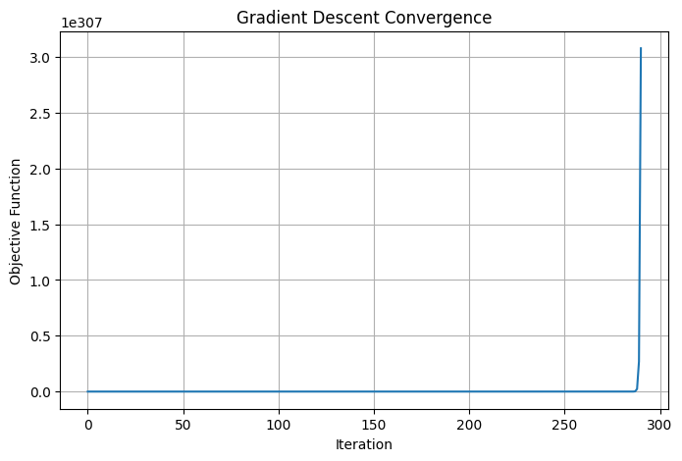
Figure 1
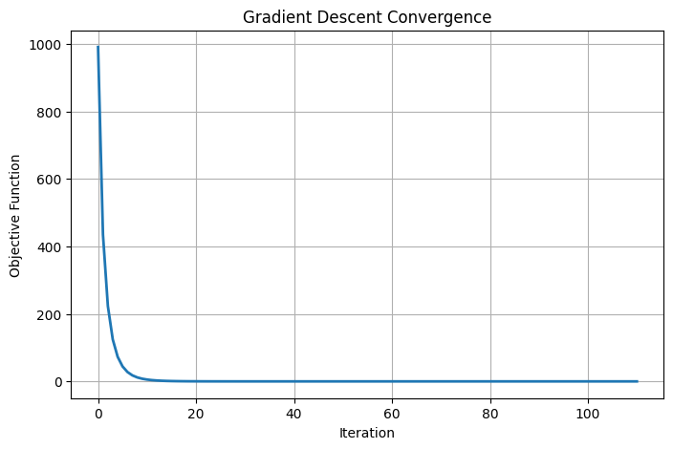
Figure 2

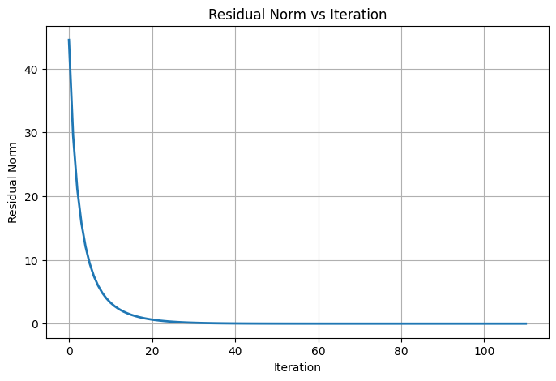
Figure 3

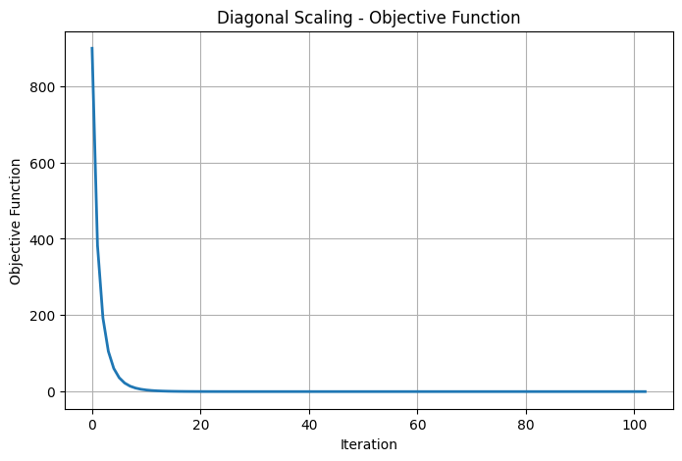
Figure 4
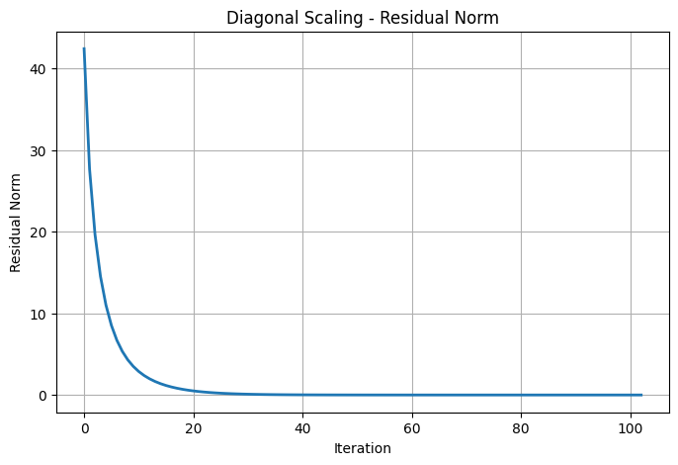
Figure 5
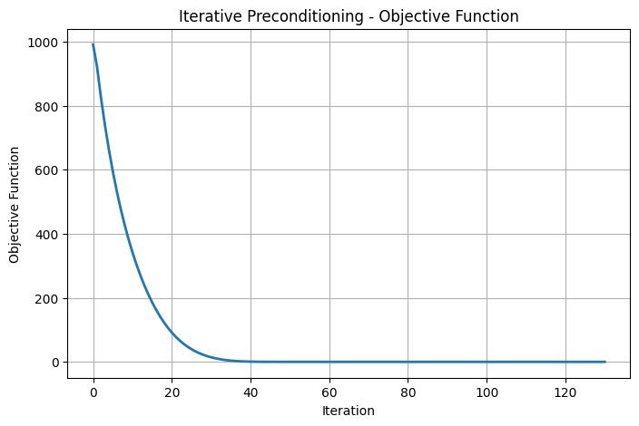
Figure 6
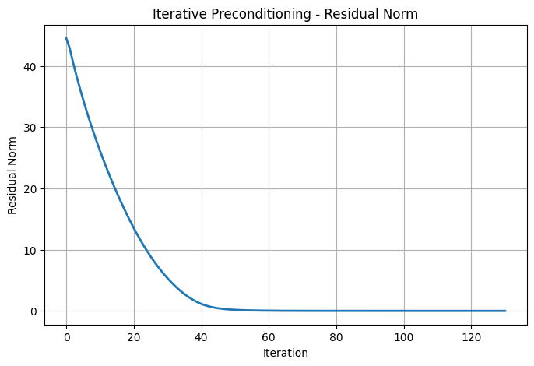
Figure 7
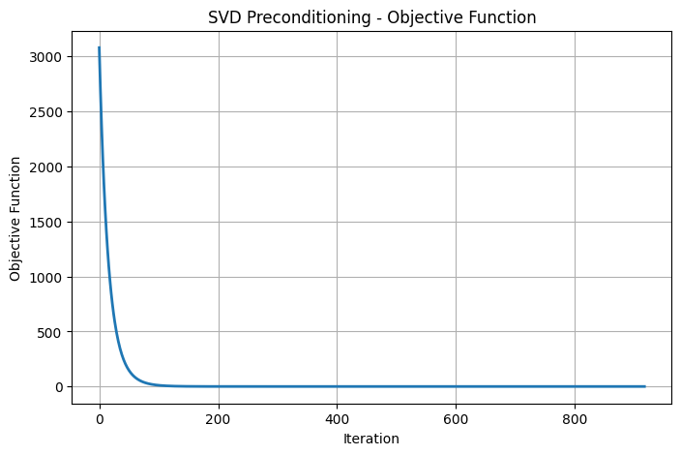
Figure 8

5.4 Accuracy Analysis
The numerical accuracy of each optimization method was evaluated using the residual norm and the relative error between the computed solution and the true solution vector.
The residual norms obtained from all four methods were of the order of 10⁻⁷, indicating that every algorithm successfully approximated the least-squares solution with high precision. Similarly, the relative errors were consistently of the order of 10⁻⁸, demonstrating excellent agreement between the computed and exact solutions.
Among the evaluated methods, Diagonal Scaling Preconditioning achieved the lowest residual norm (8.96357748 × 10⁻⁷) and the smallest relative error (1.87022756 × 10⁻⁸), indicating a slight improvement in numerical accuracy compared with the remaining optimization techniques.
Although the differences in accuracy are relatively small, the results suggest that diagonal scaling improves the quality of the computed solution while maintaining stable convergence.

5.5 Computational Performance
The computational efficiency of the optimization methods was assessed using the number of iterations required for convergence and the corresponding execution time.
Standard Gradient Descent completed the optimization process in 111 iterations with an execution time of 0.004270 seconds. The Diagonal Scaling Preconditioning method reduced the iteration count to 103 while requiring a comparable execution time of 0.004583 seconds. This represents a modest improvement in convergence efficiency without introducing a significant computational overhead.
The Iterative Preconditioning method required 131 iterations and an execution time of 0.035883 seconds. Although the algorithm converged successfully, its computational cost was noticeably higher than that of both Gradient Descent and Diagonal Scaling Preconditioning.
The SVD-Based Preconditioning method required 918 iterations and the largest execution time (0.110100 seconds). Under the experimental conditions considered in this study, the additional computational complexity associated with the SVD-based transformation did not result in improved optimization performance.
These findings indicate that the computational advantages of sophisticated preconditioning techniques depend strongly on the characteristics of the underlying optimization problem.

5.6 Discussion
The experimental evaluation demonstrates that all four optimization methods successfully solved the selected least-squares problem while satisfying the prescribed convergence criterion. The optimization trajectories remained stable throughout the iterative process, confirming the numerical reliability of the implemented algorithms.
Among the evaluated methods, Diagonal Scaling Preconditioning consistently achieved the best overall performance. It required the fewest iterations, produced the smallest residual norm, and yielded the lowest relative error while maintaining an execution time comparable to the baseline Gradient Descent algorithm.
The baseline Gradient Descent method also demonstrated strong performance. The benchmark problem considered in this study possesses a relatively low condition number (approximately 2.73), indicating that the optimization problem is already well-conditioned. Consequently, the potential benefits of advanced preconditioning techniques are naturally limited.
The Iterative Preconditioning method converged successfully but required additional computational effort without producing measurable improvements over the baseline method. Similarly, the implemented SVD-Based Preconditioning algorithm exhibited substantially slower convergence and the highest computational cost. These observations suggest that, for well-conditioned least-squares problems, the additional complexity introduced by these preconditioning strategies may not necessarily improve optimization efficiency.
It is important to emphasize that these conclusions are specific to the experimental configuration adopted in this study. The relative performance of the optimization methods may differ significantly for large-scale or highly ill-conditioned least-squares problems, where advanced preconditioning techniques are expected to provide greater computational advantages.
Overall, the experimental results support the conclusion that Diagonal Scaling Preconditioning offers an effective balance between convergence speed, numerical accuracy, and computational efficiency for the benchmark problems investigated in this work.

5.7 Chapter Summary
This chapter presented the experimental evaluation of four gradient-based optimization methods for solving linear least-squares problems. The comparative analysis demonstrated that all algorithms successfully converged to accurate numerical solutions under identical experimental conditions. Among the evaluated approaches, Diagonal Scaling Preconditioning achieved the best overall performance by reducing the number of iterations while maintaining high numerical accuracy and low computational cost. The findings presented in this chapter provide the experimental evidence supporting the conclusions of this study and establish the basis for the final conclusions presented in the next chapter.

CHAPTER 6

Conclusion
6.1 Conclusion
This study presented a comparative computational analysis of four gradient-based optimization methods for solving linear least-squares problems. The primary objective was to evaluate the convergence behaviour, computational efficiency, and numerical accuracy of Standard Gradient Descent, Diagonal Scaling Preconditioning, Iterative Preconditioning, and SVD-Based Preconditioning under identical experimental conditions.
All optimization methods were implemented in Python using the Google Colaboratory environment and evaluated using a common synthetic least-squares problem. The algorithms were compared using consistent performance metrics, including the number of iterations, residual norm, relative error, and execution time. This ensured that the experimental comparison was fair, reproducible, and directly related to the objectives of the study.
The experimental results demonstrated that all four optimization methods successfully converged to the least-squares solution while satisfying the predefined stopping criterion. The numerical solutions obtained by each method exhibited high accuracy, with residual norms on the order of 10⁻⁷ and relative errors on the order of 10⁻⁸, confirming the numerical stability of the implemented algorithms.
Among the evaluated methods, Diagonal Scaling Preconditioning achieved the best overall performance. It required the fewest iterations to converge while producing the smallest residual norm and relative error. In addition, its execution time remained comparable to that of the standard Gradient Descent algorithm, indicating that a simple preconditioning strategy can improve optimization efficiency without introducing significant computational overhead.
The Iterative Preconditioning method also converged successfully but required additional computational effort without producing measurable improvements over the baseline method for the benchmark problem considered. Similarly, the implemented SVD-Based Preconditioning approach required substantially more iterations and exhibited the highest computational cost. These observations indicate that the effectiveness of advanced preconditioning techniques depends strongly on the characteristics of the optimization problem and may not always provide computational advantages for relatively well-conditioned least-squares systems.
Overall, the findings of this study demonstrate that simple preconditioning techniques can effectively enhance gradient-based optimization while preserving numerical stability. The computational framework developed in this work provides a reproducible basis for evaluating optimization algorithms and offers a foundation for future investigations involving more challenging numerical optimization problems.

6.2 Limitations
Although the proposed comparative framework provides meaningful insights into the performance of gradient-based optimization methods, several limitations should be acknowledged.
First, the experimental evaluation was performed using a synthetic least-squares problem with a relatively low condition number. Consequently, the optimization problem was already well-conditioned, limiting the potential advantages of more sophisticated preconditioning techniques.
Second, the study focused exclusively on centralized linear least-squares optimization problems. The performance of the evaluated methods for nonlinear optimization problems, distributed optimization frameworks, or large-scale sparse systems was beyond the scope of the present work.
Finally, only four representative optimization methods were investigated. Numerous modern optimization algorithms and advanced preconditioning strategies have been proposed in the recent literature and were not considered in the computational experiments presented in this study.

6.3 Future Work
Several directions for future research naturally arise from the findings of this study.
Future investigations should evaluate the proposed computational framework using highly ill-conditioned least-squares problems to better understand the effectiveness of advanced preconditioning strategies under more demanding numerical conditions.
The experimental analysis may also be extended to large-scale sparse matrices obtained from practical scientific and engineering applications. Such benchmark problems would provide a more comprehensive assessment of computational scalability, numerical robustness, and algorithmic efficiency.
Another promising direction involves extending the comparative framework to nonlinear least-squares optimization problems, where adaptive optimization algorithms and advanced preconditioning techniques are expected to play a more significant role.
Finally, future work may investigate additional optimization methods, including quasi-Newton algorithms, conjugate gradient methods, stochastic optimization techniques, randomized preconditioning methods, and adaptive gradient algorithms. A broader comparative study involving real-world datasets and modern optimization frameworks would further enhance the practical applicability of the proposed computational framework.

Chapter Summary
This chapter presented the overall conclusions of the study, discussed its principal limitations, and identified several directions for future research. The experimental evaluation demonstrated that all four optimization methods successfully solved the benchmark least-squares problem while exhibiting different convergence characteristics and computational costs. Among the evaluated methods, Diagonal Scaling Preconditioning achieved the most favourable balance between convergence speed, numerical accuracy, and computational efficiency under the experimental conditions considered. The computational framework developed in this work provides a reproducible foundation for future comparative studies in numerical optimization and scientific computing.

Contributions of the Present Study
The present study makes several contributions to the field of numerical optimization and linear least-squares computation. Although numerous optimization algorithms have been proposed in the literature, comparatively few studies provide a consistent computational evaluation of multiple preconditioning strategies under identical experimental conditions. This work addresses that gap by developing a unified experimental framework for comparing gradient-based optimization methods applied to linear least-squares problems.
The first contribution of this study is the implementation and comparative evaluation of four optimization approaches: Standard Gradient Descent, Diagonal Scaling Preconditioning, Iterative Preconditioning, and SVD-Based Preconditioning. All algorithms were implemented using a common programming environment and tested under identical computational settings, ensuring that differences in performance arise from the optimization methods themselves rather than differences in implementation or experimental configuration.
The second contribution is the development of a reproducible computational framework for evaluating optimization algorithms. The study uses a common benchmark least-squares problem, identical initialization, consistent stopping criteria, and uniform performance metrics, allowing direct comparison of convergence behaviour, computational efficiency, and numerical accuracy. This framework can be extended to evaluate additional optimization techniques and benchmark datasets in future research.
The third contribution is the quantitative comparison of convergence characteristics across multiple optimization methods. The experimental results demonstrate that, under the benchmark problem considered in this study, Diagonal Scaling Preconditioning achieved the fastest convergence while maintaining high numerical accuracy. In contrast, the implemented Iterative Preconditioning and SVD-Based Preconditioning methods required greater computational effort without providing corresponding improvements for the selected problem. These findings illustrate that the effectiveness of preconditioning strategies depends on the characteristics of the optimization problem and should be evaluated empirically rather than assumed.
The fourth contribution is the provision of an open and reproducible implementation using Python and standard scientific computing libraries. The algorithms, computational procedures, and evaluation metrics described in this study can be reproduced and extended by other researchers, supporting transparency and reproducibility in computational mathematics research.
Finally, this study establishes a practical baseline for future investigations involving large-scale sparse systems, highly ill-conditioned least-squares problems, nonlinear optimization, and modern machine learning applications. The proposed computational framework provides a foundation upon which more advanced optimization techniques and preconditioning strategies can be systematically evaluated.

ACKNOWLEDGMENTS
The author would like to express sincere gratitude to all researchers whose published work contributed to the understanding of numerical optimization, linear least-squares problems, and preconditioning techniques. Their contributions provided valuable insights and served as an important foundation for the literature review and the development of this study.
The author also acknowledges the use of OpenAI's ChatGPT as a language and writing assistance tool during the preparation of this manuscript. ChatGPT was used to assist with the organization of the manuscript, improvement of academic writing, and refinement of language. The study design, literature review, mathematical analysis, implementation, computational experiments, interpretation of results, and all final scientific conclusions are the sole responsibility of the author.
Finally, the author is grateful for the availability of open-source scientific computing tools, including Python, NumPy, SciPy, Matplotlib, and Google Colaboratory, which facilitated the computational experiments presented in this research.

REFERENCES
[1] Scott, J., & Tůma, M. (2025). Sparse Linear Least-Squares Problems. Acta Numerica.
[2] Romeres, D., Gasparri, A., et al. (2022). Iterative Pre-conditioning for Expediting the Distributed Gradient-Descent Method: The Case of Linear Least-Squares Problem. Automatica.
[3] Ferrandi, G., & Hochstenbach, M. E. (2025). Limited Memory Gradient Methods for Unconstrained Optimization. Numerical Algorithms.
[4] Li, Y., Gu, J., et al. (2026). SVD-Preconditioned Gradient Descent Method for Solving Nonlinear Least-Squares Problems. arXiv Preprint.

