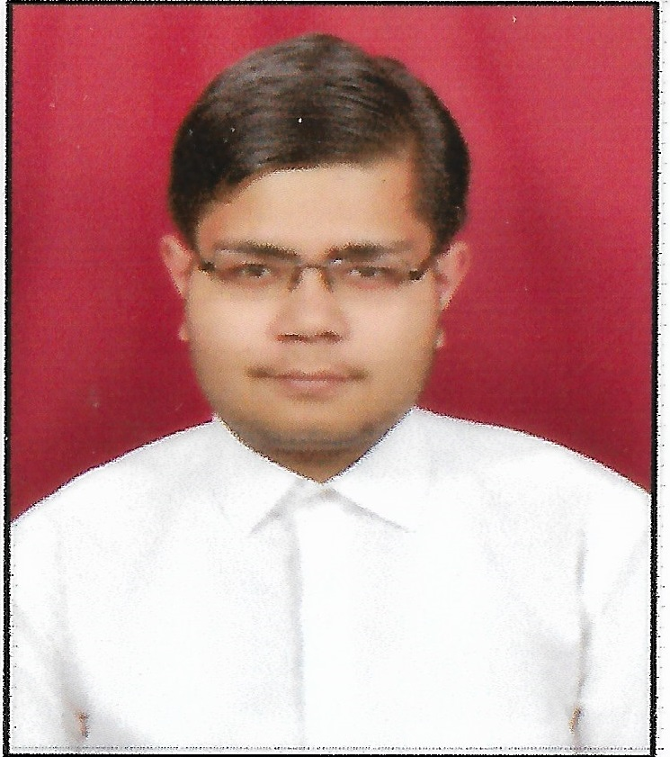
Chetanya Sharma
+918920208389 | chetanya1281998@gmail.com
Career Objective
To work in a firm with a professional work driven environment where I can utilize and apply my Knowledge, Skills which would enable me as a Fresh Graduate to grow while fulfilling organizational goals.

Educational Qualification

Examination | Board/University | School/College | Year of Passing | Percentage
B.Tech  (computer science  & engineering ) | AKTU | Krishna Engineering College | 2020 | 82.5%  (Till 5th semester)
Intermediate | CBSE | Govt. Sarvodya Bal Vidhyalaya | 2016 | 68%
High School | CBSE | Victor Public School | 2014 | 74%

Key Skills | KeyCompetencies
- Self-Motivated  - Good Communication skills  - Flexible and Adaptive  - Punctual and Disciplined  - Calm at Adverse Situations | - Tools: MS Office 2013  - Basic Programming Languages : C,CORE JAVA,J2EE.  - Web Technology : HTML,CSS,BOOTSTRAP,JAVASCRIPT.  - CMS: WORDPRESS

Specialization in Subjects

- Web Technology
- Database Management System

Industrial Training: (Not Finished Yet)

6 Months Java Summer Training
- Organization Name: Ducat India Pvt. Ltd.
- Duration Time: 6 months

Project
On-Going
Title: My Notes
Product: Web Application
Technology Used: HTML , CSS , PHP , MySql ,BOOTSTRAP , AJAX
Team Size: 4 members
Description: This is a web application who will help students as well as the faculty members carry out each activity in this department.It helps the student to provide proper notes of any subjects any units of different faculty members. My Notes is the crucial part of any educational institute in which most of the work is being done manually .The aim of or project is Automation of Sharing of Notes among students who will include minimum manual work and maximum optimization.

Achievements
.
- Certified in JAVA AND ADVANCE JAVA.
- Certified in WEB DEVELOPMENT and WORDPRESS from udemy.

Personal Profile

Father’s name : Mr. Manoj Sharma

Date of Birth :12th August,1998

Languages known : English, Hindi

Address : 717/200 Main Road Maujpur Delhi-110053

Declaration

I hereby declare that all the information mentioned above is true and correct to the best of my knowledge.
Date: Place: Delhi (Chetanya Sharma)

